Appendix 2a: Semi-targeted advertisement/flyer

Participants Wanted for Research Study

The National Center for Health Statistics
is looking for mothers (aged 18 and over) with babies 2-12 months old to answer questions that may be used on a national survey. All mothers are welcome, but we are especially interested in mothers who have a family history of breast cancer or ovarian cancer and/or had genetic testing for cancer risk. The survey research interview will be no longer than 90 minutes and participants will receive $50.

FOR MORE INFORMATION,
Call [fill name] at: 301-458-[fill XXXX]

Centers for Disease Control and Prevention
National Center for Health Statistics
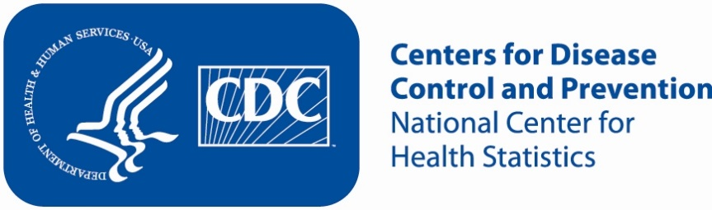
Appendix 2b: Semi-targeted advertisement/flyer [note that only one or more statements within the bracketed section below will be selected at a time, depending on recruiting needs].

Justification for advertisement: In order to reach this specific population, we need to reach a wide audience. The flyers posted in social service centers such as rehabilitation centers will reach a very specific population. By advertising to the general public, we will reach a more diverse pool of participants.

Participants Wanted for Research Study

The National Center for Health Statistics
is looking for mothers (aged 18 and over) with babies 2-12 months old to answer questions that may be used on a national survey. All mothers are welcome, but we are especially interested in mothers who used any of the following prior to or during pregnancy: [marijuana, prescription pain relievers, antidepressants, opiates, or benzodiazepines]. The survey research interview will be no longer than 90 minutes and participants will receive $50.

FOR MORE INFORMATION,
Call [fill name] at: 301-458-[fill XXXX]

Centers for Disease Control and Prevention
National Center for Health Statistics
Appendix 2c: Non-Specific Advertisement/flyer

Participants Wanted for Research Study

The National Center for Health Statistics
is looking for mothers (aged 18 and over) with babies 2-12 months old to answer questions that may be used on a national survey. The survey research interview will be no longer than 90 minutes and participants will receive $50.

FOR MORE INFORMATION,
Call [fill name] at: 301-458-[fill XXXX]

Centers for Disease Control and Prevention
National Center for Health Statistics

Appendix 2d: Interview conducted with respondents who are affiliated with a center that the CQDER staff contacted for PRAMS Phase 8.

[Center that the CQDER staff contacted] staff would read the following text to the individual:

If CQDER staff are at the facility:
“You may be eligible to participate in a research study [today/on specified date] if you would like to do so. Researchers from the National Center for Health Statistics are evaluating questions which may be used on a national survey about mothers with babies 2-12 months old and are offering $50 to those who participate in the study. The researchers are here [specific location in building]. If you are interested in learning more about the study, you can speak with them. You can then decide whether or not you want to participate.”

If CQDER staff are not at the facility:
“You may be eligible to participate in a research study [today/on specified date] if you would like to do so. Researchers from the National Center for Health Statistics are evaluating questions which may be used on a national survey about mothers with babies 2-12 months old and are offering $50 to those who participate in the study. Here is the researchers’ contact information [pointing to the flyer]. You can contact them to learn more about the study. You can then decide whether or not you want to participate.”

