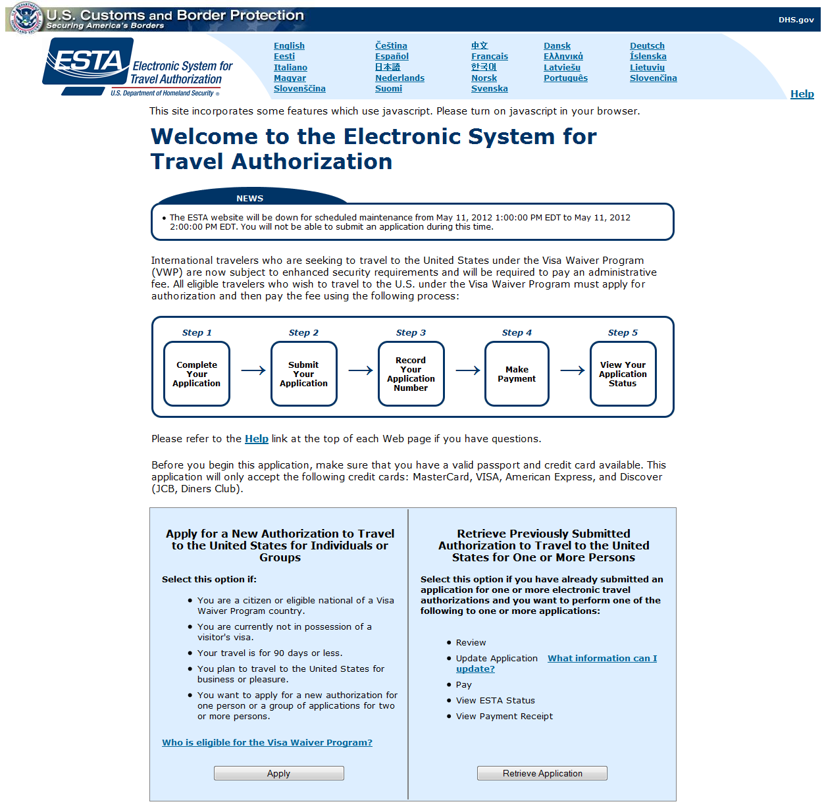

Paperwork Reduction Act: An agency may not conduct or sponsor an information collection and a person is not required to respond to this information unless it displays a current valid OMB control number and an expiration date. The control number for this collection is 1651-0111. The estimated average time to complete this application is 20 minutes. If you have any comments regarding this burden estimate you can write to U.S. Customs and Border Protection, Office of Regulations and Rulings, 90 K Street, NE, 10th Floor, Washington DC 20229. Expiration May 31, 2015.
The ESTA logo is a registered trademark of the U.S. Department of Homeland Security. Its use, without permission, is unauthorized and in violation of trademark law. For more information, or to request the use of the logo, please go to help.cbp.gov and submit a request by clicking on "Ask a Question." When selecting the Product (under Additional Information) use "ESTA" and the sub-product "Logo Assistance" to expedite handling of your request.
For inquiries or questions regarding this application, please click here.
Privacy Statement | Accessibility | www.cbp.gov/travel

