Attachment D1
Job Aid
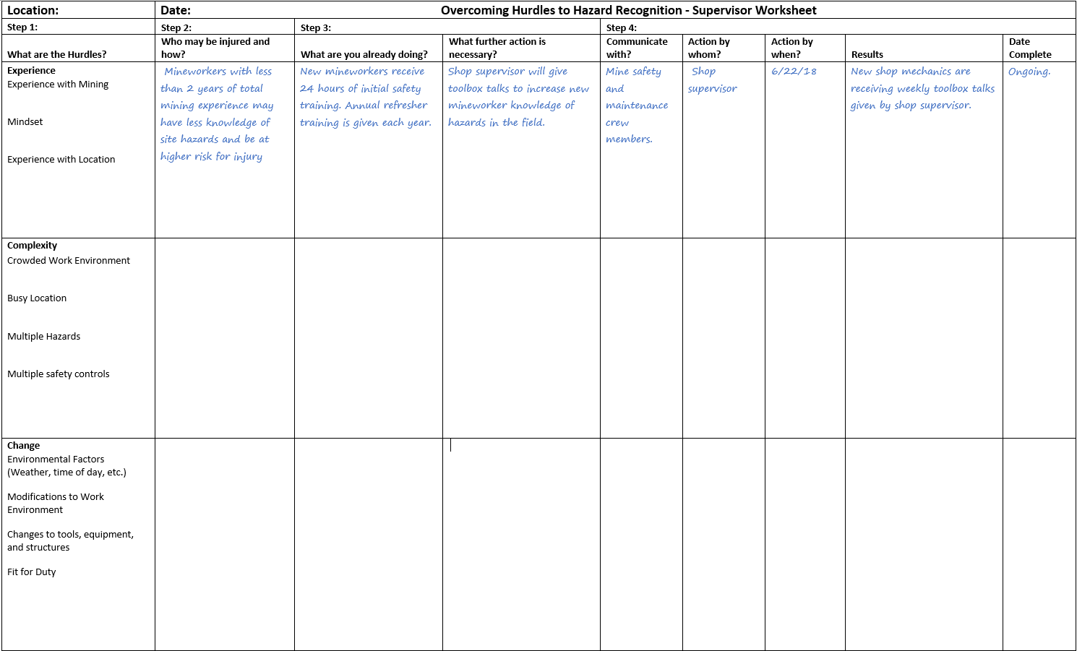

Form Approved
OMB NO. 0920-0953
Expiration Date: 7/31/2018

Job Aid: Overcoming Hurdles to Hazard Recognition – Supervisor Work Sheet
Introduction
The job aid is intended to be used as a field guide to help supervisors and safety professionals identify the hurdles to hazard recognition and decide which action should be put in place to control or eliminate those hurdles. In practice, the job aid allows supervisors and safety professionals to apply and reinforce the concepts covered in the NIOSH “Are you thinking like an EXAMiner?” training module in the field. Use of the job aid begins with identifying the hurdles to hazard recognition. Example hurdles and concepts are listed on the left hand side of the job aid as a reminder of what potential hurdles may exist in the work environment. The job aid then asks a series of questions to help the supervisor or safety professional systematically identify who may be injured, what is being done to prevent injury, what further action is necessary, who should complete the action, and when the action should be completed. Once complete, the job aid should be reviewed and updated on a regular basis.
Procedure
Review the concepts presented in the “Are You Thinking like an Examiner?” training module. Many factors such as experience, complexity of the work environment, and change in the work environment can affect hazard recognition. When thinking about potential hurdles in your work environment, remember:
- Experience affects the number of hazards that mineworkers recognize. Think about:
- How many years have my employee(s) worked in the mining industry?
- Are my employee(s) knowledgeable of hazards in the work environment?
- Are my employee(s) focused on safety?
- Will my employee(s) be exposed to a new or unfamiliar location in the mine?
- Complexity affects the number of hazards a mineworker is able to find. Think about:
- Are my employee(s) working in cluttered work environments?
- Are my employees(s) working in busy (high traffic, divided attention) locations?
- Are my employee(s) working in areas where multiple hazards may be present?
- Are my employee(s) performing tasks that require multiple safety procedures?
- Change in the work environment can affect hazard recognition. Think about:
- What conditions are my employees exposed to? (weather, time of day, etc.)
- What changes may be made to the mine plan? (traffic pattern, location of roads, etc.)
- What changes may be made to tools, equipment, and structures?
- Are my employee(s) fit for duty? (fatigue, illness, distraction)
Step 1: Identify the Hurdles to Hazard Recognition at your mine site.
  - Walk around your mine site and determine what could affect your mineworker’s abilities to find hazards using the concepts outlined above. Be sure to think about all areas of the mine such as the pit, plant, roadway, and shop.
  - Ask your employees what they think. They may have insights to existing or potential hurdles that you may not be able to find.
  - Review workplace examination records.
Public reporting burden of this collection of information is estimated to average 90 minutes per response, including the time for reviewing instructions, searching existing data sources, gathering and maintaining the data needed, and completing and reviewing the collection of information. An agency may not conduct or sponsor, and a person is not required to respond to a collection of information unless it displays a currently valid OMB control number. Send comments regarding this burden estimate or any other aspect of this collection of information, including suggestions for reducing this burden to CDC/ATSDR Information Collection Review Office, 1600 Clifton Road NE, MS D-74, Atlanta, Georgia 30333; ATTN: PRA (0920-0953).

  - Review your accident, illness, and near miss incident records.
  - Review your mine plan and potential changes in traffic patterns and the work environment.
STEP 2: Determine who may be injured and how.
- For each hurdle, think about who may be injured and how. This may be more easily accomplished by identifying groups of people (e.g. shop mechanics, haul truck drivers, plant operators) rather than individuals.
- For each hurdle, think about how this person or group may be injured. For example, shop mechanics with less than 2 years of total mining experience may have less knowledge of site hazards and be at a higher risk for injury. Another example may be a loader operator who must divide his or her attention between the stockpile and multiple customer trucks.
- Remember to think of workers who may not be in a particular location of the mine all the time. For example, a shop mechanic who is dispatched to help repair a truck located in the pit area.
- Ask your employees if they can think of anyone you may have missed.
STEP 3: Determine what you are already doing to reduce or eliminate hurdles to hazard recognition. Then, think about what further action may be necessary.
- Think about what practices, procedures, and controls are in place to help reduce or eliminate the hurdles to hazard recognition. Then compare this with best practices to determine if there is more you should be doing.
- In the first example above, shop mechanics with less than 2 years of total mining experience were identified as a potential hurdle to hazard recognition. You may already be doing annual refresher trainings to help reduce this hurdle. However, an additional practice to help reduce this hurdle may be to follow-up with new employees in the field with periodic toolbox talks and safety shares of potential hazards.
- In the second example above, a loader operator must divide his attention between the stockpile and truck traffic. You may already have rules to govern traffic patterns in this area. However, additional procedures and controls may help the loader operator communicate with truck traffic. These may include implementing horn or radio communication methods or adding additional signage to remind truck traffic of specific traffic rules.
STEP 4: Determine who should be responsible for implementing changes and when they should occur.
- Use the field guide to help keep track of what additional practices, procedures, and controls should be put in place to help reduce the hurdles to hazard recognition.
- Use the results column to keep track of your improvements. For example, this may be as simple as writing “new shop mechanics are receiving weekly toolbox talks given by shop supervisor” or “traffic sign added to truck loading area to help improve a busy location”.
- Writing down actions, assigning responsibility, and sharing the results with your staff helps to encourage improvements in the work environment.
STEP 5: Review your worksheet regularly and update if necessary.
- Changes to the work environment such as new equipment, personnel, and workflows may introduce new hurdles to hazard recognition.
- Think about:
  - What changes have been made?
  - What improvements still need to be made?
  - What input have you received from your employees?
  - Have you had any near-misses or incidents? How could these have been prevented?

