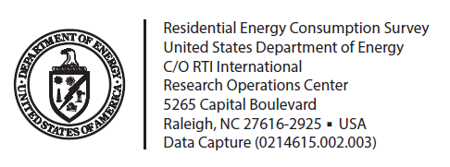

[City] Resident
[Recipient Address]
[City, ST Zip]

Dear Resident,
Your household has been chosen to participate in the 2015 Residential Energy Consumption Survey, a nationwide study of home energy use sponsored by the U.S. Department of Energy.
Soon, you’ll be receiving a letter that will give you more information. As a token of appreciation for your participation, a gift will also be provided. In the meantime, you can visit our website at www.eia.gov/consumption/residential.
Your identity and the information you will provide will be held in strict confidence; your name and address will not be given to anyone else! The data released will not have any identifying features and will be used only for statistical purposes.

Thank You for Your Cooperation!

