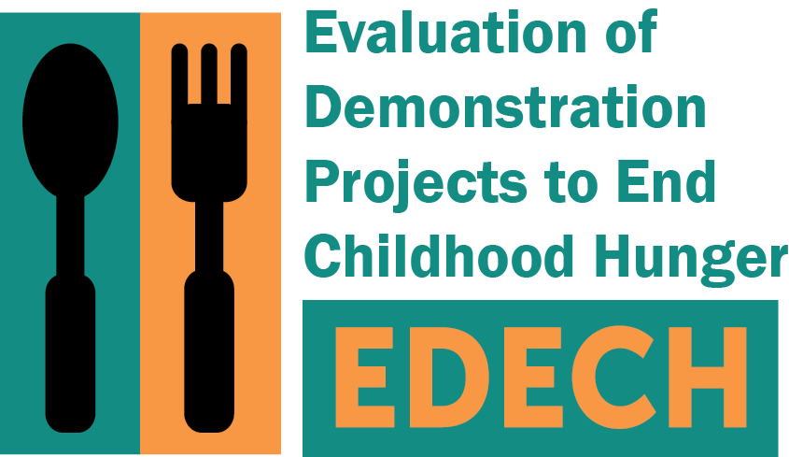
OMB Control No: 0584-XXXX
Expiration date: XX/XX/XXXX

[DATE]
[FNAME] [LNAME]
[ADDRESS1]
[ADDRESS2]
[CITY], [STATE] [ZIP]

Dear [FNAME]:
We have been trying to reach you for an important study sponsored by the U.S. Department of Agriculture’s (USDA) Food and Nutrition Service (FNS). Around the summer of 2015, you [IF ACTIVE CONSENT: signed a consent form to take part; IF PASSIVE CONSENT: received a letter about taking part] in a telephone survey. This study will help us learn more about how projects like [DEMONSTRATION PROJECT] can help families feed their children. FNS has hired Mathematica Policy Research to conduct the evaluation.
We need you to complete a short survey by phone. The survey asks about your household’s experiences related to food. Once you complete the interview, you will receive $30 as a thank you.
We have tried calling you, but have not been able to reach you. Please call Mathematica’s toll-free number 1-888-XXX-XXXX to provide your current number, or to complete the survey. You can also email us at XXX@mathematica-mpr.com to provide the best number to reach you. If we do not hear from you in the next few weeks, a professional interviewer in your area will contact you in person to complete the phone survey.
Please know that the only purpose of the interview is research. Your answers will be kept private and will not be shared with anyone from [DEMONSTRATION PROJECT]. The information you provide will help us learn about how different projects like [DEMONSTRATION PROJECT] help families provide food for their children.
We look forward to speaking with you soon.
Sincerely,

Sarah Forrestal
EDECH Survey Director

