ODPHP: Website Survey Example Screenshots
OMB Control Number: 0990-0379

Example Screenshots Overview
Below are examples from 3 HHS agency websites that use the Voice of Consumer (VoC) survey tool. The screenshots included illustrate how ODPHP website surveys will be situated on the site and how the surveys will be structured at the site level and page level.

Site-Level Survey Example Screenshots
From USA.gov [demo]

Pop-up invitation to begin survey

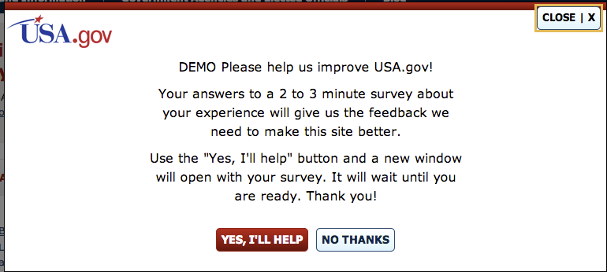

From StopBullying.gov

Invitation to begin survey via link in footer

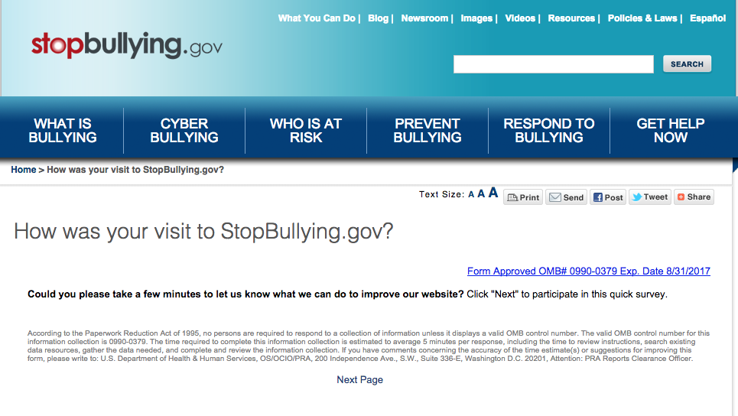

Sample question page 1

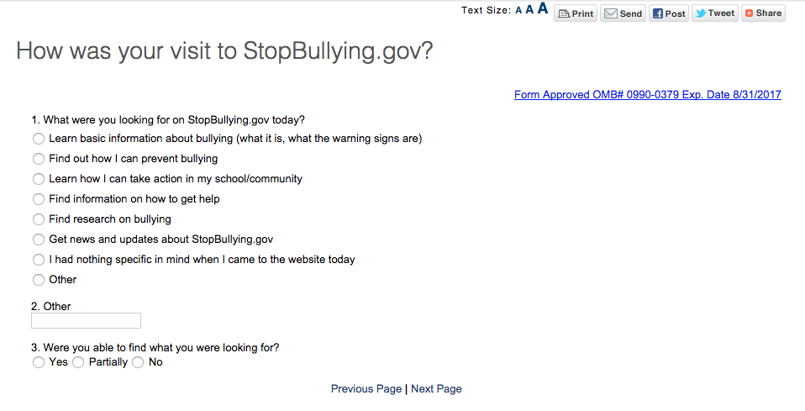

Sample question page 2

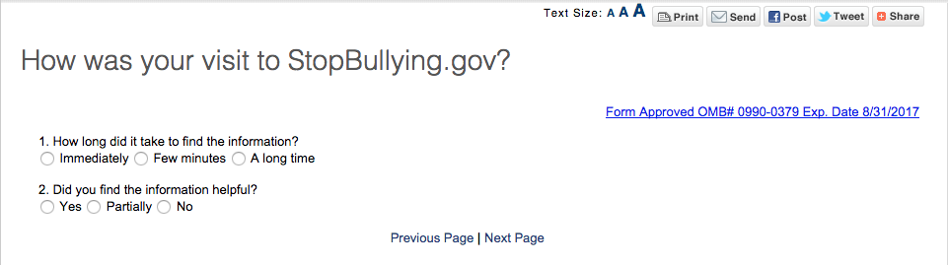

Page-Level Survey Example Screenshots
From Usability.gov

Sample first question

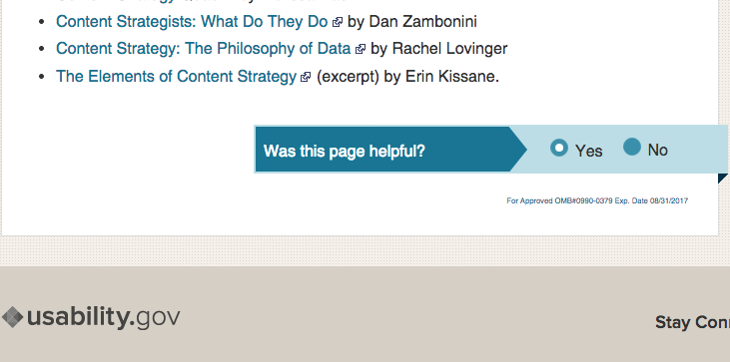

Sample second question

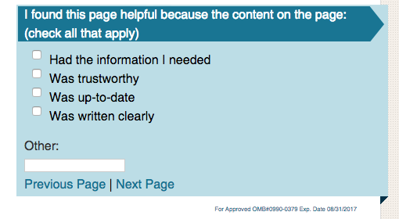

Sample third question

