APPENDIX A – SuperTracker Screenshots

Create Profile Page
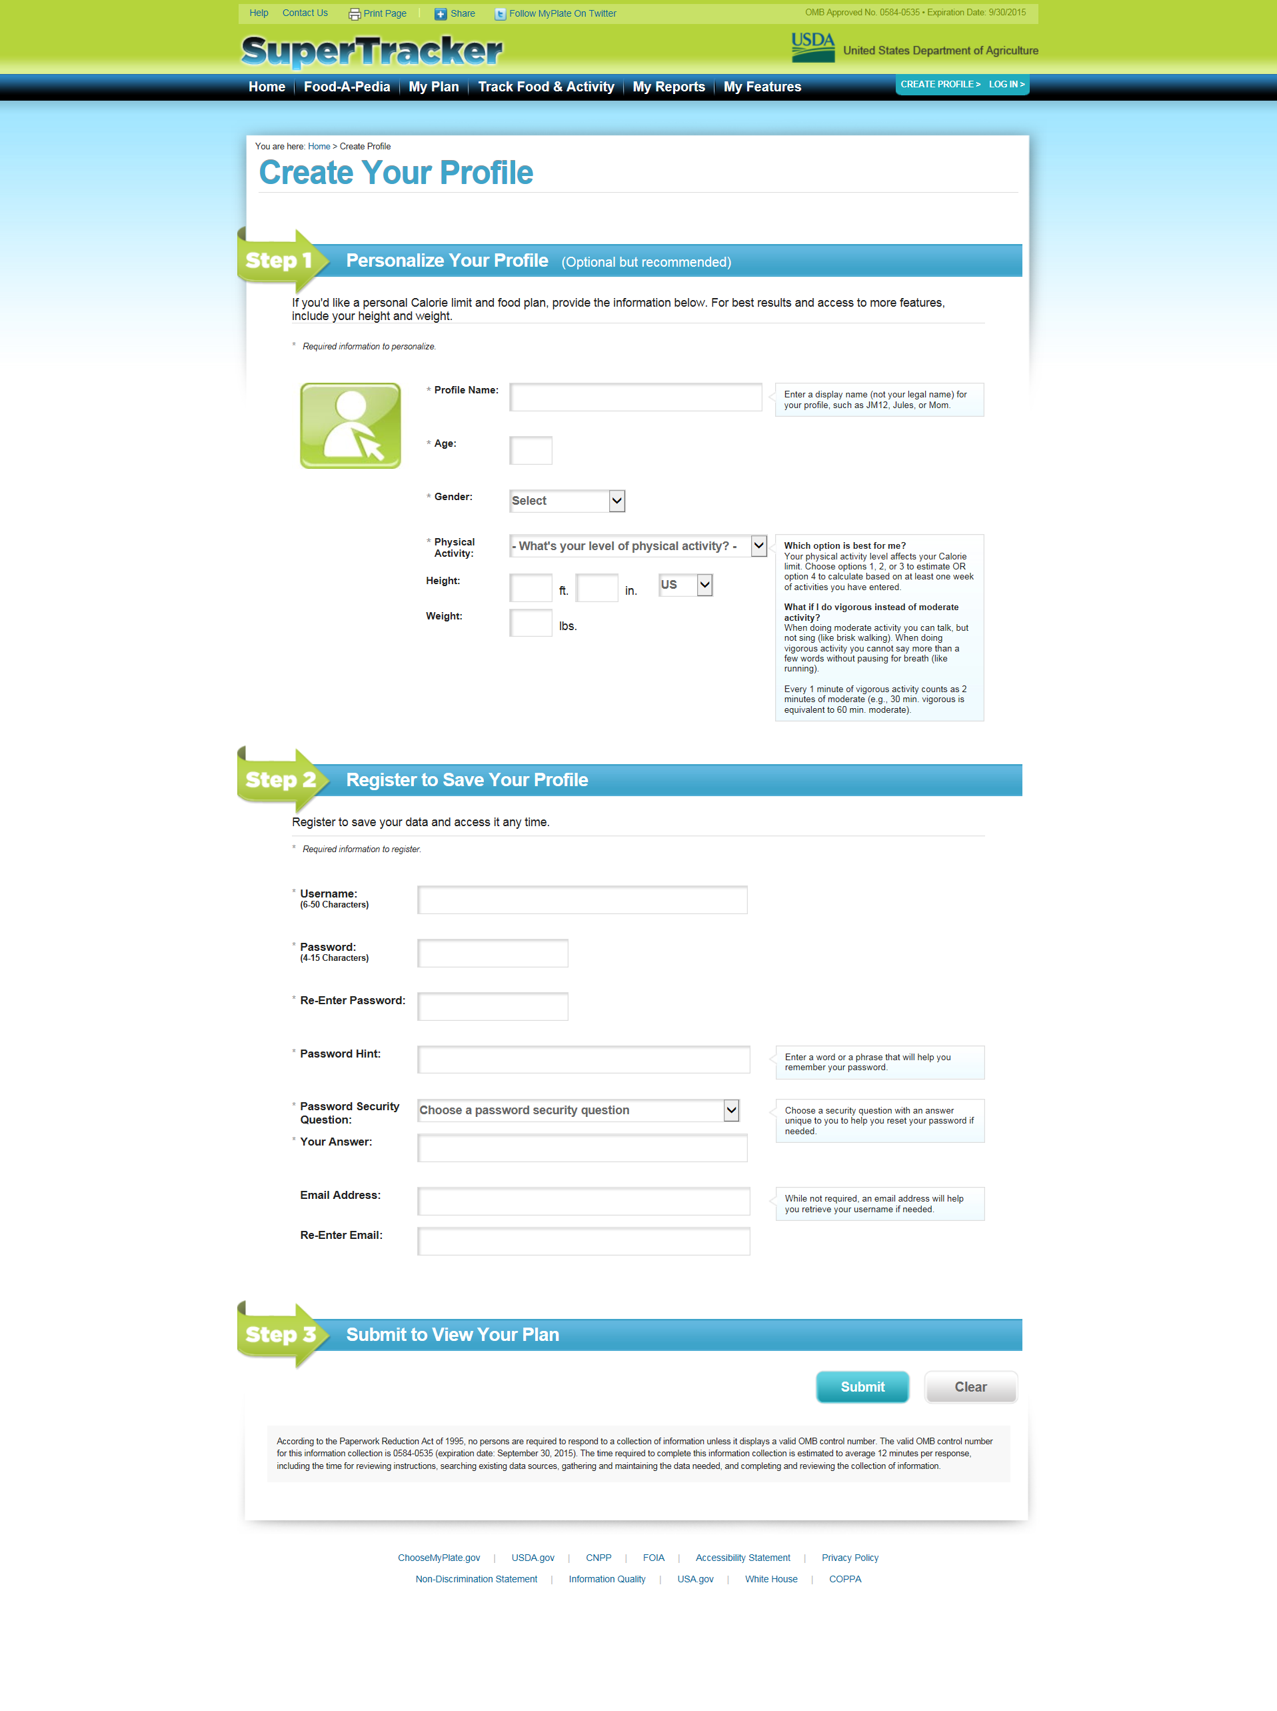
Enlarged view of public burden statement on the next page

Enlarged View of Public Burden Statement

