Typical Riding Gear (Form A)
For each item, indicate whether you: never, rarely, sometimes, usually or always wear it. The pictures are examples only.
Example | Item | Use  Mark your response with an “X”
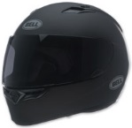  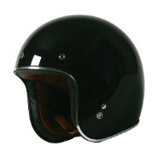  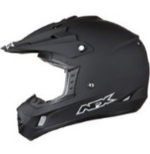  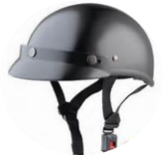  If you wear a helmet, circle the type that best reflects the one you use. | Helmet | Never
 | Helmet | Rarely
 | Helmet | Sometimes
 | Helmet | Usually
 | Helmet | Always
If you wear a helmet, is it DOT certified? (circle your response)

YES NO DON’T KNOW

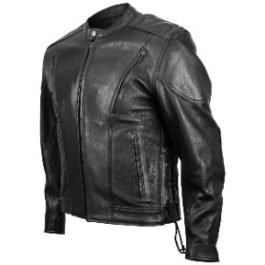 | Leather jacket | Never
 | Leather jacket | Rarely
 | Leather jacket | Sometimes
 | Leather jacket | Usually
 | Leather jacket | Always
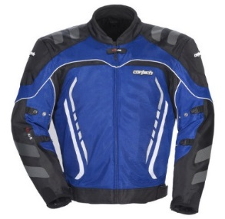 | Armored/protective jacket | Never
 | Armored/protective jacket | Rarely
 | Armored/protective jacket | Sometimes
 | Armored/protective jacket | Usually
 | Armored/protective jacket | Always
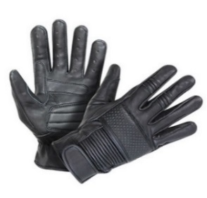 | Riding gloves | Never
 | Riding gloves | Rarely
 | Riding gloves | Sometimes
 | Riding gloves | Usually
 | Riding gloves | Always
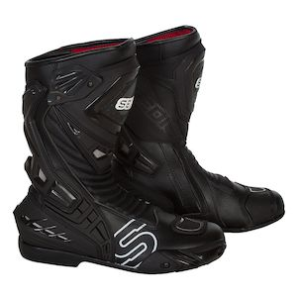  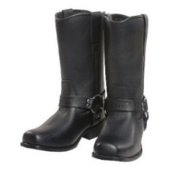 | Riding boots | Never
 | Riding boots | Rarely
 | Riding boots | Sometimes
 | Riding boots | Usually
 | Riding boots | Always

Example | Item | Use  Mark your response with an “X”
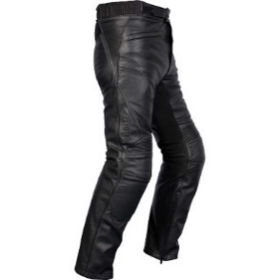 | Leather pants | Never
 | Leather pants | Rarely
 | Leather pants | Sometimes
 | Leather pants | Usually
 | Leather pants | Always
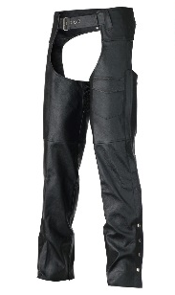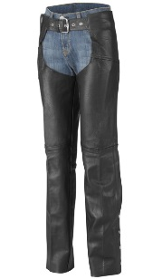 | Chaps | Never
 | Chaps | Rarely
 | Chaps | Sometimes
 | Chaps | Usually
 | Chaps | Always
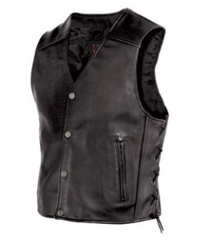 | Leather vest | Never
 | Leather vest | Rarely
 | Leather vest | Sometimes
 | Leather vest | Usually
 | Leather vest | Always
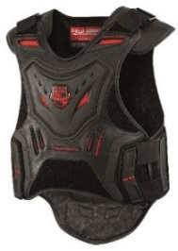 | Armored vest | Never
 | Armored vest | Rarely
 | Armored vest | Sometimes
 | Armored vest | Usually
 | Armored vest | Always
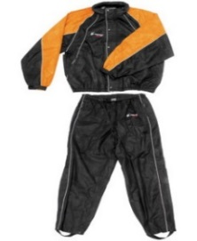 | Rain gear | Never
 | Rain gear | Rarely
 | Rain gear | Sometimes
 | Rain gear | Usually
 | Rain gear | Always
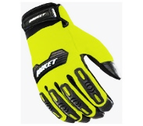  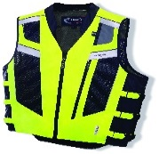  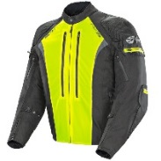  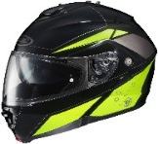 | High visibility gear | Never
 | High visibility gear | Rarely
 | High visibility gear | Sometimes
 | High visibility gear | Usually
 | High visibility gear | Always

Example | Item | Use  Mark your response with an “X”
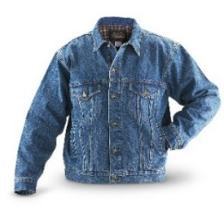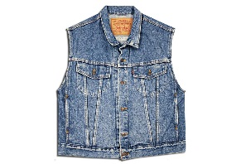 | Denim jacket /vest | Never
 | Denim jacket /vest | Rarely
 | Denim jacket /vest | Sometimes
 | Denim jacket /vest | Usually
 | Denim jacket /vest | Always
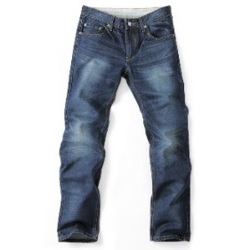 | Denim pants | Never
 | Denim pants | Rarely
 | Denim pants | Sometimes
 | Denim pants | Usually
 | Denim pants | Always
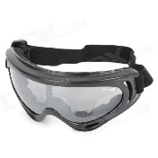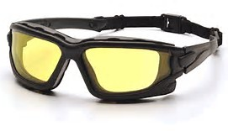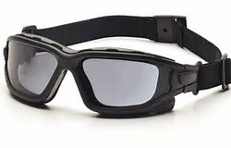 | Eye protection | Never
 | Eye protection | Rarely
 | Eye protection | Sometimes
 | Eye protection | Usually
 | Eye protection | Always

OTHER (Specify) ________________________________________________________________________

