Attachment C: Materials For Testing (November 2016)

FEMALE GROUPS
http://www.cdc.gov/cancer/skin/badges.htm
INFOGRAPHICS
Base Tan

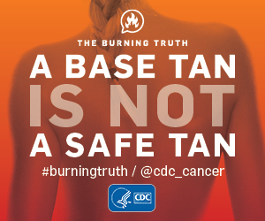

Controlled Tanning 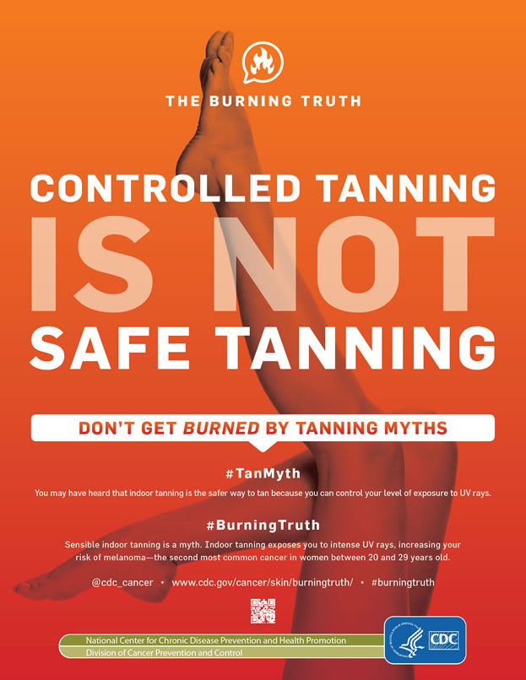
Not Healthy Skin
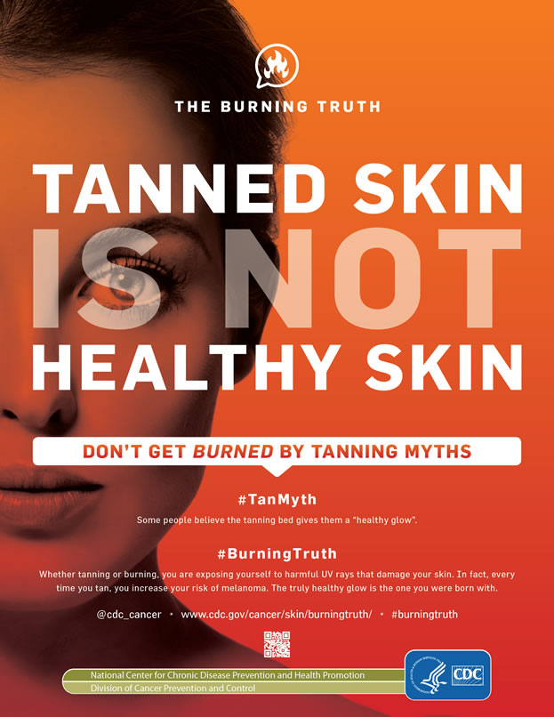
FACTSHEETS
Family, pg. 1
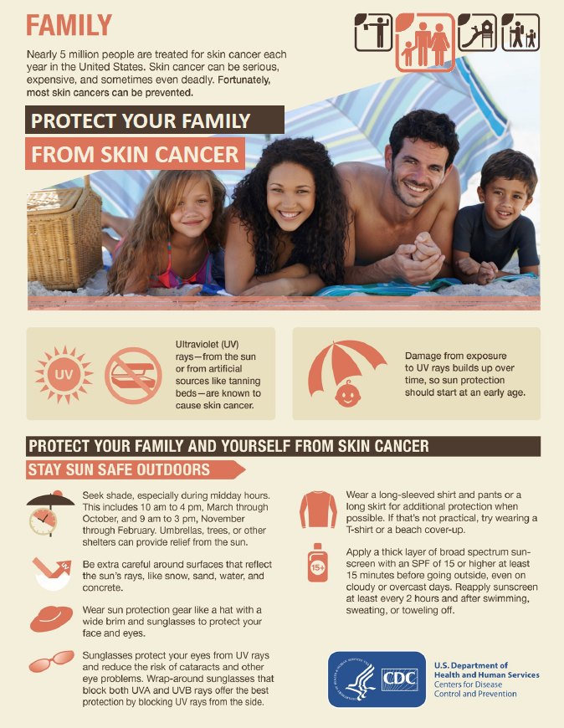
Family, pg. 2
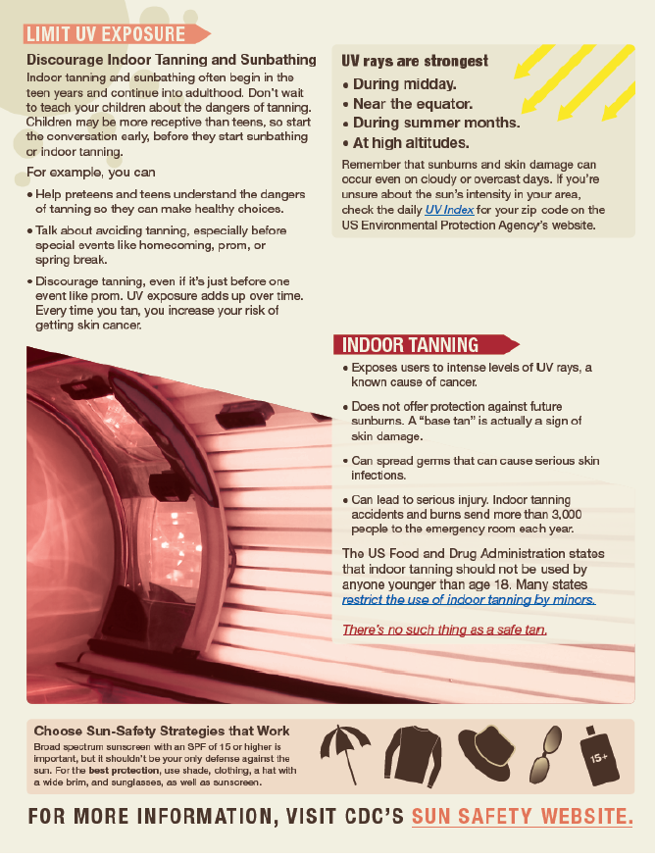
Skin You’re in
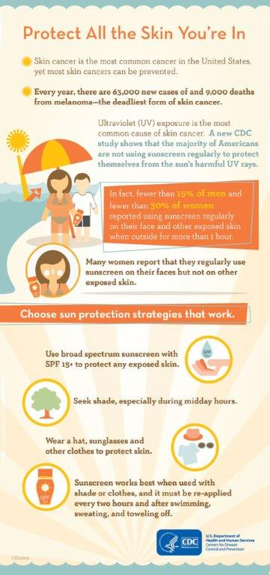

MALE GROUPS
http://www.cdc.gov/cancer/skin/tips-for-men.htm
DIGITAL AD

No Regrets

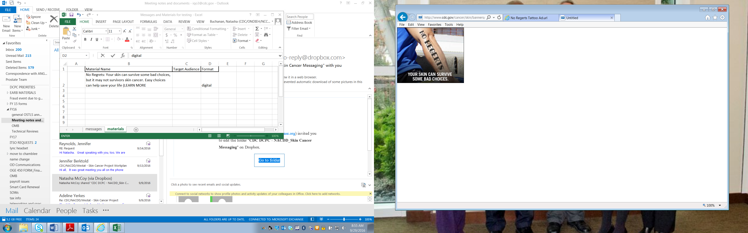

INFOGRAPHIC

Protection from UV

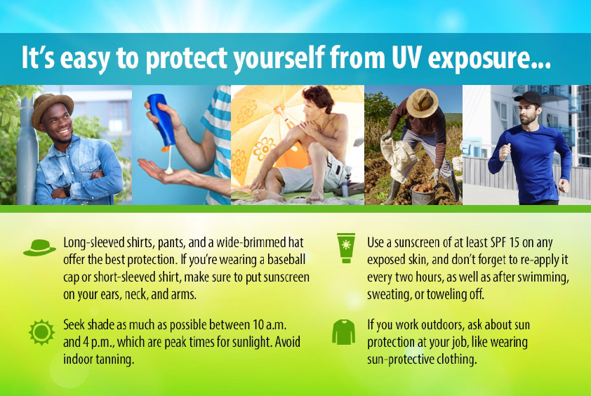

FACT SHEETS
Safety Tips for Men, pg. 1
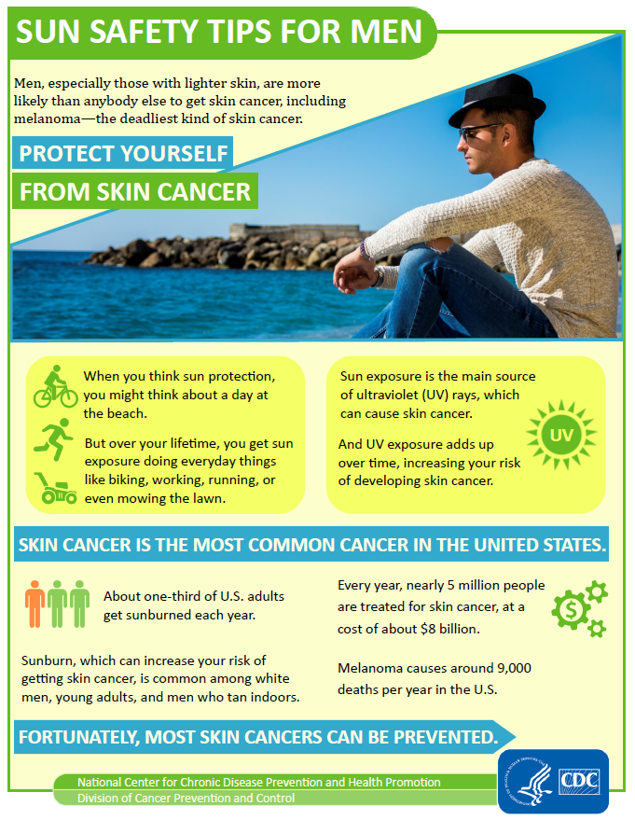
Safety Tips for Men, pg.2
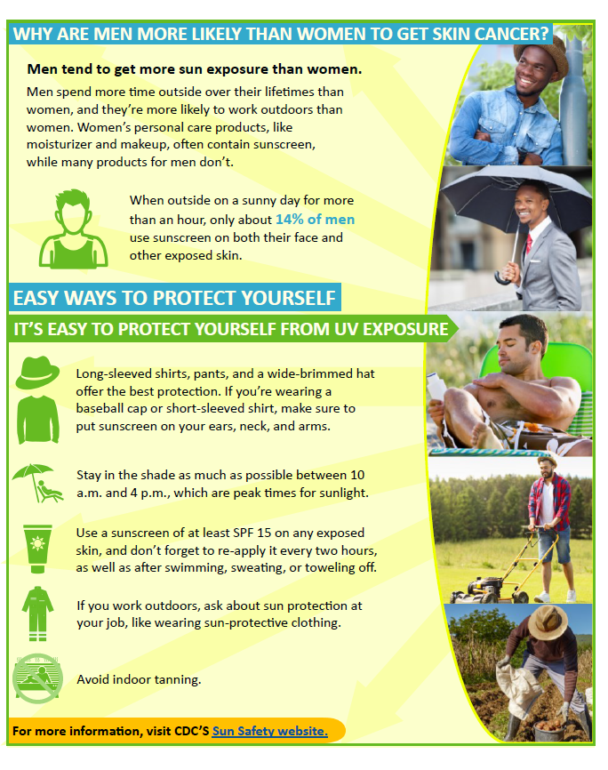

Fact Sheet #2
Family, pg 1
Family, pg. 2

