Form Approved
OMB No. 0920-0572
Exp. Date 03/31/2018

OADC Message and Material Feedback Surveys — Health Material Questions (online)

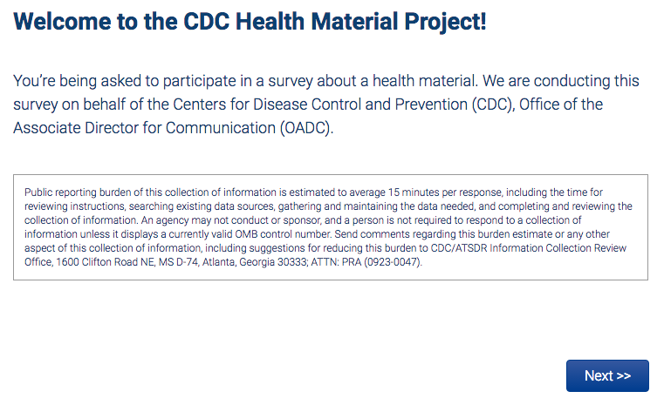
Form Approved
OMB No. 0920-0572
Exp. Date 03/31/2018

Review Material:
Survey #1 Material — for participants in Survey 1 ONLY
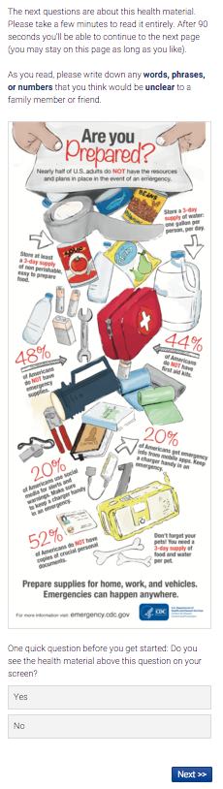
Review Material:
Survey #2 Material — for participants in Survey 2 ONLY
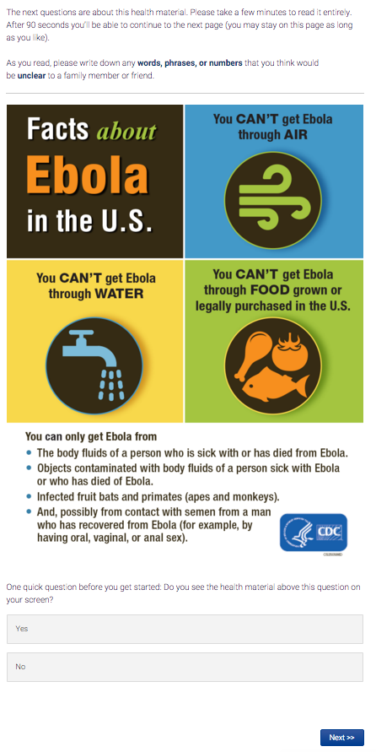
Review Material:
Survey #3 Material — for participants in Survey 3 ONLY
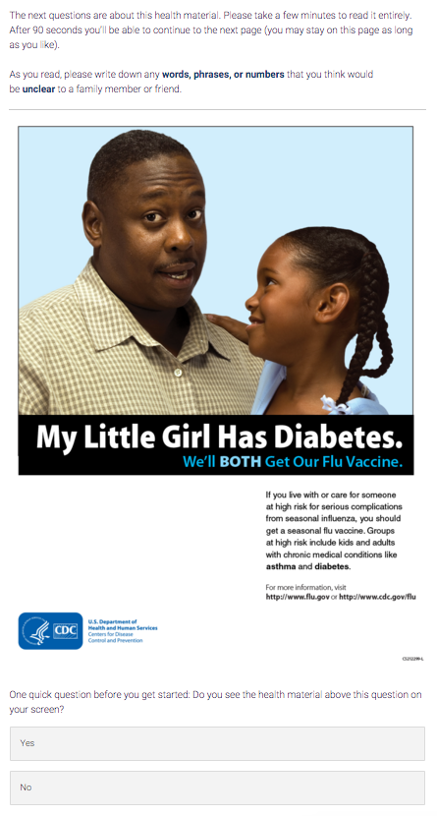
Review Material:
Survey #4 Material — for participants in Survey 4 ONLY
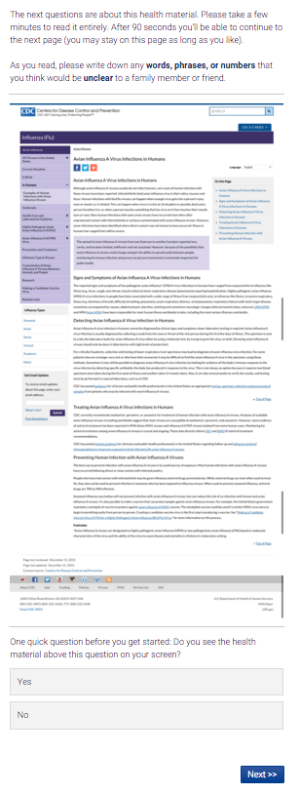

Main Audience, Message, & Intended Behavioral Recommendation
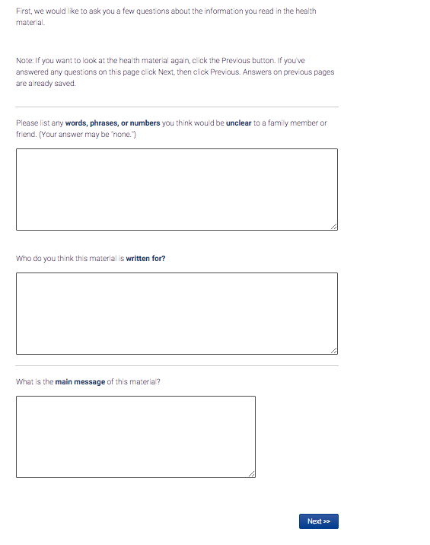

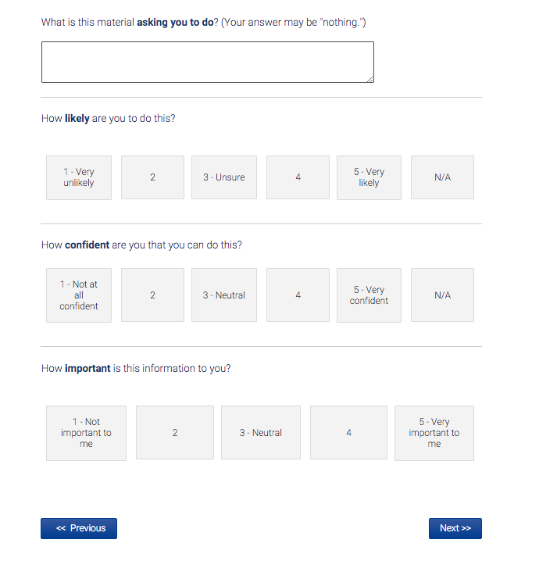
Modified Consumer Information Rating Form (CIRF):
Includes Survey #1 Material — for participants in Survey 1 ONLY
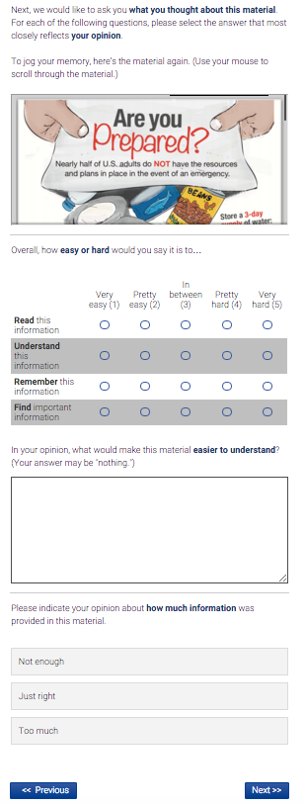
Modified Consumer Information Rating Form (CIRF):
Includes Survey #2 Material — for participants in Survey 2 ONLY

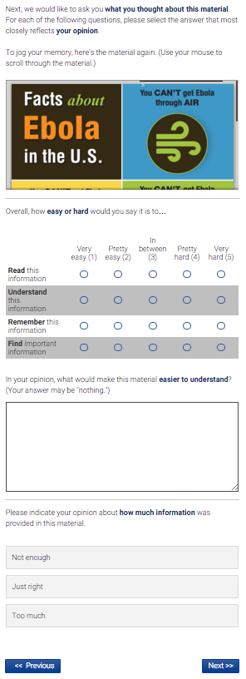
Modified Consumer Information Rating Form (CIRF):
Includes Survey #3 Material — for participants in Survey 3 ONLY
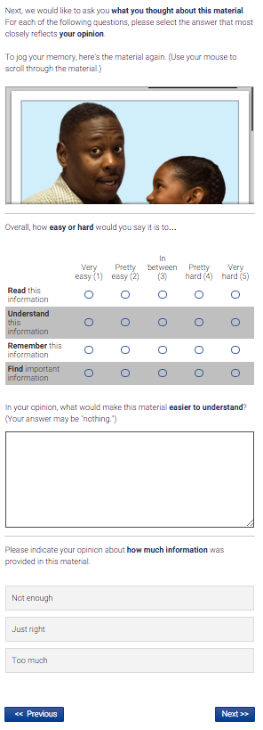
Modified Consumer Information Rating Form (CIRF):
Includes Survey #4 Material — for participants in Survey 4 ONLY
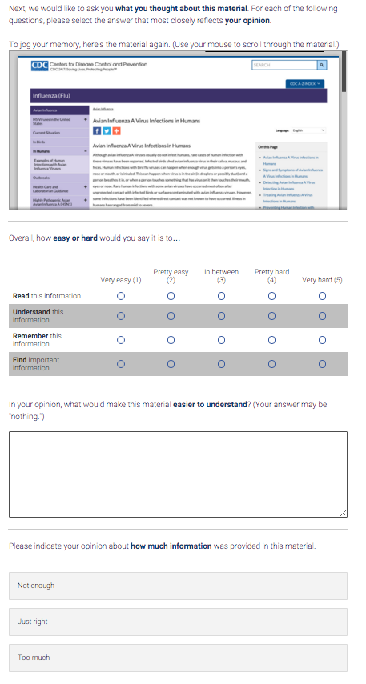

Modified Consumer Information Rating Form (CIRF), continued
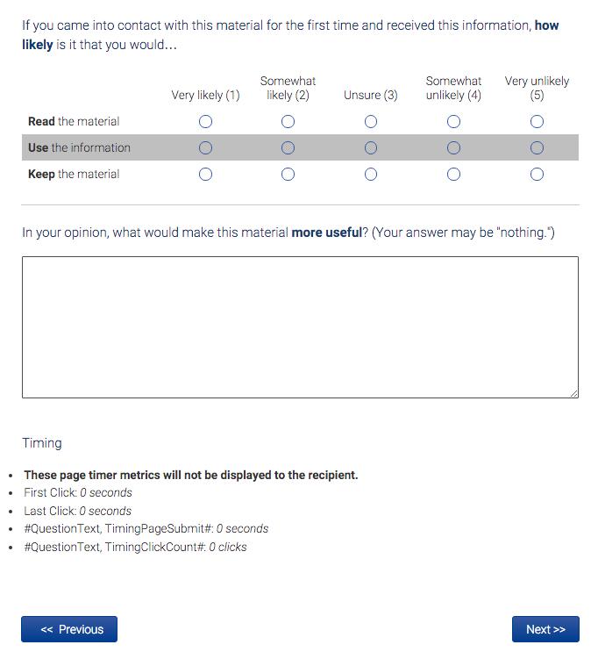

Modified Consumer Information Rating Form (CIRF), continued:
Includes Survey #1 Material — for participants in Survey 1 ONLY
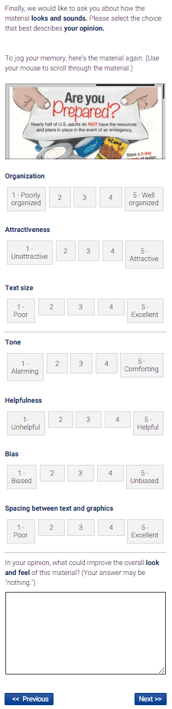
Modified Consumer Information Rating Form (CIRF), continued:
Includes Survey #2 Material — for participants in Survey 2 ONLY
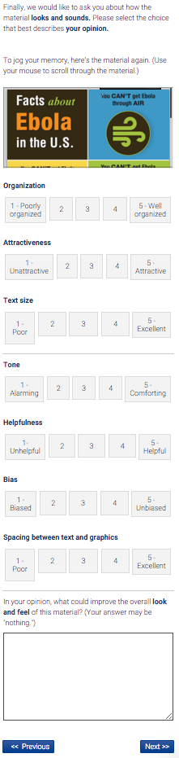
Modified Consumer Information Rating Form (CIRF), continued:
Includes Survey #3 Material — for participants in Survey 3 ONLY
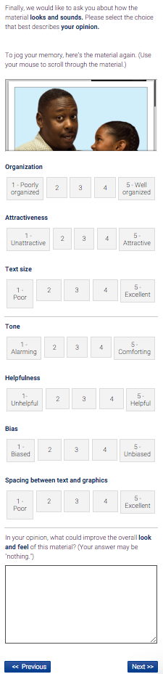
Modified Consumer Information Rating Form (CIRF), continued:
Includes Survey #4 Material — for participants in Survey 4 ONLY
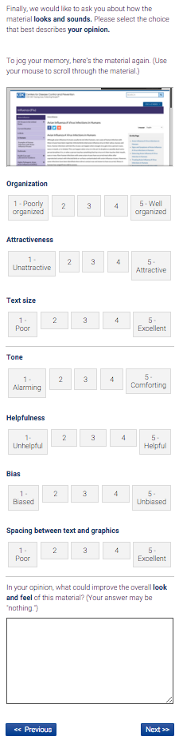

Thank You & End of Survey

