CDC/NCEH TO21: Outdoor Air Quality Focus Groups

March 2016

Project Officer:
Scott Damon
National Center for Environmental Health, Air Pollution and Respiratory Health Branch
Centers for Disease Control and Prevention
4770 Buford Hwy NE
Atlanta, GA 30341

Table of Contents
Objectives 3
Participants 4
Recruitment Overview 4
Methods 5
Testing Procedures 5
Stimulus Materials 6
Summary Report 6
Appendix A: Moderator’s Guide for At-Risk Adults 7
Appendix B: Moderator’s Guide for Parents of At-Risk Children 14
Appendix C: Behavioral Intentions Activity (At-Risk Adults) 21
Appendix D: Behavioral Intentions Activity (Parents of At-Risk Children) 22
Appendix E: Air Quality and Physical Activity Infographic 23
Appendix F: Weather Channel Breathing Index Webpage 25
Appendix G: US EPA AirNow.gov Website 26
Appendix H: Recruitment Screener 27
Overview 27
Script 28
Appendix I: Incentive Receipt Form 32
Appendix J: Participant Information Sheet 33
Appendix K: Consent Form 35

Objectives
Individuals with asthma, diabetes, and cardiovascular disease are at heightened risk of adverse health effects from prolonged exposure to poor air quality. The Centers for Disease Control and Prevention (CDC) currently, through partnerships with federal agencies, states, non-government organizations and other, print material and online platforms (www.cdc.gov/asthma) provides educational information for all individuals with asthma. Unpublished information indicates that a gap between provider and patient perceptions of provider-patient education related to air quality may place patients at unnecessary risk of adverse health events from exposure to poor air quality. This study will examine ways to address the gap through new and improved health communication tools. The goal of the study is to examine barriers and facilitators among at-risk populations for adopting recommended health behaviors in locations or situations with poor outdoor air quality.

On behalf of the CDC, CommunicateHealth (CH) will conduct a needs assessment of at-risk populations to understand knowledge, attitudes, and behaviors related to air quality and health, and the U.S. Environmental Protection Agency’s Air Quality Index (AQI) and other existing tools and to inform the design of related health communication messages and materials. CH will conduct focus groups with at-risk populations (defined as adults who have asthma, diabetes, or cardiovascular disease, or who have a child diagnosed with asthma or diabetes).

Based on focus group findings, CH will make recommendations for better reaching at-risk populations. The goal of the study is to gather knowledge that will help CDC better communicate with at-risk individuals about outdoor air quality, furthering the mission of CDC’s Air Pollution & Respiratory Health Branch to inform the public about the health effects of air pollution and to provide people with accurate and useful information about steps they can take to protect their health.

CH will conduct 6 in-person focus groups with adults who have asthma, diabetes, or cardiovascular disease, or who have a child diagnosed with asthma or diabetes.

Specifically, we want to learn:
- To what extent are the at-risk populations aware of the AQI?
- Are at-risk populations aware of the specific self-protective behavioral health messages and recommendations in the AQI?
- What motivates at-risk populations to take the protective health actions to minimize exposure to poor outdoor air quality?
- What are the barriers for at-risk populations in taking action to protect their health from poor outdoor air quality?
- How can CDC better reach at-risk populations with tailored behavioral health messages to minimize health effects associated with poor outdoor air quality? What are the best tools and strategies for accomplishing this?

OMB Approval
CDC will seek OMB approval through an amendment to its existing broad-based agency approval for message testing [OMB No. 0920-0572 Exp. Date 3/31/2018 Health Message Testing System (HMTS)]. CDC will attempt to use questions from a pre-approved question bank in developing data collection instruments.

Participants
CH will use professional recruitment firms to identify, screen, and recruit all participants for the focus groups. The focus groups will take place in the San Francisco, CA and Washington, D.C. metro areas -- two regions with lower than average air quality.

Recruitment Overview
UserWorks, Inc. (http://www.userworks.com) will conduct recruitment for the focus groups on behalf of CH. UserWorks recruits and schedules participants for client-run studies -- including usability tests, focus groups, and user surveys -- according to client-specified screening criteria. They maintain a database of willing volunteers and target specific external groups as needed. UserWorks recruits participants from diverse backgrounds and has access to a large pool of potential participants.
UserWorks will use the approved screener (Appendix H) provided by CH to identify and screen potential participants from their databases. As recruiters identify each eligible participant, they will schedule him or her for one of 6 focus group sessions.
Up to 48 total participants (8 per focus group) will participate. CH will over recruit participants (10 per focus group) to ensure an adequate number of participants.
Participants across the focus groups will represent an ethnically, racially, and socioeconomically diverse sample of at-risk adults, and parents of at risk children.
CH will aim to stratify focus groups by health condition and parents of at-risk children to reduce stigma and allow for question tailoring. No children will participate in this study. Parents and caregivers of children will respond on behalf of children.
Participants will be offered $75 cash as a token of appreciation for their participation in a 90-minute focus group:
- This amount is consistent with standard practice for qualitative data collection efforts and CH’s experience with this population on previous projects.
  - Note: In the spring of 2015, CH was unable to complete a recruit using a lower incentive ($40). The recruitment firm contacted over 1,600 individuals for a 24-person focus group study. The recruitment firm could not complete the recruit at a $40 incentive and the study had to be canceled.
- This amount has also been shown to be the minimum required incentive to offset the challenges for this audience to travel to and participate in a focus group outside of regular work hours. Incentive amounts lower than this make it difficult to recruit this audience.
- UserWorks will use the incentive in order to recruit a diverse set of participants.
CH will provide participant incentives, and will retain copies of the incentive receipt forms (Appendix I) on a secure server.

Methods
The moderator will follow a standard protocol for the focus group that draws questions from the CDC Health Message Testing System (HMTS).

CH will conduct 6 in-person focus groups in the San Francisco, CA and Washington, D.C. metro areas. All sessions will be conducted in person and audio recordings and a final report will be delivered to CDC upon completion.

Each focus group will last approximately 90 minutes and will involve 1 CH moderator and 1 CH note taker. CDC staff will observe the focus groups. Focus groups will have up to 8 participants each. The moderator will guide the participants through questions and activities about the AQI.

Testing Procedures
The moderator will follow a standard protocol for each focus group that includes the following (see moderator’s guides in Appendices A and B for details):
- Welcome and Opening Remarks
  - The moderator will introduce the session and explain ground rules
  - The moderator will make sure that all participants have received and read the participant information sheet (Appendix J).
  - The moderator will make sure that all participants have read and signed the consent form (see Appendix K)
- Warm-up
- Knowledge Base: Air Quality
- Behavioral Intentions (Appendices C and D)
- Knowledge Base: Air Quality Index
- Stimulus Materials (Appendices E, F, and G)
- Thank You and Closing

Stimulus Materials
- Participants will receive paper copies of the behavioral intentions activity worksheet (Appendices C and D).
- Participants will be shown a digital version of CDC’s Air Quality and Physical Activity infographic (http://www.cdc.gov/air/infographics.htm) (Appendix E).
- Participants will be shown a digital version of the Weather Channel Breathing Index (http://www.weather.com/maps/health/allergies/breathingindex) (Appendix F).
- Participants will be shown a digital version of AirNow.gov (http://airnow.gov/) (Appendix G).

Summary Report
CH will analyze data from the focus groups to identify key barriers and facilitators to following the AQI that will inform recommendations for better reaching at-risk populations with tailored behavioral recommendations. The data analysis process will include:
- Reviewing the notes and recordings of the focus group sessions
- Creating a list of key findings and observations
CH will deliver a summary report that summarizes results, key observations, and recommendations for future action. The report development will be an iterative process: CH will draft the report, CDC will review it and provide feedback, and CH will revise the report accordingly.

Findings from this work will not be published. Findings will be used solely for developing messages and materials and for internal program improvement. These recordings will be destroyed when CDC completes development of messages and materials.

Appendix A: Moderator’s Guide for At-Risk Adults
Form Approved
OMB No. 0920-0572
Exp. Date 3/31/2018
CDC estimates the average public reporting burden for this collection of information as 90 minutes per response, including the time for reviewing instructions, searching existing data sources, gathering and maintaining the data needed, and completing and reviewing the collection of information. An agency may not conduct or sponsor, and a person is not required to respond to, a collection of information unless it displays a currently valid OMB control number. Send comments regarding this burden estimate or any other aspect of this collection of information, including suggestions for reducing this burden, to: CDC/ATSDR Information Collection Review Office, MS D-74; 1600 Clifton Road NE, Atlanta, Ga. 30333; OMB No. 0920-0572.

Welcome/Opening Remarks (5 minutes)
Welcome everyone and thank you for joining us today. My name is [NAME]. We also have [NAME OTHERS] here to listen and take notes. I am here to lead this discussion on behalf of the Centers for Disease Control and Prevention (CDC). I want you to know that I’m not an expert in the topic we’ll be covering. My job today is to guide the discussion. We’re having this focus group discussion to try to understand how CDC can better reach people with recommendations for staying healthy.

The ideas and information you share with us are very important. Before we begin, I’d like to make a few things clear and explain how the discussion will work.

- We are not trying to sell or promote any product or service to you.
- There are no right or wrong answers — we want your opinions.
- We will be taking notes and audio recording the discussion. We have to write a report about your suggestions for CDC. Recording the discussion will help us write the report. We will share the audio recording with CDC. We will not use your name in the report and all results will be reported in aggregate. We will only share the report with people working on this project.
- In order to make sure that we hear everyone’s thoughts and opinions, it’s important that you only speak one at a time. I may occasionally interrupt you when 2 or more people are talking at once, so we clearly understand what each person has to say.
- This discussion will last approximately an hour and a half. I don’t want to keep you here longer than that, so I may occasionally interrupt you to keep the discussion focused.
[Prior to the focus group, the moderator will have emailed participants the participant information sheet (see Appendix J) and an informed consent form (see Appendix K). Each participant will review, sign, and have an opportunity to ask questions. Participants will then return a signed consent form back to the moderator. The informed consent statement will assure participants that information provided during the discussion group will be kept confidential and will only be used for the development of CDC initiatives. The statement will also contain language explaining that signing the form confers permission to be audio recorded. The Moderator will review the following points below.]

Your participation in this discussion is voluntary. You may discontinue your participation at any time. Your names will not be used in any report. The audio recording is only to be sure that we get all your opinions and ideas.

Do you have any questions before we start?

Warm-up (5 minutes)
First, let’s state our first names and one thing we do to stay healthy. I’ll start and then we’ll go around the room. My name is [NAME] and I [EXAMPLE OF HEALTHY BEHAVIOR].

Knowledge Base: Air Quality (10 minutes)
For this focus group, we will discuss some topics related to health. We’ll start with some general questions.

95.D Have you ever heard of [air quality]?
- PROBE: When you hear the term “air quality,” what comes to mind?
- PROBE: (if participants mention health): How does air quality relate to health?
- PROBE (if participants do not mention health): Can air quality affect someone's health? How?

How often do you think about air pollution in terms of your health?
- PROBE: What do you think about?

[For participants with asthma] How does poor air quality affect your asthma?

130.D How does this concept fit relative to your everyday challenges raising your [family, living with air pollution]?
- PROBE: What can you do to limit how much you or your family come into contact with air pollution?

Have you ever looked for information on air quality?
PROBE: If so, what were you looking for?

69.D Where do you get information about [air quality]?
- PROBE: From television, the internet, newspapers, the radio, or other ways?

If you wanted to find out what the air quality was like today, how would you do that?
- PROBE: If there was a mobile app where you could find out what the air quality is like in your city each day, would you use it? Why or why not?
- PROBE: Describe how you might use an air quality app.

70.D Has your doctor talked with you about [air pollution]?
- PROBE: If so, what did you talk about?
- PROBE: Did the doctor or nurse start the conversation or did you?
- PROBE: What did the doctor say?
- PROBE: Did the doctor mention anything about avoiding certain activities when the air quality is poor? If so, what?
- PROBE: Did you get any takeaways from the conversation, such as a brochure or a link to a website for more information?

Have you talked with a doctor or nurse about how to balance other ways of staying healthy (like being more physically active) with reducing the time you spend outside when the air quality is poor?
- PROBE: What did the doctor or nurse say?
- PROBE: If a doctor or nurse encouraged you to be physically active, did they mention air quality?

Knowledge Base: Air Quality Index (10 minutes)

Now we are going to switch gears and talk about something called the Air Quality Index.

95.D Have you ever heard of the [“Air Quality Index”]?
- PROBE: If so, where?
- PROBE: Who do you think puts out the Air Quality Index?
- PROBE: When you hear the term “Air Quality Index,” what comes to mind?

70.D Has your doctor ever talked with you about [the Air Quality Index]?
- PROBE: What did the doctor or nurse say?

If you wanted to find out what the Air Quality Index forecast was on a particular day, how would you look for that information?

80.D What types of information would you like to receive regarding [air quality/air pollution]? What would be the most effective way or format to provide this information?
- PROBE: Would you look on a website, email, text message, newspaper, or some other way?

Behavioral Intentions (15 minutes)
I’m going to pass around a sheet with some descriptions of actions to take on days when the air quality is poor. On your own, please circle the activities that seem doable to you. Cross out any activities that don’t seem doable.

[Moderator distributes worksheet (Appendix C)]

38.D Which actions, if any, sound doable to you? Why?
- PROBE: Of the activities that you circled, which would you try first? Why?

Which activities did you cross out and why?
- PROBE: Were there any activities that you would never try? Why not?

117.D Did any of the concepts not motivate you at all? Why not?

118.D Did any of the concepts turn you off? What was it about the statement/s that turned you off?

70.D Has your doctor talked with you about [taking any of these steps]? What did he/she tell you?
- PROBE: How did that conversation go?
- PROBE: After your doctor recommended these steps, did you take them?

Stimulus 1: Air Quality and Physical Activity infographic (10 minutes)
Now, we’ll look at a graphic that has information about outdoor air quality.

[Moderator shows Air Quality and Physical Activity infographic (Appendix E)]
6.E What is your general reaction to the way these look?

8.E How do you feel about the colors and graphics? What do you like/dislike about them?

Look at the action steps in the graphic. After the exercise where we circled and crossed out activities, would you be more or less likely to take these steps after seeing this graphic?
- PROBE: Why or why not?

2.E What is the main message of this illustration? What does it tell you?
- PROBE: What do you think about looking at a graphic to get health information?

24.D Who would you say they are trying to reach?
- Does it seem this message is talking to you, and people like you? Or someone else?
- What in the message suggested it was talking to you and people like you or someone else?

Stimulus 2: Weather Channel Breathing Index Webpage (15 minutes)
Next, we’re going to look a website that has information about outdoor air quality.

[Moderator shows Weather Channel Breathing Index, using narrow view to avoid advertisements. (Appendix F)]

Collectively, these images are called the Breathing Index.

6.E What is your general reaction to the way these look?

7.D How would you sum up in just a few words your first impression of this message? Do you like it? Not like it? What makes you say that?

2.E What is the main message of this illustration? What does it tell you?
- PROBE: What do you think about using this website to get information about air quality?

12.E Are there things about the pictures that BOTHER you in any way?
- PROBE: Is there anything confusing or unclear? If so, what?

24.D Who would you say they are trying to reach?
- PROBE: Does it seem this message is talking to you, and people like you? Or someone else?
- PROBE: What in the message suggested it was talking to you and people like you or someone else?

Is this website credible? Why or why not?

1.F Does this message make you want to do anything? Does it motivate you to take action?
- PROBE: If you saw the Breathing Index, would you do anything differently afterwards?
- PROBE: What would you do or not do?

Stimulus 3: AirNow.gov Website (15 minutes)
Now, we’ll look at a different website.

[Moderator shows AirNow.gov. Moderator displays a screenshot of an Air Quality Index Forecast pertaining to participants’ location (Appendix G)]

6.E What is your general reaction to the way these look?

7.D How would you sum up in just a few words your first impression of this message? Do you like it? Not like it? What makes you say that?

2.E What is the main message of this illustration? What does it tell you?
- PROBE: What do you think about using this website to get information about air quality?
- PROBE: Is there anything confusing or unclear? If so, what?

24.D Who would you say they are trying to reach?
- PROBE: Does it seem this message is talking to you, and people like you? Or someone else?
- PROBE: What in the message suggested it was talking to you and people like you or someone else?

Do you think this website is credible? Why or why not?

1.F Does this message make you want to do anything? Does it motivate you to take action?
- PROBE: If you saw the AQI Forecast, would you do anything differently afterwards?
- PROBE: What would you do or not do?
- PROBE: Why?

Thank You and Closing (5 minutes)

That was our final activity for the day.

Before we wrap up, is there anything else you would like to share?

Thank you all for your participation today and for sharing your thoughts and opinions with us. Remember the purpose of today’s discussion was simply to get your opinions about the Air Quality Index. Everything you have said today will be helpful as we make recommendations to CDC.

I’d like to remind each one of you that if you have any questions about outdoor air quality, your health, or anything that has come up today, please make sure to see your doctor or other healthcare provider.

Appendix B: Moderator’s Guide for Parents of At-Risk Children
Form Approved
OMB No. 0920-0572
Exp. Date 3/31/2018
CDC estimates the average public reporting burden for this collection of information as 90 minutes per response, including the time for reviewing instructions, searching existing data sources, gathering and maintaining the data needed, and completing and reviewing the collection of information. An agency may not conduct or sponsor, and a person is not required to respond to, a collection of information unless it displays a currently valid OMB control number. Send comments regarding this burden estimate or any other aspect of this collection of information, including suggestions for reducing this burden, to: CDC/ATSDR Information Collection Review Office, MS D-74; 1600 Clifton Road NE, Atlanta, Ga. 30333; OMB No. 0920-0572.

Welcome/Opening Remarks (5 minutes)
Welcome everyone and thank you for joining us today. My name is [NAME]. We also have [NAME OTHERS] here to listen and take notes. I am here to lead this discussion on behalf of the Centers for Disease Control and Prevention (CDC). I want you to know that I’m not an expert in the topic we’ll be covering. My job today is to guide the discussion. We’re having this focus group discussion to try to understand how CDC can better reach people with recommendations for staying healthy.

The ideas and information you share with us are very important. Before we begin, I’d like to make a few things clear and explain how the discussion will work.

- We are not trying to sell or promote any product or service to you.
- There are no right or wrong answers — we want your opinions.
- We will be taking notes and audio recording the discussion. We have to write a report about your suggestions for CDC. Recording the discussion will help us write the report. We will share the audio recording with CDC. We will not use your name in the report and all results will be reported in aggregate. We will only share the report with people working on this project.
- In order to make sure that we hear everyone’s thoughts and opinions, it’s important that you only speak one at a time. I may occasionally interrupt you when 2 or more people are talking at once, so we clearly understand what each person has to say.
- This discussion will last approximately an hour and a half. I don’t want to keep you here longer than that, so I may occasionally interrupt you to keep the discussion focused.
[Prior to the focus group, the moderator will have emailed participants the participant information sheet (see Appendix J) and an informed consent form (see Appendix K). Each participant will review, sign, and have an opportunity to ask questions. Participants will then return a signed consent form back to the moderator. The informed consent statement will assure participants that information provided during the discussion group will be kept confidential and will only be used for the development of CDC initiatives. The statement will also contain language explaining that signing the form confers permission to be audio recorded. The Moderator will review the following points below.]

Your participation in this discussion is voluntary. You may discontinue your participation at any time. Your names will not be used in any report. The audio recording is only to be sure that we get all your opinions and ideas.

Do you have any questions before we start?

Warm-up (5 minutes)
First, let’s state our first names and one thing we do to stay healthy. I’ll start and then we’ll go around the room. My name is [NAME] and I [EXAMPLE OF HEALTHY BEHAVIOR].

Knowledge Base: Air Quality (10 minutes)
For this focus group, we will discuss some topics related to health. We’ll start with some general questions.

When you hear the term “air quality,” what comes to mind?
- PROBE: (if participants mention health): How does air quality relate to health?
- PROBE (if participants do not mention health): Can air quality affect someone's health? How?

How often do you think about air pollution in terms of your children’s health?
- PROBE: What do you think about?

[For parents of children with asthma] How does poor air quality affect your child’s asthma?

130.D How does this concept fit relative to your everyday challenges raising your [family, living with air pollution]?
- PROBE: Do you think there are things you can do to limit how much your child comes into contact with air pollution? If so, what?

69.D Where do you get information about [air quality]?
- PROBE: From television, the internet, newspapers, the radio, or other ways?

If you wanted to find out what the air quality was like today, how would you do that?
- PROBE: If there was a mobile app where you could find out what the air quality is like in your city each day, would you use it? Why or why not?
- PROBE: Describe how you might use an air quality app.

70.D Has your doctor talked with you about [air pollution, or your child’s doctor]?
- PROBE: If so, what did you talk about?
- PROBE: Did your child’s doctor or nurse start the conversation, or did you?
- PROBE: What did the doctor say?
- PROBE: Did the doctor mention anything about avoiding certain activities when the air quality is poor? If so, what?
- PROBE: Did you get any takeaways from the conversation, such as a brochure or a link to a website for more information?

Have you talked with a doctor or nurse about how to balance other ways for your child to stay healthy (like being more physically active) with reducing the time your child spends outside when the air quality is poor?
- PROBE: What did the doctor or nurse say?
- PROBE: If a doctor or nurse encouraged your child to be physically active, did they mention air quality?

Knowledge Base: Air Quality Index (10 minutes)

Now we are going to switch gears and talk about something called the Air Quality Index.

95.D Have you ever heard of “Air Quality Index”?
- PROBE: If so, where?
- PROBE: Who do you think puts out the Air Quality Index?
- PROBE: When you hear the term “Air Quality Index,” what comes to mind?

70.D Has your doctor ever talked with you about [the Air Quality Index]?
- PROBE: What did the doctor or nurse say?

If you wanted to find out what the Air Quality Index forecast was on a particular day, how would you look for that information?

80.D What types of information would you like to receive regarding [air quality/air pollution]? What would be the most effective way or format to provide this information?
- PROBE: Would you look on a website, email, text message, newspaper, or some other way?

Behavioral Intentions (15 minutes)
I’m going to pass around a sheet with some descriptions of actions to take on days when the air quality is poor. On your own, please circle the activities that seem doable to you. Cross out any activities that don’t seem doable.

[Moderator distributes worksheet (Appendix D)]

38.D Which actions, if any, sound doable to you? Why?
- PROBE: Of the activities that you circled, which would you try first? Why?
- PROBE: Which activities did you cross out and why?
- PROBE: Were there any activities that you would never try? Why not?

117.D Did any of the concepts not motivate you at all? Why not?
- PROBE: Would you be willing to try any of the activities that you crossed out?
- PROBE: What would make you more likely to try one of these activities?

70.D Has your doctor talked with you about [taking any of these steps]? What did he/she tell you?
- PROBE: How did that conversation go?
- PROBE: After your doctor recommended these steps, did you take them?

Stimulus 1: Air Quality and Physical Activity infographic (10 minutes)
Now, we’ll look at a graphic that has information about outdoor air quality.

[Moderator shows Air Quality and Physical Activity infographic (Appendix E)]
6.E What is your general reaction to the way these look?

8.E How do you feel about the colors and graphics? What do you like/dislike about them?

Look at the action steps in the graphic. After the exercise where we circled and crossed out activities, would you be more or less likely to encourage your child to take these steps after seeing this graphic?
- PROBE: Why or why not?

2.E What is the main message of this illustration? What does it tell you?
- PROBE: What do you think about looking at a graphic to get health information?

24.D Who would you say they are trying to reach?
- PROBE: Does it seem this message is talking to you, and people like you? Or someone else?
- PROBE: What in the message suggested it was talking to you and people like you or someone else?

Stimulus 2: Weather Channel Breathing Index Webpage (15 minutes)
Next, we’re going to look a website that has information about outdoor air quality.

[Moderator shows Weather Channel Breathing Index, using narrow view to avoid advertisements (Appendix F)]

Collectively, these images are called the Breathing Index.

What are your first impressions when looking at the Breathing Index?

6.E What is your general reaction to the way these look?

8.E How do you feel about the colors and graphics? What do you like/dislike about them?

2.E What is the main message of this illustration? What does it tell you?
- PROBE: What do you think about using this website to get information about air quality?
- PROBE: Is there anything confusing or unclear? If so, what?

24.D Who would you say they are trying to reach?
- PROBE: Does it seem this message is talking to you, and people like you? Or someone else?
- PROBE: What in the message suggested it was talking to you and people like you or someone else?

Is this website credible? Why or why not?

1.F Does this message make you want to do anything? Does it motivate you to take action?
- PROBE: If you saw the Breathing Index, would you do anything differently afterwards?
- PROBE: What would you do or not do?

Stimulus 3: AirNow.gov Website (15 minutes)
Now, we’ll look at a different website.

[Moderator shows AirNow.gov. Moderator displays a screenshot of an Air Quality Index Forecast pertaining to participants’ location (Appendix G)]

6.E What is your general reaction to the way these look?

7.D How would you sum up in just a few words your first impression of this message? Do you like it? Not like it? What makes you say that?

2.E What is the main message of this illustration? What does it tell you?
- PROBE: What do you think about using this website to get information about air quality?
- PROBE: Is there anything confusing or unclear? If so, what?

24.D Who would you say they are trying to reach?
- PROBE: Does it seem this message is talking to you, and people like you? Or someone else?
- PROBE: What in the message suggested it was talking to you and people like you or someone else?

Do you think this website is credible? Why or why not?

1.F Does this message make you want to do anything? Does it motivate you to take action?
- PROBE: If you saw the AQI Forecast, would you do anything differently afterwards?
- PROBE: What would you do or not do?
- PROBE: Why?

Thank You and Closing (5 minutes)

That was our final activity for the day.

Before we wrap up, is there anything else you would like to share?

Thank you all for your participation today and for sharing your thoughts and opinions with us. Remember the purpose of today’s discussion was simply to get your opinions about the Air Quality Index. Everything you have said today will be helpful as we make recommendations to CDC.

I’d like to remind each one of you that if you have any questions about outdoor air quality, your child’s health, or anything that has come up today, please make sure to see your doctor or other healthcare provider.

Appendix C: Behavioral Intentions Activity (At-Risk Adults)
This sheet has some descriptions of actions to take on days when the air quality is poor. On your own, please circle the activities that seem doable to you. Cross out any activities that don’t seem doable.
Spend less time outdoors | Exercise for less time
Choose less intense exercise, like walking instead of jogging | Exercise on a different day or at a different time
Close the windows where I live | Avoid exercising near busy roads
Exercise indoors instead of outdoors

Appendix D: Behavioral Intentions Activity (Parents of At-Risk Children)
Encourage your child to spend less time outdoors | Encourage your child to exercise for less time
Encourage your child to choose less intense exercise, like walking instead of jogging | Encourage your child to exercise on a different day or at a different time
Close the windows where my family lives | Encourage your child to avoid exercising near busy roads
Encourage your child to exercise indoors instead of outdoors
This sheet has some descriptions of actions to take on days when the air quality is poor. On your own, please circle the activities that seem doable to you. Cross out any activities that don’t seem doable.

Appendix E: Air Quality and Physical Activity Infographic
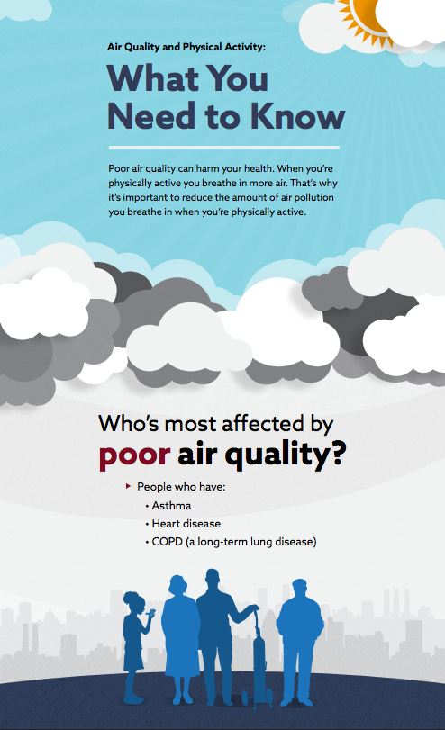
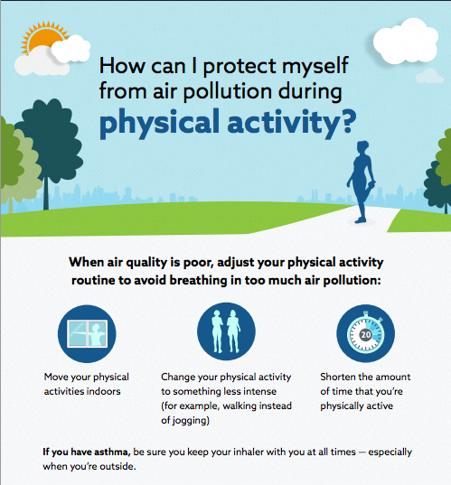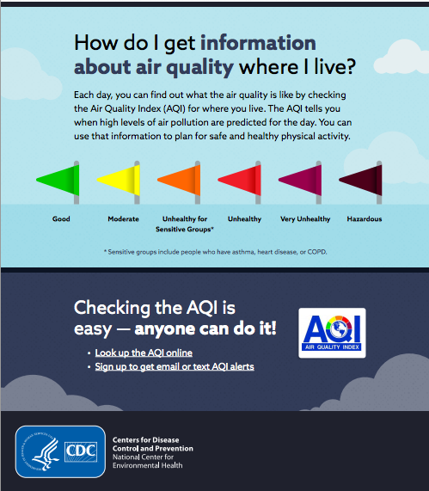

Appendix F: Weather Channel Breathing Index Webpage
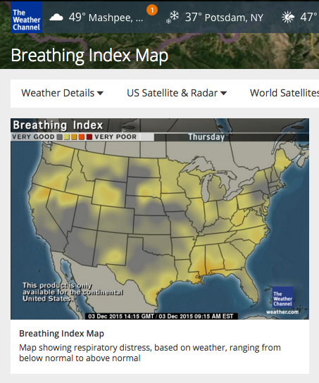

Appendix G: US EPA AirNow.gov Website
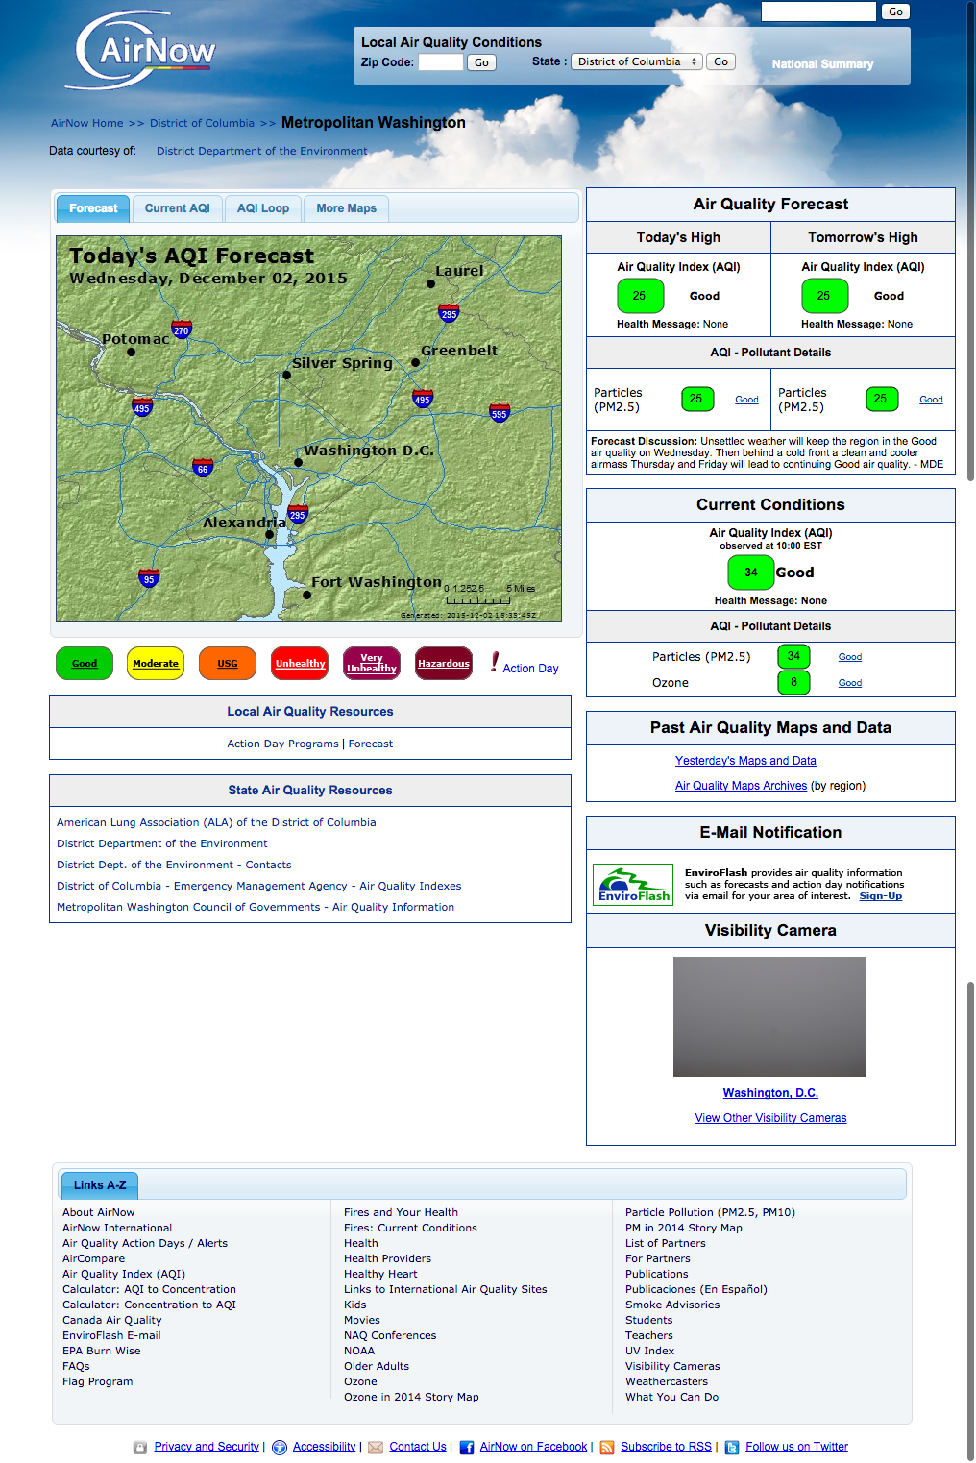

Appendix H: Recruitment Screener
Form Approved
OMB No. 0920-0572
Exp. Date 3/31/2018
CDC estimates the average public reporting burden for this collection of information as 5 minutes per response, including the time for reviewing instructions, searching existing data sources, gathering and maintaining the data needed, and completing and reviewing the collection of information. An agency may not conduct or sponsor, and a person is not required to respond to, a collection of information unless it displays a currently valid OMB control number. Send comments regarding this burden estimate or any other aspect of this collection of information, including suggestions for reducing this burden, to: CDC/ATSDR Information Collection Review Office, MS D-74; 1600 Clifton Road NE, Atlanta, Ga. 30333; OMB No. 0920-0572.

Overview
CommunicateHealth will recruit a total of 48 participants for 6 in-person focus groups in San Francisco, CA, and the Washington, D.C. metro areas (3 groups in each location). Our desired participants are adults with asthma, diabetes, and cardiovascular disease, and parents of children with asthma and diabetes.

Age: Recruit a mix of ages (no participants will be under 18 years old)
Education level: At least a third will have a high school education or less
Race/Ethnicity: Mixed
Gender: Mixed
Income level: At least a third will be considered low income
Health status: Mix of adults with asthma, diabetes, and cardiovascular disease, and parents of children with asthma and diabetes, according to the following:

- Group 1: Adults with asthma – San Francisco
- Group 2: Adults with asthma – Washington, D.C.
- Group 3: Adults with cardiovascular disease and/or diabetes – San Francisco
- Group 4: Adults with cardiovascular disease and/or diabetes – Washington, D.C.
- Group 5: Parents of a child with asthma or diabetes – San Francisco
- Group 6: Parents of a child with asthma or diabetes – Washington, D.C.

We will exclude from participation people who:
- Are under the age of 18
- Have participated in any research within the past 6 months
- Conduct market research or work in advertising or public relations
- Work in public health or health care
- Work for the Federal government
- Are unable to speak and read English well enough to complete the study

Script
Hello,
My name is [NAME] from [RECRUITMENT COMPANY] and I’m calling on behalf of CommunicateHealth and the Centers for Disease Control and Prevention (CDC). CDC is doing a study about outdoor air quality and is looking for people to participate in a discussion session.
The session will take place in [LOCATION]. If you qualify, we’ll offer you a $75 gift as a thank you. The session will last about an hour and a half — you’ll participate in a group discussion, look at materials, and provide feedback on them. Many people who’ve participated in this type of session in the past have found it interesting and fun.
Does this sound like something you would be interested in?
[If yes, CONTINUE. If no, TERMINATE]
Great. Let's find out if you qualify. I have a few simple questions to ask. This should take about 5 minutes. At some point, I may end the questions if I discover you don't qualify. This has nothing to do with you. We simply are looking for people who meet certain criteria.
Screener Questions:
- 1.A Gender [Recruit a mix]
  - Male
  - Female

- 2.A In which of the following categories does your age fall:
  - Under 18 [TERMINATE]
  - 18 to 24 [CONTINUE]
  - 25-34 years of age [CONTINUE]
  - 35-44 years of age [CONTINUE]
  - 45-54 years of age [CONTINUE]
  - 55-64 years of age [CONTINUE]
  - 65-74 years of age [CONTINUE]
  - 75 years of age or older [CONTINUE]

- 42.A Most of the discussion will involve speaking and reading in English. Are you comfortable with speaking and reading in English?
  - Yes [CONTINUE]
  - No [TERMINATE]

- 2.B Have you participated in a focus group, intercept interview, telephone survey, and/or online survey in which you were asked your opinions regarding a product, a service, or advertising within the past six months?
  - No [CONTINUE]
  - Yes [TERMINATE]

- 1.B Do you, or does any member of your household or immediate family work for:
  - a market research company [TERMINATE]
  - an advertising agency or public relations firm [TERMINATE]
  - the media (TV/radio/newspapers/magazines) [TERMINATE]
  - as a healthcare professional (doctor, nurse, pharmacist, dietician, etc.) [TERMINATE]
  - a public health agency [TERMINATE]
  - None of the above [CONTINUE]

- Do you work for the Federal government?
  - Yes [TERMINATE]
  - No [CONTINUE]

- Have you ever been told by a health care provider that you or your child have any of the following conditions?
  - I have been told that I have asthma [CONTINUE]
  - I have been told that I have diabetes [CONTINUE]
  - I have been told that I have cardiovascular disease [CONTINUE]
  - I have been told that my child has asthma [CONTINUE]
  - I have been told that my child has diabetes [CONTINUE]
  - I have been told that my child has cardiovascular disease [CONTINUE]
  - No, I have never been told that I have or my child has asthma, diabetes, or cardiovascular disease [TERMINATE]

- [If yes to child in Q7] Does the child who has been diagnosed with asthma, diabetes, or cardiovascular disease live in your home?
  - Yes [CONTINUE]
  - No [TERMINATE]

- [If yes to child in Q7] Is the child who has been diagnosed with asthma, diabetes, or cardiovascular disease age 17 or under?
  - Yes, the child is age 17 or under [CONTINUE]
  - No, the child is age 18 or over [TERMINATE]

- [If yes to child in Q7] How old is the child who has been diagnosed with asthma, diabetes, or cardiovascular disease? [Recruit a mix]

To make sure we have a diverse group of participants, we are going to ask you some questions about your education level, income, and racial/ethnic background.
- 4.A What is the highest level of education that you have completed? [Recruit at least a third of participants with a high school education or less.]
  - Grade school
  - Less than high school graduate/some high school
  - High school graduate or completed GED
  - Some college or technical school
  - Received four-year college degree
  - Some post-graduate studies
  - Received advanced degree
  - Other: ________________

- Which of the following categories best describe your total, annual household income? (Recruit a mix.)
  - Under $20,000/year
  - $20,001 - $30,000/year
  - $30,001 - $40,000/year
  - $40,001 - $50,000/year
  - $50,001 - $60,000/year
  - $60,001 - $80,000/year
  - $80,001 - $100,000/year
  - Over $100,000/year

- 6.A Please indicate your race or ethnic background. Are you? (recruit a mix)

Ethnicity:
  - Hispanic or Latino
  - Not Hispanic or Latino

Race:
- White/Caucasian
- Black or African-American
- American Indian or Alaska Native
- Native Hawaiian or Other Pacific Islander
- Asian
  - Vietnamese
  - Cambodian
  - Filipino
  - Japanese
  - Korean
  - Chinese
[If participant qualifies, offer times, get them scheduled, record their email address to send a confirmation, and ask if they’d like a reminder by phone, text, or email the day before.]

Appendix I: Incentive Receipt Form
I have received $75 for participating in a focus group for CommunicateHealth and the Centers for Disease Control and Prevention (CDC).

Name (print): ________________________________
Name (sign): ________________________________
Date: _________________

Appendix J: Participant Information Sheet
On this page, you will find information about this project. Please read it and feel free to ask us any questions you may have.

Who is working on this project?
This project is being run by CommunicateHealth, a health communication consulting firm. The project is funded by the Centers for Disease Control and Prevention (CDC).

What is the goal of this project?
The goal of the study is to gather knowledge that will help CDC better communicate with at-risk individuals about outdoor air quality, furthering the mission of CDC’s Air Pollution & Respiratory Health Branch to inform the public about the health effects of air pollution and to provide people with accurate and useful information about steps they can take to protect their health.

How can I help?
We are interested in learning from your experiences. If you choose to participate in this project, we will ask you to be part of a 90-minute discussion group with up to 7 other people. Your feedback and knowledge will help CDC better communicate with the public about outdoor air quality.

Do I have to participate in this project?
No. It is your choice whether to participate or not. You can stop at any time, and you don’t have to answer any questions you don’t want to answer. If you don’t want to participate or decide to stop, that’s okay.

Will I be paid to participate in the project?
Yes. If you participate in the project, you will receive $75 as a thank you for your time and feedback.

How will you protect my privacy?
We will keep your identity and all of your information confidential — that means we will not share it with anyone outside of our staff. We will use your feedback and ideas to write a report. Your name will not be used in the report.

What are the risks of participating in this project?
If you choose to participate in this project, we will take every precaution to protect your privacy. However, we can not guarantee that other participants in the discussion group will not repeat what you say.

Where can I get more information?
If you have questions about the project, contact Rachel Pryzby, Health Communication Manager, at rachel@communicatehealth.com or (413) 582-0425.

Appendix K: Consent Form
I, _________________________________________, agree to take part in this focus group discussion.

I understand that I do not have to be in this study. I can discontinue participation at any time without penalty. I can agree to be in the study and then change my mind later.

I allow the Centers for Disease Control and Prevention (CDC) to use the information from this discussion. I understand that the information is for a report only, and that my name will not be used in the report.

I agree to ask questions about the discussion if I don't understand something. If I have questions after the study is over, I can contact Rachel Pryzby, Health Communication Manager, at rachel@communicatehealth.com or (413) 582-0425.

Audio Recording Release

I understand that I will be audio recorded during this study. I allow CommunicateHealth to use the recordings of me for report-writing purposes only. I understand the recording will not be transcribed. I understand that the recording will be destroyed and my name will not be used for any other purpose.

Summary

I have read and understood this consent form. I understand that I will get a copy of this form.

Print Name: _________________________________________

Signature: _________________________________________

Date: _________________________________________

The AQI is an index for reporting daily air quality developed by US EPA. It focuses on health effects that may be experienced within a few hours or days after breathing polluted air. EPA calculates the AQI for five major air pollutants regulated by the Clean Air Act: ground-level ozone, particle pollution (also known as particulate matter), carbon monoxide, sulfur dioxide, and nitrogen dioxide. (source: http://cfpub.epa.gov/airnow/index.cfm?action=aqibasics.aqi)
Consent forms will be maintained separately from session recordings to render it impossible to link study participants to individually identifiable information. Recordings will be destroyed when no longer needed for development of educational materials and messages.

