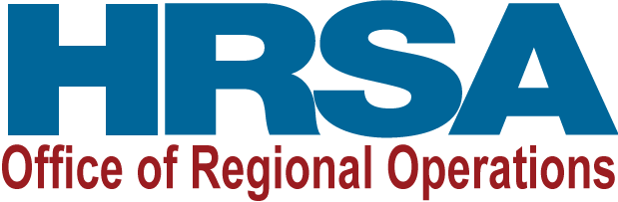

Participant Feedback Form

Title of Activity

(e.g., “webinar”/“presentation”/“technical assistance”/“grants workshop”)

to characterize the event when individualizing the survey

Date(s) of Activity

DIRECTIONS: Please take a few moments to complete this Feedback Form about your participation in this activity (e.g., webinar; presentations; technical assistance; grantee workshops) offered by HRSA’s Office of Regional Operations. Your feedback will help us improve future “activities” (e.g., webinar; presentations; technical assistance; grantee workshops). You will NOT be personally identified in any report of results. Please contact XX by phone XX, or by email XX if you have questions.

- Please select the type of organization below that BEST describes your organization.
- Academic
- Community-Based
- Faith-Based
- Government
  - Federal
  - State
  - Local
- Health Center
- Rural Health
- Tribal
- Other (please specify): ____________________

- Please select the category below that BEST describes your role in the organization.
- Community Advocate/Leader
- Educator
- Grant Writer
- Program Administrator/Coordinator
- Project Officer/Grants Management Specialist
- Program/Policy Analyst
- Provider/Clinician

- Other (please specify): ____________________

- What motivated you to participate in this activity/event? Check All That Apply.
- Individual/Professional Development
- Continuing Education Requirement
- Unique Learning Opportunity
- Other: _____________________

- How many people viewed the activity/webinar with you?
- None
- 1-5
- 6-9
- 10-15
- 16-20
- 21 or more

- Please rate this activity for each of the following using a scale ranging from 1 = “Strongly Disagree” to 5 = “Strongly Agree.”

Strongly Strongly
Agree Disagree
Organization of the program was excellent. | 5 4 3 2 1
Subject matter was relevant. | 5 4 3 2 1
Content was clearly presented. | 5 4 3 2 1
Amount of information presented was about right. | 5 4 3 2 1
Pace of the program was suitable for learning. | 5 4 3 2 1
Learned new knowledge and skills. | 5 4 3 2 1
My expectations of this activity were met. | 5 4 3 2 1
Presenters were informative, prepared, and understandable. | 5 4 3 2 1
Materials (PowerPoint slides, handouts) used aided learning. | 5 4 3 2 1
Presenters answered questions to my satisfaction. | 5 4 3 2 1
Delivery method was appropriate. | 5 4 3 2 1

- Thinking about the activity/webinar I just attended, overall, I am…. (please circle one number):
1 | 2 | 3 | 4
Not at all  Satisfied | A little  Satisfied | Somewhat  Satisfied | Very  Satisfied

- Using a scale ranging from 1 = “Extremely Unlikely” to 5 = “Extremely Likely,” please rate how likely you are to do each of the following because you participated in this activity/webinar:

Extremely Extremely
Likely Unlikely
Seek to learn more about HRSA funding and/or programs. | 5 4 3 2 1
Apply for HRSA funding. | 5 4 3 2 1
Inform others about HRSA. | 5 4 3 2 1
Seek to form a new relationship/partnership. | 5 4 3 2 1
Seek to implement a new service or best practice | 5 4 3 2 1
Apply the knowledge and skills learned to my job. | 5 4 3 2 1
Attend additional activities/webinars offered by HRSA. | 5 4 3 2 1

- Would you recommend this activity to others in your field?
- Yes
- No

- What other topics would you like to see addressed in future activities/webinar offerings?
______________________________________________________________

- Please provide up to two (2) suggestions to improve this activity if it is offered again in the future.

a. _____________
______ ______
______
b. ______
______
______

Thank you very much for your time and responses!

