CREAPP-001: Create Application – Choose Program Office

CREAPP-005: Create Application – Choose Application Type for VS

CREAPP-0094: Select Agent Confirmation
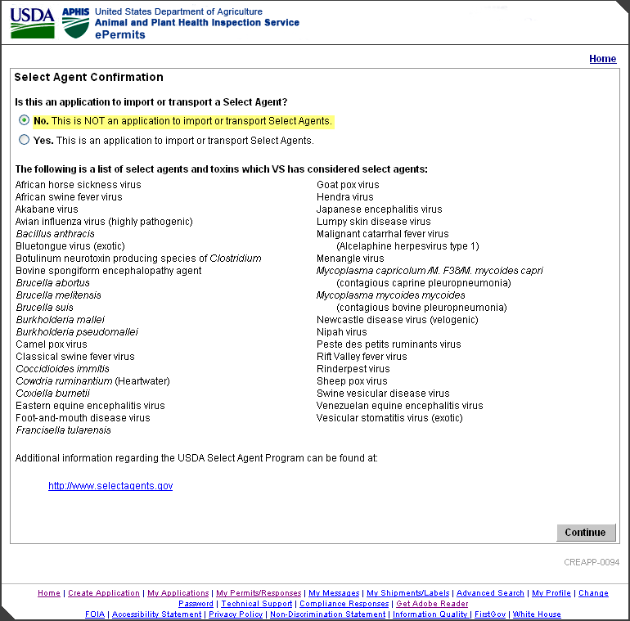

CREAPP-0096: Select Agent Warning
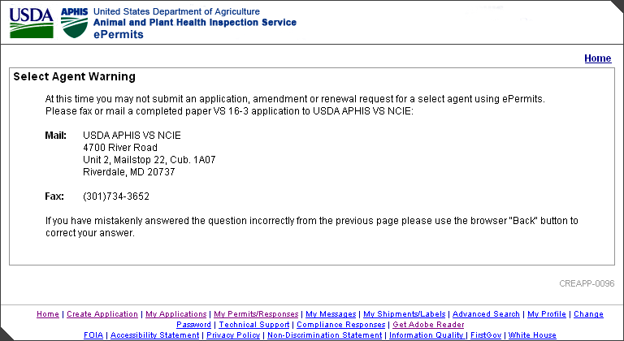

CREAPP-0042: Specify: New, Amendment or Renewal Application (Applicant View)
CREAPP-0039: Specify: New, Amendment or Renewal Application (APHIS View)

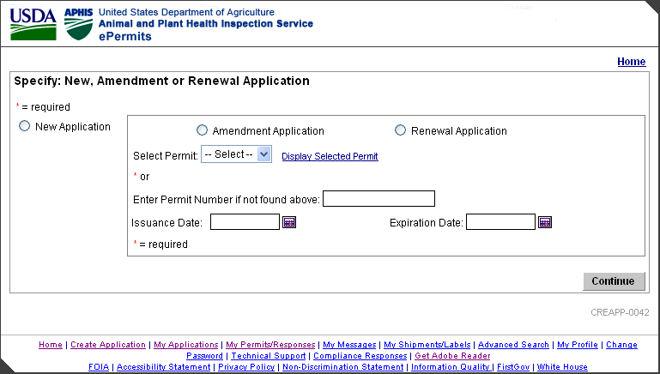
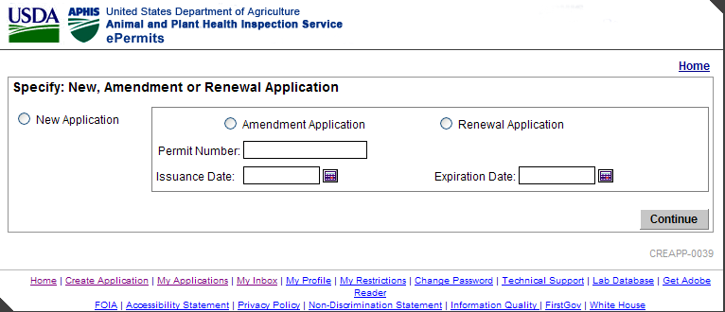

CREAPP-0098: Permit Number Prefix will be Changed

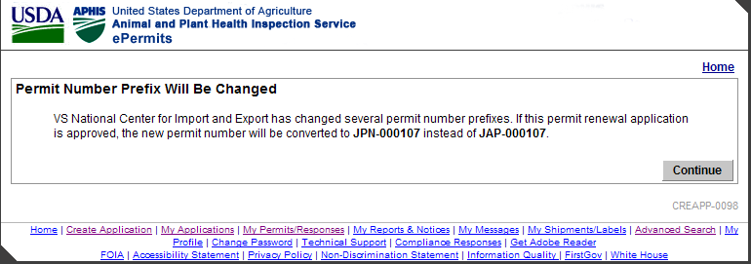

VS0163-010-080: Type of 16-3

. 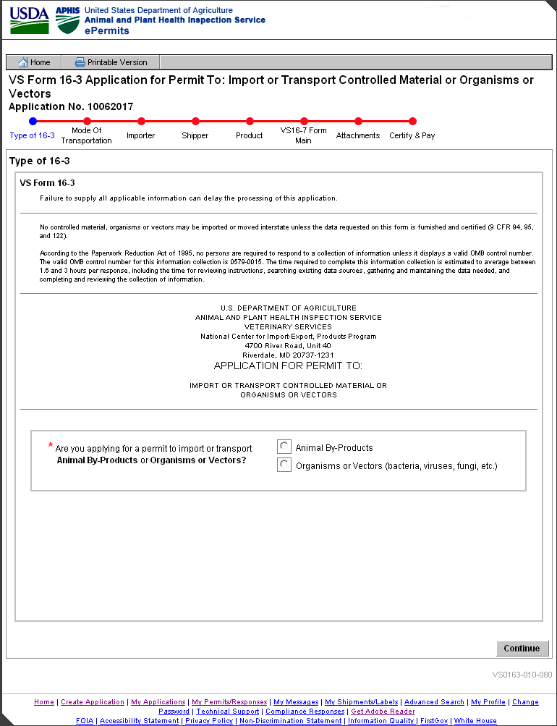

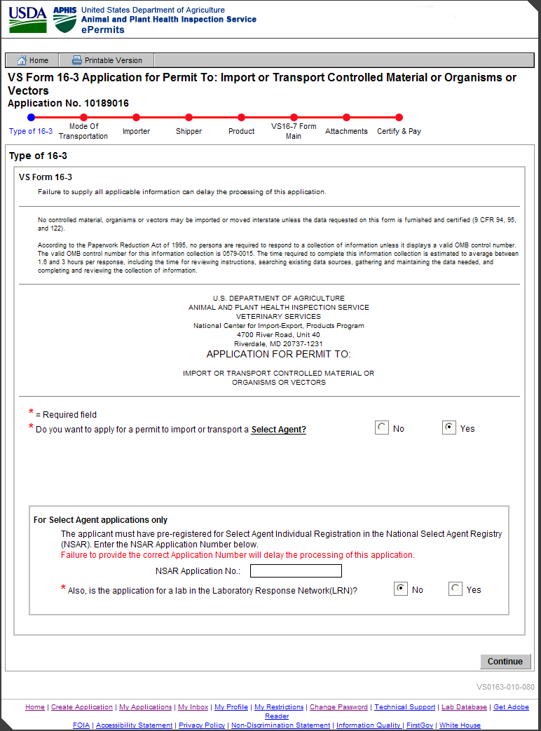
Figure 16: Type of 16-3: APHIS View after Selecting Yes for Select Agent
[VS0163-010-080]

VS0163-001-001: Mode of Transportation
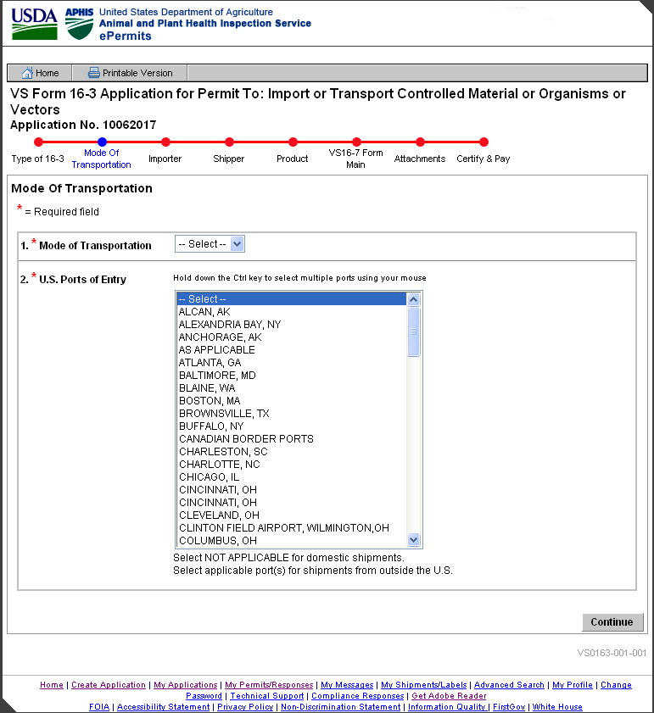

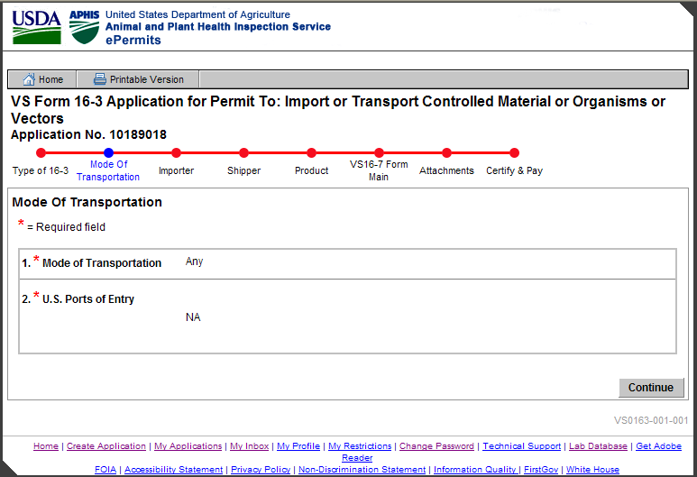

VS0163-002-108: Importer Information
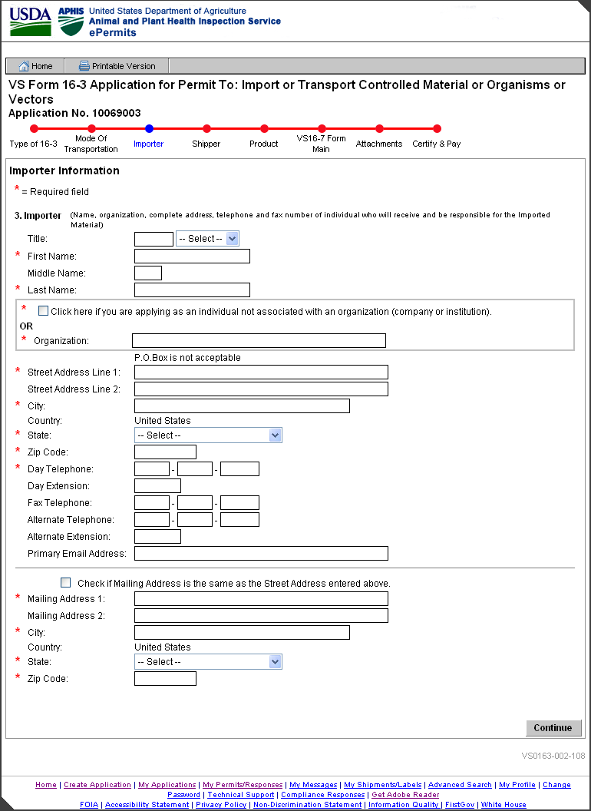
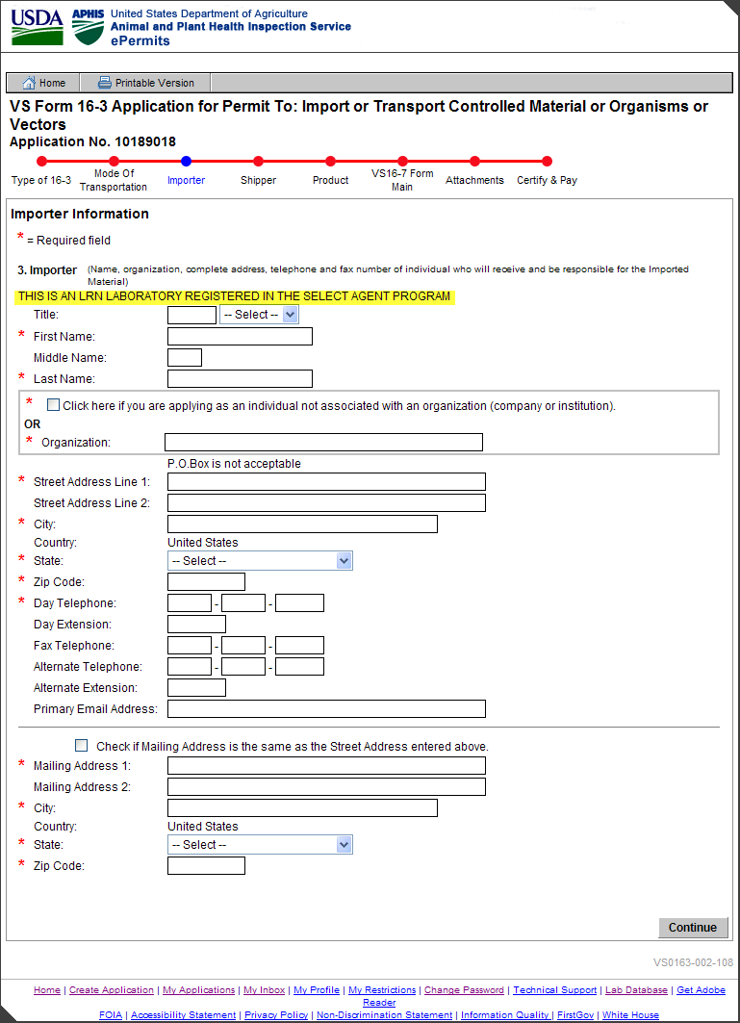

VS0163-002-110: Unknown City and ZIP Code Combination

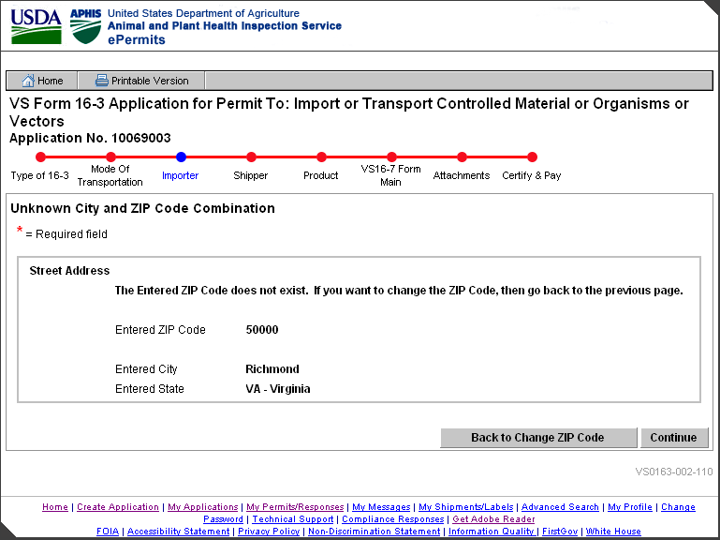

VS0163-005-114: Unknown City and ZIP Code Combination

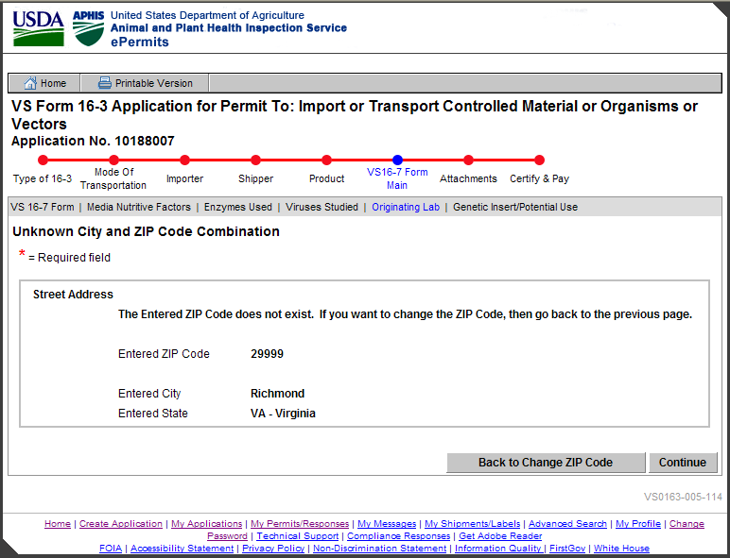

VS0163-003-112: Unknown City and ZIP Code Combination

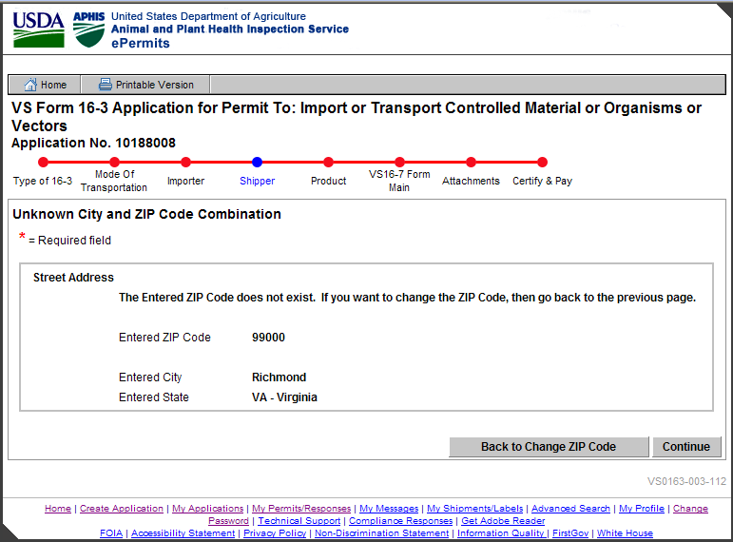

VS0163-002-102: Verify Application Does Not Duplicate Previous Application

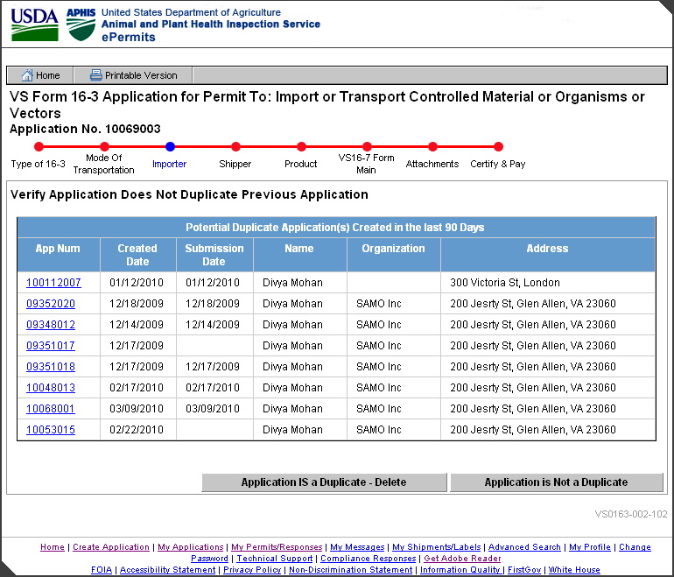

VS0163-003-011: Quantity of Shippers
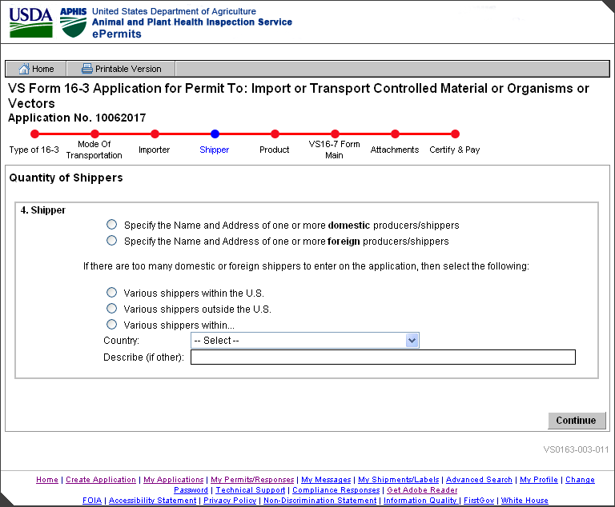

VS0163-003-016: Shipper Summary
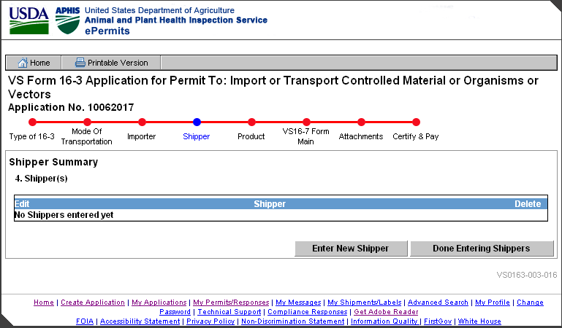

VS0163-003-015: Shipper Information
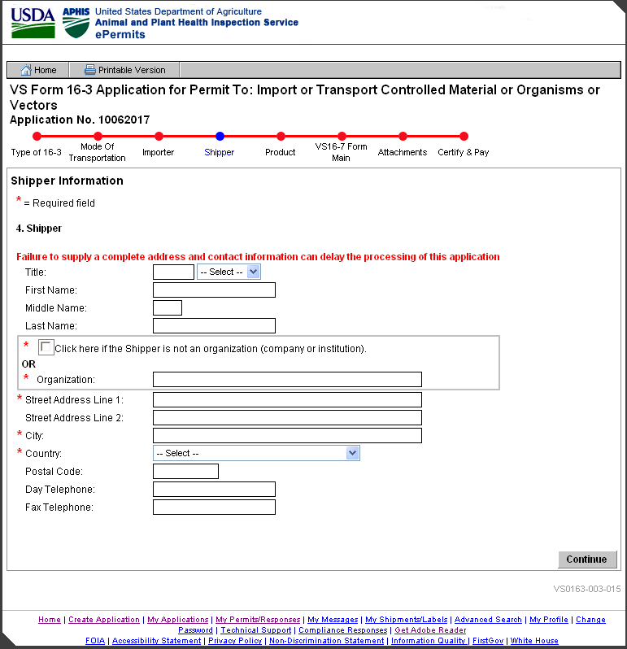

VS0163-003-067: LRN Lab Shipper(s)
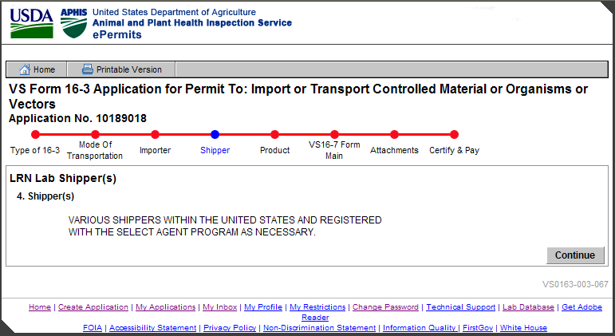

VS0163-004-017: Product Summary
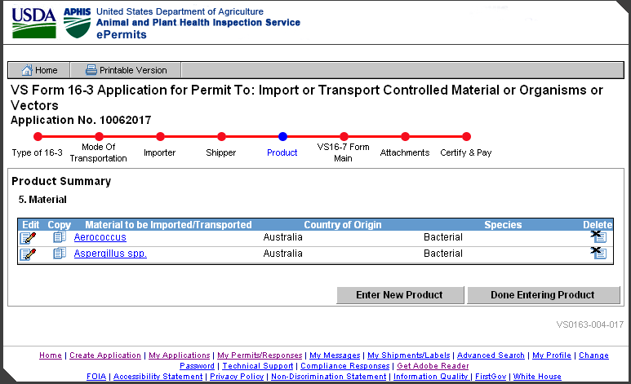

VS0163-004-022: Product Information

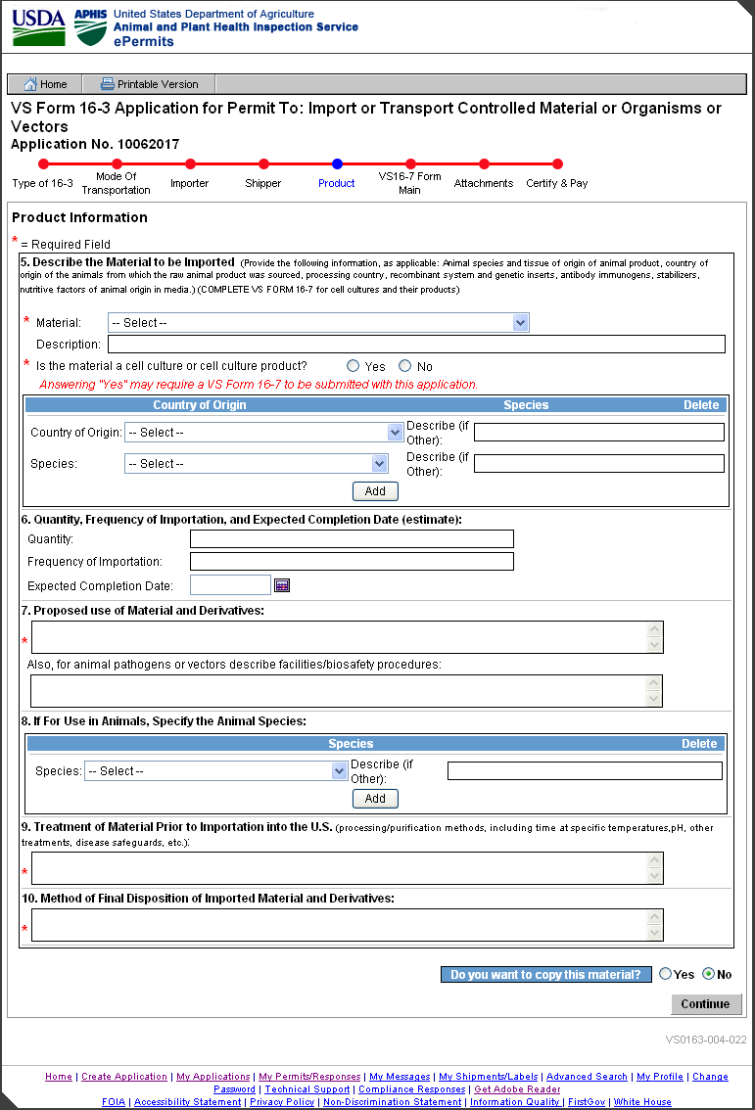

VS0163-004-019: Product Information – Select Agent
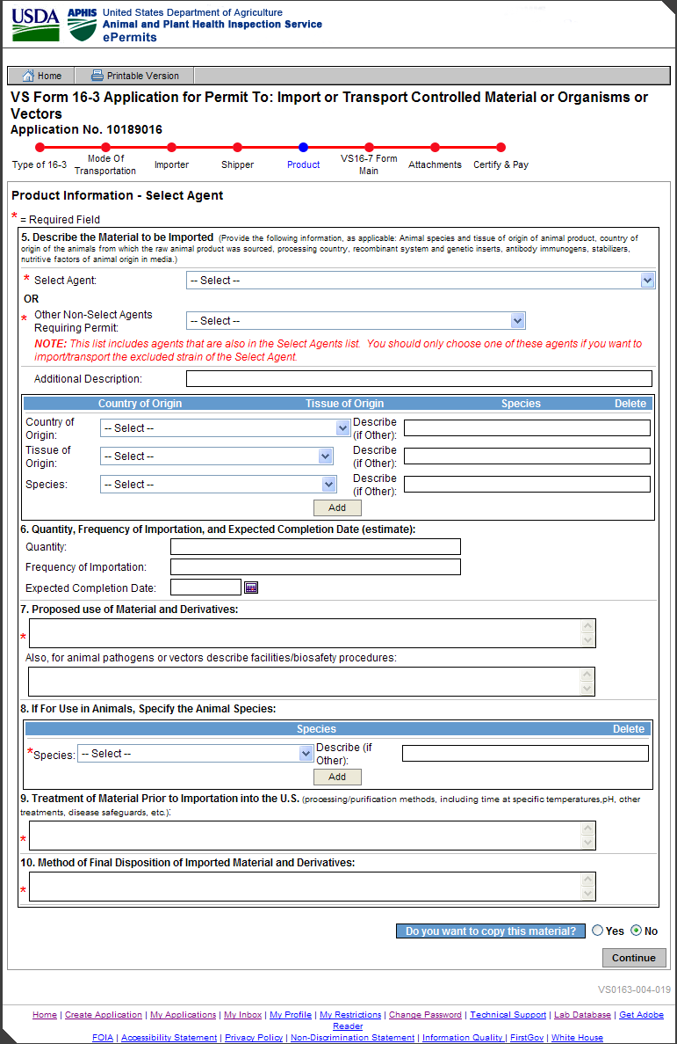

VS0163-004-020: Product Information – LRN
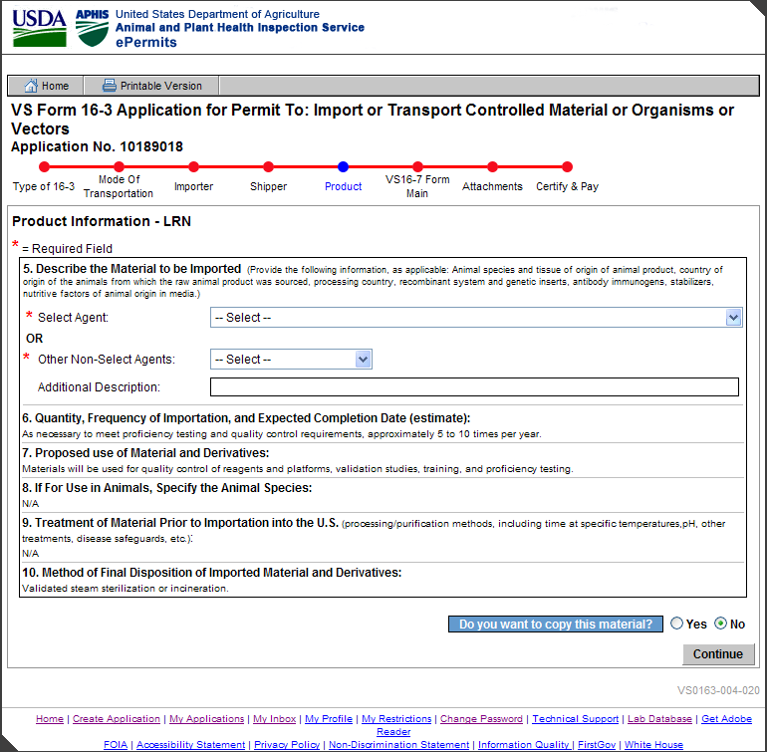

VS0163-005-055: VS16-7 Summary
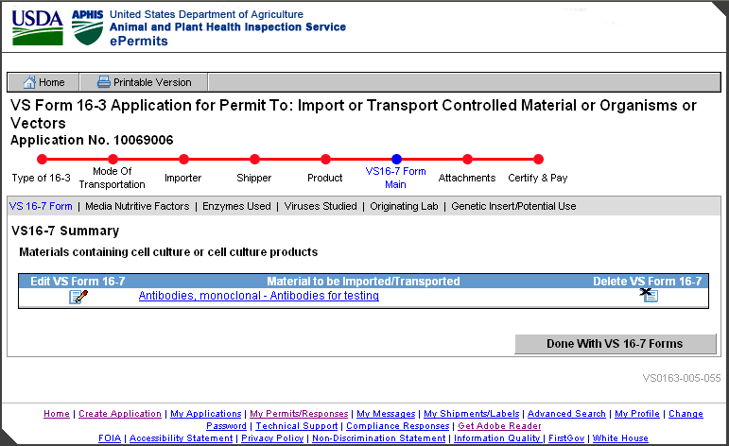

VS0163-005-027: VS16-7 Information
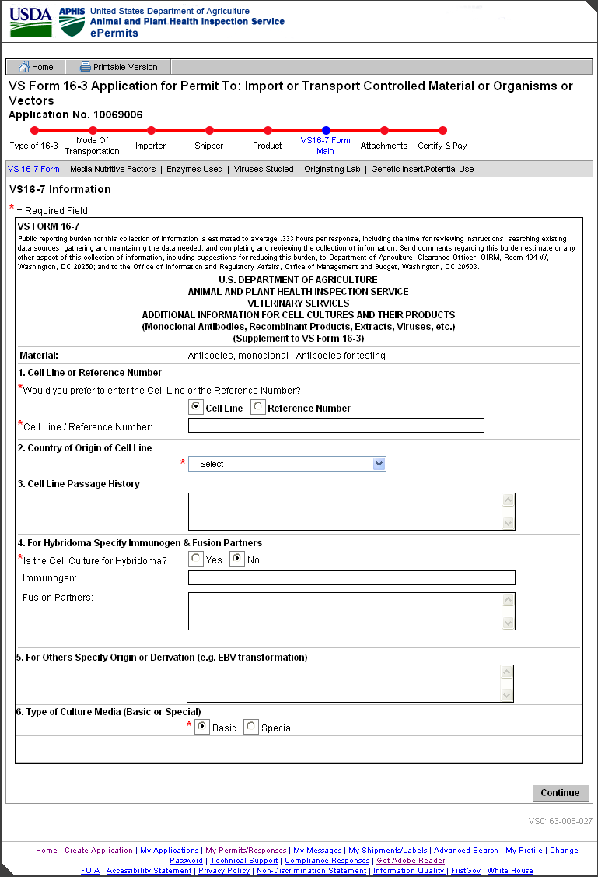

VS0163-005-032: Media Nutritive Factors Summary
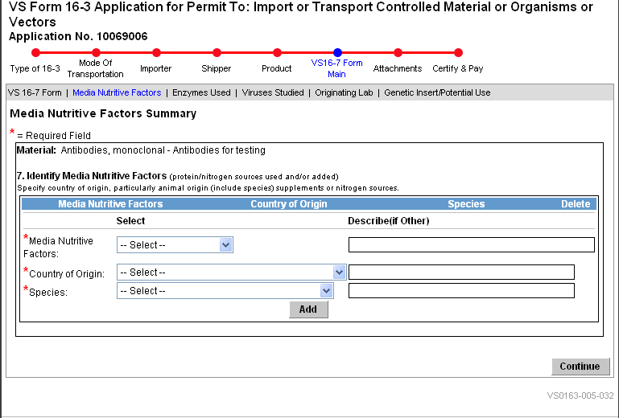

VS0163-005-035: Country of Origin and Source of Enzymes Used Summary
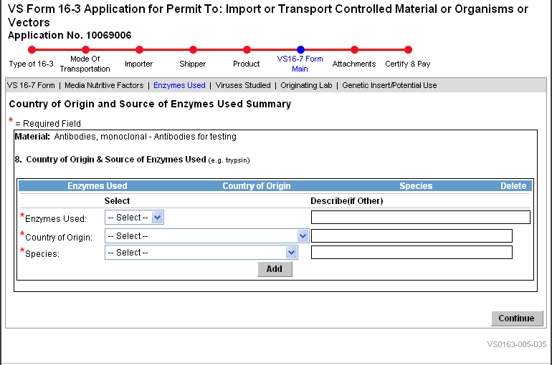

VS0163-005-042: Animal Virus Studied Summary
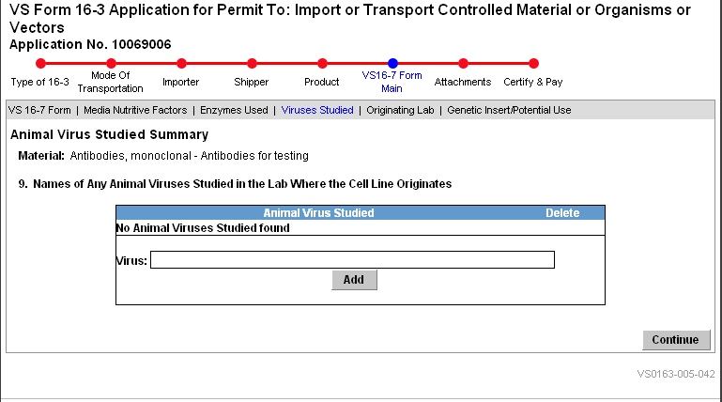

VS0163-005-049: Originating Labs Summary
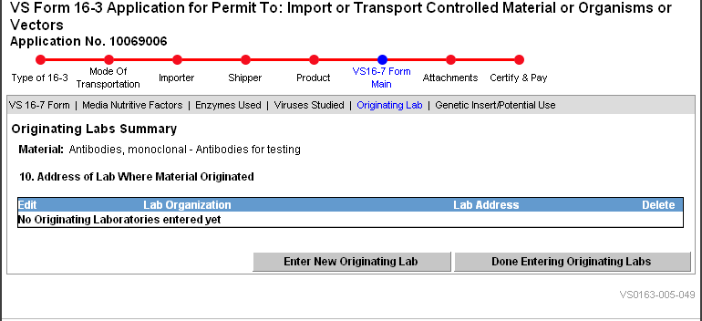

VS0163-005-046: Originating Lab Address Information
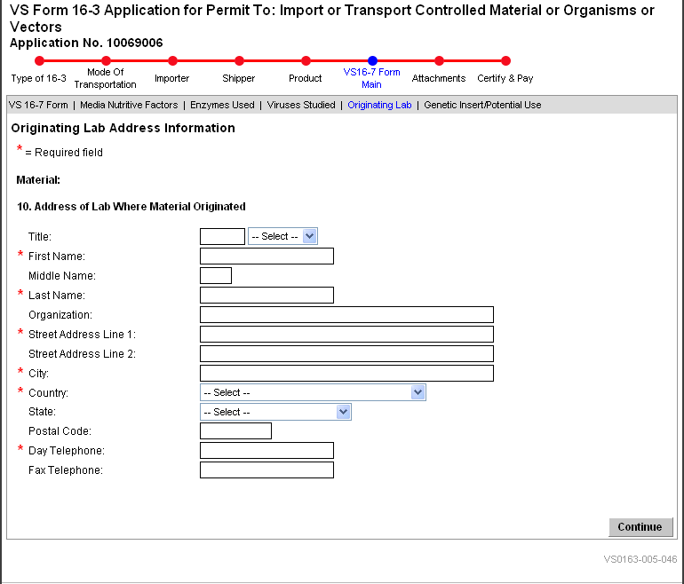

VS0163-005-050: Genetic Insert and Potential Use
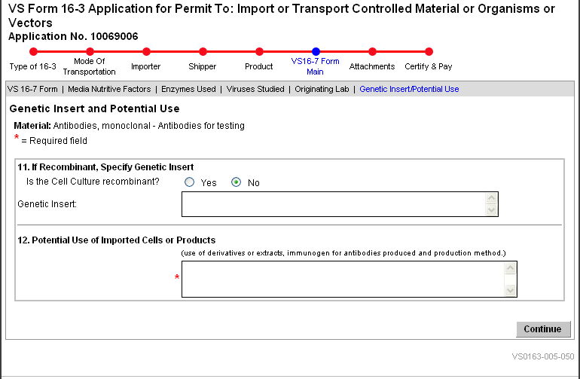

VS0163-006-056: Attachments Summary
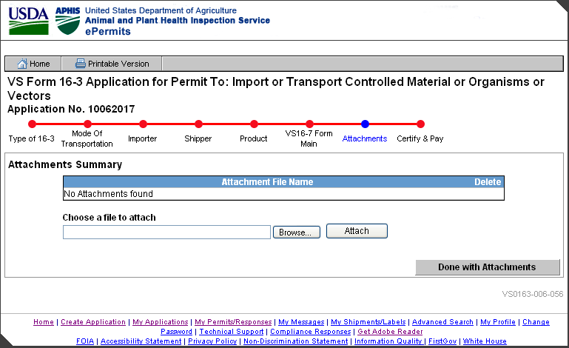

VS0163-011-082: Initiate Workflow
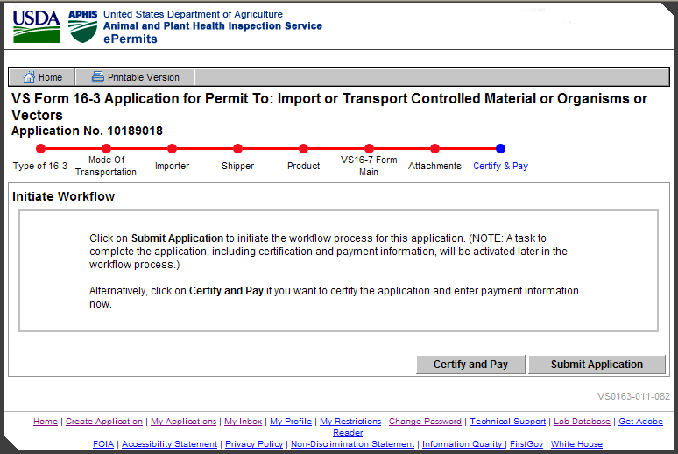

VS0163-011-083: Workflow Initiated
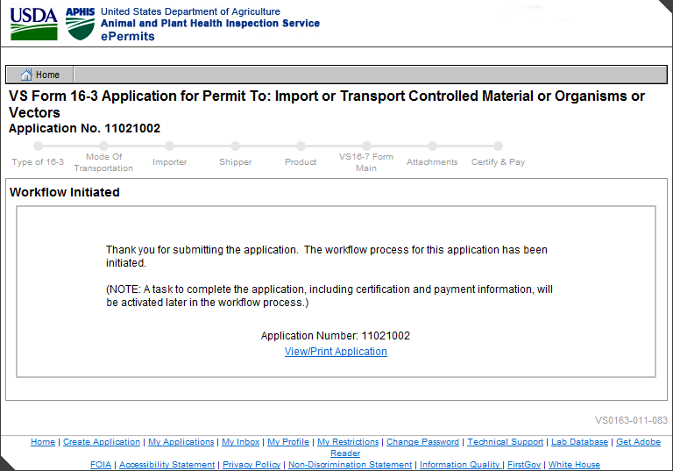

VS0163-011-072: Certify & Pay
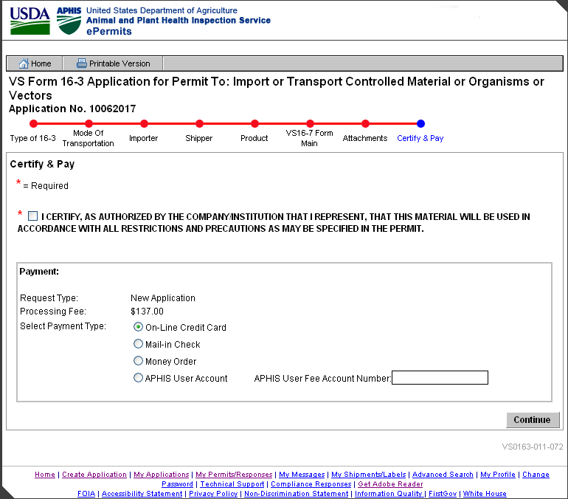
Certify & Pay Applicant View

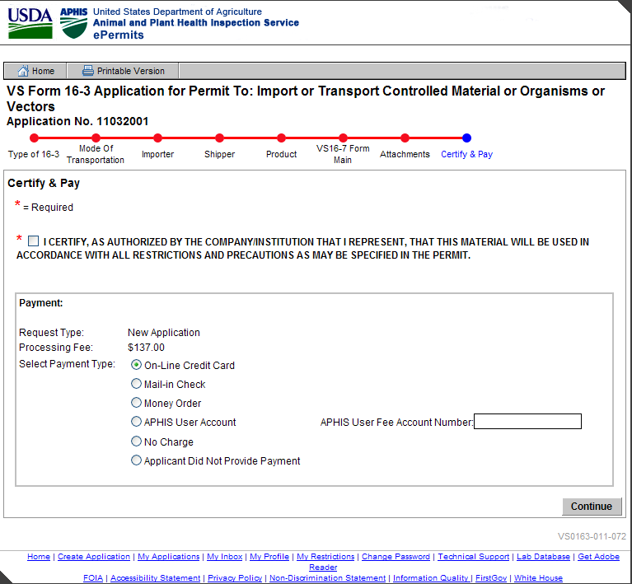
Certify & Pay APHIS View

VS0163-011-064: Credit Card Payment
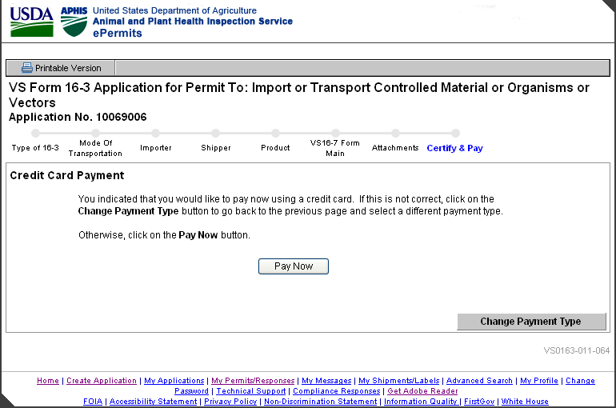

Online Payment: Step 1: Enter Payment Information

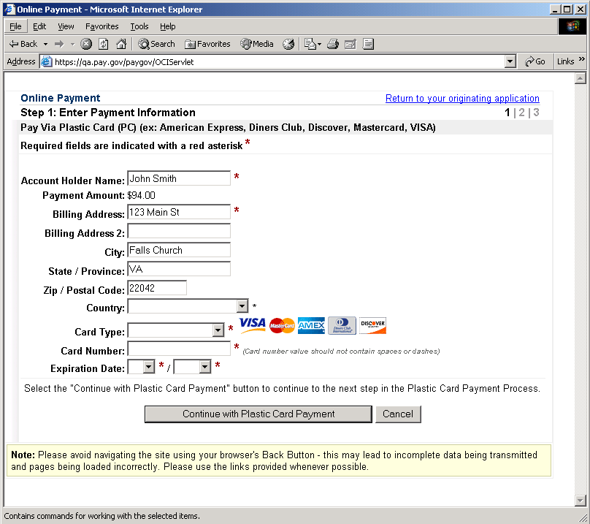

Online Payment: Step 2: Authorize Payment
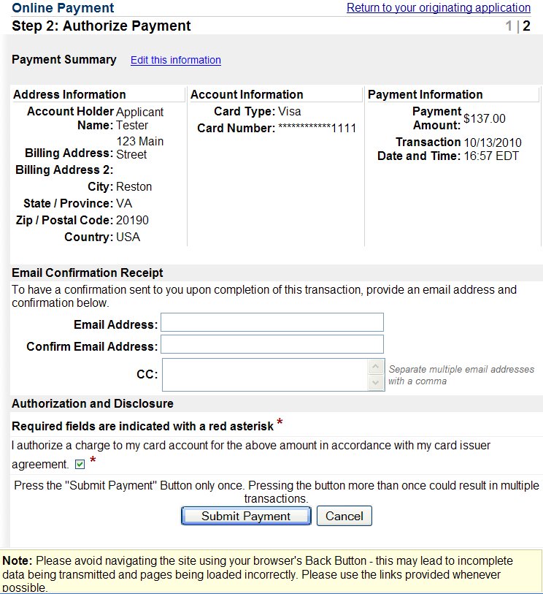

Online Payment: Your request is being processed. Please wait.

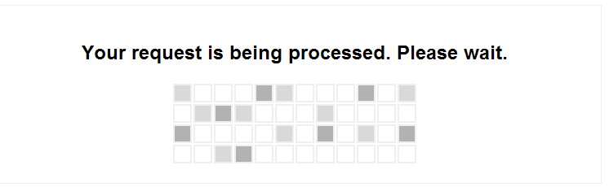

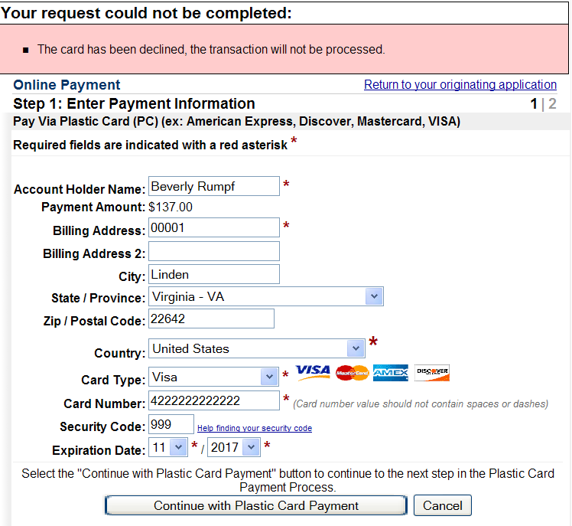

VS0163-011-076: Application Submitted
