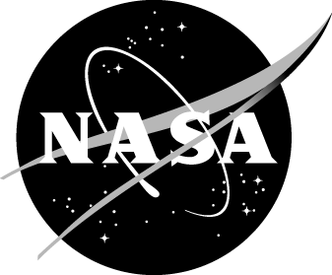
Scientific Research Challenge Activity
Student Feedback Form (Post-survey)
Educator Instructions

Educator Instructions: Please complete the following two items first, prior to obtaining student responses.

- What is the name of the site where the student participated in the NASA Scientific Research Challenge (SRC) Activity?

- What is the student’s identification number?

Privacy Notice: This is an official NASA application hosted on Surveymonkey.com. This is not a government application, the application is controlled and operated by a third party. NASA’s Web Privacy Policy does not apply to this application. NASA will not maintain, use, or share Personally Identifiable Information (PII) that becomes available through the use of this third party application unless expressly stated and consent is obtained from the user. For additional information on NASA’s Third-Party Privacy Notice please go to http://www.nasa.gov/about/highlights/HP_Privacy.html.
Paperwork Reduction Act Statement: This information collection meets the requirements of 44 U.S.C. §3507, as amended by section 2 of the Paperwork Reduction Act of 1995. You do not need to answer these questions unless we display a valid Office of Management and Budget (OMB) control number. The OMB control number for this collection is 2700-0159 and expires 04/20/2018. We estimate that it will take 15 minutes to read the instructions and answer the questions. Send only comments relating to this time estimate to: richard.l.gilmore@nasa.gov.

