NWS 2018 Quarterly Pop-up Customer Satisfaction Survey_Q1 FY17

Final (9/11/17)

Introduction
Note: Section headers will not be included in online survey. Items in BOLD AND CAPS are programmer instructions. Response options will be randomized, except when sequential. All rated questions will include a “Don’t Know” and/or “NA” option. When a “RANDOMIZE” instruction is provided, any “Other,” “Don’t Know,” “NA,” or “None” style of response will be forced to the bottom of the response set.
Introduction
The National Oceanic and Atmospheric Administration’s (NOAA) National Weather Service (NWS) is committed to serving the needs of all of its users. The NWS is undertaking research on how satisfied users are and would appreciate your feedback. The purpose of this research, conducted in partnership with the federal government as part of the American Customer Satisfaction Index, is to help the NWS improve its services for you and others like you.

Your answers are voluntary, but your opinions are very important for this research. Your responses will be kept completely confidential, and you will never be identified by name. CFI Group, a third-party research and consulting firm, is administering this survey via a secure server. The time required to complete this survey will depend on how certain questions are answered, but will likely take about 10 minutes. This survey is authorized by Office of Management and Budget Control No. 1090-0007, which expires May 31, 2018.

Please click on the “Next” button below to begin the survey.

Screeners
Q1. What is your age?
Under 15 | 1 | [THANK AND TERMINATE]
15-24 | 2
25-34 | 3
35-44 | 4
45-54 | 5
55-64 | 6
65+ | 7

Q2. Are you familiar with the watches and warnings issued by the NWS as they relate to hazardous flooding and tropical storms/hurricanes?
Yes, both hazardous flooding and tropical storms/hurricanes | 1
Flooding only | 2 | [SKIP TO FLOOD SECTION]
Tropical storms/hurricanes only | 3 | [AFTER TROP STORM/HURRICANE Q’S, SKIP TO CSI]
Neither hazardous flooding nor tropical storms/hurricanes | 4 | [THANK AND TERMINATE]

Sources of Weather Information
Q3. What is your preferred method to check the weather?
My personal computer (i.e., laptop, desktop) | 1
Television | 2
NOAA Weather Radio/All Hazards | 3
Commercial Radio Broadcast | 4
My smartphone | 5
My tablet | 6

NWS Information for Tropical Storms/Hurricanes
Q4. Please think about the information you receive from the NWS regarding tropical storms/hurricanes. Using a scale from 1 to 10 where 1 is “Poor,” and 10 is “Excellent,” please rate NWS on the following:
(Select one for each row)
 | Poor 1 | 2 | 3 | 4 | 5 | 6 | 7 | 8 | 9 | Excellent 10 | Don’t Know/NA
Ease of finding tropical storm/hurricane forecast information specific to your geographic area of interest
Accuracy of information for tropical storms/hurricanes
Explaining the threat and expected impacts of tropical storms/hurricanes
Providing information to help you make decisions relative to tropical storms/hurricanes (e.g., remaining indoors, evacuating, sheltering pets/livestock)

Q5. [If “providing information to help you make decisions…” <6]
Please indicate what the NWS should change to better help you in making decisions when tropical storms/hurricanes are forecasted (Open End)

Contribution to Understanding of Tropical Storms/Hurricanes
Q6. How would you rate your current knowledge of tropical storms/hurricanes using a 10-point scale in which 1 means “Not at all knowledgeable” and 10 means “Very knowledgeable”?
Q7. Now please rate the extent to which the information provided by the NWS has contributed to your understanding of the dangers of tropical storms/hurricanes, using a 10-point scale in which 1 means “Not at all” and 10 means “Significantly.”

Storm Surge
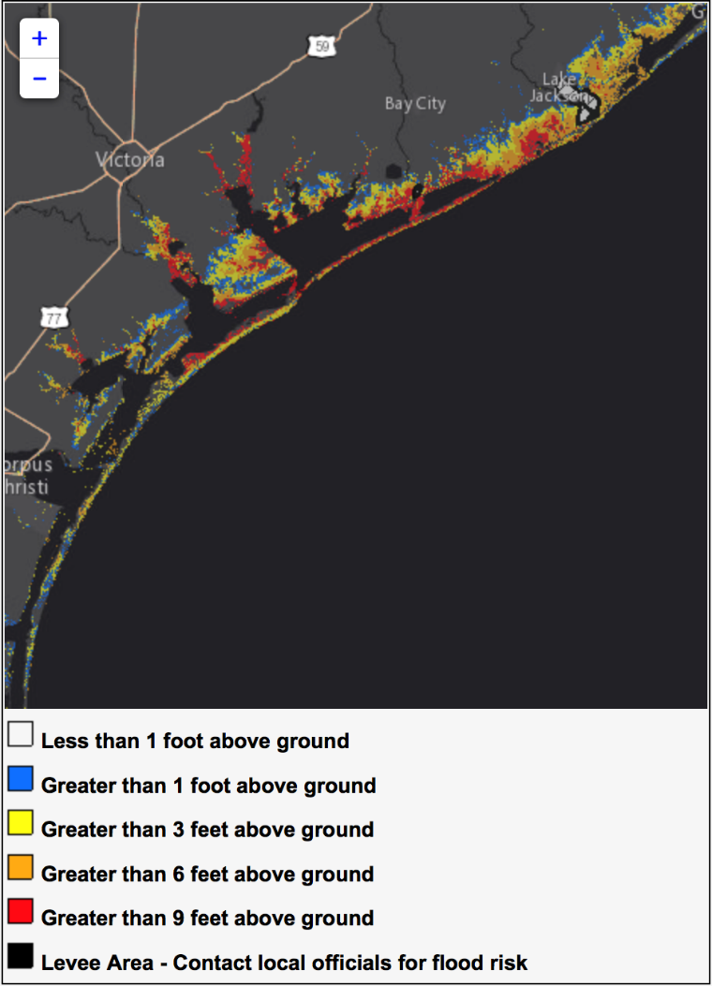
Q8. The NWS National Hurricane Center provides an online graphic called a Potential Storm Surge Inundation Map, which shows potential flooding impacts from tropical storms and hurricanes. An example of this tool is pictured below. Have you ever referred to this online resource?

Yes | 1
No | 2
Not sure | 3

[If “No” or “Not sure,” skip to Contribution to Understanding of Tropical Storms/Hurricanes]
Q9. When you used the Potential Storm Surge Inundation Map how did you interpret the results in terms of the predicted magnitude of flooding?

Worst case scenario (the greatest amount of flooding) | 1
Best case scenario (the least amount of flooding) | 2
Most likely scenario (the most likely amount of flooding) | 3
Not sure | 4

Q10. [This question will be on a new page in the online survey]
The Potential Storm Surge Inundation Map is intended to show the worst-case scenario for the depicted areas. Please provide any feedback you would like to share about how we may make this feature most useful for you. [Open End]

NWS Information for Hazardous Flooding
Q11. Now consider the information you receive from the NWS regarding hazardous flooding. Using a scale from 1 to 10 where 1 is “Poor,” and 10 is “Excellent,” please rate NWS on the following:
(Select one for each row)
 | Poor 1 | 2 | 3 | 4 | 5 | 6 | 7 | 8 | 9 | Excellent 10 | Don’t Know/NA
Ease of finding hazardous flooding forecast information specific to your geographic area of interest
Accuracy of information for hazardous flooding events
Explaining the threat and expected impacts of hazardous flooding events
Providing information to help you make decisions relative to hazardous flooding (e.g., avoiding flooded roadways, evacuating, moving personal property, moving to higher ground)

Q12. [If “providing information to help you make decisions…” <6]
Please indicate what the NWS should change to better help you in making decisions when hazardous flooding is forecast (Open End)

Contribution to Understanding of Hazardous Flooding
Q13. How would you rate your current knowledge of hazardous flooding using a 10-point scale in which 1 means “Not at all knowledgeable” and 10 means “Very knowledgeable”?

Q14. Now please rate the extent to which the information provided by the NWS has contributed to your understanding of the dangers of hazardous flooding, using a 10-point scale in which 1 means “Not at all” and 10 means “Significantly.”

Weather Hazard Preparedness
Q15. Do you have a safety plan and/or a safety kit for coping with any of the following hazard types? Select all that apply
 | Safety Plan (e.g., evacuation, shelter, communication) | Emergency Preparedness/Safety/ Disaster Supply Kit
Hazardous Flooding
Tornadoes
Tropical Storms/Hurricanes
Tsunamis
Wildland Fires
Hazardous Winter Weather

Customer Satisfaction Index (CSI)
Q16. Now, please consider all your experiences with the NWS. Using a 10-point scale where 1 means “Very Dissatisfied” and 10 means “Very Satisfied,” how satisfied are you with the NWS?
 | Very Dissatisfied 1 | 2 | 3 | 4 | 5 | 6 | 7 | 8 | 9 | Very Satisfied 10
Overall Satisfaction with the NWS

Q17. [If Overall Satisfaction <6]
Please indicate what the NWS should change to improve your satisfaction? (Open End)
Q18. Using a 10-point scale where 1 now means “Falls Short of your Expectations” and 10 means “Exceeds Your Expectations,” to what extent has the NWS fallen short of or exceeded your expectations?
 | Falls Short Of Your Expectations 1 | 2 | 3 | 4 | 5 | 6 | 7 | 8 | 9 | Exceeds Your Expectations 10
How well the NWS has met your expectations
Q19. Now, imagine what an ideal organization providing weather information would be like. Using a 10-point scale where 1 means “Not Very Close to the Ideal,” and 10 means “Very Close to the Ideal,” how well do you think the NWS compares with that ideal weather information provider?
 | Not Very Close to the Ideal  1 | 2 | 3 | 4 | 5 | 6 | 7 | 8 | 9 | Very Close to the Ideal  10
NWS compared to an ideal weather information provider

Desired Outcomes
Q20. Using a scale from 1 to 10 where 1 means “Not at All Likely” and 10 means “Very Likely,” please indicate how likely you are to:
 | Not at All Likely 1 | 2 | 3 | 4 | 5 | 6 | 7 | 8 | 9 | Very Likely  10 | Don’t Know
Take action based on the information you receive from the NWS?
Use the NWS as a source of weather information in the future
Recommend the NWS to a colleague or a friend

Q21. Please share with us any final thoughts about your experience with NWS, including how we can improve our services to you and what you value most about our services. (Open End)

Demographics and Additional Background
We’re almost done! We would like to ask you just a few more questions:
Q22. Please enter your zip code (Text Box)
Q23. What is your gender?
Male | 1
Female | 2
Prefer not to answer | 3

Q24. What is your race or origin?
White/Caucasian | 1
Black/African American | 2
Hispanic or Latino | 3
Native Hawaiian or Other Pacific Islander | 4
Asian | 5
American Indian or Alaska Native | 6
Other (please specify) | 7
Prefer not to answer | 8

Q25. What is the highest degree or level of education that you have completed?
12th grade or less (no diploma) | 1
High school diploma or GED | 2
Some college, no degree | 3
Associate or technical degree | 4
Bachelor’s degree | 5
Graduate/Professional degree | 6
Don’t know | 7
Prefer not to answer | 8

Q26. What was your household income last year?
Less than $20,000 | 1
Between $20,000 and $29,999 | 2
Between $30,000 and $39,999 | 3
Between $40,000 and $49,999 | 4
Between $50,000 and $59,999 | 5
Between $60,000 and $79,999 | 6
Between $80,000 and $99,999 | 7
$100,000 or more | 8
Don’t know | 9
Prefer not to answer | 10

Close

Those are all the questions we have. Please click “Submit” below to finalize your responses. Thank you for your participation!

