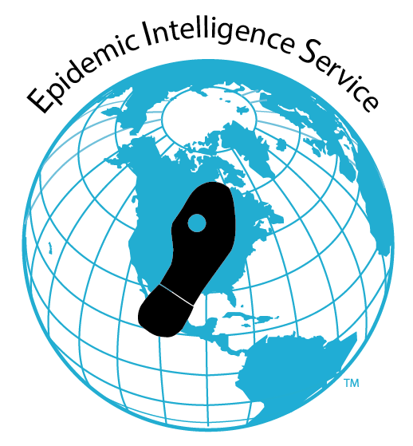
What is an Epi-Aid?
Attachment A
An Epi-Aid is an essential mechanism CDC uses for public health authorities to request short-term (1–3 weeks) epidemiologic assistance. An Epi-Aid allows rapid response by CDC’s Epidemic Intelligence Service (EIS) officers, who assist in investigating an infectious or non-infectious disease outbreak, natural or manmade disaster, or other public health emergency. The focus of the epidemiologic investigation is to make practical recommendations for actions to mitigate the urgent public health problem.
Who participates?
An Epi-Aid team consists of an EIS officer supported by CDC subject matter experts and other CDC staff as needed. This team joins local staff in the field to assist the external health authority in the investigation.
Who can request an Epi-Aid?
A local, state, federal, or international public health authority must invite CDC to assist in the investigation. Public health authorities who can request an Epi-Aid include:
- State or territorial epidemiologists
- Tribal chiefs
- Commanding generals (American military bases)
- Federal agencies
- Vessel Sanitation Program at CDC
- Ministers of health of foreign countries
How is an Epi-Aid requested and approved?
- The public health authority contacts the subject matter expert (SME) program at CDC. (For assistance in identifying the SME program, contact the EIS program or the Emergency Operations Center).
- The CDC SME Division communicates with the EIS office to discuss the Epi-Aid request. If CDC can support the Epi-Aid, the requesting public health authority sends a letter of invitation to the CDC division responsible for the subject matter.
- The CDC SME division forwards to the EIS program the letter of invitation and Epi-1, request for an Epi-Aid form, signed and cleared by the Division.
- The EIS program approves the Epi-Aid.

How does the public health authority benefit?
An Epi-Aid benefits the public health authority in several ways. Epi-Aids:
- Increase the manpower available for rapid response
- Streamline access to CDC subject matter experts and laboratory resources
- Build epidemiologic capacity through collaboration with CDC staff
- Train and mentor CDC trainees
What is the role of the public health authority?
The public health authority provides overall leadership of the Epi-Aid investigation while benefitting from a collaborative relationship with the CDC team. The public health authority owns all data. After the Epi-Aid is completed, the public health authority can request CDC’s continued assistance in data analysis, report writing, and presentation preparation. CDC may not publish or present the data without prior approval and clearance from the public health authority.
Where can I get more information?
For more information about Epi-Aids, call the EIS office at 404-498-6100, send an e-mail to EpiAid@cdc.gov, or visit the EIS website.

Requesting an Epi-Aid
- Contact the CDC subject matter expert (SME) program directly
- Contact the EIS office
  - At any time: E-mail EpiAid@cdc.gov
  - During business hours (8:00 a.m.–4:30 p.m. ET): Call the EIS office at 404-498-6100
  - Exception: After business hours: Call the CDC Emergency Operations Center (EOC) at 770-488-7100

