Attachment I-1
Annual Questionnaire

Form Approved
OMB No. 0920-0260
Expires xx/xx/20xx

Study Title:
Evaluating Interventions for Airplane Cargo Baggage Handling

Public reporting burden of this collection of information is estimated to average 30 minutes per response, including the time for reviewing instructions, searching existing data sources, gathering and maintaining the data needed and completing and reviewing the collection of information. An agency may not conduct or sponsor, and a person is not required to respond to a collection of information unless it displays a currently valid OMB control number. Send comments regarding this burden estimate or any other aspect of this collection of information, including suggestions for reducing this burden to CDC, Project Clearance Officer, 1600 Clifton Road, MS D-74, Atlanta, GA 30333, ATTN.: PRA (0920-xxxx). Do not send the completed form to this address.

SECTION A. GENERAL INFORMATION

Today's Date:__ __ / __ __ / __ __ __ __ Work site (3 letter airport code): ______
month day year

- Last Name: _________________________________________________________
- First Name: _________________________________________________________
- Middle Initial: _____
- Your Employee Number (or Clock Number): __________________
- Date of Birth: __ __ / __ __ /__ __ __ __
month day year

- Gender: Male Female
- Your home address: _______________________________________________________
- Your home or cell phone number: _________________________
- Your Height: __ feet __ __ inches
- Your Weight: __ __ __ pounds
- Are you of Hispanic or Latino origin? No Yes
- Race (check all that apply): White
Black or African American
Asian
Native Hawaiian or Pacific Islander
Native American or Alaska Native

13. What is the highest grade in school that you completed?

8th grade or less
Some high school
High school graduate or GED
Some college
College graduate (Bachelor's Degree or higher)

14. Have you ever smoked at least 100 cigarettes in your ENTIRE LIFE?

No
Yes

Yes, but I NO LONGER smoke
Yes, I CURRENTLY smoke

15. Which hand do you use the most at work?

Left
Right
Both

16. In the past year, on average, how many alcoholic beverages did you have?

None
Less than 12 drinks
Less than 3 drinks per week
3 to 7 drinks per week
8 to14 drinks per week
More than 14 drinks per week

17. In the past year, on average, how much total time did you spend in a vehicle each day?

Less than 1 hour per day
1 hour to less than 2 hours per day
2 hours to less than 3 hours per day
3 hours to less than 5 hours per day
More than 5 hours per day

SECTION B. WORK INFORMATION

18. How long have you worked as an airline baggage handler?

Less than 3 months
3 months to less than 1 year
1 year to less than 3 years
3 years to less than 5 years
5 years to less than 10 years
10 years or more

19. How long have you worked at this airport?

Less than 3 months
3 months to less than 1 year
1 year to less than 3 years
3 years to less than 5 years
5 years to less than 10 years
10 years or more

20. How long have you worked in the tarmac (ramp) area at this airport?

Less than 3 months
3 months to less than 1 year
1 year to less than 3 years
3 years to less than 5 years
5 years to less than 10 years
10 years or more

21. Are you a crew leader?

No
Yes

22. What is the length of your employment at this company?

less than 1 year
1 year to less than 5 years
5 years to less than 10 years
10 years to less than 15 years
15 years to less than 20 years
20 years to less than 25 years
25 years or more

23. How would you describe your work arrangement?

Permanent/full time (at least 40 hours per week)
Permanent/full time (at least 20 hours per week)
Temporary worker under contract-work at least 20 hours per week
Temporary worker under contract-work at least 40 hours per week
On-call (work only when called to work)

24. On your current job, do you usually work:

Regular daytime shift (anytime between 6 A.M. to 6 P.M.)
Regular evening shift (anytime between 2 P.M. to Midnight)
Regular night shift (anytime around 9 P.M. to 8 A.M.)
Forward rotating shift - one that changes from days to evenings to nights
Backward rotating shift - one that changes from nights to evenings to days
Irregular schedule arranged by employer
Other shift
(Specify____________________________________________)

25. How many HOURS PER DAY do you USUALLY work during your regular work shift at this company, not including overtime hours?

Less than 7 ½ hours
At least 7 ½ hours but less than 8 ½ hours
At least 8 ½ hours but less than 10 hours
At least 10 hours but less than 12 hours
12 hours or more

26. How many DAYS PER WEEK (7 days) do you USUALLY work, not including overtime hours?

Less than 3 days per week
3 days per week
4 days per week
5 days per week
6 days per week
7 days per week

27. Do you work overtime?

No (Skip to question 28)
Yes, voluntary overtime
Yes, mandatory overtime
Yes, BOTH voluntary and mandatory overtime

a. How many overtime HOURS PER WEEK do you USUALLY work?

Less than 5 hours per week
5 to 10 hours per week
11 to 20 hours per week
More than 20 hours per week

b. In the past 12 months (52 weeks), approximately how many weeks did you work overtime?

1 to 9 weeks in the past year (up to 15% of the year)
10 to 19 weeks in the past year (approximately 30% of the year)
20 to 29 weeks in the past year (approximately 50% of the year)
30 to 39 weeks in the past year (approximately 70% of the year)
40 weeks or more in the past year (77% of the year or more)

28. What body position do you usually use to handle bags inside airplane cargo compartments?

Kneeling
Sitting
Squatting
Standing
Combination of kneeling and sitting

29. Do you wear knee pads for work?

No
Yes

30. In the past year, what is the average percentage of your work time spent in cargo compartments loading/unloading baggage during your typical workday?

100%
About 75%
About 50%
About 25%
I do not use the Power Stow

31. In the past year, what is the average percentage of your work time spent on lifting bags to/from baggage carts during your typical workday?

100%
About 75%
About 50%
About 25%
I do not use the Vacuum Lift

32. Do you work at a second job?

If you checked no, go to the top of page 7

No
Yes

- How long have you been working at your second job?
Less than 3 months
3 months to less than 1 year
1 year to less than 3 years
3 years to less than 5 years
5 years to less than 10 years
10 years or more

- How many HOURS PER WEEK do you USUALLY work at your second job?

Less than 5 hours per week
5 to 10 hours per week
11 to 20 hours per week
More than 20 hours per week

- Do you usually work your first and second job on the SAME day(s) or on DIFFERENT days?

Work SAME day(s)
Work DIFFERENT day(s)
Both

- Does this second job involve LIFTING, PUSHING, PULLING, or CARRYING:

MODERATE weight objects? No Sometimes Often
HEAVY weight objects? No Sometimes Often

e. Does this second job involve bending your back?

Never or rarely
Less than half of the time
Half the time or more

f. On the scale below, rate the typical activity of your HANDS and ARMS while working at your second job.

no regular motion; hands and arms mostly idle |  | very slow motion; a lot of pauses |  | slow, steady motion; frequent pauses |  | steady motion, occasional pauses |  | rapid, steady motion; few pauses |  | rapid, steady motion; difficulty keeping up

SECTION C. PHYSICAL ACTIVITIES OUTSIDE OF WORK

Please think for a moment about all the different PHYSICAL activities you perform when you are not at work. Although you may not do the same activities every week, estimate below how much time “on average” you spend each week on physical activities outside of work.

33. How many hours on average do you spend on activities in which...

a. you twist your back or bend forward at least as much as shown in this picture?

Less than 5 hours each week
5 to less than 10 hours each week
10 to less than 20 hours each week
20 or more hours each week⁴

b. you lift, push, pull or carry moderate to heavy weights?

Less than 5 hours each week
5 to less than 10 hours each week
10 to less than 20 hours each week
20 or more hours each week

34. How many hours on average do you use vibrating tools?

Less than 5 hours each week
5 to less than 10 hours each week
10 to less than 20 hours each week
More than 20 hours each week

35. Are there sports or hobbies that you do every week?

No
Yes

SECTION D. HEALTH INFORMATION

36. Overall, how would you rate your health at the present time?

Poor
Fair
Good
Very good
Excellent

37. Have you ever told by a physician that you had any of the following?

a. Arthritis No
Yes

If YES to Arthritis, which areas are affected (Mark X for all that apply)

Neck
Shoulder
Elbow/Forearm
Hands/Wrists/Fingers
Back
Other (specify: _________________________________________)

b. Thyroid problems No
Yes

c. Raynaud’s disease No
Yes

d. Gout No
Yes

e. Kidney failure No
Yes

f. High blood pressure No
Yes

g. Diabetes No
Yes

h. Depression No
Yes

FEMALES ONLY

38. Are you currently pregnant?

No
Yes
The FOLLOWING SECTIONS ask if you have had symptoms (pain, aching, stiffness, spasm, burning, numbness, or tingling) in any of the body parts listed below:

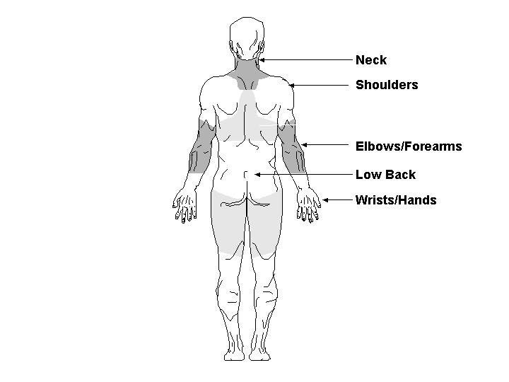
Knees

39. Have you EVER had NECK symptoms (pain, aching, stiffness, spasm, burning, numbness, or tingling) lasting a week (7 days) or longer?

No (Skip to question 46)
Yes

40. Have you EVER had surgery for your NECK symptoms?

No
Yes

41. In the past 12 months, have you had NECK symptoms every day for a week (7 days)?

No
Yes

42. In the past 12 months, how much did the NECK symptoms interfere with your normal work including both work outside the home and housework?

Very little
A little
Moderate amounts
Much
Very much

43. In the past 12 months, how many times have you SEEN a doctor, nurse, physical therapist or chiropractor or other health care provider for your NECK symptoms?

None
1 time
2-4 times
5 or more than 5 times

44. In the past 12 months, how many days have you MISSED work because of NECK symptoms?

0 days
1 day to 1 week
More than 1 week to 2 weeks
More than 2 weeks

45. Did the NECK symptoms in the past 12 months result from an accident or sudden injury such as a car accident or slips/falls?

No
Yes

46. Have you EVER had SHOULDER symptoms (pain, aching, stiffness, spasm, burning, numbness, or tingling) lasting a week (7 days) or longer?

No (Skip to question 53)
Yes

47. Have you EVER had surgery for your SHOULDER symptoms?

No
Yes

48. In the past 12 months, have you had SHOULDER symptoms every day for a week (7 days)?

No
Yes

49. In the past 12 months, how much did the SHOULDER symptoms interfere with your normal work including both work outside the home and housework?

Very little
A little
Moderate amounts
Much
Very much

50. In the past 12 months, how many times have you SEEN a doctor, nurse, physical therapist or chiropractor or other health care provider for your SHOULDER symptoms?

None
1 time
2-4 times
5 or more than 5 times

51. In the past 12 months, how many days have you MISSED work because of SHOULDER symptoms?

0 days
1 day to 1 week
More than 1 week to 2 weeks
More than 2 weeks

52. Did the SHOULDER symptoms in the past 12 months result from an accident or sudden injury such as a car accident or slips/falls?

No
Yes

53. Have you EVER had LOW BACK symptoms (pain, aching, stiffness, spasm, burning, numbness, or tingling) lasting a week (7 days) or longer?

No (Skip to question 60)
Yes

54. Have you EVER had surgery for your LOW BACK symptoms?

No
Yes

55. In the past 12 months, have you had LOW BACK symptoms every day for a week (7 days)?

No
Yes

56. In the past 12 months, how much did the LOW BACK symptoms interfere with your normal work including both work outside the home and housework?

Very little
A little
Moderate amounts
Much
Very much

57. In the past 12 months, how many times have you SEEN a doctor, nurse, physical therapist or chiropractor or other health care provider for your LOW BACK symptoms?

None
1 time
2-4 times
5 or more than 5 times

58. In the past 12 months, how many days have you MISSED work because of LOW BACK symptoms?

0 days
1 day to 1 week
More than 1 week to 2 weeks
More than 2 weeks

59. Did the LOW BACK symptoms in the past 12 months result from an accident or sudden injury such as a car accident or slips/falls?

No
Yes

60. Have you EVER had KNEE symptoms (pain, aching, stiffness, spasm, burning, numbness, or tingling) lasting a week (7 days) or longer?

No
Yes

61. Have you EVER had surgery for your KNEE symptoms?

No
Yes

62. In the past 12 months, have you had KNEE symptoms every day for a week (7 days)?

No
Yes

63. In the past 12 months, how much did the KNEE symptoms interfere with your normal work including both work outside the home and housework?

Very little
A little
Moderate amounts
Much
Very much

64. In the past 12 months, how many times have you SEEN a doctor, nurse, physical therapist or chiropractor or other health care provider for your KNEE symptoms?

None
1 time
2-4 times
5 or more than 5 times

65. In the past 12 months, how many days have you MISSED work because of KNEE symptoms?

0 days
1 day to 1 week
More than 1 week to 2 weeks
More than 2 weeks

66. Did the KNEE symptoms in the past 12 months result from an accident or sudden injury such as a car accident or slips/falls?

No
Yes

SECTION E. WORK ENVIRONMENT

67. For each of the following questions about the work environment at this airport, please indicate how much you agree or disagree by marking an X in the circle for one of the options.
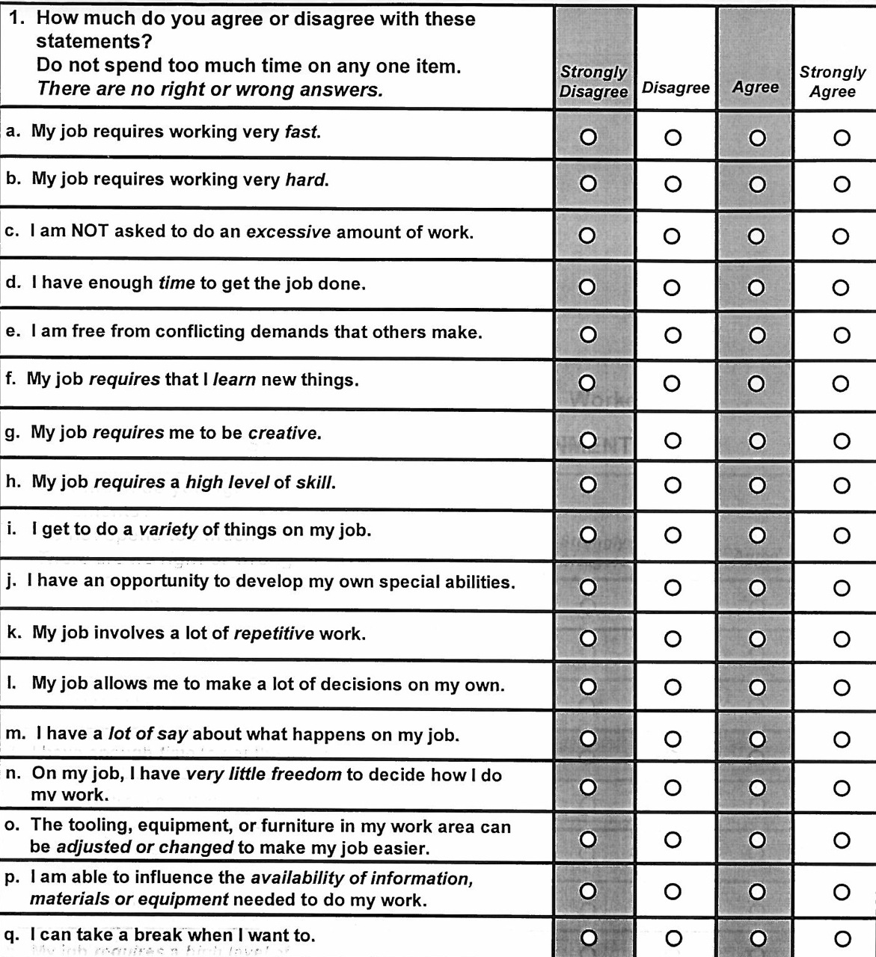

68. For each of the following questions about the work environment at this airport, please indicate how little or how much you have over aspects of your work by marking an X in the circle for one of the options.

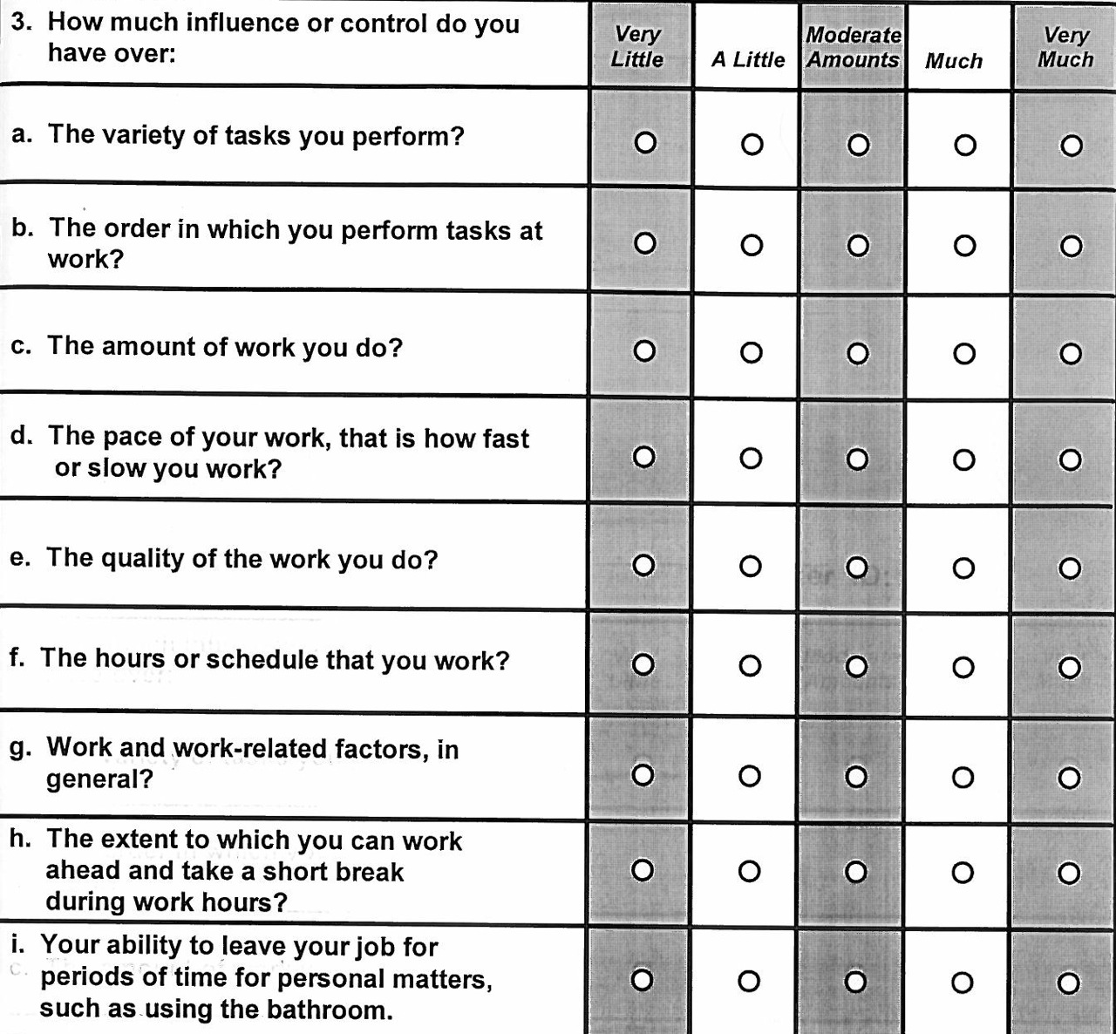

69. For each of the following questions about the work environment at this airport, please indicate how little or how much support you receive on the job by marking an X in the circle for one of the options.

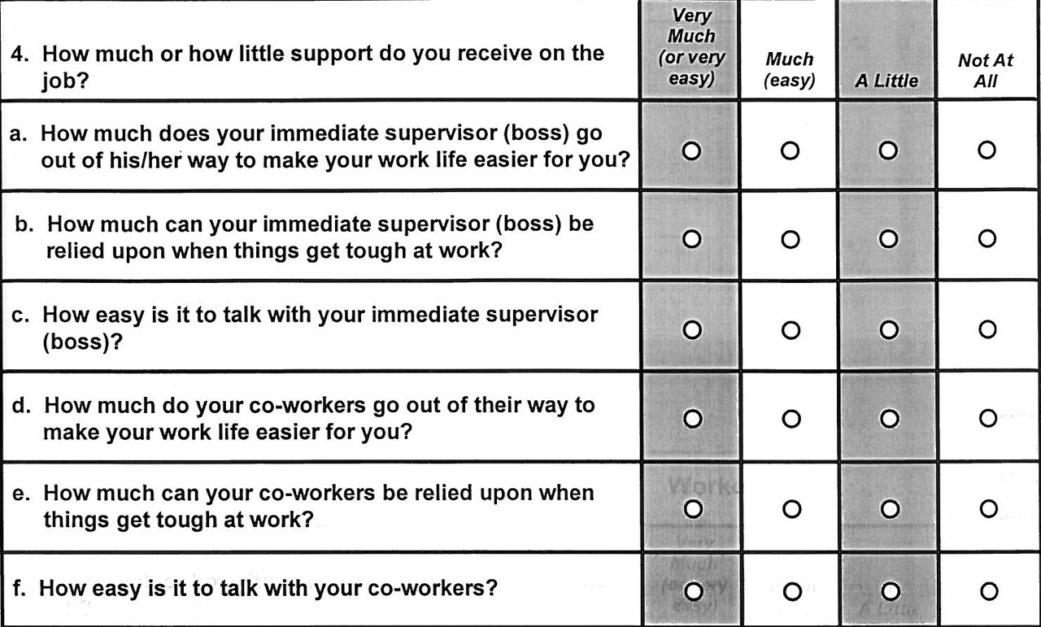

70. All in all, how satisfied are you with your job?

Not at all satisfied
Not too satisfied
Somewhat satisfied
Very satisfied

71. During the past year, how often were you in a situation where you thought you might be laid off?

Never
Faced the possibility once
Faced the possibility more than once
Constantly
Was actually laid off

72. On the scale below, rate the typical activity of your HANDS/ARMS while working at this airport. Please mark one of the circles below.

no regular motion; hands and arms mostly idle |  | very slow motion; a lot of pauses |  | slow, steady motion; frequent pauses |  | steady motion, occasional pauses |  | rapid, steady motion; few pauses |  | rapid, steady motion; difficulty keeping up

73. Please rate your OVERALL PHYSICAL EFFORT level demanded by your job today. Please mark the circle next to the number with an X:

