Screen Shots of FTP Site for Data Transmission

Connection Interface
Screen shot of connection interface (4 pieces of information required to log in —including username and password—on the row with the “Quickconnect” button)

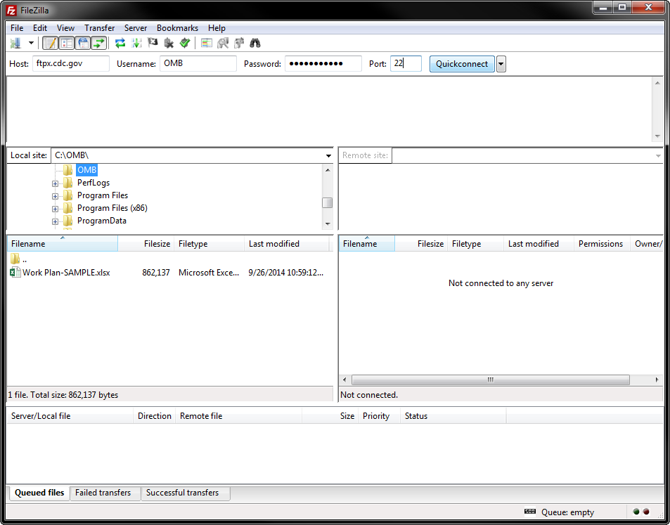

FTP Site
Screenshot of interface while connected to FTP site: Right-click the file to upload, and select the Upload operation. User name will put states directly into the state-specific directory; cannot view any other state’s folder.

