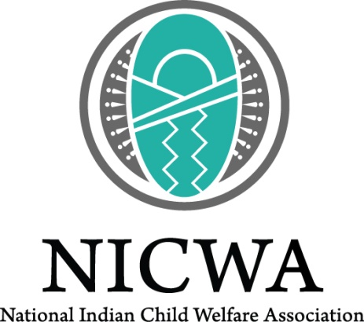

Adult Focus Group Information Sheet

The National Indian Child Welfare Association, Better World Advertising, and the Food and Drug Administration – Center for Tobacco Products (FDA-CTP) are conducting focus groups to learn more about Native youth smoking and use of media to inform the development of a smoking prevention campaign.

What is this?
The purpose of these focus group discussions is to develop a campaign to prevent smoking among American Indian and Alaska Native youth. Our discussions with you will help us develop our campaign.

Who can join?
- American Indian or Alaska Native youth ages 10–16 in [community]
- Parents/caregivers of American Indian/Alaska Native youth in [community]
- Elders/community leaders/service providers of [community]

When and where will this happen?
[May 2016- April 2017 and in Alaska or the Northern Plains]

What will I be asked to do?
As a focus group participant in this research study, you will be asked to participate in a two-hour focus group. You will be asked to discuss a series of questions about youth commercial tobacco use and media habits (for example, if youth use social media websites like Facebook, listen to radio programs or watch television, etc.) in your community. All responses from the discussion will be kept private. We will not ask you personal questions about tobacco use, but will be asking more general questions about tobacco use in your community. Service providers participating in the focus group will be reminded not to share privileged, sensitive information about their youth or adult clients in the community. We will also show you images, and you will have an opportunity to react to suggested campaign messages or ideas.

To thank you for the time you spend with us, you will receive a $75 Visa gift card. Food and refreshments will be provided as well as a $25 gift card for travel costs. Anyone who provides transportation for participants to and from the focus groups, whether or not they are participants themselves, will receive a $25 Visa gift card. There is a limit of one transportation incentive per individual regardless of the number of participants transported.

Who can I contact for more information?
If you have any questions or would like to sign up, please call xxx-xxx-xxxx and ask for [name], or email [email address]. You may also contact Jen Rountree, research manager at NICWA, at (503) 222-4044 ext. 144 or jen@nicwa.org.

