Central Valley Sport Fishing

[insert photo]

We want to learn about your fishing experience in the Central Valley!
Participation in this survey is voluntary.

Please address any questions you have regarding this survey to:
800-xxx-xxxx or xxx@noaa.gov
Public reporting burden for this collection of information is estimated to average 25 minutes per response, including the time for reviewing instructions, searching existing data sources, gathering and maintaining the data needed, and completing and reviewing the collection of information. Send comments regarding this burden estimate or any other suggestions for reducing this burden to Cindy Thomson, NOAA, National Marine Fisheries Service, 110 Shaffer Rd., Santa Cruz, CA 95060.

Notwithstanding any other provisions of the law, no person is required to respond to, nor shall any person be subjected to a penalty for failure to comply with, a collection of information subject to the requirements of the Paperwork Reduction Act, unless that collection of information displays a currently valid OMB Control Number.

 | OMB Control Number: 0648-XXXX  Expiration date: xx/xx/xx
INTRODUCTION
This survey pertains to your fishing in the Central Valley. For purposes of the survey, the Central Valley is defined as the area depicted on the map – including the Sacramento and San Joaquin Rivers and their tributaries (medium blue), nearby lakes and reservoirs (dark blue), and the Sacramento/San Joaquin Delta (green). If you fished on tributaries, lakes or reservoirs that are not named on the map but are connected to the Sacramento River or San Joaquin River, the survey covers those fishing trips as well.

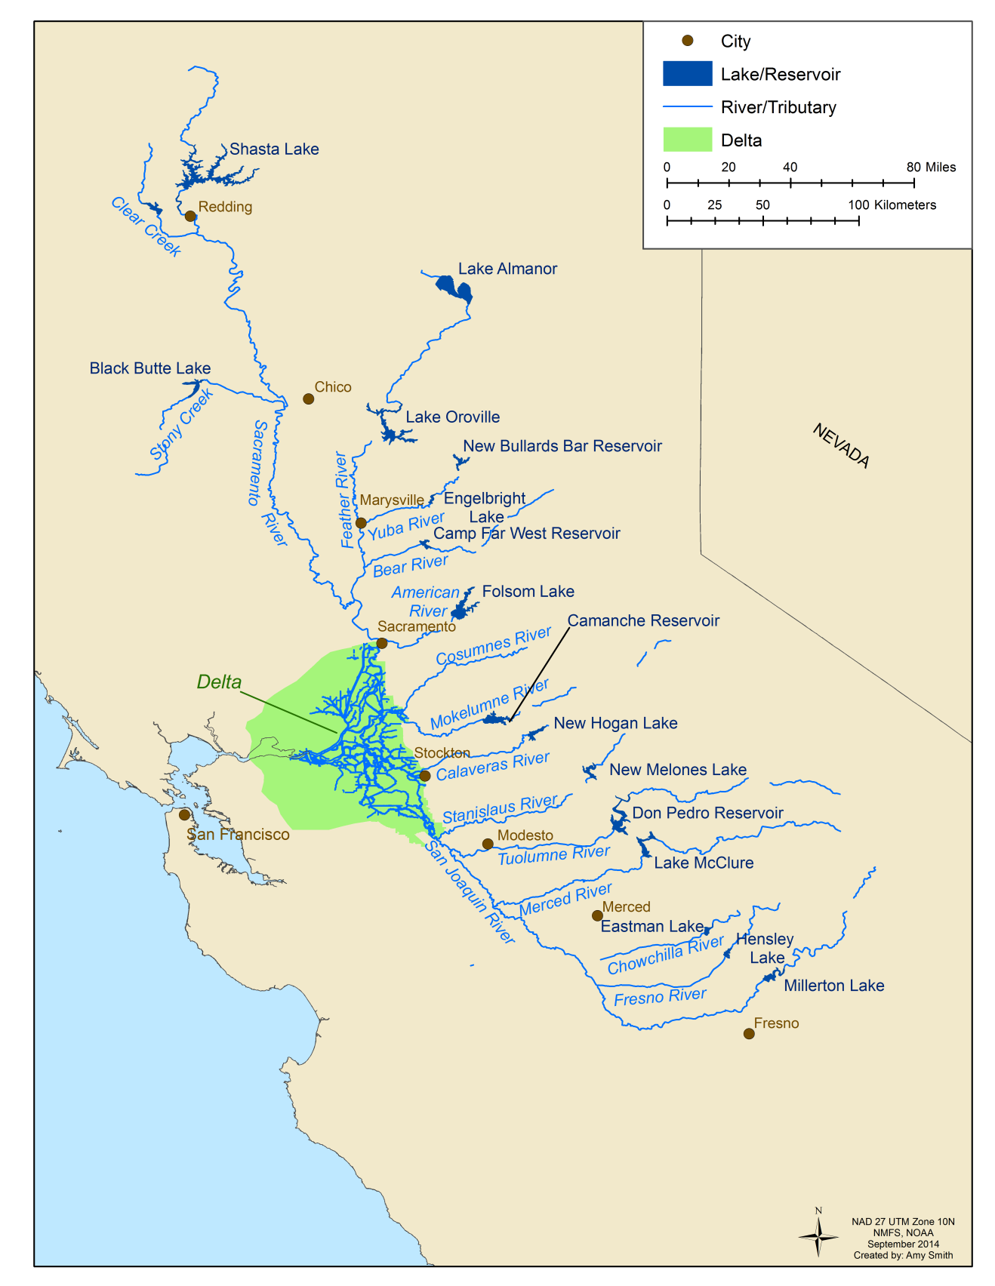

SECTION A
Your Fishing Experiences in the Central Valley in the Past 12 Months

The questions in this section pertain to your fishing in the past 12 months on Central Valley waterbodies – including rivers and creeks, lakes and reservoirs, and Delta waterways.

A1. Over the past 12 months, did you fish on any Central Valley water bodies – including rivers/creeks, lakes/reservoirs, or Delta waterways?
- Yes → Continue to Question A2
- No → Thank you. Please do not fill out the questionnaire. Just return it in the envelope
provided.
Questions A2 and A3 pertain to the number of fishing trips that you made on Central Valley waterbodies in the past 12 months. For purposes of these questions, a fishing trip covers the time from when you left your home to when you returned. Some fishing trips are completed within one day. Other fishing trips involve overnight stays away from home where you may have fished on one or more days.

A2. How many one-day fishing trips did you make on Central Valley waterbodies in the past 12 months?

Central Valley  waterbody | Number of ONE-DAY fishing trips in past 12 months in the Central Valley  by waterbody type  Check one box in each row.
Central Valley  waterbody | 0 | 1-2 | 3-6 | 7-12 | 13-24 | 25-50 | 51-75 | 76-100 | 101-200 | >200
Rivers/creeks
Lakes/reservoirs
Delta waterways

A3. How many overnight trips did you make on Central Valley waterbodies in the past 12 months where you fished on one or more days away from home?

Central Valley  waterbody | Number of OVERNIGHT fishing trips in past 12 months in the Central Valley  by waterbody type  Check one box in each row.
Central Valley  waterbody | 0 | 1-2 | 3-6 | 7-12 | 13-24 | 25-50 | 51-75 | 76-100 | 101-200 | >200
Rivers/creeks
Lakes/reservoirs
Delta waterways

Questions A4 through A9 pertain to the number of days that you fished in the Central Valley in the past 12 months. If any of your Central Valley fishing trips were overnight trips, count each day that you fished on those trips separately.

A4. Over the past 12 months, did you fish on any Central Valley rivers or creeks?
- Yes → Continue to Question A5
- No → Skip to Question A6
A5. Over the past 12 months, about how many days did you spend fishing on Central Valley rivers and creeks? Count partial days as full days.

River/creek  (see map) | Days fished in past 12 months  Check one box per row for only those rivers/creeks that you fished.
River/creek  (see map) | 1-2 | 3-6 | 7-12 | 13-24 | 25-50 | 51-75 | 76-100 | 101-200 | >200
Sacramento River
Clear Creek
Stony Creek
Feather River
Yuba River
Bear River
American River
Cosumnes River
San Joaquin River
Mokelumne River
Calaveras River
Stanislaus River
Tuolumne River
Merced River
Chowchilla River
Fresno River
Other Central Valley rivers/creeks (please specify):
_________________
_________________
_________________

A6. Over the past 12 months, did you fish on any Central Valley lakes or reservoirs?
- Yes → Continue to Question A7
- No → Skip to Question A8
A7. Over the past 12 months, about how many days did you spend fishing on Central Valley lakes and reservoirs?

Lake/reservoir (see map) | Days fished in past 12 months  Check one box per row for only the lakes/reservoirs that you fished.
Lake/reservoir (see map) | 1-2 | 3-6 | 7-12 | 13-24 | 25-50 | 51-75 | 76-100 | 101-200 | >200
Shasta Lake
Black Butte Lake
Lake Almanor
Lake Oroville
New Bullards Bar Reservoir
Engelbright Lake
Camp Far West Reservoir
Folsom Lake
Camanche Reservoir
New Hogan Lake
New Melones Lake
Don Pedro Reservoir
Lake McClure
Eastman Lake
Hensley Lake
Millerton Lake
Other Central Valley lakes/ reservoirs (please specify): ______________________
______________________
______________________

A8. Over the past 12 months, did you fish on any Delta waterways? Delta waterways include sloughs, canals, water tracts, rivers, creeks, lakes, bays, etc.
- Yes → Continue to Question A9
- No → Skip to Question A10
A9. Over the past 12 months, about how many days did you spend fishing on Delta waterways?

Days fished on Delta waterways in past 12 months

Check one box.
1-2 | 3-6 | 7-12 | 13-24 | 25-50 | 51-75 | 76-100 | 101-200 | >200

A10. Over the past 12 months, which of the following species did you target while fishing on Central Valley rivers and creeks, lakes and reservoirs, and Delta waterways? Check all that apply.

Target species | Species targeted in the Central Valley in past 12 months, regardless of whether you caught them  For each waterbody that you fished (columns), check all species that you targeted.
Target species | Rivers/creeks | Lakes/reservoirs | Delta waterways
Largemouth bass
Smallmouth bass
Spotted bass
Striped bass (striper)
White bass
Bass, don’t know what kind
Bluegill
Carp
Catfish
Crappie
King (Chinook) salmon
Kokanee
Perch
Shad
Splittail
Sturgeon
Sunfish
Brown trout
Rainbow trout
Trout, don’t know what kind
Steelhead
Whatever I could catch
Other fish (please specify) _______________________
_______________________
_______________________

SECTION B
Your Most Recent Fishing Trip in the Central Valley

The questions in this section pertain to your most recent fishing trip in the Central Valley.

B1. Thinking about your most recent fishing trip in the Central Valley, did you do most of your fishing on a river or creek, lake or reservoir, or a Delta waterway? Check one box only.
- River or creek → Continue to Question B2
- Lake or reservoir→ Skip to Question B3
- Delta waterway → Skip to Question B4

Answer Question B2 only if your most recent Central Valley fishing trip was on a river or creek. Then skip to Question B5.

B2. On which river/creek did you do most of your fishing on your most recent Central Valley fishing trip?

Location fished on your most recent  Central Valley fishing trip  Check one box only. | River/creek (see map)
 | Sacramento River
 | Clear Creek
 | Stony Creek
 | Feather River
 | Yuba River
 | Bear River
 | American River
 | Cosumnes River
 | San Joaquin River
 | Mokelumne River
 | Calaveras River
 | Stanislaus River
 | Tuolumne River
 | Merced River
 | Chowchilla River
 | Fresno River
 | Other Central Valley river/creek (please specify):_________________________

Answer Question B3 only if your most recent Central Valley fishing trip was on a lake or reservoir. Then skip to Question B5.

B3. On which lake/reservoir did you do most of your fishing on your most recent Central Valley fishing trip?

Location fished on your most recent Central Valley fishing trip  Check one box only. | Lake/reservoir (see map)
 | Shasta Lake
 | Black Butte Lake
 | Lake Almanor
 | Lake Oroville
 | New Bullards Bar Reservoir
 | Engelbright Lake
 | Camp Far West Reservoir
 | Folsom Lake
 | Camanche Reservoir
 | New Hogan Lake
 | New Melones Lake
 | Don Pedro Reservoir
 | Lake McClure
 | Eastman Lake
 | Hensley Lake
 | Millerton Lake
 | Other Central Valley lake/reservoir (please specify): ______ _______________________________________

Answer Question B4 only if your most recent Central Valley fishing trip was on a Delta waterway.
B4. Please name the Delta waterway (slough, canal, water tract, river, creek, lake, bay, etc.) where you did most of your fishing on your most recent Central Valley fishing trip. If you’re not sure where you fished in the Delta, enter a landmark or town that was close to where you fished.

_________________________________

B5. Which of the following species did you target on your most recent Central Valley fishing trip, regardless of whether you caught any? Check all that apply.
Species targeted on most recent trip, regardless of whether you caught any  Check all that apply. | Target species
 | Largemouth bass
 | Smallmouth bass
 | Spotted bass
 | Striped bass (striper)
 | White bass
 | Bass, don’t know what kind
 | Bluegill
 | Carp
 | Catfish
 | Crappie
 | King (Chinook) salmon
 | Kokanee
 | Perch
 | Shad
 | Splittail
 | Sturgeon
 | Sunfish
 | Brown trout
 | Rainbow trout
 | Trout, don’t know what kind
 | Steelhead
 | Whatever I could catch
Other fish (please specify):______________
____________________________________

B6. In what mode did you fish on your most recent Central Valley fishing trip? Check all that apply.
- Riverbank (including wading)
- Lake/reservoir shoreline
- Delta shoreline (pier, bank, etc.)
- Private boat
- Rental boat
- Hired guide

B7. Why did you choose that particular location for your most recent Central Valley fishing trip?
Check all that apply. | Reason(s) for location choice on most recent trip
 | Type of species available at this location
 | Variety of species available at this location
 | Fish planting and stocking information
 | Local fishing reports
 | Fishing regulations
 | Good fishing conditions (lake level, river flow, water temperature, water clarity, etc.)
 | Fishing derby
 | Fishing tournament
 | Not too crowded
 | Easy shore access to water
 | Easy boat access to water
 | Boating safety (safe flow, not much debris, etc.)
 | Clean water (not contaminated)
 | Scenic beauty
 | Peace and quiet
 | Not too far from home
 | Conveniently located even if not close to home
 | Good parking (convenient, enough spaces)
 | Safe location for people/vehicles/belongings
 | Boat ramp
 | Full service marina
 | Guide/outfitter services
 | Rental boats
 | Tackle/bait shop
 | Picnic areas
 | Trash cans
 | Pit toilets
 | Flush toilets
 | Showers
 | Laundry
 | Grocery or convenience store
 | Place to eat out (deli, fast food, restaurant, etc.)
 | Gas station
 | Playground
 | Overnight accommodations (campground, etc.), for anglers who spent at least one night away from home on this trip
 | Past use and familiarity with site
 | Location chosen by someone else
 | Other (please specify):___________________________ ___
B8. What other activities did you participate in on your most recent trip – besides fishing?

Check all that apply. | Activities on most recent trip
 | Swimming
 | Boating/rafting/kayaking (for purposes other than fishing)
 | Water skiing, jet skiing, etc.
 | Walking/jogging/hiking
 | Camping
 | Backpacking
 | Biking
 | Picnicking/BBQ/eating/drinking
 | Scenery/wildlife viewing
 | Being with family/friends
 | Horseback riding
 | Hunting
 | Other (please specify): _____________________________
 | No other activities besides fishing

B9. Fishing can involve a day trip or an overnight trip away from home. Did you spend any nights away from home on your most recent trip?
- Yes → Continue to Question B10
- No → Skip to Question B13
B10. How many nights were you away from home on your most recent trip?
________ nights

B11. Where did you spend your night(s) away from home on your most recent trip? Check all that apply.
- Backcountry/primitive camping
- Car, van, camper, etc. parked in no-fee area
- Campground
- RV park
- Cabin/cottage
- Fishing resort/lodge
- Hotel/motel
- Home of family/friends
- Aboard boat
- Other (please specify): ____________________
B12. How many days did you fish on your most recent trip?

________ days fished

B13. Did you make your most recent trip alone or with other people?
- Alone → Skip to Question B17
- With other people → Continue to Question B14
B14. How many people were with you on this trip?

Yourself + ____ people

B15. How many of the people with you actually fished?

Yourself + ____ people

B16. How many of the people with you were under the age of 18?

_____ children under age 18

B17. Approximately how much money did you personally spend on yourself and others on your most recent trip? Please include expenses related to this trip only.

Cost category | Fill in the blanks. Write “0” if a particular category does not pertain to your  most recent trip.
Cost category | Your estimated  expenditure ($) | Number of people covered by this expense (including yourself)
Gas for vehicle, bridge tolls, etc.
Entry/day use/parking fees, etc.
Derby/tournament fees
Tackle, gear, bait, lures and other such items, if bought specifically for this trip
Guide fees, if you hired a guide
Rental boat fees, if you rented a boat
Private boat fuel, launch fees, etc., if you fished from a private boat
Food and beverage from grocery/convenience stores
Food and beverage from delis/fast food/restaurants
Clothing, toiletries, camping supplies, etc., if bought specifically for this trip
Non-fishing recreation (horseback riding, hunting, etc.), if you engaged in other types of recreation on this trip
Lodging, if you spent any nights away from home on this trip
House/pet sitting, if you paid someone to care for your house/pet while you were away from home
Other (please specify):__________________________
Total Estimated Trip Cost (sum of all costs)

SECTION C
Questions About Your Other Fish- and Water-Related Activities

C1. Please indicate whether you have participated in any of the following activities in the Central Valley in the past 3 years. Check all that apply.
Participated in past 3 years | Central Valley Activity
 | Belonged to fishing club or organization
 | Participated in fishing derby
 | Participated in fishing tournament
 | Attended fishing seminar
 | Helped teach the public to fish (Fishing in the City, etc.)
 | Helped with fish planting (Project Kokanee, etc.)
 | Toured Central Valley hatchery
 | Toured Central Valley dam
 | Visited Central Valley river to watch fish spawn
 | Attended festival (Coleman Return of the Salmon Festival, Stanislaus River Festival, Wild and Scenic River Festival, Rio Vista Bass Festival, etc.)
 | Volunteered for Central Valley river/creek cleanup
 | Volunteered for Central Valley lake/reservoir cleanup
 | Volunteered for Delta waterway cleanup
 | Belonged to watershed stewardship organization (Resource Conservation District, local watershed council, river trust, etc.)
 | Other (please specify):______________________________________________

C2. Suppose that efforts to restore habitat and improve fish passage on Central Valley rivers led to new or improved salmon fishing opportunities in restored areas or areas above dams. Would you consider fishing for salmon at new or improved fishing locations in the Central Valley? Please select the one column that best describes your level of interest.
I may be interested  in new Central Valley salmon fishing locations, depending on:  (check all that apply)  The quality of fishing at the location  Fishing regulations at the new location  How close the location is to my home  The types of facilities available at the location→ Please indicate types of facilities that particularly interest you (boat ramp, campground, etc.):  _____________________  Other reason(s) why you may be interested in new salmon fishing locations (please specify): _ _ _____________________________________________________________ | I probably would not be interested  in new Central Valley salmon fishing locations because:  (check all that apply)  Salmon fishing doesn’t interest me that much.  Fishing in rivers doesn’t interest me that much.  Fishing in general doesn’t interest me that much.  My current fishing locations suit me fine.  Other reason(s) why you probably would not be interested in new salmon fishing locations (please specify): ________________________  _______________________________  _______________________________ | I don’t know if I would be interested.
C3. Over the past 12 months, have you done any fishing in the U.S. outside the Central Valley?
- Yes → Continue to Question C4
- No → Skip to Question C5
C4. In the past 12 months, how many total days did you go freshwater or saltwater fishing anywhere in the U.S.?

Number of days fishing in past 12 months anywhere in the U.S.

Include both saltwater and freshwater days. Check one box.
 | 1-2 | 3-6 | 7-12 | 13-24 | 25-50 | 51-75 | 76-100 | 101-200 | >200
# of days fished in freshwater
or saltwater

C5. This question pertains to your freshwater and saltwater fishing expenditures in the past 12 months that are not related to any particular trip. Approximately how much money did you spend in the past 12 months in each of the following categories?

Fishing cost category | Estimated expenditures ($)  Enter “0” if you spent nothing in the category
Fishing equipment (rods, reels, lines, lures, flies, nets, tackle box, etc.)
Fishing license and/or report card
Other fishing costs such as fishing magazine subscription, fishing club membership, etc.
Clothing and equipment such as foul weather gear, waders, boots, camping gear, etc.
Boat-related expenses:
Boat maintenance, moorage, storage, registration
Loan payments
Insurance
Boat accessories (motor, trailer/hitch, etc.)
Other boat-related expenses (please specify): __________________
Truck, camper, trailer, van, or motor home expenses:
Maintenance, registration
Loan payments
Insurance
Other truck, camper, trailer, van or motor home-related expenses
(please specify): __________________ _________
Other costs (please specify):___________________________________
Total Annual Fishing Costs (sum of all costs)

Check this box if you had no expenditures in the above categories in the past 12 months.

SECTION D
More About You

The following questions will help us learn more about people who fish in the Central Valley. The information you provide will remain strictly confidential and you will not be identified with your answers.

D1. How many years have you fished in the Central Valley? Include total years fished in the Central Valley since you were a child.

________ years

D2. What is your age?
18-24 45 - 54
25-34 55 - 64
35-44 65 years and older

 | Male |  | Female
D3. You are:

D4. Are you Hispanic or Latino?

 | Yes |  | No

D5. Which of the following best describes you? Check all that apply.
 | American Indian or Alaska Native |  | Caucasian or White
 | Asian |  |  | Native Hawaiian or Other Pacific Islander
 | Black or African American |  |  | Other (please specify) ________________

D6 What is the highest level of education you have completed? Check one box only.

Some high school
High school graduate
Technical or professional school
Some college
4-year college graduate
Postgraduate degree

D7 Including yourself, how many adults and children (under 18) live in your household?

______ adults, including yourself ______ children

D8 Which of the following categories best describes your household’s total annual income before taxes in 2014?

Less than $10,000
$10,000 - $24,999
$25,000 - $49,999
$50,000 - $99,999
$100,000 - $249,999
$250,000 or more

Thank you for participating in this survey!

Your responses will be combined with the responses of others to help us better understand the activities and preferences of Central Valley anglers.

Please feel free to provide comments below regarding the survey or anything you would like us to know about your Central Valley fishing experiences, including how those experiences could be improved.

_____________________________________________________________________________________

_____________________________________________________________________________________

The results of the survey will be summarized in a report that will be available in late 2015. Please provide your e-mail address below if you would like to receive a copy of this report.

e-mail address: _____________________________

Your input is much appreciated.

