Sample 401(k) Plan Statement for John Doe
Plan Name XXXX
Quarterly Retirement Plan Statement, 6/30/12
For more information about your plan, contact (XXX) 555-5555

- Account Information

Account Balances |  | Explanation
End of statement period | $102,105.53 | This is the total amount of money in your account on 6/30/2012
Beginning of statement period | $97,000.26 | This is the total amount of money in your account on 4/1/2012
Vested account value | $66,251.74 | This is the amount of money in your account that you currently own (you do not own all money that your employer contributes to your account right away, you earn it over time)

Investment Allocation | Beginning of period  (4/1/12) | End of  period  (6/30/12) | Percentage of account  (6/30/12)
XYX Institutional Fund (Large cap stock fund) | $41,710.11 | $43,190.64 | 42.3%
ABCD Management Fund (Mixed Stock Bond fund) | $55,290.14 | $58,914.89 | 57.7%
To help achieve long-term retirement security, you should give careful consideration to the benefits of a well-balanced and diversified investment portfolio. Spreading your assets among different types of investments can help you achieve a favorable rate of return, while minimizing your overall risk of losing money. You may not be adequately diversified if you hold more than 20 percent of your portfolio in the security of one entity (such as employer securities) or industry. Although diversification is not a guarantee against loss, it is an effective strategy to help you mange investment risk.

- Activity
This section shows the activity in your account in the period of time shown

Activity | Last Period  (since 4/1/12) | Year to Date  (since 1/1/12) | Explanation
1. Contributions / withdrawals
Your contributions | $1,253.01 | $2,506.03 | This is the total contribution you made
Your employer’s contributions | $250.60 | $501.21 | This is the total contribution your employer made
Withdrawals | ($0) | ($0) | This is the sum of your withdrawals
SUBTOTAL | $1,503.61 | $3,007.23 | This is the sum of contributions and withdrawals.
2. Investment changes
Investment gains and losses | $3,722.07 | $5,120.78 | This is the total amount your account gained or lost due to changes in the value of your investments.
General plan administrative service fees | ($120.40) | ($235.99) | These include fees to legal, accounting and recordkeeping that are actually charged to your account during the preceding quarter for such services.
Individual fees and expenses | ($0) | ($0) | These include fees for processing plan loans or qualified domestic relations orders, investment advice, brokerage windows, commissions, front- or back-end loads or sales charges, redemption, transfer and optional rider charges in annuity contracts that are actually charged to your account during the preceding quarter for such services.
SUBTOTAL | $3,601.67 | $4,884.79 | This is the sum of investment gains, losses and fees.
Change in account value | $5,105.28 | $7,892.02 | This is the total increase or decrease in your account value in the period of time shown. It is the sum of 1 and 2.

For more information about your plan, contact (XXX) 555-5555

- Projections

This section shows (1) total account values, (2) the monthly income that these total account values could generate for you after you retire, and (3) the monthly income these total account value could generate after you retire for a spouse who survives you.
- Future projections presented account for inflation. Inflation will change the purchasing power of your money in the future. $1 when you retire will buy less than $1 today. Presenting your account value in this way will give you an idea of how much you could buy with your retirement account when you retire.
- Caution: projected values at retirement are only estimates. If you have to retire early, or spend money on a health condition, or the market performs poorly, the estimate could be high. It is good for people to leave a buffer zone in their retirement savings so they can be ready for unusual circumstances that could change their financial picture.
- Is the monthly income projection enough money for you to live on during retirement? To figure this out, you could compare it to your current monthly income. You can also estimate your monthly expenses when you retire to see if this projected monthly income will cover them.

 | 1. Account Value | 2. Monthly Income after Retirement | 3. Survivor Monthly Income | Explanation
A. Estimated for Current Account Value | $100,000 | $350 | $180 | This row shows estimates of the amount of monthly retirement income from your current account value.
B. Projected at Retirement | $550,000 | $1,900 | $940 | This row shows projections for your account at retirement if your current employer contributions and your personal monthly contributions as shown on page 1 grow at the same rate of inflation until you retire.

All calculations on this page use the following information and assumptions:
- Your current age is 40
- Your account balance as of June 30, 2012
- An average life expectancy assumption for individual men
- A retirement age of 65
- A joint-survivorship annuity purchased at age 65, with level payments, assuming the person and his/her spouse are the same age, and survivor benefits are equal to 50% of the monthly payment with no other additional features. The value of the annuity shown reflects current market pricing at the time of this statement.
- Calculations in Row A use:
  - An inflation rate equal to the expect rate of return on your investment, with no further account contributions
- Projections in Row B use:
  - An inflation rate of 3%
  - An expected rate of return on your investments of 7%, which after inflation would be 4%

D. Factors that could change monthly income at retirement

Suppose that you continue making contributions to your plan until you retire.

How much can I gain if I make additional contributions?
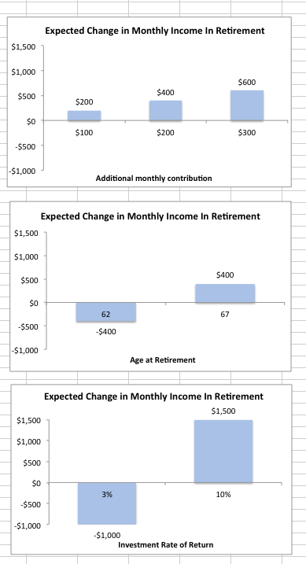
This graph shows your expected change in monthly income at retirement if you decide to increase current contributions to your retirement account. The graph shows this expected monthly income if you contributed $100, $200 and $300 more each month until you retire.

- The more you contribute, the more you save and the more you are likely to withdraw in the future.
- For example, if you make $100 more each month in contributions starting today, then you could get approximately $200 more each month when you retire ($2100 versus $1900). For $200 more in contribution each month now, you could get approximately $400 each month when you retire ($2300 versus $1900).

How much can I gain from working longer?
This graph shows your expected change in monthly income at retirement if you decide to change the age when you retire.

- The longer you work, the more you save and the more you can expect to withdraw in the future.
- For example, if you delay retirement to age 67, then you could expect to get approximately $400 more each month when you retire ($2300 versus $1900) than you would at age 65. If you retire early at age 62, then you could expect to get approximately $400 less each month when you retire ($1500 versus $1900)

How much could I gain or lose depending on the performance of my investments?
This graph shows your expected change in monthly income at retirement and how it depends on the rate of return on your investment portfolio from now until you retire.
- The better your investments perform, the more valuable your savings will be, and the more you can expect to withdraw in the future. On the other hand, if your investments do not perform well, you can expect to accumulate less.
- For example, if your average return is 10%, then you can expect to get approximately $1500 more each month when you retire ($3400 vs. $1900) than you would if the average return is 7%. If your average return is 3%, then you can expect to get approximately $1000 less each month when you retire ($900 vs. $1900)

- Caution: expected values at retirement are only guesses.
- Expected values shown on this page account for inflation.
- Unless otherwise noted, all projections on this page were calculated using the following information and assumptions:
  - You are currently age 40
  - Your account balance as of June 30, 2012
  - A joint-survivorship annuity, with level payments, assuming the person and his/her spouse are the same age, and survivor benefits are equal to 50% of the monthly payment with no other additional features
  - An annuity interest rate of 4%
  - An inflation rate of 3%
  - An expected rate of return on your investments of 7%, which after inflation would be 4%

