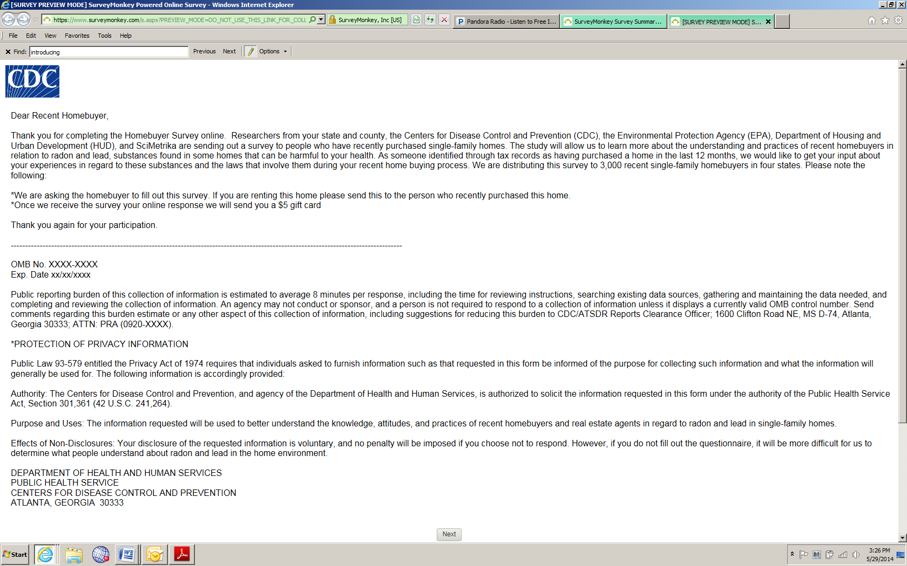

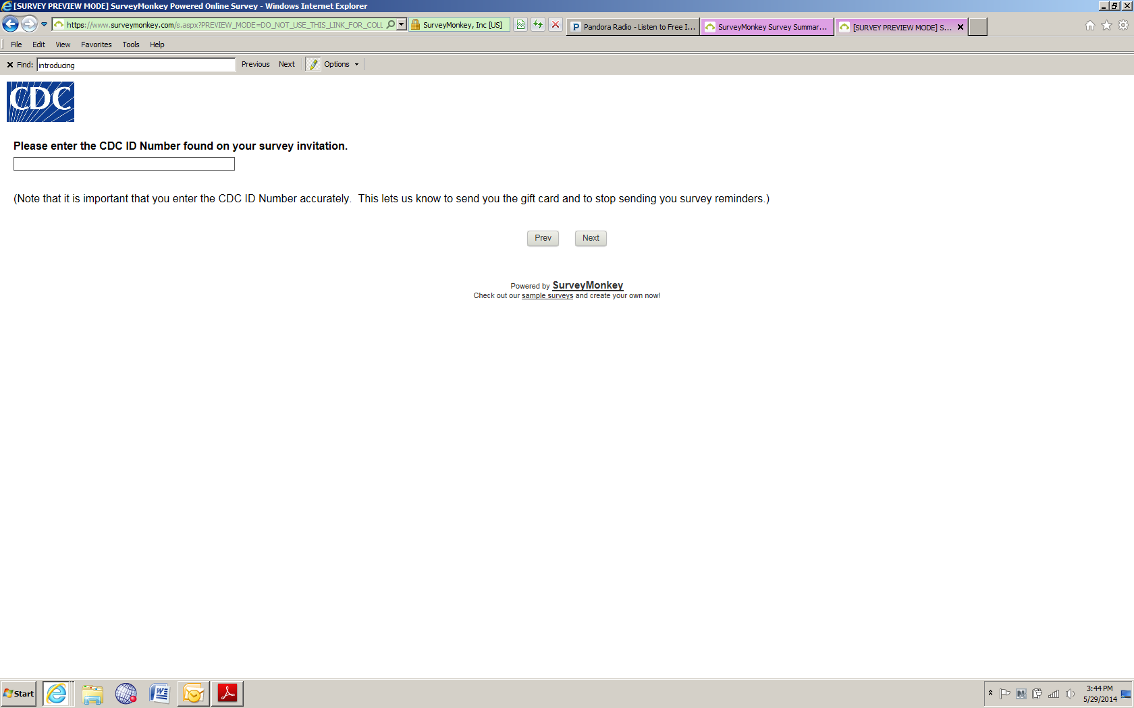

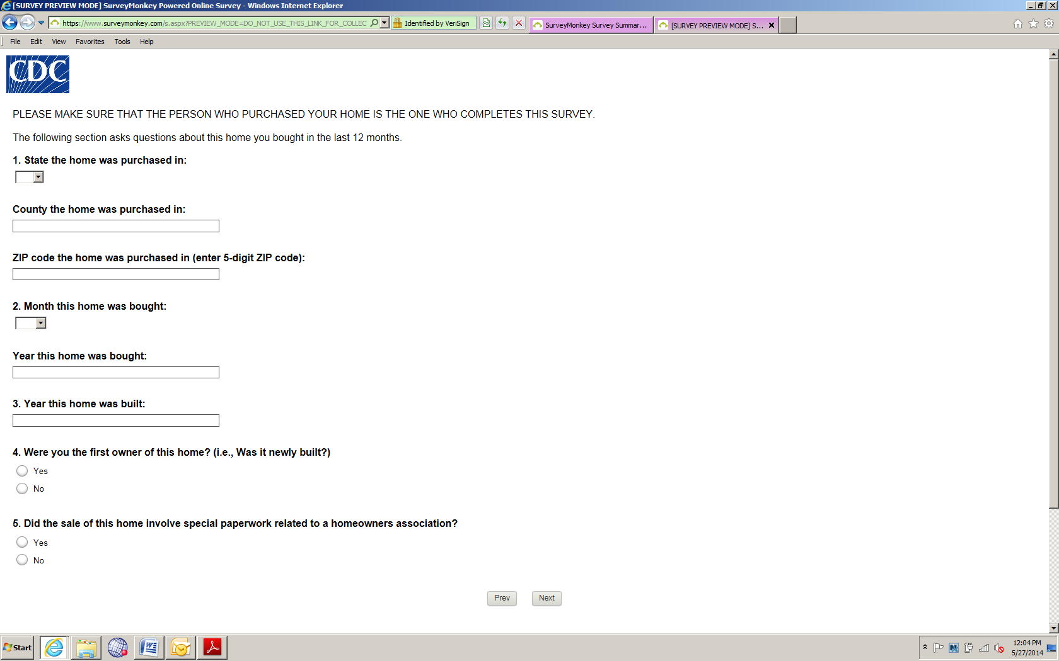
Note survey logic: If they answer “Yes” to Question 5, they are not eligible to complete the survey. They are directed to a screen that says, “We are sorry, you are not eligible to complete the survey. Thank you for your time,” and they exit the survey.
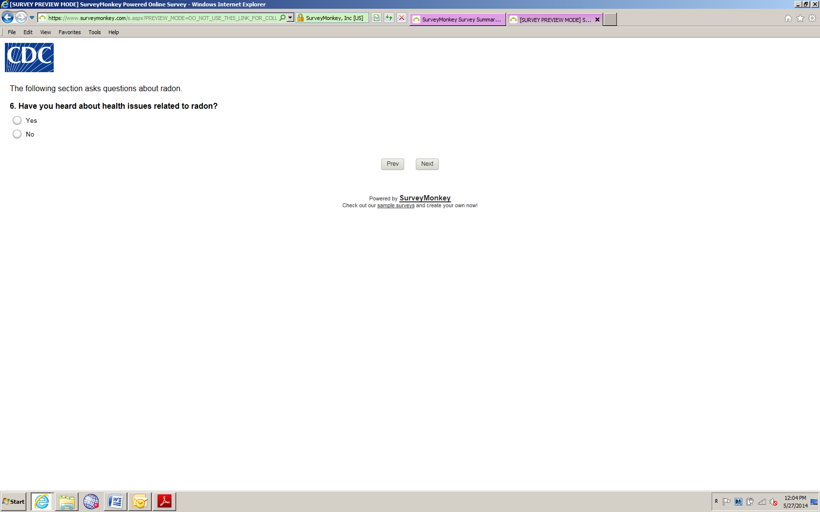

Note survey logic: If they answer “No” to Question 6, they skip to Question 7.
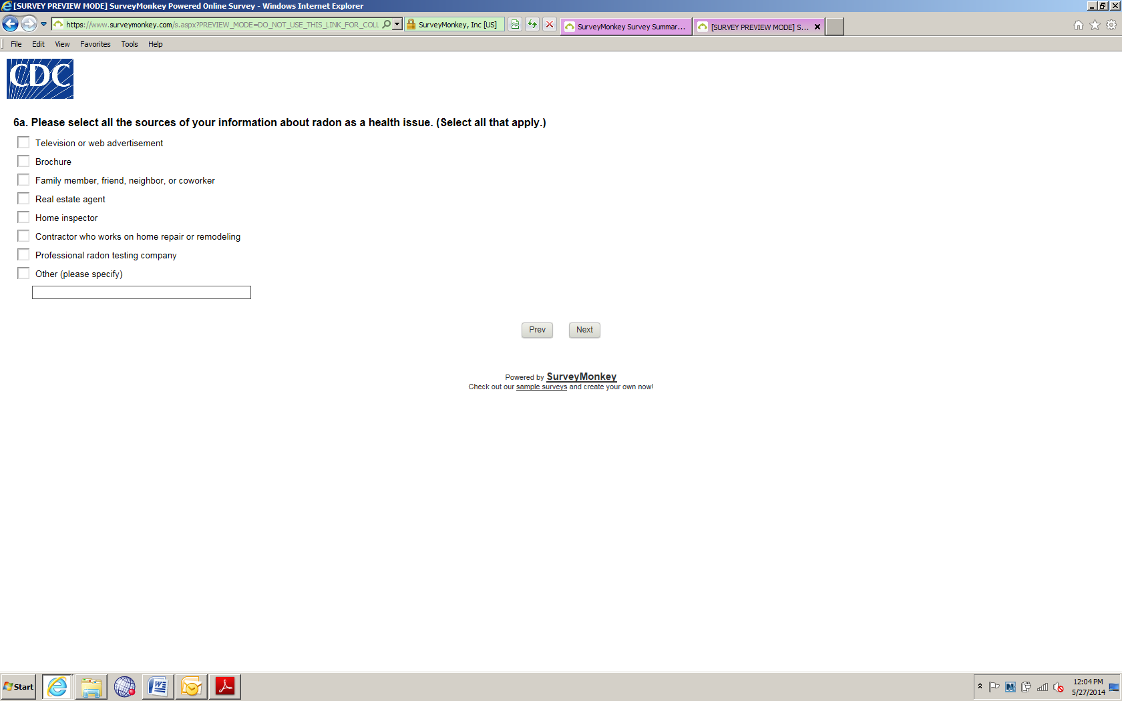

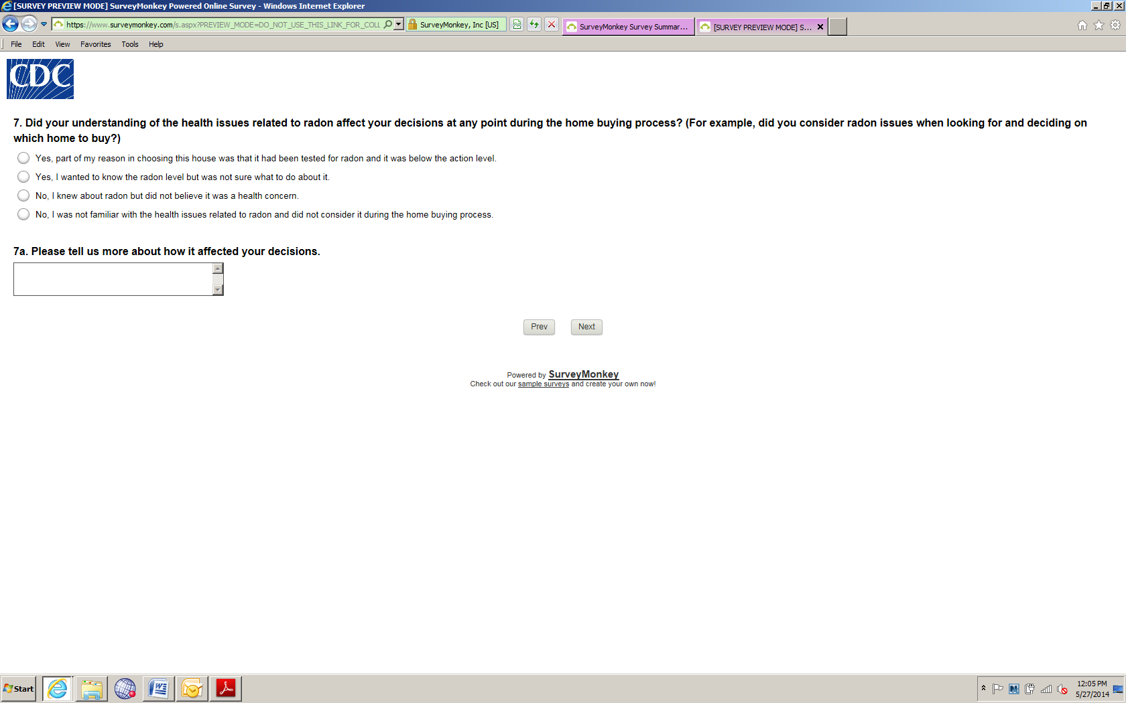

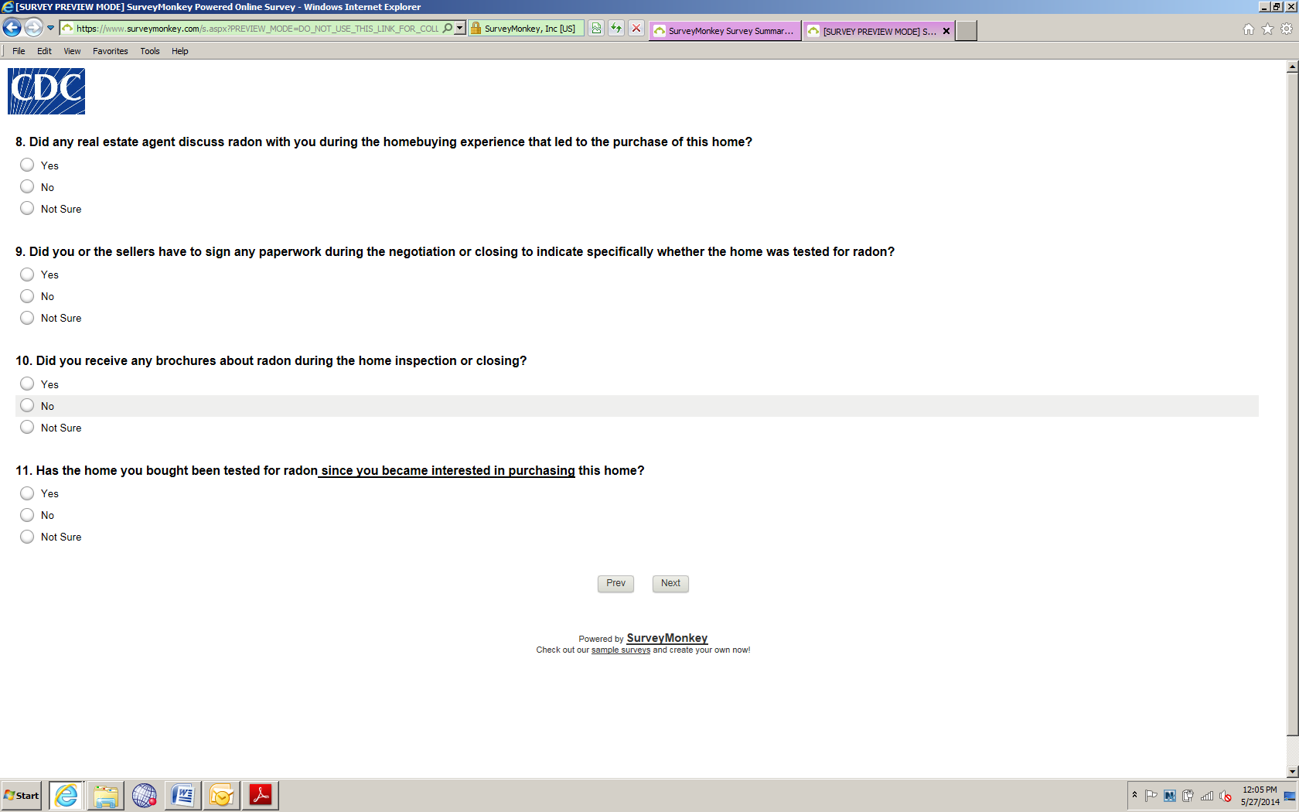

Note survey logic: If they answer “No” or “Not Sure” to Question 11, they skip to Question 12.
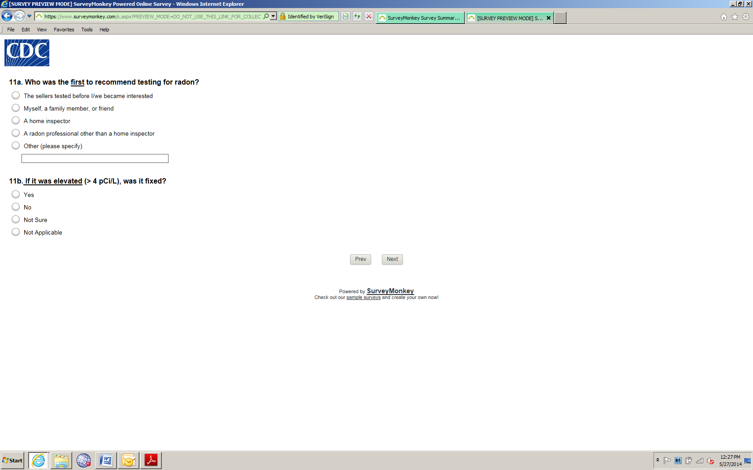

Note survey logic: If they answer “No,” “Not Sure,” or “Not Applicable” to Question 11b, they skip to Question 12.

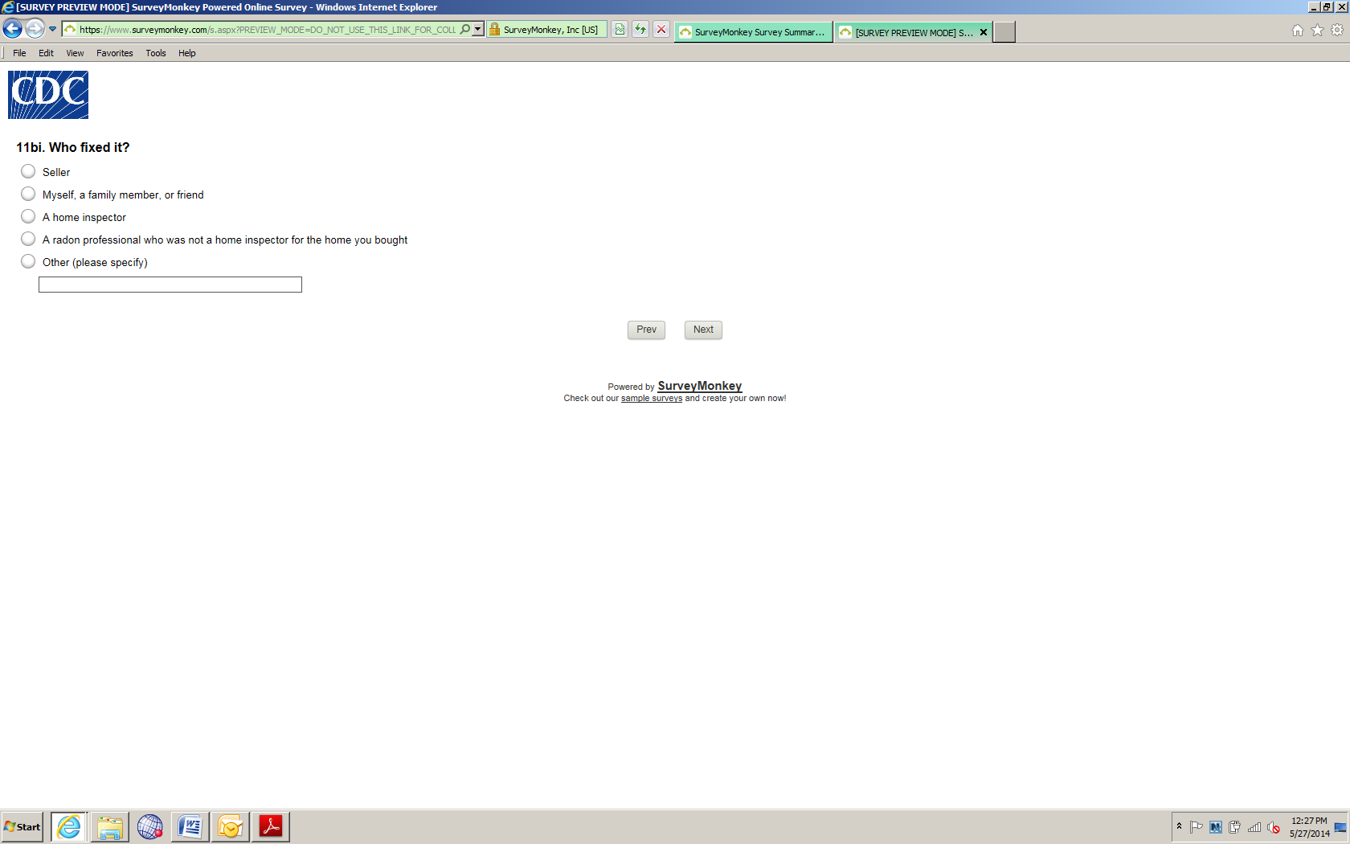
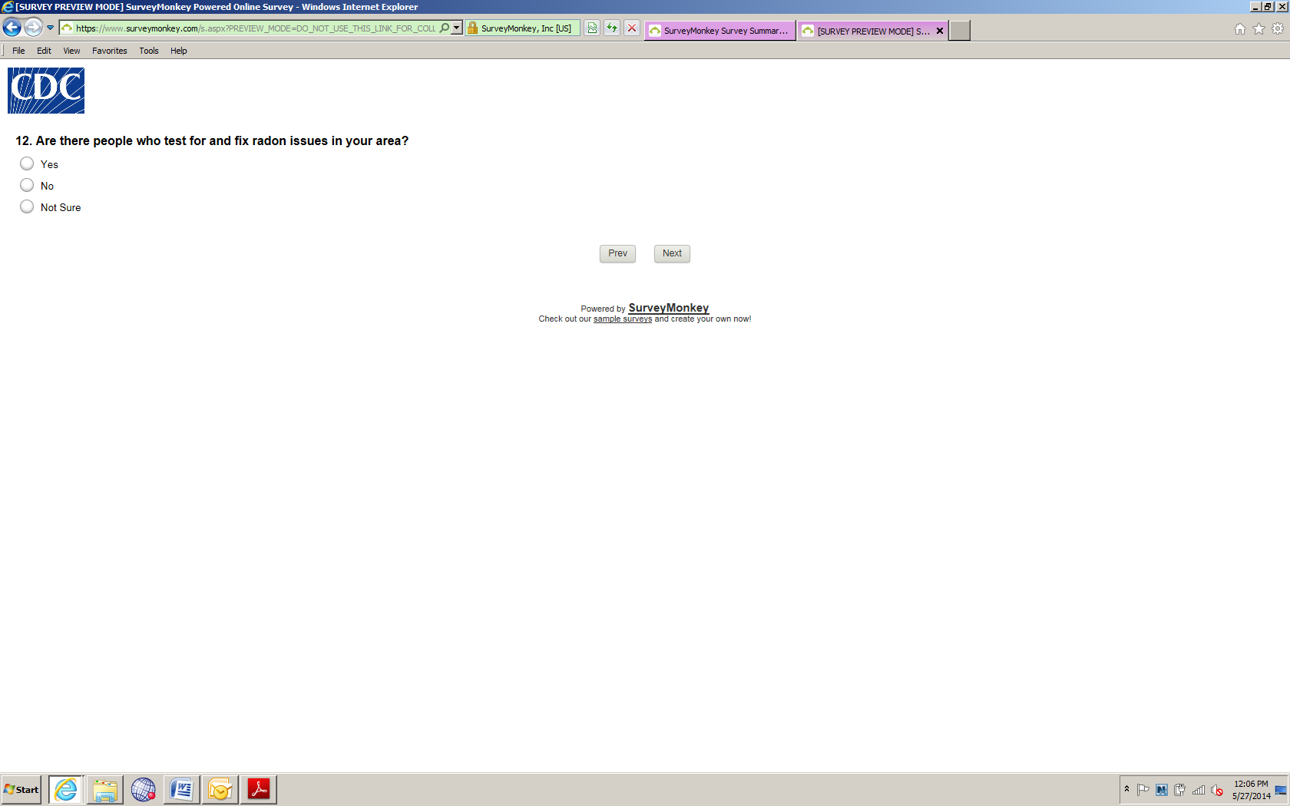

Note survey logic: If they answer “No” or “Not Sure” to Question 12, they skip to Question 13.

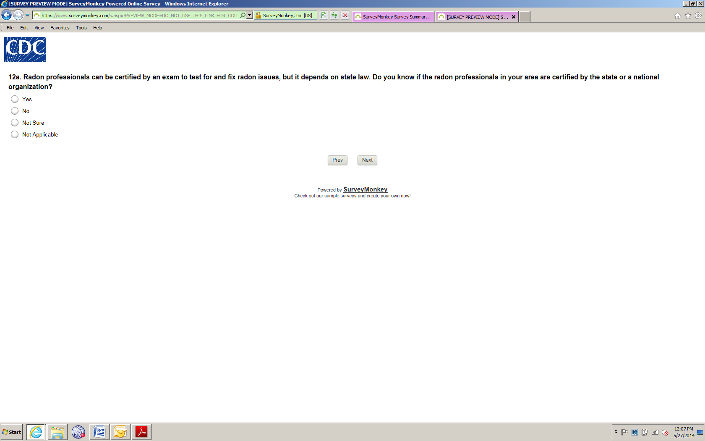

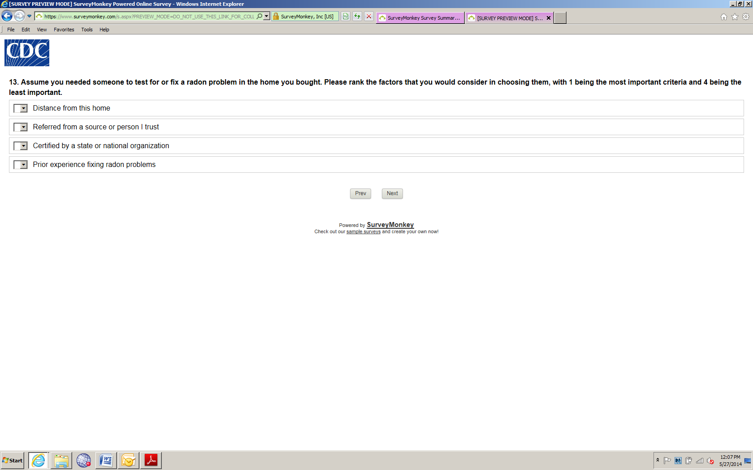

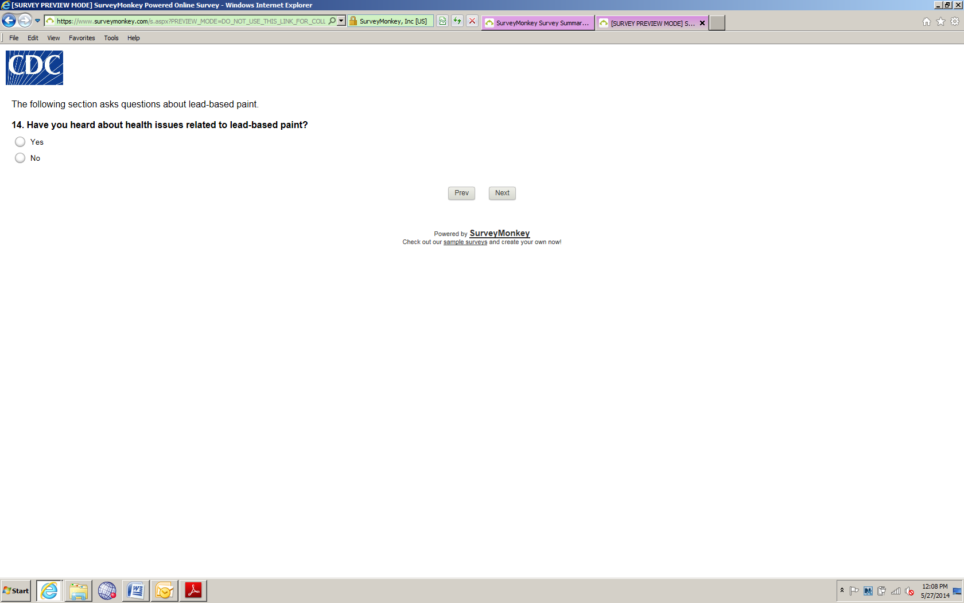

Note survey logic: If they answer “No” or “Not Sure” to Question 14, they skip to Question 15.
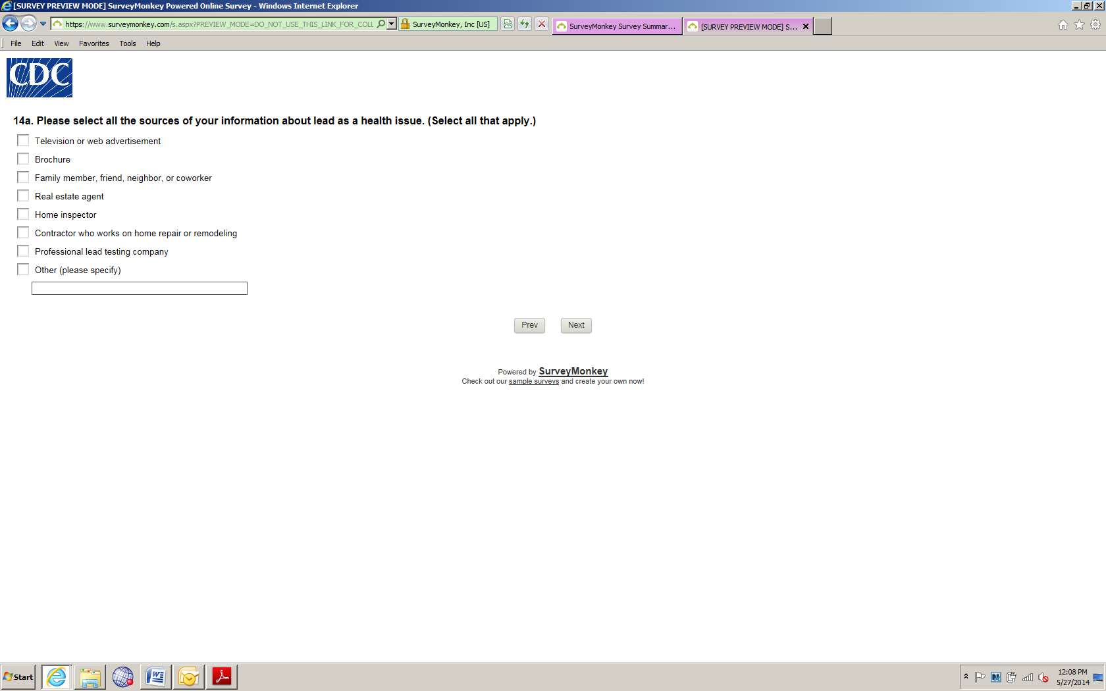

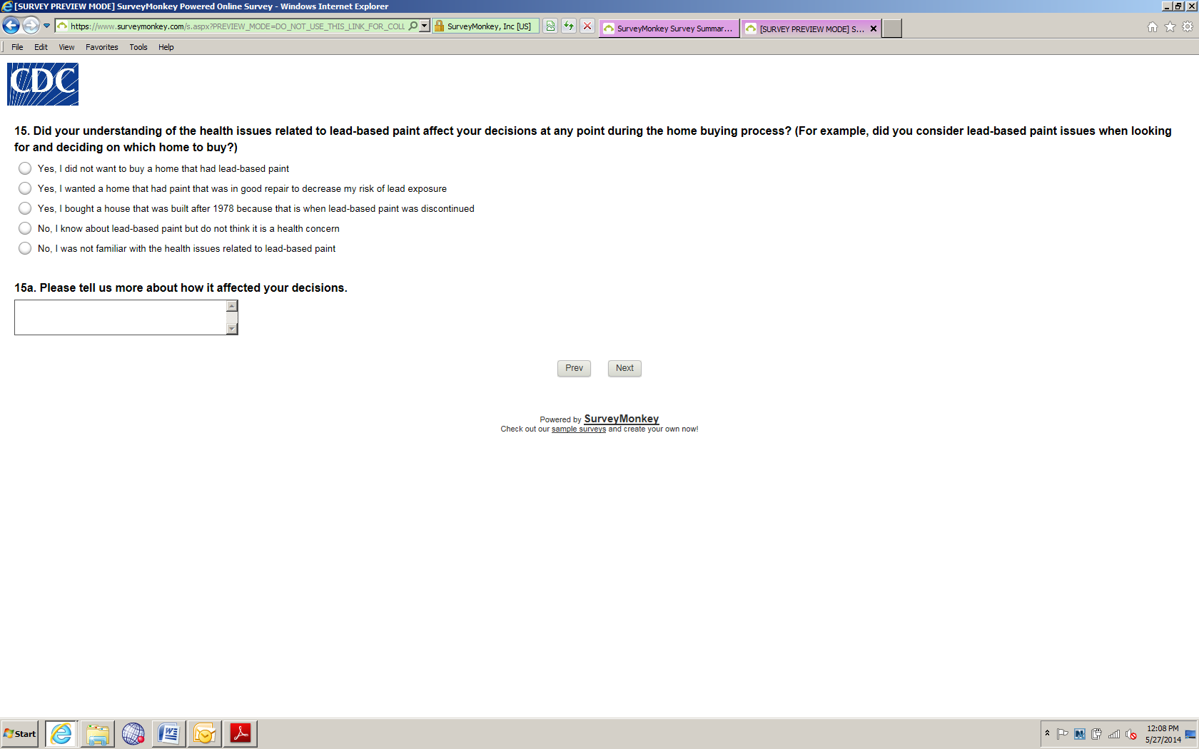

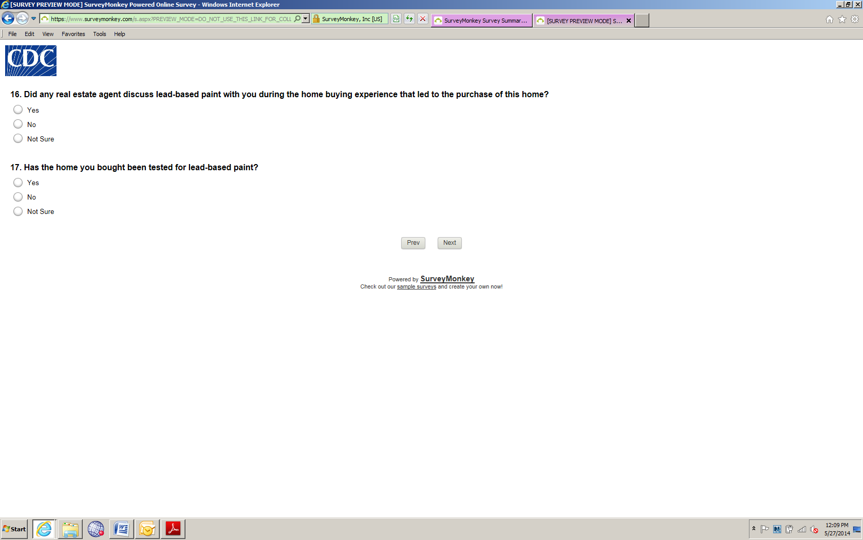

Note survey logic: If they answer “No” or “Not Sure” to Question 17, they skip to Question 18.
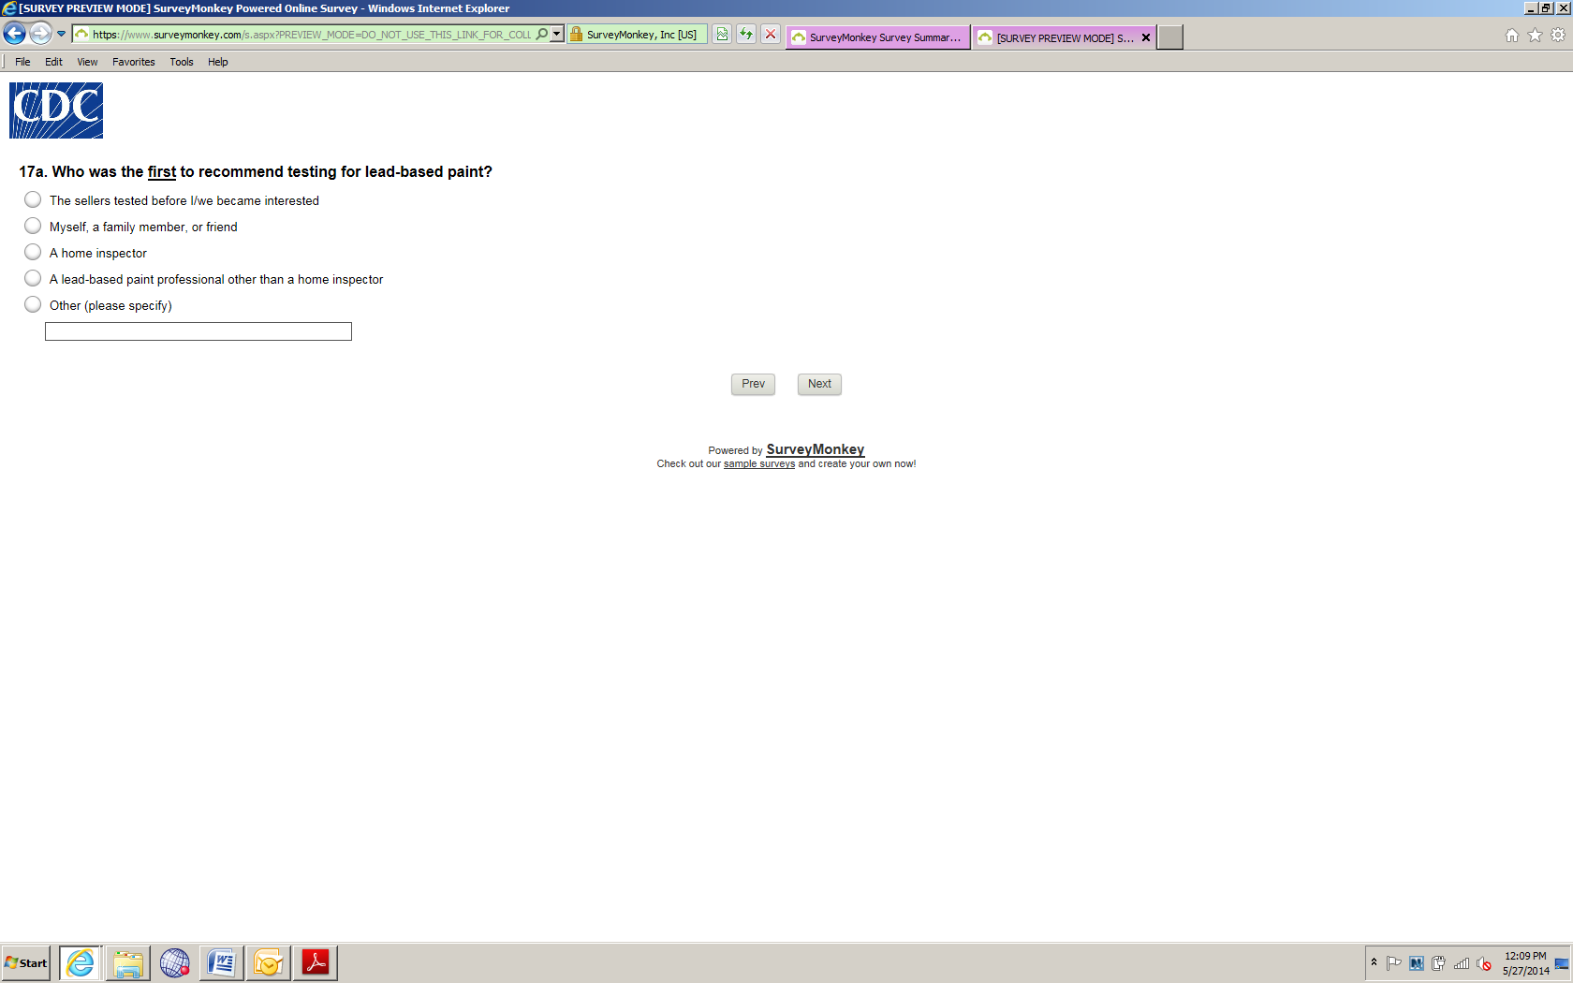

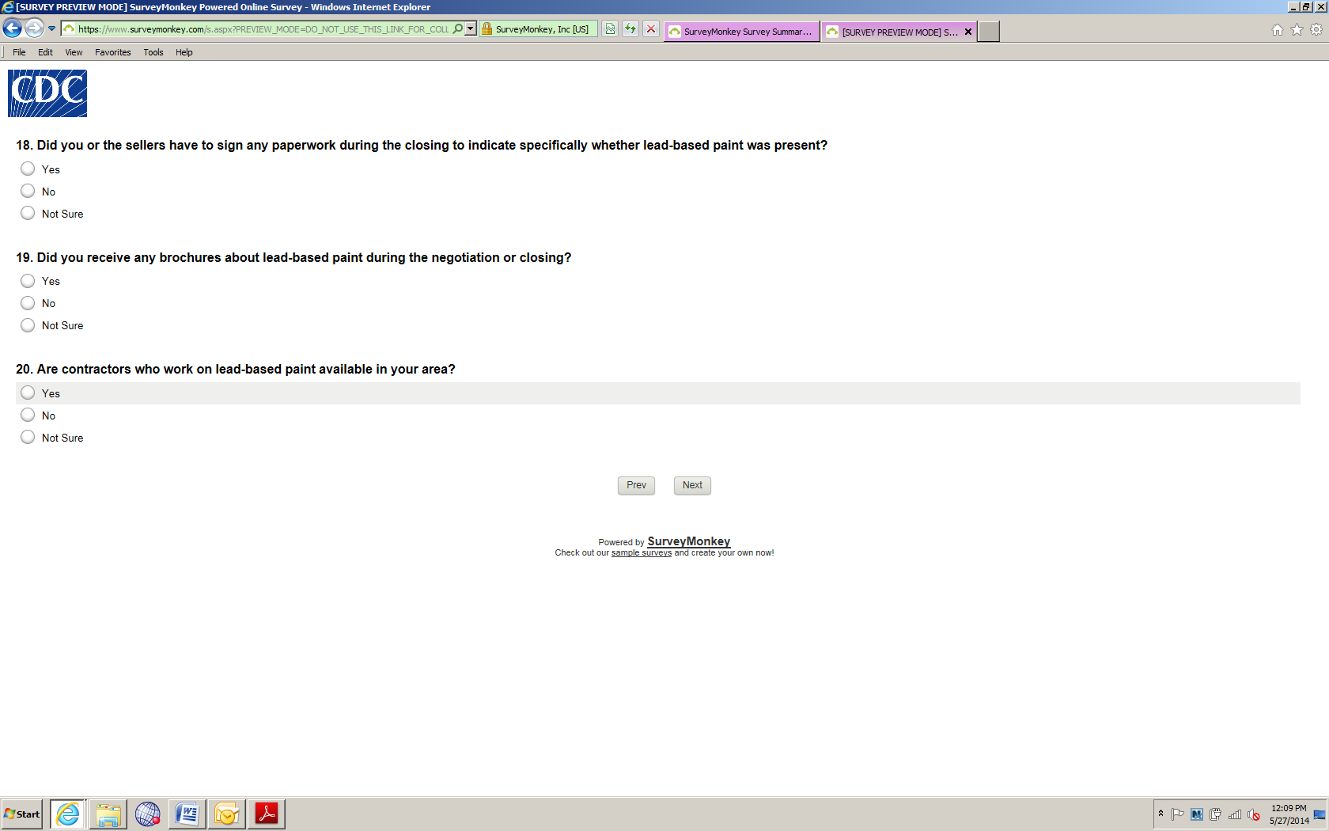

Note survey logic: If they answer “No” or “Not Sure” to Question 20, they skip to Question 21.
