Pre-notification postcard for homebuyer survey cognitive testing interviews

Dear recent homebuyer,
We will soon be sending you a letter to invite you to review questions we would like to ask to recent homebuyers in your area. This study will look at how laws about environmental issues sometimes found in homes affect people’s choices during the home buying or selling process. The results of this study will help us develop programs that better address these issues. We value your help with this so please watch for this survey.
Sincerely,

Antonio Neri MD, MPH
Principal Study Investigator
Phone: 770-488-3288
E-mail: ANeri@cdc.gov

IRB/OMB Note: Reading grade level 9.0 assessed using the Flesch-Kincaid analysis in MS Word.

Recruitment letter for homebuyer survey cognitive testing interviews
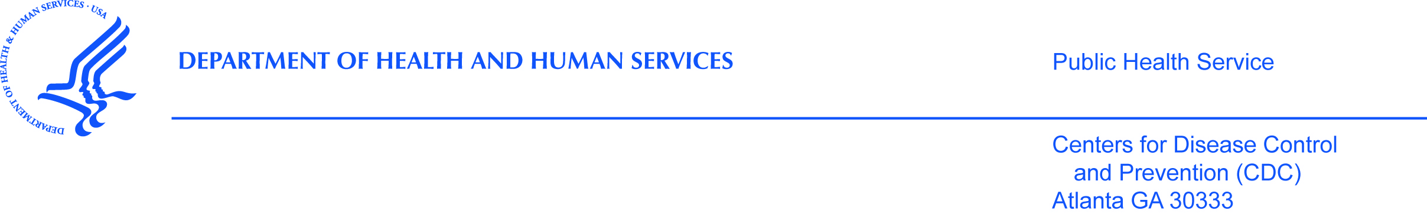

Dear recent homebuyer,
The Centers for Disease Control and Prevention (CDC), [Name of State or local HD], and our partners are looking to talk to people who bought a home meant for a single family in the last 12 months. The purpose of this study is to see how laws related to environmental issues sometimes found in homes affect people’s choices during the home buying or selling process.
We noted your house was sold in the last 12 months from the county or city tax office records. People who bought homes in areas with homeowners association rules about buying a home, townhomes, or condominiums are not eligible. If you are not the person who bought the home, please send this packet to the person who bought the home.
If you are eligible, we are writing to see if you could take part in a one hour phone call. This call will help us refine a survey to be sent to other recent home buyers in your area. During the call you will be asked to think through the questions on a survey. If you are eligible and would like to take part in the study please read the next pages.

Sincerely,

Antonio Neri, MD, MPH
Principal Investigator
Division of Cancer Prevention and Control
Centers for Disease Control and Prevention (CDC)
4770 Buford Hwy. MS F-76
Atlanta, GA 30341
Phone: 770-488-3288
E-mail: ANeri@cdc.gov

IRB/OMB Note: Reading grade level 9.3 assessed using the Flesch-Kincaid analysis in MS Word.

