Electronic System for Travel Authorization (ESTA) Traveler Satisfaction Survey

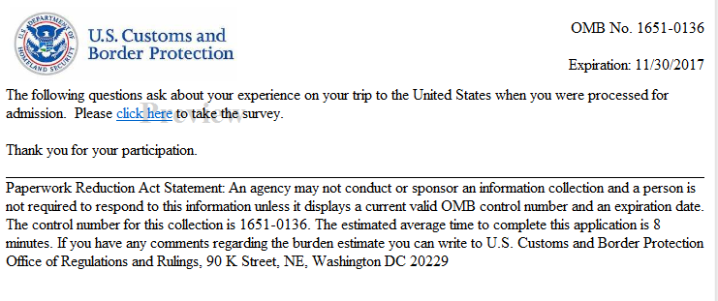
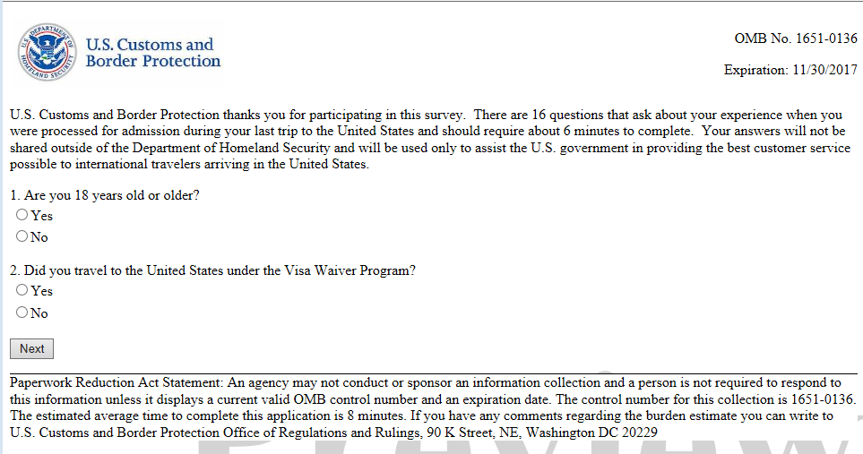

ESTA Traveler Satisfaction Survey
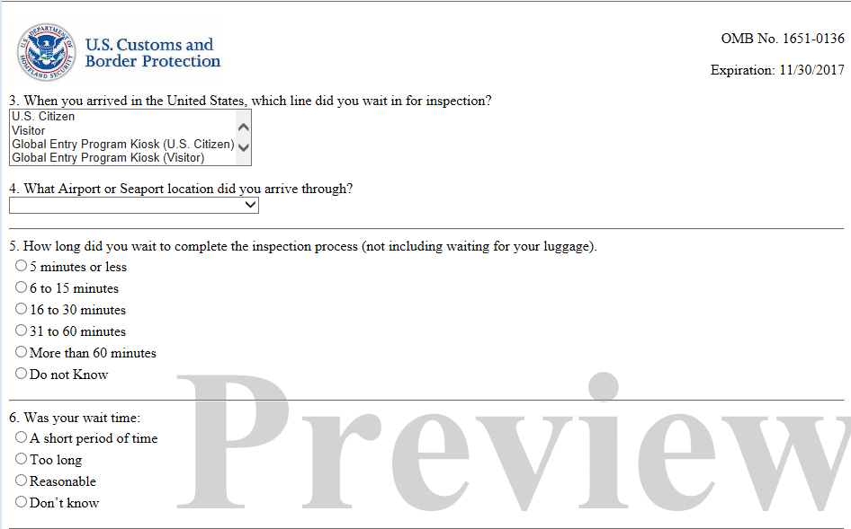

ESTA Traveler Satisfaction Survey
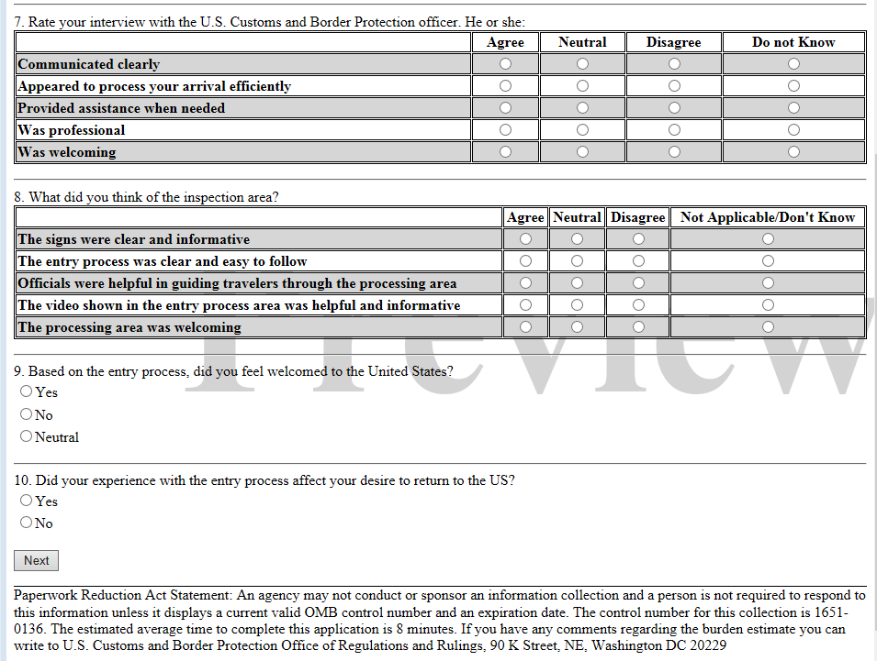

ESTA Traveler Satisfaction Survey
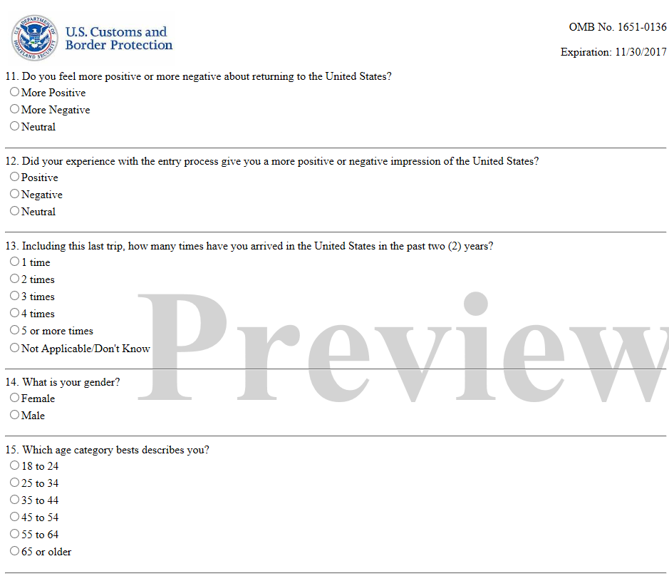

ESTA Traveler Satisfaction Survey
