


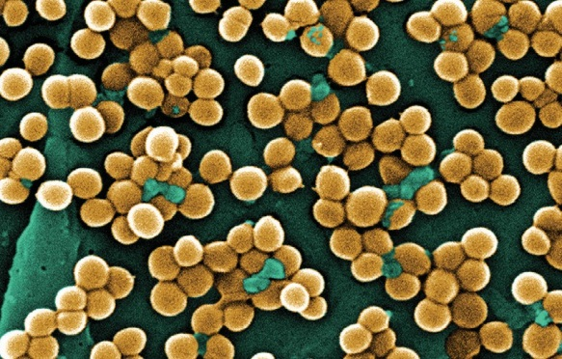



Attachment E
Draft Guide to
Nursing Home
Antimicrobial
Stewardship

Contents
Website Overview of Nursing Home Antimicrobial Stewardship Modules 4
Module 1: Improving Communication and Decisions About Antibiotic Use in Nursing Homes (Communication/Decision Module) 5
Table of Contents for the Communication/Decision Module 6
Introduction to the Communication/Decision Module 6
What is the purpose of the Communication/Decision Module? 6
Who is the Communication/Decision Module for? 6
Preparing to Implement the Communication/Decision Module 7
What are the tools in the Communication/Decision Module? 7
Is the nursing home ready to implement a toolkit in the Communication/Decision Module? 10
What are the resources needed to implement a toolkit in the Communication/Decision Module? 10
How do I select which toolkit to implement from the Communication/Decision Module? 11
Toolkit #1: Suspected Urinary Tract Infection: Tools to Improve Communication and Decisionmaking (UTI Communication Toolkit) 12
Table of Contents for the UTI Communication Toolkit 13
Overview of the Toolkit 13
Tool 1: Suspected UTI SBAR Form 16
Tool 2: Clinician Letter 19
Tool 3: Key Article 21
Tool 4: Urinalysis and UTIs: Improving Care (Training Slides) 22
Tool 5: Not All “Infections” Need Antibiotics (Nurse Handout) 26
Toolkit #2: Common Suspected Infections: Tools to Improve Communication and Decisionmaking (Communication and Decisionmaking for Four Infections Toolkit) 28
Table of Contents for the Communication and Decisionmaking for Four Infections Toolkit 29
Overview of the Toolkit 29
Tool 1: Medical Care Referral Form 33
Tool 2: 12 Common Nursing Home Situations in Which Systemic Antibiotics are Generally Not Indicated (Pocket Card) 35
Tool 3: Be Smart About Antibiotics (Text of Pamphlet) 38
Tool 4: QI Meetings Tip Sheet 40
Tool 5: Common Suspected Infections: Tools to Improve Communication and Decisionmaking (Training Slides) 41
Module 2: Antibiograms: Choosing An Appropriate Antibiotic (Antibiogram Module) 46
Table of Contents for the Antibiogram Module 47
Introduction to the Antibiogram Module 47
What is the purpose of the Antibiogram Module? 47
Who is the Antibiogram Module for? 48
Preparing to Implement the Antibiogram Module 48
What are the tools in the Antibiogram Module? 48
What are the resources needed to implement a toolkit in the Antibiogram Module? 51
How do I select which toolkit to implement from the Antibiogram Module? 51
Is my nursing home ready to implement an antibiogram toolkit? 51
Toolkit #1: Using Nursing Home Antibiograms to Choose the Right Antibiotic (Concise Antibiogram Toolkit) 52
Table of Contents for the Concise Antibiogram Toolkit 53
Overview of the Toolkit 53
Tool 1: Create and Implement Antibiograms in Nursing Homes 55
Tool 2: Getting Started – Sources of Data 56
Tool 3: Using WHONET to Create an Antibiogram 62
Tool 4: How to Enter Data Manually into an Antibiogram Template 67
Tool 5: Comprehensive Antibiogram Template 71
Tool 6: Data Entry Form 73
Toolkit #2: The Nursing Home Antibiogram Program Toolkit: How to Develop and Implement An Antibiogram Program (Comprehensive Antibiogram Toolkit) 74
Table of Contents for the Comprehensive Antibiogram Toolkit 75
Overview of the Toolkit 75
Phase 1. Assessment and Planning 77
Phase 1: Assessment Tools 83
Phase 1: Planning Tools 93
Phase 2. Development 96
Phase 2: Nursing Home/Clinical Laboratory Communication 100
Phase 2: Antibiogram Development 107
Phase 3. Implementation 123
Phase 3: Policy and Procedures 132
Phase 3: Training Materials 135
Phase 3: Dissemination Materials 163
Phase 4. Monitoring 169
Phase 4: Quality Assurance 172
Phase 4: Monitoring 175

Website Overview of Nursing Home Antimicrobial Stewardship Modules
The Nursing Home Antimicrobial Stewardship Modules include four, tested, evidence-based toolkits to help optimize antibiotic use in nursing homes.
The modules are intended to assist nursing homes develop antimicrobial programs. The inappropriate and over use of antibiotics is recognized as a serious problem in nursing homes. Overexposure to antibiotics allows the emergence of bacterial strains that are resistant to treatment. When this occurs, it is harder to treat infections and complications develop resulting in increased costs, resident morbidity, and resident mortality. The Agency for Healthcare Research and Quality supported the development of four toolkits to assist nursing homes and help prescribing clinicians—physicians, nurse practitioners, and physician assistants—make evidence-based decisions about whether an antibiotic is appropriate to use and which antibiotic to use.
Module 1: Improving Communication and Decisions About Antibiotic Use in Nursing Homes (Communication/Decision Module) includes two toolkits, Suspected Urinary Tract Infection: Tools to Improve Communication and Decisionmaking (UTI Communication Toolkit), and the Common Suspected Infections: Tools to Improve Communication and Decisionmaking (Communication and Decisionmaking for Four Infections). Module 1 addresses:
- How to effectively collect resident infection information by nurses for prescribing clinicians
- How to make evidence-based or best-practice decisions about the use of antibiotics by prescribing clinicians
- How to engage nurses, prescribing clinicians, residents, and family members around inappropriate use of antibiotics
- Who the main users will be of each of the toolkits
- How to choose which toolkit to use
Module 2: Antibiograms: Choosing An Appropriate Antibiotic (Antibiogram Module) includes two toolkits, Using Nursing Home Antibiograms to Choose the Right Antibiotic (Concise Antibiogram Toolkit) and The Nursing Home Antibiogram Program Toolkit: How to Develop and Implement An Antibiogram Program (Comprehensive Antibiogram Toolkit). Module 2 addresses:
- How to work with laboratories to obtain information to create a nursing home-specific antibiogram
- How to help prescribing clinicians determine which antibiotics to prescribe empirically for residents based on the antibiotics used and the resistance to certain organisms in the nursing home.
- How to engage nurses and prescribing clinicians regarding inappropriate use of antibiotics
- Who the main users will be of each of the toolkits
- Which toolkit to choose or differences between the toolkits
Users can download each entire module in zipped format by selecting: insert two links.

Module 1: Improving Communication and Decisions About Antibiotic Use in Nursing Homes (Communication/Decision Module)

Table of Contents for the Communication/Decision Module
- Introduction to the Communication/Decision Module
  - What is the purpose of the Communication/Decision Module?
  - Who is the Communication/Decision Module for?
- Preparing to Implement the Communication/Decision Module
  - What are the tools in the Communication/Decision Module?
  - Is my nursing home ready to implement a toolkit in the Communication/Decision Module?
  - What are the resources needed to implement a toolkit in the Communication/Decision Module?
  - How do I select which toolkit to implement from the Communication/Decision Module?

Introduction to the Communication/Decision Module
“Improving Communication and Decisions About Antibiotic Use in Nursing Homes” or the Communication/Decision module is a module for nursing homes and other long term care facilities that are interested in improving decisions about the use of antibiotics for residents with suspected infections. The module includes two toolkits that have been developed with funding from the Agency for Healthcare Research and Quality (AHRQ):
- Suspected Urinary Tract Infection (UTI): Tools to Improve Communication and Decisionmaking (UTI Communication Toolkit) was developed by the American Institutes for Research, Texas A&M University’s School of Rural Public Health, and the TMF Health Quality Institute.
- Common Suspected Infections: Tools to Improve Communication and Decisionmaking (Communication and Decisionmaking for Four Infections) was developed by Abt Associates and the University of North Carolina at Chapel Hill.

What is the purpose of the Communication/Decision Module?
The purpose of both toolkits is to guide communication and decisionmaking between nursing home staff and prescribing clinicians about the potential need for antibiotics for nursing home residents. Both toolkits are mostly based on the criteria for antibiotic prescribing developed by Loeb, Bentley, Bradley, et al. (2001). The UTI Communication Toolkit focuses solely on UTIs, and the Communication and Decisionmaking for Four Infections Toolkit reflects guidelines related to prescribing for presumed urinary tract, respiratory, skin and soft tissue infections, and an infection not covered by Loeb et al., for example gastrointestinal infections.
Both toolkits in this module provide tools and resources for nursing homes to consider and implement as they work to improve decisionmaking around the use of antibiotics.

Who is the Communication/Decision Module for?
The Toolkits within the Module are intended for two general audiences—for implementers of each program, and also the actual users of the tools. Below is more specific guidance on the audiences for each toolkit.
The UTI Communication Toolkit is intended for a variety of implementers including: nursing home administrators, performance improvement directors, nurses and prescribing clinicians. The individual tools are intended to be used by nurses and prescribing clinicians such as physicians, nurse practitioners, and physician assistants.
Communication and Decisionmaking for Four Infections is intended for nursing home administrators, nurses, and prescribing clinicians for implementation. The individual tools included in the toolkit are intended to be used by prescribing clinicians, other nursing home staff, as well as residents and families.

Preparing to Implement the Communication/Decision Module
This section describes the specific tools included in each toolkit and provides information about the purpose of each tool. It also includes information about the resources needed to implement either toolkit, along with a readiness assessment checklist to help nursing home staff gauge whether they are ready to implement one of the toolkits in the Communication/Decision Module. Finally, guidance is provided on how to select a toolkit that best addresses the nursing home’s needs related to communication and clinical decisionmaking.

What are the tools in the Communication/Decision Module?
This section provides an overview of the tools included in the Module, divided by each toolkit.
 | Use this tool to… | Description and formatting
Toolkit 1: Suspected Urinary Tract Infection: Tools to Improve Communication and Decisionmaking (UTI Communication Toolkit)
Supporting Material: User Guide | Learn how to implement Toolkit #1. | - User’s guide which provides information for four separate audiences (QIOs and state agencies, nursing homes, implementers within the nursing homes, and staff in charge of training) to help them understand the information that is in the Toolkit and how to use it.  - Format: 15-page document
Tool 1: Suspected UTI SBAR Form | Help nurses collect resident information to facilitate evidence-based and informed decisionmaking by prescribing clinicians. | - Used by nurses to record and communicate information about a resident’s condition to prescribing clinicians and hospital personnel in a consistent manner following the SBAR structure.  - Format: 2-page faxable form
Tool 2: Clinician Letter | Inform prescribing clinicians about the Form, the protocol it reflects, and the rationale for its use. | - Sample letter from nursing home or medical director to prescribing clinicians that introduces the Form.  - Format: 2-page letter
Tool 3: Key Article | Provide background information to nursing home staff, management, and prescribing clinicians about the use of antibiotics in long-term care facilities. | - Link to a peer-reviewed journal article that frontline staff, management, and prescribing clinicians can access and read about the use of antibiotics.  - Format: 4-page handout
Tool 4: Urinalysis and UTIs: Improving Care (Training Slides) | Train nurses about how to collect key information for clinicians and to communicate effectively about antibiotic use decisions. | - Training presentation which explains the purpose of safe antibiotic stewardship, a description of the Form, the rationale for the Form, and how to use the Form.  - Format: PowerPoint presentation with talking points
Tool 5: Not All “Infections” Need Antibiotics (Nurse Handout) | Inform nursing staff about the need for optimizing antibiotic use and problems with antibiotic overuse. | - Handout serves as a reminder for staff about the Form and what is included, why antibiotics are a problem, and the rationale for using the Form.  - Format: 1-page handout
Toolkit 2: Common Suspected Infections: Tools to Improve Communication and Decisionmaking (Communication and Decisionmaking for Four Infections Toolkit)
Tool 1: Medical Care Referral Form | Document information prescribing clinicians need for evidence-based prescribing. | - Helps nursing staff communicate information about a resident’s condition to prescribing clinicians and hospital personnel in a consistent manner following the SBAR structure.  - Format: 1-page form
Tool 2: 12 Common Nursing Home Situations in Which Systemic Antibiotics are Generally Not Indicated (Pocket Card) | Train and remind nurses about common nursing home infections and infection control guidelines. | - Pocket reference card that describes 12 common situations in which systemic antibiotics are generally not indicated along with infection control guidelines for common infections.  - Format: 2-page pamphlet
Tool 3: When Do You Need An Antibiotic? (Pamphlet) | Educate residents, families, and staff about antibiotics. | - Pamphlet explains instances when antibiotics may not be needed and promotes shared decisionmaking with residents and families.  - Format: 2-page pamphlet
Tool 4:QI Meetings Tip Sheet | Provide a framework for quality improvement and monitoring of Toolkit #2. | - Tip sheet summarizes key steps and organizational tips for integrating these tools into existing quality improvement activities  - Format: 1-page tip sheet
Tool 5: Evidence-Based Diagnosis and Treatment of Infections in Nursing Homes (Training Slides) | Train staff about antibiotics and using Tools 1-4 from this toolkit. | - Presentation includes information for prescribing clinicians and nurses on the rationale for quality improvement in antibiotic prescribing, and the use of the other tools in this toolkit.  - Format: PowerPoint presentation with talking points

Is the nursing home ready to implement a toolkit in the Communication/Decision Module?
This readiness assessment is for nursing home leaders, such as the administrator, director of nursing, medical director, and infection control lead. The checklist is designed to help determine a nursing home’s readiness to successfully implement one of two toolkits aimed at enhancing communication and clinical decisions regarding the use of antibiotics. If a nursing home is seeking guidance to determine which antibiotic to use, please see the module, “Antibiograms: Choosing An Appropriate Antibiotic” (Antibiogram Module).
Specifically, this assessment will help to:
- determine whether key elements are in place such as staffing
- determine whether the nursing home has the necessary resources such as funding
- identify areas to address before implementation

A higher proportion of “yes” responses indicate readiness to implement one of the toolkits in its entirety or select tools from the toolkits.
Is The Nursing Home Ready? | Yes | No
Is key leadership willing to support this effort? (i.e., at least two of the following: Administrator, Director of Nursing, or Medical Director)?
Is the Medical Director involved in quality improvement and/or infection control?
Is the nursing home financially stable?
Is the nursing home’s ownership and/or management stable (i.e., no changes anticipated over the next six months)?
Is the nursing home in good standing with the State Survey Agency (e.g., not identified as a Special Focus Facility, not under State receivership, has not had admissions frozen)?
Are there at least two staff who can serve as program champions and commit to leading the activity? Program champions could include (but are not limited to) the Director of Nursing, Nurse Educator or Infection Control Nurse, Assistant Director of Nursing, Charge Nurse, and/or the Medical Director. It is critical that at least 2, if not more, staff are willing to lead the effort and champion it.
Is there time to train staff? Implementation will require training for nursing staff and possibly prescribing clinicians, depending on the toolkit. Initial nurse and prescribing clinician training may take approximately 30 minutes. Are there sufficient resources (i.e., time, funds) to cover such training?
Are there sufficient funds to make copies of materials for nurses, clinicians, and as appropriate, residents and family members?
Are the resources for implementing mechanisms to sustain the effort, for example, staff who can train new nurses as they are hired? The key to sustaining any new activity is ensuring everyone is knowledgeable about the toolkit.

What are the resources needed to implement a toolkit in the Communication/Decision Module?
- Staffing (i.e., staff involved in implementing and training)
  - Nurses and trainers should be given approximately 30 minutes to 2 hours of training.
  - A staff member will need time to create packets for prescribing clinicians and send out packets.
  - Medical director will need time to sign letters.
- Supplies (Computer or laptop for training presentations)
- Costs (printing toolkits for trainers and individual tools)

How do I select which toolkit to implement from the Communication/Decision Module?
Choose the UTI Communication Toolkit if the nursing home…
- Wants to focus on UTIs and the meaning of urinalysis test results—excellent for nursing homes that are new to antimicrobial stewardship program
- Wants to provide specific guidance to prescribing clinicians to make decisions
- Seeks a concise but comprehensive toolkit for a common problem

Choose the Communication and Decisionmaking for Four Infections Toolkit if the nursing home…
- Wants to include UTIs, upper respiratory infections, skin infections, and gastrointestinal infections—excellent for nursing homes that have an antimicrobial stewardship program or want to cover more infections.
- Wants to focus on providing guidance for prescribing clinicians for them to make decisions
- Wants to provide information to residents and families about antibiotic best practices
- Seeks a comprehensive toolkit that allows the nursing home to also pick and choose individual tools

Toolkit #1: Suspected Urinary Tract Infection: Tools to Improve Communication and Decisionmaking (UTI Communication Toolkit)

Table of Contents for the UTI Communication Toolkit
- What is the UTI Communication Toolkit?
- Why Use the UTI Communication Toolkit? How Will It Help a Nursing Home?
- How Do I Implement the UTI Communication Toolkit?

Overview of the Toolkit

What is the UTI Communication Toolkit?
The UTI Communication Toolkit is intended to guide communication regarding the potential need for antibiotic use between nurses and prescribing clinicians in nursing homes. The primary tool for implementation is the Suspected UTI SBAR Form (Tool 1). This tool is based on the SBAR form of communication, which stands for Situation, Background, Assessment, and Recommendation. The SBAR communication style has been shown to promote better communication by providing the specific types of information that clinicians are likely to need for decisionmaking in the order in which they typically need it. The Suspected UTI SBAR Form consists of a series of questions in the SBAR format, which guides the attending nurse in collecting the most relevant information about a resident with a suspected UTI. The information is then given to the prescribing clinician (by phone, fax, or in person), who uses it to assess the need for an antibiotic prescription. The purpose of the Suspected UTI SBAR Form is to assist clinicians in differentiating between a UTI that necessitates an antibiotic prescription and asymptomatic bacteriuria, which does not necessitate antibiotics.
Other tools that support the use and implementation of the Suspected UTI SBAR Form include:
- letter to prescribing clinicians explaining the Form and its rationale (Tool 2),
- link to the peer-reviewed journal article on the Loeb criteria (Tool 3),
- training slides for nursing staff (Tool 4),
- handout for nurses describing the Form (Tool 5), and
- supporting material in the form of a user’s guide.

Why Use the UTI Communication Toolkit? How Will It Help a Nursing Home?
Using fewer antibiotics lowers the likelihood of contracting healthcare associated infections. The use of antibiotics has been linked to higher rates of Clostridium difficile infection (CDI) and multi-drug resistant organisms. Overuse of antibiotics contributes to this problem. One setting where antibiotics are potentially overused is nursing homes. Estimates of the percentage of antibiotic prescriptions that are unnecessary or inappropriate range from 17 to 89 percent., , , Examples of such practices include prescribing antibiotics as a prophylaxis, prescribing without a clear source of the infection, and, in the case of UTIs, prescribing antibiotics based on a positive urinalysis test result for bacteriuria in the absence of symptoms. There is consistent evidence indicating that treating patients without symptoms for bacteriuria is not beneficial., , , ,,
The Suspected UTI SBAR Form helps to reduce the unnecessary use of antibiotics. A recent study in 12 nursing homes in Texas found that using the Form reduced antibiotic prescriptions for asymptomatic bacteriuria by about one-third. This is important given the consistent findings indicating that treating residents for bacteria in the urine without symptoms is not beneficial.
The Suspected UTI SBAR Form facilitates communication between nursing staff and prescribing clinicians. Prescribing clinicians need specific information about the resident to make a prescribing decision. The Form is an easy-to-use way of collecting all of the information a prescribing clinician might want to make a decision

How Do I Implement the UTI Communication Toolkit?
Implementation involves four steps.
- Identify champions. Successful implementation relies on ensuring that everyone is aware of the Suspected UTI SBAR Form, uses the Suspected UTI SBAR Form, and continues to use the Suspected UTI SBAR Form. Thus, it is important to identify at least two champions for small nursing homes, and for larger nursing homes, three to four. These champions can be Director of Nursing, Assistant Director of Nursing, Administrator, charge nurses, and/or the Medical Director.
- Introduce the Suspected UTI SBAR Form to administrators and prescribing clinicians. Successful implementation relies on support from administrators, directors of nursing, medical directors, and prescribing clinicians. Once prescribing clinicians—physicians, nurse practitioners and physician assistants—become familiar with the Suspected UTI SBAR Form, the rationale for using the Suspected UTI SBAR Form, and value of the Suspected UTI SBAR Form, they will be more likely to follow the guidelines and to expect the nursing home staff to present information in this format. The introduction should include a) a description of the Suspected UTI SBAR Form, b) discussion of the rationale for implementing the Suspected UTI SBAR Form (i.e., a need to reduce antibiotic prescriptions for ASB), and c) a discussion that includes evidence from the scientific literature/best practices evidence base (refer to Tool 3, Tool 5, and user’s guide). The rationale for implementing the Suspected UTI SBAR Form may include trend data from an organization’s prescription tracking logs.
- Introduce the Suspected UTI SBAR Form to nurses. Successful implementation hinges partly from support from the users—the nurses. Present the Suspected UTI SBAR Form to the nursing staff (RNs/LVNs/LPNs) who will use it to communicate with prescribing clinicians when a suspected UTI case arises. Tool 4 provides a sample training presentation for this purpose. This presentation can be conducted during staff in-service training, monthly staff meetings, or case management meetings using the power point training. The presentation should also include a) copies of the Suspected UTI SBAR Form, b) a discussion of the rationale for implementing the Suspected UTI SBAR Form, and c) a discussion of the available technical support. Evidence from the scientific literature/best practices evidence base should be made available.
- Incorporate the Suspected UTI SBAR Form into daily practice. Champions or other staff should provide copies of the Suspected UTI SBAR Form (either paper or electronic, depending on a facility’s charting format) to the nursing staff responsible for communicating UTI information to prescribing clinicians. Re-emphasize the rationale for using the Suspected UTI SBAR Form and communicate expectations (e.g., the Suspected UTI SBAR Form should be used for each case of suspected UTI). A periodic review of charts and prescription trends can validate whether the Suspected UTI SBAR Form is implemented fully. The nurse handout Not All “Infections” Need Antibiotics (Tool 5) should be provided to the nurses.
Please also refer to the supporting material in this toolkit which contains a user’s guide. This guide provides more detail on how to implement the toolkit in a nursing home.
Tool 1: Suspected UTI SBAR Form
Tool 2: Clinician Letter
Tool 3: Key Article (link)
Tool 4: Urinalysis and UTIs: Improving Care (Training Slides)
Tool 5: Not All “Infections” Need Antibiotics (Nurse Handout)

Tool 1: Suspected UTI SBAR Form

Tool 2: Clinician Letter
PRINTED ON NURSING HOME OR MEDICAL DIRECTOR’S STATIONERY

[MONTH] 20XX

Prescribing Clinician Name
Recipient Address
City, State Zip

Re: Change in protocol regarding urinalyses to improve care and antibiotic stewardship

Dear XXXXX,

Based on clinical practice guidelines developed by nursing home, infectious diseases, and geriatric experts, our facility has decided to modify its protocol around urinalysis to optimize antibiotic use for urinary tract infections (UTIs). We will use a Suspected Urinary Tract Infection (UTI) Situation, Background, Assessment, and Recommendation Form (UTI SBAR) to facilitate gathering critical information by nurses to communicate to prescribing clinicians. The UTI SBAR form is intended to enhance communication and provide guidance regarding managing potential urinary tract infections and indications for ordering urinalyses and cultures. The UTI SBAR form is based on the SBAR form of communication, or Situation, Background, Assessment, and Recommendation. The SBAR communication style has been shown to promote better communication by addressing the specific types of information that clinicians are likely to need for decisionmaking.
As you know, UTIs are the most commonly treated infection among nursing home residents, but proper diagnosis and treatment pose significant and distinctive challenges. While residents with specific UTI symptoms, such as dysuria, usually need treatment, urinalyses and cultures may be obtained for a variety of reasons and their results may lead to a prescription for an antibiotic.
However, research provides no evidence that treating asymptomatic bacteriuria in older adults is of benefit. Antimicrobial treatments do not affect the prevalence of bacteriuria, the frequency of symptomatic urinary infections, morbidity, or mortality⁻⁷. Asymptomatic bacteriuria applies to a positive result from any routinely collected culture, such as one obtained after a course of antibiotics used to treat an infection.
Moreover, research has shown that such treatments are potentially harmful. Nursing homes serve as one of our most fertile breeding grounds for antibiotic-resistant strains of bacteria—a very high rate of antibiotic use gives rise to Methicillin-resistant Staphylococcus aureus (MRSA), Vancomycin-resistant Enterococci (VRE), fluoroquinolone-resistant strains of a variety of bacteria, and multi-drug resistant organisms (MDROs)⁸ ⁻¹⁴. In addition, residents with asymptomatic bacteriuria who were treated with an antibiotic have been found to be 8.5 times more likely to develop Clostridium difficile infection (CDI) within the three months following their course of antibiotics¹⁵.
Embedded in the UTI SBAR form is our new protocol for initiating antibiotics for urinary tract infections. In addition to providing standardized information to help with decisionmaking, a clinician will be provided with recommendations from the nursing home’s protocol for initiating antibiotics. This recommendation will be based on current best practices and clinical guidelines. Nonetheless, prescribing decisions ultimately rest with the prescribing clinician. As with any guideline, unusual circumstances requiring exceptional treatment will occur.
In preparation for implementing the UTI SBAR form, please find enclosed a copy of the UTI SBAR form.
Your cooperation with our new protocol is greatly appreciated. We deeply appreciate your assistance in making this a success. If you have any questions, please feel free to contact me at your convenience at (###) ###-#### or XXXX@XXX.com.

Sincerely,

Signature
Printed name
Medical Director
Nursing home
Address

Tool 3: Key Article

Link: http://www.jstor.org/stable/10.1086/501875

Tool 4: Urinalysis and UTIs: Improving Care (Training Slides)
Below is the text on the training slides.
- Urinalysis and UTIs: Improving Care
- [Name]
- [Organization]
- Agenda
- Background and Purpose
- Suspected Urinary Tract Infection Situation Background Assessment and Recommendation Form (UTI SBAR form)
- Using the UTI SBAR form
- Next Steps
- Overview
- The UTI SBAR form is intended to guide communication regarding the potential need for antibiotic use between nursing staff and prescribing clinicians in long term care facilities, such as nursing homes.
- The UTI SBAR form is based on the Situation, Background, Assessment, and Recommendation form of communication, or SBAR.
- The UTI SBAR form is based on clinical practice guidelines.
- Background: Antibiotic Use in Nursing Homes
- Between 50% and 70% of nursing home residents will receive at least one course of systemic antimicrobial agent during the calendar year
- 20% to 30% of residents may receive multiple courses during the calendar year
- Frequent use of antibiotics has produced a variety of multi-drug resistant bacteria (e.g. MRSA and VRE)
- Antibiotic Use in Nursing Homes for Suspected UTIs
- In a recent study, over half of the prescriptions of antibiotics for a suspected UTI were for residents who were asymptomatic.
- No evidence indicates that antibiotics help with asymptomatic bacteriuria.
- There is evidence that they can do harm.
  - Antibiotic Use in Nursing Homes Create Risks for Multiple Groups
  - The most recent trend in healthcare associated infections is the growing incidence in the community of drug resistant microbes. They are a threat to more than those in the nursing home itself.
  - These bacteria can be unknowingly transferred from caregivers in the nursing home to your family and the community.
  - Guidelines for Antibiotic Use
  - The guidelines are based on evidence.
  - Researchers developed guidelines for a few key infections, including a UTI.
  - Other researchers independently used these guidelines and tested them and found that they were effective in reducing the number of antibiotics used.

- SBAR Tool Design
S - Situation: A concise statement of the problem (what is going on now)
B – Background: Pertinent and brief information related to the situation (what has happened)
A- Assessment: Analysis and considerations of options (what you found/think is going on)
R- Recommendation: Request/recommend action (what you want done)
- UTI SBAR Form Page 1
Suspected UTI SBAR
ABC Nursing Home
123 First Street
Hello, KS 12345
Resident Name _______________________Physician/NP/PA ______________________
Nurse _____________________Physician/NP/PA phone/fax _______________________
Facility Phone/Fax ____________________Date/Time ____________________________
How was information provided to clinician?: □ Phone □ Fax □ In Person □ Other _______

- UTI SBAR Form Page 1 (continued)
S – Situation (Use this information to complete Section A&R)
I am contacting you about a suspected UTI for above resident.
Current Assessment (check all that apply):
- Increased Urgency
- Increased frequency
- Hematuria
- Rigors (shaking, chills)
- Delirium (sudden onset of confusion, disorientation, dramatic change in mental status)
- UTI SBAR Form Page 1 (continued)
Vital Signs: BP _______/________ Pulse ____________ Resp. rate ___________ Temp. ___________
Resident complaints (check all that apply):
- Dysuria (painful, burning, difficult urination)
- Suprapubic pain
- Costovertebral tenderness (flank pain/tenderness)
- UTI SBAR Form Page 1 (continued)
Recent Urinalysis Results (within the last 10 days) If Available:
UA results that were obtained on ___________ (date) due to _______________________ (reason).
The results accompany this fax or are as follows:
______________________________________

- UTI SBAR Form Page 1 (continued)
B – Background
Indwelling catheter: NO YES
Incontinence: NO YES
If yes, is this new/worsening? NO YES
Active diagnoses (especially, bladder, kidney/genitourinary conditions):
Specify:

- UTI SBAR Form Page 1 (continued)
Advance directives for limiting treatment (especially antibiotics): NO YES
Specify:
Medication Allergies: NO YES
Specify:
The resident is on: Warfarin (Coumadin™) NO YES
The resident is diabetic: NO YES
- UTI SBAR Form Page 2
CLINICIANS ONLY NEED TO FAX BACK THIS PAGE
(PAGE 2)
Nursing Home Name _______ Facility FAX#___________

Resident Name _________________________
- UTI SBAR Form Page 2 (continued)
Physician/NP/PA Orders:
How were orders received from clinician? : □ Phone □ Fax □ In Person □ Other
- Ordered U/A (with C&S if indicated)
Would you like to initiate any of the following?
- Encourage 4 ounces of cranberry juice TID.
- Record fluid intake.
- Assess vital signs, including temp; every __ hours for __ hours.
- Notify Physician/NP/PA if symptoms worsen or if unresolved in __ hours
- Other: __
- UTI SBAR Form Page 2 (continued)
Physician/NP/PA Orders: (continued)
- Initiate the following antibiotics
Specify:
- Other
- UTI SBAR Form Page 2 (continued)
Physician/NP/PA signature
date/time
Telephone order received by ______________ date/time_____________________
Family/POA notified (name)
date/time:
Summary
- The UTI SBAR form is now your home’s protocol communicating with clinicians in cases of a suspected UTI.
- It is used in all instances in which nursing staff communicate to seek treatment guidance from clinicians about a suspected UTI.
- If the clinician is on-site, then the UTI SBAR form should still be completed for the clinician’s review.
- The information on the UTI SBAR form should be provided to the clinician before the decision to initiate treatment with antibiotics.
- Discussion and Questions
- Thoughts?
- Concerns?
- Ideas?

Tool 5: Not All “Infections” Need Antibiotics (Nurse Handout)

Not All “Infections” Need Antibiotics!
What is the UTI SBAR form? What does it include?
- The Suspected Urinary Tract Infection (UTI) Situation, Background, Assessment, and Recommendation form (the UTI SBAR form) is intended to guide communication between nursing home staff and prescribing clinicians about the potential need for antibiotics for nursing home residents.
- The UTI SBAR form is based on the Situation, Background, Assessment, and Recommendation form of communication, or SBAR. The SBAR communication style promotes better communication and performance by addressing the specific types of information that clinicians are likely to need for decisionmaking.
- The UTI SBAR form is based on criteria developed by an expert consensus panel and modified clinical practice guidelines for infections in older adults in long-term care facilities.
- The UTI SBAR form can be faxed to or used when speaking with a prescribing clinician. It takes only minutes to fill in and can be used as part of the resident’s medical record.
Why are antibiotics a problem?
- Many residents receive antibiotics. Between 50 percent and 70 percent of residents will receive a systemic antimicrobial agent during a calendar year. Anywhere from 20 percent to 30 percent of residents may receive multiple courses of antibiotics.
- Use of antibiotics has been linked to health care-acquired infections. Frequent use of antibiotics can lead to multidrug resistant bacteria (e.g., MRSA and VRE). Infections caused by multidrug resistant organisms are occurring more frequently in residents. As you provide care for these residents, you are also exposed to these drug-resistant organisms, and you might take these organisms home to your family and community!
- Many antibiotics are unnecessary. Unnecessary use of antibiotics in nursing home residents ranges from 17 percent to 89 percent. Examples of such practices include prescribing prophylactic antibiotics, prescribing antibiotics without determining the source of the infection, and, in the case of UTIs, prescribing antibiotics based on a positive urinalysis test result for bacteriuria without localized symptoms.
- Antibiotics for asymptomatic bacteriuria do not help and can be harmful. A study in two Rhode Island nursing homes showed that 8.5 percent of residents treated with antibiotics for a UTI when they were asymptomatic went on to develop a Clostridium difficile infection within 3 months of treatment.
Why use the UTI SBAR form?
- The UTI SBAR form helps to reduce the unnecessary use of antibiotics. A recent study in 12 Texas nursing homes found that using the UTI SBAR form reduced the use of antibiotics for asymptomatic bacteriuria by about one-third. This is important given the consistent finding that treating residents for bacteria in the urine without localized symptoms is not beneficial.
- The UTI SBAR form facilitates communication between nursing staff and prescribing clinicians. Prescribing clinicians need specific information about the resident to make a prescribing decision. The UTI SBAR form is an easy-to- use way of collecting all of the information a prescribing clinician might want to make a decision. Forms like these have proven effective in improving care. A landmark 2006 study of hospitals in Michigan demonstrated that evidence-based interventions using standardized protocols led to a significant reduction in catheter-related bloodstream infections.

Toolkit #2: Common Suspected Infections: Tools to Improve Communication and Decisionmaking (Communication and Decisionmaking for Four Infections Toolkit)

Table of Contents for the Communication and Decisionmaking for Four Infections Toolkit
- Overview of the Toolkit
  - What is the Communication and Decisionmaking for Four Infections Toolkit?
  - Why Use the Communication and Decisionmaking for Four Infections Toolkit? How Will It Help a Nursing Home?
  - How Do I Implement the Communication and Decisionmaking for Four Infections Toolkit?

Overview of the Toolkit

What is the Communication and Decisionmaking for Four Infections Toolkit?
The Communication and Decisionmaking for Four Infections Toolkit is intended to help residents, families, nursing home staff, and prescribing clinicians work together to make better decisions when a resident is ill, when the use of antibiotics may be considered, and when infections are present in the nursing home. The toolkit targets nursing home administrators, prescribing clinicians (physicians, nurse practitioners, or physician assistants) and nurses, as well as residents and families.
The tools included in this toolkit are:
- a medical care referral form to document information for prescribing clinicians (Tool 1),
- a pocket card for nurses that contain the twelve common nursing home situations where systemic antibiotics are generally not indicated along with infection control guidelines (Tool 2),
- a pamphlet explaining antibiotic use for residents, families, and staff (Tool 3), and
- training slides for prescribing clinicians and nursing staff (Tool 4).

Why Use the Communication and Decisionmaking for Four Infections Toolkit? How Will It Help a Nursing Home?
At least 25 percent of antibiotic prescriptions in nursing homes do not meet clinical guidelines for prescribing. For example, one-third of residents receiving antibiotics for a urinary tract infection (UTI) are being treated for asymptomatic bacteriuria (which is not responsive to antibiotics). Unfortunately, use and overuse of antibiotics result in side effects and drug-resistant bacteria. While resistant strains have more than tripled in the last decades, new drug development is not meeting demand due to expense and challenging regulations. The situation is now such that the World Health Organization considers antibiotic resistance to be one of the three biggest threats to human health. One approach to reduce antimicrobial resistance is to reduce overuse in key areas, most notably long-term care settings.
Information collected in six North Carolina nursing homes over two months found a range of 3.8 – 9.2 antibiotic prescriptions per patient per year, many of which did not meet criteria related to prescribing. Of note, almost 30 percent of those receiving antibiotics were on hospice, or had a “no antibiotic” or “situational antibiotic” advance directive. Also, 40 percent had an allergy to one or more antibiotics prescribed.
The goal of the Communication and Decisionmaking for Four Infections Toolkit is to better inform prescribing.

How Do I Implement the Communication and Decisionmaking for Four Infections Toolkit?
Implementation of the Communication and Decisionmaking for Four Infections Toolkit involves six steps:
- Identify champions. Successful implementation relies on deciding what to implement and ensuring that everyone is aware of the tools and uses the ones specific to them. Thus, it is important to identify at least two champions for small to medium size nursing homes (under 100 beds), and for larger nursing homes (100 or more beds), three to four. These champions can be Director of Nursing, Assistant Director of Nursing, Administrator, charge nurses, and/or the Medical Director.
- Introduce the Tools to appropriate staff. Successful implementation relies on support awareness of the issues and use of the tools by appropriate staff. The training covers all tools and which tool is used by which type of staff. The training provides a rationale for optimizing antibiotic use and trains staff how to use each of the tools. Once staff become familiar with the tools they will be more likely to use or present the tools. The training should include a) a description of the problem of inappropriate use of antibiotics, b) a description of the tools and how to use them/distribute them, and c) a discussion that includes evidence from the scientific literature/best practices evidence base.
- Use The Medical Care Referral Form. This tool was developed for nurses to document the information prescribing clinicians need for evidence-based prescribing. It reflects guidelines related to prescribing for presumed urinary tract, respiratory, skin and soft tissue, and gastrointestinal infections. It is recommended that the Medical Care Referral Form be used in all situations when a resident has a new problem and infection may be suspected, and is being referred to a medical care provider, including transfer to an emergency department or hospital.
Use of the Medical Care Referral Form is expected to facilitate evidence-based communication between nurses and providers, and so better inform prescribing. Nurses will be trained to complete the form, and prescribing clinicians will be familiarized with its content. See Tool 4 for training slides on using the form.
The Medical Care Referral Form includes sections on (1) description of current problem; (2) vital signs; (3) usual cognitive function; (4) recent/current health status; (5) medical history (including advance directives for no antibiotics); and (6) suspected infections. Sections 1-5 should be completed for all referrals; for section 6, only the appropriate component needs to be completed, related to the type of suspected infection. Throughout the form, the use of “?” indicates that the nurse is not certain as to the presence or absence of that sign/symptom.
- Refer to the Pocket Card and Infection Control Guidelines. This tool is for prescribing clinicians to use. Based on the guidelines referenced above and others, twelve common nursing home situations have been identified in which systemic antibiotics are generally not indicated. Tool 2 summarizes these situations on a pocket card, along with infection control guidelines for vancomycin-resistant enterococci, Clostridium difficile, and Methicillin-resistant Staphylococcus aureus.
Remaining attentive to these situations and guidelines may reduce inappropriate prescribing and infections. Nurses and prescribing clinicians will be trained in use of the pocket card. Prescribing clinicians will additionally be trained in the use of order forms for specific conditions that suggest treatment other than/in addition to antibiotics. Nurses and prescribing clinicians should refer to the pocket card when infections are being considered.
- Share the “When Do You Need an Antibiotic?” Pamphlet with all residents, their family members, and nursing home staff. Sometimes residents, family members, and staff believe antibiotics will be helpful even when they are not indicated, and they may ask that they be prescribed. The Resident/Family/Staff Pamphlet was developed based on information needed by residents, families, and others to better understand the benefits and risks of antibiotics, why antibiotics may or may not be indicated, and their own role regarding the use of antibiotics. Because the majority of residents and families are not aware of these matters, it is recommended that the pamphlet be provided to all current residents and their primary family member; to new residents at the time of admission; and again when hospice is being considered. Staff also should receive the pamphlet.
- Hold Quality Improvement Meetings. Having a Quality Improvement (QI) Team and QI team meetings is important to successfully implement and oversee progress being made in relation to antibiotic use, infection control, and care practices related to communication with medical care providers (the Medical Care Referral Form) and residents and their families (the resident/family/staff pamphlet). Based on successful models of QI, it recommended that team meetings be held monthly to review progress; that all individuals responsible for the QI program attend the meetings; and that a team leader be identified who is responsible for:
- Convening the meetings and review information from the last month
- Following up on matters identified during the meeting, including with prescribing clinicians
- Training new staff in the QI program
- Assuring that all current residents and families, new residents, and those considering hospice receive the resident/family/staff pamphlet
The tools include the following:
Tool 1: Medical Care Referral Form (1 page)
Tool 2: 12 Common Nursing Home Situations in Which Systemic Antibiotics are Generally Not Indicated (Pocket Card) (2 pages)
Tool 3: Be Smart about Antibiotics (Pamphlet) (2 pages)
Tool 4: QI Meetings Tip Sheet (1 page)
Tool 5: Evidence-Based Diagnosis and Treatment of Infections in Nursing Homes (Training Slides) (23 slides)

Tool 1: Medical Care Referral Form

Tool 2: 12 Common Nursing Home Situations in Which Systemic Antibiotics are Generally Not Indicated (Pocket Card)

Nursing Ho m e Infection Control Guidelines for C. Difficile

When to Perform Toxin Assay on Stool:
- Resident symptomatic with diarrhea ( >3 loose/watery stools a day)
- Especially consider in residents who received antibiotics in previous 60 days and have one or more of the following: fever, elevated WBC, fecal leukocytes, abdominal pain/tenderness
- Do not perform toxin assay on formed stool
- Do not culture stool; only perform toxin assay
- After treatment, do not retest for cure (toxin may stay positive even when resident is improved)

When to Treat:
- Symptomatic resident with toxin-positive stool

How to Isolate Culture-positive Residents:
- Limit the time a C. difficile positive resident are out of their room while symptomatic; especially when the resident is unable to contain stool
- Use gloves for contact with resident or resident’s environment while on therapy
- Perform hand hygiene with soap and water (Alcohol doesn’t kill C. difficile spores)
- Consider daily use of diluted hypochlorites (household bleach diluted 1:10 with water) to disinfect resident’s environment

When to Decolonize a Resident:
- Do not attempt; no proven successful regimen exists

www.ahrq.gov/NH-ASPGuide
AHRQ Pub. No. 14-0011-3-EF 1/2014

Nursing Ho m e Infection Control Guidelines for VRE

When to Culture:
- When enterococcus is cultured, check sensitivities or ask lab if it is vancomycin resistant

When to treat:
- Symptomatic infection, not colonization

How to Isolate Culture-positive Residents:
- Do not use contact precautions best to recommend the CDC’s modified guidance in their 2006 guide. Namely for MDRO’s, you use contact precautions during period when infected drainage or secretions cannot be controlled by normal dressings/methods – same for MRSA.
- Use appropriate hand hygiene before and after all resident contacts (soap and water, or waterless alcohol product)
- Avoid placing resident in same room with person with indwelling medical device or open wound
- Use sterile bandages to contain secretions from VRE-infected wound
- Clean contaminated surfaces with EPA-registered hospital disinfectant

When to Decolonize a Resident:
- Do not attempt; no proven successful regimen exists

www.ahrq.gov/NH-ASPGuide
AHRQ Pub. No. 14-0011-3-EF 1/2014

12 Common Nursing Home Situations in Which Systemic Antibiotics are Generally Not Indicated
- Positive urine culture in an asymptomatic resident
- Urine culture ordered solely because of change in urine appearance
- Nonspecific symptoms or signs not referable to the urinary tract (with or without a positive urine culture)
- Upper respiratory infection (common cold)
- Bronchitis or asthma in a resident who does not have COPD
- “Infiltrate” on chest x-ray in the absence of clinically significant symptoms
- Suspected or proven influenza in the absence of a secondary infection (but DO treat influenza with antivirals)
- Respiratory symptoms in a resident with advanced dementia, on palliative care, or at the end of life
- Skin wound without cellulitis, sepsis, or osteomyelitis (regardless of culture result)
- Small (<5cm) localized abscess without significant surrounding cellulitis (drainage is required of all abscesses)
- Decubitus ulcer in a resident at the end of life
- Acute vomiting and/or diarrhea in the
absence of a positive culture for shigella or salmonella, or a positive toxin assay for Clostridium difficile

www.ahrq.gov/NH-ASPGuide
AHRQ Pub. No. 14-0011-3-EF 1/2014

Nursing Home Infection Control l
Guidelines for MRSA

When To Culture:
- resident with abscess > 5 cm (via needle aspirate)
- Tracheostomy resident with evidence of pneumonia
- Expectorated sputum of resident with acute bacterial bronchitis or pneumonia

When To Treat:
- Symptomatic infection, not colonization
- Use anti-MRSA antibiotic empirically for abscess or chronic ulcer meeting criteria for deep infection

How To Isolate Culture-positive Residents:
- Do not use contact precautions
- Use appropriate hand hygiene before and after all resident contacts (soap and water, or waterless alcohol product)
- Avoid placing resident in same room with person with indwelling medical device or open wound
- Use sterile bandages to contain secretions from MRSA-infected wound
- Clean contaminated surfaces with EPA-registered hospital disinfectant

When To Decolonize a Resident:
- Attempt to decolonize residents who have repeated infections with MRSA ( >3 in 12 months)
- Consider decolonization in residents with MRSA infection and hardware such as an artificial hip
- Prior to decolonization must treat and resolve all active infections

www.ahrq.gov/NH-ASPGuide
AHRQ Pub. No. 14-0011-3-EF 1/2014

Tool 3: Be Smart About Antibiotics (Text of Pamphlet)
Be Smart About Antibiotics

Taking antibiotics when you don’t need them is like leaving the lights on all the time.

- The lights may burn out, leaving you in the dark when you most need them.
- If you use antibiotics when you don’t need them, they may not work when you get sick.
When antibiotics are NOT needed:
Antibiotics can help the body fight bacterial infections, but they are not miracle drugs for everything.
They are NOT helpful when:
- You have an infection caused by a virus (such as a cold, bronchitis, the flu, or most types of diarrhea).
- You don’t have an infection but instead have some other medical problem (such as anemia).
- You are not actually sick (except in a few situations where antibiotics have been shown to prevent infection).
- You have decided against them (such as near the end of life).
Why doctors may give antibiotics when they are NOT needed:
- Doctors are not always sure what is causing an illness and may worry they have to provide treatment right away.
- Some patients and families think they are not getting good care if they don’t get an antibiotic and insist that they want one.

What you can do:
- Talk with the doctor about the benefits and harms of antibiotics.
- Take medicine exactly the way the doctor says. Don’t skip doses.
- Take care of yourself: get rest, eat and drink enough, and take over-the-counter medicines as needed.
- If you are on hospice or thinking about hospice, talk with your doctor about whether you need antibiotics anymore.
What not to do:
- Don’t ask for an antibiotic when the doctor says it isn’t needed.
- Don’t take an antibiotic for a virus (cold, cough, or flu).
How antibiotics can hurt you:
- Antibiotics normally work by killing germs called bacteria. Sometimes not all of the germs are killed. The strongest ones are left to grow and spread. A person can get sick again, and this time the germs are harder to kill because the antibiotics no longer work. This is called resistance and makes some infections very hard to control. Resistance can make you sick longer, requiring more doctor visits and drugs that are even stronger. The more often you use an antibiotic, the greater the chance that the germs will become resistant.
- Antibiotic drugs can save lives, but using antibiotics can cause problems, too. Older people have more side effects from medicines, which can cause problems all over the body.

Don’t Take Antibiotics for Granted
Antibiotics are helpful, but now you know why sometimes you or a family member may not need them. You can help yourself and others by taking antibiotics only when they are needed.
Resources for you: ADD PHOTO NEXT TO: “I got better on my own!”
CDC: www.cdc.gov/getsmart/
FDA: http://www.fda.gov/Drugs/ResourcesForYou/UCM078484

Tool 4: QI Meetings Tip Sheet
QI Meetings Tip Sheet

Having a Quality Improvement (QI) Team and QI team meetings is important to successfully implement and oversee progress being made in relation to antibiotic use, infection control, and care practices related to communication with medical care providers (the Medical Care Referral Form [MCRF]) and residents and their families (the Be Smart About Antibiotics handout).

Based on successful models of QI, it recommended that:

- Team meetings be held monthly to review progress
- All individuals responsible for the QI program attend the meetings
- A team leader be identified who is responsible to:

  - Provide an update on progress
    - How often the MCRF has been used
    - Changes in antibiotic usage
  - Convene the meetings and review information from the last month
  - Follow-up on matters identified during the meeting
  - Train or delegate training new staff in the Common Suspected Infections: Tools to Improve Communication and Decisionmaking toolkit
  - Work with staff to assure that all current residents and families, new residents, and those considering hospice receive the Be Smart About Antibiotics handout

Points for the team to address:

Who will complete the MCRF:

Where blank copies of the MCRF will be kept:

Where completed copies of the MCRF will be kept:

When monthly meetings will be held:

Other:

Tool 5: Common Suspected Infections: Tools to Improve Communication and Decisionmaking (Training Slides)
Below is the text from the training slides.
- Common Suspected Infections: Tools to Improve Communication and Decisionmaking
- Why Quality Improvement for Antibiotic Prescribing?
- Problems with taking antibiotics
- Drug resistance and lack of new antibiotics
- Approaches to antimicrobial stewardship
- Description of the tools and how to use them
- Additional information about suspected infections
- Problems with Taking Antibiotics
- GI: Nausea, vomiting, diarrhea
- Secondary infections: C Difficile, yeast
- Allergic reactions: rash, anaphylaxis
- Drug interactions: coumadin, glipizide
- If on fluoroquinolones tendon rupture
- Dehydration falls
- Photosensitivity skin reaction
- Resistant bacteria
- Antibiotic Resistance
- Multi-drug resistance is increasingly common
  - Streptococcus pneumoniae
  - Staphylococcus aureas
  - Enterococcus, e coli, pseudomonas auruginosa
  - Acinetobacter baumannii
  - Tuberculosis
- Resistant Strains Spread Rapidly
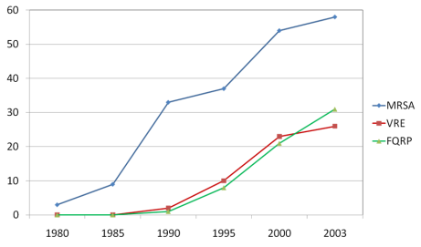
- Few New Antibiotics

- Developing a New Drug Is Expensive

- Consequences
- World Health Organization:
- “Antibiotic resistance is one of the three biggest threats to human health”
- Indications of Overuse
- Between 25%-75% of antibiotic prescriptions in nursing homes do not meet clinical guidelines for prescribing.
- Example: One-third of residents receiving antibiotics for UTI are being treated for asymptomatic bacteriuria.
- Approaches to Antimicrobial Stewardship
- Encourage research into new classes of antibiotics
- Reduce overuse in key areas
  - Populations with high prescription rates
    - Respiratory infections in children
    - Long-term care populations
  - Developing countries
  - Veterinary use, food industry, and aquaculture
- Goal: Better informed prescribing
- Components of the Communication and Decisionmaking for Four Infections
- Evidence-based communication between nurses and prescribers using a Medical Care Referral Form (MCRF)
- Nurse vigilance to twelve common situations and infection control practices (pocket card)
- Prescriber training
- “Be Smart about Antibiotics” resident and family handout
- Quality improvement practices
- 1. Evidence-based Communication Between Nurses and Prescribers: Using a Medical Care Referral Form (MCRF)
- Development and Rationale for Use: Medical Care Referral Form (MCRF)
Researchers:
- Reviewed prescribing criteria from consensus conference
- Reviewed prescribing in this and five other nursing homes and extent to which they met components of criteria
- Developed the MCRF to assure attention to and communication of key signs and symptoms
- The Medical Care Referral Form (MCRF)
- (sample MCRF)
- Medical Care Referral Form (MCRF)
- Designed to facilitate evidence-based communication between nurses and prescribers
- Intended to be used for ALL situations when a resident has a new problem and infection may be suspected
- In those instances, should be used for ALL referrals to medical care providers, including transfer to ED or hospital
- MCRF: Components
- Description of current problem
- Vital signs
- Usual cognitive function
- Recent/current health status (including falls)
  - Falls, minor injury: requires on-site first aid treatment (dressing, ice pack, pain medication)
  - Falls, serious injury: require stitches, immobilization, ED assessment or treatment, surgery, hospitalization
- Medical history (including AD for no antibiotics)
- Suspected infections – complete only relevant
- section
- Use of question mark (“?”)
- End-of-Life
- Antibiotics may not be indicated at the end of life; their use should be discussed with residents and families
- The Physician Orders for Life Sustaining Treatment (POLST) form is the best-accepted method to record resident and family wishes
- 2. Twelve Common Situations and Infection Control Practices and the Pocket Card
- Situations In Which Systemic Antibiotics Are Generally Not Indicated
- Positive urine culture in asymptomatic resident
- Urine culture ordered because of change in urine appearance
- Nonspecific symptoms or signs not referable to urinary tract (with or without positive urine culture)
- Upper respiratory infection (common cold)
- Bronchitis or asthma in resident who does not have COPD
- “Infiltrate” on chest x-ray in absence of clinically significant symptoms
- Suspected or proven influenza in absence of secondary infection
- Respiratory infections in resident with advanced dementia, on palliative care, or at the end of life
- Skin wound without cellulitis, sepsis, or osteomyelitis (regardless of culture result)
- Small (<5 cm) localized abscess without significant surrounding cellulitis
- Decubitus ulcer in resident at the end of life
- Acute vomiting and/or diarrhea in the absence of a positive culture for shigella or salmonella, or positive toxin assay for Clostridium difficile
- Infection Control Guidelines
- Vancomycin-resistant enterococci
- Clostridium difficile
- Methicillin-resistant Staphylococcus aureus
- Pocket Card
- 4. “Be Smart About Antibiotics” Handout
- INSERT SCREENSHOT OF FINAL HANDOUT HERE
- To be distributed to current and new residents and when hospice is considered
- Primary purpose is to educate about instances when antibiotics may not be indicated and to promote shared decisionmaking
- 5. Quality Improvement Practices
- Monthly Meetings
- Be held monthly to review progress
- All individuals responsible for the QI program should attend the meetings
- Additional Information About Infections and Symptom Management
- Fever and Older Adults
- Do you know why a resident DOES NOT need to have a fever to have an infection?
  - Fever may be absent in 30-50% of older adults with serious infections
  - Factors such as chronic diseases, medications, and time of day can effect an older person’s temperature
- Suspected UTI—Cloudy or Smelly Urine: To Culture or Not?
- Urine changes have many causes
  - foul-smelling urine may be caused by dehydration, hygiene, medication, diet, or infection
- Clinicians will over diagnose infection in 1/3 of cases
- Improved toileting and fluid intake is often better treatment than antibiotics; hydration and perineal hygiene can prevent recurrence
- Culture should be ordered only if new urinary symptoms are present
- Suspected Respiratory Infection
- Symptomatic care:
  - Monitor vital signs
  - Encourage fluid intake
  - Acetaminophen 650mg q 6 hrs PRN for fever and pain reduction
  - Nasal saline 2 sprays to each nostril PRN for nasal congestion
  - Guaifenesin 2 teaspoons every 4 hours as needed for cough
  - AVOID Antihistamines, especially Benadryl
- Suspected Skin/Soft Tissue Infection
- Appropriate care:
  - Mobility – encourage mobility (passive or active)
  - Acetaminophen 650 mg as needed or prior to cleaning/dressing changes
  - Cleanse wounds with each dressing change with saline or warm water; do not use antiseptic cleansers
  - Apply dressing as needed

Module 2: Antibiograms: Choosing An Appropriate Antibiotic (Antibiogram Module)

Table of Contents for the Antibiogram Module
- Introduction to the Antibiogram Module
  - What is the purpose of the Antibiogram Module?
  - Who is the Antibiogram Module for?
- Preparing to Implement the Antibiogram Module
  - What are the tools in the Antibiogram Module?
  - Is my nursing home ready to implement a toolkit in the Antibiogram Module?
  - What are the resources needed to implement a toolkit in the Antibiogram Module?
  - How do I select which toolkit to implement from the Antibiogram Module?

Introduction to the Antibiogram Module
”Antibiograms: Choosing An Appropriate Antibiotic” or the Antibiograms module is a module for nursing homes and long term care facilities that are interested in using antibiograms to help them determine which antibiotics to prescribe empirically for residents. An antibiogram presents sensitivities of specific bacterial strains to different antibiotics. Understanding which bacterial strains are sensitive to which antibiotics can help a prescribing clinician identify the best antibiotic. The module includes two toolkits that have been developed with funding by the Agency for Healthcare Research and Quality (AHRQ):
- The first toolkit included in this module, Using Nursing Home Antibiograms to Choose the Right Antibiotic (Concise Antibiogram Toolkit), was developed by Denver Health, in collaboration with the University of Maryland School Of Medicine.

- The second toolkit included in this module, The Nursing Home Antibiogram Program Toolkit: How to Develop and Implement An Antibiogram Program (Comprehensive Antibiogram Toolkit) was developed by Abt Associates.

What is the purpose of the Antibiogram Module?
Both toolkits in this module provide tools and resources for nursing homes to consider as they work to improve decisionmaking around the use of antibiotics and specifically, as they consider the use of antibiograms to help them decide which antibiotics to use. The purpose of the Concise Antibiogram Toolkit is to guide nursing homes in creating and maintaining their own antibiograms, an important tool for guiding empiric antimicrobial therapy. The purpose of Comprehensive Antibiogram Toolkit is to assist nursing homes interested in incorporating an antibiogram program into their standard care practices and includes tools for assessment and planning, development, implementation, and program monitoring.
The two toolkits were developed independently, and nursing homes may choose to implement one or the other.

Who is the Antibiogram Module for?
The Concise Antibiogram Toolkit and the Comprehensive Antibiogram Toolkit in the Antibiogram Module targets nursing home administrators who are interested in implementing an antibiogram program in their nursing home. The tools included in the Concise Antibiogram Toolkit are primarily for infection control professionals who would likely create and maintain an antibiogram, as well as for teaching other personnel how to interpret the results. The tools included in Comprehensive Antibiogram Toolkit are intended for a range of audiences including: Nursing Home Administrators, Medical Directors, prescribing clinicians, Nurses, and infection control professionals.

Preparing to Implement the Antibiogram Module
This section provides more information on the module, and helps nursing homes understand what specific tools are included within each toolkit and how to use these tools. In addition, a section on the resources needed to implement either toolkit , and a readiness assessment checklist to help nursing homes gauge whether they are ready to implement one of the toolkits in “Antibiograms: Choosing An Appropriate Antibiotic” are included. Finally, this toolkit provide guidance on how to select a toolkit that best addresses nursing home needs related to decisionmaking and choosing the right antibiotic.

What are the tools in the Antibiogram Module?
The table below provides an overview of the tools included in the Module, by toolkit.
Tool name | Use this tool to… | Description and formatting
Toolkit 1: Using Nursing Home Antibiograms to Choose the Right Antibiotic (Concise Antibiogram Toolkit)
Tool 1: Create and Implement Antibiograms in Nursing Homes | Become familiar with background information on antibiograms | - Provides the basics on what is an antibiogram, why should one be developed and used, and what nursing homes should know before deciding on using an antibiogram.  - Format: 1-page document
Tool 2: Getting Started – Sources of Data | Begin developing a nursing home antibiogram | - Answers five key questions about creating, interpreting, implementing, and updating an antibiogram  - Format: 5-page document
Tool 3: Using WHONET to Create an Antibiogram | Download WHONET and learn how to use it | - Walks users through how to download WHONET, a free Windows-based database software designed by the World Health Organization (WHO) Collaborating Centre for Surveillance of Antimicrobial Resistance.  - Explains how to utilize the software to find the percentage susceptibilities, and check the results.  - Format: 5-page document
Tool 4: How to Enter Data Manually into an Antibiogram Template | Understand how to enter data in an antibiogram template | - Explains how to enter the percentage susceptibilities from the WHONET results printout into the antibiogram template.  - Format: 4-page document
Tool 5: Comprehensive Antibiogram Template | Use in conjunction with Tool 4 to create an antibiogram | - Provides a template for a nursing home to enter percent susceptibilities for specific organism-antimicrobial combinations.  - Format: Excel spreadsheet
Tool 6:Data Entry Form | Manually enter data from culture results prior to creating an antibiogram | - Provides a template for nursing homes to enter their paper-based culture results.  - Format: Excel spreadsheet
Toolkit 2: The Nursing Home Antibiogram Program Toolkit: How to Develop and Implement An Antibiogram Program (Comprehensive Antibiogram Toolkit)
Phase 1: Assessment and Planning
Tools 1-5:  - Nursing Home Readiness and Resource Checklist  - Prescribing Clinician Survey  - Checklist for Discussion with Local Hospitals and Providers Including Emergency Departments  - Antibiogram Fact Sheet  - Timeline | To assess the current state and plan for an antibiogram program | - Includes an evaluation of facility, laboratory, clinic prescriber interest, and resources  - Basic tools to help nursing homes begin planning antibiogram programs  - Format: 1-2 page checklists, handouts, and pamphlets
Phase 2: Development
Tools 6-12  - Sample Letter of Agreement  - Sample Data Request  - Handout on Antibiogram Specifications for a Laboratory  - Antibiogram Development Tool Workbook  - Sample Laboratory Data Print Out  - Checklist for Identifying Nursing Home-Specific Antibiogram Modifications  - Sample Antibiogram | To develop communication around the antibiogram program and develop the antibiogram | - Includes tools to communicate with clinical laboratory microbiology directors  - Provides detailed instructions and examples about developing antibiogram programs  - Formats: 1-7 page letters, specifications, workbook, checklists, and handouts.
Phase 3: Implementation
Tools 13 – 21:  - Sample Policy  - Sample Procedures  - Antibiogram Fact Sheet  - Training Slides For Prescribing Clinicians  - Training Slides For Nurses  - Sample Vignettes and Discussion Questions  - Sample Pocket Card Short Version  - Sample Pocket Card Long Version  - Sample Email for Distribution of the Antibiogram | Begin implementation of an antibiogram program | - Includes policy and procedures, training, and dissemination materials  - Guidance for sample policies and procedures  - Provides background to nursing home staff through a fact sheet and training slides (Prescribing clinicians and nurses)  - Includes sample pocket cards to disseminate antibiogram information  - Formats include: 1-2 page documents, pamphlets, pocket cards, and handouts; multiple slide presentations.
Phase 4: Monitoring
Tools 22-24  - Antibiotic Use Tracking Sheet  - Quality Improvement Review Tool for Antibiotic Use in Urinary Tract Infections  - Antibiogram Feedback Survey | Assure quality of the antibiogram program as well as monitor success | - Materials and tools to ensure sustainability of the program  - Format: 1-page documents

What are the resources needed to implement a toolkit in the Antibiogram Module?
- Staffing (Staff involved in implementing and monitoring)
- Supplies (Computer or laptop for creating antibiograms, Microsoft Excel software)
- Costs (Printing toolkits and individual tools, Internet access)

How do I select which toolkit to implement from the Antibiogram Module?
Both toolkits focus on the development and use of an antibiogram. The key difference is that the Concise Antibiograms Toolkit is more focused on providing technical guidance on antibiogram development and the Comprehensive Antibiograms Toolkit is more comprehensive, providing guidance on planning, implementation, and monitoring of an antibiogram.

Is my nursing home ready to implement an antibiogram toolkit?
The Comprehensive Antibiograms Toolkit includes a readiness assessment to use to help determine whether the nursing home is ready to successfully implement one of the toolkits in this module. Please see page 12 of the toolkit. Key questions to consider are:
- Does the leadership support and champion the effort?
- Is the nursing home stable, both financially and with the state?
- Is the laboratory the nursing home uses capable of generating the needed data for an antibiogram?
- Are prescribing clinicians interested and willing to use data from the antibiogram?
- Does the facility have resources to an infection control professional or other qualified staff to develop and maintain the antibiogram?

Toolkit #1: Using Nursing Home Antibiograms to Choose the Right Antibiotic (Concise Antibiogram Toolkit)

Table of Contents for the Concise Antibiogram Toolkit
- Overview of the Toolkit
- What is the Concise Antibiogram Toolkit?
- Why Use the Concise Antibiogram Toolkit? How Will It Help a Nursing Home?
- How Do I Implement the Concise Antibiogram Toolkit?

Overview of the Toolkit

What is the Concise Antibiogram Toolkit?
The Concise Antibiogram Toolkit, developed by Denver Health, in collaboration with the University of Maryland School of Medicine, is intended to guide nursing homes in creating and maintaining their own antibiograms, an important tool for guiding empiric antimicrobial therapy. Antibiograms utilize microbiologic data from patient specimens from a facility to estimate the floor- or facility-wide prevalence of antibiotic susceptibilities for common bacterial pathogens. They are also an important component of monitoring trends in antimicrobial resistance within different areas of a facility.
Six tools are included in the Concise Antibiogram Toolkit:
- background information on antibiograms (Tool 1),
- information on understanding the sources of data for creating antibiograms (Tool 2),
- instructions on using free database software (Tool 3),
- instructions on manually entering data into an antibiogram template (Tool 4),
- template for entering culture results (Tool 5), and
- comprehensive antibiogram template (Tool 6).

Why Use the Concise Antibiogram Toolkit? How Will It Help a Nursing Home?
- Antibiograms encourage responsible use of antibiotics throughout facilities. Prescribing clinicians—physicians, nurse practitioners, physician assistants—can consult these tools before initiating empiric antibiotic therapy, which may improve outcomes among patients with infections.
- Antibiograms are a good way to detect changes in resistance patterns for an entire facility or for locations within a facility.
- Antibiograms can be inexpensive to develop and maintain. The results are easily accessible to nursing home staff and prescribing clinicians.

How Do I Implement the Concise Antibiogram Toolkit?
Implementation of the Concise Antibiogram Toolkit involves four steps:
- Identify champions. Successful implementation relies on implementing and disseminating the information and monitoring the results. It is helpful to have at least two individuals at the nursing home champion the antibiogram to ensure that an antibiogram is created and distributed for use. These champions can be the Administrator, Director of Nursing, Assistant Director of Nursing, the staff in charge of infection control, and/or the Medical Director.
- Develop the antibiogram. The toolkit provides instructions on how to create the antibiogram.
- Distribute the antibiogram. The distribution of the antibiogram should be accompanied with instructions for use and interpretation. At the same time, each nursing home is different and the nursing home leadership will need to determine the best way to distribute information to the prescribing clinicians and the nursing home.
- Update the antibiogram. To maintain the value of the antibiogram, it will help to update the antibiogram annually if possible.
The following tools are used for this toolkit.
Tool 1: Create and Implement Antibiograms in Nursing Homes (1 page)
Tool 2: Getting Started – Sources of Data (5 pages)
Tool 3: Using WHONET to Create an Antibiogram (5 pages)
Tool 4: How to Enter Data Manually into an Antibiogram Template (4 pages)
Tool 5: Comprehensive Antibiogram Template (1 tab – 6 pages)
Tool 6: Data Entry Form (2 tabs – 9 pages)

Tool 1: Create and Implement Antibiograms in Nursing Homes

Using Nursing Home Antibiograms to Choose the Right Antibiotic

Create and Implement Antibiograms in Nursing Homes

This toolkit is designed to guide nursing homes in creating their own antibiograms, an important tool for guiding empiric antimicrobial therapy. Information about antibiograms and instructions on how to create them is included.

What is an antibiogram?
- Antibiograms are important tools for health care professionals involved in prescribing empiric antibiotics for suspected bacterial infections. These tools utilize microbiologic data from patient specimens from a nursing facility to estimate the ward- or facility-wide prevalence of antibiotic susceptibilities for common bacterial pathogens. They are also an important component of monitoring trends in antimicrobial resistance within different areas of a facility.

- Hospitals use antibiograms as part of their infection control measures to classify types of bacteria found in cultures, to identify patterns of antibiotic susceptibility in those bacteria, and to track changes in antibiotic susceptibility over time. Hospitals use these cumulative antimicrobial susceptibility test data reports to determine the most appropriate agents for initial empirical antimicrobial therapy and to target efforts to reduce inappropriate antibiotic use.

Why develop and use an antibiogram?
- Antibiograms encourage responsible use of antibiotics throughout facilities. Prescribing clinicians—physicians, nurse practitioners, and physician assistants—can consult these tools before initiating empiric antibiotic therapy, which may improve outcomes among patients with infections.
- Antibiograms are a good way to detect changes in resistance patterns for an entire facility or for locations within a facility.
- Antibiograms can be inexpensive to develop and maintain. The results are easily accessible to health care providers.

Is there anything important to know before using an antibiogram?
- Antibiograms are not generalizable to different nursing facilities; they can be useful tools for guiding empiric therapy and monitoring antibiotic susceptibility trends within a specific facility.
- Selection of empiric therapy in a particular patient should not be based solely on an antibiogram. A patient's particular infection history, including past antimicrobial use, must also be considered.
- Antibiograms only capture the aggregate proportion of susceptible isolates for a given organism-antibiotic combination. They do not provide the prevalence resistance to multiple antibiotics.
- Antibiograms provide guidance for empiric antibiotic use in patients, but other factors including patient characteristics and prevalence of other risk factors should be incorporated when making therapeutic decisions.

Tool 2: Getting Started – Sources of Data

Concise Antibiogram Toolkit

Getting Started—Sources of Data
Consider the following before creating an antibiogram:
What is needed to create the antibiogram?
What data are needed to create an antibiogram?
How is an antibiogram interpreted?
How will the tool be implemented in the facility?
How often will the antibiogram be updated?

What is needed to create the antibiogram?
To create a facility’s antibiogram, the staff responsible will need some working knowledge of computers and a good understanding of culturing practices and infection control.
The resources included in this toolkit can be used with the 2007 (or later) Microsoft Office suite. The software recommended to create the antibiogram (WHONET) can be downloaded for free from the Internet at http://www.who.int/drugresistance/whonetsoftware/en/. It is important to know and use Microsoft Office and feel comfortable learning new software.
It is important to know how the tool will be used in the facility. One factor to consider is whether the antibiogram will be used by prescribing clinicians in the entire facility or only by those on a certain floor or ward. This information may result in the decision to create separate antibiograms instead of one facility-wide tool. An infection control professional could be ideal for creating and maintaining an antibiogram as well as for teaching other personnel how to interpret the results.

What data are needed to create an antibiogram?
An antibiogram cannot be developed without specific information about the facility’s microbiological cultures. Results of the cultures, including those concerning antibiotic susceptibilities, must be easily accessible. Multiple sources can provide these data.

Potential Data Sources

Laboratory—electronic or paper based
The most convenient way to obtain data for the facility’s antibiogram may be to contact the primary laboratory which the nursing home works with for culture results. This laboratory may be independent or affiliated with another health care facility, such as a hospital. The laboratory that processes the facility’s cultures will have a record of the antibiotic susceptibility tests performed for each culture which may be accessible. Whether the data are electronic or paper format will affect how to process the data further. If at all possible, try to obtain the data electronically, either in a spreadsheet or text file. Paper-based results will require that the data be manually entered into a spreadsheet before using WHONET (See Tool “How To Enter Data Manually Into an Antibiogram Template” and Tool “Antibiogram Data Entry Form”).
- Who is the best contact for the data?
If the staff at the local and primary laboratory are not known, it can be difficult to determine how to best obtain the data for an antibiogram. Contacting the director of the primary laboratory is recommended. If more than one facility is used, contact the director of each laboratory.
- What data should be requested?
After the contact has been identified, ask for culture data specific to the facility and within the date range of interest. Begin with data spanning a minimum of 6 months, but a period of 1 year is recommended. Request the following data elements from the contact:
- Culture ID number
- Patient ID number
- Patient name
- Culture date
- Culture source
- Culture results (organism(s))
- Antibiotic susceptibilities
If elements will be added to the laboratory data, be sure to ask for the data in a spreadsheet format. Consider adding the room numbers or other patient characteristics before converting the spreadsheet into a text file and importing the file into WHONET.
If the laboratory cannot send this information electronically, ask for a printed report. As long as the data elements are present in the report, it is possible to enter the information into a spreadsheet manually.

Resident medical charts
If it is difficult to obtain the required data directly from the laboratory, it is possible to review the charts of residents and abstract the culture results by hand. If this is the case, record the culture information for every culture result in the timeframe of interest. If there are some records (e.g., billing or laboratory) of all of the cultures that were ordered during that timeframe, review all of the patient charts noted in that record. The culture results for each culture that was ordered during this time period are needed for this activity. If this information is located in individual charts, it may be easiest to photocopy the culture reports. Enter the information collected into a spreadsheet before WHONET can be used. The information can be directly entered into a spreadsheet from the resident charts as well. A spreadsheet template is also available with the toolkit titled “Antibiogram Data Entry Form.” If this method has been used, it make sense to collect this information prospectively or on a monthly basis. Then, after a period of 6 months to 1 year, an antibiogram can be created. It may be helpful to keep the culture reports in a binder in order of date.

How is an antibiogram interpreted?
Below is an example antibiogram.

Title: Figure 1: Example Antibiogram
Major Headings: Gram (-), Gram (+), # of patients, Aminoglycoside, B-Lactams, Cephalosporins, Quinolones, Others
Description: This figure depicts an example antibiogram that may be created. The first column lists the organisms that were included, separated by Gram-positive and Gram-negative results. The second column shows the number of patients in the facility who had the organism and were included in the antibiogram. The remaining columns of the antibiogram are the antibiotics that were tested and the organisms’ susceptibilities.
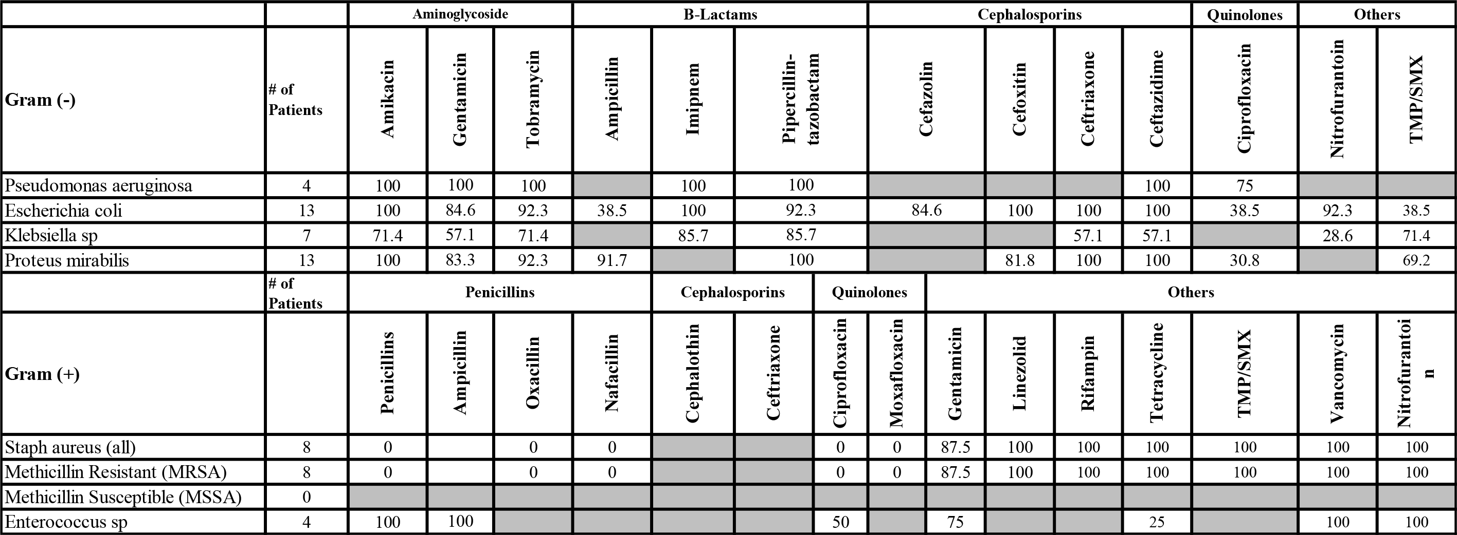

The first column lists the organisms that were included, separated by Gram-positive and Gram-negative results. The second column shows the number of patients in the facility who had the organism and were included in the antibiogram. The tool only includes the first isolate per person, regardless of culture source within the decided timeframe. This ensures that each person contributes equally to the antibiogram. A resident may be cultured multiple times in a year and his results consistently reveal Staphylococcus aureus. Only that person’s first Staphylococcus aureus culture will be counted.
The remaining columns of the antibiogram are the antibiotics that were tested and the organisms’ susceptibilities. For example, Pseudomonas aeruginosa was isolated in four people. It was tested against ciprofloxacin. Of the Pseudomonas aeruginosa cultures tested against ciprofloxacin, 75 percent were susceptible to the antibiotic.
The antibiogram should be used to guide empiric therapy and to monitor antibiotic susceptibility trends within the facility. Selection of empiric therapy in a particular patient should not be based solely on an antibiogram. A patient's particular infection history, including past antimicrobial use, must also be considered.

How will the tool be implemented in the facility?
Once an antibiogram has been created, it is important to decide how to distribute the results to the prescribing clinicians at this facility. The distribution of the antibiogram should be accompanied with instructions for use and interpretation. Printing the antibiogram on 3x5 or 4x6 index cards is one option for distributing the tool to practitioners. Below is an example of formatting for a 3x5 card. Gram-positive bacteria appear on one side and Gram-negative bacteria are on the other side.
Title: Figure 2: Example Antibiogram for Distribution to Providers
Headings: Gram-Positive, MRSA, Enterococcus sp, Streptococcus agalactiae, Gram-Negative, Pseudomonas aeruginosa, Escherichia coli, Klebsiella sp, Proteus mirabilis
Description: This figure shows an example of printing an antibiogram on a 3x5 index card. One side shows the gram-positive bacteria and the other side shows gram-negative bacteria.

Consider posting the antibiogram in a central location for easy reference.
When it is time to implement the antibiogram, take special care to communicate the strengths and limitations of the tool as discussed in the background. Seminars and in-person presentations of the antibiogram can be the most direct and effective format to distribute the tool and explain its implications. Face-to-face communication is imperative for answering questions as well. One presentation may be all that is needed; however, consider planning for more than one in order to make sure that everyone who will be using the antibiogram has the pertinent information.
One additional goal of the presentation(s) may be to encourage prescribing clinicians to order more cultures for suspected infections when prescribing empiric antibiotics, especially if confidence in the antibiogram data is low due to infrequent testing.

How often will the antibiogram be updated?
In general, hospital antibiograms are updated annually. This is the suggested timeframe if staffing allows for someone to update the antibiogram and disseminate the information.
It is also important to keep in mind the frequency at which culturing occurs within the facility. If only a small number of cultures are represented in the antibiogram, updating an antibiogram once a year may be sufficient. Remember, an antibiogram may not highlight emerging infection outbreaks, but it can monitor trends in antibiotic susceptibilities.

Tool 3: Using WHONET to Create an Antibiogram

Concise Antibiogram Toolkit

Using WHONET to Create an Antibiogram
WHONET is a free Windows-based database software developed in 1989 by the World Health Organization (WHO). The software is used in laboratories worldwide for the management and analysis of microbiology laboratory data with a special focus on the analysis of antimicrobial susceptibility test results. This software will analyze the culture results of a nursing home facility and provide the susceptibility results for the antibiogram.
The tutorials available on the WHONET website are helpful. Registration is free. Please use this document to supplement the tutorials. This document is specific to creating an antibiogram.
A troubleshooting section is included to address some of the issues that emerge. WHONET also provides technical support, available once an individual has registered and logged in.

Downloading WHONET Software Program
- Go to the World Health Organization’s webpage for WHONET Software at http://www.who.int/drugresistance/whonetsoftware/en/
- Click on the “Click here to download the software and manuals” link. A new window should open titled “WHONET Login Page.”
- Click on “Create a New Account” (if necessary). Registration is free.
- Click on the “DOWNLOAD WHONET” button in the upper left corner of the page. 
- In the “Softwares” box, click on the version of “WHONET 5.6” which fits the version of Microsoft Windows currently running on most computers. For Windows 98 through Windows Vista users, click the top “WHONET 5.6.” For Windows 2000 through Windows 7, click the bottom one. If unsure, right click on “My Computer” icon on the desktop and choose “Properties.” The version of Microsoft Windows will appear under “System.”
- If a dialog box opens up asking to run or save the file, click “Run.” If it asks whether to save the file or cancel, click “Save.” Then, the location can be saved permanently on the computer or desktop. Otherwise, the files may save to the “Downloads” folder. The necessary files will begin downloading.
- If it was possible to select “run,” the InstallShield Wizard should open automatically. If the file was “Saved,” look in recent downloads and double-click on “whonet56setup” to launch the installer. Recent downloads can be found either in a dialog box that opened when the download started, or in the “Downloads” folder under “My Documents.”
- A security warning may pop up saying “This publisher could not be verified. Are you sure you want to run this software?” Click “Run” and the installer should start.
- Click “Next” to move through the installer. Use the default recommended settings.
- When the InstallShield Wizard is finished, WHONET should be installed on the computer. Two new icons on the desktop should appear, each with a picture of a globe. One will say “WHONET 5.6” and the other will say “BacLink 2.” BacLink is the program that converts data into a format that WHONET can read.
Note: If at any point a problem is not explained in these instructions, click on the “Technical Support” button on the left side of the screen to contact a WHONET technical support representative.
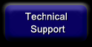

Using WHONET
WHONET has a set of tutorials to help with using WHONET. These can be accessed by clicking on the “Tutorials” button on the left side of the screen.
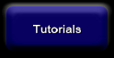
Begin with the BacLink tutorials to convert files in BacLink to be used by WHONET.

Converting files in BacLink
The BacLink Tutorials will walk through converting data into a format that WHONET can read. First, convert the file containing the facility’s culture data (often a Microsoft Excel or Access file) into a Text file format. This process is explained in the tutorials. Then use BacLink to convert that Text file for use in WHONET. The first three tutorials—“Getting started,” “Excel, text files, other applications,” and “Laboratory Information Systems”—are particularly helpful.
Prior to using WHONET, define the data fields from the database (Culture Date, Organism, etc.) so that WHONET can understand them:
- The dialog box for defining data fields can be found in BacLink under “New format” or “Edit format,” then “File structure,” and then “Data fields.”
- Under “Data fields,” click on “Select a sample data file,” and then select the Text file created earlier from the electronic data or from the Access or Excel table provided in the toolkit (See BacLink 2 Tutorial).
- Then, select the data fields from the database (shown on the right) which correspond with the WHONET data fields (on the left). Here are some suggestions to define the data fields in BacLink, using the template Access or Excel table included in the toolkit as an example:
Identification Number = Resident ID
Sex = Sex
Date of Birth = Birthdate
Location = Room
Department = Floor*
Specimen number = Culture ID
Specimen Date = Collection Date
Specimen Type = Source
Organism = Organism
“Antibiotic result” fields can be defined for any or all of the antibiotics that have susceptibility results. The templates from the toolkit include a comprehensive list of antibiotics that isolated bacteria are commonly tested against in microbiology laboratories. If the facility’s affiliated lab regularly tests only some of the antibiotics on this list include those antibiotics only.
*The “Department” field does not necessarily have to be “Floor.” It could also be “Bed,” or any other location category of interest. WHONET was designed for use in hospitals, so the fields may not fit perfectly in a nursing home setting. Fortunately, being able to define the fields offers some flexibility to tailor the data to the facility. Also, it is not necessary to define “Department” or any other particular field. But if susceptibility trends on a particular floor are of interest, WHONET can help break down the data accordingly.
It is strongly recommended to obtain culture data from the affiliated lab electronically if at all possible. It will be more efficient to convert that electronic file directly to a Text file, instead of entering the data manually into a database. This Text file can then be converted in BacLink for use in WHONET. Data field names will likely differ slightly, but the list above should offer some guidance.
It should be noted that these are just suggestions, and it is possible to modify the field definitions based on specific data and facility needs.

Using WHONET to Find Percent (%) Susceptibilities
As with BacLink, the WHONET Tutorials are very helpful. In particular, the two “Data Analysis” tutorials will be helpful for finding the percent (%) susceptibilities that will go into the antibiogram. Below are a few tips for Data Analysis in WHONET that should make creating and updating the antibiogram easier. These are covered in more detail in the tutorials, but there are many options for data analysis and the steps below will make creating the antibiogram easiest:
- After opening “Data Analysis” in WHONET, click on “Analysis type.” A box will open with options.
- For “Analysis type,” select “% RIS and test measurements.”
- For “Report format,” choose “Summary.”
- Under “Antibiotics” leave “All antibiotics” selected. This will give the percent (%) susceptibility for all antibiotics that have susceptibility results.
- Click “OK.”
- Click on “One per patient?” in the top right corner. Another box will open with options.
- At the top, under “Include which result in the analysis of each species?” select “By patient.”
- Then select “First isolate only.” This will ensure that only the first isolate found for each resident is analyzed, so results are not biased by residents with recurring infections by the same organism.
- Click “OK.”
- Under “Organisms,” select all the organisms that have been found in cultures at the facility.
- Under “Data files,” select the Text file of the culture data.
Running analysis under these settings will display the results in a format similar to the antibiogram. It will list each organism along with the number of residents who had a positive culture for that organism and the percent (%) susceptibility to each antibiotic. These percent (%) susceptibilities can then be manually entered into the antibiogram template provided in the toolkit.
Click on “Print Table” at the top of the screen to print the susceptibility results. Printing the results should make entering the percent (%) susceptibilities into the antibiogram template easier.

Checking the Results/Troubleshooting
Double check the printout to make sure everything looks correct and fits with the data. A few specific things to look for are:
- Are all the organisms in the data listed on the printout?
  - If an organism is missing from the printout, first check the settings in the “Data analysis” box. Clicking “Continue” after printing the results page will bring back to the “Data analysis” setup box, with the current settings. Check to see if the missing organism is listed in the box under the “Organisms” button. If not, click on the “Organisms” button and add the missing organism.
  - If the organism is listed, try going into BacLink and running the file conversion again to make sure WHONET is recognizing the organism correctly. If at the end of the conversion WHONET notes that it is not recognizing all of the codes in the data file, click “Yes” to define the codes. If the missing organism is listed here, define it (along with any other unrecognized codes) and rerun the conversion. Then rerun the Data analysis in WHONET and see if the organism shows up.
- Do the numbers of first isolates for each organism (listed under the “Number of patients” column; see red arrow in Figure 1 in Tool titled How to Enter Data Manually Into an Antibiogram Template) seem to fit with the frequency seen for these organisms in positive cultures?
  - Remember, WHONET restricts its results to the first isolate per patient, so the numbers may be smaller than expected. However, if any number seems unexpectedly low, check the database to see if the numbers are consistent (taking into account repeat isolates from the same person).
  - Make sure that all of the entries for each organism are spelled correctly and consistently in the database. For example, if one of the S. aureus isolates was accidentally entered as “A. aureus,” it will not be recognized by WHONET and, therefore, will not be included in the results.
- Are all the antibiotics which had susceptibility results showing up in the printout?
  - If an antibiotic that has susceptibility results is missing from the printout, there are 2 likely reasons:
    - The antibiotic may not be defined, or may be defined incorrectly, in BacLink. This can happen if a new or edited antibiotic has been added since last running the conversion.
- Open BacLink, select the laboratory, and click “Edit format,” then “File structure,” and then “Data fields.” Under “Data fields,” click on “Select a sample data file,” and then select the Text file created earlier from the database (see above/BacLink 2 Tutorial). Use the Text file created from the most current version of the database.
- Scroll to the bottom of WHONET’s list of data fields (on the left) and look for the missing antibiotic. If it is not there, click the “Add” button beneath the list to add it. If it is there, confirm that it is set equal to the same antibiotic from the data fields (listed on the right). If not, or if the spelling is different, confirm the antibiotic on the left is highlighted and then double click the antibiotic from the data on the right to correctly define the field.
- Run the conversion again and then the analysis in WHONET to see if the antibiotic shows up in the results.
    - The antibiotic may not have been added when setting up the initial laboratory in WHONET (see WHONET 2 Tutorial). If this is the case, the antibiotic will not be listed in the key of antibiotic abbreviations at the bottom of the WHONET printout (see Figure 3 in Tool titled How to Enter Data Manually Into an Antibiogram Template for an example of a printout). If, as described above, the antibiotic is improperly defined in BacLink, then the abbreviation key will list the antibiotic but its abbreviation will not be listed as a column header for percent (%) susceptibilities.
- Open WHONET, select the laboratory, click “Modify laboratory,” and then click “Antibiotics.” In the box that opens, check for the missing antibiotic in the list on the right, which shows the antibiotics selected when setting up the lab in WHONET (i.e., all the antibiotics that the affiliated laboratory might test against). If the antibiotic is not listed, search for it in the list on the left and then double click to move it to the list on the right.
- Run the analysis again and see if the antibiotic shows up in the results.
- One other thing to check is that the most current form of the database is being used. This is particularly important if the database has been renamed or saved in multiple locations. When ready to analyze the data, confirm the most current database is converted to a Text file, that that Text file is then selected for conversion in BacLink, and that that converted file is selected for analysis in WHONET. Otherwise, outdated or incomplete data may be used, leading to many of the problems described above.

Other Uses
In addition to making and updating the antibiogram, WHONET can answer more specific infection control questions. For example, a specific organism can be analyzed. Or click on “Isolates” when setting up data analysis to set more specific criteria for the results (for example, to look at only one floor or one ward). See the WHONET and BacLink Tutorials for more detailed information.

Tool 4: How to Enter Data Manually into an Antibiogram Template

Concise Antibiogram Toolkit

How To Enter Data Manually Into an Antibiogram Template

Once the results are printed from WHONET, enter the percent (%) susceptibilities into the antibiogram template. This should be fairly straightforward, but there are a few things to note before beginning:
Only include an organism in the antibiogram if it has been isolated from at least four patients:
On the WHONET printout, note the “Number of patients” column (see red arrow in Figure 1 below). This column contains the number of patients who had cultures from which each organism was isolated at least once. The percent (%) susceptibilities for each organism are based on susceptibility results from the number of isolates noted in the “Number of patients” column. Some of these numbers may be quite low, which could give unreliable percent (%) susceptibilities. For example, in Figure 1 there is a “2” in the “Number of patients” column next to “Enterobacter cloacae” (see blue arrow). This means the percent (%) susceptibilities for E. cloacae are only based on two isolates and will all be 0 percent, 50 percent, or 100 percent. These numbers are clearly not very helpful, as even one more isolate with a different susceptibility pattern could change the percent (%) susceptibilities significantly. It is best to include an organism in the antibiogram if it has been isolated from at least four patients (i.e., a “4” in the “Number of patients” column).
In general, including organisms with four isolates will increase the number of organisms in the antibiogram. However, this is still a fairly low number of isolates and should be interpreted with caution. Percent (%) susceptibilities based on four isolates should give a general idea of how effective various antibiotics are against those organisms, but organisms with more isolates will likely produce more accurate results resulting in greater confidence.
Additionally, a higher number of isolates implies that that organism is infecting more people in the facility. Therefore, more weight may be given to the percent (%) susceptibilities for organisms with more isolates when selecting empiric antibiotics (while still taking into account factors like likelihood of an organism given infection site, individual infection history, etc.).
Title: Figure 1. Top section of the WHONET percent (%) susceptibilities printout.
Headings: Number of patients, Organism
Description: This figure shows the top section of the WHONET percent (%) susceptibilities printout. The red arrow points out the “number of patients” column which contains the number of patients who had cultures from which each organism was isolated at least once. The percent (%) susceptibilities for each organism are based on susceptibility results from the number of isolates noted in the “number of patients” column, as indicated by the blue arrow. It is recommended that only organisms with at least four isolates be included in the antibiogram.
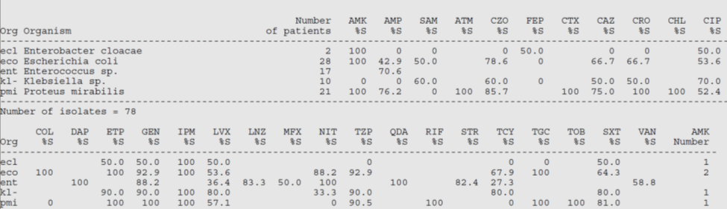
Only include percent (%) susceptibilities for antibiotics where at least 70 percent of the isolates were tested against that antibiotic:
At the bottom of the printout (or scroll all the way to the right on the susceptibilities table in WHONET), after the percent (%) susceptibilities, numbers are listed for each organism under each antibiotic (e.g., “AMP Number,” “SAM Number,” etc.; see Figure 2). These numbers indicate the number of isolates of each organism that were tested against a given antibiotic. For a given organism, this could be any number from 0 (blank) up to the total number of isolates included (listed in the “Number of patients” column). Different isolates of an organism are not always tested for susceptibilities to the exact same antibiotics. For example, in Figure 1 above, a “28” next to Escherichia coli in the “Number of patients” column, indicating that this nursing home had 28 first isolates of E. coli contributing susceptibility data to their antibiogram. However, in Figure 2 below that there is a “27” under the “IPM Number” column next to E. coli (abbreviated “eco;” see red arrow). This indicates that only 27 of the E. coli isolates were tested against imipenem.
Title: Figure 2. Lower section of the WHONET percent (%) susceptibilities printout.
Headings: Org, CAZ Number, IPM Number
Description: This figure shows the lower section of the WHONET percent (%) susceptibilities printout. The red and blue arrows in the figure note the number of isolates of each organism that were tested against a given antibiotic. For example, there is a “27” under the “IPM Number” column next to E. coli (abbreviated “eco;” see red arrow). This indicates that only 27 of the E. coli isolates were tested against imipenem.
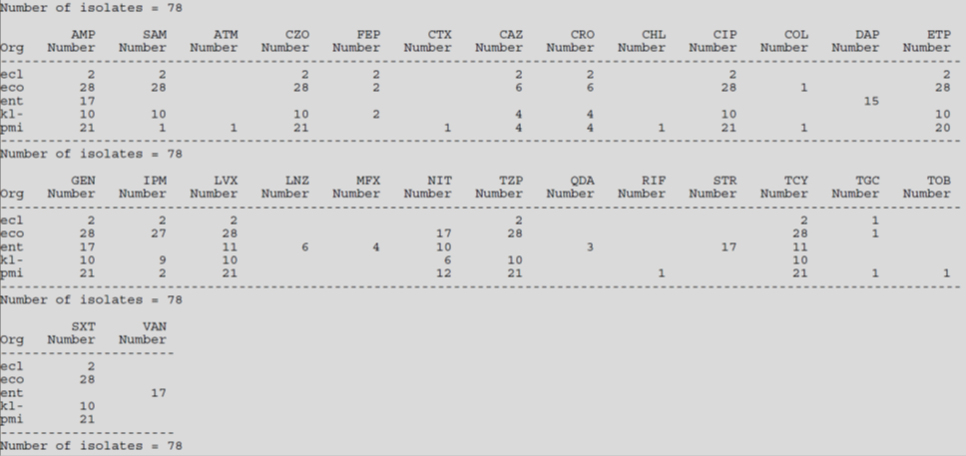
Similar to how a low number of overall isolates may lead to unreliable or misleading data, a low number of an organism’s isolates tested against a given antibiotic may lead to an inaccurate interpretation of susceptibility patterns. For example, while 27 out of 28 E. coli isolates tested against imipenem likely gives a fairly accurate idea of the overall percent (%) susceptibility of E. coli to imipenem in a facility, imagine if only six of the isolates were tested against an antibiotic, as is the case with ceftazidime (abbreviated “CAZ” in Figure 2 above; see blue arrow). This makes it much harder to gauge E. coli’s actual overall percent (%) susceptibility to ceftazidime. Although Figure 1 shows that 66.7 percent (or 4/6) of the E. coli isolates tested were susceptible to ceftazidime, imagine all 22 of those not tested happened to be resistant. In this case, the apparent susceptibility of 66.7 percent would in reality be much lower (only 14.3%). Because of this uncertainty, include percent (%) susceptibilities for antibiotics where at least 70 percent of the isolates were tested against that antibiotic. So, in the example, percent (%) susceptibilities for antibiotics which about 20 or more isolates were tested against should be included in the antibiogram. Accordingly, ceftazidime would not be included in this nursing home’s antibiogram.
Taking these points into account, begin to enter the percent (%) susceptibilities from the WHONET printout into the cells of the antibiogram template. For each percent (%) susceptibility, find the cell in the template which corresponds to that organism and antibiotic and enter the value. A key for the antibiotic abbreviations is listed at the bottom of the printout (see Figure 3). Continue until all of the values are transferred from the WHONET printout (except those which don’t fit the above criteria, that is, too few total isolates or an insufficient proportion of isolates tested against a given antibiotic. Color any empty cells grey to make the antibiogram easier to read. Also, fill in the “Number of patients” column for each organism based on the numbers from the corresponding column on the WHONET printout.
Title: Figure 3. WHONET Percent (%) Susceptibilities Printout
Headings: Organism, Number of patients
Description: This figure illustrates an example of the full printout of percent (%) susceptibilities using the WHONET software.
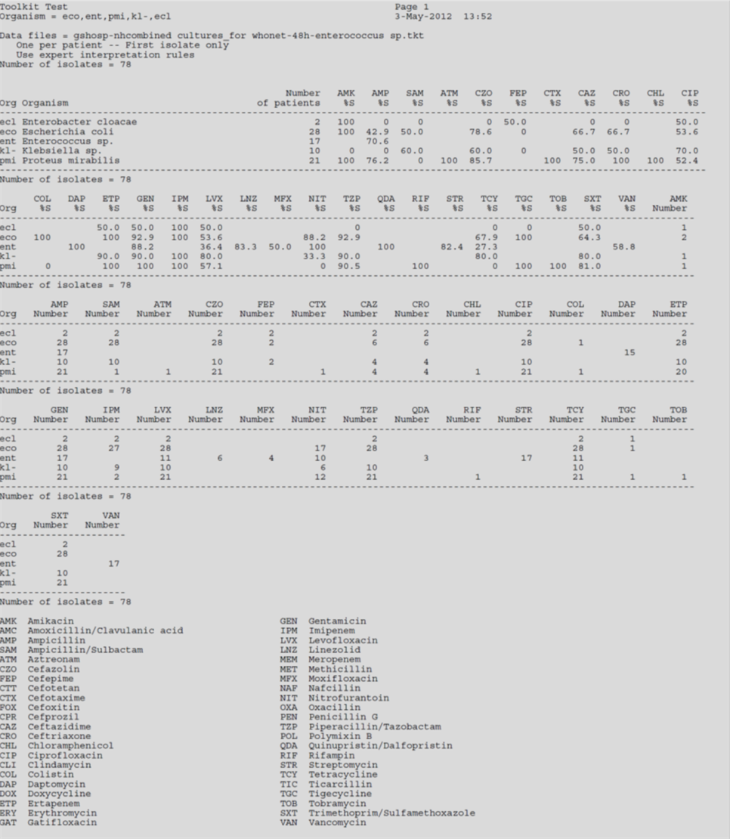

Tool 5: Comprehensive Antibiogram Template
 |  | Aminoglycosides |  |  | B-Lactams |  |  |  |  |  | Cephalosporins |  |  |  |  | Quinolones |  |  |  | Others
Gram (-) | # of Patients | Amikacin | Gentamicin | Tobramycin | Ampicillin | Amoxacillin-Clavulanate | Ampicillin-Sulbactam | Imipnem | Meropenem (tested by MIC) | Pipercillin-Tazobactam | Cefazolin | Cefepime | Cefoxitin | Ceftazidime | Ceftriaxone | Ciprofloxacin | Gatifloxacin | Levofloxacin | Moxifloxacin | Ertapenem | Colistin | Nitrofurantoin | Polymixin B | Streptomycin | Tigecycline | Ticarcillin | TMP/SMX
Acinetobacter baumanni
Citrobacter freundii
Citrobacter koseri
Citrobacter sp
Enterobacter aerogenes
Enterobacter cloacae
Enterobacter sp
Escherichia coli
Klebsiella oxytoca
Klebsiella pneumoniae
Klebsiella sp
Morganella morganii
Proteus sp
Providencia sp
Pseudomonas aeruginosa
Salmonella sp
Serratia marcescens
Shigella sp

 |  | Aminoglyc-osides |  | Penicillins |  |  |  |  | Cephalosporins |  |  |  |  | Macrolides |  |  | Quinolones |  |  |  | Others
Gram (+) | # of Patients | Gentamicin | Tobramycin | Ampicillin | Oxacillin | Nafcillin | Penicillin | Ticarcillin | Cephalothin | Cefoxitin | Cefepime | Ceftazidime | Ceftriaxone | Erythromycin | Clindamycin | Linezolid | Ciprofloxacin | Gatifloxacin | Levofloxacin | Moxifloxacin | Amoxacillin-Clavulanate | Aztreonam | Daptomycin | Ertapenem | Nitrofurantoin | Rifampin | Streptomycin | Tetracycline | TMP/SMX | Vancomycin
Staph aureus (all)
Methicillin Resistant (MRSA)
Methicillin Susceptible (MSSA)
Staphylococcus coag neg
Enterococcus faecalis
Enterococcus faecium
Enterococcus sp
Streptococcus pneumoniae
Streptococcus agalactiae
Streptococcus sp

Tool 6: Data Entry Form
Resident ID | Birthdate | Sex | Floor | Room | Bed | Laboratory Used | Culture ID | Collection Date | Source | Organism | Amikacin (AMK) | Amoxicillin-Clavulanate (AMC) | Ampicillin (AMP) | Ampicillin-Sulbactam (SAM) | Aztreonam (ATM) | Cefazolin (CZO) | Cefepime (FEP) | Cefoxitin (FOX) | Ceftazidime (CAZ) | Ceftriaxone (CRO) | Chloramphenicol (CAM) | Ciprofloxacin (CIP) | Clindamycin (CLI) | Colistin (COL) | Daptomycin (DAP) | Ertapenem (ETP) | Erythromycin (ERY) | Gatifloxacin (GAT) | Gentamicin (GEN/HLG) | Imipenem (IMP) | Levofloxacin (LVF) | Linezolid (LZN) | Meropenem (MEM) | Methicillin (MET) | Moxifloxacin (MFX) | Nafcillin (NAF) | Nitrofurantoin (NIT) | Oxacillin (OXA) | Penicillin (PEN) | Piperacillin-Tazobactam (TZP) | Polymyxin B (POL) | Quinopristin/Dalafopristin (QDA) | Rifampin (RIF) | Streptomycin (STR/HLS) | Tetracycline (TCY) | Ticarcillin-Clavulanate (TIC) | Tigecycline (TGC) | Tobramycin (TOB) | Trimethoprim/Sulfa (SXT) | Vancomycin (VAN)

Toolkit #2: The Nursing Home Antibiogram Program Toolkit: How to Develop and Implement An Antibiogram Program (Comprehensive Antibiogram Toolkit)

Table of Contents for the Comprehensive Antibiogram Toolkit
- Overview of the Toolkit
  - What is the Comprehensive Antibiogram Toolkit?
  - Why Use the Comprehensive Antibiogram Toolkit? How Will It Help a Nursing Home?
  - How Do I Implement the Comprehensive Antibiogram Toolkit?

Overview of the Toolkit

What is the Comprehensive Antibiogram Toolkit?
The Comprehensive Antibiogram Toolkit is intended to guide nursing homes interested in incorporating an antibiogram program into their standard care practices. This toolkit contains the steps and materials needed to develop and implement an effective nursing home antibiogram program. This toolkit consists of four major phases:
- Phase 1. Assessment and Planning
- Phase 2. Development
- Phase 3. Implementation
- Phase 4. Program Monitoring
Each phase contains a description of the task, instructional materials, and tools and samples that can be modified to be nursing home-specific to carry out the effort.

Why Use the Comprehensive Antibiogram Toolkit?
The inappropriate and over use of antibiotics is recognized as a serious problem across all healthcare settings. Overexposure to antibiotics allows the emergence of strains that are resistant to treatment. When this occurs, the antibiotics lose their ability to control or kill the bacteria. Complications may develop that result in prolonged treatment times and increased healthcare costs. Frail older adults who reside in nursing homes are particularly prone to infection due to their advanced age and compromised health status. Additionally, many residents have multiple chronic conditions and are often functionally and cognitively impaired. Comorbidity complicates the observance of new symptoms, and makes identifying the effect of antibiotics on any one condition difficult.
Experts recommend the judicious use of antibiotics as one way to prevent the overuse or inappropriate use of antibiotics while at the same time maintaining high quality resident care. One tool that may be effective for improving the appropriateness of prescribing is a nursing home-specific antibiogram. An antibiogram is a report that displays the organisms present in clinical specimens sent by a nursing home for laboratory testing, aggregated across all residents for a certain time period, and the susceptibility of each organism to an array of antibiotics. Referring to an antibiogram report enables prescribing clinicians to make prompt empirically-based decisions. Since antibiograms provide information on local susceptibility patterns based on previous laboratory results, they may help to reduce prescribing of antibiotics with high resistance rates in the nursing home and in the emergency department.
The use of antibiograms in hospitals is common, but is relatively new in the nursing home setting. The Comprehensive Antibiogram Toolkit strives to encourage nursing home administrators and other leaders to consider implementing an antibiogram program, and will be valuable resource for developing and instituting a successful program.

How Do I Implement the Comprehensive Antibiogram Toolkit?
Implementation of the Comprehensive Antibiogram Toolkit involves four phases with activities within each phase:
- Phase 1. Assessment and Planning. This includes determining whether a facility has the resources and interest, whether prescribing clinicians have the interest, and several checklists and other preparatory materials to plan for implementing the antibiogram.
- Phase 2. Development. This phase focuses on working with clinical laboratories and developing an antibiogram.
- Phase 3. Implementation. This phase involves training prescribing clinicians and nurses to use the form.
- Phase 4. Program Monitoring. To assess whether the antibiogram program will work it is important to track the antibiotics prescribed; thus, this phase focuses on monitoring and evaluation.
Each phase has multiple tools within it.

Phase 1. Assessment and Planning
To ensure success of any new program, it is customary to assess the environment and devise a detailed plan for implementation. The first phase of implementing an antibiogram program is to conduct a thorough assessment of the nursing home’s capacity and readiness for change. Most likely this assessment will be conducted by the nursing home Administrator and/or the Director of Nursing. The nursing home must be stable with no outstanding resident safety, quality or staffing issues that require resolution before undertaking this new endeavor. There must also be sufficient interest in improving antibiotic prescribing to justify the use of nursing home resources to implement the program.
This section contains a number of checklists devised to assist with assessment and planning. These checklists are meant to help facility staff think through various facets of nursing home operations that could impact the success of an antibiogram program. They are not meant to deter a facility from embarking on such an effort and for that reason, were not configured to include any type of scoring system to indicate a particular point above or below which a facility should proceed or not. Each facility is unique and the decision to implement a new program will hinge on a number of factors. Our goal was to prompt a thorough review of those factors.
Timeframe: Allow several months for assessment and planning.

Action Checklist

Assessment

Nursing Home Readiness Assessment
While the antibiogram program does not require significant resources, a stable environment is important for any new program.
- Review the status of nursing home key leadership positions. A stable staff with good working relationships will facilitate a smooth implementation of the new program. During the review, consider any recent turnover in Director of Nursing, Administrator and Medical Director positions and how this might impact the program. Review the degree of involvement of the Medical Director in areas of quality improvement and infection control.

- Review the status of the contract with the clinical laboratory. Has the current laboratory that processes microbiologic specimens been under contract with the nursing home for at least 12 months? If no, then revisit at a later date since at least 12 months of data are required for an antibiogram. Are there any issues/complaints with the laboratory that should be resolved before adding new contractual responsibilities?

- Review the nursing home’s business status. Is the nursing home stable financially? Does corporate management support the program? Are there any ownership changes anticipated that might impact the support for this program?

- Review the nursing home’s recent State certification survey. Is the nursing home in good standing with the State Survey Agency or are there issues that should be resolved before implementing a new program?

Nursing Home Resources Assessment
- Implementation success will hinge on identification of one or more leaders or program champions who will support and promote the program.

        - Is there an individual(s) who will commit to leading this endeavor? Individuals who might assume the role of program champion include (but are not limited to) the Director of Nursing, Medical Director, Nurse Educator or Infection Control Nurse. Ideally, there would be both a nursing and a physician/provider program champion.
        - Can sufficient buy-in be obtained from nursing and clinical prescribing staff including both nursing home and covering clinicians?
        - Can a team of individuals who will be involved in implementation be identified and organized? Team members should include at a minimum, the nursing home Administrator, Medical Director, Pharmacist, Director of Nursing, Nurse Educator, and Infection Control Nurse (if different than the Nurse Educator).

- Implementation will require training for clinical prescribers and nursing staff. Are there sufficient resources (i.e., time, funds) to cover such training? Initial nurse and clinical prescriber training may take approximately 30 minutes.

- A sample of the combined Nursing Home Readiness and Resource Assessment is included in the Materials Section of this chapter; these can be adapted to fit the needs of any nursing home.

Clinical Prescriber Interest Assessment
- Assess the level of clinical prescriber (i.e., physician, nurse practitioner, physician’s assistant) interest in using antibiograms to improve antibiotic prescribing, by administering a brief survey. The survey should include a self-assessment of current empiric prescribing patterns and current knowledge and use of antibiograms, solicit questions clinical prescribers may have about using antibiograms, and seek input on the best means of communicating antibiograms. This information will help tailor the program to the prescribers caring for residents in a specific nursing home.

- Communicate with area hospitals that frequently care for the nursing home’s residents when they are transferred to the emergency department or admitted to the hospital. Offer to share the nursing home antibiogram. The emergency department director and hospital epidemiologist are appropriate contacts.

- A sample Clinical Prescriber Survey is included in the Materials Section of this chapter.

Exploration of Concept with Clinical Laboratory
- The program champion or his/her designee should identify the correct contact at the clinical laboratory and initiate a conversation regarding antibiograms. In general, conversations with both a business contact and the clinical laboratory’s medical contact (e.g., a microbiologist, epidemiologist or infection control specialist) will be needed.

- A sample email is included at the end of this section.

- Discuss with the laboratory their capability to generate an antibiogram. The ability of the laboratory to generate a complete antibiogram report will be a key factor in advancing the program. If the laboratory cannot generate the antibiogram, nursing home staff will develop the antibiogram based on laboratory data. This activity, while not labor intensive, will require one nursing home employee with skills in data entry and formatting, as well as the guidance of someone with basic knowledge of microbiology laboratory reports. The time required for developing the antibiogram is negligible if the laboratory has the software to generate it. If nursing home staff create the antibiogram, approximately four hours will be needed to insert the laboratory data into a template and format the document. Less time will be needed if an automated tool such as the one described in Chapter 2 is utilized.

- Determine the feasibility of generating the antibiogram. This will be done in collaboration with the clinical laboratory that processes microbiological specimens from the nursing home. If more than one laboratory is used, all will need to be engaged to ensure that the necessary laboratory data are obtained. Since clinical laboratories already store microbiological data in formats that are either automatically or easily transferable into antibiograms, this request should not be outside the scope of their usual services. If more than one laboratory is used, it is likely that nursing home staff will have to compile the data to create the antibiogram.

- Work with the clinical laboratory contact to discuss the availability and format of data and request the initial antibiogram.

- Determine whether any changes are needed to existing laboratory contractual agreements. This is further discussed in Chapter 3, Development.

Exploration of Concept with Local Hospitals, Emergency Departments and Covering Physicians
- One potential benefit of developing a nursing home antibiogram is that it can be made available to outside facilities and clinical prescribers who care for residents who are transferred to hospitals. Nursing home residents are frequently transferred to emergency departments for acute care complaints that are related to infections (e.g., fever) or could be interpreted to be from an infection (e.g., abdominal pain). Physicians in the hospital and emergency department may begin antibiotics or change antibiotics in these cases, and the information available in an antibiogram can help tailor empiric choices to the nursing home’s recent pattern of microbial susceptibility.

- The success of this program will benefit by collaboration between clinical staff from the nursing home and the local hospital and emergency departments. Discussions should inform the hospital and emergency department’s Medical Directors about the program, and gain their input on the most effective ways to share the nursing home antibiogram. Steps include: 1) identifying the correct contact at the hospital (e.g., hospital epidemiologist), emergency department (e.g., emergency department director), and key clinical prescribers, 2) establishing a process to send the nursing home antibiogram with residents when they are transferred to the emergency department, and 3) establishing a mechanism for ongoing communications regarding antibiograms.

- A checklist for communicating the nursing home antibiogram program to the local hospital and emergency department is included in the Materials Section of this chapter.

Planning
- When all assessment activities are complete, arrange a time to present the findings to nursing home leadership (and corporate representative(s), if applicable) and management. A stable staff that is interested and committed to the use of antibiograms, with sufficient support and resources, will enhance successful implementation.

- An Antibiogram Fact Sheet is included in the Materials Section of this chapter to facilitate this discussion.

- Assemble the leader(s) and implementation team to devise a timeline and schedule. Include time for presentations to clinical prescribers and nursing staff, development of the antibiogram, meetings with the laboratory, and training for clinical prescribers and nursing staff. If available, solicit input from other nursing homes that have implemented such a program. The clinical laboratory may be a resource for these contacts.

- A sample timeline is included in the Materials Section of this chapter.

Materials Included

Assessment Tools
- Nursing Home Readiness and Resources Assessment

- Clinical Prescriber Survey

- Checklist for Local Hospitals/Emergency Department

Planning Tools
- Antibiogram Fact Sheet

- Sample Timeline

Phase 1: Assessment Tools

The Antibiogram Program: Nursing Home Readiness and Resource Assessment

This worksheet is designed to be used as a tool to evaluate the nursing home’s readiness to successfully implement an antibiogram program. ‘Yes’ responses to items below indicate readiness in a particular area of the environment or resources that will be needed to design and implement an antibiogram program. The overall results of this assessment can help the nursing home’s decision-makers determine whether the necessary resources are available, keeping in mind that some components may not be as critical as others. In the event that adequate support is not present, this assessment will identify specific areas that will require additional effort to achieve a reasonable level of support before moving on to Phase 2, Developing the Antibiogram.
 |  | Yes | No
Facility Assessment | Have key positions been filled by experienced staff for a minimum of six months (i.e., Administrator, Director of Nursing, Medical Director)?
Facility Assessment | Is the Medical Director involved in quality improvement and/or infection control?
Facility Assessment | Is the facility satisfied with the current services provided by the clinical laboratory?
Facility Assessment | Is the nursing home financially stable?
Facility Assessment | Is there corporate support for an antibiogram program?
Facility Assessment | Is the nursing home’s ownership and/or management considered stable (i.e., no changes anticipated over the next six months)?
Facility Assessment | Is the nursing home in good standing with the State Survey Agency (e.g., not identified as a Special Focus Facility, not under State receivership, has not had admissions frozen)?
Laboratory Assessment | Does the laboratory have the capability to generate an antibiogram from the nursing home’s laboratory data?
Laboratory Assessment | If the laboratory is unable to generate the antibiogram, are staff at the nursing home experienced with basic data entry and analysis (e.g., familiar with Excel)?
Clinical Prescriber Interest | Are clinical prescribers interested in and willing to use an antibiogram?
Clinical Prescriber Interest | Are local hospital and emergency department clinicians interested in and willing to use the nursing home’s antibiogram?

Facility Resources | Is there a senior individual at the nursing home who is interested and willing to serve as a champion for the antibiogram program?
Facility Resources | Is there sufficient interest among other clinical staff to support the implementation of the antibiogram program?
Facility Resources | Can a team of individuals (e.g., Director of Nursing, Nurse Educator, Medical Director) be selected who will work to implement the program?
Facility Resources | Does the facility have sufficient resources (e.g., time, funds) to develop the antibiogram and provide the staff/clinical prescriber training?*
* Note. Initial nurse and clinical prescriber training may take approximately 30 minutes. The time required for developing the antibiogram is negligible if the laboratory has the software to generate it. If nursing home staff create the antibiogram, approximately four hours will be needed to insert the laboratory data into a template and format the document. Less time will be needed if an automated tool such as the one described in Chapter 2 is utilized. The funds required are entirely related to staff time as the data are standard for most laboratories.

The Antibiogram Program: Clinical Prescriber Survey
(Physician, Nurse Practitioner, Physician’s Assistant)

[NURSING HOME NAME] is considering implementing an antibiogram program. The use of antibiograms is common in the hospital setting but not in nursing homes. We are interested in determining how the use of an antibiogram would be viewed by the physicians and nurse practitioners caring for our residents. Implementing an antibiogram program will require a substantial commitment on the part of the nursing home’s clinical, educational and administrative staff. Before embarking on such an endeavor, we are conducting a thorough assessment of the nursing home’s current status in a number of areas (e.g., staff stability, finances). We are surveying clinical prescribers to determine interest and willingness to use antibiograms. Results of the survey will help to determine whether or not we move forward with this program and how best to structure it to meet your needs, and the needs of our nursing home staff.

Clinical Prescriber Information | What is your title? | MD | NP | PA
Clinical Prescriber Information | How long have you been in practice?
Clinical Prescriber Information | How long have you been providing care for residents at this [NURSING HOME NAME]?
Clinical Prescriber Information | What percent of your week is spent caring for nursing home residents? | %
Familiarity with  and Usefulness of Antibiograms | On a scale of 1-5 with ‘1’ indicating not well at all and ‘5’ indicating very well, how well do you feel that you know the antibiotic sensitivity/ resistance pattern of common infections in this nursing home? | 1 2 3 4 5
Familiarity with  and Usefulness of Antibiograms | Are you familiar with antibiograms? | Yes | No
Familiarity with  and Usefulness of Antibiograms | Have you used antibiograms in the nursing home setting? | Yes | No
Familiarity with  and Usefulness of Antibiograms | If you responded “NO” to either of the previous two questions, please skip the next two questions.
Familiarity with  and Usefulness of Antibiograms | On a scale of 1-5 with ‘1’ indicating not useful at all and ‘5’ indicating very useful, how useful are antibiograms in the nursing home setting for selecting the most effective antibiotic for a particular infection or organism? | 1 2 3 4 5
Familiarity with  and Usefulness of Antibiograms | On a scale of 1-5 with ‘1’ indicating not useful at all and ‘5’ indicating very useful, how useful are antibiograms in general for selecting the most effective antibiotic for a particular infection or organism? | 1 2 3 4 5
Familiarity with  and Usefulness of Antibiograms | Have you used antibiograms in another setting? | Yes | No
Familiarity with  and Usefulness of Antibiograms | If Yes, please circle the setting(s):  hospital, home health, clinic, other _______________
Familiarity with  and Usefulness of Antibiograms | On a scale of 1-5 with ‘1’ indicating not useful at all and ‘5’ indicating very useful, how useful are antibiograms, regardless of the setting, for selecting the most effective antibiotic for a particular infection or organism? | 1 2 3 4 5
Antibiogram Users | If you are currently using antibiograms in any setting or have used them in the past, please answer the following:  How is/was the antibiogram communicated to you?  (circle all the apply)  Fax Email Mail Other____________
Antibiogram Users | Is this method of communication convenient and efficient? | Yes | No
Antibiogram Users | How could communication of antibiograms be improved?
Antibiogram  Nonusers | If not using antibiogram, please complete the following statement:  I would use antibiograms when prescribing antibiotics for nursing home patients if…

The Antibiogram Program: Checklist for Discussion with Local Hospitals and Providers
including Emergency Departments

This checklist is designed to help initiate a discussion with staff at local hospitals and emergency departments about the nursing home’s interest and plans to develop an antibiogram. Collaboration with the local hospital and emergency department will inform them of the program and identify the most effective way of delivering the antibiogram to them. First, identify the appropriate contacts at local hospitals which the nursing home transfers a significant number of residents. While most of these residents will go to the emergency department, it is reasonable to also reach out to hospital staff involved in microbiology, infection control, and infectious diseases. Next, draft an email and/or plan an introductory telephone call, being prepared with the information listed in the checklist.

Identify Appropriate Contacts
Critical Contacts | The facility’s usual hospital contact in care coordination / hospital administration.  Name __________________________________  Telephone Number _______________________  Email Address ___________________________ | Yes | No
Critical Contacts | Emergency Department contact such as the  chief/director of emergency medicine.  Name __________________________________  Telephone Number _______________________  Email Address ___________________________ | Yes | No
Beneficial Contacts | Clinical laboratory director (microbiology).  Name __________________________________  Telephone Number _______________________  Email Address ___________________________ | Yes | No
 | Hospital infection control contact such as the hospital epidemiologist or infection preventionist. This department is often involved in developing antibiograms for the hospital.  Name __________________________________  Telephone Number _______________________  Email Address ___________________________ | Yes | No

 | Infectious disease physician contact. These physicians treat patients with infection disease and may have important clinical input regarding use of the antibiograms.  Name __________________________________  Telephone Number _______________________  Email Address ___________________________ | Yes | No
Introductory Email | Explain that the nursing home will be generating an antibiogram. | Yes | No
 | Express interest in sharing the antibiogram with the hospital, as many of the residents are transferred there. | Yes | No
 | Suggest a conference call to discuss details, although agreement may be reached by e-mail. | Yes | No
 | Forward the introductory e-mail to above contacts. | Yes | No
Operational Details for Conference Call | Provide the hospital with a copy of the facility’s antibiogram prior to the conference call | Yes | No
 | Explain the plan to transfer the antibiogram with residents (e.g., paper copy stapled to transfer sheets) | Yes | No
 | Suggest that the hospital distribute a copy of the antibiogram to frontline clinicians (emergency department physicians, hospitalists, infectious disease specialists). | Yes | No
 | Ask if the hospital will post a copy of the antibiogram with other similar clinical information (e.g., intranet, emergency department’s secretary’s desk, etc.). | Yes | No
 | Consider asking for a copy of the hospital’s antibiogram. If the facility receives a large volume of patients from this hospital, this information will be of use to nursing home clinicians. | Yes | No
Communication / Feedback | Maintain open lines of communication for feedback and quality improvement | Ongoing

Phase 1: Planning Tools

The Antibiogram Program: Fact Sheet


Antibiograms Fact Sheet

What is an antibiogram?
Antibiograms aggregate information about susceptibility patterns of organisms to commonly prescribed antibiotics. They display the organisms present in clinical specimens sent by the clinician for laboratory testing, and the susceptibility of each organism to an array of antibiotics. Antibiograms are routinely prepared by hospital laboratories, over a period of months or years, but are not routine in the nursing home setting.
How will antibiograms be created?
The nursing home antibiogram will be generated by the nursing home’s contracted clinical laboratory, using the results from residents’ cultures collected at the nursing home over the past twelve to twenty-four months. The antibiogram will be formatted as a table that is easy for prescribers to read and utilize when making decisions about antibiotics for residents.
Why are antibiograms important?
Antibiotics are among the most commonly prescribed pharmaceuticals in long-term care settings, yet research indicates that a high proportion of antibiotic prescriptions are inappropriate. The adverse consequences of inappropriate prescribing practices are serious and have become a major public health concern. Using an antibiogram to guide empiric antibiotic selection can help improve the likelihood that the antibiotic will be effective even before the bacteria have been identified by the laboratory.
What is the potential impact of using antibiograms?
Research has shown that the use of antibiograms can result in reduced reliance on broad-spectrum antibiotics as initial therapy, and fewer clinical failures of antibiotics that are first prescribed.

The Antibiogram Program: Sample Timeline

Chapter Two

Phase 2. Development
Developing an antibiogram can initially appear to be a complex task beyond the scope of the average nursing home, but experience shows that it can be accomplished by a nursing home using existing data and resources. The antibiogram development group should include a program champion, the nursing home Medical Director, and the staff member in charge of infection control, at a minimum. Additional people who could be involved in reviewing the antibiogram prior to distribution include interested clinicians and infectious disease consultants.

To develop the antibiogram, the program champion should first understand how antibiograms are constructed and review the steps to obtain the data and collate it into an antibiogram. Second, a data request needs to be made to the nursing home’s clinical laboratory, based on industry standard specifications. Third, either the clinical laboratory generates an antibiogram report using an existing software program, or they provide the microbiologic data to nursing home staff who enter the data into a template or an automated antibiogram tool such as the Antibiogram Development Tool developed by Abt Associates Inc. The antibiogram (either the one generated by laboratory software, or the one created by the nursing home from microbiologic data) should be formatted so that it is nursing home-specific and complies with quality specifications for antibiograms.

Timeframe: Allow 1-2 months for developing the first antibiogram, from the initial data request to production of an antibiogram.

Action Checklist

Nursing Home/Clinical Laboratory Data Agreement
- Since the success of the antibiogram program hinges on the analysis of laboratory data, it is vital to review the standing contract that the nursing home has with the contracted laboratory, and modify it as necessary.

- The contract should explicitly request an antibiogram report. This report is a built-in function in most laboratory software programs, so providing it should not create extra work.

- If the laboratory is unable to provide a computer-generated antibiogram report, then the contract should include a request for the necessary data so that the nursing home can create its own antibiogram report.

- Alternatively, if modifying the contract is not feasible, then the nursing home can request a Letter of Agreement requesting the laboratory results/reports noted above.

- A sample Letter of Agreement is included in the Materials Section of this chapter.

Nursing Home/Clinical Laboratory Agreement on Request for Specific Laboratory Results
- A data request should be submitted to the clinical laboratory. The data request should include details on all of the nursing home’s residents over a particular timeframe. Several other technical specifications should be included (see Data Request in the Materials Section of this chapter). The nursing home should ask if the clinical laboratory can print the antibiogram using their current software program; otherwise, the nursing home should request that the laboratory send the facility data in raw form so that nursing home staff can enter the information into an existing antibiogram template or into an automated antibiogram tool such as the one developed by Abt Associates Inc.

- Antibiogram specifications are included in the Materials Section of this chapter.
- A followup discussion about the data request should occur between the program champion at the nursing home and the contact at the clinical laboratory. This should include the laboratory staff member who understands their data systems. Review the data request and the ability of the laboratory to produce the data in a common computer format (e.g. Microsoft Word or Excel). Ensuring that both parties understand and agree on the data request can help avoid wasted time with multiple data requests.

Obtain Summary Data from Clinical Laboratory
- The clinical laboratory should be able to generate summary antibiotic sensitivity data that comprise the antibiogram. For sensitivity guidelines see the Clinical and Laboratory Standards Institute at http://www.clsi.org. The clinical laboratory should save these data in a common computer format. The laboratory should transmit the antibiogram data to the program champion electronically. Generating the data and transferring it in a computerized format will save work for the nursing home staff who will develop the antibiogram report.

Develop Draft Antibiogram
- If the laboratory cannot generate the antibiogram, the program champion or a designated staff member could develop an antibiogram. It is most efficient to use an automated antibiogram development tool such as the one provided with this toolkit

- Step-by-step instructions for creating the antibiogram using the automated Antibiogram Development Tool are provided in the Antibiogram Development Tool Workbook in the Materials Section of this chapter.

- In addition, a sample print-out of a laboratory report containing the necessary data elements to generate the antibiogram is provided for the user’s review (see Materials Section of this chapter). Please note that the format of the reports will differ across laboratories but the reports should all contain the elements needed to create the nursing home’s antibiogram.

- The antibiogram should conform to important quality standards, detailed in the antibiograms specifications attachment.

Modify Antibiogram to Meet Nursing Home’s Specific Needs
- Finally, the antibiogram draft should be modified to address the nursing home’s specific needs. A series of questions should be reviewed such as which antibiotics should be listed on the antibiogram and in what order they should be listed (based on use, formularies, etc.). Additionally, the antibiogram report can be modified to make it consistent with other documentation within the nursing home.

- A checklist for developing nursing home-specific antibiogram modifications is included in the Materials Section of this chapter. A sample antibiogram is included in the Materials Section of this chapter.

Materials Included

Nursing Home/Clinical Laboratory Communication
- Sample Letter of Agreement

- Sample Data Request

- Antibiogram Specifications

Antibiogram Development
- Antibiogram Development Tool Workbook

- Sample Laboratory Data Print Out

- Checklist for Identifying Nursing Home-Specific Antibiogram Modifications

- Sample Antibiogram

Phase 2: Nursing Home/Clinical Laboratory Communication

The Antibiogram Program: Sample Letter of Agreement

Date

Name
Address of Laboratory
RE: Developing an Antibiogram for [NURSING HOME NAME]
Dear [title, last name]:
I am sure that you agree that the issue of appropriate antibiotic use in nursing homes is an important issue. For several years, antibiogram reports have been used in hospitals to address this problem; nursing homes are now implementing antibiograms as well. The [NURSING HOME NAME] is planning to implement an antibiogram program as a quality improvement initiative.
As the Executive Director of the [NURSING HOME NAME], I am writing to request that you generate an antibiogram report for [NURSING HOME NAME] based on the past 12-months of bacteriological laboratory results that you have processed for us (specifications attached). Please refer to the sensitivity guidelines from the Clinical and Laboratory Standards Institute at http://www.clsi.org. If you do not have the software necessary to compile this report, please provide me with individual culture reports from [name of nursing home] residents so we can create our own antibiogram. The output of the antibiogram created using either method will display the antimicrobial sensitivities for common organisms by culture source.
Please accept this signed letter as authorization to generate the antibiogram report or provide individual aggregate culture results to create our own antibiogram. In return, please confirm this request in writing.
Sincerely,
[Name]
Executive Director
[NURSING HOME NAME]
[NURSING HOME ADDRESS]
[NURSING HOME PHONE NUMBER]

The Antibiogram Program: Sample Data Request

Date

Dear Clinical Laboratory Microbiology Director;
I am following up on our discussion about creating an antibiogram for [NURSING HOME NAME]. As we discussed, I hope that you can generate an antibiogram report using your laboratory software. As a first step, I would like to request data for the antibiogram, including several subsets in alternate data presentation formats.
- Data from several time periods. By extending the time on the antibiogram, we will be able to generate a larger sample size. If possible, please generate a full antibiogram for the following time periods:
  - 12 months: mm/dd/yy – mm/dd/yy
  - 24 months: mm/dd/yy – mm/dd/yy
- Antibiogram with a single isolate per patient. When creating antibiograms, guidelines recommend only using a single organism per resident, so that residents who have had multiple cultures do not overly influence the sample. Please choose the option that allows for only the first organism isolated per resident.
- Breakdown of source of culture. If possible, please list the type of sample (urine, blood, sputum, wound culture) from which the microbiology samples for each antibiogram came. We do not wish to have distinct antibiograms or specific results for each sample type, but would like to know the proportion of each type in the total (e.g., 60 percent urine, 10 percent blood, 20 percent sputum, and 10 percent wound culture).
- Data in electronic format. In order to create a one-page antibiogram that is easy to interpret, we will be reformatting the data that you send. It would be easier and less prone to error if we can manipulate electronic data. Preferable formats are those easily imported into the Microsoft Excel (e.g., xls, csv, or HTML).
We would be happy to discuss this by telephone or answer questions by e-mail. For sensitivity guidelines, please see the Clinical and Laboratory Standards Institute at http://www.clsi.org.
Thank you very much for your assistance.

[NAME OF PROJECT CHANGPION/MEDICAL DIRECTOR [NURSING HOME NAME]
[NURSING HOME ADDRESS]

The Antibiogram Program: Antibiograms Specifications
This document outlines key specifications for antibiograms and recommendations for constructing a nursing home-specific antibiogram. The nursing home program champion or his/her designee should share this document with the affiliated laboratory. The specifications are based on the guidelines of the Clinical and Laboratory Standards Institute (CLSI) on Analysis and Presentation of Cumulative Antimicrobial Susceptibility Testing (Antibiograms; 3rd Ed.).²⁰ General data specifications and microorganism specifications to be considered when constructing an antibiogram are listed in the following table. The table is followed by detailed information on each specification. Finally, a table that lists the basic steps for developing an antibiogram is provided.

Antibiogram Specifications
General Data Specifications | Analyze and present cumulative antibiogram, at least annually.
General Data Specifications | Include only final, verified test results.
General Data Specifications | Include only species with testing data for ≥ to 30 isolates. If less than 30 isolates, include note that results must be interpreted with caution.
General Data Specifications | Include only diagnostic isolates (not surveillance).
General Data Specifications | Eliminate duplicates by including only the first isolate of a species per patient, irrespective of body site or antimicrobial profile.
General Data Specifications | Include only antimicrobial agents routinely tested.
General Data Specifications | Report percentage sensitive (%S) and do not include percent intermediate susceptibility (%I).
Microorganism Specific Recommendations | Staphylococcus aureus: list %S for all and MRSA subset.
Microorganism Specific Recommendations | Streptococcus pneumoniae and cefotaxime/ceftriaxone/penicillin: list %S using both meningitis and nonmeningitis breakpoints; for penicillin, also indicate %S using oral breakpoint.
Microorganism Specific Recommendations | Viridans group streptococci and penicillin: list both %I and %S

General Data Specifications
Analyze and present cumulative antibiogram report at least annually.
For an antibiogram to effectively represent a community's antimicrobial resistance patterns, it is important that it contain timely data. Antibiogram data should be collated and updated at least once per year, so that antibiogram reports are not older than one year. In nursing facilities with small sample sizes, it is reasonable to include more than 12 months of data, but they should still be updated annually.
Include only final, verified test results.
Only final verified test results should be included in an antibiogram. This is included in the data request form for clinical labs and should not require attention from the nursing home staff.
Include only species with testing data for ≥ to 30 isolates. For species with 10-30 isolates it is reasonable to provide data with acknowledgment of the sample size limitations.
Susceptibility data from small sample sizes can lead to unreliable and nonrepresentative antibiograms. Small sample sizes allow the individual resistance pattern of individuals to overly influence the estimate of resistance for an entire facility, and can miss important antibiotic resistance patterns entirely. The recommendation from CLSI is to only include species with ≥30 isolates. As many nursing homes will have smaller sample sizes, this would lead to many species not been reported at all. It is best to report species with 10 to 30 specimens, but clearly marking these species with a disclaimer. For example, “Organisms with < 30 isolates should be interpreted with caution, as small numbers may bias the group susceptibilities.”
Include only diagnostic isolates (not surveillance).
The antibiogram should only include culture results from specimens that were taken to diagnose clinical disease. If the facility collects specimens for surveillance, e.g., screening patients’ nares for MRSA, these specimens should not be used in constructing the antibiogram.
Eliminate duplicates by including only the first isolate of a species per patient, irrespective of body site or antimicrobial profile.
Some patients received multiple microbiological cultures during their stay in a nursing home. If all specimens from an individual or included in the antibiogram, it would bias the purported susceptibility. Therefore, only the first isolate of a species from each patient should be included in the antibiogram. This is included in the data request form for clinical labs and should not require attention from the nursing home staff.
Include only antimicrobial agents routinely tested.
If some antibiotics are tested occasionally, they should not be reported in the antibiogram, as their susceptibility will be biased compared to the entire sample.
Report percentage sensitive (percent S) and do not include percent intermediate susceptibility (percent I).
Antimicrobial sensitivity results from clinical culture specimens are frequently reported in three categories: “Susceptible”, “Intermediate”, and “Resistant”. The antibiogram should be reported as percent of each species that is susceptible to each antibiotic. Intermediate results should not be included in the susceptible percentage.
Microorganism Specific Recommendations
The final three recommendations regard reporting of specific antimicrobial sensitivities for specific organisms have been built into the data request to clinical laboratories.
Staphylococcus aureus: list percent S for all and Methicillin Resistant Staphylococcus aureus (MRSA) subset.
As MRSA is an important concern in the nursing home setting, this is an important specification to follow. Staphylococcus aureus specimens should be reported as two populations: 1) all S. aureus isolates, and 2) just MRSA isolates.
Streptococcus pneumoniae and cefotaxime/ceftriaxone/penicillin: list percent S using both meningitis and nonmeningitis breakpoints; for penicillin, also indicate percent S using oral breakpoint
While the recommendation regarding meningitis is important for acute care hospitals, it is less applicable to nursing facilities, as nursing home providers would not be treating residents for meningitis empirically. Therefore, adding these details are not recommended for a standard nursing home antibiogram.
Viridans group streptococci and penicillin: list both percent I and percent S⁵
As this recommendation will rarely influence the prescribing behavior in nursing homes, modifying the antibiogram to report both percent I and percent S for one organism is not recommended. Keeping all antimicrobial resistance patterns as percent S will limit confusion of interpreting staff.

Steps for Developing an Antibiogram |  | Yes | No
Initial Preparation | Review data agreement (contract) with laboratory and draft Letter of Agreement, if needed.
Submit original data request with clinical laboratory | Verify that the laboratory antibiogram software is compatible with CLSI standards.
Submit original data request with clinical laboratory | Note nursing home name and unit location.  Name____________________________________  Location _________________________________
Submit original data request with clinical laboratory | Dates included (one and two years are the most likely time periods to request).
Submit original data request with clinical laboratory | Request the following specifications
Submit original data request with clinical laboratory | Include only the first isolate of a species per patient,  irrespective of body site or antimicrobial profile.
Submit original data request with clinical laboratory | Include only diagnostic isolates (not surveillance  cultures).
Submit original data request with clinical laboratory | Include only final, verified test results.
Final Preparation | Review clinical summary data from laboratory.
 | Transfer to antibiogram template or development tool.
 | Review data with “Checklist for Identifying Nursing Home-Specific Antibiogram Modifications.”

Phase 2: Antibiogram Development

The Antibiogram Program: Antibiogram Development Tool Workbook
This workbook provides data entry forms that generate an antibiogram report based on a user's selection of antibiotics, bacteria, and cultures. The data entry tables and output reports are programmatically generated based on the user's input, all flexible and customizable. There are three steps—selection, data entry, and output report. Use the navigation pane on the top of each sheet to navigate between steps—clicking these buttons will automatically activate the spreadsheet changes.
Use step 1 to enter the nursing home's address and contact information and in consultation with the Medical Director, to select the antibiotics, bacteria, and cultures to be included in the antibiogram.
Use step 2 to enter the number of isolates and percentages for each of the bacteria-antibiotic-culture combinations. The data entry sheet will have changed to reflect the user's selections from step 1. Each box corresponds to a type of bacteria, each row to an antibiotic, and each column to a culture type.
Use step 3 to generate an output report based on the data input in step 2, which provides the weighted average over all the selected of the isolates/percentages for each antibiotic-bacteria combinations.
The lists of antibiotics, bacteria, and cultures are fully customizable and the rest of the workbook will change to reflect any changes to the size and contents of the lists in the hidden sheet "SelOpts". When making changes to these lists, be sure to use the Excel functions to insert or delete any of the whole rows above the end of the list, marked as "...". The auxiliary columns for bacteria (GRAM) and for antibiotics (ORAL_IV) are important to fill out, as changes here will reflect in the output report. Similarly, the order of these lists determines the order of the data entry forms and output report.

Step 1: Select
There are two components to Step 1 – entering the address and contact information related to the nursing home and laboratory, and selecting from the list of antibiotics, bacteria, and culture types. Use the fields in the upper part of the sheet to enter the address and contact information, and use the multi-select list boxes to select which parameters to use. The “Select All” and “Unselect All” buttons are available for each of the lists. Once the selections are made, press the “Submit” button on top.

Step 2: Data Entry
The data entry tables are constructed based on the selections made in Step 1. Each pair of columns represents a culture type, each large box represents a bacterium, and each row within a large box represents an antibiotic. Scroll down to see more bacteria. Only the items that the user selected in Step 1 will appear. The user is to input from the laboratory report, the number of isolates and percent data for each antibiotic/bacteria/culture combination for which there is data. Click the back button to return to the select page. Any item that is unselected upon returning to Step 1 will have its data erased, so take care when reselecting options. Click the next button to generate the antibiogram report.

Step 3: Output Report
The antibiogram report contains two sections. The first section repeats the address and contact information for the nursing home that was entered in Step 1. The second section is a calculated table which summarizes the data entry from Step 2, where each row is an antibiotic and each column is a bacterium. Each cell represents the weighted average over all the selected culture types for a given bacteria-antibiotic combination. Furthermore, the bacteria and antibiotics are color-coded – bacteria for gram-negative or gram-positive, and antibiotics for oral or intravenous administration. Note that any bacteria with a total of isolates that is greater than 10 but fewer than 30 will be flagged, since samples with such few data points may be unreliable. Click the back button to return to Step 2.

Select Options
This hidden sheet will be made available to the programmer designing the antibiogram tool, and will be hidden from the nursing homes and laboratories that are supposed to fill out the data. Anytime that the sheet is hidden but needs to be accessed, the user can right-click anywhere on the worksheet tabs at the bottom of the workbook and select the “unhide” option. Elect to unhide “SelOpts (hidden)” and press OK. The hidden sheet is not intended to be accessed by the nursing homes and laboratories after the tool has been customized and distributed.

The sheet contains three fully customizable lists which determine the construction of the data entry tables and output reports. To add or remove any items, “insert” or “delete” a whole row within a list but above the item labeled “…”. Be sure to complete the information for GRAM and ORAL_IV – these fields are used to color code the output report. Anything can be used in the “ID” column for each of the lists except for value “0” and “A0”. Once all the intended changes have been made, click the “Update” button. A dialog box will appear that will allow the user to move to the next sheet and hide the select options sheet, in preparation for distribution.

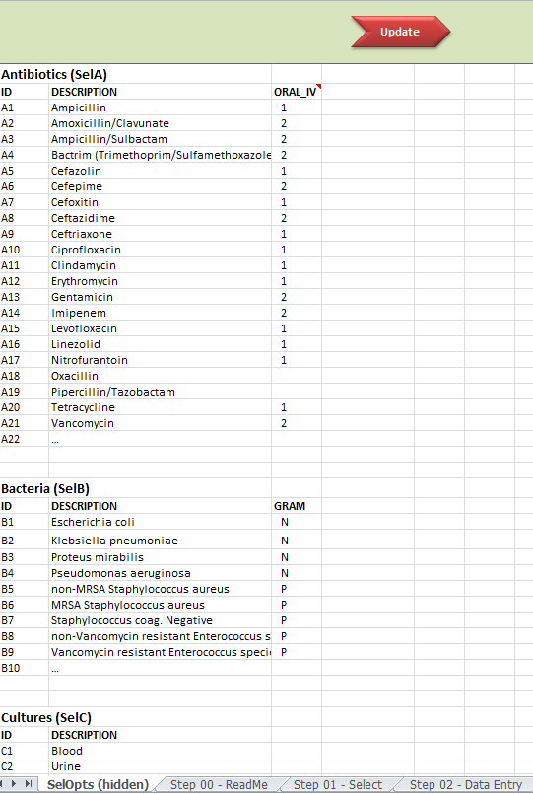

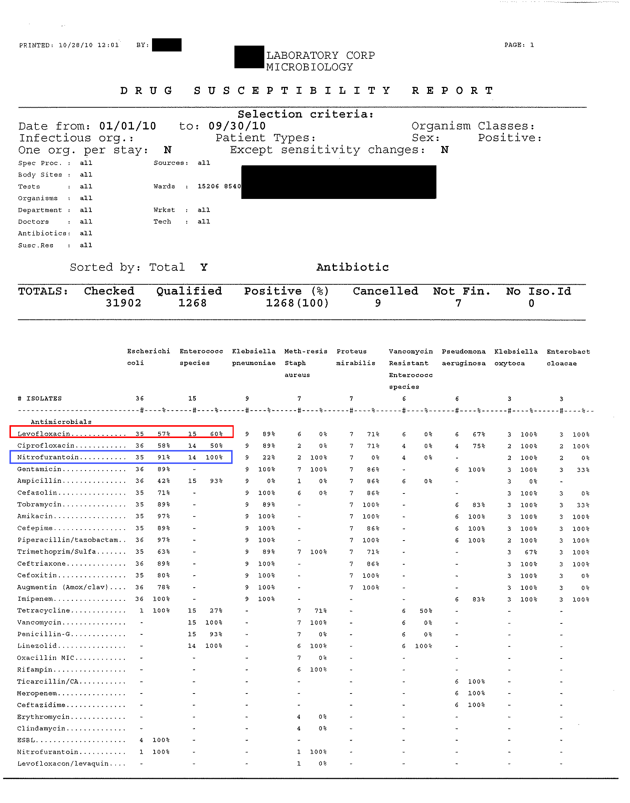
Note. The red box shows that this laboratory had 36 isolates of E. Coli and 35 were tested for levofloxacin, with 57 percent being sensitive; The blue box shows that the laboratory tested 35 isloates for nitrofurantoin and 91percent were sensitive.

The Antibiogram Program: Checklist for Identifying Nursing Home Specific Antibiogram Modifications

There is wide variation in the format of the antibiogram data that is provided by laboratories. The format can range from a report that is ready for use by the nursing home with only minor editing; to a series of data results that must be computed and incorporated into a table (see Antibiogram Development Tool). This checklist is designed to be used as a tool to help the nursing home make general modifications to the laboratory-generated antibiogram.

Sample Sizes Considerations | Remove bacteria with fewer than 10 isolates in the reporting period. | Yes | No
Sample Sizes Considerations | Place an asterisk by bacteria with between 10 and 30 isolates in the reporting period, and insert disclaimer that organisms with less than 30 isolates should be interpreted with caution (see Antibiogram Specifications Document). | Yes | No
Stratify by Source | Urine | Yes | No
Stratify by Source | Blood | Yes | No
Stratify by Source | Sputum | Yes | No
Stratify by Source | Wound | Yes | No
Review Presentation | Review clinical prescriber preferences (e.g., list only preferred abbreviations). | Yes | No
 | Present summary findings on reverse side | Yes | No
 | Group antibiotics by route of delivery (e.g., oral, IV) | Yes | No
 | Present alphabetically regardless of route | Yes | No

Nursing Home Name / Clinical Laboratory Name
Antibiogram for dd/mm/yyyy to dd/mm/yyyy
 | Gram Negative |  |  |  |  |  | Gram Positive
Antibiotic Tested |  | Escherichia coli | Klebsiella pneumoniae | Proteus mirabilis | Pseudomonas aeruginosa |  | Staphylococcus aureus  nonMRSA | MRSA † |  |  |  | Staphylococcus coag. Neg | Enterococcus sp
# of Isolates‡ |  | 165 | 75 | 39 | 33 |  | 10* | 35 |  |  | 18 | 68
Oral or Oral Equivalent |  |  |  |  |  |  | Oral or Oral Equivalent
Ampicillin |  | 46% | 0% | 62% |  |  | 50% |  |  | 0% | 50% | 96%
Amox / Clav |  | 77% | 96% | 100%
Cefazolin |  | 70% | 93% | 88% |  |  | 100% |  |  | 0% | 50%
Cefoxitin |  | 82% | 100% | 100%
Ceftriaxone |  | 85% | 79% | 92%
Ciprofloxacin |  | 58% | 79% | 62% | 56% |  |  |  |  | 0% | 0% | 47%
Levofloxacin |  | 59% | 79% | 62% | 57% |  | 33% |  |  | 20% | 0% | 64%
Nitrofurantoin |  | 100% | 0% | 0% |  |  | 100% |  |  | 100% | 100% | 100%
TMP / SMX |  | 64% | 79% | 54% |  |  | 67% |  |  | 100% | 100%
Tetracycline |  | 64% | 60% | 0% |  |  | 100% |  |  | 100% | 80% | 38%
Oxacillin |  |  |  |  |  |  | 100% |  |  | 0% | 50%
Clindamycin |  |  |  |  |  |  | 50% |  |  | 50% | 100%
Erythromycin |  |  |  |  |  |  | 50% |  |  | 0% | 0%
Linezolid |  |  |  |  |  |  | 100% |  |  | 100% |  | 100%
IV Only |  |  |  |  |  |  | IV Only
Pip / Taz |  | 98% | 96% | 100% | 100%
Cefepime |  | 89% | 95% | 92% | 91%
Ceftazidime |  |  |  |  | 91%
Gentamicin |  | 85% | 83% | 92% | 91% |  | 100% |  | 100% |  | 67%
Imipenem |  | 100% | 100% | 100% | 71%
Vancomycin |  |  |  |  |  |  | 100% |  | 100% |  | 100% | 100%
* Organisms with fewer than 30 isolates should be interpreted with caution, as small numbers may bias the group susceptibilities
† MRSA = Methicillin-resistant Staphylococcus aureus, represents a subset of all Staphylococcus aureus isolates
‡ N= pooled isolates by species from urine, wound, sputum and blood specimens
Abbreviations: PIP/TAZ = Pipercillin/Tazobactam; TMP/SMX= Trimethoprim/sulfamethoxazole ;Amox/Clav = Amoxicillin/Clavunate
Please direct questions to: [Program champion name, phone, e-mail].
[NURSING HOME NAME] Key Antibiogram Findings from dd/mm/yyyy to dd/mm/yyyy)

THE FOLLOWING IS SAMPLE TEXT TO BE EDITED BASED ON THE NURSING HOME’S ANTIBIOGRAM

- Most of our data comes from urine cultures: Of XXX cultures used to make the antibiograms, XX % were urine cultures, YY% were wound cultures, and ZZ% were sputum cultures. The antibiograms will be most applicable when selecting antibiotics to treat urine infections and systemic infections that may have come from the urine.

- The leading organisms for positive urine cultures were:
  - E. coli: XX% of urine cultures
  - Enterococcus species: XX %
  - Klebsiella pneumoniae: XX%
  - Proteus mirabilis XX %

- All antibiotics are not tested -- one antibiotic from each class is usually tested. Antibiotics from the same class are likely to have similar resistance patterns, for example with cephalosporins:
  - 1st generation: cefazolin (Ancef) was tested; a comparable oral agent is cephalexin (Keflex).
  - 2nd generation: cefoxitin (Mefoxin) was tested; a comparable oral agent is cefuroxime (Ceftin).
  - 3rd generation: ceftriaxone (Rocephin) was tested; a comparable oral agent is cefpodoxime (Simplicef, Vantin).

Urinary tract infections (UTIs) from Gram Negative Organisms
- XX % of positive urine cultures were due to gram-negative organisms.
- Significant resistance to commonly used antibiotics is seen among the gram-negative organisms that frequently cause UTIs (E. coli, Klebsiella):
  - TMP/SMX (Bactrim) sensitivity for E. coli is limited (XX %)
  - Quinolones sensitivity for E. coli is limited (levofloxacin [Levaquin] XX %, ciprofloxacin [Cipro] XX %)
  - First-generation cephalosporins sensitivity for E. coli is limited: cefazolin (Ancef) XX %.
- Nitrofurantoin (Macrobid) has good sensitivity for E. coli (XX %), but poor activity against other urinary pathogens.

Gram positives
- XX of XX (XX %) Staph aureus cultures were MRSA.
- MRSA was XX % sensitive to TMP/SMX (Bactrim), and XX % sensitive to clindamycin (Cleocin).

Chapter Three

Phase 3. Implementation
After the antibiogram has been developed, the nursing home team will need a plan for how the program will be introduced and sustained. Nursing home management will decide if a new policy is required; if so, this must be developed and communicated. Procedures to cover the roles and responsibilities of key staff as well as the multiple operational processes involved will be necessary. The procedures developed for the antibiogram program will serve as the foundation for implementing the program and will require input from all members of the antibiogram team (i.e., nursing, Medical Director, administration). During the implementation phase the nursing home team will also develop a timeline for rolling out the antibiogram (if not already developed during the planning phase), development of training materials for clinical staff, training for all staff affected and the initial implementation.
Timeframe: Preliminary work on program procedures should begin after the decision to move forward has been made but before the antibiogram is complete. The team will need to consider the nursing home’s unique characteristics, needs, and resources to develop the new policy (if needed) and procedures. Training should be conducted just prior to implementation.
- A sample timeline is included in the Materials Section of Chapter 2, Assessment and Planning.

Action Checklist

Policy and Procedures
- If a new policy is required, it should include a statement of the nursing home’s commitment to quality care, the goal of the antibiogram, implementation of the program, and date of issue.

- Draft procedures should include a statement of the purpose and scope of the program, the identification of the person/position responsible for the procedure, the procedure itself, and the required documentation signed by the person authorizing the procedure. The draft procedures should cover:

  - Development of the antibiogram
  - Communication of the antibiogram to clinical prescribers and hospital emergency departments
  - Training (initial and ongoing) for nursing staff and clinical prescribers
  - Quality monitoring

- Arrange for a review by management of the policy (if developed) and procedures and make any revisions required.

- Set the date for the adoption of the policy (if developed) and procedure, and communicate the policy and procedures to clinical prescribers and nursing home staff.

  - Draft a letter to clinical prescribers containing background information on antibiograms, the timeline for implementation, a copy of the policy and procedures, and plans for training sessions. Check with the Medical Director to identify all physicians/nurse practitioners who care for the nursing home’s residents as well as those who cover for regular physicians/nurse practitioners to arrange for training on the use of antibiograms.

- Inform nursing (and nursing support) staff of the new policy/procedures at a regular staff meeting (or through whatever means the nursing home uses to communicate to the nursing staff). Arrange time for a nursing in-service training on antibiograms and the new procedures that will be employed. It is expected that this training will require 10 minutes.
- Develop training materials (see below) and handouts that can be used by shift supervisors to reach all staff.

- Sample policy and procedure documents are included in the Materials Section of this chapter.

Development and Delivery of Training Materials
- Antibiogram training should be delivered as in-person educational sessions. Presenters could include the nurse educator and/or the Infection Control Nurse to train the nursing staff, and the Medical Director to train the clinical prescribers. Opportune times to hold a training session include during in-service training for nurses and during monthly staff meetings for physicians/nurse practitioners. The training sessions should be scheduled following program development and creation of new policy and procedures (if needed), and prior to program implementation. Inclusion of the following materials is recommended for use during nurse and clinical prescriber training sessions.

Fact Sheet
- The training materials for both the nursing staff and/or the clinical prescribing staff should include a one-page fact sheet to introduce the antibiogram program. The fact sheet should briefly describe what an antibiogram is, how it will be created, and why it is important. It should also mention the potential impact of implementing the program.

- A sample factsheet is included in the Materials Section of Chapter 2 and this Chapter for convenience.

Power Point Presentation
- Training materials should also include an in-person, step-by step, detailed presentation of the antibiogram program, specific to the nursing home. Since this presentation is the backbone of the training session for both nurses and clinical prescribers, it should be presented in a clear and organized manner. The trainer (e.g., nurse educator for nursing staff, Medical Director for clinical prescribing staff) should preferably organize and deliver the detailed description of the antibiogram program as a PowerPoint Presentation. The content of the presentation should include a discussion of the what and why of antibiogram use, and should include instructions on how to read and utilize the nursing home-specific antibiogram report. If new policy and procedures have been developed for this program, communication of these can be included in the Power Point Presentation. The trainer should allow approximately 30 minutes (60 minutes if new policy and procedures are included) to present the material, including answering any questions.

- Sample nurse and clinical prescriber PowerPoint Presentations are included in the Materials Section of this chapter.

Nursing Home Vignettes
- The final recommended component of the training materials is a series of four vignettes that serve as a learning tool for clinical prescribers. The vignettes describe common nursing home clinical situations that physicians/nurse practitioners/physician assistants may face in the nursing home setting. The clinical prescribers are presented with the vignettes, and asked to make clinical prescribing decisions based on the information. They are then asked to discuss their rationale for the antibiotic decisions that they made. Next, clinical prescribers are presented with the same vignettes but in the second round, they are asked to refer to an antibiogram when making their clinical prescribing decisions. Once again, they are asked to discuss their prescribing decisions. This time they are also asked to discuss the difference in their decisionmaking based on the use of the antibiogram. Two of these vignettes are included in the Training Slides for Clinical Prescribers. They are provided here for use as worksheet handouts.

- Sample vignettes and discussion questions are included in the Materials Section of this chapter.

Dissemination of the Antibiogram

Nursing Home Web Site
- If the nursing home has a Web site or intranet, uploading an image of the most current antibiogram ensures that doctors and nurses have a permanent, accessible place to find relevant nursing home information before prescribing antibiotics to a resident. It also allows nursing home directors to provide the Web site hyperlink when they send periodic emails to clinical prescribers reminding them of the antibiogram, or when sending the newest version of the antibiogram. One issue to consider is whether to post the antibiogram on the nursing home’s external Web site or internal intranet. As the antibiogram does not contain identifiable resident information, there is no restriction to placing it on an external Web site. In addition, having it on an external Web site will allow offsite clinical prescribers, such as on-call physicians/nurse practitioners and emergency department physicians to access the antibiogram. While every nursing home Web site employs different Web styles and themes, the recommendations listed below can assist in making the Web site antibiogram operate most effectively. Consider the following when disseminating the antibiogram on the nursing home’s Web site:

  - One Web page devoted specifically to the antibiogram so that it is not lost among other information.
  - A link on the main page of the nursing home Web site or, the employee homepage, so that the link is prominent and easy to find.
  - A hyperlink to the antibiogram Web page that is easy to remember. For instance, http://www.[yournursinghomesite].com/antibiogram. This could be especially useful if an emergency department clinician needs to locate the nursing home’s antibiogram.
  - Uploading the antibiogram as an image, in a PDF, rather than a table that is posted directly on the Web site in html form. This will allow greater flexibility in sizing and pose fewer formatting differences across computer screens.
  - A left-aligned antibiogram Web page. If the Web site employs a side menu bar on the left side of the screen, it may be worth removing so that the antibiogram can be viewed on the page without scrolling left and right, as table cells will be more difficult to align when row headers are out of view. If the left side menu cannot be removed, consider splitting the tables so that the antibiogram is wide enough to be viewed without scrolling left to right (see pocket card for possible formatting).
  - Offer the option to download a copy of the antibiogram from the Web site. Having a download link for a PDF version allows clinical prescribers or nurses to save the antibiogram to their computer or print off another hard copy, giving them access to information offline. Some facilities may find that having a direct link URL for antibiogram downloads is a better option than creating and formatting a Web page that displays the antibiogram on the page.
  - Include a copy of the antibiogram fact sheet on the Web site.

Pocket Card
- Antibiogram information can also be distributed as a pocket card to clinical prescribers, so that they may carry it on their person for easy access to aggregate nursing home antibiotic information. Pocket cards should be printed on heavy paper or cardstock for durability. Nursing home staff may elect to produce and share with their clinical prescribers, a short version of the antibiogram pocket card in which the antibiogram alone is presented. Because it contains only the report itself, this version can be produced as a credit-card size card with only one fold. However, the details and explanation of the antibiogram are not included on the short version and would have to be referenced elsewhere. Alternatively, nursing home staff can produce and share a long version of the pocket card that includes the antibiogram as well as detailed information about the report. This version is also produced as a credit-card size card but requires two folds. The detailed information that is contained on the long version of the pocket card will be filled in by the nursing home and be specific to the antibiogram that appears on the pocket card.

- Short and long versions of sample pocket cards are included in the Materials Section of this chapter.

Email
- Emails should be sent to all clinical prescribers at regular intervals to remind them that the nursing home has implemented the antibiogram program. The email should include the antibiogram as an attachment, as well as a hyperlink to the nursing home antibiogram Web page if one has been created. A high priority email should be sent when a new antibiogram is available (often annually) with the message indicating that the old antibiogram should be discarded and replaced with the new antibiogram.

- Information that should be conveyed in the email to clinical prescribers includes:

- Nursing home name
- Period for which the antibiogram is valid
- Description of the antibiogram
- Contact person at the nursing home
- Links (if applicable) for Web and/or mobile download URL

- A sample email to clinical prescribers is included in the Materials Section of this chapter.

Smart Phone Application
- A smart phone application would allow clinical prescribers to access the antibiogram on their cellular phones, providing them with a convenient way to access the nursing home’s aggregated antibiotic data. Smart phones are increasingly used by prescribing clinicians at nursing homes and hospitals. However, there is not one particular platform across all cellular phones (i.e., Android, iPhone, or BlackBerry). Following is a description of three options that are currently available for smart phone applications:

  - SMS Application. An SMS application would allow the assigned nursing home staff to text a specific URL with a brief message to the appropriate prescribing clinician. The URL downloads the antibiogram directly as a PDF, instead of directing to a Web site. Clinical prescribers using smart phones would select the URL in the text, and the PDF would download and open. This would require: 1) posting the PDF on a Web site /Web page, 2) compiling and posting a list of clinical prescribers’ cell phone numbers, and 3) preparing a standard brief (<140 character) message, inclusive of the URL, to send to the clinical prescriber, e.g. "Please review the Shady Groves Nursing Home antibiogram here: http://www.shadygroves.com/ab.pdf." While this application has a relatively small start-up and operating cost, involving only the cost of sending and/or receiving messages, it may not be the most efficient or effective way to send this information to the clinical prescribers.
  - Downloadable application. A downloadable application (app) is another possible method for disseminating the antibiogram to clinical providers. Although our research found that developing a downloadable app to accommodate the antibiogram is feasible, it is not a practical approach for the vast majority of nursing homes. First and foremost, the cost to build an app is significant ($3,000-$10,000), and a separate system must be built for every mobile operating system (e.g., Blackberry, iPhone). In addition, there are practical limitations that should be considered such as the fact that app software will become obsolete as soon as the smart phone software is upgraded.
  - Mobile browser-enabled Web page. A mobile browser-enabled Web page is formatted specifically to enable viewing on the screen of an internet-ready cellular phone. The general recommendations for a Web page also apply to a Web page formatted for cellular phones. Whether the nursing home posts the antibiogram on the Web page or offers a URL for direct PDF download, the table will need to be sized for optimal viewing on a cellular phone. When considering the size of the table (and the formatting necessary), note that the size and quality of smart phone screens vary by vendor and model. It is recommended that rather than posting the antibiogram to the Web page, the nursing home create a URL for direct downloads. Having a direct download will allow prescribers to view the antibiogram offline, and will save staff from having to format the antibiogram and upload it to the mobile browser-enabled Web page.

Posting Hardcopies
- Antibiograms should be posted in the nursing home in convenient locations so that they are easily accessible when nurses call the clinical prescribers to discuss resident treatment. It is recommended that hard copies of antibiograms be printed on color card stock, so that they will be easily distinguishable from other reference documents, and laminated for durability. To reduce confusion over versions of the antibiogram, it is recommended that updated antibiograms be printed on color stock that is different than the previous version. Also, it is helpful to document the locations of where the antibiograms are posted so that old copies can be replaced as new versions are created.

- Following are options for where hard copies can be placed throughout the nursing home:

- By each phone in each nurses’ station
- At the front of every Medication Book
- In front of the doctors’ orders section of the medical record
- Stapled to the referral forms that accompany residents when they are transferred to the emergency department

Materials Included

Policy and Procedures
- Sample Policy Document

- Sample Procedures Document

Training Materials
- Antibiogram Fact Sheet

- Training Slides for Clinical Prescribers

- Training Slides for Nurses

- Sample Vignettes and Discussion Questions

Dissemination Materials
- Sample Pocket Card Short Version

- Sample Pocket Card Long Version

- Sample Email for Distribution of the Antibiogram

Phase 3: Policy and Procedures

The Antibiogram Program: Sample Policy

[NAME OF NURSING HOME]
Antibiogram Program
[DATE]
Antibiotics are among the most commonly prescribed pharmaceuticals in long-term care settings, yet reports indicate that a high proportion of antibiotic prescriptions are inappropriate. The adverse consequences of inappropriate prescribing practices including drug reactions/interactions, secondary complications, and the emergence of multi-drug resistant organisms have become more common. Inappropriate prescribing practices by primary care clinicians and overuse of newer, broad-spectrum antibiotics when either no antibiotic or an older narrow-spectrum drug would suffice are believed to be the primary contributors to this problem. As a result of the above complexities, nursing homes are increasingly recognized as reservoirs of antibiotic-resistant bacteria.
Antibiograms aggregate information for an entire institution over a period of several months or a year. They display the organisms present in clinical specimens sent for laboratory testing, and the susceptibility of each organisms to an array of antibiotics. Use of antibiograms help reduce reliance on broad-spectrum antibiotics as initial therapy, and lead to fewer clinical failures of antibiotics that are first prescribed.
To improve appropriate antibiotic use for the residents at [NAME OF NURSING HOME], the antibiogram program will be implemented on [DATE]. A facility-specific antibiogram will be made available to all prescribers on [DATE], prior to implementation.

[NAME AND TITLE OF AUTHORIZING OFFICER] [DATE]

The Antibiogram Program: Sample Procedures

[NURSING HOME NAME]
[DATE]
Purpose and Scope
This procedure covers the use of an antibiogram at [NURSING HOME NAME]. Antibiotics are among the most commonly prescribed pharmaceuticals in long-term care settings, yet reports indicate that a high proportion of antibiotic prescriptions are inappropriate. The use of antibiograms can help reduce inappropriate prescribing and lead to fewer clinical failures of antibiotics that are first prescribed.
Responsibility for implementing the Antibiogram
[Identify who will implement the procedure]
Procedures [ADD DETAILS SPECFIC TO FACILITY]
- Development of the initial and subsequent antibiograms
- Initial and ongoing training for nurses
- Introduction and ongoing communication with prescribers
- Monitoring the use of the antibiogram

Documentation
List any documents that will be used. Attach the antibiogram, training materials, quality improvement tracking documents.
Records
List any records that will be kept in conjunction with the program (for example, the infection control log).

[NAME AND TITLE OF AUTHORIZING OFFICER] [DATE]

Phase 3: Training Materials

The Antibiogram Program: Fact Sheet

Antibiograms Fact Sheet

What is an antibiogram?
Antibiograms aggregate information about susceptibility patterns of organisms to commonly prescribed antibiotics. They display the organisms present in clinical specimens sent by the clinician for laboratory testing, and the susceptibility of each organism to an array of antibiotics. Antibiograms are routinely prepared by hospital laboratories, over a period of months or years, but are not routine in the nursing home setting.
How will antibiograms be created?
The nursing home antibiogram will be generated by the nursing home’s contracted clinical laboratory, using the results from residents’ cultures collected at the nursing home over the past twelve to twenty-four months. The antibiogram will be formatted as a table that is easy for prescribers to read and utilize when making decisions about antibiotics for residents.
Why are antibiograms important?
Antibiotics are among the most commonly prescribed pharmaceuticals in long-term care settings, yet research indicates that a high proportion of antibiotic prescriptions are inappropriate. The adverse consequences of inappropriate prescribing practices are serious and have become a major public health concern. Using an antibiogram to guide empiric antibiotic selection can help improve the likelihood that the antibiotic will be effective even before the bacteria have been identified by the laboratory.
What is the potential impact of using antibiograms?
Research has shown that the use of antibiograms can result in reduced reliance on broad-spectrum antibiotics as initial therapy, and fewer clinical failures of antibiotics that are first prescribed.

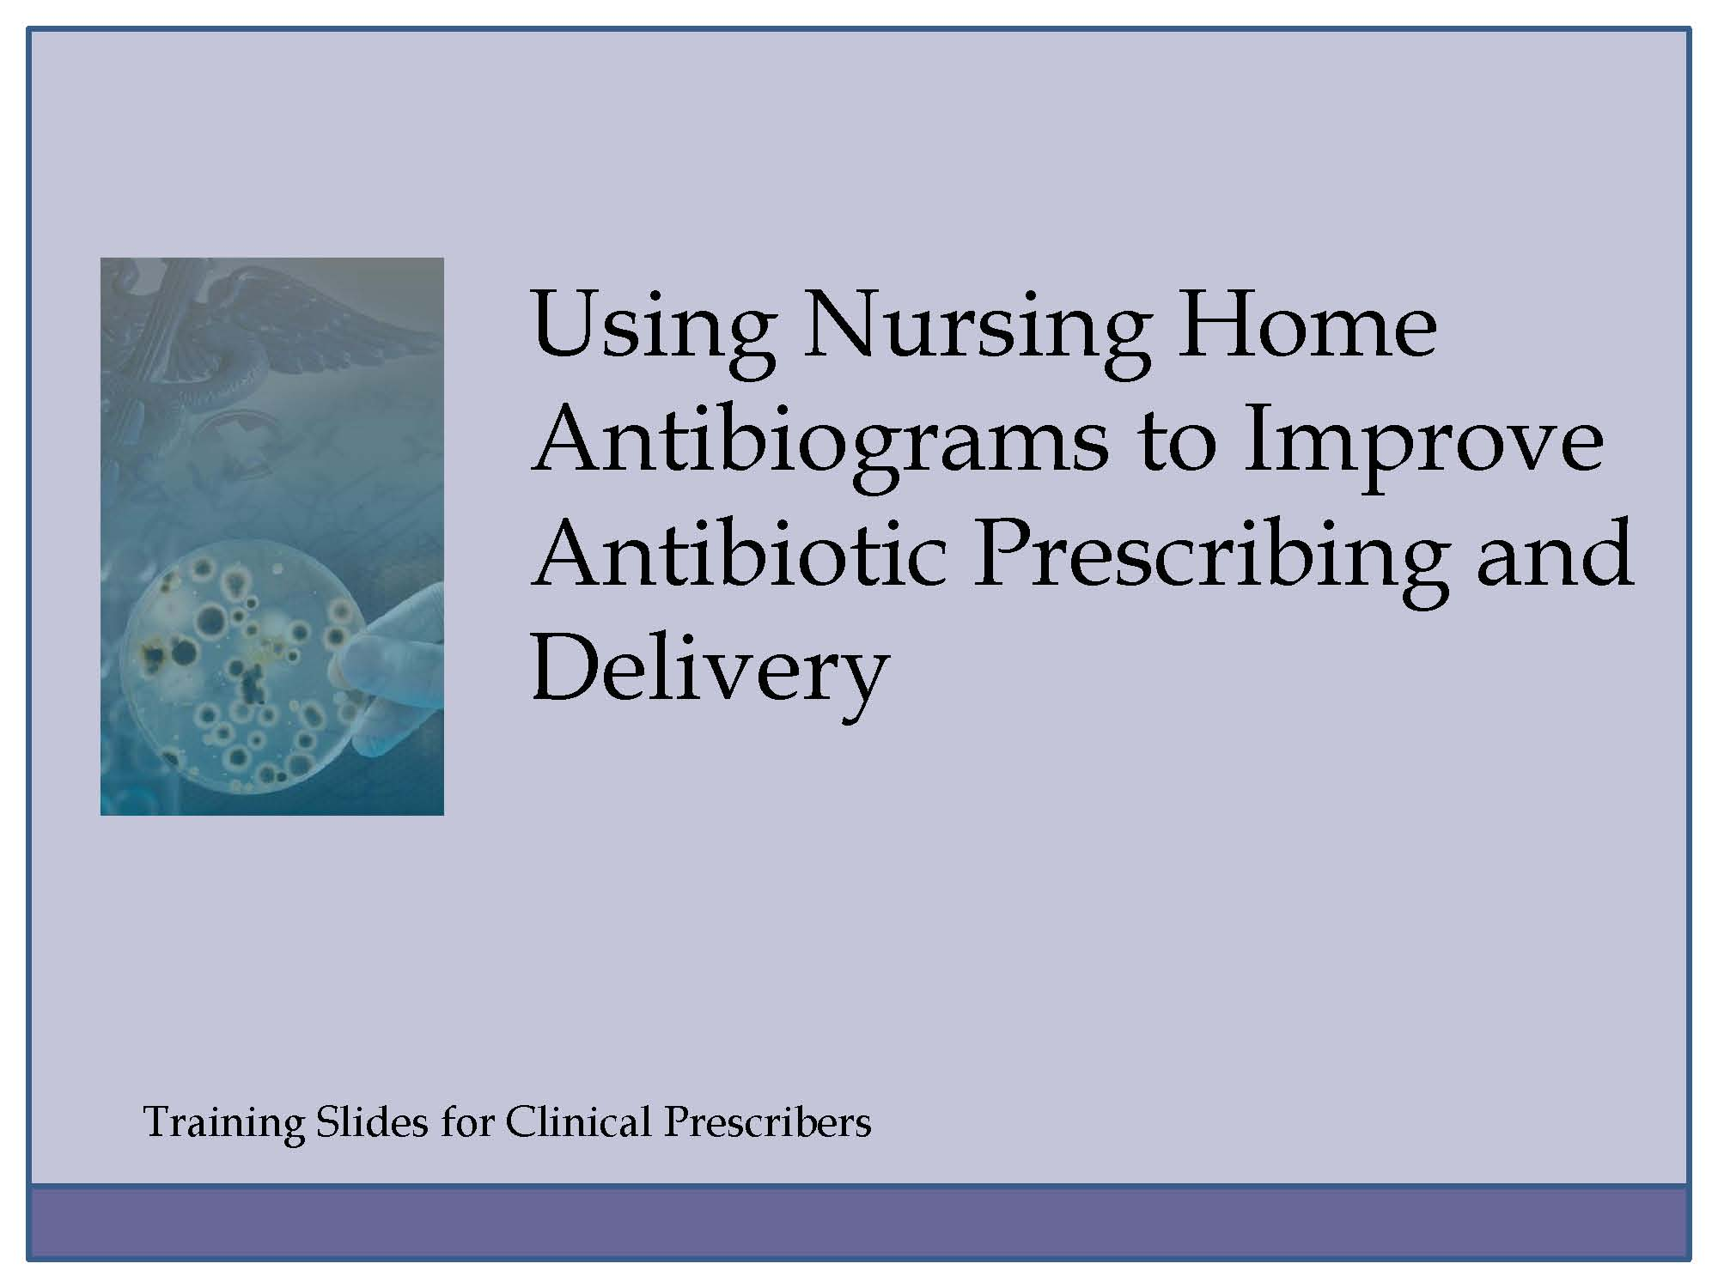
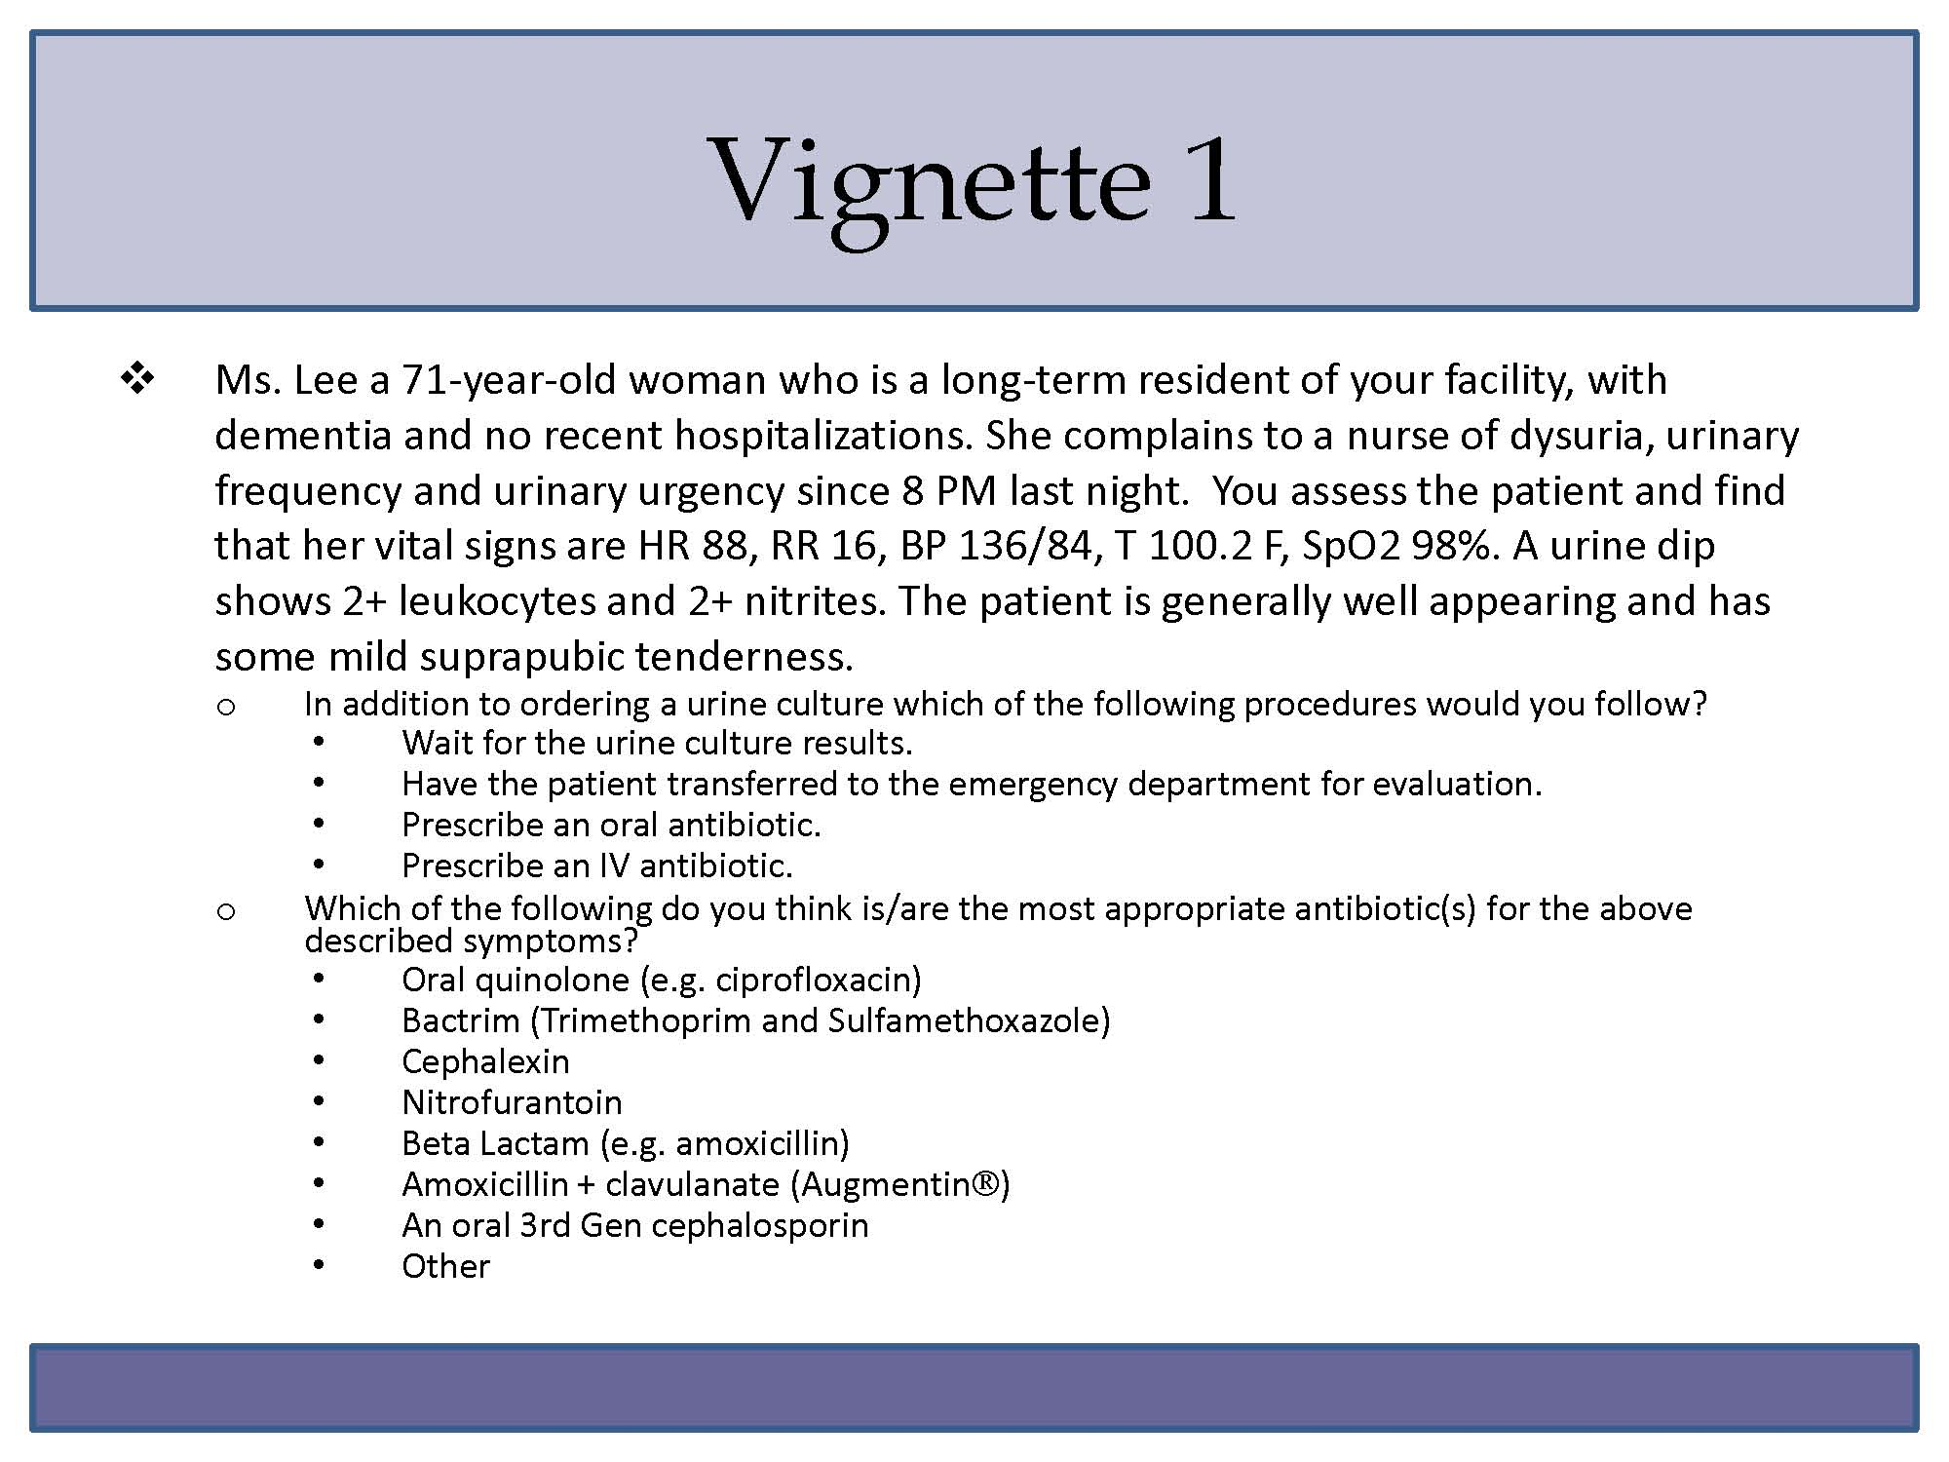
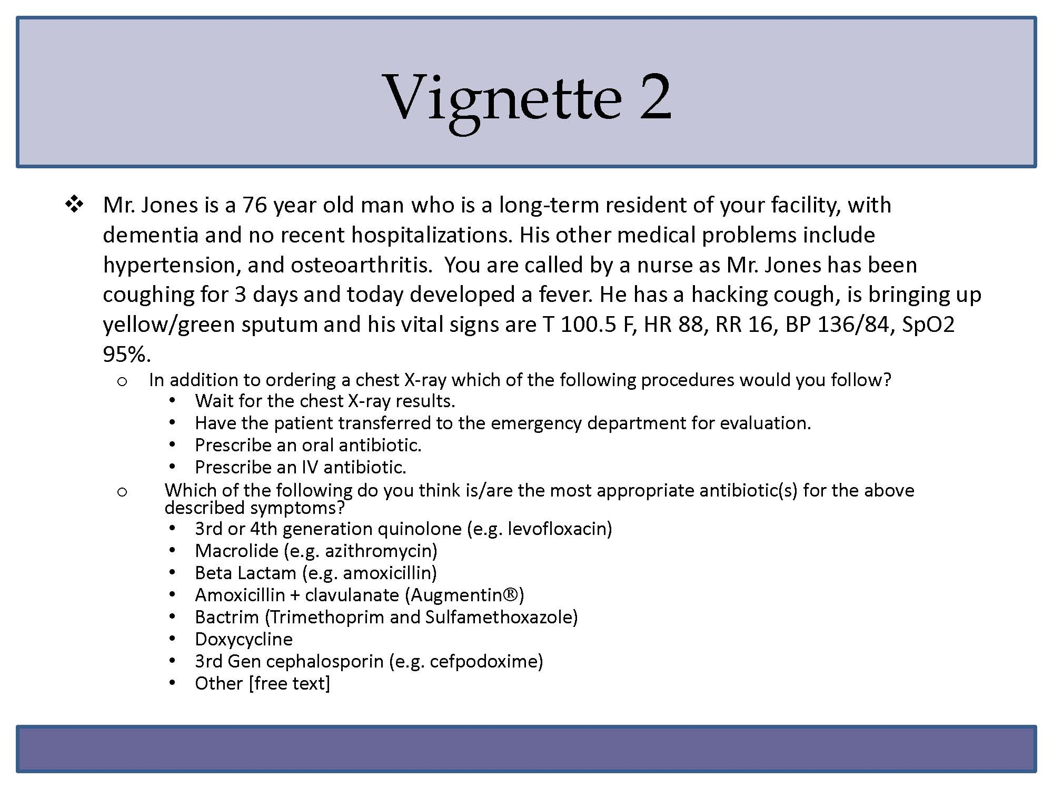
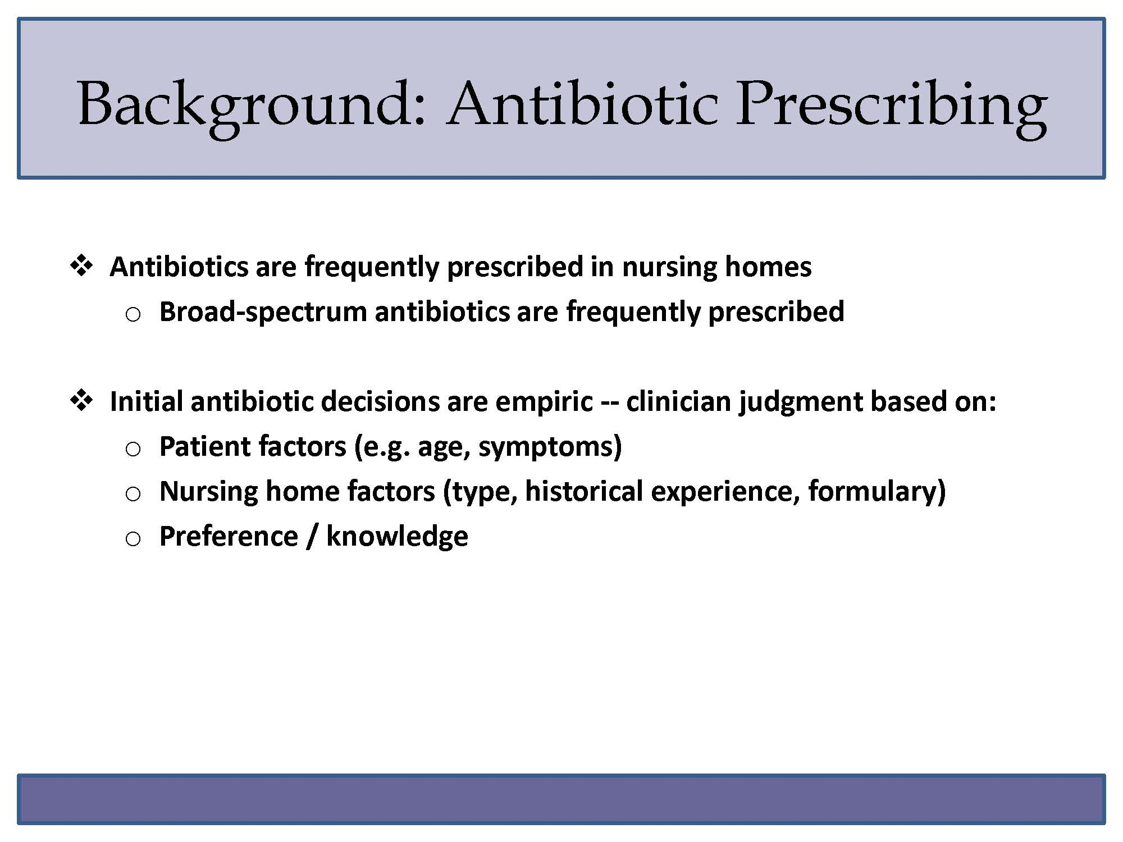
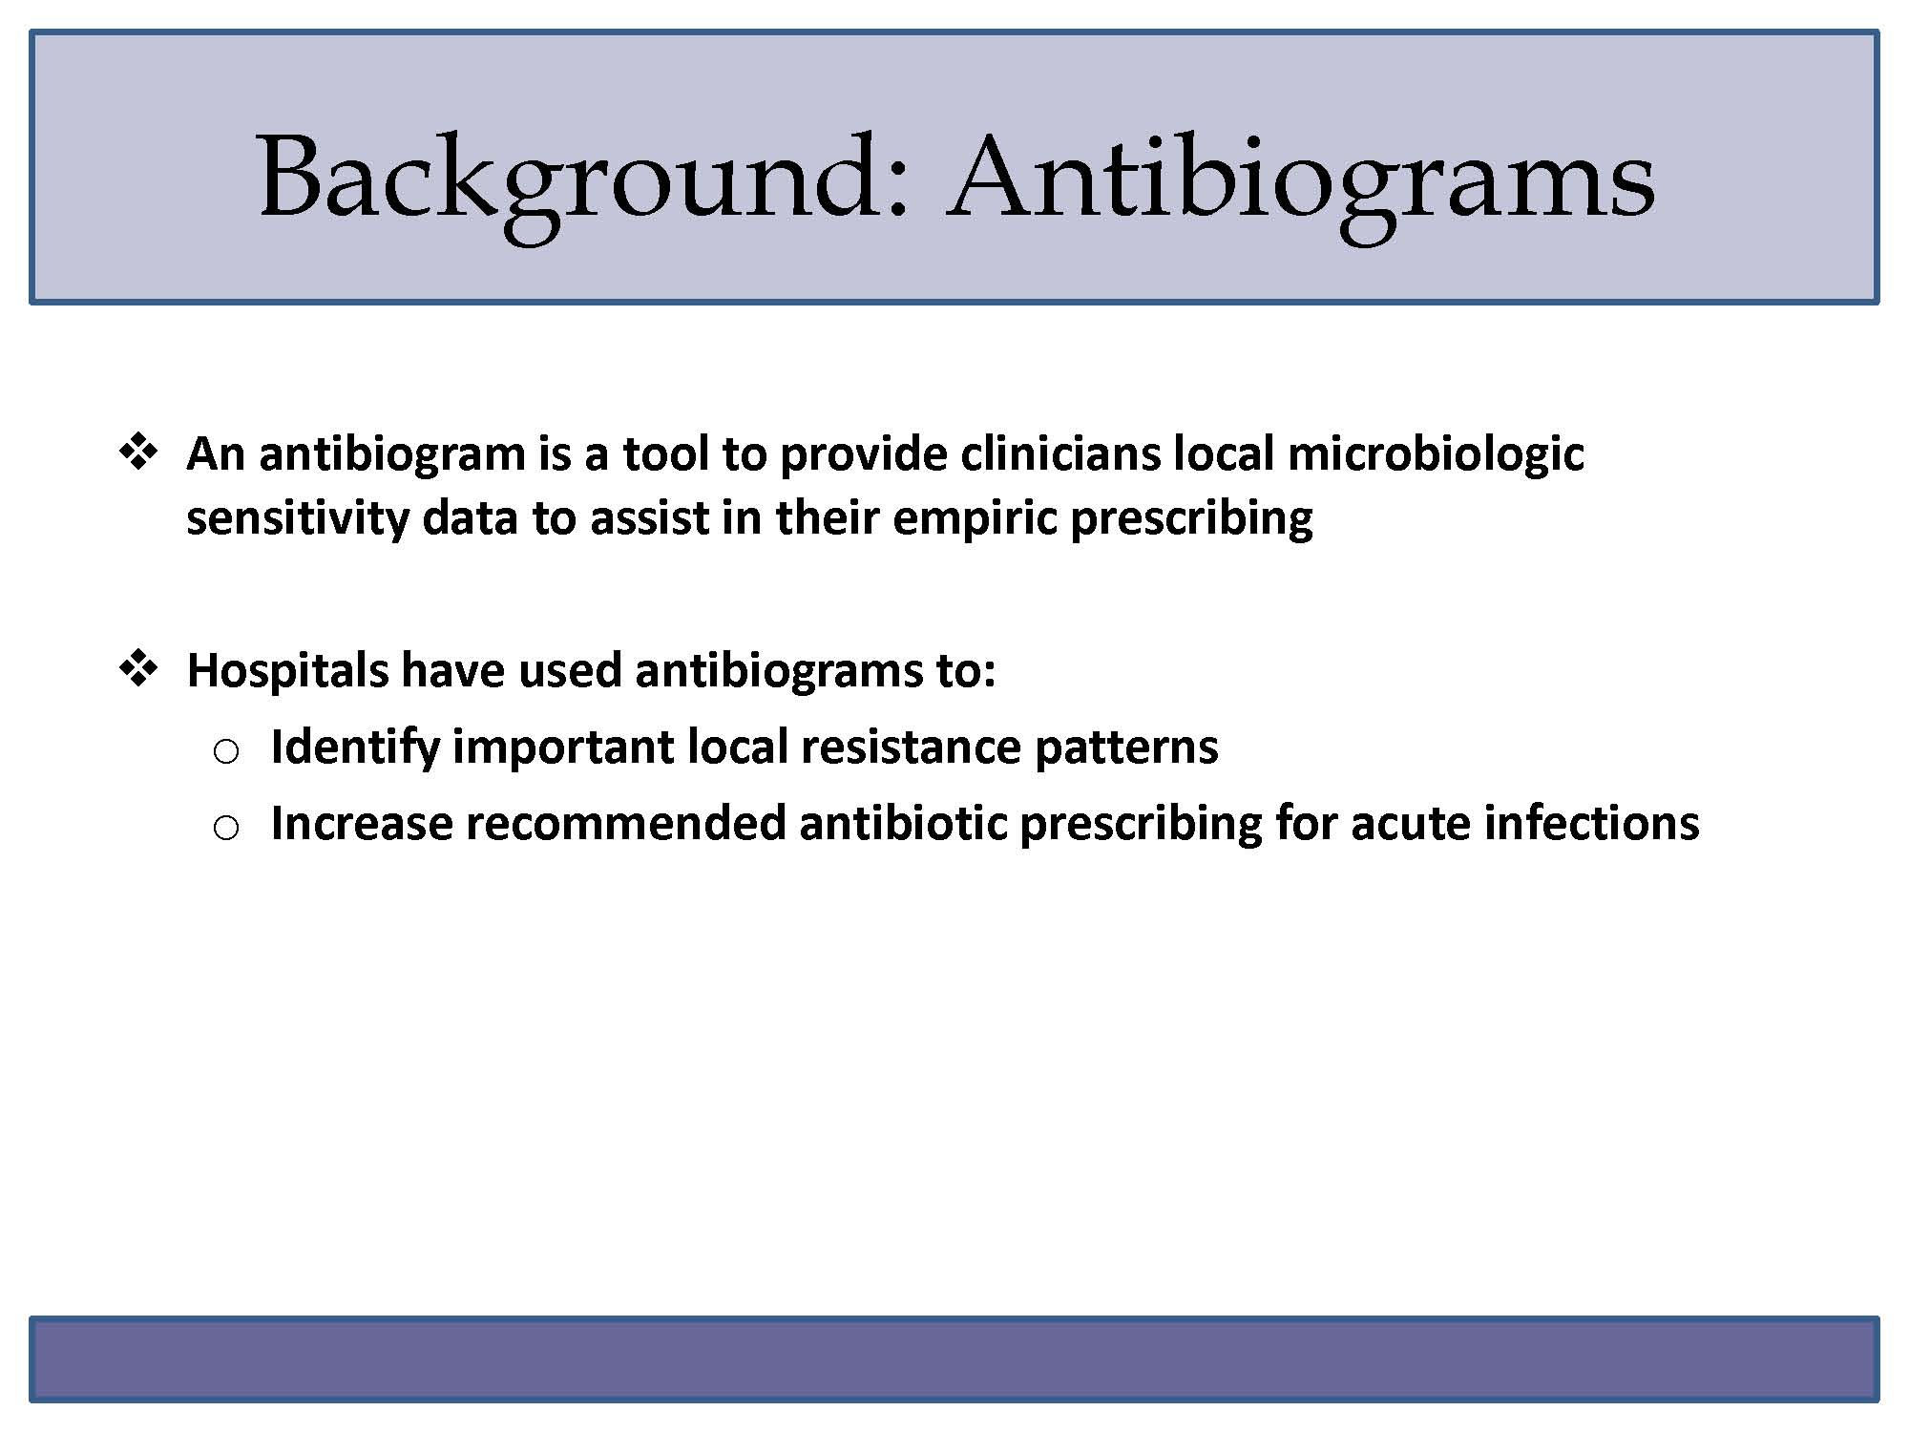
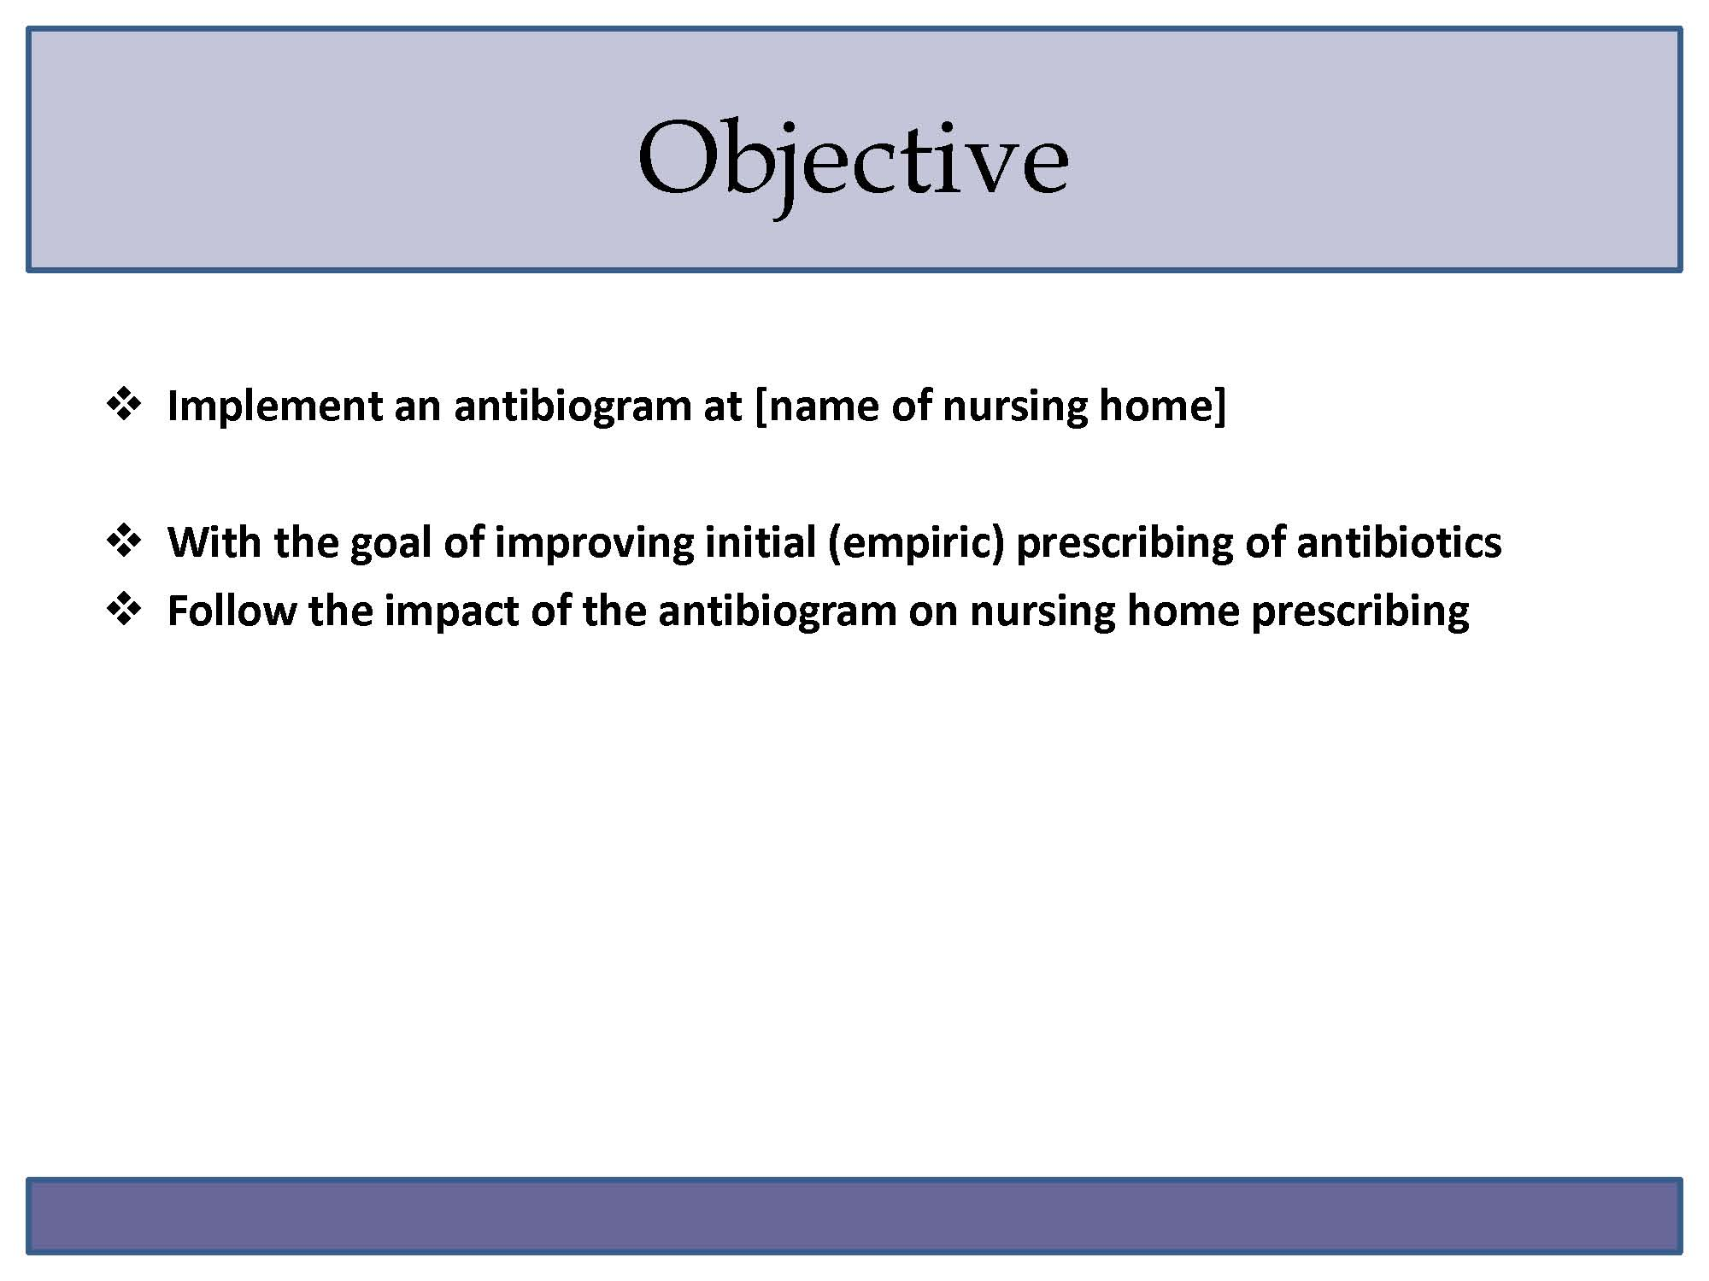
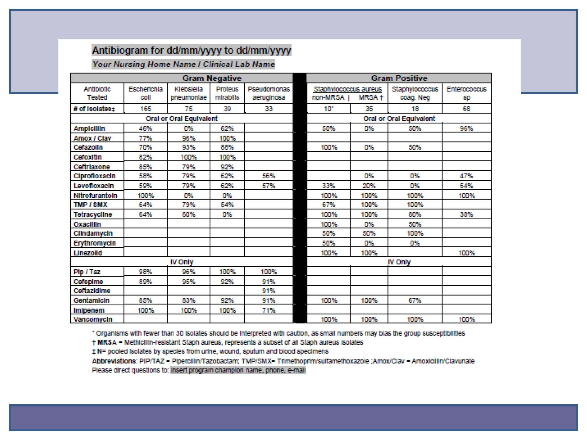
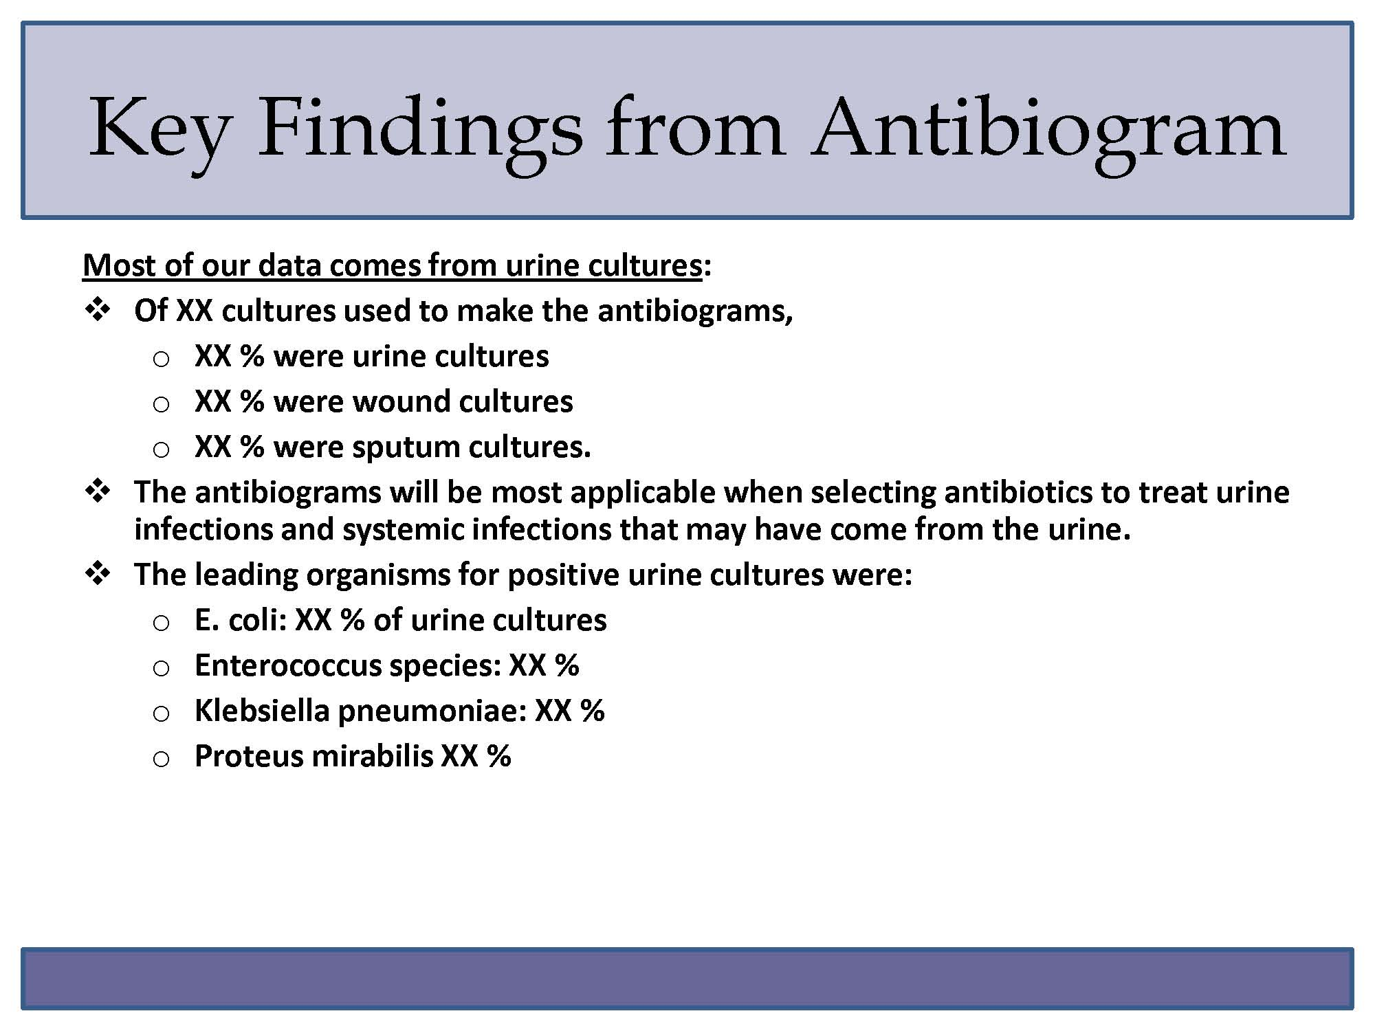
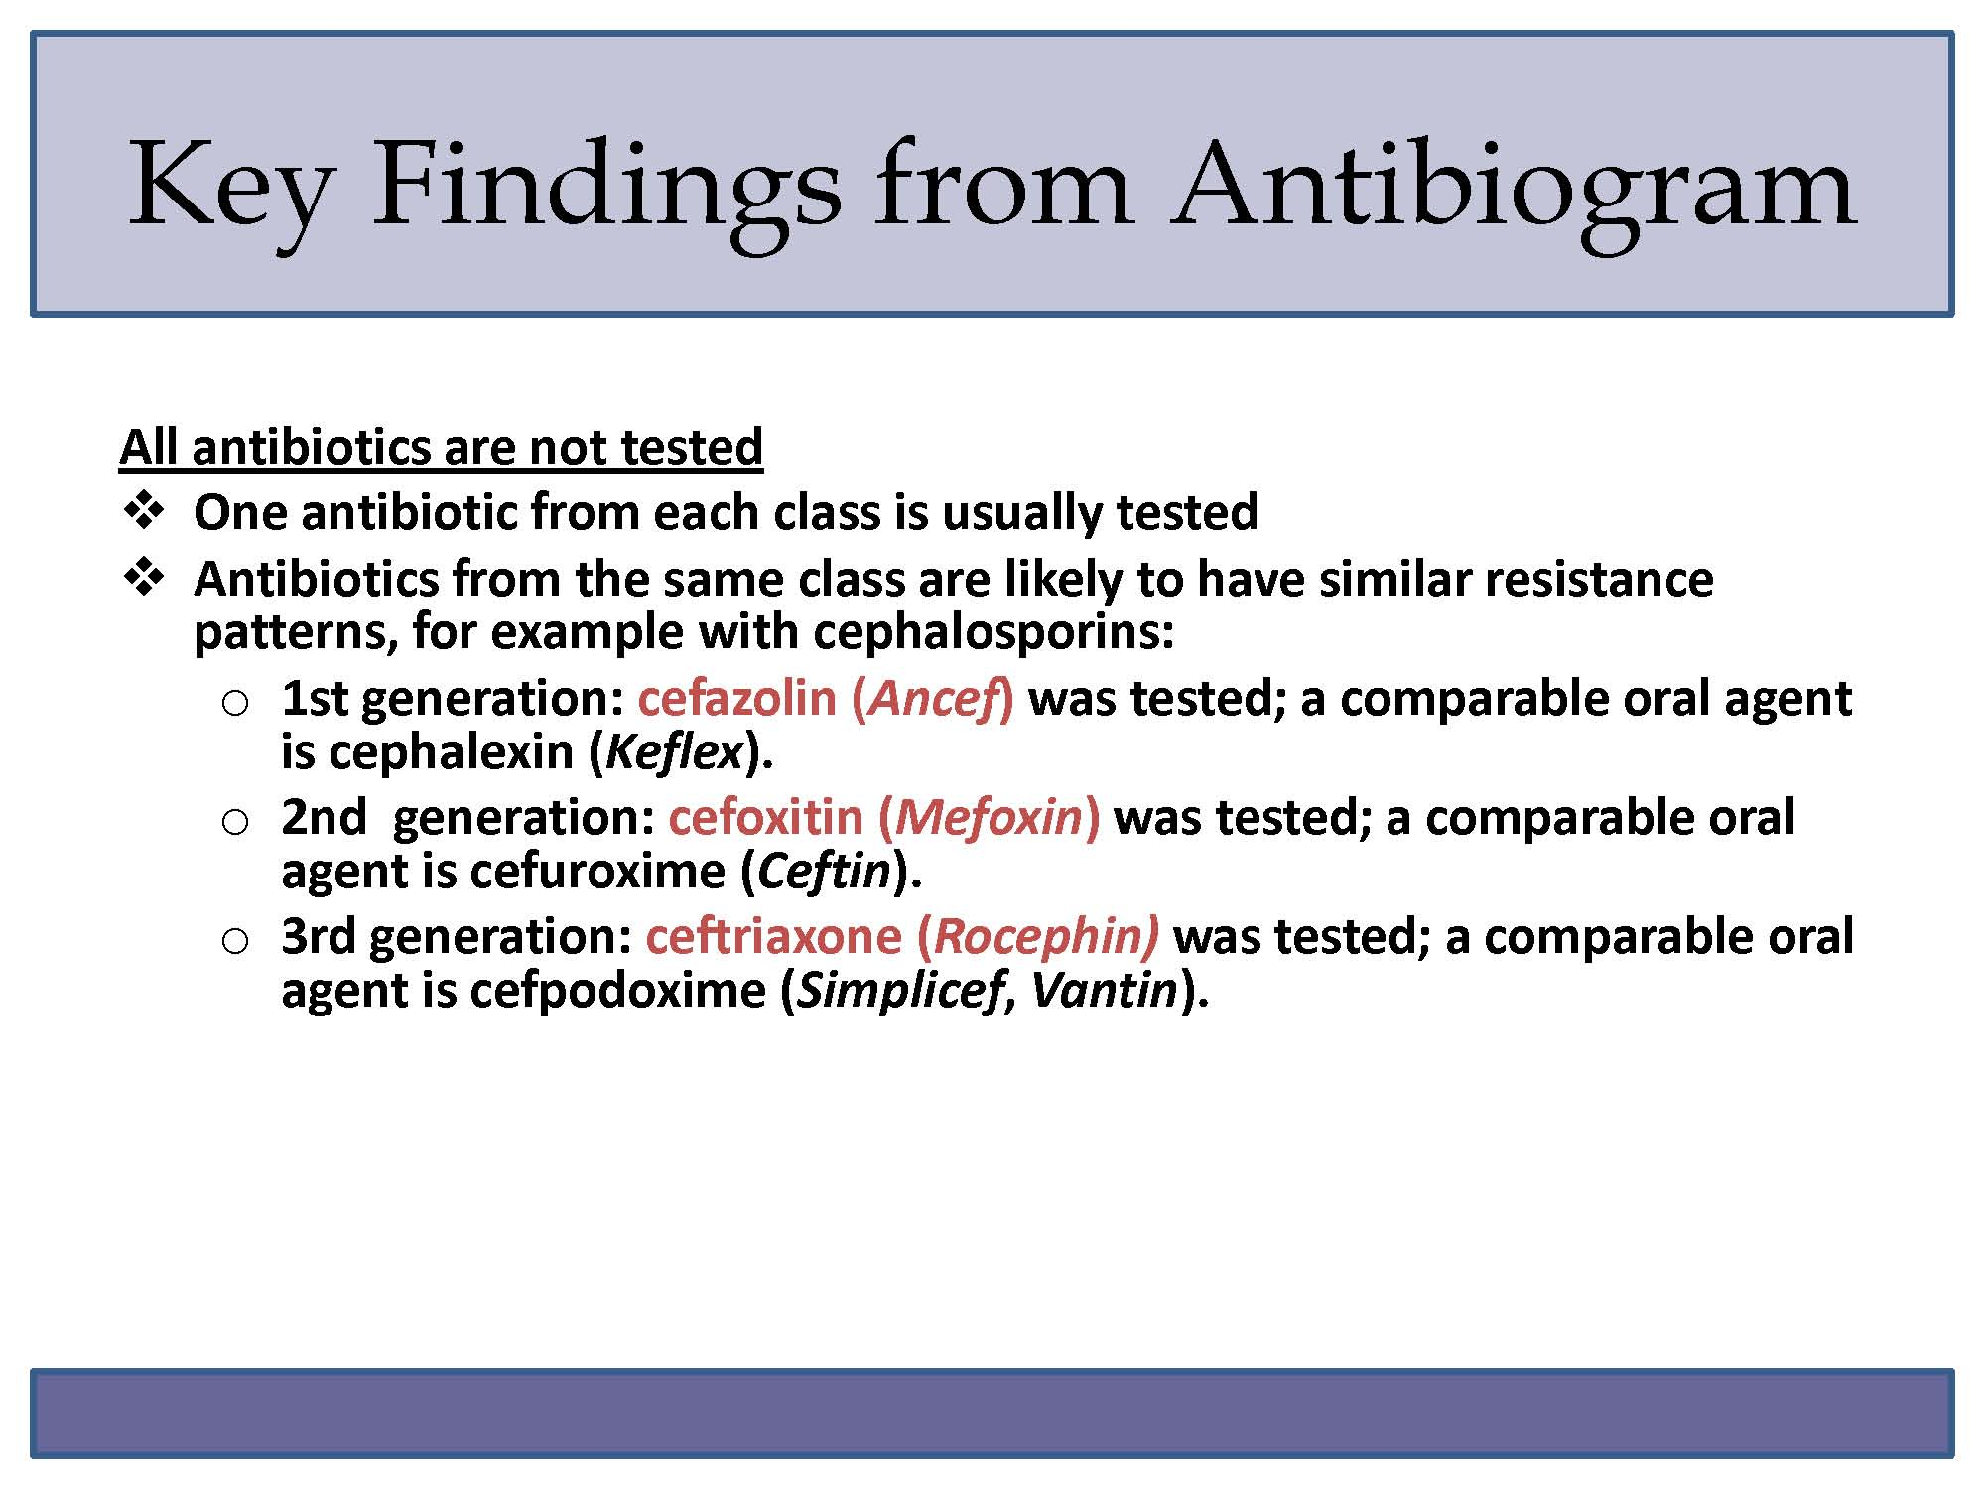
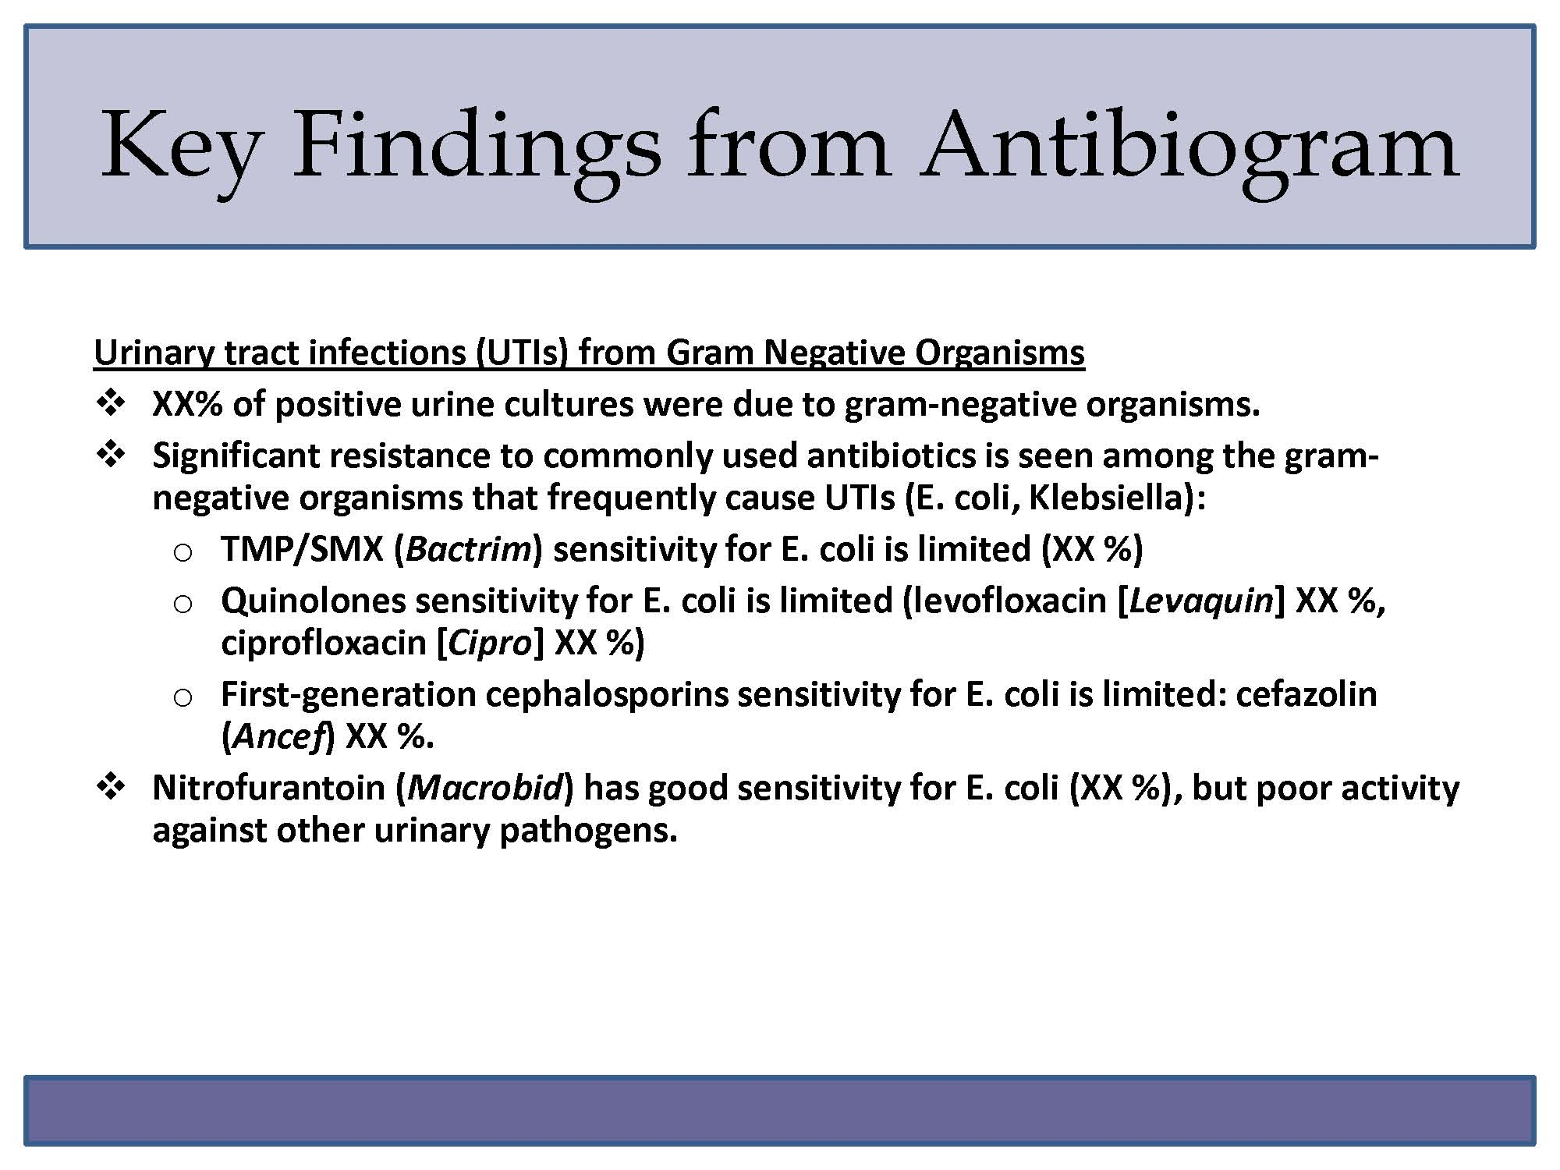
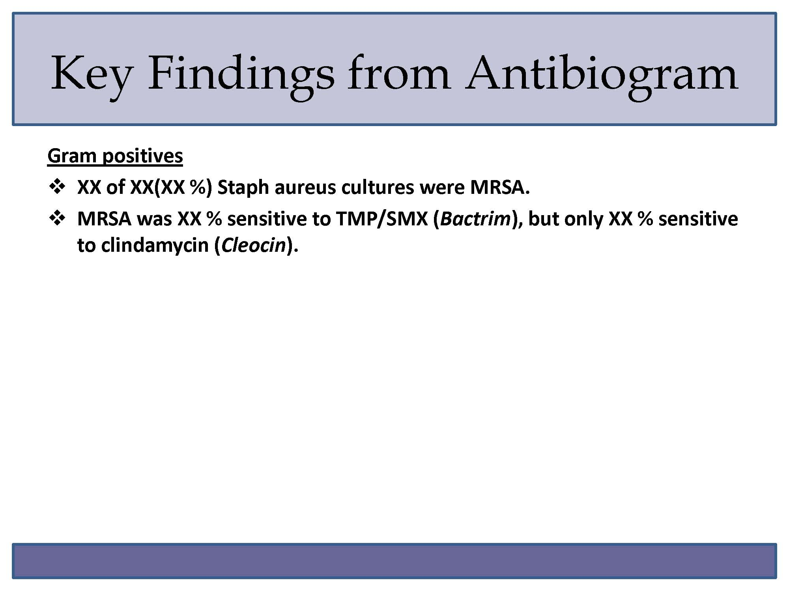
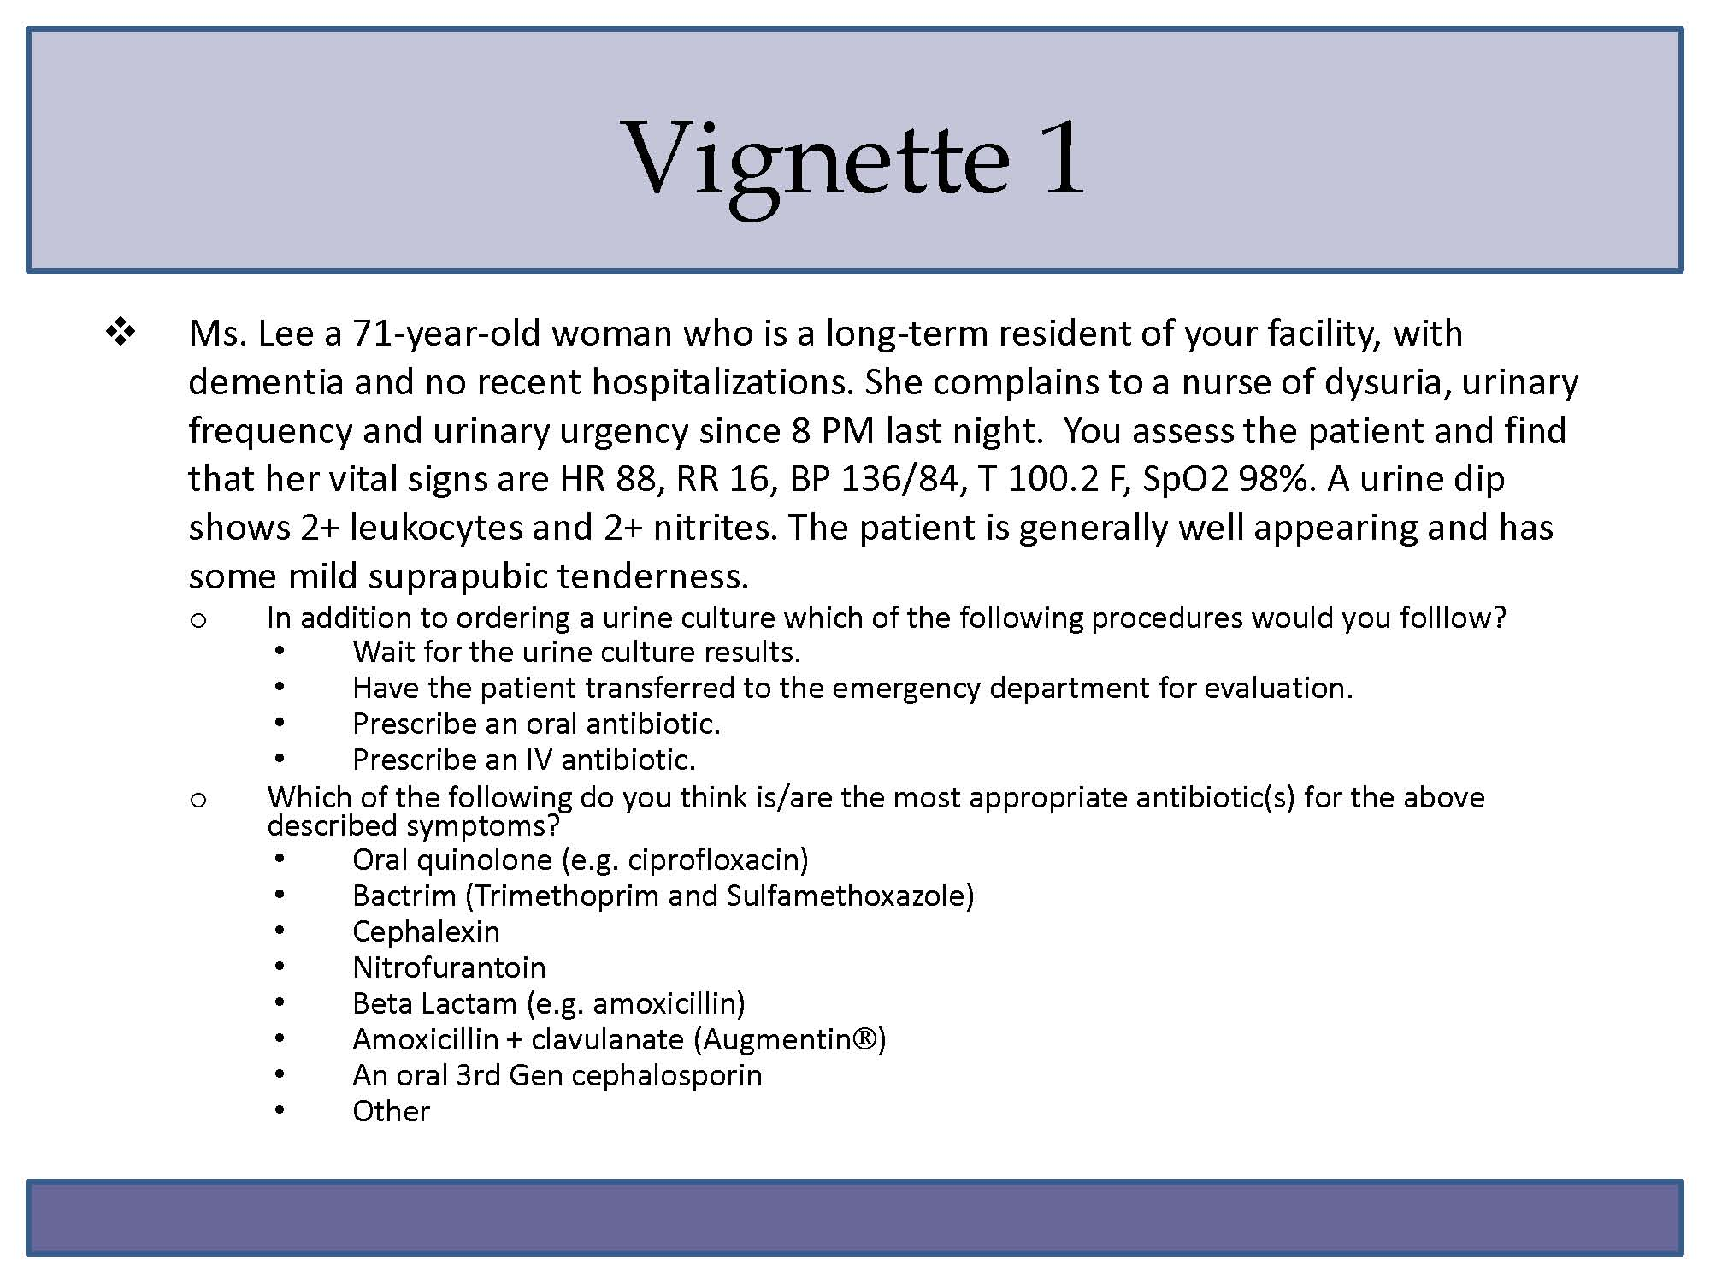
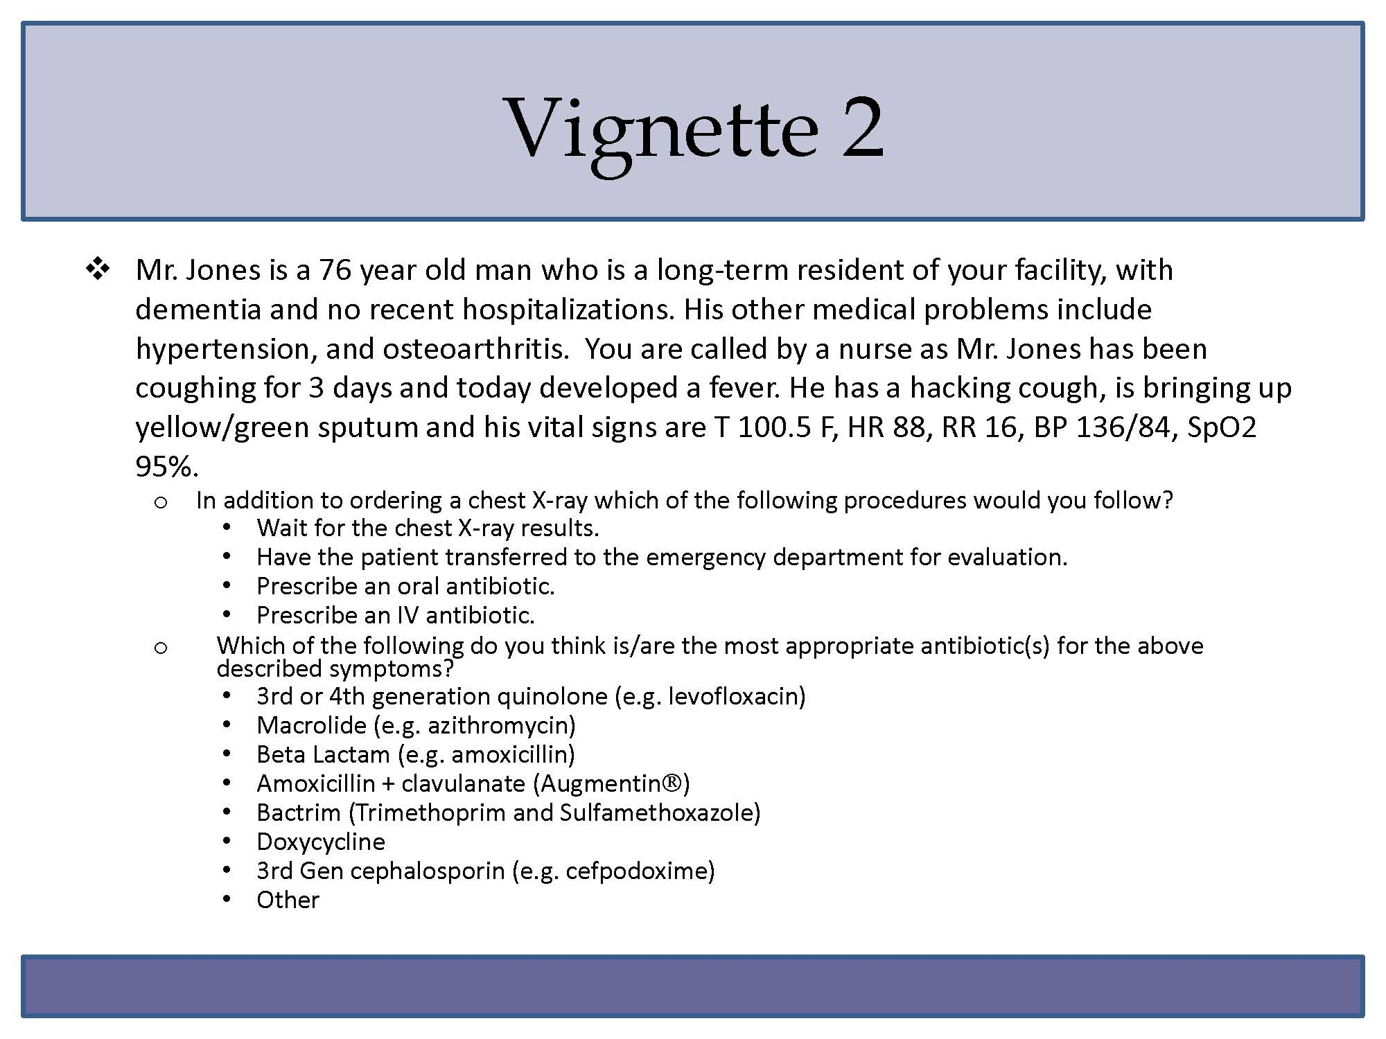
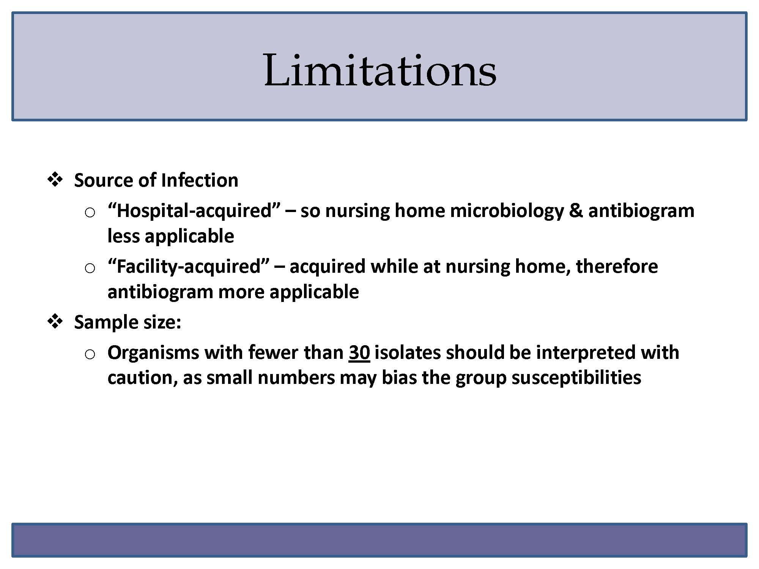
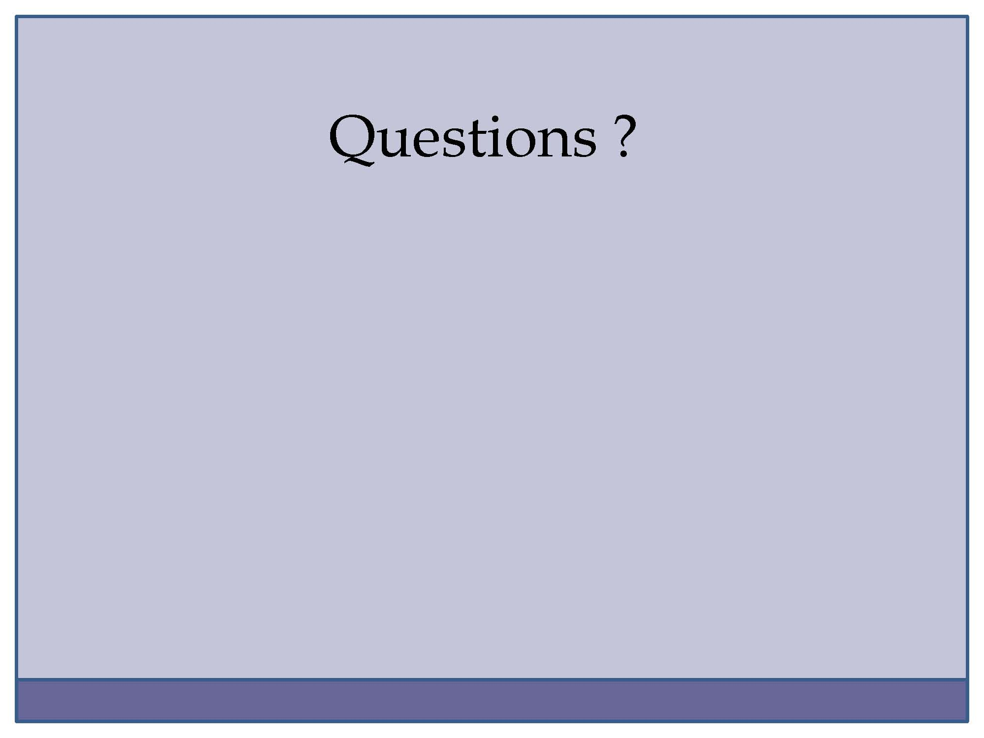

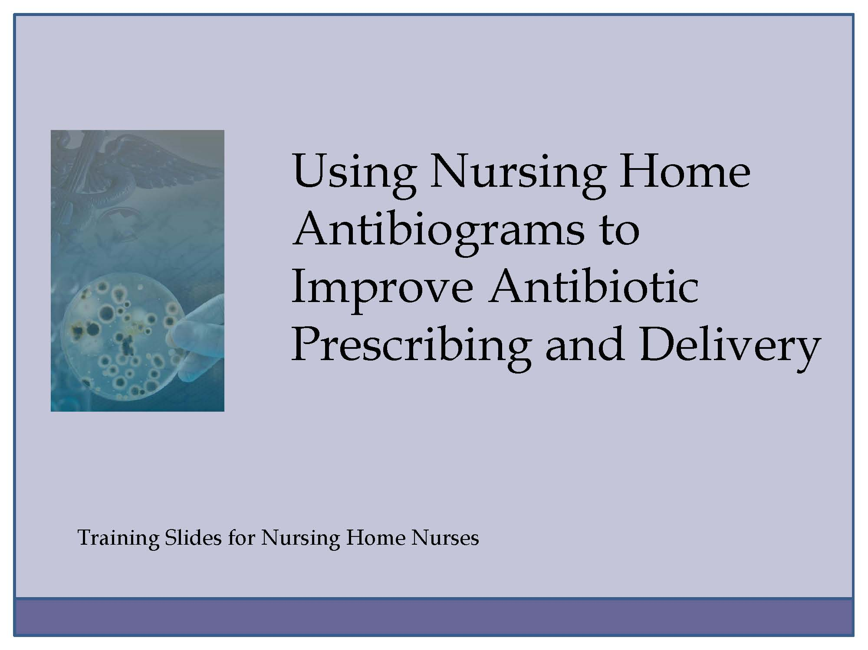
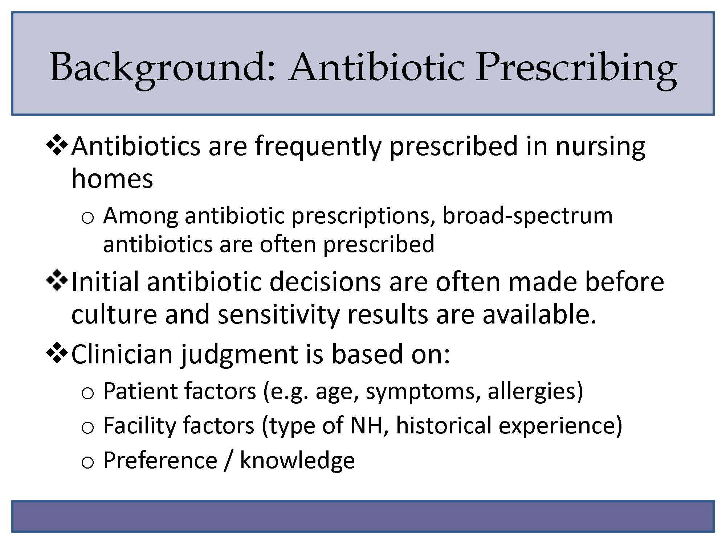
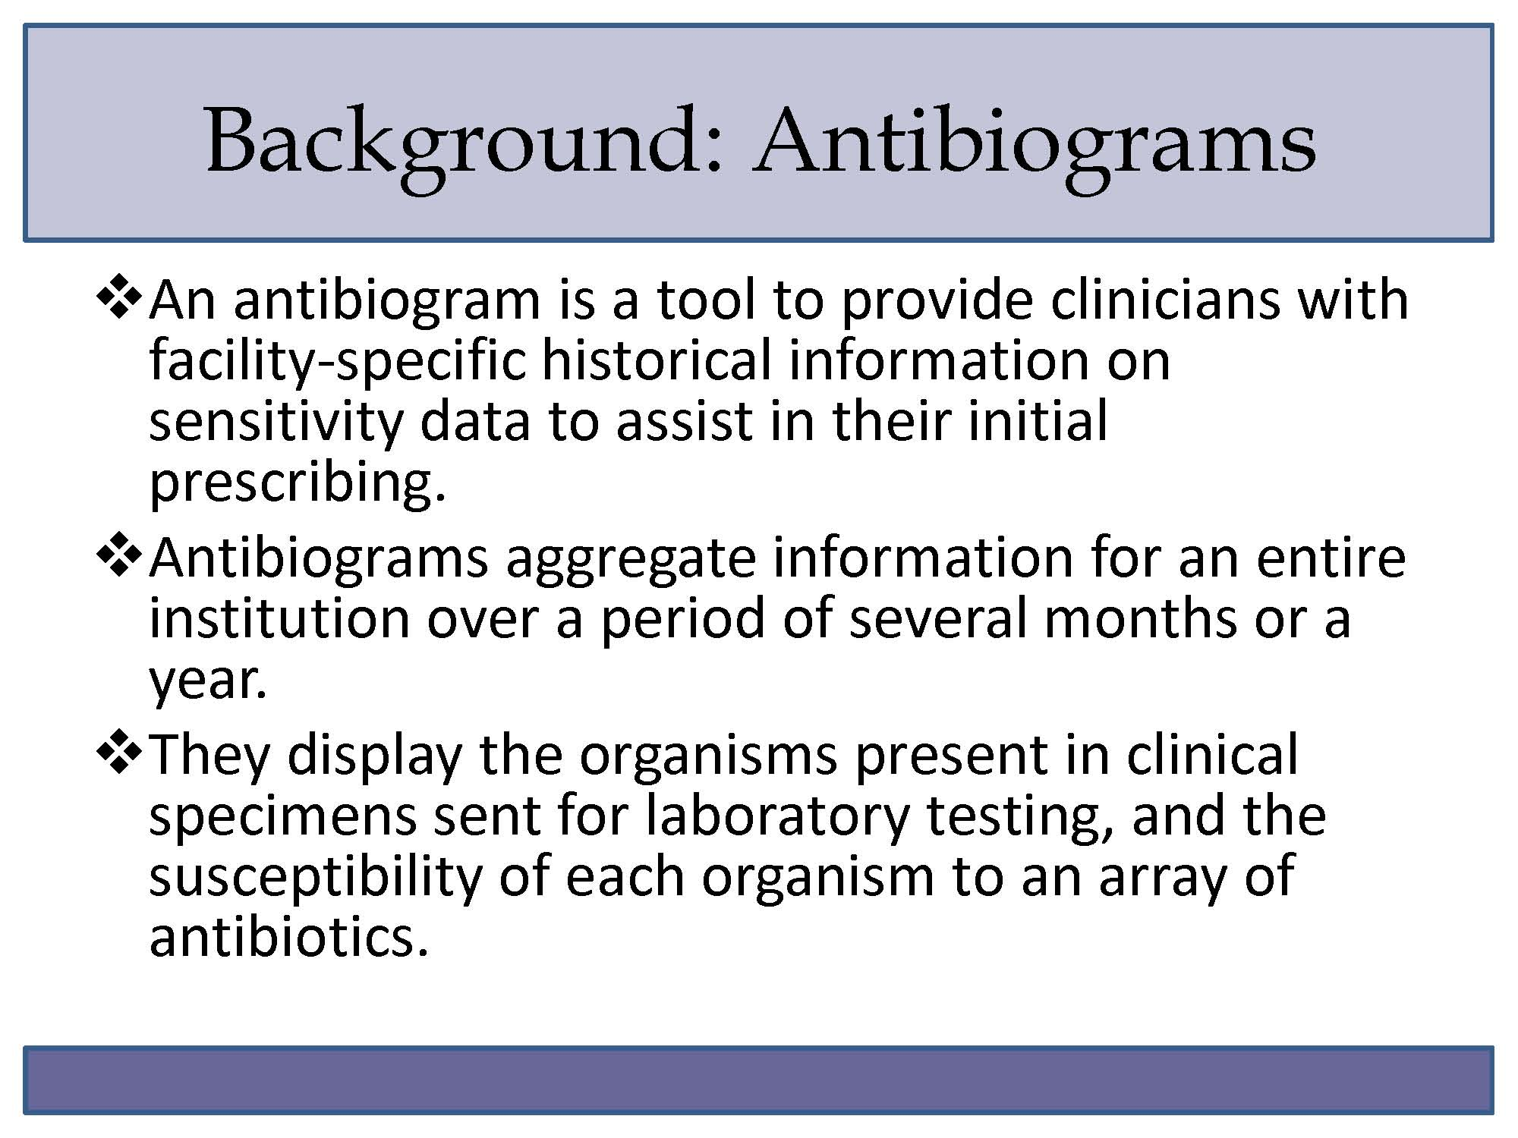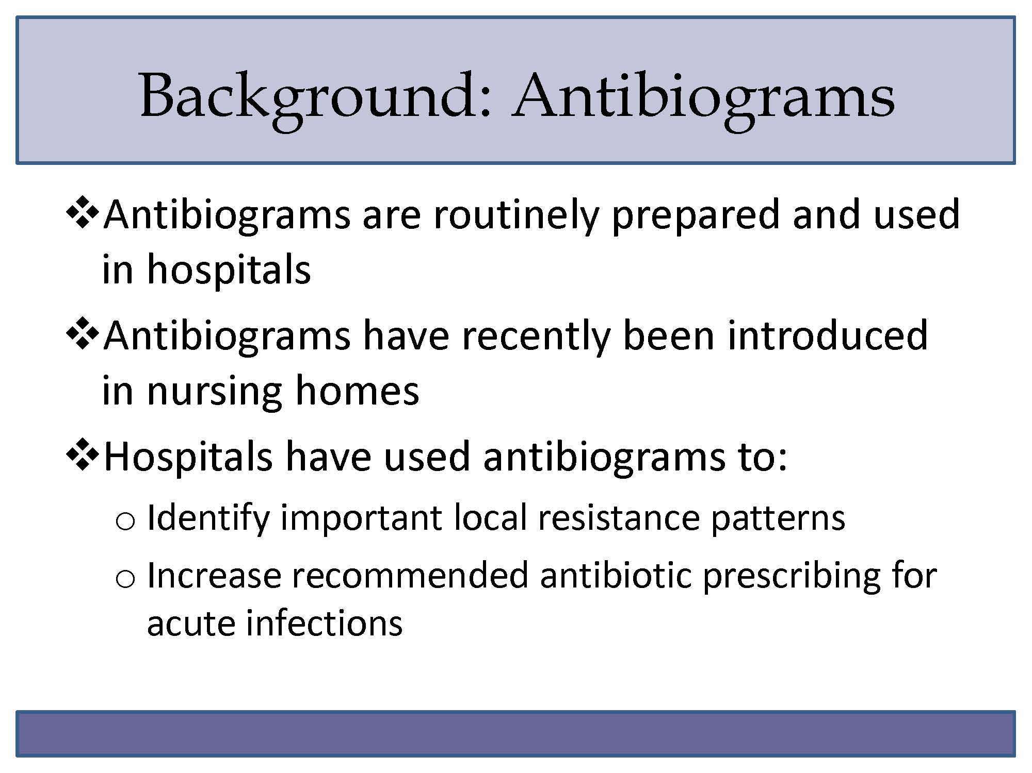
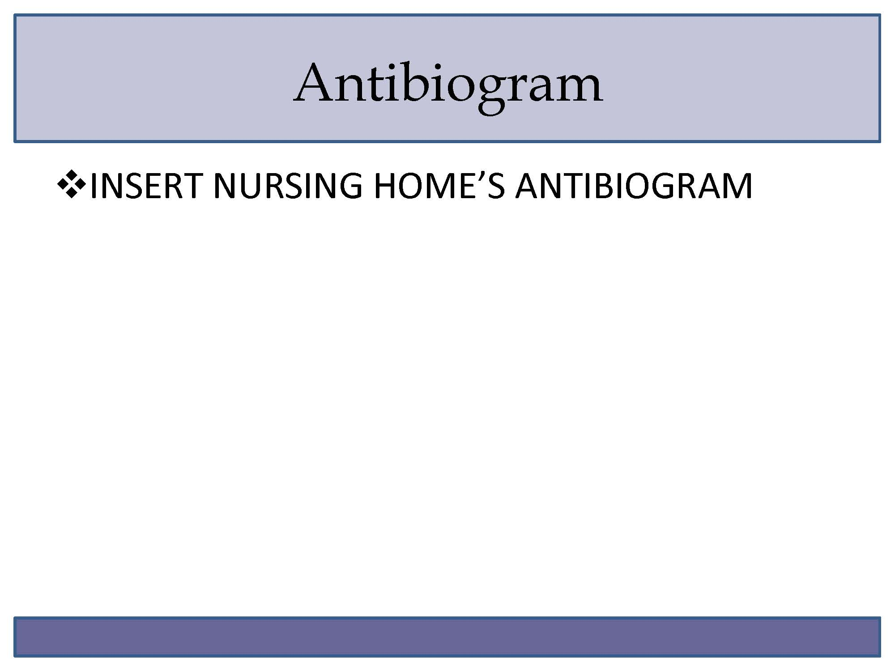
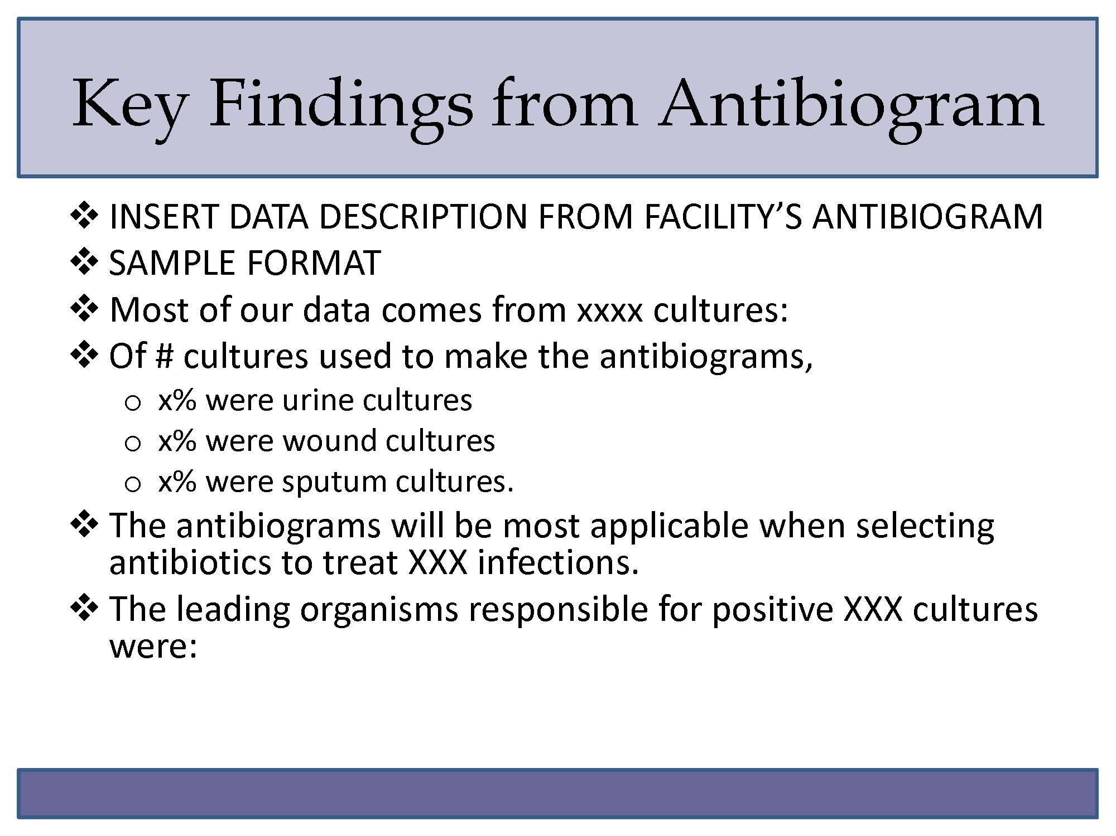
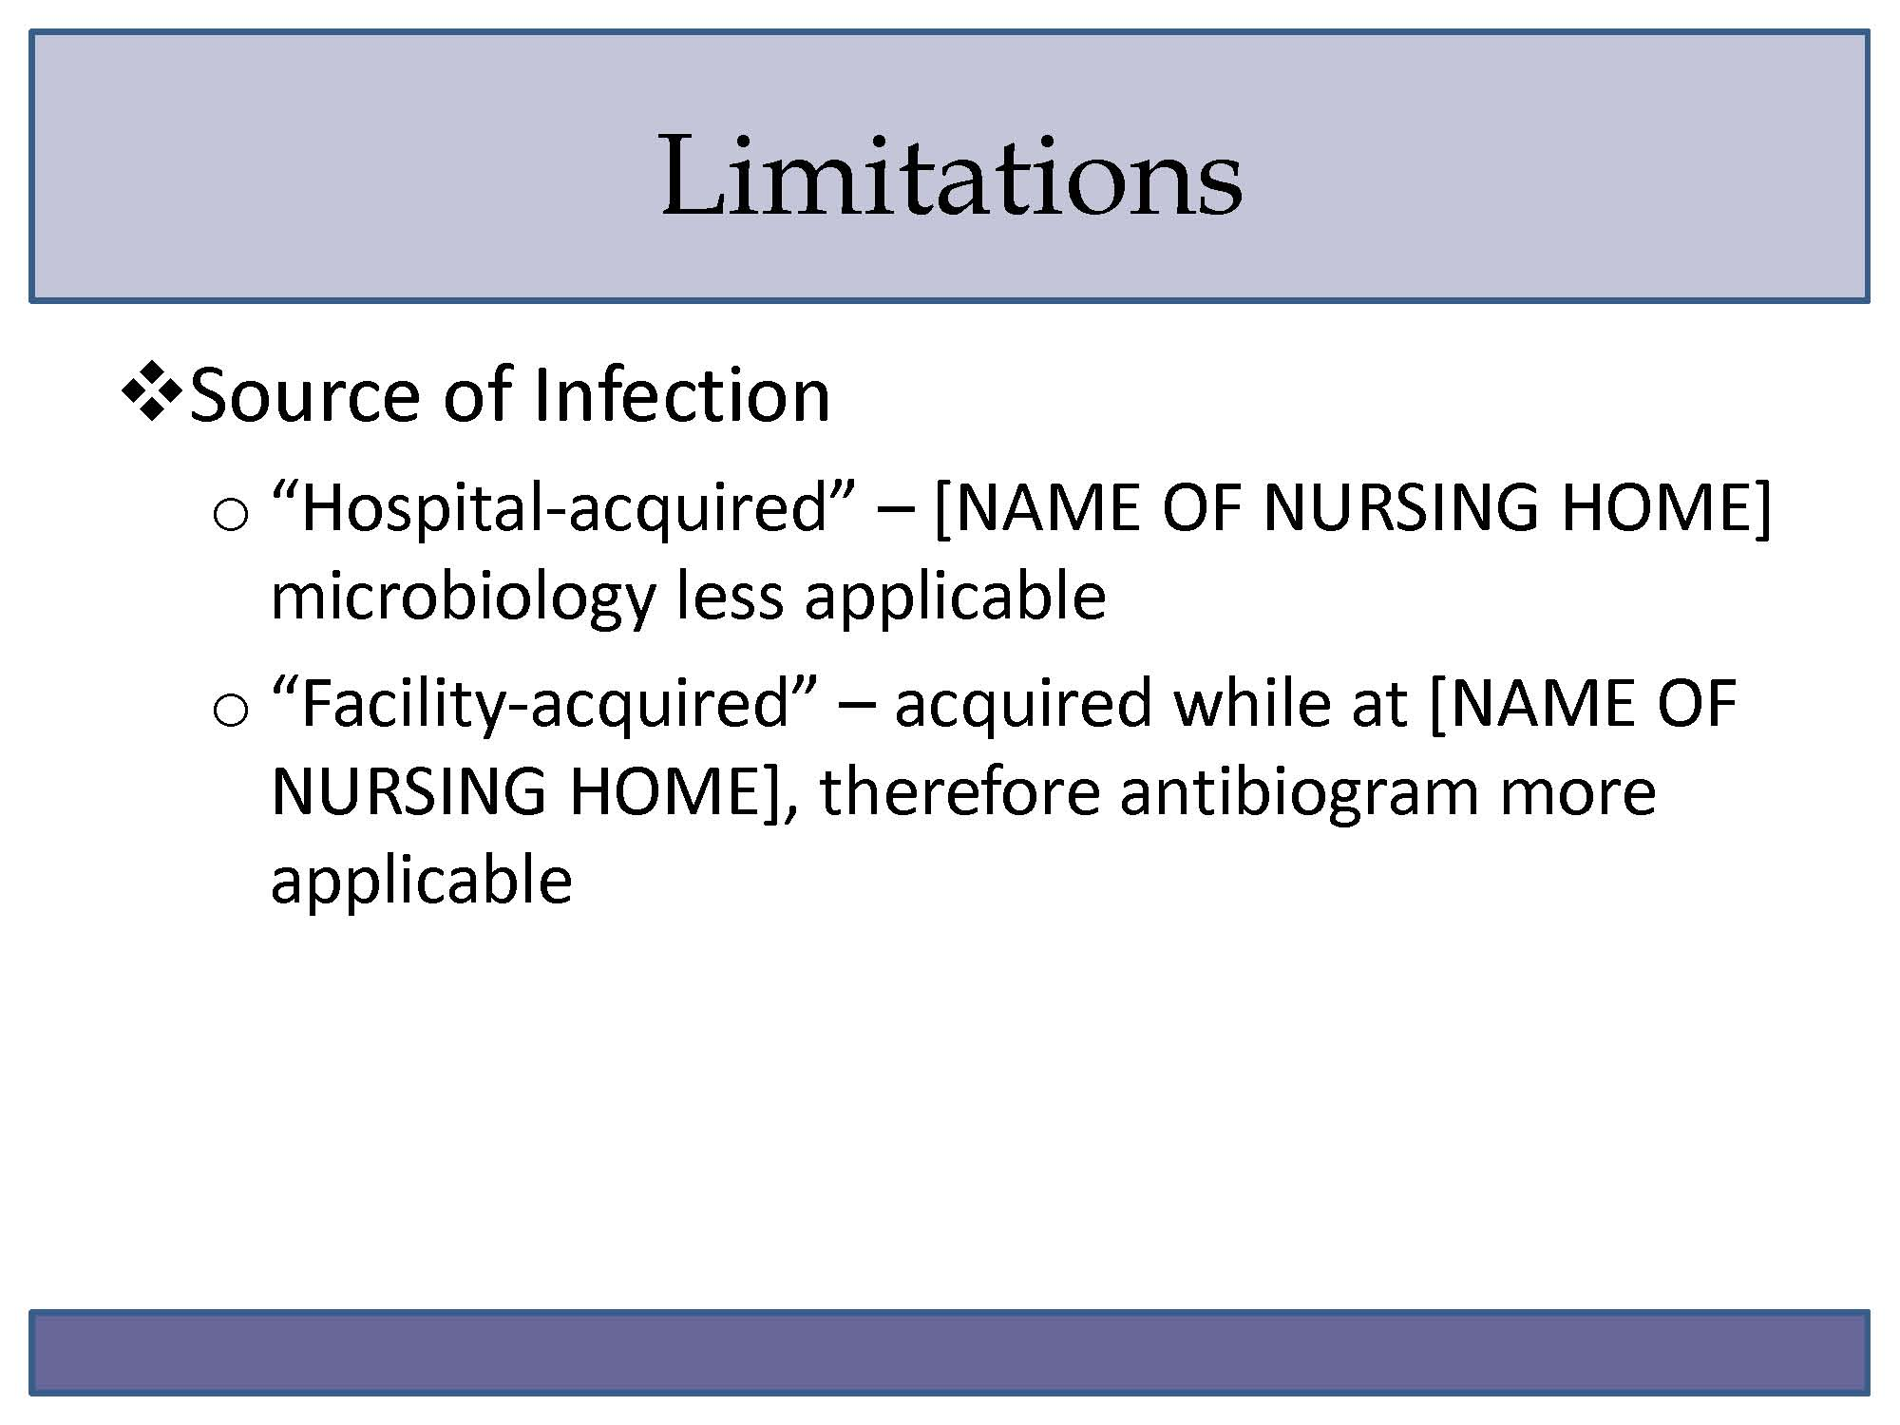
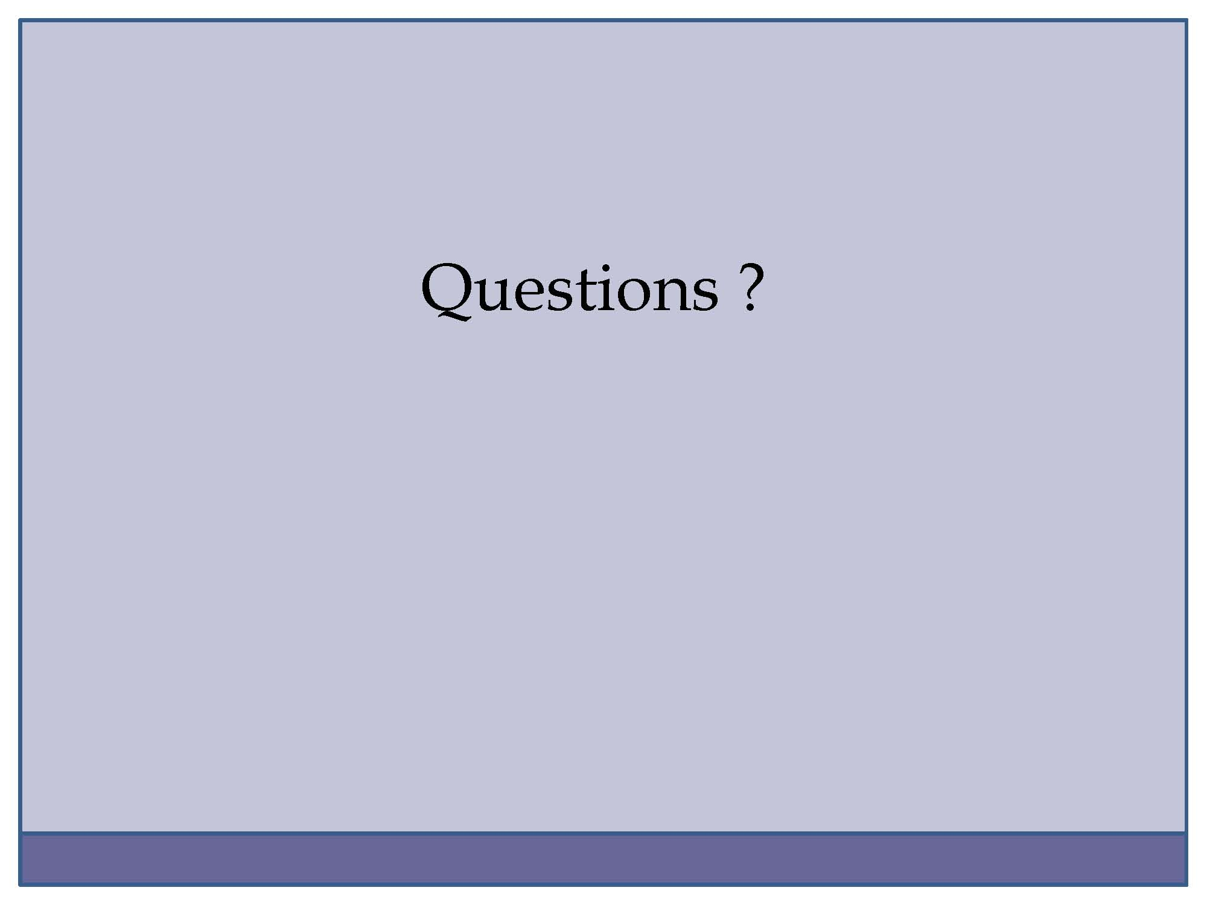

The Antibiogram Program: Sample Vignettes

Following is a series of vignettes that are similar to cases that a clinician may be presented with in the nursing home. Work through the vignettes and discussion questions first without referring to the antibiograms, and then by referring to the antibiograms.

- Ms. Lee, a 71-year-old female, is a long-term resident of the nursing home. She has dementia and no recent hospitalizations. For review: she has been complaining to the nurses of dysuria, urinary frequency and urinary urgency since 8 PM last night. You assess the patient and find that her vital signs are HR 88, RR 16, BP 136/84, T 100.2 F, SpO2 98 percent. A urine dip shows 2+ leukocytes and 2+ nitrites, 50 WBCs, 5 RBCs and 3+bacteria. The patient is generally well appearing and has some mild suprapubic tenderness. A urine culture is pending.

- Mr. Jones is a 76-year-old man who is a long-term resident of the nursing home facility. He has dementia and no recent hospitalizations. For review: His other medical problems include hypertension, and osteoarthritis. Mr. Jones was transferred to the emergency department because he has been coughing for 3 days and today developed a fever. He has a hacking cough, is bringing up yellow/green sputum and his vital signs are T 100.5 F, HR 88, RR 16, BP 136/84, SpO2 95 percent. His chest x-ray shows a right middle lobe infiltrate. His chem-7 and lactate are normal.

- Ms. Williams is a 66-year-old woman who is a long-term resident of the nursing home. She has dementia and no recent hospitalizations. For review: She has a past medical history of osteoarthritis, and elevated cholesterol, for which she takes acetaminophen and simvastatin. She was transferred to the emergency department after a nurse noticed an area on her right ankle and lower leg that is red, warm, and tender. The rest of her leg is not remarkable and her calf is soft, nontender and not swollen compared to the left side. Her vitals: T 100.5 F, HR 88, RR 16, BP 136/84, SpO2 97 percent. Her chem-7 and lactate are normal.

- Mr. Jackson is a 75-year-old who is a long-term resident of your facility, with no recent hospitalizations. For review: He has a history of post-herpetic neuralgia and depression for which he takes gabapentin and citalopram. Mr. Jackson is transferred to the emergency department after having had a fever throughout the day: 101F in the morning and 101.8F when repeated this afternoon. His current vital signs are HR 90, BP 120/80, RR 14, SpO2 95 percent. He appears to be his normal self and does not have any specific complaints except that he is tired and has had some chills. You do not find anything new on his exam. A urine dip shows 1+ nitrites and no leukocyte esterase, 5 WBCs, 3 RBCs, and 1+ bacteria. A chest x-ray shows no acute process. You ordered cultures (blood and urine). His chem-7 and lactate are normal. His WBC count is 12,000 without bands.

Questions for Discussion:
- Would you prescribe this patient an antibiotic? What kind (IV, oral)?
- What disposition is most appropriate for this patient? Would you transfer and/or admit the patient to the hospital?
  - What is the most appropriate antibiotic regimen for the above described symptoms? Give names, doses, and routes for each antibiotic you would recommend.
  - [After using the antibiogram] How did having the antibiogram help to inform your decisions regarding this patient? What changes, if any, did you make to your action plan because of the antibiogram?
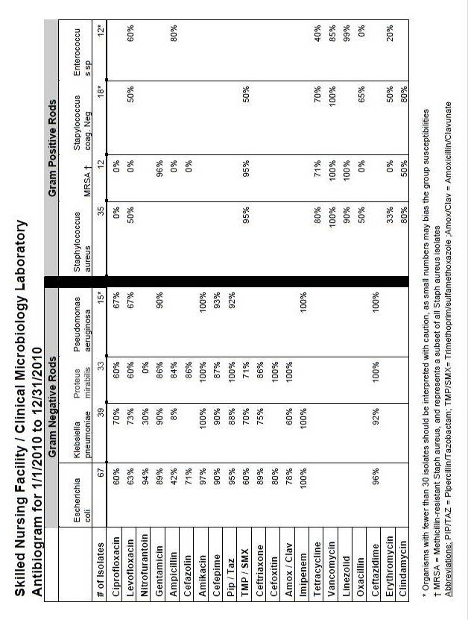

Phase 3: Dissemination Materials

The Antibiogram Program: Sample Pocket Card Short Version

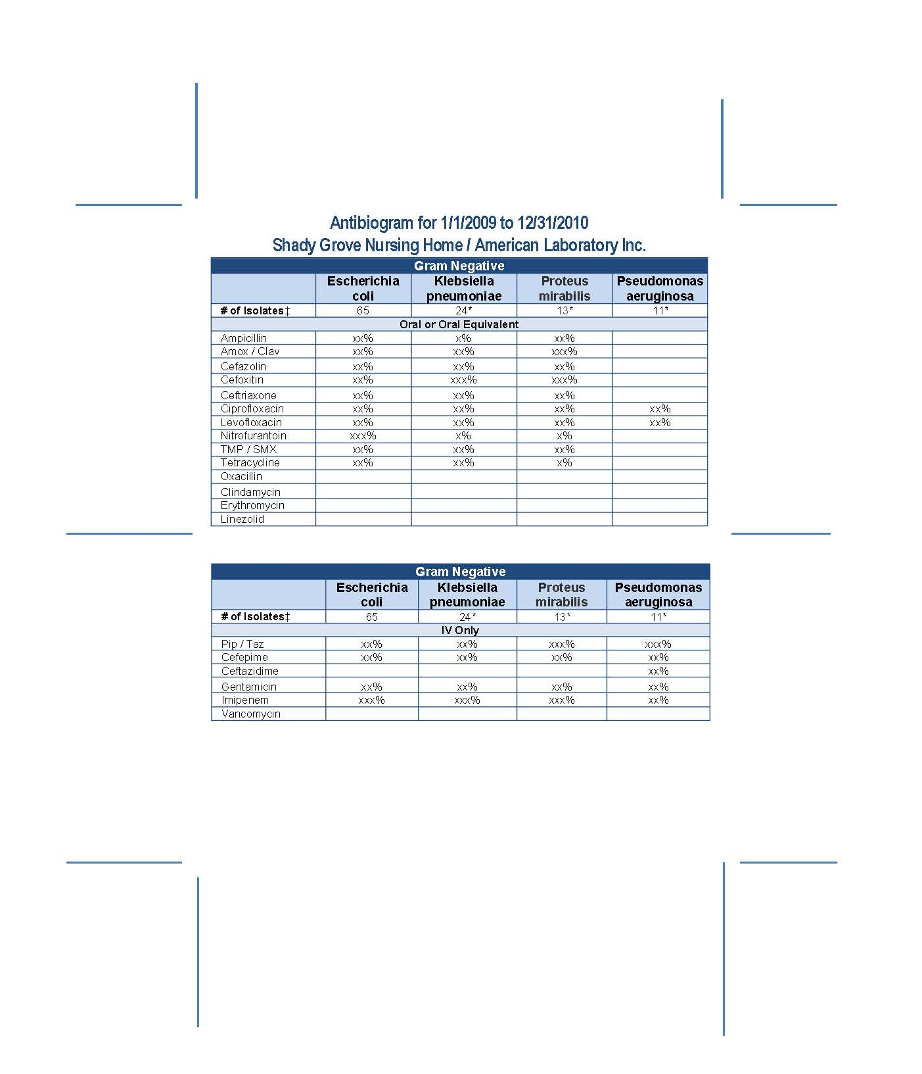

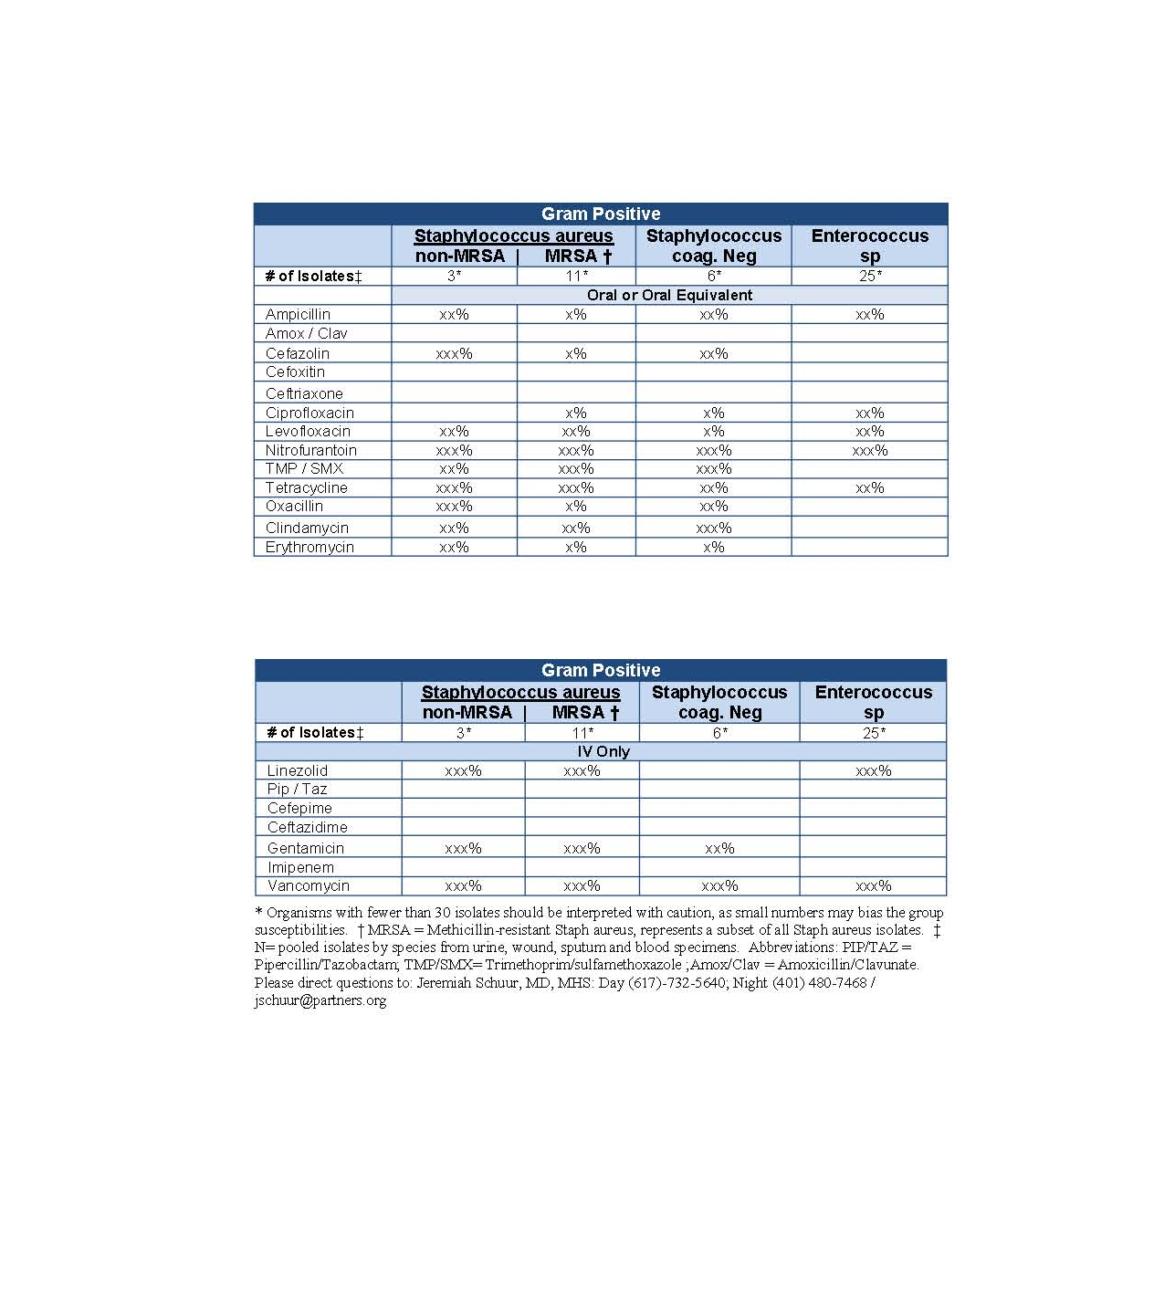

The Antibiogram Program: Sample Pocket Card Long Version

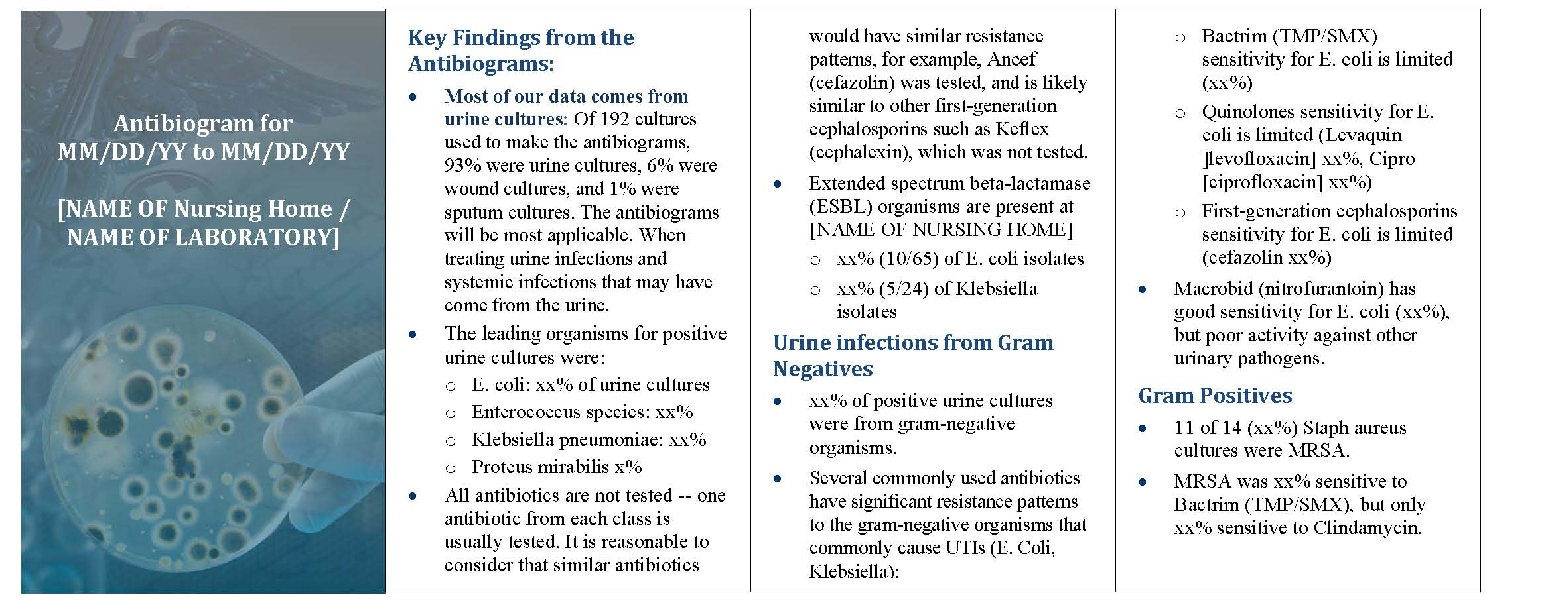

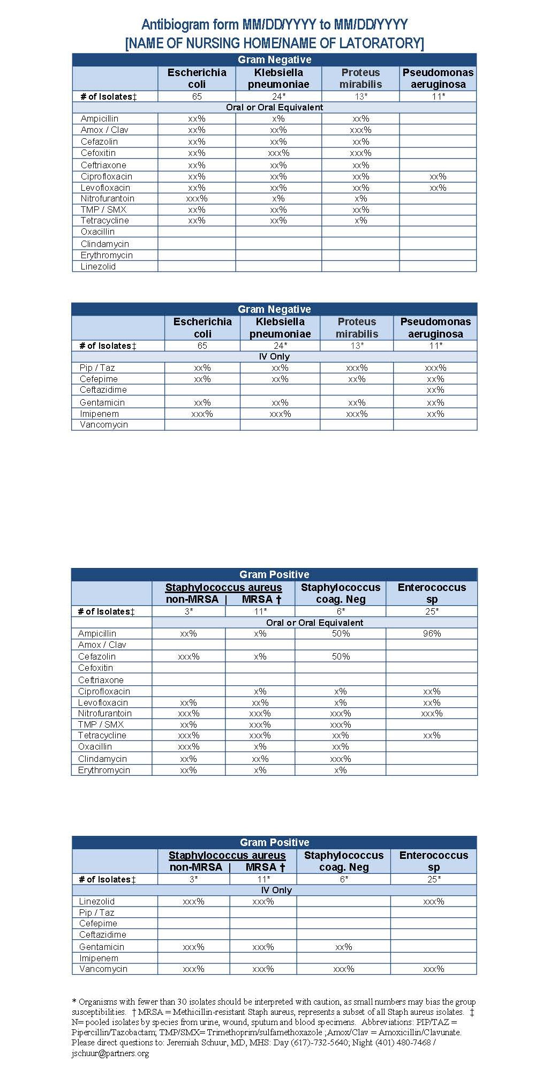

The Antibiogram Program: Sample Email for Distribution of the Antibiogram

Suggested Subject Line: Attached Antibiogram for [NURSING HOME NAME]

Dear [name of clinical prescriber];
Attached to this email you will find an antibiogram for the [NURSING HOME NAME]. This antibiogram contains relevant antibiotic sensitivities aggregated over across all residents from mm/dd/yy to mm/dd/yy. Please refer to this antibiogram when considering an antibiotic order for a [NURSING HOME NAME] resident.
[Add if appropriate:] The [NURSING HOME NAME] antibiogram can also be found on our Web site at http://www.shadygrove.com/antibiogram .
If you have any questions, please contact [nursing home antibiogram program contact].

Chapter Four

Phase 4. Monitoring
It will be important to monitor the antibiogram program by 1) soliciting feedback from clinical prescribers and nursing home staff on ways to improve the usability of the antibiogram; and 2) tracking the prescribing of different types of antibiotics. Infections and antibiotic use are generally monitored through the nursing home’s infection control log. Additional tracking of the use of broad and narrow spectrum antibiotics, and/or the appropriateness of certain antibiotics for particular infections, will provide input on the effect of the antibiogram program. Urinary tract infections and pneumonia are common nursing home infections and can readily be tracked through the nursing home’s infection control log. A key aim of monitoring is to track 1) the use of antibiotics with high levels of resistance as empiric antibiotics, and 2) the use of broad versus narrow spectrum antibiotics.

Timeframe: Tracking the prescribing of antibiotics for certain infections – either broad or narrow spectrum – can begin during the planning and assessment phase, to provide baseline information on prescribing practices. Continued tracking after implementation of the program may allow some estimation of the impact of the program. Program champions should solicit feedback from clinical prescribers on the antibiogram program during the initial implementation at staff meetings. Formal evaluation of the antibiogram program should not occur until after clinical prescribers have had sufficient experience using the antibiogram. This will depend on the number of residents at the nursing home, the number of clinical prescribers and the number of antibiotic prescriptions written. It is suggested that nursing home staff use the antibiograms for at least six months before being asked for formal feedback.

Action Checklist

Quality Improvement Program
- Add monitoring of antibiotic prescribing patterns to the current quality improvement program. The nursing home’s infection control program likely tracks and reports the numbers, types, and room locations of infections on a monthly or quarterly basis. Adding information on the use of broad/narrow spectrum antibiotics will require the advice of the nursing home’s Infectious Disease consultant (if available), the pharmacist, and/or the nursing home’s Medical Director to identify the antibiotics in each category. Similarly, if treatment for specific conditions is tracked (e.g., urinary tract infections), the determination of the “appropriate” antibiotics based on the nursing home’s antibiogram will require input from the Medical Director or other physician experienced in interpreting the antibiogram. Current evidence-based guidelines for treating common infections in nursing facilities should be consulted.

- A sample antibiotic prescribing tracking sheet and a list of appropriate antibiotics for urinary tract infection by broad versus narrow spectrum are included in the Materials Section of this chapter.

- As pneumonia guidelines address healthcare associated pneumonia rather than specifically nursing home acquired pneumonia, guidelines of appropriate use need to be developed locally. Nursing home staff can develop a list of appropriate and inappropriate antibiotics for pneumonia that is specific for the nursing home and based on recent guidelines.⁴ ⁷ This should be done in conjunction with the Medical Director, pharmacist and infectious disease consultant (if available).

Monitoring
- Solicit feedback from clinical prescribers and nurses regarding use of the antibiogram. Develop a brief feedback tool similar to the initial survey used with clinical prescribers, and administer it after several months of experience using the antibiogram. Surveys will need to be distributed (as hard copy or electronic via email), collected, and results tabulated. Results should be summarized and presented to the nursing home’s Quality Improvement team and to the individuals on the antibiogram implementation team. Modifications of the antibiogram will be decided by nursing home administration and members of the antibiogram implementation team.

- A sample feedback survey is included in the Materials Section of this chapter.

Revisions to Antibiograms
- The antibiogram should be updated regularly to reflect the needs of the nursing home staff and to incorporate new microbiological susceptibility data. Suggestions about improving the format of the antibiogram can be solicited at regular intervals. The update schedule will depend on the size of the nursing home, volume of microbiological specimens sent to the laboratory, and willingness of the laboratory to generate new data. As smaller sample sizes provide less reliable data, smaller nursing homes and those that send smaller numbers of microbiological specimens should plan to update less frequently than larger facilities, but the antibiogram should be updated at least annually. The same steps that were followed in developing the initial antibiogram should be followed when new data are incorporated. As the laboratory and the facility staff are now familiar with antibiograms, revisions and updates should require less work and little retraining.

Materials Included

Quality Assurance
- Antibiotic Use Tracking Sheet

- Quality Improvement Review Tool for Antibiotic Use in Urinary Tract Infection
        - List of Antibiotics for Urinary Tract Infection: Appropriateness and Broad versus Narrow Spectrum

Monitoring
- Antibiogram Feedback Survey

Phase 4: Quality Assurance

The Antibiogram Program: Sample Antibiogram Use Tracking Sheet

The Antibiogram Program: Quality Improvement Review Tool for Antibiotic Use in Urinary Tract Infection

The goal of this tool is to allow nursing home staff to review empiric antibiotic choices recorded in the Antibiotic Use Tracking Sheet in order to see if prescribing is consistent with national guidelines and with the nursing home’s resistance/susceptibility patterns. The review will classify each antibiotic as:
- Significant resistance (<80 percent sensitive) or no significant resistance on the nursing home antibiogram.
- Narrow or broad spectrum.
- Appropriate or potentially inappropriate, based on guidelines.

As clinical guidelines exist for uncomplicated urinary tract infections (UTIs), this classification should not include patients with complicated UTIs. Complicated UTIs need to be defined by each facility, but should include at a minimum: UTIs in patients with indwelling urinary catheters, recent UTIs (within 2 weeks), and pyelonephritis. Categories are based on the 2010 Infectious Disease Society of America guidelines.

List of Antibiotics for Urinary Tract Infection:
Appropriateness

Resistance Pattern
- Significant Resistance: if the nursing home antibiogram shows < 80 percent sensitivity for the antibiotic prescribed.
- No significant resistance: if the nursing home antibiogram shows ≥ 80 percent sensitivity for the antibiotic prescribed.

Phase 4: Monitoring

The Antibiogram Program: Clinical Prescriber Feedback Survey
(Physician, Nurse Practitioner, Physician’s Assistant)

[NURSING HOME NAME] implemented an antibiogram program as of [date]. We are interested in your experiences using the antibiogram. Results of the survey will help determine whether or not we continue to make the antibiogram available and ways that we can improve it to best serve the needs of prescribers and nursing home staff.

Clinical Prescriber Information | What is your title? | MD | NP | PA
Usefulness of Antibiograms | On a scale of 1-5 with ‘1’ indicating not at all well and ‘5’ indicating very well, how well do you feel that you know the antibiotic sensitivity/ resistance pattern of common infections in this nursing home? | 1 2 3 4 5
Usefulness of Antibiograms | Have you used the antibiogram that the nursing home provided? | Yes |  | No
Usefulness of Antibiograms | On a scale of 1-5 with ‘1’ indicating not at all useful and ‘5’ indicating very useful, how useful has the nursing home antibiogram been for selecting the most effective antibiotic for a particular infection or organism? | 1 2 3 4 5
Usefulness of Antibiograms | Have you made any changes to your prescribing practices since you’ve had access to the nursing home’s antibiogram? | Yes No
Antibiogram Communication | If you are currently using the nursing home antibiogram, please answer the following:  How is the antibiogram communicated to you?  (circle all the apply)  NH Staff Fax Email Mail Other____________
Antibiogram Communication | Is this method of communication convenient and efficient? | Yes |  | No
Antibiogram Communication | How could communication of antibiograms be improved?
Antibiogram Improvements | How could the information contained in this antibiogram be improved?  Would you suggest any changes to the format of the antibiogram (organization, size of print, etc.)?  If not using antibiogram, please complete the following statement:  I would use antibiograms if ….
Thank you for completing our survey.

Contract No. HHSA290-2006-000-191, Task Order No. 8
Contract No. HHSA290-2006-000-19i, Task Order No. 11
Loeb et al., (2001). Development of minimum criteria for the initiation of antibiotics in residents of long-term care facilities: results of a consensus conference. Infection Control and Hospital Epidemiology 22:120-124.
Agency for Healthcare Research and Quality. (2011). Effectiveness of early diagnosis, prevention, and treatment of Clostridium difficile infection. Comparative Effectiveness Review, 31.
Katz, P. R., Beam, T. R., Frank, B., & Boyce, K. (1990). Antibiotic use in the nursing home. Archives of Internal Medicine, 150, 1465–1468.
Nicolle, L. E., Strausbaugh, L. J., & & Garibaldi, R. A. (1996). Infections and antibiotic resistance in nursing homes. Clinical Microbiology Review , 9, 1-17.
Loeb, M., Simor, A. E., Landry, L., Walter, S., McArthur, M., & Duffy, J., et al. (2001). Antibiotic use in Ontario facilities that provide chronic care. Journal of General Internal Medicine , 16, 376–383.
Richards, C. R. (2006). Preventing antimicrobial-resistant bacterial infections among older adults in long-term care facilities. Journal of the American Medical Directors Association, 7, S89–S96.
Boscia, J. A., Kobasa, W. D., Knight, R. A., Abrutyn, E., Levison, E., & Kaye, D. (1987). Therapy vs no therapy for bacteriuria in elderly ambulatory nonhospitalized women. JAMA , 257, 1067-71
Nordenstam, G. R., Bradberg, C. A., Oden, A. S., Svanborg-Eden, C. M., & Svanborg, A. (1986). Bacteriuria and mortality in an elderly population. NEJM , 314, 1152–6.
Nicolle, L. E., Bjornson, J., Harding, G. K., & MacDonell, J. A. (1983). Bacteriuria in elderly institutionalized men. N Engl J Med , 309, 1420-5.
Abrutyn, E., Mossey, J., Berlin, J. A., & al, e. (1994). Does asymptomatic bacteriuria predict mortality and does antimicrobial treatment reduce mortality in elderly ambulatory women? Ann Intern Med, 120.
Nicolle, L.E., Mayhew, W.J., Bryan, L. (1987). Prospective randomized comparison of therapy and no therapy for asymptomatic bacteriuria in institutionalized elderly women. American Journal of Medicine, 83:27-33.
Nicolle, L.E. (2000). Asymptomatic Bacteriuria – Important or Not? N Engl J Med, 343:1037-1039.
Ouslander, J.G., Schapira, M., Schnelle, J.F. et al. (1995). Does eradicating bacteriuria affect the severity of chronic urinary incontinence in nursing home residents? Ann Intern Med,122(10):749-54.
Loeb et al., (2001). Development of minimum criteria for the initiation of antibiotics in residents of long-term care facilities: results of a consensus conference. Infection Control and Hospital Epidemiology 22:120-124.
Contract No. HHSA29020060020Task Order No. 9
Contract No. HHSA2902006000111 Task Order No. 12
Developed by Abt Associates Inc. and Brigham and Women’s Hospital with funding and input from the Agency for Healthcare Research and Quality (AHRQ) and the Centers for Disease Control and Prevention (CDC), this toolkit reflects the results of preliminary work with three nursing homes to develop the antibiogram, train staff and implement the program.
Clinical and Laboratory Standards Institute. Analysis and Presentation of Cumulative Antimicrobial Susceptibility Test Data; Approved Guideline – Third Edition. M39-A3. 02/05/2009. ISBN Number: 1-56238-692-1
CLSI recommendations that NH may choose not to follow.
Dyson M, “How and when to write policies and procedures” Australian Council for the Rehabilitation of the Disabled (ACROD) 1999. http://www.safework.sa.gov.au/contentPages/docs/labrWritingPolicy.pdf
Furman, C. D., Rayner, A. V., & Tobin, E. P. (2004). Pneumonia in Older Residents of Long-Term Care Facilities. American Family Physician, 70( 8), 1495 - 1500.
Official statement of the American Thoracic Society and the Infectious Diseases Society of America. (2005). Guidelines for the Management of Adults with Hospital-acquired, Ventilator-associated, and Healthcare-associated Pneumonia. Am J Respir Crit Care Med,171, 388–416.
Nicolle, L. E. & the SHEA Long-Term Care Committee. (2001). Urinary Tract Infections in Long-Term–Care Facilities. Infect Control Hosp Epidemiol, 22(3):167-175.
Gupta K, et al. International clinical practice guidelines for the treatment of acute uncomplicated cystitis and pyelonephritis in women: A 2010 update by the Infectious Diseases Society of America and the European Society for Microbiology and Infectious Diseases. Clin Infect Dis. 2011 Mar;52(5):e103-20.)
Abrutyn E, Mossey J, Berlin JA, et al. Does asymptomatic bacteriuria predict mortality and does antimicrobial treatment reduce mortality in elderly ambulatory women? Ann Intern Med. 1994;120(10):827-33. PMID: 7818631. ²Boscia JA, Kobasa WD, Knight RA, et al. Therapy vs no therapy for bacteriuria in elderly ambulatory nonhospitalized women. JAMA. 1987; 257(8): 1067-71. PMID: 3806896. ³Nicolle L E. Asymptomatic Bacteriuria – Important or Not? N Engl J Med. 2000;343(14):1037-9. PMID: 11018172. ⁴Nicolle L E, Bjornson J, Harding GK, et al.Bacteriuria in elderly institutionalized men. N Engl J Med. 1983; 309(23):1420-5. PMID: 6633618. ⁵Nicolle LE, Mayhew WJ, Bryan L. . Prospective randomized comparison of therapy and no therapy for asymptomatic bacteriuria in institutionalized elderly women. Am J Med. 1987;83(1):27-33.. PMID: 3300325. ⁶Nordenstam GR, Bradberg CA, Odén AS, et al.. Bacteriuria and mortality in an elderly population. N Engl J Med. 1986;314(18):1152-6. PMID: 3960089. . ⁷Ouslander JG, Schapira M, Schnelle JF, et al. Does eradicating bacteriuria affect the severity of chronic urinary incontinence in nursing home residents? Ann Intern Med. 1995;122(10):749-54. PMID: 7717597.. ⁸Denis O, Jans B, Deplano A, et al. Epidemiology of methicillin-resistant Staphylococcus aureus (MRSA) among residents of nursing homes in Belgium. J Antimicrob Chemother. 2009 Dec;64(6):1299-306. PMID: 19808236. ⁹Lautenbach E, Marsicano R, Tolomeo P, et al. Epidemiology of antimicrobial resistance among gram-negative organisms recovered from patients in a multistate network of long-term care facilities. Infect Control Hosp Epidemiol. 2009 Aug;30(8):790-3. PMID: 19566445. ¹⁰Matheï C, Niclaes L, Suetens C, et al. Infections in residents of nursing homes. Infect Dis Clin N Am. 2007;21:761–72 ¹¹Sandoval C, Walter SD, McGeer A, et al. Nursing home residents and Enterobacteriaceae resistant to third-generation cephalosporins. Emerg Infect Dis. 2004 June;10(6):1050–5. PMCID: PMC3323163. ¹²Vromen M, van der Ven AJ, Knols A, et al. Antimicrobial resistance patterns in urinary isolates from nursing home residents. Fifteen years of data reviewed. J Antimicrob Chemother. 1999 Jul;44(1):113-6. PMID: 10459818. ¹³Wiener J, Quinn JP, Bradford PA, et al. (1999). Multiple antibiotic-resistant Klebsiella and Escherichia coli in nursing homes. JAMA. 1999 Feb 10;281(6):517-23. PMID: 10022107. ¹⁴Yoshikawa TT. (1998). VRE, MRSA, PRP, and DRGNB in LTCF: lessons to be learned from this alphabet. J Am Geriatr Soc. 1998 Feb;46(2):241-3. PMID: 9475457. ¹⁵Rotjanapan P, Dosa D, Thomas KS. Potentially inappropriate treatment of urinary tract infections in two Rhode Island nursing homes. Arch Intern Med. 2011 Mar 14;171(5):438-43. PMID: 21403040.

