Application Confirmation Page
– Case 1: DPRP Preferred or alternate curriculum file submitted with the DPRP Application
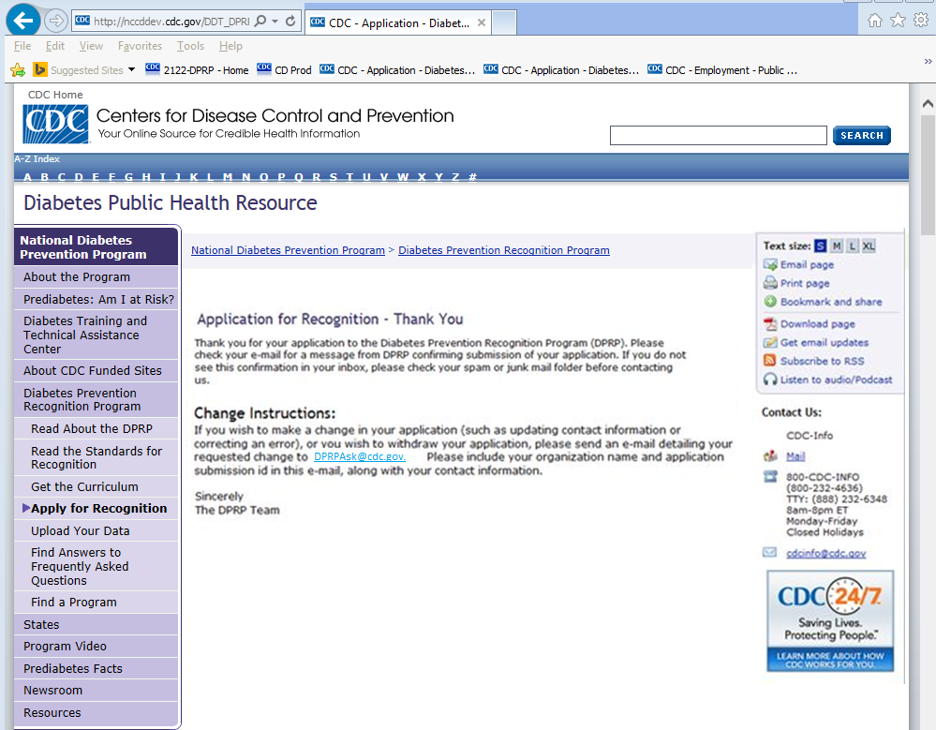

– Case 2: Alternate curriculum files to be submitted separately by email
