The DPRP Application – initial & Reapply screenshots
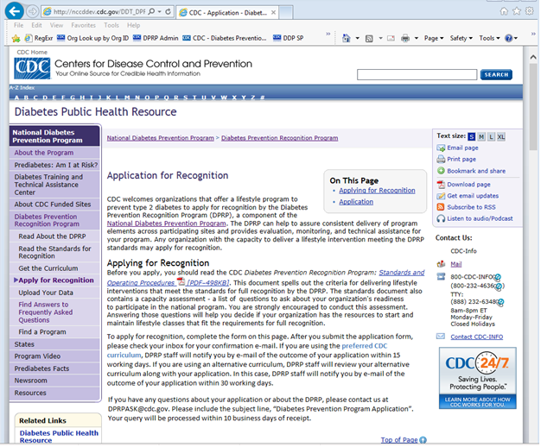

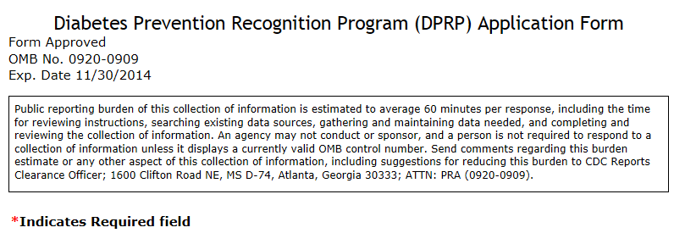

GENERAL INFORMATION
1. Type of Application
Initial Re-Apply Previous OrgCode Assigned (Enter only if Re-Apply is selected)

2. Organization Name*
Upon approval of your application, this will be published in the DPRP registry and on the program’s website.

3. Organization Physical Address (No P.O. Boxes)*
Upon approval of your application, this will be published in the DPRP registry and on the program’s website.
Street Address*

Street Address Line 2

City*

State*
Zip Code* +4
4. Organization Mailing Address
Include if different from Organization Physical Address. DPRP staff will use this address to communicate by mail with your organization.
Street Address

Street Address Line 2

City

State
Zip Code +4
5. Organization Web Address or URL
Optional. Upon approval of your application, if provided, this will be published in the DPRP registry and on the program’s website.
Check URL Entry
6. Organization Phone Number*
This is the number that participants, payers, and others should call to obtain information about your program. Upon approval of your application, this will be published in the DPRP registry and on the program’s website.
- - Ext:

CONTACT INFORMATION (enter secondary and / or data preparer if apply)
-Primary Contact
7. Contact Person Name*
The name of the individual who will be the applicant organization’s DPRP contact person. Salutation (e.g. Mr., Ms., Mrs., Miss, Dr., other [please specify]), last name, first name, middle initial, academic credentials (e.g. MD, RN, MPH, MPA, PhD, etc. [please specify]). The contact person’s information will not be included in the registry.
Salutation Enter only if other is selected

Last Name* First Name* Middle Initial

Academic Credentials

8. Contact Person Title*
The contact person’s title within your organization (e.g., Lifestyle Program Coordinator).

9. Contact E-mail Address*
The contact person’s e-mail address. DPRP staff will use this e-mail address to communicate with your organization.
E-Mail Address*

Verify E-Mail Address*

10. Contact Phone Number *
The contact person’s phone number. DPRP staff will use this number to communicate with your organization.
-- Ext:

11. Contact Fax Number
Optional. The contact person’s fax number. DPRP staff will use this number to communicate by fax with your organization.
--

CONTACT INFORMATION (enter secondary and / or data preparer if apply)
- Enter Secondary Contact
12. Contact Person Name*
The name of the individual who will be the applicant organization’s DPRP contact person. Salutation (e.g. Mr., Ms., Mrs., Miss, Dr., other [please specify]), last name, first name, middle initial, academic credentials (e.g. MD, RN, MPH, MPA, PhD, etc. [please specify]). The contact person’s information will not be included in the registry.
Salutation Enter only if other is selected

Last Name* First Name* Middle Initial

Academic Credentials

13. Contact Person Title*
The contact person’s title within your organization (e.g., Lifestyle Program Coordinator).

14. Contact E-mail Address*
The contact person’s e-mail address. DPRP staff will use this e-mail address to communicate with your organization.
E-Mail Address*

Verify E-Mail Address*

15. Contact Phone Number *
The contact person’s phone number. DPRP staff will use this number to communicate with your organization.
-- Ext:

16. Contact Fax Number
Optional. The contact person’s fax number. DPRP staff will use this number to communicate by fax with your organization.
--

CONTACT INFORMATION (enter secondary and / or data preparer if apply)
- Enter Data Preparer Contact
17. Contact Person Name*
The name of the individual who will be the applicant organization’s DPRP contact person. Salutation (e.g. Mr., Ms., Mrs., Miss, Dr., other [please specify]), last name, first name, middle initial, academic credentials (e.g. MD, RN, MPH, MPA, PhD, etc. [please specify]). The contact person’s information will not be included in the registry.
Salutation Enter only if other is selected

Last Name* First Name* Middle Initial

18. Affiliation*
The contact person’s affiliated organization. If none, enter ‘self’.

19. Contact E-mail Address*
The contact person’s e-mail address. DPRP staff will use this e-mail address to communicate with your organization.
E-Mail Address*

Verify E-Mail Address*

20. Contact Phone Number *
The contact person’s phone number. DPRP staff will use this number to communicate with your organization.
-- Ext:

21. Contact Fax Number
Optional. The contact person’s fax number. DPRP staff will use this number to communicate by fax with your organization.
--

CURRICULUM INFORMATION (CHECK ONE)
22. Curriculum*
If you select Other Curriculum, you must submit your curriculum files.
National Diabetes Prevention Program Curriculum
Other Curriculum

23. Intended Mode of Delivery (check all that apply)
In-Person On-Line Other Enter only if other is selected

CURRICULUM INFORMATION (CHECK ONE)
Other Curriculum
Curriculum Name*

Curriculum Description

Upload Option
- Multiple files can be uploaded.
- To upload more than one file follow these steps:
- Place your curriculum files into a single folder on your computer’s hard drive where you can easily find it.
- Click the browse button in the file upload box below.
- In the dialogue box that opens your file system, select the folder you created.
- Select all the files in the folder and click on Open.
- Confirm the correct number of files you selected in the upload window.
- Confirm the file names by moving your mouse over the upload window and checking the list that appears.
- Complete the rest of the form and submit your application.
- Allowed file types: doc, docx, xls, xlsx, pdf.
- Maximum length of file name: 200 characters.
- Combined file size: 10MB (10,240 KB).
- Maximum number of files: 20.
Curriculum Files*(at least one file is required if 'Upload Option' is selected)
file upload control
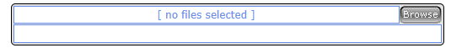
E-mail Option
If your curriculum files exceed the total size limit of 10 megabytes for online submission, please select 'E-mail Option' to indicate that you will be submitting your files as e-mail attachments.
This e-mail option should be used only when your curriculum is too large to submit online.
After you complete your DPRP application and click to submit, please check your inbox for an automated e-mail message with additional information and instructions.

CERTIFICATION OF APPLICATION
Electronic signature: By submitting this application, your organization asserts that it has thoroughly reviewed the CDC Diabetes Prevention Recognition Program: Standards and Operating Procedures and would like to participate in the CDC’s voluntary recognition program. Your organization agrees to comply with all of the recognition criteria contained in the standards document, including the transmission of data to CDC every six months from the date of the initial lifestyle class for the purpose of program evaluation, continuing recognition and technical assistance.

Name of Authorized Representative*

Title of Authorized Representative*

Organization Name*

Today's Date*

VERIFICATION
Spam Prevention - Please answer the following math question.*
8 + 8 =

