Attachment J-4:
Individual Recruitment Flyer

Material Handling Research Study
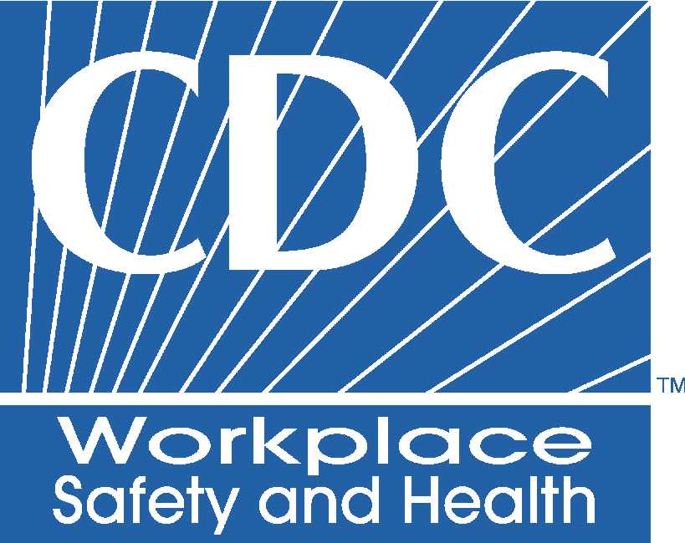
Your company is participating in a research study conducted by the
National Institute for Occupational Safety and Health (NIOSH)
WHO: NIOSH is looking for employees who perform manual material handling to volunteer for this study.

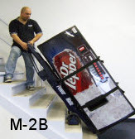

WHY: NIOSH wants to find out if controls like powered hand carts and truck lift gates are effective in preventing injuries and illnesses on the job.
WHAT: NIOSH will collect questionnaires from delivery workers to self-rate low back and shoulder pain before and after these controls are put into place at your workplace. Questionnaires are:
  - Voluntary and secure (to the extent allowed by the Privacy Act)
  - Brief and can be answered online
  - Completed every 3 months for 2 years (less than 3 hours total for entire study)
RISKS/ BENEFITS: There are minimal risks for you to participate. The workplace controls (powered hand truck or truck lift gate) are not expected to increase your risk of injury beyond the risks of your regular work. Injury data will also be collected from your company and the Ohio Bureau of Workers Compensation (OBWC). Your questionnaire data will not be provided to your company or OBWC. There may be no immediate direct benefits to you from being in the study, but the information gained from the study may help to prevent low back and shoulder disorders. The information may also help design tools, equipment, and practices to improve delivery tasks. Participants will be given a $5 gas card upon completion of each combined questionnaire data collection (a total of $45 for the entire study).
PARTNERS: NIOSH is partnering with the OBWC and your company for this study. OBWC and your company are providing funds to pay for the equipment. The OBWC is providing workers compensation information and your company may provide information about absenteeism, delivery quality and productivity. All data from your company and from the OBWC will be coded so that individual names will not be provided to NIOSH. NIOSH has designed the study and will analyze the data to determine if equipment like powered hand carts and truck lift gates are effective in preventing injuries and illnesses on the job.
MORE INFORMATION: Contact Steve Wurzelbacher, NIOSH Researcher: srw3@cdc.gov or 513-841-4322

