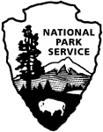 | Social Science Program  National Park Service  U.S. Department of the Interior  Visitor Services Project

Cuyahoga Valley
National Park

Visitor Study

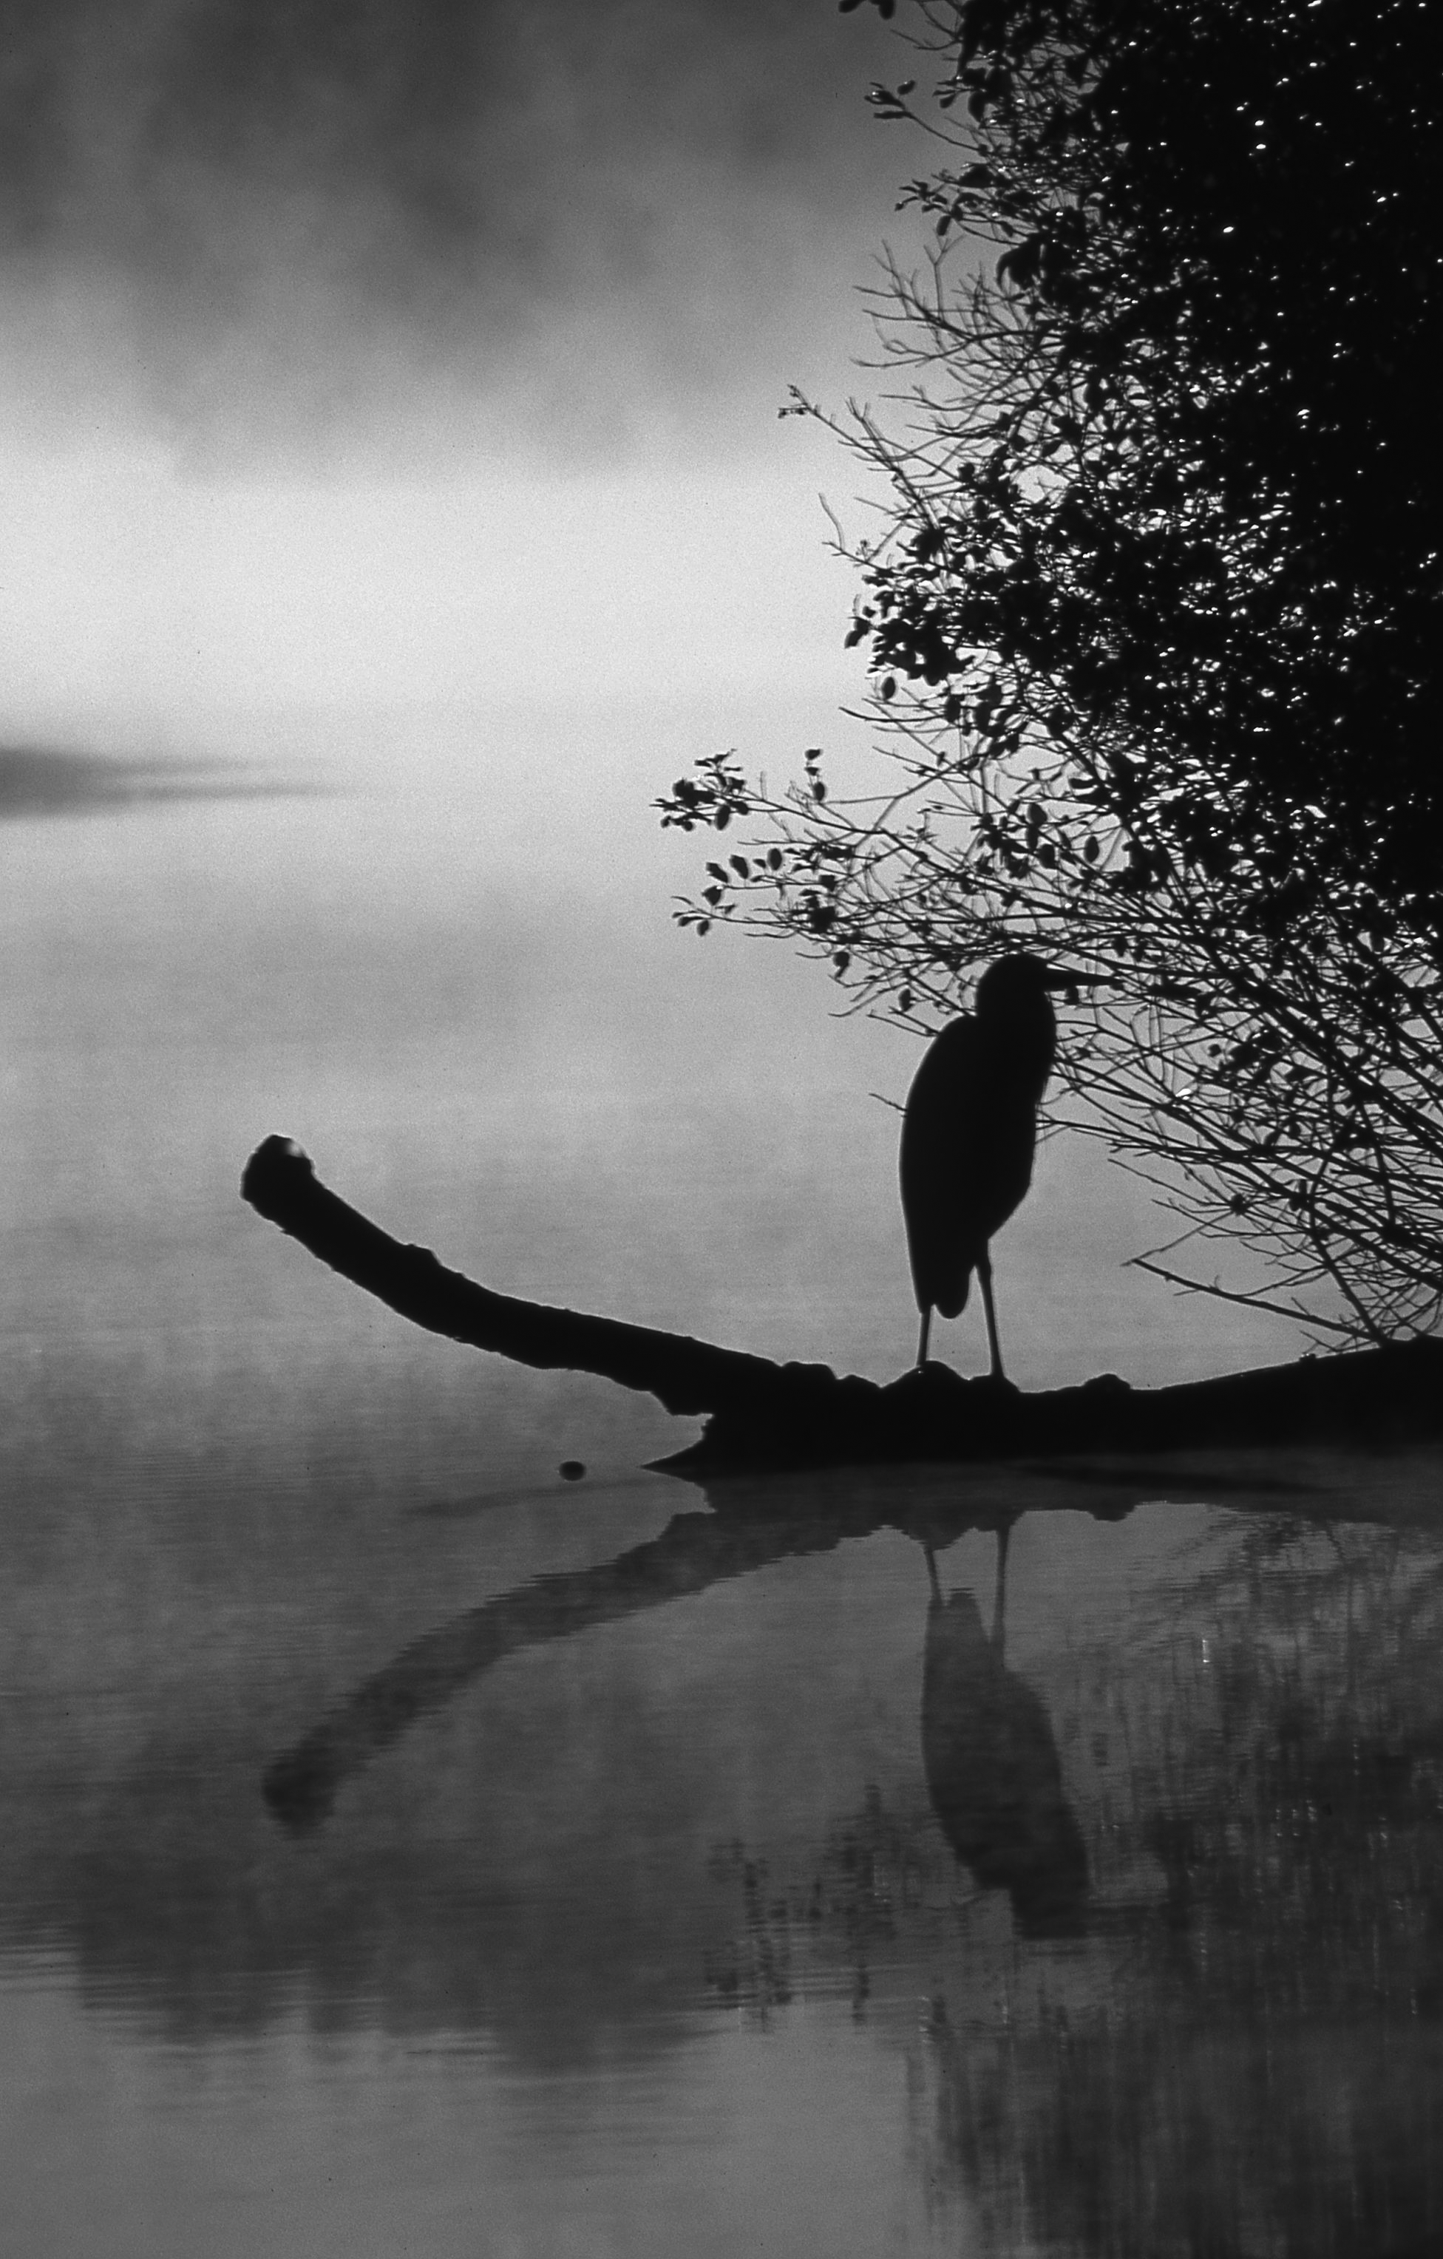

2015

OMB Approval Number: 1024-0224
Expiration Date: xx-xx-xxxx

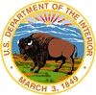 | United States Department of the Interior  NATIONAL PARK SERVICE  Cuyahoga Valley National Park  15610 Vaughn Road  Brecksville, OH 44141-3018

July 2015

Dear Visitor:

Thank you for participating in this important study. We want to learn about the expectations, opinions, and interests of visitors to Cuyahoga Valley National Park. This information will help us improve our management of this park and better serve you, our visitor.

This questionnaire will be given to only a few visitors, so your participation is very important! It should only take about 20 minutes after your visit to complete.

When your visit is over, please complete the questionnaire. Seal it with the stickers provided on the last page and drop it in any U.S. mailbox.

If you have any questions, please contact Social Science Program Chief, National Park Service, 1201 Oakridge Drive, Fort Collins, CO, 80525-5596; nps_nrss_social_science@nps.gov (email).

We appreciate your help.

Sincerely,

Craig Kenkel.
Superintendent

DIRECTIONS

At the end of your visit:

1. Please have the adult in your group (at least 18 years old) who has the next birthday complete this questionnaire. That will help give us a statistically reliable sample.

2. For questions that use circles (O), please mark your answer by filling in the circle with black or blue ink. Please do not use pencil.

4. Seal it in the postage-paid envelope provided.

5. Drop it in a U.S. Postal mailbox.

Paperwork Reduction and Privacy Act Statement: The Paperwork Reduction Act requires us to tell you why we are collecting this information, how we will use it, and whether or not you have to respond. This information will be used by the National Park Service as authorized by 16 U.S.C. 1a-7. We will use this information to evaluate visitor services and facilities managed by Cuyahoga Valley National Park. Your responses are voluntary and anonymous. Your name and address have been requested for follow-up purposes only. At the completion of this collection all names and personal information will be destroyed and in no way be connected with the results of this survey. A Federal agency may not conduct or sponsor and you are not required to respond to, a collection of information unless it displays a currently valid OMB Control Number.

BURDEN ESTIMATE: We estimate that it will take an average of 20 minutes to complete the survey associated with this collection of information. You may send comments concerning the burden estimates or any aspect of this information collection to the Social Science Program Chief, National Park Service, 1201 Oakridge Drive, Fort Collins, CO, 80525-5596; nps_nrss_social_science@nps.gov (email).

A. Trip Description
Please have the adult in your group (at least 18 years old), who has the next birthday, complete this questionnaire.
NOTE: In this questionnaire, your personal group is defined as anyone with whom you visited Cuyahoga Valley National Park on this trip, such as a spouse, family, friends, etc. This does not include the larger group that you might have traveled with, such as a school, church, scout, or tour group.

TOPIC AREA 1 – GR3
1. Including yourself, how many people were in your personal group on this trip to Cuyahoga Valley National Park?

_______ Number of adults (18 years or over)

_______ Number of children (under 18 years)

TOPIC AREA 1 – GR1
2. On this trip to Cuyahoga Valley National Park, what type of group were you with? Please mark (●) one.
O Alone
O Friends
O Family
O Family and friends
O Other (Please specify)

TOPIC AREA 3 – TRANS1
3. Which of the following forms of transportation did you personally use to enter Cuyahoga National Park on this trip? Please mark (●) one.
O Car, truck, or SUV (Number of people in vehicle, including you) ______
O Recreational vehicle or motorhome (Number of people in vehicle, including you) ______
O Tour bus or tour van
O Bicycle
O Walk/hike
O Other (Please specify) _________________________

TOPIC AREA 3 – TRIPC8
4. On this trip, how much total time did you spend within Cuyahoga Valley National Park?
Number of hours, if a day trip
Number of days, if greater than 1 day

B. Trip Planning and Motivations

TOPIC AREA 2 - TPLAN1
5. Prior to this visit, how did you and any other member of your personal group obtain information about Cuyahoga Valley National Park? Please mark (●) all that apply.
O Did not obtain information prior to this visit
O Previous visits
O Friends/relatives/word of mouth
O Park staff/volunteer at an event in my community
O Walking/driving by and saw park signs
O Travel guides/tour books/brochures
O Television/radio/newspapers/magazines
O Telephone/e-mail/written inquiry to park
O Website (Specify below)
O www.nps.gov/cuva
O www.conservancyforcvnp.org
O www.ohioanderiecanalway.org
O Other (Please specify)____________________________________
O Social media
O Mobile app
O School class or program
O Other (Please specify) _______________________________________

TOPIC AREA 2 – TPLAN2 & TPLAN3
6. Did you and your personal group have the type of information about Cuyahoga Valley National Park you needed on this trip? Please mark (●) one.
O Yes
O No (Please specify information you needed but didn’t have on this trip) ____________
________________________________________________________________________
________________________________________________________________________

TOPIC AREA 6 – EVALSERV4
7. On this visit, were the signs directing you to Cuyahoga Valley National Park adequate? Please
mark (●) one for each row.

 | Yes | No | Not sure
Signs on interstates | O | O | O
Signs on local roadways | O | O | O

TOPIC AREA 3 – TRIPC12
8. On this visit, did you have any difficulty locating Cuyahoga Valley National Park? Please mark (●) one.
O Yes (Please explain) _____________________________________________________
________________________________________________________________________
________________________________________________________________________
O No
TOPIC AREA 6 – EVALSERV6
9. On this visit, were the signs inside Cuyahoga Valley National Park adequate for you to find your
way around the park? Please mark (●) one.
O Yes
O No (Please explain) ______________________________________________________
______________________________________________________________________
______________________________________________________________________

TOPIC AREA 2 – TPLAN15
10. Cuyahoga Valley National Park protects cultural and natural resources, while at the same time provides for public enjoyment. How important to you was each of the following resources/qualities/ attributes as a reason for visiting the park on this trip? Please mark (●) one for each row.

 | Extremely Important | Very Important | Moderately Important | Slightly Important | Not at All Important
To visit a National Park Service site | O | O | O | O | O
To escape from urban setting | O | O | O | O | O
To spend time with friends/family | O | O | O | O | O
To view wildlife or natural scenery | O | O | O | O | O
To get physical exercise | O | O | O | O | O
To relax | O | O | O | O | O
To learn more about American history and culture | O | O | O | O | O
To learn more about nature | O | O | O | O | O
To attend a special event (Please specify)_________________________ | O | O | O | O | O
To hear the sounds of nature/quiet | O | O | O | O | O
To experience solitude | O | O | O | O | O
To be outdoors | O | O | O | O | O
To view dark night sky/stars | O | O | O | O | O
Other (Please specify) ___________________________ | O | O | O | O | O

TOPIC AREA 2 – TPLAN16

11. Of the items listed in Question 10, which was the most important reason for you to visit Cuyahoga Valley National Park on this trip?
_________________________________________________________________________

C. Park Activities, Programs, and Services

TOPIC AREA 3 – ACT1

12. In which of the following activities did you personally participate, on this trip to Cuyahoga Valley National Park? Please mark (●) all that apply.

O | Take a scenic drive/drive for pleasure
O | Visit historic houses/sites
O | Attend special programs/ events/ tours (nature walks, concerts, etc.)
O | Hiking/walking
O | Dog-walking
O | Jogging/running
O | Bicycling
O | Horseback riding
O | Canoeing/kayaking
O | Fishing
O | Attending farmers’ market (Please specify): ______________________________
O | Visiting a farm (Please specify): ________________________________________
O | Picnicking
O | Photography/painting
O | View scenery
O | Birdwatching/nature study
O | Camping
O | Other (Please specify): ______________________________________________

TOPIC AREA 3 – ACT2

13. Of the activities listed in Question 12, which was your primary activity on this trip to Cuyahoga Valley National Park? Please list one activity.

OR

O I did not have a primary activity on this trip to Cuyahoga Valley National Park.

TOPIC AREA 3 – ITIN1

14. Which of the following sites did you personally visit on this trip to Cuyahoga Valley National Park? Please refer to enclosed map to help answer the question and mark (●) all that apply.
O | Canal Exploration Center
O | Boston Store Visitor Center
O | Hunt House
O | Towpath Trail
O | Virginia Kendall Park (Ledges, Octagon, Salt Run, Virginia Kendall Lake & Hills, Cross Country)
O | Other Trails (Please specify) __________________________________________________
O | Everett Covered Bridge
O | Brandywine Falls
O | Blue Hen Falls
O | Other (Please specify) _______________________________________________________
O | Other (Please specify) _______________________________________________________

TOPIC AREA 3 – ACT7 Variation

15. Which of the following information services did you personally use on this trip and/or any previous trips to Cuyahoga Valley National Park? Please mark (●) all that apply for this trip and any previous trips.

Used on this Trip | Used on Previous Trip
O | O | Printed materials (books, brochure, map, park newspaper, etc.)
O | O | Concerts/cultural events
O | O | Festivals/special events
O | O | Ranger-led tours/programs
O | O | Assistance from information desk staff
O | O | Roving rangers/volunteers available to answer questions
O | O | Trailhead bulletin boards
O | O | Self-guided materials (Quests, Junior Ranger activity books)
O | O | Education signs/outside exhibits
O | O | Visitor center/indoor exhibits
O | O | Visitor center/bookstore sales items
O | O | Audio-visual programs (videos, movies, slide shows, etc.)
O | O | Special programs on Cuyahoga Valley Scenic Railroad train
O | O | Audio tour on Cuyahoga Valley Scenic Railroad train
O | O | Guest lectures and/or workshops to improve skills (e.g., birdwatching, photography)

TOPIC AREA 1 – FVIS5 Variation
                - 16. If you were to visit in the future, are there information sources that you would prefer to use to learn about the natural and cultural history of Cuyahoga Valley National Park? Please mark (●) one.
O Yes (Specify information sources you’d like to use) _____________________________

O No

TOPIC AREA 3 – ACT1

17. How important to you personally was each of the following services and how satisfied were you with the quality of each of the services on this trip to Cuyahoga Valley National Park? Please mark (●) one for Importance and one for Quality for each row.

 | IMPORTANCE |  |  |  |  | QUALITY
 | Extremely Important |  | Somewhat Important |  | Not at all Important | Very Good | Good | Average | Poor | No Service At All
Food service/restaurants | O | O | O | O | O | O | O | O | O | O
Lodging | O | O | O | O | O | O | O | O | O | O
Gifts/gift shops | O | O | O | O | O | O | O | O | O | O
Rentals (e.g., recreational equipment, strollers, etc.) | O | O | O | O | O | O | O | O | O | O
Other (Please specify) _______________________  _______________________ | O | O | O | O | O | O | O | O | O | O

TOPIC AREA 3 – ACT1

18. Overall, were you able to find the commercial services you needed at the quality you wanted on this trip to Cuyahoga Valley National Park? Please mark (●) one.

O Yes
O No (Please explain):_______________________________________________________
___________________________________________________________________________________________
___________________________________________________________________________________________

TOPIC AREA 6 – EVALSERVE13 Variation
19. Have you or any of your group members ridden the Cuyahoga Valley Scenic Railroad (CVSR)
train? Please mark (●) all that apply.

O Yes, on this trip to Cuyahoga Valley National Park
O Yes, on a previous trip to Cuyahoga Valley National Park
O No
TOPIC AREA 6 – EVALSERVE13 Variation
20. If you rode on the train on this trip to Cuyahoga Valley National Park, did it meet your
expectations? Please mark (●) one.
O Yes
O No (Please explain):______________________________________________________
___________________________________________________________________________________________
___________________________________________________________________________________________
O Not applicable (Didn’t ride the train on this trip)

TOPIC AREA 5 – CROWD2 Variation
21. Did you feel crowded at any time during your visit to Cuyahoga Valley National Park on this
trip? Please mark (●) one.

O Yes (Please list places where you felt crowded) ________________________________

O No

TOPIC AREA 6 – EVALSERV8
22. How safe did you feel during your visit to Cuyahoga Valley National Park on this trip? Please
mark (●) one for each row.

Safety Issue | Very  safe | Somewhat safe | No  opinion | Somewhat unsafe | Very  unsafe
Personal property—from crime | O | O | O | O | O
Personal safety—from crime | O | O | O | O | O
Personal safety—from accidents | O | O | O | O | O

TOPIC AREA 6 – EVALSERV9
23. If you marked “somewhat unsafe” or “very unsafe” for any safety issue listed in Question 21,
please explain why.

TOPIC AREA 1 – GR4
24. a) Did anyone in your personal group have a physical condition that made it difficult to access or participate in park activities or services, on this trip to Cuyahoga Valley National Park? Please mark (●) one.
O Yes
O No Go to Question 25
b) If YES, what activities, services, or facilities did the person(s) have difficulty participating in or accessing? Please be specific.

TOPIC AREA 3 – FVIS24 Variation
25. Would you be likely to use a shuttle bus service for each of the following purposes, if you were to visit Cuyahoga Valley National Park in the future and such a service was available? Please mark (●) one for each row.

 | Likely | Not likely | Don’t know/ Not sure
Ride a shuttle bus, rather than drive, to your park destination(s) | O | O | O
Combine shuttle service with a ride on the Cuyahoga Valley Scenic Railroad | O | O | O

D. Park Partners

TOPIC AREA 1 – KNOW9 Variation
26. Prior to this trip to Cuyahoga Valley National Park, were you aware of any of the following opportunities provided by park partners? Please refer to enclosed map to help answer the question and mark (●) one for each row.
 | Yes | No
Train excursions aboard Cuyahoga Valley Scenic Railroad | O | O
Overnight accommodations at Stanford House and Campground | O | O
Family, youth, and camp programs through Cuyahoga Valley Environmental Education Center | O | O
School programs through Cuyahoga Valley Environmental Education Center | O | O
Countryside Farmers’ Market | O | O
Countryside Initiative Farms in the park | O | O
Ability to get married in the park | O | O
Ability for community groups and businesses to have meetings in the park | O | O
Extraordinary Spaces program | O | O
Shopping and food at Trail Mix Boston | O | O
Shopping and food at Trail Mix Peninsula | O | O
Trails Forever | O | O
Opportunities to volunteer | O | O

TOPIC AREA 1 – PART2
27. The Conservancy for Cuyahoga Valley National Park (Conservancy) is a friends group that supports Cuyahoga Valley National Park through programs, awareness, and funding. Prior to this visit, were you aware of the Conservancy? Please mark (●) one.
O Yes
O No

TOPIC AREA 1 – PART1
28. Do you or would you be willing to support the Conservancy in either of the following ways?
Please mark (●) all that apply for each row.

 | Already do this | Likely to do this in the future | Not likely to do this
Become a member | O | O | O | (If Not likely, please explain: _______  ______________________________  ______________________________)
Make a charitable donation | O | O | O | (If Not likely, please explain: _______  ______________________________  ______________________________)

TOPIC AREA 1 – PART2 Variation
29. The Countryside Conservancy has a partnership with Cuyahoga Valley National Park to increase public awareness about sustainable food and farming. Prior to this visit, were you aware of the Countryside Conservancy? Please mark (●) one.
O Yes
O No

TOPIC AREA 1 – KNOW2 Variation
30. Prior to this visit, were you aware that Cuyahoga Valley National Park is located in the Ohio and Erie Canalway National Heritage Area? Please mark (●) one.
O Yes
O No

E. Expenditures on This Trip
Please refer to the map when answering the questions in this section.

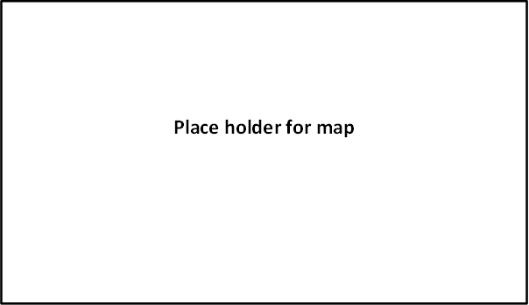

TOPIC AREA 1 – RES1 Variation
31. Do you live within the highlighted area shown on the map? Please mark (●) one.
O Yes
O No

TOPIC AREA 3 – TRIPC3
32. a) On this trip to Cuyahoga Valley National Park and the nearby area, did you stay overnight away from your permanent residence either inside Cuyahoga Valley National Park or within the nearby area (within the highlighted area of the enclosed map)? Please mark (●) one.
O Yes
O No Go to Question 33

b) If YES, please list the number of nights you stayed in Cuyahoga Valley National Park (NP) and/or in the nearby area (within the highlighted area of the enclosed map) on this trip.

Accommodation | Number of Nights
Camping in Cuyahoga Valley NP | ________
Camping outside Cuyahoga Valley NP | ________
Lodging in Cuyahoga Valley NP | ________
Lodging outside Cuyahoga Valley NP | ________
Other accommodations (e.g. friends/relatives) | ________

TOPIC AREA 3 – TRIPC1 Variation
33. Was this trip to Cuyahoga Valley National Park? Please mark (●) one.
O Your primary or sole purpose of your trip away from home?
O One of several equally important destinations on your trip away from home?
- Was one or more of the other equally important destinations located within the nearby area (within the highlighted area of the enclosed map)? Please mark (●) one.
O Yes
O No
O Just an incidental or spur of the moment stop on your trip away from home?
- Was your primary destination located within the nearby area (within the highlighted area of the enclosed map)? Please mark (●) one.
O Yes
O No

TOPIC AREA 3 – TRIPC19 Variation
34. Did you visit any other National Park Service sites on your trip away from home? Please mark (●) one.
O Yes (Please specify)______________________________________________________

O No

Topic Area 3 – TRIPC7
35. On how many days during this trip did you enter or re-enter Cuyahoga Valley National
Park? If you were on a day trip or if you camped or lodged inside the park and did not
leave the park boundaries for the entire length of your stay, then answer 1 day.

________ Number of days entering or re-entering Cuyahoga Valley National Park

OR

O Don’t know/Not sure

TOPIC AREA 7 – ECON4
36. Please estimate how much you and your personal group with whom you shared expenses (e.g., other family members, traveling companions) spent both inside Cuyahoga Valley National Park and within the nearby area (within the highlighted area of the enclosed map) during this trip to Cuyahoga Valley National Park and the nearby area?

If you no longer have your receipts, estimate as closely as you can how much you and your group spent. Please enter 0 (zero) if you did not spend any money in a particular category.

Note: Residents living within the highlighted area of the map should only include expenditures that were directly related to this trip to Cuyahoga Valley National Park (NP).

Expenses | Amount spent in Cuyahoga Valley NP and nearby area
Gas and oil (auto, RV, etc.) | $________
Rental cars | $________
Taxis, shuttles, and public transportation | $________
Snacks/beverages | $________
Groceries and convenience foods | $________
Hotels, motels, resorts | $________
Camping fees (tent, RV) | $________
Recreation and entertainment expenses (movies, bowling, miniature golf, etc.) | $________
Souvenirs, clothing, supplies, other retail | $________
Equipment rental | $________
Cuyahoga Valley Scenic Railroad | $________
Guides and tour fees | $________
Other (please list)____________________ | $________

OR

O Don’t know/Not sure

TOPIC AREA 7 – ECON5
37. a) Including yourself, how many people in your personal group were covered by the expenses for this trip away from home?
Number of adults (18 years or over)
Number of children (under 18 years)

b) Including yourself, how many people in your group split these trip expenses?
_______ Number of people

F. Background

TOPIC AREA 1 – VISITHIS5 Variation
38. How frequently have you personally visited Cuyahoga National Park during the last 12 months? Please mark (●) one.
O Daily
O Several times a week
O Several times a month
O Several times a year
O Only once (this trip)

TOPIC AREA 1 – AGE1, GEND1, RACE/ETH1
39. For your personal group on this trip to Cuyahoga Valley National Park, please provide the following information.

(If you do not know the answer, enter “DK.”)

 | Yourself | Member #2 | Member #3 | Member #4 | Member #5 | Member #6 | Member #7
Current age | O | O | O | O | O | O | O
U.S. ZIP code or name of country other than U.S. | ________ | ________ | _______ | _______ | ________ | ________ | ________
Male | O | O | O | O | O | O | O
Female | O | O | O | O | O | O | O
Hispanic or Latino | O | O | O | O | O | O | O
Not Hispanic or Latino | O | O
Don’t’ know | - | O DK | O DK | O DK | O DK | O DK | O DK

TOPIC AREA 1 – RACE/ETH3
40. What is the race of each member of your personal group on this trip to Cuyahoga Valley National Park? Please mark (●) one or more for each group member, including yourself.

(If you do not know the answer, enter “DK.”)

 | Yourself | Member #2 | Member #3 | Member #4 | Member #5 | Member #6 | Member #7
American Indian or Alaska Native | O | O | O | O | O | O | O
Asian | O | O | O | O | O | O | O
Black or African American | O | O | O | O | O | O | O
Native Hawaiian or other Pacific Islander | O | O | O | O | O | O | O
White | O | O | O | O | O | O | O
Don’t’ know | - | O DK | O DK | O DK | O DK | O DK | O DK

TOPIC AREA 1 – ED2 Variation
41. What is the highest level of formal education completed by each member of your personal group on this trip to Cuyahoga Valley National Park? Please mark (●) one for each group member, including yourself.

(If you do not know the answer, enter “DK.”)

 | Yourself | Member #2 | Member #3 | Member #4 | Member #5 | Member #6 | Member #7
Less than high school | O | O | O | O | O | O | O
Some high school | O | O | O | O | O | O | O
High school graduate or GED | O | O | O | O | O | O | O
Some college, business, or trade school | O | O | O | O | O | O | O
College, business, or trade school graduate | O | O | O | O | O | O | O
Some graduate school | O | O | O | O | O | O | O
Master’s, doctoral, or professional degree | O | O | O | O | O | O | O
Don’t’ know | - | O DK | O DK | O DK | O DK | O DK | O DK

TOPIC AREA 7 – ECON1
42. Including yourself, how many people are in your household?

______ Number of people

TOPIC AREA 1 – LANG1

43. When visiting an area such as Cuyahoga Valley National Park, what language do you personally prefer to use? Please mark (●) one for speaking and one for reading.

 | Speaking | Reading
English | O | O
Spanish | O | O
Other (Specify) _________________________ | O | O

TOPIC AREA 6 – OPMGMT3
44. Is there anything else you and your group would like to tell us about your trip to Cuyahoga Valley National Park?

Thank you for your help! Please seal the questionnaire with the stickers provided and drop it in any U.S. mailbox.

 | Printed on recycled paper

