UNITED STATES MINT
QUANTITATIVE CONSUMER RESEARCH
UNITED STATES MINT American Eagle Silver and Gold Sales Research Survey
OMB Clearance Request
12/8/2017

- Introduction /Purpose of the Research

This collection request is for the United States Mint to conduct a new product research study seeking information about potential reasons behind the decline in American Eagle Silver and Gold coin sales between 2017 and 2016.

The survey research will inquire customers regarding the following purchase aspects:

- Have you ever purchased an American Eagle Coin?

- Did you buy an American Eagle coin in 2016? In 2017? Which one(s)?

- What reasons, if any, deterred you from purchasing your American Eagle coin in 2017?

- What could U.S. Mint have done to get you to buy an American Eagle coin?

- Reasons for purchasing more American Eagle coins in 2017 than 2016

- What are your purchase plans for 2018?

- How likely are you to purchase American Eagle coins in 2018?

- How likely are you to purchase other U.S. Mint items in 2018?

Part of the United States Mint’s mission is to produce and make collectible coin products available directly to the American public. Executive Order No. 12862 (September 1993), titled “Setting Customer Service Standards,” establishes a mandate for the government to improve and adhere to best practices when providing customer service directly to the American people, such as by conducting research to determine satisfaction with existing services and to ensure the kind and quality of services offered are aligned with those the public wants (Section 1b). To effectively accomplish these goals, the United States Mint utilizes a combination of accepted research methods that shed light on the awareness, satisfaction and preferences among the public as they relate to collectible coin products and services. The United States Mint American Eagle Silver and Gold Sales Research survey is one of these instruments.

The consequence of not performing this collection is the United States Mint’s diminished ability to maintain service levels and product satisfaction that will continue to satisfy customers.

II. Sample Design and Methodology

The American Eagle Silver and Gold sales research survey is designed to be web-based, with customers receiving an e-mail invitation to complete the survey. The targeted sample is a total of 6,000 United States Mint customers divided into two main groups:

- Any individual gold coin or gold coin set sold from 2016-2017

- Any individual silver coin or silver coin set sold from 2016-2017

The sampling allocation will focus on American Eagle Gold and Silver buying patterns as listed below:

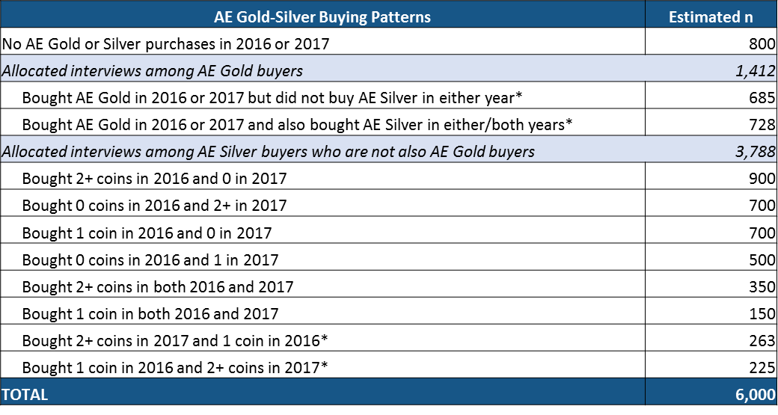

The customer sample for the survey will be obtained from the customer database lists and will be selected randomly among the population of customers fitting the defined criteria. Collected survey data will be cleaned, tabulated and weighted proportionally to the United States Mint customer database.

As indicated before, potential customer respondents will be sent email invitations to take the survey on-line. The survey should take no more than 10 minutes to complete.

Survey Design

The survey is designed to assess potential reasons behind the decline in American Eagle Silver and Gold coin sales between 2017 and 2016.

Participants will be asked several standard screening questions pertaining to purchasing history to precious metal products, future intent and purchase likelihood.

Afterwards, the survey asks a set of questions exploring reasons for decline and likelihood to purchase to purchase in the future. Finally, all respondents are asked a set of standard demographic questions, after which they have completed the survey.

Methods to Maximize Response Rates

This survey approach is designed to minimize the amount of intrusion and burden that is placed on customers. Accordingly, calls will not be made to them, nor will other “intrusive” measures that normally might be used to maximize response rates. We plan to send e-mail invitations to respondents explaining that participation is totally voluntary and that their feedback will be used to help improve the products and services we offer. Multiple reminder emails (e.g., one to two) will be sent to potential respondents to invite them to complete the survey. Respondents can complete the survey at a time convenient to them. No monetary incentive will be offered to customers.

We ensure that our data provides reliable population-level inferences by carefully designing the sampling plan with appropriate strata and sample sizes and by weighting the data to account for the survey design and to adjust for non-response.

The United States Mint deals with non-response bias in a number of ways. First, question non-response (those who don’t answer a question but would otherwise complete the survey) is minimized by the survey tool, which requires respondents to make a selection for all questions. Second, survey non-response (people who don’t respond to the survey invitation and those who respond but don’t complete the survey) is minimized by keeping the survey short and as simple as practicable, allowing respondents to take the survey at a time convenient to them, and by sending reminder emails (usually one to two) to invitees who have not yet responded.

The United States Mint will account for non-response bias by weighting the survey data and applying other adjustment techniques where appropriate and available.

Estimate of the Burden Hours

The collection of information will involve completion of the survey via the Internet with up to 6,000 randomly selected customers. The average time to complete the survey will be approximately 10 minutes. Therefore, the total estimated burden for this survey is 1,000 hours.

 | United States Mint American Eagle Silver and Gold Sales Research Survey
All respondents | 6,000
Average minutes to complete survey | 10 mins
Total estimated burden hours | 1,000 hrs

If you have questions related to the review of this collection request, you may contact any of the following individuals at the United States Mint’s Numismatic and Bullion Directorate:
- Manoj Pillai – manoj.pillai@usmint.treas.gov; 202-354-7255

