Victim Race Variables
- White: RaceWhite
- Black or African American: RaceBlack
- Asian: RaceAsian
- Native Hawaiian or other Pacific Islander: RacePacificIslander
- American Indian or Alaska Native: RaceAmericanIndian
- Unspecified race: RaceUnspecified

Definitions:
- White: Person with origins among any of the original peoples of Europe, North Africa, or the Middle East
- Black or African American: Person with origins among any of the black racial groups of Africa
- Asian: Person with origins among any of the original peoples of the Far East, Southeast Asia, or the Indian subcontinent
- Native Hawaiian or other Pacific Islander: Person with origins among any of the original peoples of the Pacific Islands (includes Native Hawaiians)
- American Indian or Alaska Native: Person with origins among any of the original peoples of North America and who maintains cultural identification through tribal affiliation or community recognition (includes Alaska Natives)
- Unspecified: If an appropriate match cannot be determined for any person’s race (see Discussion), or if a person’s ethnicity is provided in place of their race( e.g., race is given as “Hispanic”, and no other valid race value is given), mark their race as “unspecified”

Response Options:
Checkbox

Discussion:
For multi-racial decedents, please check each race identified in source documents (e.g., if the decedent is identified as “white” and “Asian”, please check “white” and “Asian”). If source documents indicate “Mulatto,” check both “white” and “black”. If “Asian/Pacific Islander” is indicated, check both “Asian” and “PacificIsland”. These standards were used by the U.S. Census Bureau in the 2010 decennial census.

Decedents should only be indicated as being of “Unspecified” race if their indicated race does not fit into one of the five summary categories (white, black, Asian, Native Hawaiian or Pacific islander, American Indian or Alaska native). The five summary categories are consistent with current OMB and HHS standards:

http://aspe.hhs.gov/datacncl/standards/ACA/4302/index.shtml

Also note that HHS includes more granular categories that roll up into the five summary categories (the OMB standard). Please consult the following table to determine if any other specified race can be categorized into one of the five summary race categories:
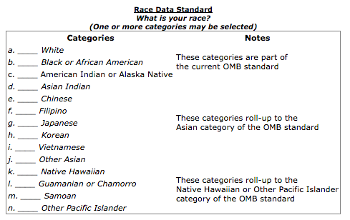
Source: U.S. Department of Health and Human Services, Implementation Guidance on Data Collection Standards for Race, Ethnicity, Sex, Primary Language, and Disability Status. October, 2011. Available on the web: http://aspe.hhs.gov/datacncl/standards/ACA/4302/index.shtml

