LGBT Campaign: Focus Group Study of Brand and Creative Concepts Designed to Prevent LGBT Young Adult Tobacco Use
Addendum B: Creative Concept Stimuli

Phase 1
The following fifteen preliminary ad concepts will be tested as part of Wave 1 of Brand and Creative Concepts Testing in the form of storyboards:

- Year One
- Let Love In v1
- Bathroom Mirror v1
- Illusions
- Unpredictable v1
- Our Story
- Be Known For Your Flawless v1
- Tip The Scale v1
- Family Dinner
- FOMO (Fear of Missing Out)
- Let Love In v2
- Bathroom Mirror v2
- Be Known For Your Flawless v2
- Unpredictable v2
- Tip The Scale v2

CREATIVE CONCEPT #1: Year One

Key Frame
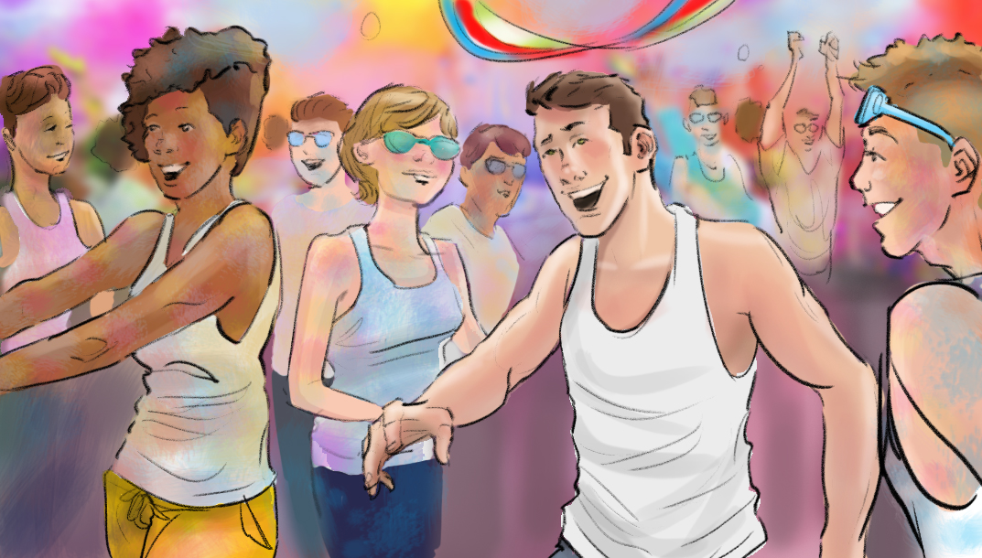

Concept Overview
Using PRIDE as a unifying way to bring together the LGBT young adult audience, this concept will touch on the difficulties, and eventually the breakthrough that happens when an LGBT young adult decides to “come out.” A young male will walk through a non-descript lifeless urban environment, unhappy, and looking down as people walk past him. The tone will be dark and strangers will bump into him because they don’t see him as if he is invisible. The surroundings slowly change and we hear in the distance a celebration. He begins to shed his bland attire and walks through a passageway and hits a wall of color (similar to “color runs”). People are celebrating throwing color as an abstract representation of pride. The dialogue in this spot is all voiceover.

Concept Script
VIS: Camera pans around youth who is looking forward. The coloring is ‘bland,’, depressing and lifeless. Nondescript people walk past him, bumping into him as if they don’t see him. He is wearing a plain white tank top.
VO:
Back then I felt rejected… insulted… disrespected.
Sometimes, I just wanted to disappear.

VIS: Surroundings are depressing and lifeless as camera spins around protagonist.
VO:
I wasn’t living in my hometown. I was just surviving.

VIS: Surroundings slowly begin to change. Crowd noises are faint. Subject begins to shed bland attire.
VO:
But I knew that one day I would find the life I was meant to live. And I would be FREE.

VIS: He walks through a passage or doorway into the middle of colored dust being thrown similar to a “color run”
SFX:
crowd/parade noises

VIS: He laughs and soaks in the chaos.
VO:
Now I am HERE. Present. A FIRE within lit.

VIS: People throw color all over his white tank top.
VO:
I don’t just survive. I thrive.

VIS: He engages in the joyful throwing of colored dust. He paints his face with vibrant colors.
VO:
After 18 years of just trying to get by, now this is just my beginning. Year one of my true story.

VIS: A sentimental shot of him laughing with friends. SHOW FACT ON SCREEN: “Every year, 16,320 LGBT lives are cut short by a smoking-related disease (Gates 2012, p. 1; CTP 2014, p. 15).”
VO:
And the last thing I plan to do is cut it short with something like smoking.
I just found where I’m meant to be, and I plan to be here for a long-time.

ANNOUNCER:
Live Proud. Live Long. Live Tobacco-free.

ENDCARD

CREATIVE CONCEPT #2: Let Love In v1

Key Frame
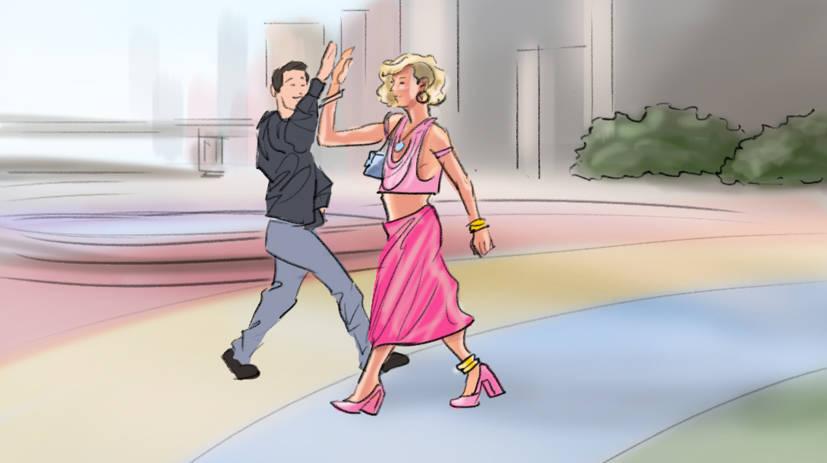

Concept Overview
A striking androgynous male DJ decides to walk around the city. His appearance challenges the stereotypical gender norms for a male young adult. The commercial will cut through different days each with a different outfit and location, but wherever he walks, he attracts attention. He is unbothered by the negative attention and walks confidently, only acknowledging the positive attention.

Concept Script
VIS: A striking androgynous male walks down the street. Heads turn as he walks down the street.
VO:
Sickening is the standard.

VIS: Match cuts to him walking in pride.
VO:
Confidence? It’s required.
NEVER in the shade.

VIS: Match cuts to him walking past people who stare. He is unbothered.
VO:
I block the hate.

VIS: Passes a group of people who give him a look of confusion. They look at him with disgust.
VO:
Poisons... stay out.

VIS: Match cuts to him walking and taking a “selfie” with “fans” on street.
VO:
Love shines in.

VIS: He continues to walk. He passes a woman who likes his look and snaps her fingers with approval. Fact on Screen: All tobacco products contain toxic chemicals (USDHHS Fact Sheet 2014, p. 126; USDHHS 2010, p. iii).
VO:
Controlling your life means choosing what affects you.
And for me, cigarettes, social smoking, bumming one on the patio…whatever you call it, you’re allowing something toxic in you (USDHHS Fact Sheet 2014, p. 126; USDHHS 2010, p. iii)

VIS: Shares a glance with a guy walking by obviously checking him out.
VO:
And this body... it’s non-toxic.

VIS: He enters a bar and friends and “fans” greet him openly.
VO:
I choose to live Tobacco-Free.

ENDCARD

CREATIVE CONCEPT #3: Bathroom Mirror v1

Key Frame
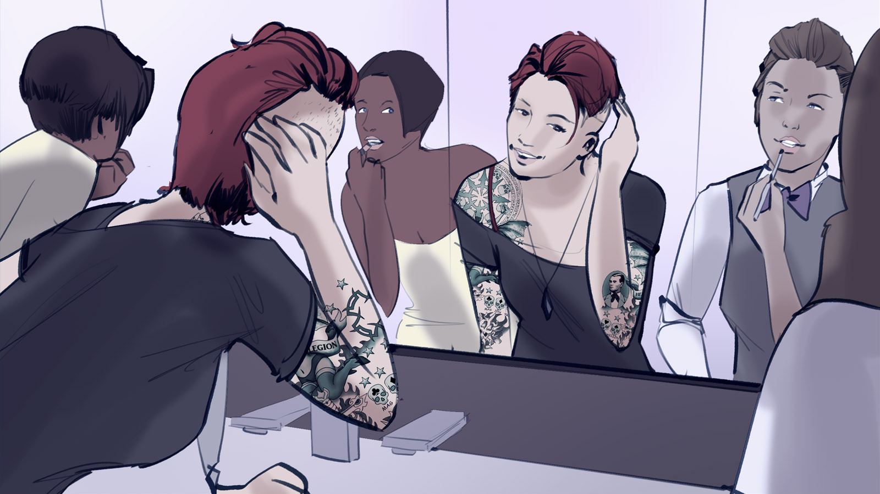

Concept Overview
An attractive, confident and socially successful young lesbian woman is touching up her outfit in a public restroom alongside a couple other lesbian girls who are also fixing themselves up as well. Our subject is clearly the best looking girl and she seems to know it. As she speaks, she walks out of the restroom and into the venue (nightclub). As she walks she has several girls checking her out behind her back – trying to be sly while they do it. She realizes they’re looking but she likes it and even toys with them a little.

She speaks out loud – to the camera. The viewer hears her speak but the other people in the scenes do not.

Concept Script
VIS: Attractive female touching up her outfit in a clean, modern public restroom alongside a few other girls who are also getting ready. She speaks confidently and somewhat flirty.
VO:
I came out when I was 18. I grew into myself.
She finishes up her hair and walks off screen. VO: I’m not a shallow person, but I like who I see in the mirror now. No more hiding.

VIS: She exits the restroom into a trendy night spot (dance club or music venue) that is noticeably a lesbian venue. Girls check her out as she walks by them. She stops near the front of the venue and we see behind her that the venue is popular and that she has attracted the gaze of several girls.
VO:
I finally feel my looks reflect the person I feel I am on the inside. Beautiful inside and out.
And the idea of cigarettes poisoning me inside AND affecting my look on the outside, is not the reflection I want to see.

VIS: As she delivers this last line, she smirks and glances back behind her. A few of the girls quickly (but obviously) turn their gaze away realizing they’ve been busted. Fact on screen: People consider smokers less physically attractive than non-smokers (Hines 1996, p. 862;
VO:
I gotta keep this look as long as I can. For me… [hah] and for them. Dermer 1986, p. 719).

ANNOUNCER:
Be tobacco-free.

ENDCARD

CREATIVE CONCEPT #4: Illusions

Key Frame
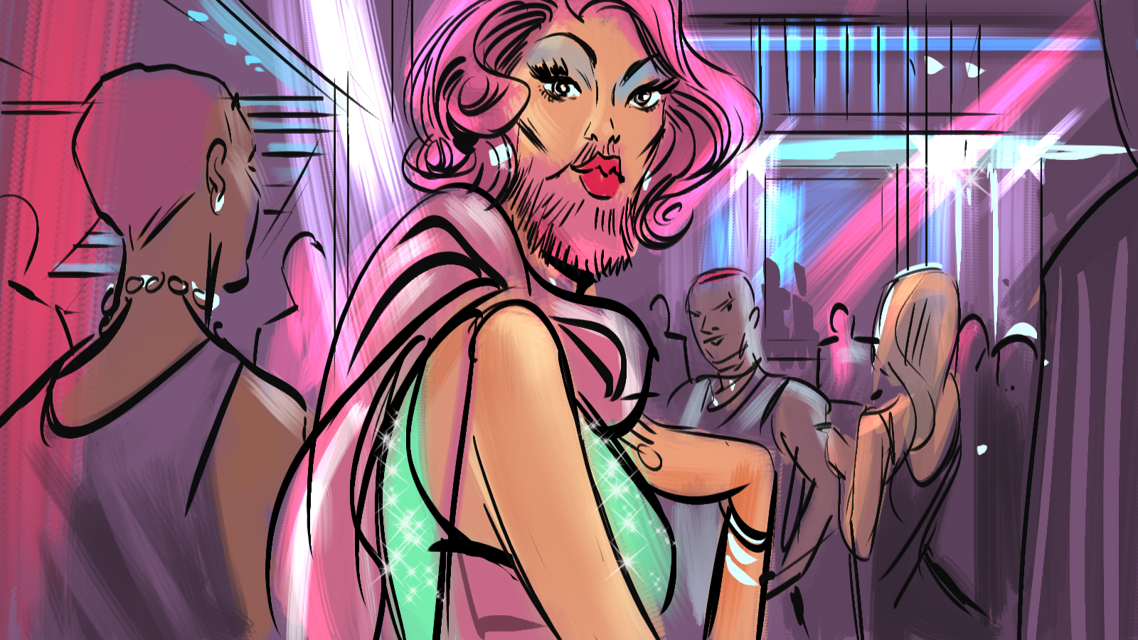

Concept Overview
At the club, people get to truly express themselves. They get to look and act as crazy as they want and show their own unique identity. Celebrating unique individuals that are popular, attractive and highly fashionable will feel like the brand is part of the cool crowd. This concept features a cool LGBT young adult walking through a social venue, speaking confidently to the camera as he describes the variety of unique individuals.

Concept Script
VIS: A guy is talking to the camera as he walks through a club.
VO: Talking On Camera (TOC):
In here, you never know what you’ll find. Like someone who is…

VIS: Shot of a bearded friend in drag.
VO:
Girlishly rugged.

VIS: Shot of a sexy masculine lesbian.
VO:
A masculine fem.

VIS: Shot of youth wearing elaborate ‘ballroom culture’ attire.
VO:
Freakishly gorgeous.

VIS: Shot of a youth who is known for a different look like the model Shaun Ross.
VO:
Or just beautifully different.

VIS: Back to our narrator.
TOC:
These are the illusions that make this place like no other.
TOC:
But there are some illusions that are doing real damage.

VIS: Fact on screen: People who stop smoking feel less stress than people who continue to smoke. VO:
Like cigarettes. People say they help with stress. But in reality, research shows that people who stop smoking feel less stress than people who continue to smoke (Parrott 1999, p. 817).

VIS: He points to the original girls having a good time.
TOC:
These illusions are what build our community…
But tobacco’s illusion damages us.
Live Tobacco-Free.

ENDCARD

CREATIVE CONCEPT #5: Unpredictable v1

Key Frame
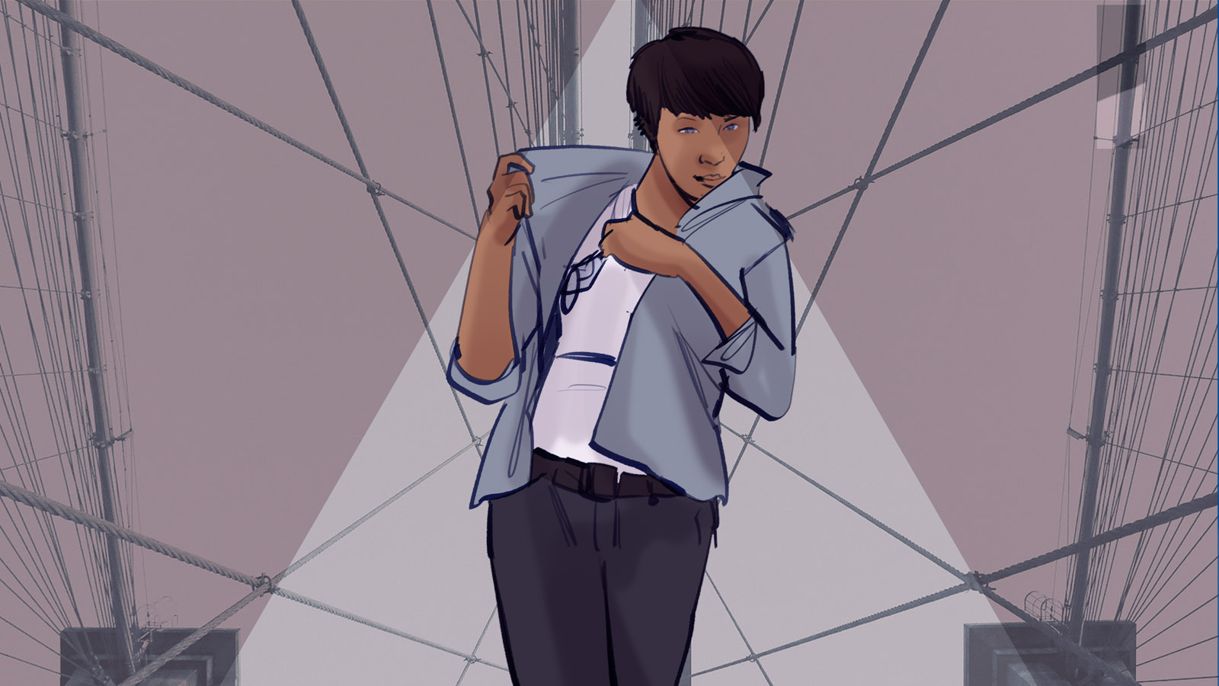

Concept Overview
This concept will spotlight multiple lesbian artists who share snippets of their lifestyle of living and breathing art. As entrepreneurs, the women share how being an artist involves unpredictable days, not following trends and making art that will outlive them.

Concept Script
VIS: Lesbian #1 stands full body in front of camera looking left off into the distance. Her surroundings are accented with graphical elements to make the image more unique and trendsetting. These elements are used throughout the visuals of this ad.
VO:
I search...

VIS: Lesbian #2 shops through a vibrantly colored section of a flea market.
VO:
Outside the lines.

VIS: Wideshot of Lesbian #3 in a picturesque metro station.
VO:
A creator. An explorer.

VIS: Lesbian #1 walks in an urban environment.
VO:
Walking the unknown.

VIS: Lesbian #4 thumbs through swatches.
VO:
Designing the beyond.

VIS: Lesbian #5 tries on different clothes as if the camera is a mirror. She shows off her personality.
VO:
Left of expectations.

VIS: Lesbian #5 shows off her personality.
VO:
Free...

VIS: Lesbian #1 shows off an unconventional outfit.
VO:
Bold...

VIS: Lesbian #3 walking down a street with an epic city view.
VO:
Beyond.

VIS: Quick match cuts of every lesbian featured looking directly into the camera. Fact on screen: Smokers are more than twice as likely to die prematurely compared to people who have never smoked (USDHHS Fact Sheet 2014, p. 639).
VO:
Nothing about me is predictable, so why would I die predictably?

ANNOUNCER:
Live beyond. Live tobacco-free.

ENDCARD

CREATIVE CONCEPT #6: Our Story

Key Frame
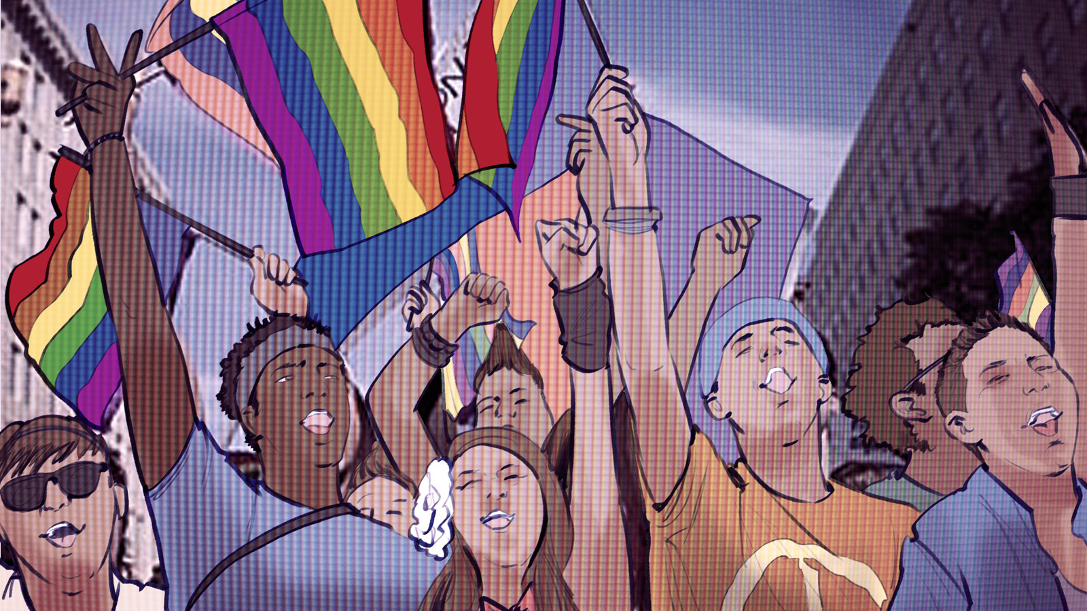

Concept Overview
This concept will have an “anthem-like” feel to it as a video that could feature a diverse cast of LGBT young adults who represent the majority of the target audience and the shared experiences they’ve had. The concept could be executed as a collection of “found” online video content from individual LGBT young adults that collectively reflect the tone or message of the script’s voice-over. These video clips may be shot, or licensed from existing web content; to the audience it will come across as existing videos from real people.

Concept Script
VIS: A rapid montage of various YouTube videos in a monochromatic color scheme.
VO:
Born in a black and white world

VIS: Cut to a vlog of a LGBT youth with a huge personality.
VO:
We saw color in the mirror.

VIS: An LGBT younger male tries on drag. A lesbian plays with a gender queer masculine look.
VO:
Embarking on a journey where our sexuality, our gender,

VIS: A young adult comes out to his parents.
VO:
our identity was never quite understood.

VIS: He cries.
Cut to another girl who cries on camera. She wipes away makeup.
VO:
Avoidance, disguises and perseverance,
With these tools we endured,
And eventually found love for our own truth.

VIS: Cut to the same male who came out and now he is happy as if his parents accepted him.
VO:
There is pain in our past, yes,
But joy is on the horizon.

VIS: A couple of cuts of people working out, happy.
VO:
Health and happiness
These are our new destinations

VIS: A group of LGBT people walking towards the camera.
VO:
But one seemingly insignificant factor
is blocking our path.

Black Screen.
VO:
Tobacco.
Yes, that moment at the bar
That tiny occasional cigarette

VIS: Rapid Cuts Of:
Footage of someone vlogging their doctor appointment.
An ambulance shot.
Someone visiting someone in hospital who is gravely ill.

VO:
It undermines our future.
Its smoke damages nearly every part of our bodies (USDHHS Consumer Booklet 2010, p. 2-3).
Its addiction takes control of our daily lives (USDHHS Consumer Booklet 2010, p. 4)
And its diseases claim over sixteen-thousand LGBT people every year (Gates 2012, p. 1; CTP 2014, p. 15).

VIS: Black Screen.
VO:
So I ask why now,
inflict this damage to ourselves?

VIS: Shots of people inside a bar having the time of their lives. Various shots of LGBT young adults being highly social.
VO:
No.
This new life
Free from judgment
Free from the shadows

VO:
Will also be
Free from tobacco.

ENDCARD

CREATIVE CONCEPT #7: Be Known for Your Flawless v1

Key Frame
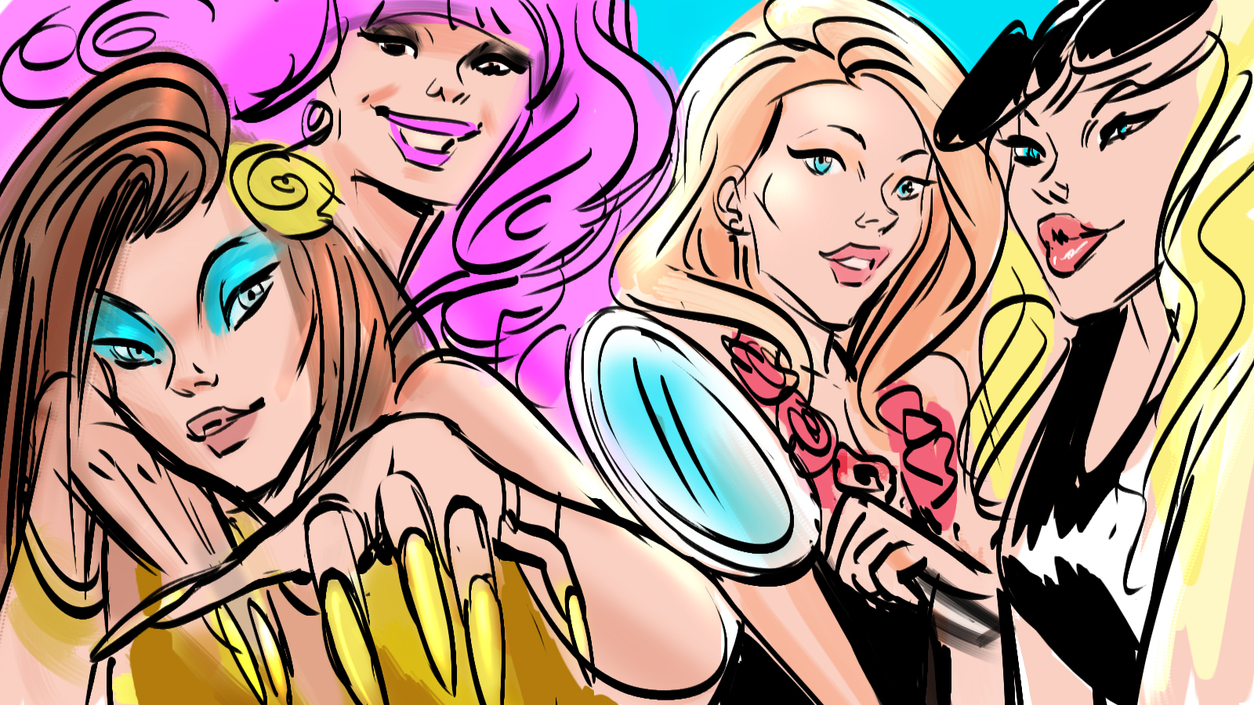

Concept Overview
Four drag queens who are well known for specific features will be showcased each in their own respective environments. Each queen will talk about her famous feature (e.g. Skin / Nails / Hair / Mouth), then unanimously they proclaim they will never be known for the negative version of those features that tobacco can directly cause.

Concept Script

VIS: Introductory montage of four drag queens looking fabulous in separate unique environments. Each environment will feature an over-the-top object that represents the queen’s unique characteristic.
SFX:
Dance Music

VIS: Drag Queen #1: Who is known for a beautiful face.
VO Drag Queen #1:
I am known for my cute face and flawless SKIN.

VIS: Sequence showcasing her beautiful face
SFX: Dance Music

VIS: Drag Queen #2: Who is known for eccentric manicures.
VO Drag Queen #2:
I am known to be a queen with a sensible NAIL

VIS: Sequence showcasing her nails
SFX: Dance Music

VIS: Drag Queen #3: Who is known for large hair.
VO Drag Queen #3:
HAIR. Known for that.

VIS: Sequence showcasing her hair.
SFX: Dance Music

VIS: Drag Queen #4: Who is known for lips.
VO Drag Queen #4:
My MOUTH.
SFX: Singing a warm up range.

VIS: Sequence showcasing her hair.
SFX: Dance Music

VIS: Drag Queen #1
VO Drag Queen #1:
I’ll be known for a lot of things, but I will NEVER

VIS: Drag Queen #2
VO Drag Queen #2:
NEVER

VIS: Drag Queen #1 has wrinkled skin
VO Drag Queen #1:
be known for wrinkled skin (Ortiz 2012, p.251-252; Just 2006, p. 85),

VIS: Drag Queen #2 with yellow basic nails
VO Drag Queen #2:
Yellow nails (Ortiz 2012, p. 250),

VIS: Drag Queen #3 wigless airing out her wig
VO Drag Queen #3:
Smelly hair,

VIS: Drag Queen #4 singing but does a breath check
VO Drag Queen #4:
Or ashy stank breath (NCI 2013).

VIS: Drag Queen #3
VO Drag Queen #3:
ALL caused by what? Tobacco. Yes queen, every cigarette is doing you damage (Ortiz 2012, p.251-252; Just 2006, p. 85).

VIS: Several Queens speak
VO:
Drag Queen #1: That’s basic.
Drag Queen #2: NEV…(cut)
Drag Queen #3: ...ERRRRR.
Drag Queen #4: I’m known for my flawless.
Drag Queen #1: I Live Tobacco Free.

ENDCARD

CREATIVE CONCEPT #8: Tip the Scale v1

Key Frame
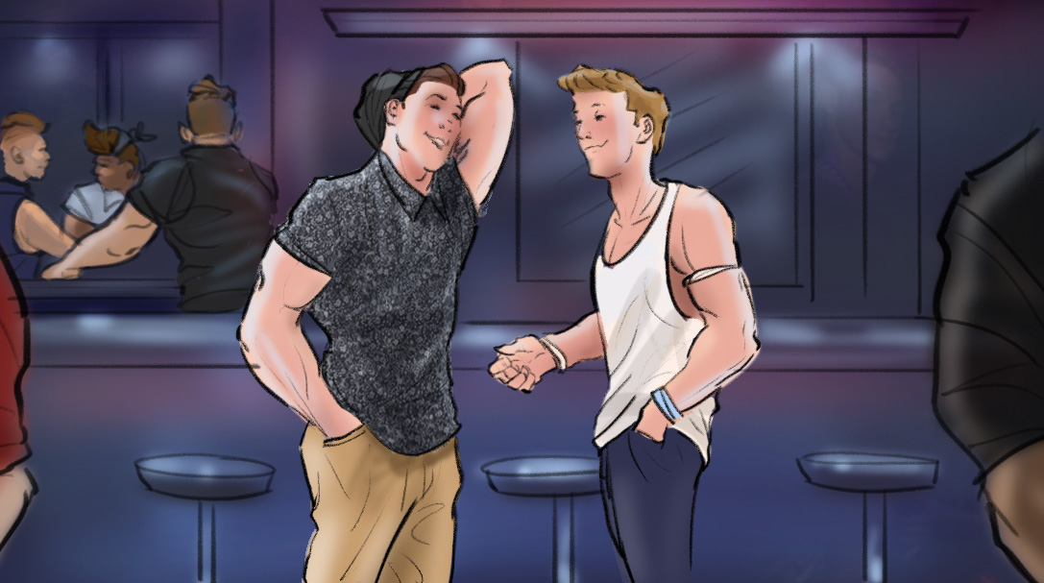

Concept Overview
This concept uses a first-person point-of-view (POV) of a gay man at an LGBT bar. As he enters, the footage is sped up along with the EDM music. He hugs his friends, signals to others who are dancing and hanging out. He walks into another gay male who he finds attractive and the music and video both slow down to regular speed. They trade flirtatious smiles while a voiceover talks about this being a moment of decision—a moment where being tobacco-free can give you that extra edge in the already competitive gay dating scene. The music then picks up again; the men are dancing together and trade phone numbers indicating that they were interested in each other. A voice-over closes the spot with a tobacco-free message.

Concept Script
VIS: Accelerated first person camera view of gay young adult male walking through an LGBT club.
POV is hugging their friends, seeing people dancing, and waving to them. Catchy EDM dance music plays throughout, though it is sped up during this sequence.
Once he spots the cute boy, the music slows down to regular BPM. VO begins.
VO:
This is that moment...

VIS: They begin to flirt closely. It’s obvious they can smell each other.
VO:
...when being tobacco-free tips the scale...

VIS: End first person camera, zoom out to see both guys. Beat drops, visuals accelerate again and the couple begins to dance together.
VO:
I stopped smoking ‘cause I didn’t like how it smells.

VO:
I stay tobacco-free cause I’d never want him to smell it on me (NCI 2013).

VIS: They enjoy each other’s company and visibly exchange numbers with their phones.
VO:
Live... Love... tobacco-free.

ENDCARD

CREATIVE CONCEPT #9: Family Dinner

Frame
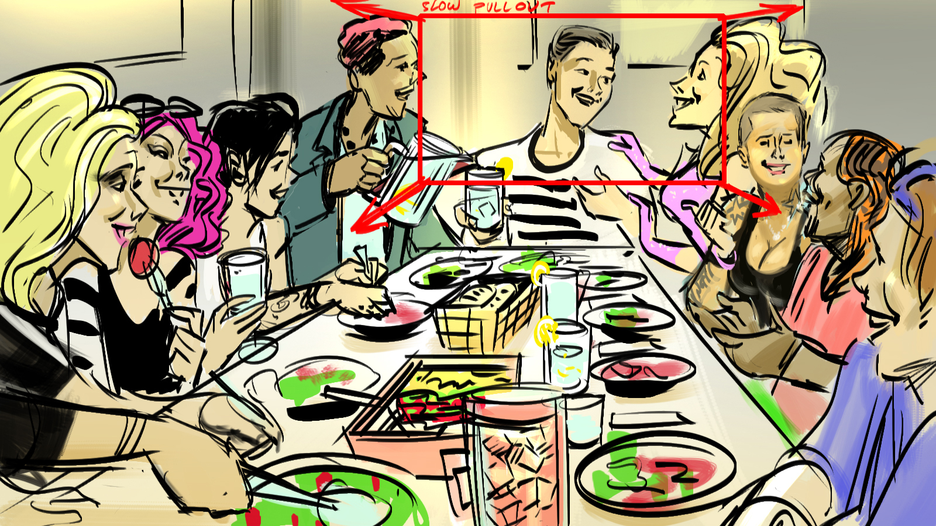

Concept Overview
A young gay male is prepping dinner for his family. The voice-over talks about how he shows his love for his family by using his impressive culinary skills. The viewer gets the impression that this is a traditional family dinner with a conventional definition of family. He talks about how he doesn’t smoke because he would never put his family at risk of secondhand smoke. The audience thinks it’s a traditional dinner until the very end when we see that his ‘family’ is a ragtag group of LGBT friends – somewhat of a shocking reveal. The food prep and hugs/greetings are shot in standard slow mo (not super slow mo).

Concept Script
VIS: A male preparing food in kitchen. The copy is all VO.
VO:
My family has done so much for me.

VIS: Male sets table. Everything looks traditional.
VO:
They embraced me when I was trying to figure myself out, and love me for who I’ve become.

VIS: Well-dressed friends (family) arrive but we never fully see them.
VO:
We look out for each other.

VIS: We see quick, partial shots: subject hugging people who appear to be female, shaking hands with guys, kissing cheeks, etc. We tease the viewer for now.
VO:
So I live tobacco-free, because I refuse to put my family in harm’s way with secondhand smoke (USDHHS Consumer Booklet 2006, p. 4).
THIS is my family.

(REVEAL) The entire crowd is revealed to be a ‘family’ of fabulous gay guys, trendy cool lesbians and drag queens. Should be surprising but not humorous.
SFX: Volume of house guests increases

VO:
And to me, they’re EEEVVVERYTHING

VO:
I have the life I want with my family and would never put them at risk.

ENDCARD

CREATIVE CONCEPT #10: FOMO “Fear of Missing Out”

Key Frame
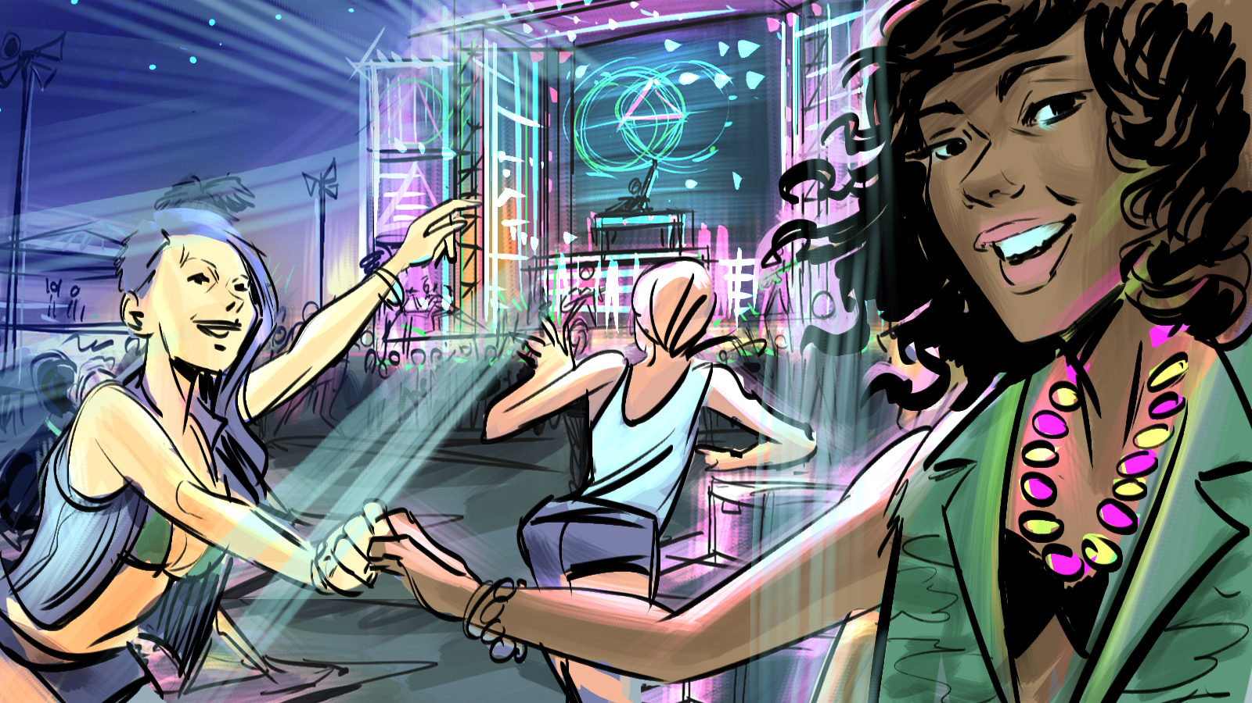

Concept Overview
This concept highlights the beauty and celebrations of a music festival, the effort it takes to stay healthy for the event, and how this is in direct contrast with the toxicity of tobacco. The commercial will feature a group of happy and friendly LGBT young adults who are clear minded and social, fully enjoying the festival experience and living in the moment. The talking on camera will describe the feeling as ‘living beautiful’.

Concept Script
VIS: 10-15 second intro: A vlogger gives us a “selfie” video tour of a festival. She shows us cool things often found at festivals. She is saying little things to the camera and to her friends as she is showing us things. This includes:
A wide shot of music festival.
Shots of LGBT specific imagery.
Time-lapse footage.
SFX: Music. Ambient noise.

TALKING ON CAMERA (TOC):
Look…
Check this out…

VIS: She sits down on a blanket with her friends and decides to have a one-on-one with the camera. A selfie-vlog.
TOC:
OK, so I once thought a place like this was just a fantasy.
But now I know it’s real.
And when living your dream means going for three days straight, your body has to be ready.

VIS: She holds up a water bottle and protein bars.
TOC:
You gotta keep hydrated, get your protein … these are a must to survive a place like this.

VIS: B-roll footage of LGBT specific festival life, with the fact on screen overlaid: “Smoking weakens your immune system, making it easier to get sick (USDHHS Fact Sheet 2014, p. 7; NCI 2013).”
VO:
But I also live tobacco-free. You see, smoking actually weakens your immune system. Making you more likely to get sick.

VIS: She is talking and then she turns the camera around for an epic wide shot that comes all the way back around to her face.
TOC/VO:
And there’s no way I would risk missing out on times like these.
This body, these moments…
They’re tobacco-free.

ENDCARD

CREATIVE CONCEPT #11: Let Love In v2

Key Frame
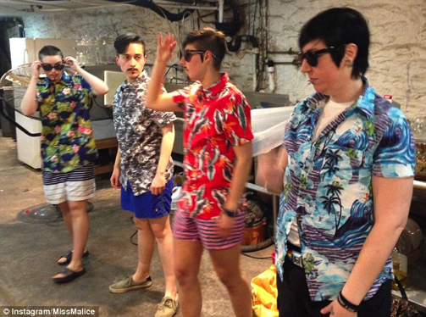

Concept Overview
A striking androgynous female decides to walk around the city dressed in male drag. The commercial will cut through different days each with a different outfit and location, but wherever she walks, she attracts attention. She is unbothered by the negative attention and walks confidently, only acknowledging the positive attention.

Concept Script
VIS: A striking androgynous female walks down the street. Heads turn as she walks down the street.
VO:
Sickening is the standard.

VIS: Match cuts to her walking in pride.
VO:
Confidence? It’s required.
NEVER in the shade.

VIS: Match cuts to her walking past people who stare. She is unbothered.
VO:
I block the hate.

VIS: Passes a group of people who give her a look of confusion. They look at her with disgust.
VO:
Poisons... stay out.

VIS: Match cuts to her walking and taking a “selfie” with “fans” on street.
VO:
Love shines in.

VIS: She continues to walk. She passes a woman who likes her look and snaps her fingers with approval. Fact on Screen: All tobacco products contain toxic chemicals (USDHHS Fact Sheet 2014, p. 126; USDHHS 2010, p. iii).
VO:
Controlling your life means choosing what affects you.
And for me, cigarettes, social smoking, bumming one on the patio…whatever you call it, you’re allowing something toxic in you (USDHHS Fact Sheet 2014, p. 126; USDHHS 2010, p. iii)

VIS: Shares a glance with a female walking by obviously checking her out.
VO:
And this body... it’s non-toxic.

VIS: She enters a bar and friends and “fans” greet her openly.
VO:
I choose to live Tobacco-Free.

ENDCARD

CREATIVE CONCEPT #12: Bathroom Mirror v2

Key Frame
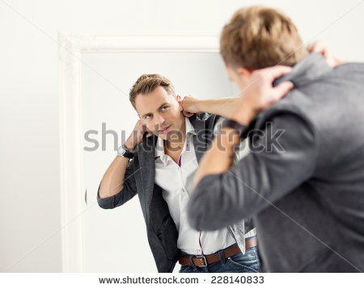
Concept Overview
An attractive, confident and socially successful young gay male is applying hair gel in a public restroom alongside a couple other gay males who are also fixing themselves up. Our subject is clearly the best looking guy and he seems to know it. As he speaks, he walks out of the restroom and into the venue (nightclub). As he walks he has several guys checking him out behind his back – trying to be sly while they do it. He realizes they’re looking but he likes it and even toys with them a little.

Concept Script
VIS: Attractive man touching up his outfit in a clean, modern public restroom alongside a few other guys who are also getting ready. He speaks confidently and somewhat flirty.
VO:
I came out when I was 18. I grew into myself.
He finishes up his hair and walks off screen. VO: I’m not a shallow person, but I like who I see in the mirror now. No more hiding.

VIS: He exits the restroom into a trendy night spot (dance club or music venue) that is noticeably a gay venue. Guys check him out as he walks by them. He stops near the front of the venue and we see behind him that the venue is popular and that he has attracted the gaze of several men.
VO:
I finally feel my looks reflect the person I feel I am on the inside. Beautiful inside and out.
And the idea of cigarettes poisoning me inside AND affecting my look on the outside, is not the reflection I want to see.

VIS: As he delivers this last line, he smirks and glances back behind him. A few of the guys quickly (but obviously) turn their gaze away realizing they’ve been busted. Fact on screen: People consider smokers less physically attractive than non-smokers (Hines 1996, p. 862;
VO:
I gotta keep this look as long as I can. For me… [hah] and for them. Dermer 1986, p. 719).

ANNOUNCER:
Be tobacco-free.

ENDCARD

CREATIVE CONCEPT #14: Be Know For Your Flawless v2

Key Frame
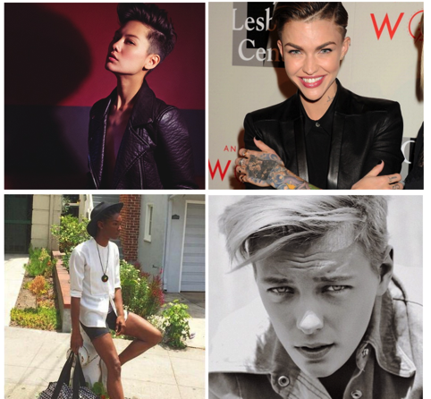

Concept Overview
This “B spot” would be a more subdued execution, with an emphasis on the sexy, cool, confident vibe the models give. Four out lesbian models speak about how their appearance like skin/hair/youthfulness are their livelihood and what they want to be known for.

Concept Script

VIS: Introductory montage of four drag king looking fabulous in separate unique environments. Each environment will feature an over-the-top object that represents the king’s unique characteristic.
SFX:
Dance Music

VIS: Drag King #1: Who is known for a beautiful face.
VO Drag King #1:
I am known for my cute face and flawless SKIN.

VIS: Sequence showcasing her beautiful face
SFX: Dance Music

VIS: Drag King #2: Who is known for eccentric manicures.
VO Drag King #2:
I am known to be a king with a sensible NAIL

VIS: Sequence showcasing her nails
SFX: Dance Music

VIS: Drag King #3: Who is known for large hair.
VO Drag King #3:
HAIR. Known for that.

VIS: Sequence showcasing her hair.
SFX: Dance Music

VIS: Drag King #4: Who is known for lips.
VO Drag King #4:
My MOUTH.
SFX: Singing a warm up range.

VIS: Sequence showcasing her hair.
SFX: Dance Music

VIS: Drag King #1
VO Drag King #1:
I’ll be known for a lot of things, but I will NEVER

VIS: Drag King #2
VO Drag King #2:
NEVER

VIS: Drag King #1 has wrinkled skin
VO Drag King #1:
be known for wrinkled skin (Ortiz 2012, p.251-252; Just 2006, p. 85),

VIS: Drag King #2 with yellow basic nails
VO Drag King #2:
Yellow nails (Ortiz 2012, p. 250),

VIS: Drag King #3 wigless airing out her wig
VO Drag King #3:
Smelly hair,

VIS: Drag King #4 singing but does a breath check
VO Drag King #4:
Or ashy stank breath (NCI 2013).

VIS: Drag King #3
VO Drag King #3:
ALL caused by what? Tobacco. Yes girl, every cigarette is doing you damage (Ortiz 2012, p.251-252; Just 2006, p. 85).

VIS: Several Kings speak
VO:
Drag King #1: That’s basic.
Drag King #2: NEV…(cut)
Drag King #3: ...ERRRRR.
Drag King #4: I’m known for my flawless.
Drag King #1: I Live Tobacco Free.

ENDCARD

CREATIVE CONCEPT #14: Unpredictable v2

Key Frame
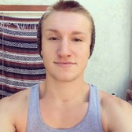

Concept Overview
This concept will spotlight multiple gay artists who share snippets of their lifestyle of living and breathing art. As entrepreneurs, they share how being an artist involves unpredictable days, not following trends and making art that will outlive them.

Concept Script
VIS: Gay Male #1 stands full body in front of camera looking left off into the distance. His surroundings are accented with graphical elements to make the image more unique and trendsetting. These elements are used throughout the visuals of this ad.
VO:
I search...

VIS: Gay Male #2 shops through a vibrantly colored section of a flea market.
VO:
Outside the lines.

VIS: Wideshot of Gay Male #3 in a picturesque metro station.
VO:
A creator. An explorer.

VIS: Gay Male #1 walks in an urban environment.
VO:
Walking the unknown.

VIS: Gay Male #4 thumbs through swatches.
VO:
Designing the beyond.

VIS: Gay Male #5 tries on different clothes as if the camera is a mirror. He shows off his personality.
VO:
Left of expectations.

VIS: Gay Male #5 shows off his personality.
VO:
Free...

VIS: Gay Male #1 shows off an unconventional outfit.
VO:
Bold...

VIS: Gay Male #3 walking down a street with an epic city view.
VO:
Beyond.

VIS: Quick match cuts of every Gay Male featured looking directly into the camera. Fact on screen: Smokers are more than twice as likely to die prematurely compared to people who have never smoked (USDHHS Fact Sheet 2014, p. 639).
VO:
Nothing about me is predictable, so why would I die predictably?

ANNOUNCER:
Live beyond. Live tobacco-free.

ENDCARD

CREATIVE CONCEPT #15: Tip the Scale v2
Key Frame
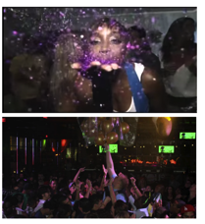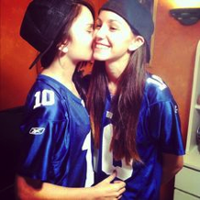

Concept Overview
This concept uses a first person POV of a lesbian at an LGBT bar. As she enters, the footage is sped up along with the EDM music. She hugs her friends, signals to others who are dancing, etc. She walks into a lesbian who is super fine, and the music and footage both slow down to regular speed.

Concept Script
VIS: Accelerated first person camera view of a young adult lesbian walking through an LGBT club.
POV is hugging their friends, seeing people dancing, and waving to them. Catchy EDM dance music plays throughout, though it is sped up during this sequence.
Once she spots the cute woman, the music slows down to regular BPM. VO begins.
VO:
This is that moment...

VIS: They begin to flirt closely. It’s obvious they can smell each other.
VO:
...when being tobacco-free tips the scale...

VIS: End first person camera, zoom out to see both women. Beat drops, visuals accelerate again and the couple begins to dance together.
VO:
I stopped smoking ‘cause I didn’t like how it smells.

VO:
I stay tobacco-free cause I’d never want her to smell it on me (NCI 2013).

VIS: They enjoy each other’s company and visibly exchange numbers with their phones.
VO:
Live... Love... tobacco-free.

ENDCARD

Phase 2

The following six preliminary ad concepts will be tested as part of Wave 2 of Brand and Creative Concept Testing. Video storyboards will take the form of a series of still images with narrative voiceover.

Concepts
- What I Said v1
- What I Said v2
- Getting Ready To Go Out
- In It Together
- Moving Forward v1
- Moving Forward v2

CREATIVE CONCEPT #1: What I Said v1

Key Frame
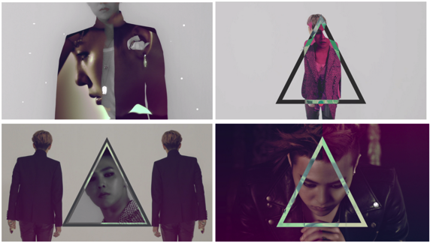

Concept Overview
This commercial will feature one Lesbian narrator looking back at different key stages of her gender/sexual growth and would show scenes in her life where she was not confident and used cigarettes as a tool to meet people, only to get rejected. The narrator then takes us into the present to show what she does now. The scenes from the present mirror the scenes from her past, but now our character is confident and smokefree.

CREATIVE CONCEPT #2: What I Said v2

Key Frame

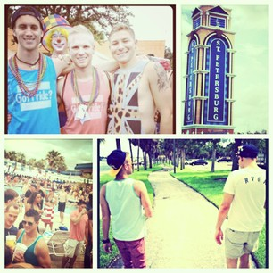

Concept Overview
This commercial will feature one Gay male narrator looking back at different key stages of his gender/sexual growth and would show scenes in his life where he was not confident and used cigarettes as a tool to meet people, only to get rejected. The narrator then takes us into the present to show what he does now. The scenes from the present mirror the scenes from his past, but now our character is confident and smokefree.

CREATIVE CONCEPT #3: Getting Ready To Go Out – LGBT

Key Frame

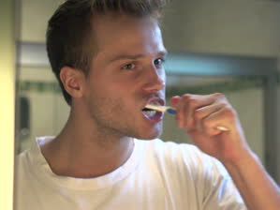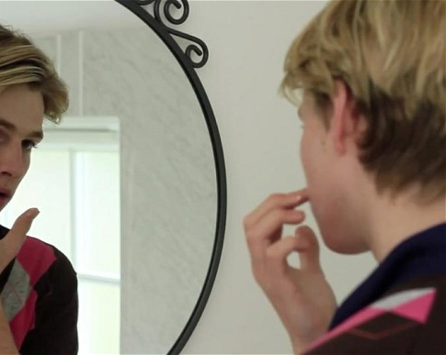

Concept Overview
A split screen of a male and female preparing to head out, spending time on their appearance and focusing on details. The images will be first person and cut quickly. The concept focuses on how important appearance is and how it takes a lot of work to keep your appearance on point, which is why one shouldn’t smoke tobacco as it harms their physical appearance. Unraveling the work one puts into their appearance.

CREATIVE CONCEPT #4: In It Together

Key Frame

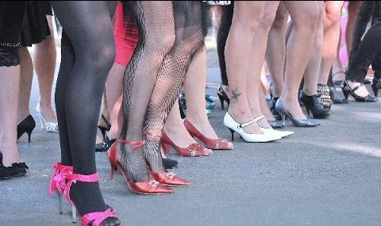

Concept Overview
A row of high-heeled legs struts down a street fiercely and in-unison, with the camera following, and only showing what’s below the knees. The concept features a powerful voiceover about what it means to be a community, and to act in-support of each other. As the concept comes to an end, the camera stops moving although the legs keep walking. Context shows from behind a variety of hairstyles and bodies; it is assumed that some of these legs belong to lesbians and gay men, participating in a walk/contest at Pride. They are being cheered on all sides as they cross a finish line.

CREATIVE CONCEPT #5: Moving Forward v1

Key Frame



Concept Overview
A young gay man moves on with his life. He embraces his future and leaves not only his old problems behind but we see that he has learned to not fall victim to any of the old gay problems either. He’s focused on the future.
Our subject is shot sitting in the same position for the entire spot. His background and wardrobe change in every scene but his position never does…until he gets up and walks out at the end, symbolizing his moving forward (away from tobacco and away from the pitfalls of the past). His stagnant position symbolizes the rut that both tobacco and being closeted have set him in. We never hear the speaking going on in each scene, we only hear his VO.

CREATIVE CONCEPT #6: Moving Forward v2

Key Frame
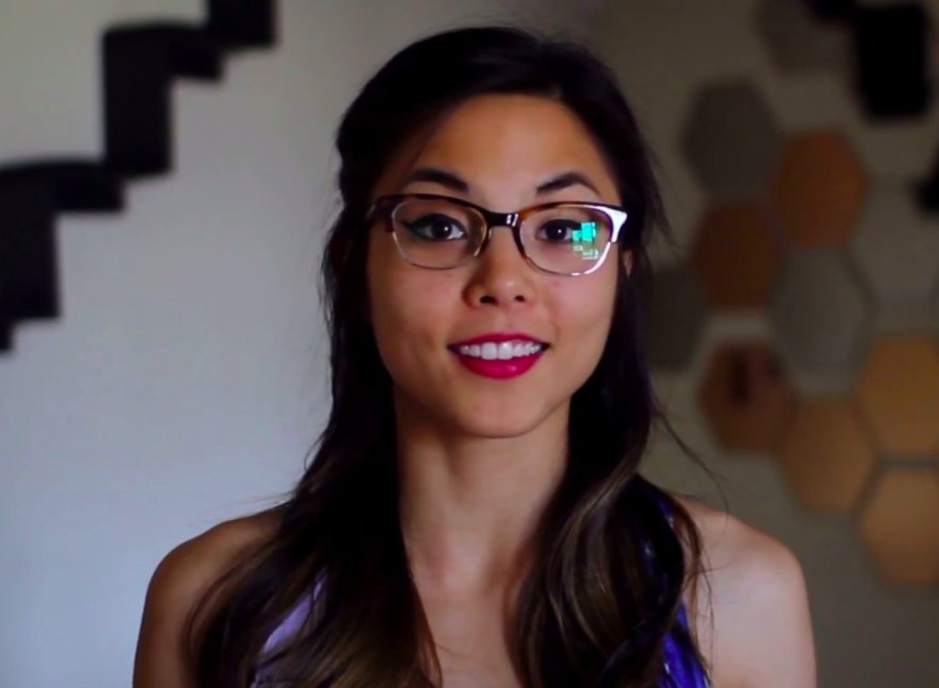

Concept Overview
A young lesbian moves on with her life. She embraces her future and leaves not only his old problems behind but we see that he has learned to not fall victim to any of the old lesbian problems either. She’s focused on the future.
Our subject is shot sitting in the same position for the entire spot. Her background and wardrobe change in every scene but his position never does…until she gets up and walks out at the end, symbolizing his moving forward (away from tobacco and away from the pitfalls of the past). Her stagnant position symbolizes the rut that both tobacco and being closeted have set him in. We never hear the speaking going on in each scene, we only hear her VO.

