APPENDIX D: CREATIVE CONCEPT & BRANDING STIMULI

TITLE OF INFORMATION COLLECTION: Rural Smokeless Creative Concept Testing – Focus Groups with Rural

Contents:
- Creative Concepts
- Radio script: “Hey Big Dipper”
- Radio script: “Pucker Up”
- Radio script: “Mr. Silver Tongue”
- TV script: “How Will You Say No”
- TV script: “Anti-Dip”
- TV script: “Save Face”
- Brands
- “Spit It Out”
- “Through with Chew”
- “The Real Cost”
A. Creative Concepts
1. (radio) :60

F1: Unidentified Female Singer
F2: Unidentified Female Speaker

F1: Hey, get your mouth away from my face. It smells like something just died. You got something in there that’s making people stare. Come on buddy, take it outside. When we were out the other night, you left your dip cup on the seat. I thought it was my drink, so I swallowed that stink, and that’s the last you’ll ever see of me. Hey big dipper, you think you’re the man, with your filthy brown snuff. You think that dippin’ is cool, but it’s just smelly drool, I got to tell you that I’ve had enough. Hey big dipper, you think you’re the man, with your filthy brown snuff. You think that dippin’ is cool, but it’s just smelly drool, I got to tell you that I’ve had enough. Hey big dipper, you think you’re the man, with your filthy brown snuff.
F2: Nasty chemicals including 28 carcinogens. Another reason dippin’ does you dirty. Learn more at [insert campaign name].org.

2. (radio) :60
M1: Unidentified Male Singer
M2: Unidentified Male Speaker

M1: Cowboy, pucker up, and spit ‘er out. I know you’re just a country boy, out hangin’ with your pals. I know you think you’re such a gift to all them pretty gals. But hoss I got to tell you straight you better start to scoot. That dirty juice missed the spittoon and landed on my boot. Cowboy, pucker up, and spit ‘er out. It’s vile and nasty, lewd, and crude, who let you off your leash? Man, the only thing that’s filthier is the color of your teeth. I hate to say that much old mulch is bringing you more bad luck. But your girlfriend in them real tight jeans is riding in my truck. Cowboy, pucker up, and spit ‘er out.
M2: One seriously gross mouth. Another reason dippin’ does you dirty. Learn more at [insert campaign name].org.
3. (radio) :60
F1: Unidentified Female Singer
F2: Unidentified Female Speaker

F1: Well… Hey you Mr. Silver Tongue. Talkin’ your way around the wrong you done. I used to fall for your sweet talk. I stuck around when I should have walked. I let you slide with Mary Lou, Barbara Ann, and Betty Sue. Sit right down I’ve got some news. If you won’t be through with chew, I’m through with you. Because you can’t be a sweet talkin’ man, with a mouth that smells like a garbage can. No you can’t have a silver tongue – with a wad in your cheek and breath like dung. And if you won’t be through with chew, I’m through with you. Yeah.
F2: Through with Chew Week is February seventeenth to the twenty-third. Visit [insert campaign name].org.
F1: Yeah. I want to believe you, I really do. But if you won’t be through with chew, I’m through with you.

4. (TV) :30
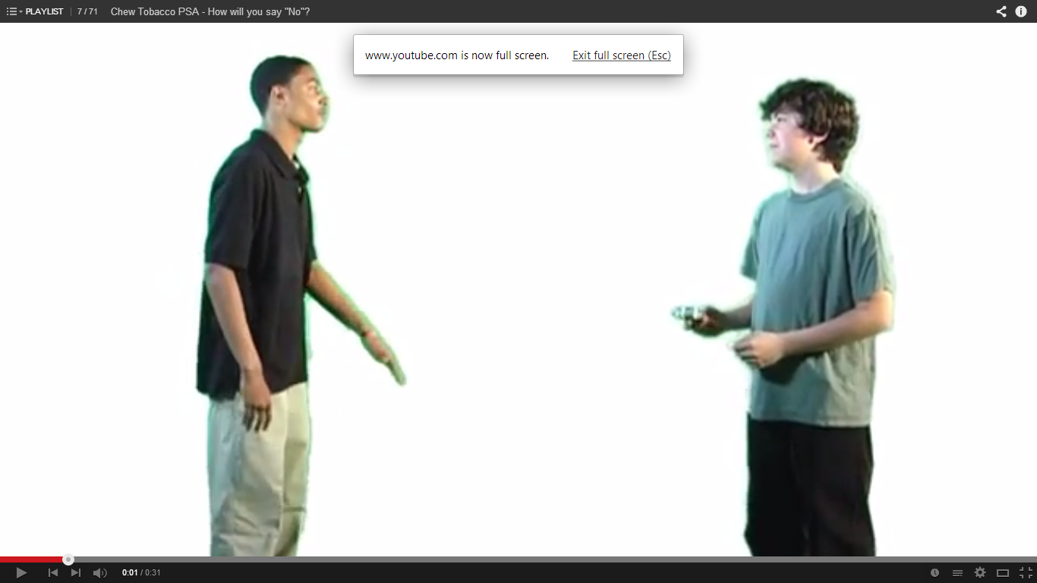
M1: Unidentified Male Speaker 1
M2: Unidentified Male Speaker 2

M1: Hey man, ya want some? [Holds out can of dip.]
M2: Where’d ya get that from?
M1: My older brother does it. And his friends.
M2: Na, man. I think I’ll pass.
M1: Come on. Girls will think you’re older.
M2: Na, not with my breath stinking man.
[cut]
M2: My parents are totally against that.
[cut]
M2: Na man, I think I’ll pass.
[cut]
M2: Na man, my girlfriend’d kill me if she found out.
[cut]
M2: Na man, I’m straight.
M1: Alright. [Puts can of dip back in his pocket.]
[Message on screen reads] There are a lot of ways to say “No”
[Message on screen reads] How will you?
[Message on screen reads] This message brought to you by [insert campaign name]

5. (TV) :30
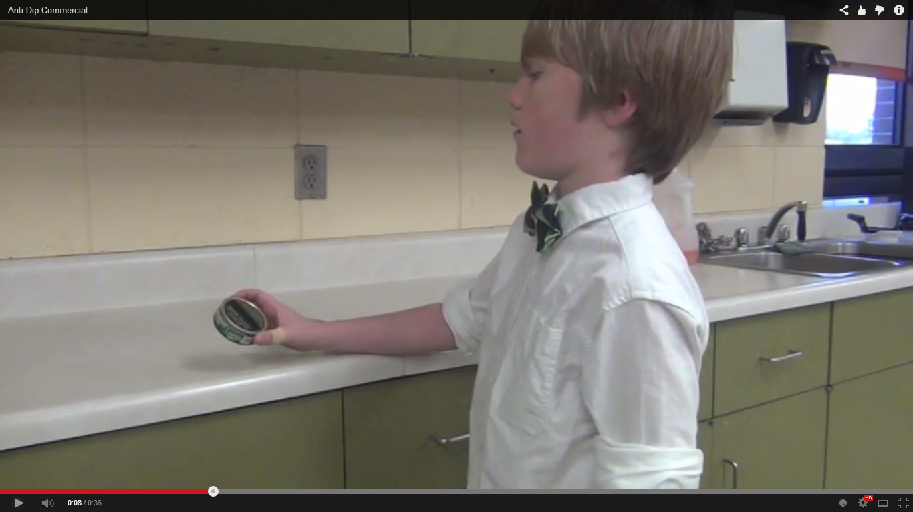

[Scene: Kitchen]
[Dad unloads keys, wallet and can of dip on kitchen counter and walks away.
Young son finds can of dip on counter, picks it up and examines it.]
[Scene: High School, 5 years later; same boy (now older) approaches girl at her locker]
[Message on screen reads] 5 Years Later…
Boy: Hey beautiful, wanna go out with me?
Girl: Eww. No.
[Scene: Living Room, same boy (now older) sitting in easy chair]
[Message on screen reads] 10 Years Later…
Man looks in his wallet and sees that there is no money.
Man then holds up his can of dip, shakes his head, and makes an exasperated sound.
[Scene: Doctor’s office]
Doctor: The results don’t look good. [Doctor hands Man test results.]
[Camera zooms in on test results that say “Cancer.”]
[Cut back to first scene in kitchen]
Young son is taking the can of dip his Dad left on the counter.
[Message on screen reads] 15 Years Earlier…
[Message on screen reads] Never start. You never have to quit.
[Message on screen reads] This message brought to you by [insert campaign name]

6. (TV) :30
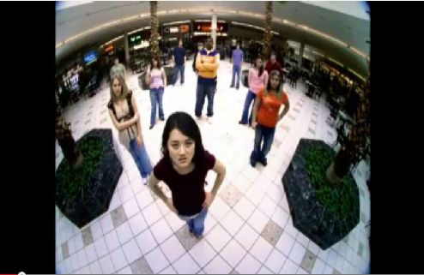

[Scene: Kids gathered in groups]
Voice over: It doesn’t matter who your friends are.
[Scene: Boys lifting weights/Girls walking together]
Voice over: It doesn’t matter where you’re from.
[Scene: Girls walk past a boy]
Voice over: If you use spit tobacco because you want people to notice you
[Scene: Boy spits. Girls walk past boy sitting on top of picnic bench. Girl puts hand up]
Voice over: You can bet
[Scene: Boy’s face, with image of jaw from a skull]
Voice over: You’ll turn some heads
[Scene: Boys lifting weights, with image of skill over boy’s head]
Voice over: Face the facts
[Scene: Girl lifts sunglasses from her eyes]
Voice over: Spit tobacco is just as hideous and deadly as smoking
[Scene: Close-up of boy’s face with skull image of damaged jaw]
Voice over: Save your life
[Scene: Several shots of kids’ faces]
Voice over: Save face
Message on screen: Logo of “Save face. Stop spit tobacco”
Message on screen: Message brought to you by [insert campaign name]

B. Brands

1. Spit it Out


2. Through with Chew
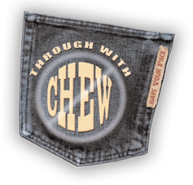

3. The Real Cost


