WAVE 2 PHASE 1 QUALITATIVE RESEARCH: GENERAL MARKET AT-RISK YOUTH TOBACCO PREVENTION FOCUS GROUPS YOUTH CREATIVE AND STRATEGIC CONCEPT STIMULI

CREATIVE CONCEPTS

11 MINUTES :30 TV SPOT
DEATH AND HIS VEHICLES
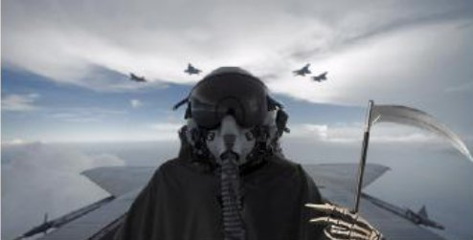
Open on an empty street.
VO: If you never smoke…
Suddenly death appears in the scene, walking on tiptoes towards camera.

VO: If you smoked one…
Death starts walking at a normal pace.

VO: If you smoked another one
Death is now riding a bicycle.

VO: Another one…
Death is now riding a horse.

VO: Another one…
Death is now riding a motorbike...

VO: Another one…
Death is now driving a fast car.

VO: Another one…
Death is now flying in a helicopter.

VO: Another one…
He’s now flying a military jet.
As we see him piloting the plane and approaching to camera, a SUPER shows up.

VO: WHEN YOU SMOKE, DEATH COMES FASTER.

SUPER: EVERY CIGARETTE TAKES 11 MINUTES OFF YOUR LIFE. FIND MORE AT THEREALCOST.GOV.
11 MINUTES :30 TV SPOT
YOLO

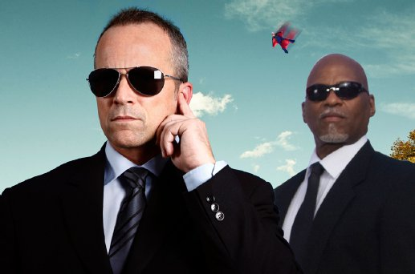
We open on a public park. Two teenage boys are about to smoke cigarettes.

KID 1: Want a cigarette?

KID 2: Sure. YOLO, right?
3 black SUV’s immediately pull up to the scene. All are unmarked, with jet black tinted windows. Two agents dressed in dark suits and sunglasses step out of the lead vehicle and flash ID at the kid, who’s dumbfounded.

AGENT 1: Jacob?

KID 2: Um, yeah?

AGENT 1: U.S. Department of YOLO. You’re in violation of section 12 of the YOLO Act.

AGENT 2: Incorrect use of YOLO.
The agent nods to a kid over at the half pipe doing a cool trick.

AGENT 1: See that guy? He can use YOLO.
The agent points at woman flying using a specially designed flying suit.

AGENT 2: Up there? She can use YOLO.
The agent points out a toddler mindlessly rolling down a hill, 3 kids playing air guitar to a boom box and an elderly woman wearing cornrows.

AGENT 1: YOLO, YOLO, YOLO.

AGENT 2: You? No.

AGENT 1: Now get in the car.

KID 2: But--

AGENT 1: Get in the car.

SUPER: YOLO abuse is a crime.
We watch the kid get hauled away.

VO: Smoking is Anti-YOLO. In fact, every cigarette you smoke decreases the L in your YOLO by 11 minutes.
WHAT IF A CIGARETTE COULD GOOGLE ITSELF :30 TV SPOT
EMBALMING FLUID

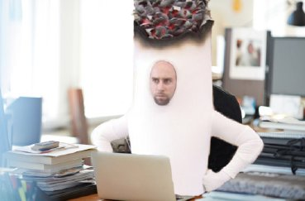
Open with a Super

SUPER: WHAT IF A CIGARETTE COULD GOOGLE HIMSELF?

Cut to a giant cigarette sitting in front of a computer. He rubs his hands and starts googling himself.

He writes, “Cigarette smoke has …” and the auto-complete system gives him one option. He reads it and freaks out.

“CIGARETTE SMOKE HAS FORMALDEHYDE”

CIGARETTE: But that’s a chemical used to preserve dead animals! Do we really put this out?

Suddenly his dog shows up next to the cigarette, and the cigarette starts petting him while he answers:

CIGARETTE: No we don’t Rex, no we don’t. Do we Rex, do we?

Suddenly, the dog becomes embalmed, hard as a rock.

SUPER: HE’LL FIND OUT CIGARETTE SMOKE HAS MORE THAN 7000 CHEMICALS. FIND OUT MORE ABOUT HIM AT THEREALCOST.GOV

WHAT IF A CIGARETTE COULD GOOGLE ITSELF :30 TV SPOT
NITROMETHANE

Open with a Super

SUPER: WHAT IF A CIGARETTE COULD GOOGLE HIMSELF?

Cut to a giant cigarette sitting in front of a computer. He starts googling himself.

He writes, “Cigarette smoke has …” and the auto-complete system gives him one option. He reads it and freaks out.

“CIGARETTE SMOKE HAS NITROMETHANE”

CIGARETTE: It’s a lie! NITROMETHANE IS IN ROCKET FUEL! I don’t have rocket fuel!

We see that he receives a text message. He types back, “I gotta go” and he leaves the room flying like a rocket.

SUPER: HE’LL FIND OUT CIGARETTE SMOKE HAS MORE THAN 7000 CHEMICALS. FIND OUT MORE ABOUT HIM AT THEREALCOST.GOV

WHAT IF A CIGARETTE COULD GOOGLE ITSELF :30 TV SPOT
ALL THE CHEMICALS

Open with a Super

SUPER: WHAT IF A CIGARETTE COULD GOOGLE HIMSELF?

Cut to a giant cigarette sitting in front of a computer. He starts googling himself.

He writes, “Cigarette smoke has …” and the auto-complete system gives him one option. He reads it and freaks out.

“CIGARETTE SMOKE HAS MORE THAN 7000 CHEMICALS”.

CIGARETTE: I PUT OUT MORE THAN 7000 chemicals? I’m going to read them one by one.

We see the cigarette scrolling down the screen and we see that days go by as his cigarette body consumes.

SUPER: HE’LL FIND OUT CIGARETTE SMOKE HAS MORE THAN 7000 CHEMICALS. FIND OUT MORE ABOUT HIM AT THEREALCOST.GOV

AIR LUNGS :30 TV SPOT
DURANT

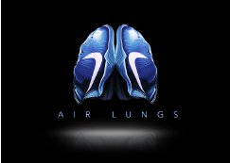
We see Durant take three big breaths.

DURANT VO: The more air…

And then take off and dunk over some dude.

DURANT VO: …the more air.

DURANT VO: Introducing the new Air Lungs.

We cut to a pair of Air Lungs in a vaguely bio-tech setting – fabricated sleek, breathing, healthy lungs, emblazoned with the Nike Swoosh.

We see Durant from behind as he inserts his Air Lungs into his chest. And then continue to dominate some dude on the court.

DURANT VO: More 02, more school.

VO: Powerfully perfect Air Lungs. You only get one pair, give them a chance to develop to their full potential.

DURANT VO: Who’s next.

CARD: Smoking as a teen can stunt lung growth, which means your lungs may never grow to their potential size or work as well as they could. No lungs. No Glory. TheRealCost.gov.

* Nike partnership for illustrative purposes. Any actual sports brand partnership would be vetted and approved via CTP.

AIR LUNGS PRINT/OOH

* Nike partnership for illustrative purposes. Any actual sports brand partnership would be vetted and approved via CTP.

AIR LUNGS PRINT/OOH

* Nike partnership for illustrative purposes. Any actual sports brand partnership would be vetted and approved via CTP.
CREATURES :30 TV SPOT
SCIENCE CLASS MISHAP

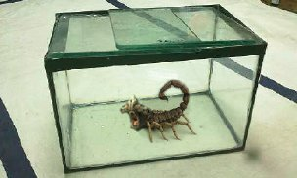
A science teacher has a strange creature restrained via vice grips on a metal slab in a classroom, its tentacles clamped.

He’s squeezing its gills and collecting fluid from its mouth, showing his students the venom. As he speaks they take notes.

TEACHER: Mercury, acetone, nitrobenzene, hydrazine. This creature has over 7,000 chemicals, and don’t get me started on what they do to you.

He moves over to another counter to drop the venom samples into a beaker.

TEACHER: Prematurely wrinkled skin…

We see the creature pulling its tentacles from the vice grips.

STUDENT: Mr. Esler--

TEACHER: …stunted lung growth, tooth loss, cancer…

STUDENT: Mr. Esler--

And it’s free! It furiously slithers off the metal slab and across the floor as everyone screams!
The students all scramble s the creature slithers through the classroom. Desks are knocked over, kids are falling over each other.

And the creature slithers right into a cigarette pack.

VO: If cigarettes looked as dangerous as they are, you’d run like hell.

CARD: TheRealCost.gov

CREATURES :30 TV SPOT
FOUND IT

Kid filmed this with their cellphone. We found the footage.

A boy is holding the strangest looking alien of an insect.

BOY: Check it out.

GIRL: What is it?

BOY: Found it out back.

GIRL: Can I hold it?

He hands it to her. She lets it crawl up her arm.

PERSON FILMING: Ewwwwwww…

It suddenly slithers up her sleeve and it bites her.

GIRL: Ow! It bit me! It bit me!

It jumps to the ground and looks for an escape. They are all screaming.

KIDS: Oh my god! GET IT AWAY!

The person filming turns the phone back on the girl. She looks green and dizzy. She’s sweating and sitting against a locker.

GIRL: I feel short of breath.

BOY: There it is!

The person with the cell phone chases it and we see it slither right into a cigarette box.

VO: With over 7,000 chemicals, if cigarettes looked as dangerous as they are, you’d run like hell.

CARD: TheRealCost.gov
HARD/EASY :30 TV SPOT
THE COVER UP

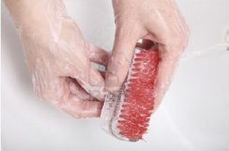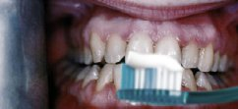
In this spot we’ll see the great lengths a teenage smoker will take, in order to cover up the smell of cigarettes on his hands, clothes, hair and car. His story will be told in a stream-of-conscience monologue - rattled off in voiceover as his story plays out on screen.

We OPEN ON a teenage boy furiously scrubbing his hands and swishing around mouthwash. The scene moves quickly with a frenetic energy. The cut bounces around at a paranoid, almost manic pace - highlighting each and every painful detail.

So while he continues to try ‘freshen up’ – no matter where he is, or what it takes - we hear a VO narrate the spot.

VO: It’s not easy to wash your hands 8 times a day, while chewing 3 sticks of gum, after rinsing, gargling and spitting out 2 cups of mouthwash and repeating, and repeating, just after spraying your hair with deodorizer and covering up the smell of the deodorizer with cologne after swapping out your t-shirt and layering it with a fresh hoodie, no that hoodie smells too – THIS hoodie – then airing out your car in a 19-degree ice-storm nor’easter that gives your backseat passengers a mild case of hypothermia.

No. It’s not easy being hooked.

But it’s easy to become hooked.

We see the Teenager light up a cigarette.

VO: Just a few cigarettes now and then can cause you to crave more.

CARD: TheRealCost.gov

HARD/EASY :30 TV SPOT
BUMMING

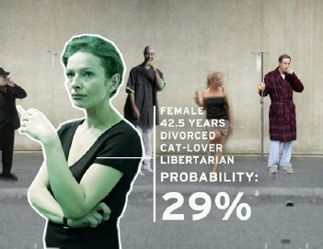
We OPEN ON a teenager standing outside on a busy intersection of an outdoor shopping area. He’s trying to bum a cigarette, but first he must decide who to ask.

The VO is a stream of conscience – sizing each person up, the visuals move just as fast as the voiceover- bounces from person to person – thought to thought – with a frenzied and hectic energy.

TEEN VO: It’s not easy to know if Mr. Metal-head is gonna be a giving person – or if that the frosty business lady in the pantsuit’s gonna feel like donating to your cause – especially not when her coworker doesn’t look like he trusts ANYONE – but then there’s the old guy who’s probably a regular ‘Santa Claus’, but if he helps you out you’ll probably have to owe him big and listen to his stories about the war for the at least 3 hours – which might be better than asking those girls – or their older boyfriends, or their friends – I think that one guy might be a cop.

No. It’s not easy being hooked.

But it’s easy to become hooked.

We see the teen walk up to the old man – and sheepishly ask for a cigarette.
TEEN: Hey man – can I bum a smoke?

VO: Just a few cigarettes now and then can cause you to crave more.
CARD: TheRealCost.gov

REASONS :30 TV SPOT
SKINNY JEANS



Open on an abandoned handball court. There’s a 14 year-old kid hanging out with some friends by the court.

Another kid with really skinny jeans walking silly (like he’s from the old west) comes up to the kids and someone asks him:

KID 1: Hey, can you give me a cigarette?

KID 2: I’m not smoking no more man.

KID 1: Why? Because you’ve heard that some of the chemicals found in cigarettes are found in batteries and rocket fuel?

KID 2: No, because I can’t carry them. Since I wear these really skinny jeans I have to choose only one thing to carry.

KID 1: What did you choose?

KID 2: This picture of Sofia Vergara.

The kid pulls out of his pocket the photo of Sofia Vergara and shows it to the other kid.

KID 1: Excellent choice.

The two kids stare at each other as the super comes in:

SUPER: ANY REASON IS A BRILLIANT REASON NOT TO SMOKE.

SUPER: Every cigarette puts more than 7,000 chemicals into your body.

CARD: #FINDYOURREASON
TheRealCost.gov

REASONS :30 TV SPOT
FINGERS


Opens on a high school patio where everyone’s on recess. We focus on two 16 year-old girls talking.

GIRL 1: Hey. Do you want to have a smoke in the bathroom?

GIRL 2: Nah, I’m not doing that anymore.

GIRL 1: Why? Because you don’t like putting ethyl carbamate and benzene into your body?

GIRL 2: No, because I can’t separate my index and middle fingers. They’re in love.

At that moment the kid shows the other kid her hand. The index and middle fingers have drawings that look like they are hugging each other.

GIRL 1: So… use the other hand.

GIRL 2: Are you crazy? I’m not breaking up the Mariachis.

The girl shows her fist and when she opens her hand we see that he has 5 Mariachis drawn there with five little sombreros each. Mexican music starts playing. She closes her hand and the music stops. They stay together in the patio. A super comes in:

SUPER: ANY REASON IS A BRILLIANT REASON NOT TO SMOKE.

SUPER: Every cigarette puts more than 7,000 chemicals into your body.

CARD: #FINDYOURREASON
LINGER CAMPAIGN
There’s nothing attractive about the smell of tobacco, but they also make you physically less attractive.
We had to find a surprising way to show teens that none of these effects–temporary or permanent–are pleasant.

SAMPLING STATION
As unsuspecting teens stroll through the mall, they will stumble upon a very exciting and very fashionable launch of a new fragrance called Linger. A street team will offer them samples of the fragrance. Hidden cameras will capture the repulsed teens as they peel back the samples only to be sucker-punched by a horrible odor. This stunt will provide us an opportunity to create content– like a video of teen’s reactions to the scent, for example.

Video script
:15-sec intro of smoky bottle shots with voice over

VO: Wherever you go, there it is. It hangs in the air long after the source has gone. A distinctive fragrance no one will be indifferent to. Linger. Hear what teens think about the scent…

Cut to event footage of teens reacting to the scent

TEEN: Ugh, that’s just awful… why would anyone wanna smell like this... That’s disgusting!...Seriously, what is this sh*t… … Eww, no way... Do people really like this?...So gross… What the h---... I wouldn’t be caught dead wearing this… No thanks, I can smell that from a mile away...

VO: There’s nothing attractive about the smell of cigarettes. But the yellowing teeth, gum disease and premature skin aging they cause–those really stink. What does smoking really cost you? Find out at TheRealCost.gov.

MOVIE THEATER STUNT
We invite teens to a special, private-screening of a movie like Anchorman 2 or The Hunger Games. A movie that teens are already buzzing about. The screening goes as planned except for one minor twist. We stop the movie with 11 minutes left to go. The teens will be baffled, upset, and most likely furious. That’s when we display our messaging that says:

“If you’re this upset about missing the last 11 minutes of a movie, how about missing 11 minutes of your life every time you smoke? Every cigarette smoked takes 11 minutes off your life.”

We document all of this, and the teens’ reactions, with hidden cameras.

We put the video on YouTube to spread the message even further.

STRATEGIC CONCEPTS

“Social Smoking” is Smoking
Just because you only smoke a cigarette when you're at a party or out with friends doesn't mean you escape the effects of tobacco. One out of three teens who try smoking become daily smokers before leaving high school.

Tobacco Makes You Gross
What you wear and how you look is up to you. But would you like to be that person with the yellow-stained teeth, smoker’s breath and wrinkled skin? Yeah, smoking does all that.

What’s Out? Smoking.
The things we consider to be cool come and go. Remember when PSY, The Harlem Shake and smoking were in? Nearly 9 out of 10 high school students 80% don’t smoke. It’s outdated, so what’s the next cool thing?

Did You Make Your Little Sister Smoke?
So you made a personal decision to smoke, but have you thought about how that might affect those around you? Your little sister looks up to you, what if your actions make her start smoking too?

Do You Want To Turn Into A Smoker?
You have the right to decide who you want to be. You say you’re just experimenting with cigarettes. You think you will be able to stop whenever you want. But the truth is that 3 out of 4 teens who smoke keep doing so into adulthood. Is that the person you want become?

