Watson Caritas Patient Score©
DIRECTIONS: When answering the questions, please consider the overall consistency of human-to-human CARE you have received during this hospital stay. Please circle the number for the one best answer.
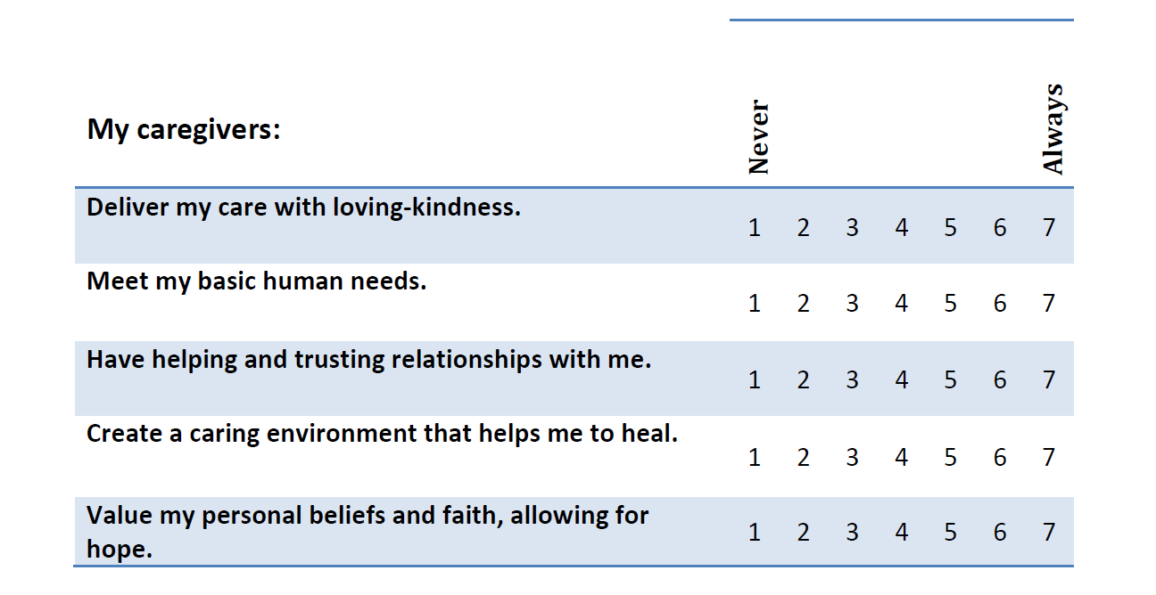
We invite you to share any notable caring or uncaring moments you experienced during this hospital stay.
Thank you for completing our questionnaire!

