

Patient Satisfaction Questionnaire

OMB No. 2900-0770
Estimated burden: 5 minutes
Expiration Date xx/xx/xxxx

The Paperwork Reduction Act of 1995: This information is collected in accordance with section 3507 of the Paperwork Reduction Act of 1995. Accordingly, we may not conduct or sponsor and you are not required to respond to, a collection of information unless it displays a valid OMB number. We anticipate that the time expended by all individuals who complete this survey will average five (5) minutes. This includes the time it will take to follow instructions, gather the necessary facts and respond to questions asked. Customer satisfaction is used to gauge customer perceptions of VA services as well as customer expectations and desires. The results of this telephone/mail survey will lead to improvements in the quality of service delivery by helping to achieve services. Participation in this survey is voluntary and failure to respond will have no impact on benefits to which you may be entitled.

VA Form 10-0516

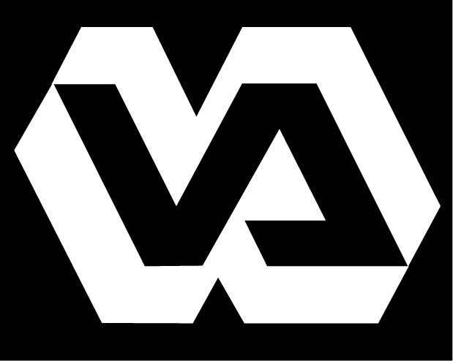
Department of Veterans Affairs
Patient Satisfaction Questionnaire

Network Consolidated Laboratory P&LMS VA New England Healthcare System

The Network Consolidated Laboratory’s (NCL) goal is to serve New England’s Veterans with the highest quality of care possible. To that end we seek input from our most valued asset – you, our customer. Periodic evaluation of this questionnaire will help us identify areas which may need improvement and allow us to strive toward providing the veterans of New England “The Best Care Anywhere.”

Instructions: Participation in this questionnaire is voluntary and anonymous. Using the pen or pencil provided please fill in the present Date and Time. Thinking about your visit to our blood drawing room today, please mark the answer to the question or statement that most closely represents your impression of the service you received. Please place the completed questionnaire in the designated box or hand it to the phlebotomist. Thank you!
Date: ______________________ Time: ______________________

- How long after the time you arrived did you wait to have your blood drawn?
❒ Less than 15 minutes
❒ 15-30 minutes
❒ 30-45 minutes
❒ 45-60 minutes
❒ More than 1 hour

- Rate the courteousness of the staff:
❒ Excellent
❒ Very Good
❒ Good
❒ Fair
❒ Poor

- I had confidence in the skill of the people serving me.
❒ Strongly Agree
❒ Agree
❒ Uncertain
❒ Disagree
❒ Strongly Disagree

- Did you have problems entering or moving around the blood drawing area due to clutter, traffic, equipment placement or poor design?
❒ Yes  No

- Were you asked to confirm your full name and full social security number before your specimen (blood, urine, or other) was collected by the phlebotomy (blood drawing) staff?
❒ Yes  No

- Do you believe the confidentiality of your personal health and identification information was protected during your time spent with the phlebotomy staff?
❒ Yes  No
The Paperwork Reduction Act of 1995 requires us to notify you that this information collection is in accordance with the clearance requirements of section 3507 of the Paperwork Reduction Act of 1995. The public reporting burden for this collection of information is estimated to average 3 minutes per response, including the time for reviewing instructions, searching existing data sources, gathering and maintaining the data needed, and completing and reviewing the collection of information. Respondents should be aware that notwithstanding any other provision of law, no person shall be subject to any penalty for failing to comply with a collection of information if it does not display a currently valid OMB control number. Customer satisfaction surveys are used to gauge customer perceptions of VA services as well as customer expectations and desires. The results of this survey will lead to improvements in the quality of service delivery by helping to shape the direction and focus of specific, programs and services. Submission of this form is voluntary and failure to respond will have no impact on benefits to which you may be entitled.
VA Form 10-0516

