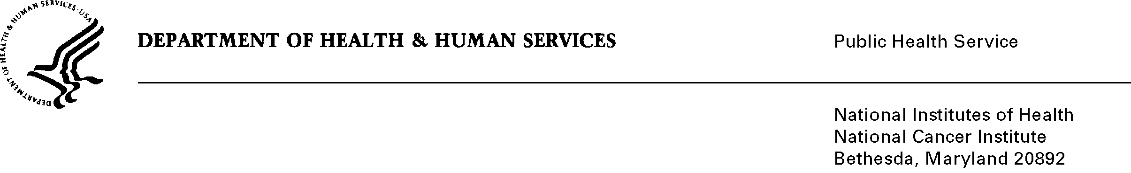
Date: February 25, 2014
To: Office of Management and Budget (OMB)
Through: Keith Tucker, Report Clearance Officer, HHS
Seleda Perryman, Report Clearance Officer, NIH
Vivian Horovitch-Kelley, PRA OMB Clearance Liaison, NCI

From: Jessica Faupel-Badger, PhD, MPH
Cancer Prevention Fellowship Program
National Cancer Institute (NCI)/NIH

SUBJECT: Change Request for “Outcomes Evaluation of the National Cancer Institute (NCI) Cancer Prevention Fellowship Program (CPFP)” (OMB NO. 0925-0690, Expiry Date 1/31/2015)

The purpose of this survey is to evaluate the NCI Cancer Prevention Fellowship Program in order to inform decision-making and identify opportunities to make improvements to or demonstrate the importance of the program to key stakeholders. The methods and products of this evaluation will not only serve to inform CPFP program administrators, but may serve to inform training programs beyond those at NCI as well as the evaluation community in general.

Through the initial collection of information, it has been discovered that email addresses for over 100 respondents are not accessible. The estimate is that 10-15% of the population either do not have email addresses or the email addresses that are available, are inaccurate and thus a portion of these have been unsuccessfully traced. This change request is to delete the phrase “You are being contacted by email to complete this instrument....” from the Privacy Act Notification Statement in all three instruments. Instead, the phrase will be replaced with “You are being contacted to complete this instrument…” The NCI Privacy Act Coordinator has been consulted and approved this change. The requested burden hours will not change.

Respondents for whom the email addresses do not work will be sent the already approved invitation letter by mail. The letter will include contact information, should the respondents want to contact the program staff, in addition to being given the address to link to the survey. The only change to the invitation letter is updating the web address.

Attachments

A: Screenshots of Revised Survey of Alumni
B. Screenshots of Revised Survey of Applicants
C. Screenshots of Revised Survey of Awardees

