Attachment 6: Survey Instrument

Form Approved
OMB No. 0920-0787
Exp Date: xx/xx/20xx
Fishing for Facts

A Survey of Fishermen’s Opinions about the
Risk of Falls Overboard and PFDs
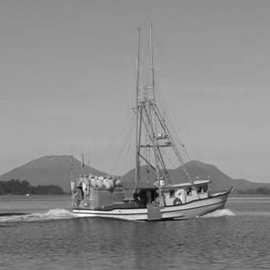

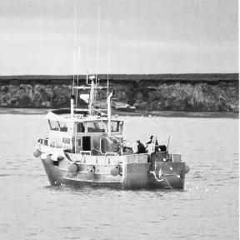

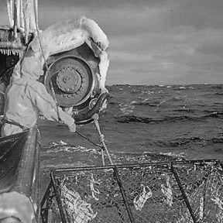

Public reporting burden of this collection of information is estimated to average 20 minutes per response, including the time for reviewing instructions, searching existing data sources, gathering and maintaining the data needed, and completing and reviewing the collection of information. An agency may not conduct or sponsor, and a person is not required to respond to a collection of information unless it displays a currently valid OMB control number. Send comments regarding this burden estimate or any other aspect of this collection of information, including suggestions for reducing this burden to CDC/ATSDR Reports Clearance Officer; 1600 Clifton Road NE, MS D-74, Atlanta, Georgia 30333.

Instructions for Respondents

This survey contains questions about your experiences, opinions, and perceptions involving personal flotation devices (PFDs) and falls overboard. Each question and its possible responses will be read to you, and you are asked to select one of the answer choices presented. The survey may take between 10 and 20 minutes to complete.

The purpose of this study is to learn more about commercial fishermen’s experiences, opinions, and perceptions involving PFDs and falls overboard. This is important information as it may help the PFD manufacturers design PFDs that better meet the needs of the fishing industry and encourage fishermen to wear PFDs while they work.

Participation is voluntary. You may choose to be in the study or not. You may choose to answer any or all questions. You may drop out any time for any reason without consequences to you. Survey results will be made available to industry, safety organizations, federal agencies, and other interested parties in a summary format only - without any personal identifiers.

Thank you for participating and helping us gather this information!

WE APPRECIATE YOUR HELP!

For questions about the research study, contact the principal investigator, Christy Forrester at cff6@cdc.gov or 202-245-0687. For questions about your rights, your privacy, or harm to you, contact the Director of Human Research Protections, Mark Toraason at mtoraason@cdc.gov, or 513-533-8591.
YOUR FISHING BACKGROUND

1. How many years have you fished commercially?

______ Years Fishing

2. What is your current position onboard the vessel?

- Captain/Skipper
- Deckhand
- Other ________________________

3. Over the past year, where and what gear type have you fished commercially?

Where? | Fish/Gear Type?
For example  Bristol Bay | salmon/gillnet

4. How many months out of the year do you usually fish?

______ Month(s) A Year

5. What is the length of your current vessel? ________ Feet
6. How many people (including yourself) are usually onboard your vessel when you go out fishing?

______ People on Board

YOUR OPINIONS ABOUT “MAN OVERBOARD” EVENTS

In this next section, “fall overboard” or “falling overboard” means any man overboard situation where a fisherman is unintentionally knocked, pitched, tripped, pushed, slipped, or pulled from the boat into the water.

7. How much do you worry about falling overboard?

- Very Much
- Somewhat
- Very Little
- Not At All

8. What do you think are the chances that you will fall overboard during your fishing career? Select a number between 0 - 100% (0% means no possibility, 100% means you think it will definitely happen)

________ % Chance of Falling Overboard

9. How much do you think an individual fisherman can do to avoid dying from a fall overboard?

- A Lot
- Some
- Not Very Much

10. Have you ever fallen overboard?

- Yes
- No
11. Have any fishermen you know personally ever fallen overboard?

- Yes
- No

12. Have any fishermen you know personally died from a fall overboard?

- Yes -- If yes, how many? _______________
- No

YOUR THOUGHTS ABOUT PFDs

13. Last season, how often did you wear a PFD on deck?

- Always
- Sometimes
- Frequently
- Never

- I did not have a PFD

14. This season, how often do you plan to wear a PFD on deck?

- Always
- Sometimes
- Frequently
- Never

- I do not have a PFD

15. How effective are PFDs (if worn) for surviving a fall overboard?

- Very Effective
- Fairly Effective
- Somewhat Effective
- Not Effective
16. How comfortable or uncomfortable are PFDs to wear when working on deck?

- Very Comfortable
- Fairly Comfortable
- Somewhat Comfortable
- Very uncomfortable

17. How much do PFDs interfere with your work when worn?

- Very much
- Somewhat
- Very little
- Not At All

18. How much does wearing a PFD increase your risk of entanglement in fishing gear?

- Very much
- Somewhat
- Very little
- Not At All

19. How much would you be willing to spend on the ideal PFD (a comfortable PFD that did not interfere with your work)?

- I would not buy a PFD
- Less than $50
- $50 - $99
- $100 - $149
- $150 - $199
- $200 - $249
- $250 - $299
- Greater than $300

20. How often are you required by captain/vessel policy to wear a PFD when working on deck (please check all that apply)?

- Never
- When I am doing specific activities (please list below)
____________________________________________
____________________________________________
____________________________________________
____________________________________________
____________________________________________
- When I am working in extreme weather conditions
- Always
- Other (please list below)
____________________________________________
____________________________________________
____________________________________________
____________________________________________
____________________________________________

PFD SAFETY MESSAGES

21. In the past month, do you remember seeing or hearing any safety ads about PFDs?

- No (if no, go to question 22).
- Yes

21A What was the message? _________________________
__________________________________________________
__________________________________________________
21B Who was the ad from? ____________________________
____________________________________________________
21C Where did you see or hear the ad (please check all that
apply)?

 | Television | Which station?
 | Radio | Which station?
 | Newspaper | Which newspaper?
 | Magazine | Which magazine?
 | Billboard | Where?
 | Poster | Where?
 | Postcard | Where?
 | Internet | Which site?
 | Email | From whom?
 | Postal mail | From whom?
 | Sticker | Where?
 | Other | Please describe.

22. Have you heard the slogan “Live to Be Salty”?

- No (if no, go to question 23).
- Yes

22A What does “Live to Be Salty” mean?

23. Do you recognize this man?  - No (if no, go to question 24).  - Yes. | 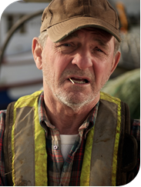

23A. Where have you seen him? ________________________

__________________________________________________

__________________________________________________

23B. On a scale of 1 (strong disagree) to 4 (strongly agree), please rate how much do you agree or disagree with the following statement. The man pictured above seems…
 |  | Strongly  Disagree |  | Disagree | Agree | Strongly  Agree
 | Smart | 1 |  | 2 | 3 | 4
 | Like me | 1 |  | 2 | 3 | 4
 | Funny | 1 |  | 2 | 3 | 4
 | Like a seasoned fisherman | 1 |  | 2 | 3 | 4
24. Have you seen ads like this?  - No (if no, go to question 27).  - Yes. |  |  | 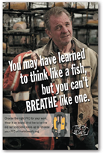

24A. If yes, where did you see it (please check all that
apply)?
 | Newspaper | Which newspaper?
 | Magazine | Which magazine?
 | Billboard | Where?
 | Poster | Where?
 | Postcard | Where?
 | Internet | Which site?
 | Email | From whom?
 | Postal mail | From whom?
 | Sticker | Where?
 | Other | Please describe.

25. Thinking about ads like the one in question 24, please rate on a scale of 1 (strong disagree) to 4 (strongly agree), how much you agree or disagree with the following statements.
(Please circle the number)

 | Strongly  Disagree | Disagree | Agree | Strongly  Agree
The message grabbed my attention. | 1 | 2 | 3 | 4
The message said something important to me. | 1 | 2 | 3 | 4
The message told me something I didn’t already know. | 1 | 2 | 3 | 4
The message was meant for fishermen like me. | 1 | 2 | 3 | 4
The message was convincing. | 1 | 2 | 3 | 4
The message was confusing. | 1 | 2 | 3 | 4
The message was funny. | 1 | 2 | 3 | 4
The message was dumb. | 1 | 2 | 3 | 4
I liked the message. | 1 | 2 | 3 | 4
The message was weak. | 1 | 2 | 3 | 4
The message was useful. | 1 | 2 | 3 | 4
I did not like the message. | 1 | 2 | 3 | 4

26. After seeing PFD message(s) like the one in question 26, have you done or thought about doing anything different? (please check all that apply)

I did not do anything.
I do not plan to do anything.
I shared the PFD message with others.
I plan to share the PFD message with others.
I plan to look for more information about PFD models.
I looked for more information about PFD models.
I plan to try on PFDs to see how it fits/feels.
I tried on a PFD to see how it fits/feels.
I plan to get a new PFD.
I got a new PFD.
I plan to wear my PFD more often while working on deck.
I wore my PFD more often while working on deck.
I plan to visit the “Live to Be Salty” website.
I visited the “Live to Be Salty” website.
I did something else. Please tell me what you did.
________________________________________________
________________________________________________
I plan to do something else. Please tell me what you plan to do. _____________________________________________
_________________________________________________

SOME FACTS ABOUT YOURSELF

27. What is your primary city and state of residence?

City? ___________________________

State? ___________________________

28. What is your age? ______ years old

29. What is your race/ethnicity?

Race:
- American Indian or Alaska Native
- Asian
- Black or African American
- Native Hawaiian or Other Pacific Islander
- White
⁭
Ethnicity:
- Hispanic or Latino
- Not Hispanic or Latino

30. What is your sex?

- Male
- Female

Thank you for completing this survey!

If you have any comments you would like to share, please write them here:



