Attachment B: Participant Recruitment and Screening Materials


JOIN A DISCUSSION ABOUT HOUSING SEARCH PRACTICES
HOSTED BY THE URBAN INSTITUTE

WHEN: [DAY/DATE & TIME]

WHERE: [LOCATION]

WHY: Urban Institute* is studying how people search for housing and factors affecting their search. We want to hear about your experiences.

Refreshments [and a stipend] will be provided

*Urban Institute is a nonprofit research organization located in Washington, DC.


[*Urban Institute is a nonprofit research organization located in Washington, DC.
*MDRC is a research organization located in New York, NY.]
RESIDENTS OF [region name]
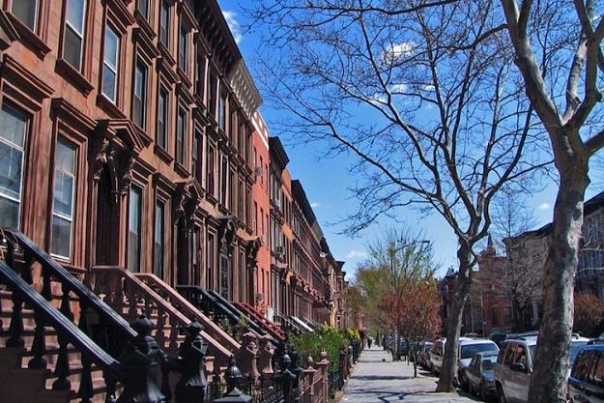

CALL [NUMBER] FOR MORE INFORMATION
Call by [DATE] to see if you’re selected to participate in the focus group.
Focus group participation is limited to adults age 18 or older.

