ATTACHMENT F – Online Instrument: Web version

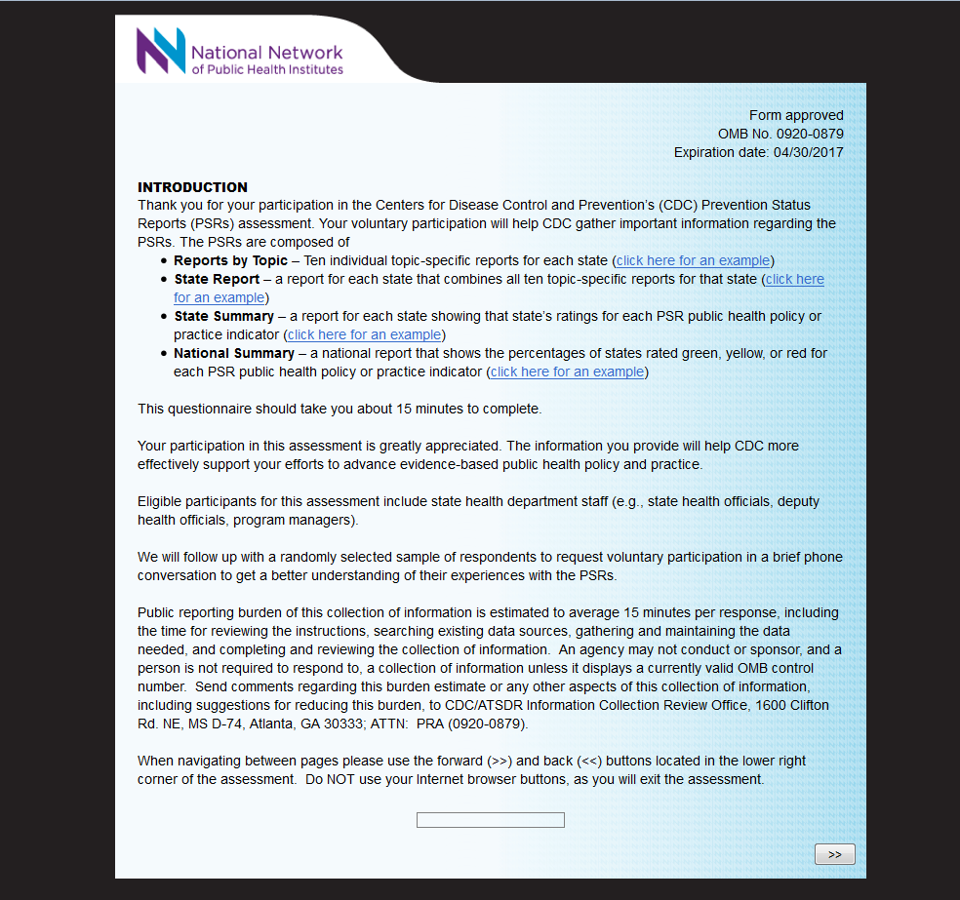
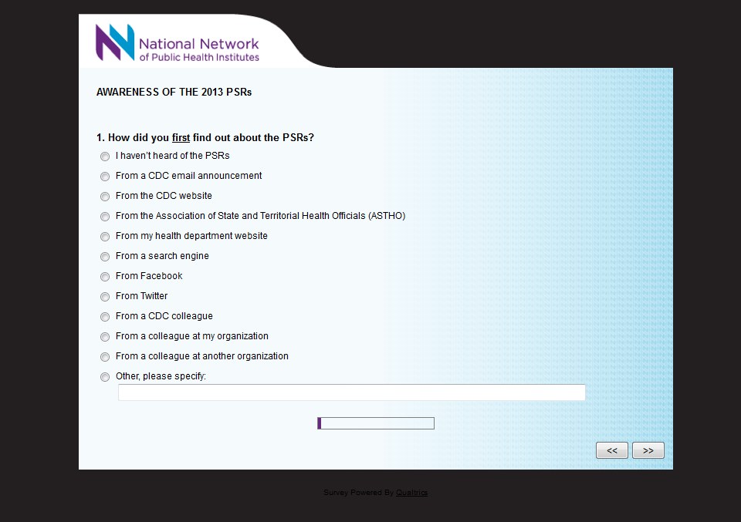

[SKIP PATTERN QUESTION: IF RESPONDENT SELECTS I HAVEN’T HEARD OF THE PSRs, THEN RESPONDENT SKIPS TO LAST SECTION ASKING ABOUT RESPONDENT CHARACTERISTICS, OTHERWISE RESPONDENT PROCEEDS TO NEXT QUESTION.]

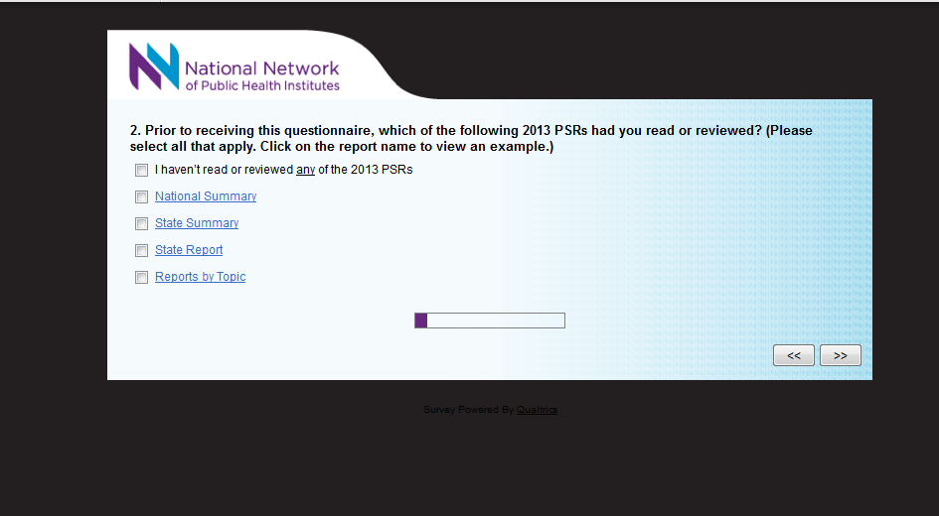

[SKIP PATTERN QUESTION: IF RESPONDENT SELECTS I HAVEN’T READ OR REVIEWED ANY OF THE 2013 PSRs, THEN RESPONDENT PROCEEDS TO QUESTION 2a. IF RESPONDENT SELECTS REPORTS BY TOPIC SKIPS TO QUESTION 2b. IF RESPONDENT SELECTS STATE REPORT SKIPS TO QUESTION 3. ALL OTHER RESPONSES SKIP TO QUESTION 4.]

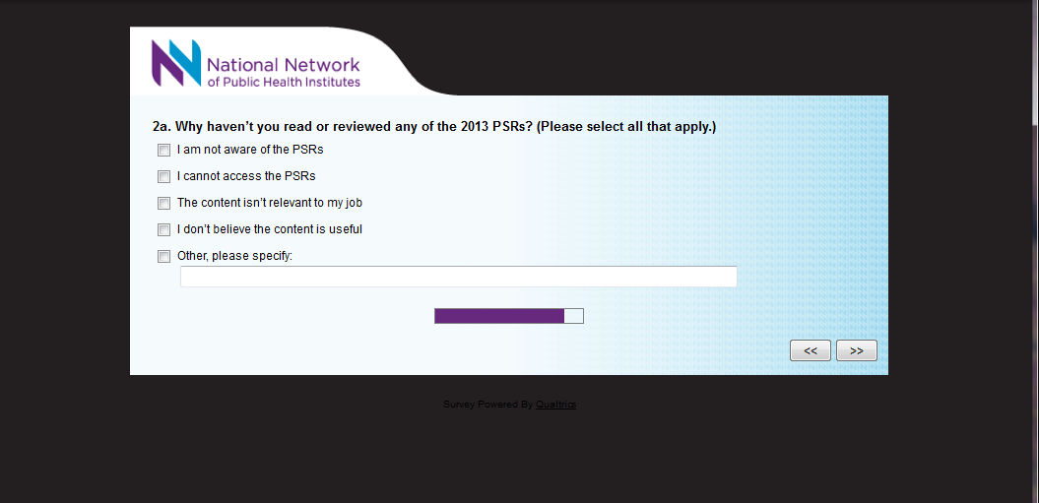
[RESONDENT SKIPS TO LAST SECTION ASKING ABOUT RESPONDENT CHARACTERISTICS].

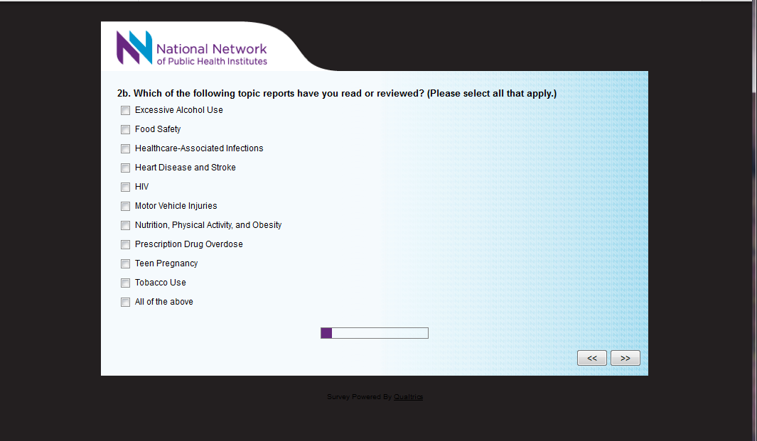
[DISPLAY LOGIC QUESTION: QUESTION ONLY DISPLAYED IF RESPONDENT SELECTS REPORTS BY TOPIC IN QUESTION 2]

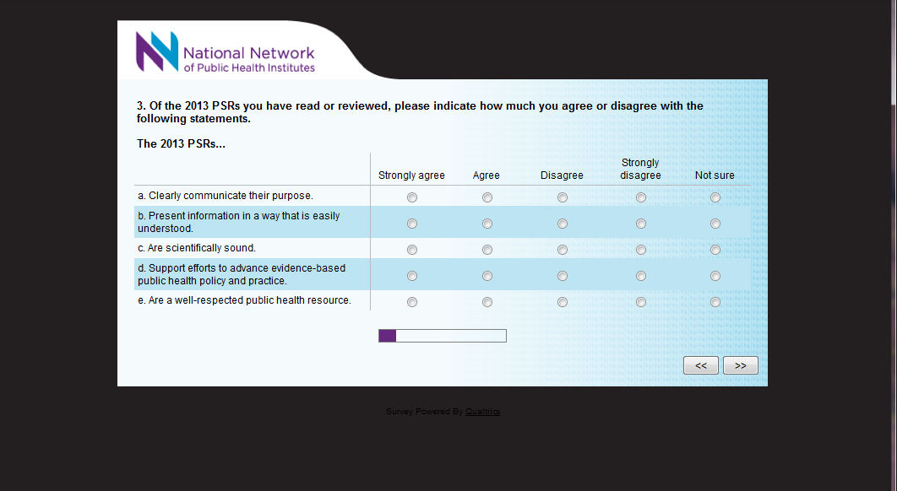
[DISPLAY LOGIC QUESTION: QUESTION ONLY DISPLAYED IF RESPONDENT SELECTS STATE REPORT OR REPORTS BY TOPIC OR BOTH IN QUESTION 2.]

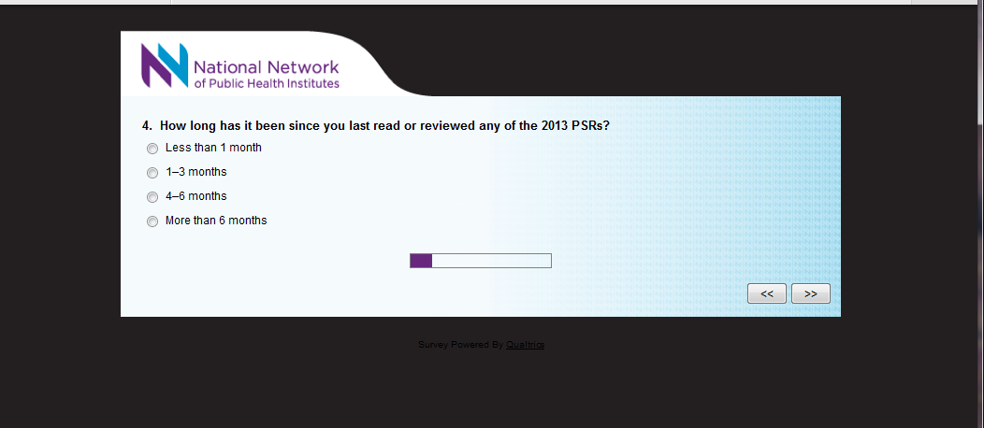

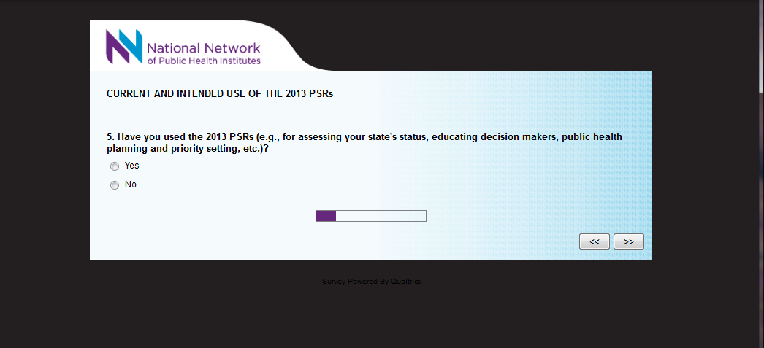
[SKIP PATTERN QUESTION: IF RESPONDENT SELECTS YES, THEN RESPONDENT SKIPS TO QUESTION 6. IF RESPONDENT SELECTS NO, THEN RESPONDENT PROCEEDS TO QUESTION 5a.]

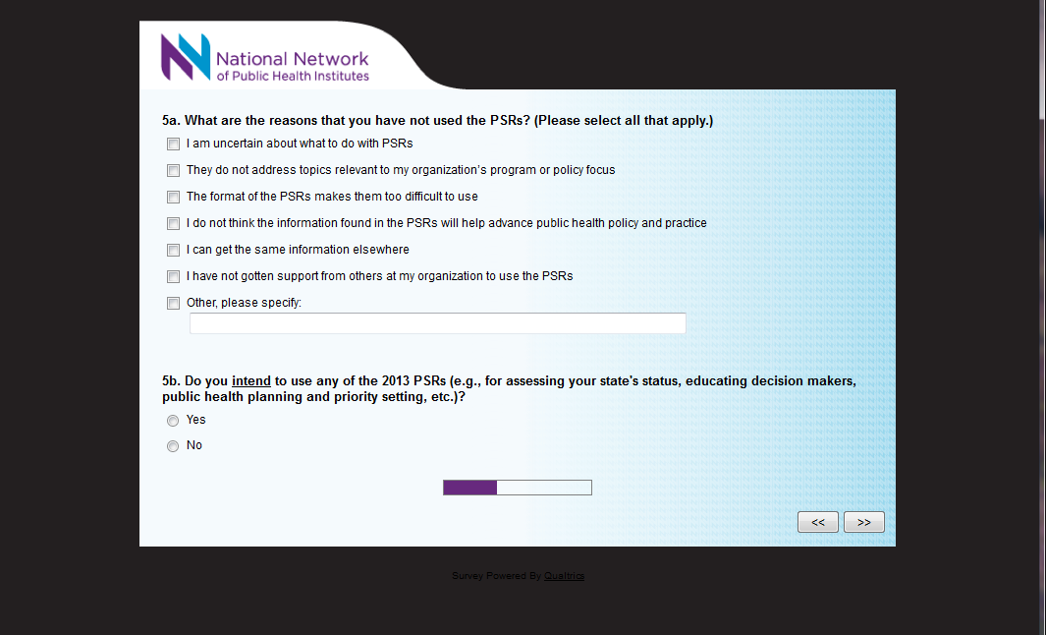
[SKIP PATTERN QUESTION: IF RESPONDENT SELECTS NO, THEN RESPONDENT SKIPS TO QUESTION 10. IF RESPONDENT SELECTS YES, THEN RESPONDENT PROCEEDS TO QUESTION 5c.]

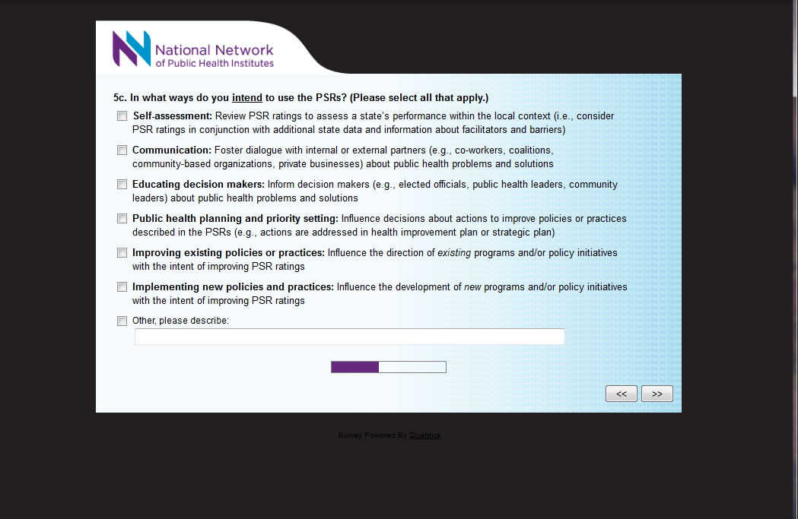
[DISPLAY LOGIC QUESTION: QUESTION ONLY DISPLAYED IF RESPONDENT SELECTS YES IN QUESTION 5b. RESONDENT THEN SKIPS TO QUESTION 10]

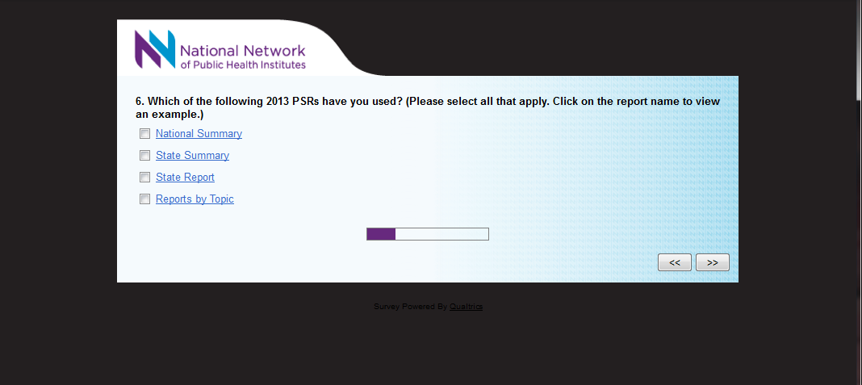

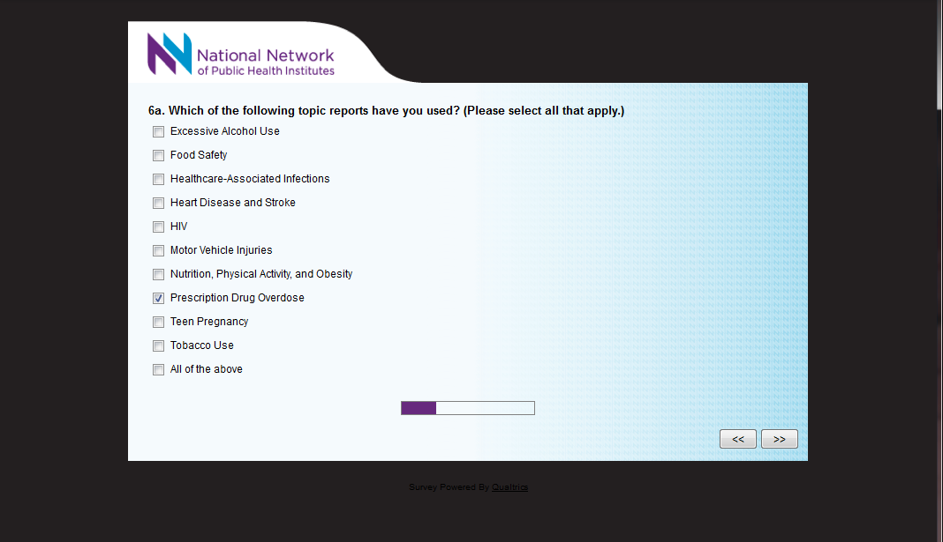
[DISPLAY LOGIC QUESTION: QUESTION ONLY DISPLAYED IF RESPONDENT SELECTS REPORTS BY TOPIC IN QUESTION 6]

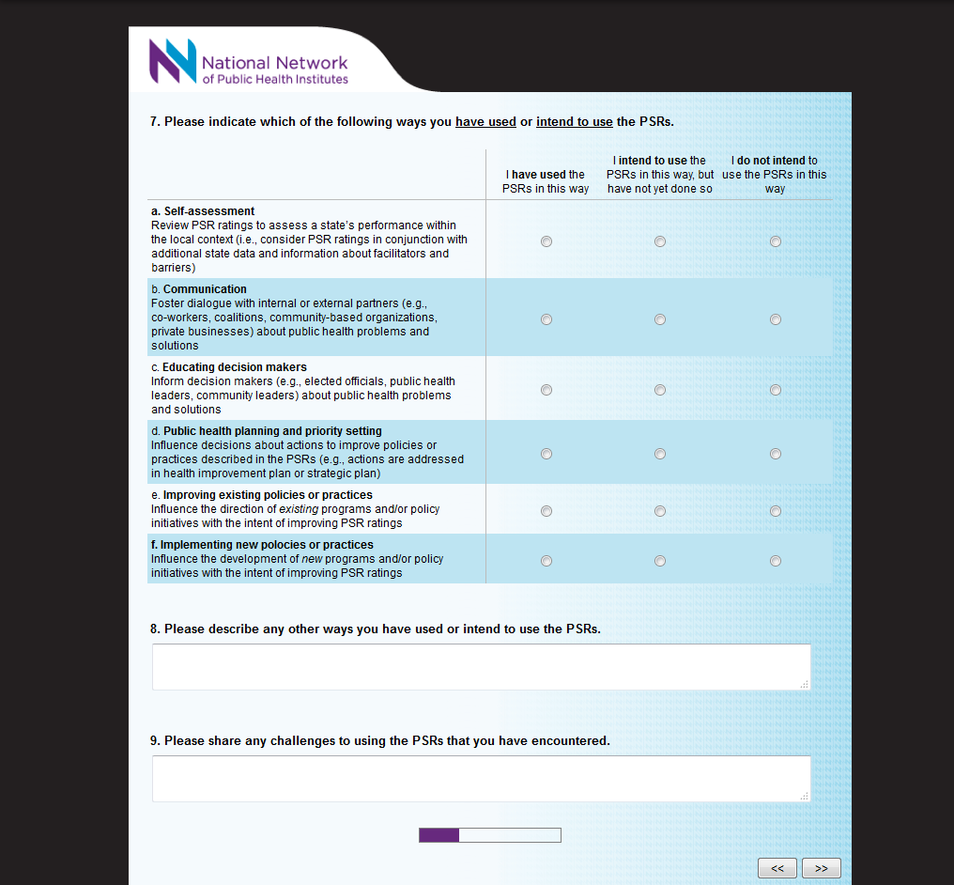

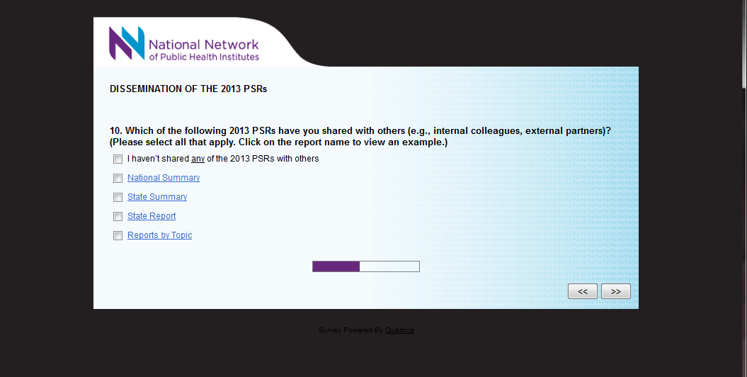
[SKIP PATTERN QUESTION: IF RESPONDENT SELECTS I HAVEN’T SHARED ANY OF THE PSRs, THEN RESPONDENT SKIPS TO SECTION ASKING ABOUT USER SATISFACTION, OTHERWISE RESPONDENT PROCEEDS TO NEXT QUESTION.]
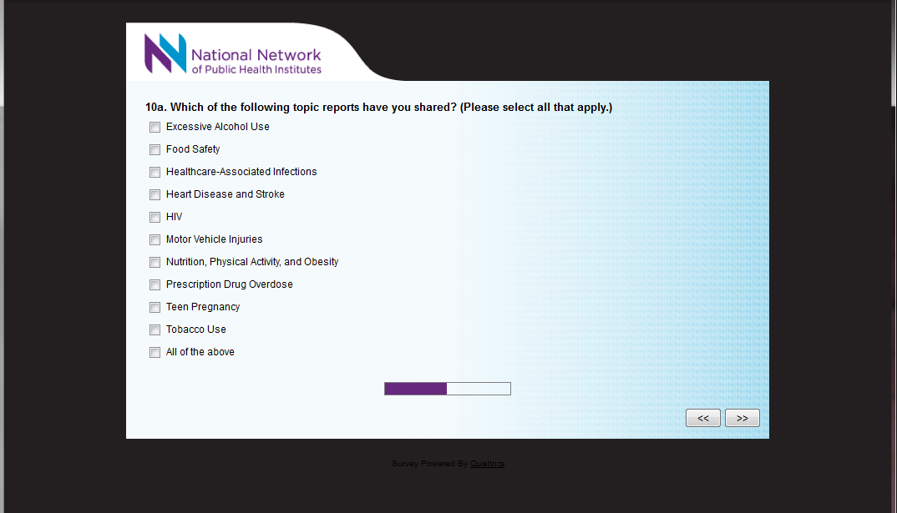
[DISPLAY LOGIC QUESTION: QUESTION ONLY DISPLAYED IF RESPONDENT SELECTS REPORTS BY TOPIC IN QUESTION 10]

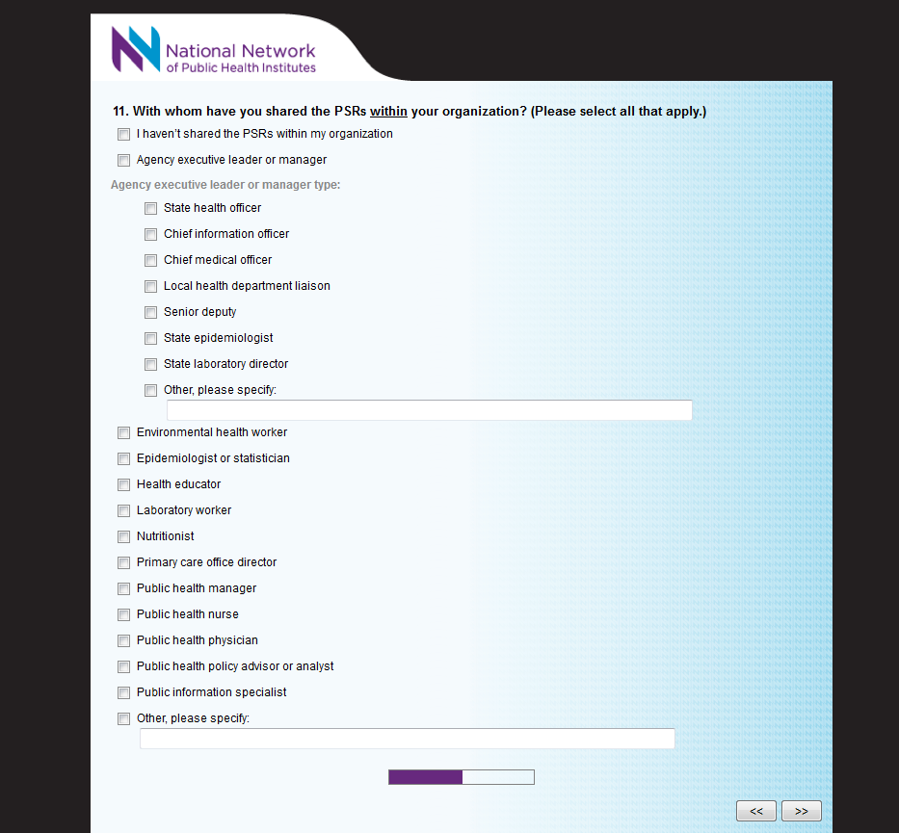
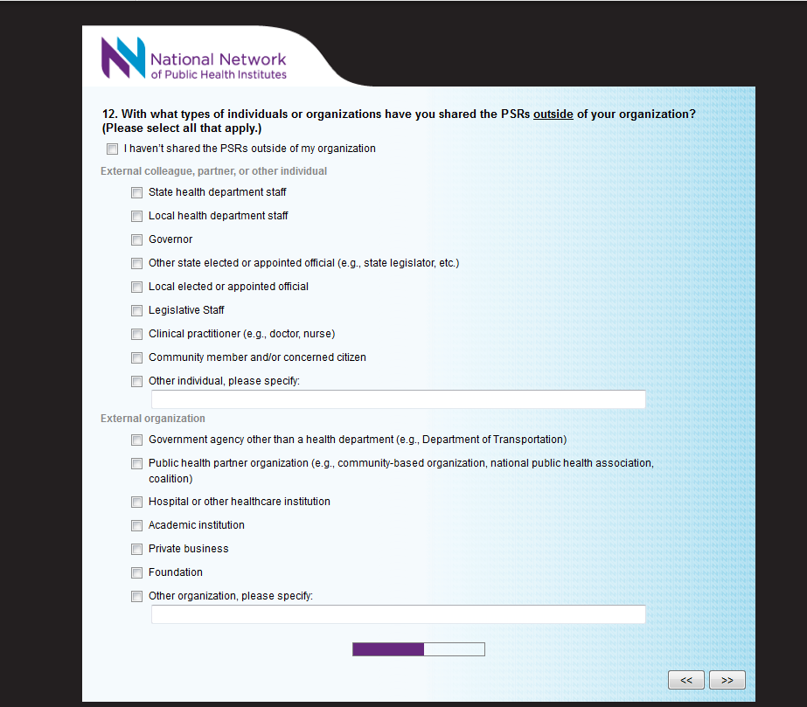

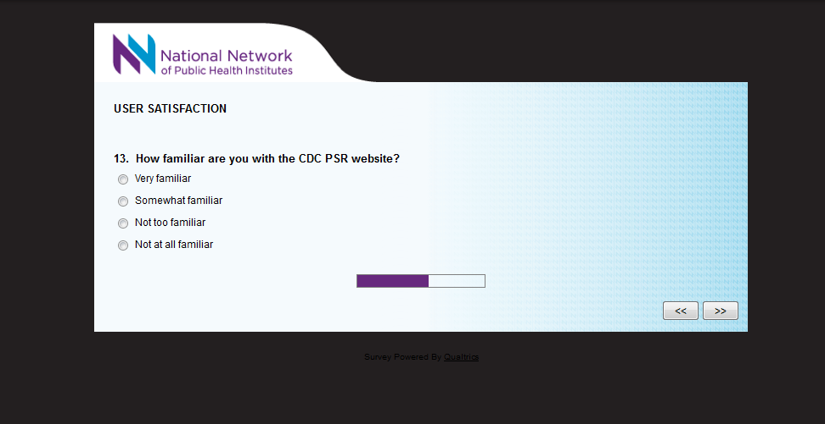

[SKIP PATTERN QUESTION: IF RESPONDENT SELECTS NOT AT ALL FAMILIAR, THEN RESPONDENT SKIPS TO QUESTION 16 ASKING ABOUT QUICK START USER GUIDE, OTHERWISE RESPONDENT PROCEEDS TO NEXT QUESTION.]

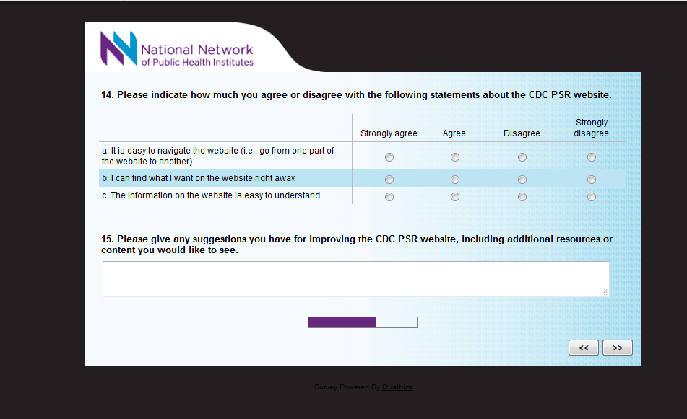

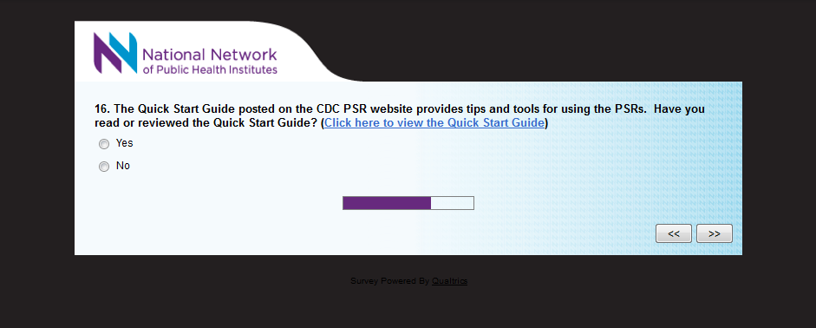
[SKIP PATTERN QUESTION: IF RESPONDENT SELECTS NO, THEN RESPONDENT SKIPS TO QUESTION 19 ASKING ABOUT SUGGESTIONS FOR IMPROVEMENT, OTHERWISE RESPONDENT PROCEEDS TO NEXT QUESTION.]

