Attachment C
CDC Digital Health Tools Survey: Digital Health Tools Survey Screen Shots

*TEXT IN RED, CAPS AND ITALICS ADDED FOR CLARIFICATION, BUT NOT TO BE INCLUDED IN ACTUAL SURVEY.

PRE-TEST QUESTIONS BEGIN, QUESTIONS ASKED OF ALL PARTICIPANTS

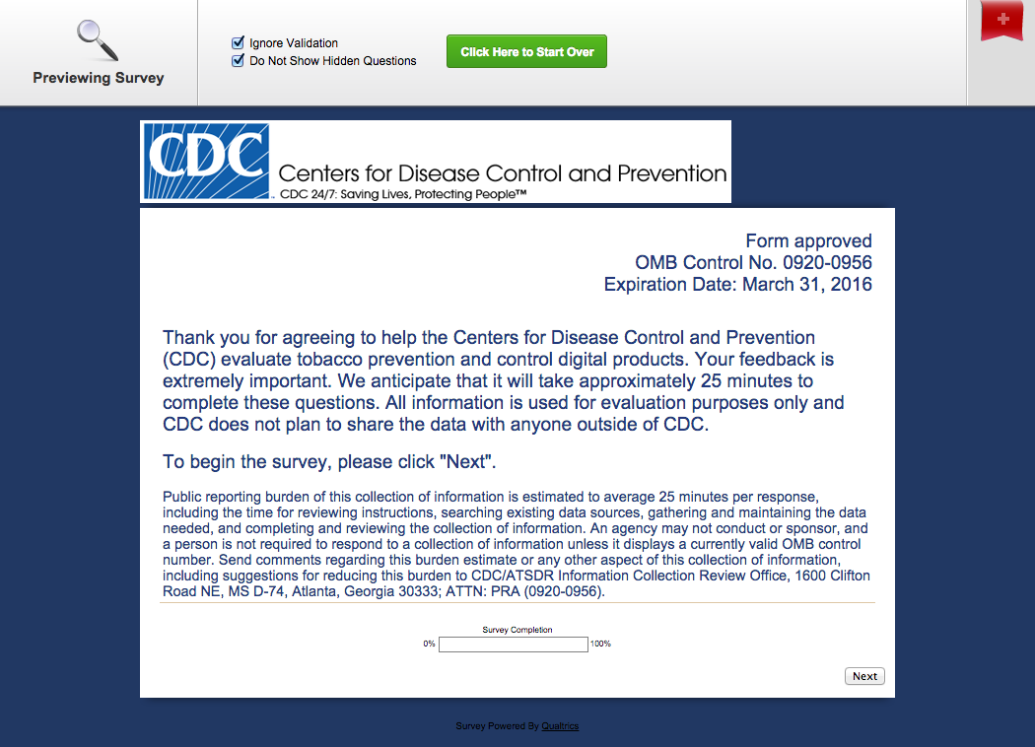

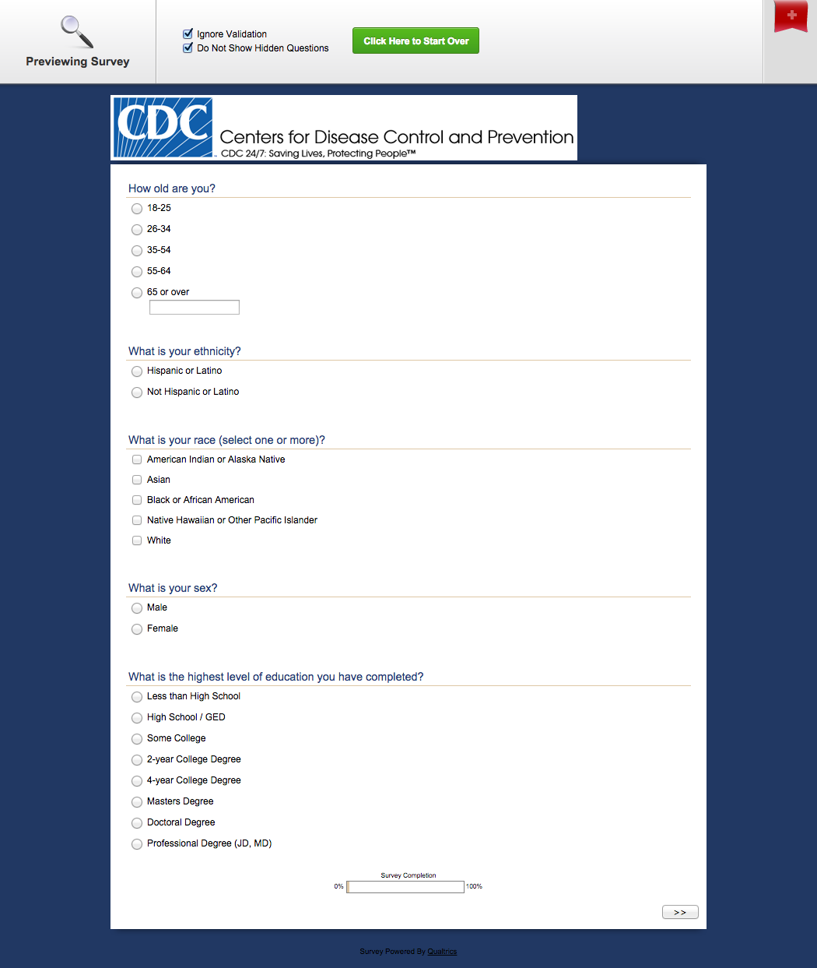

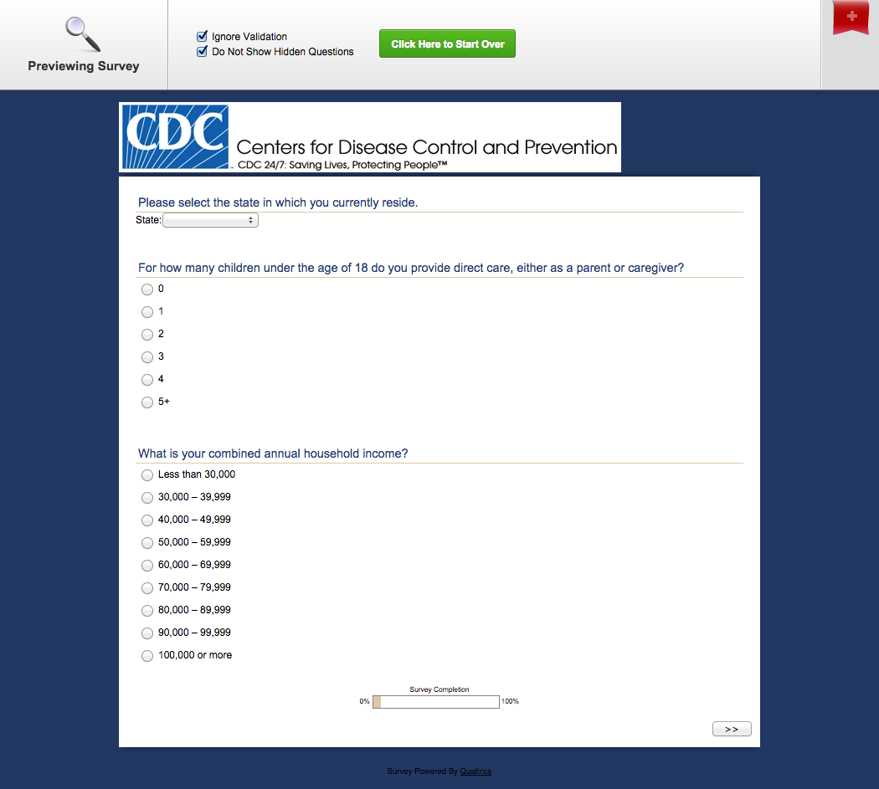

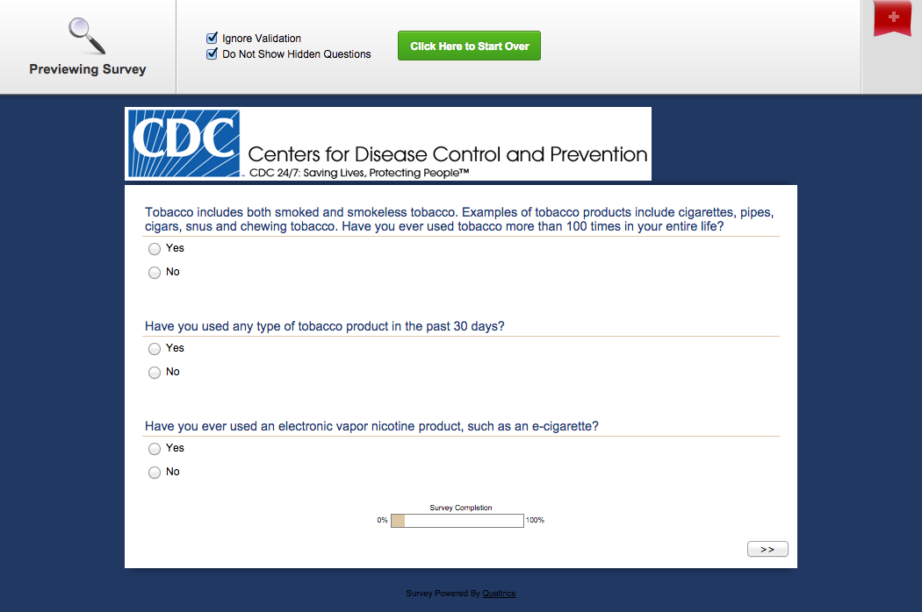
PRE-TEST QUESTIONS END
EXPOSURE TO DIGITAL TOOLS AND ALTERNATES BEGINS
ALL PARTICIPANTS EXPOSED TO ONE (1) OF FOUR (4) SITES,
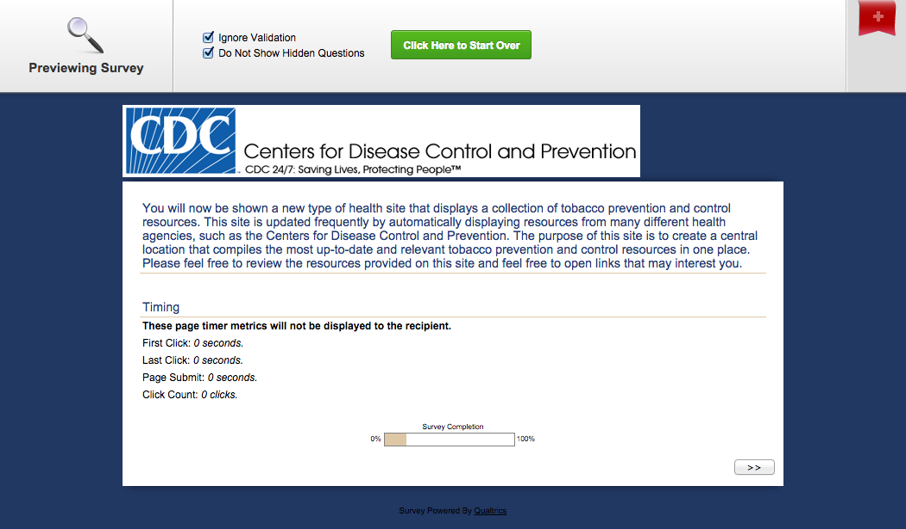
EXPOSURE TO THE MICROSITE TOOL, GROUP 1
EXPOSURE TO THE ALTERNATE TO THE MICROSITE SITE, GROUP 2

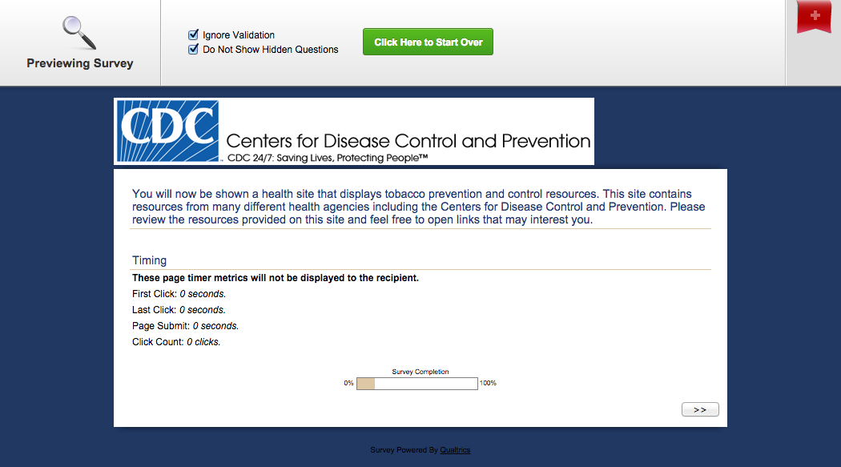
EXPOSURE TO THE DATA WIDGET TOOL, GROUP 3
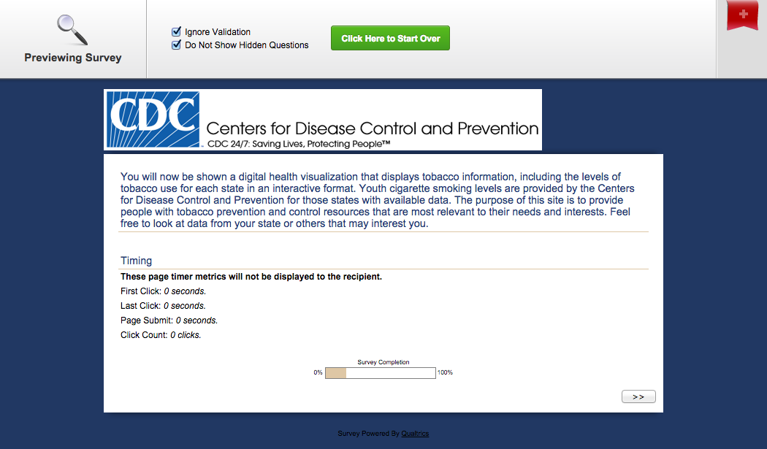
EXPOSURE TO THE ALTERNATE TO THE DATA WIDGET SITE, GROUP 4

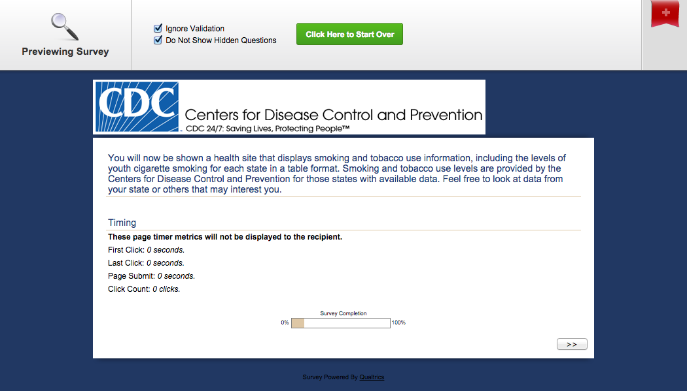
POST-TEST QUESTIONS BEGIN

ONLY PARTICIPANTS IN GROUPS 1 AND 2 ANSWER THESE QUESTIONS

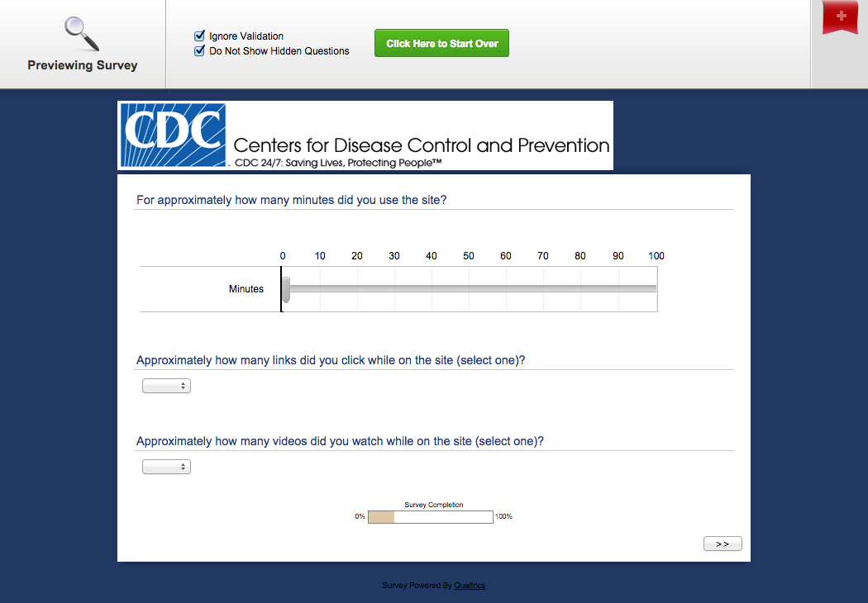
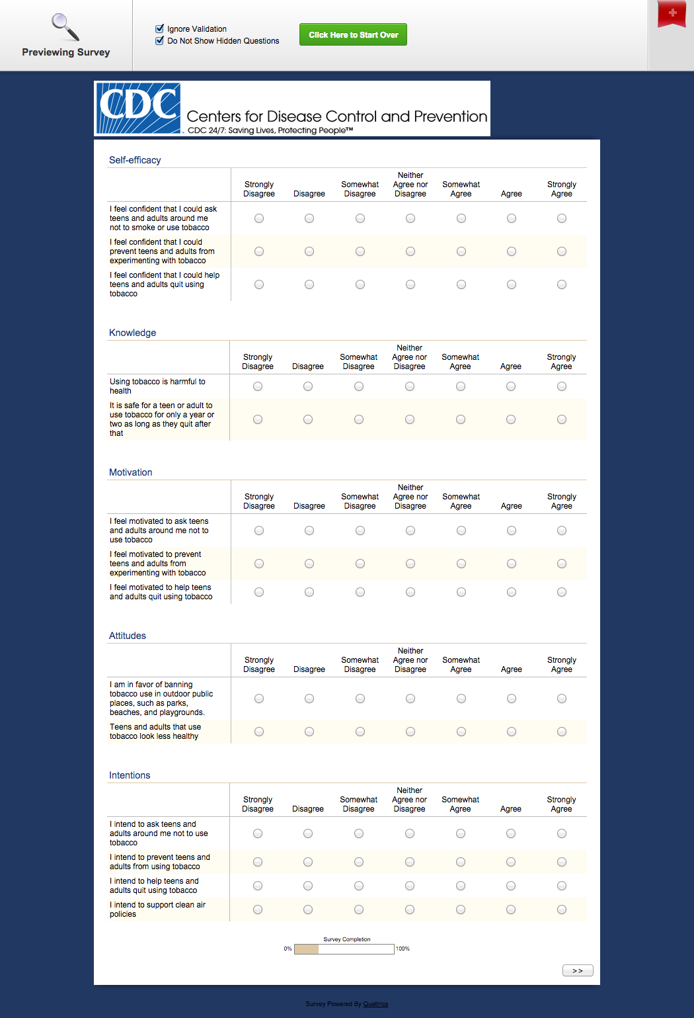
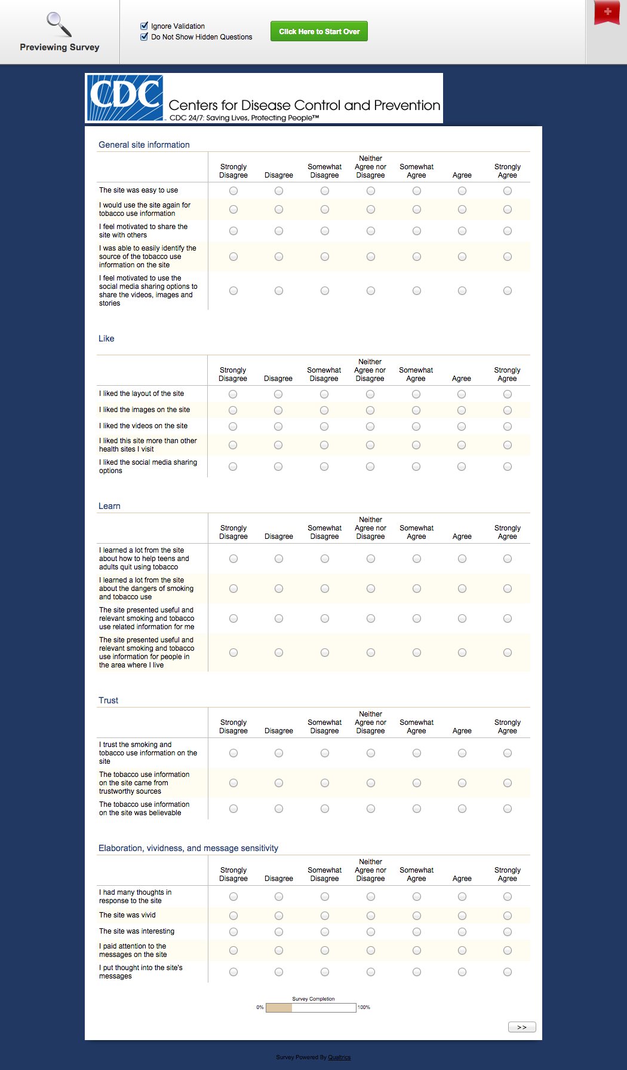
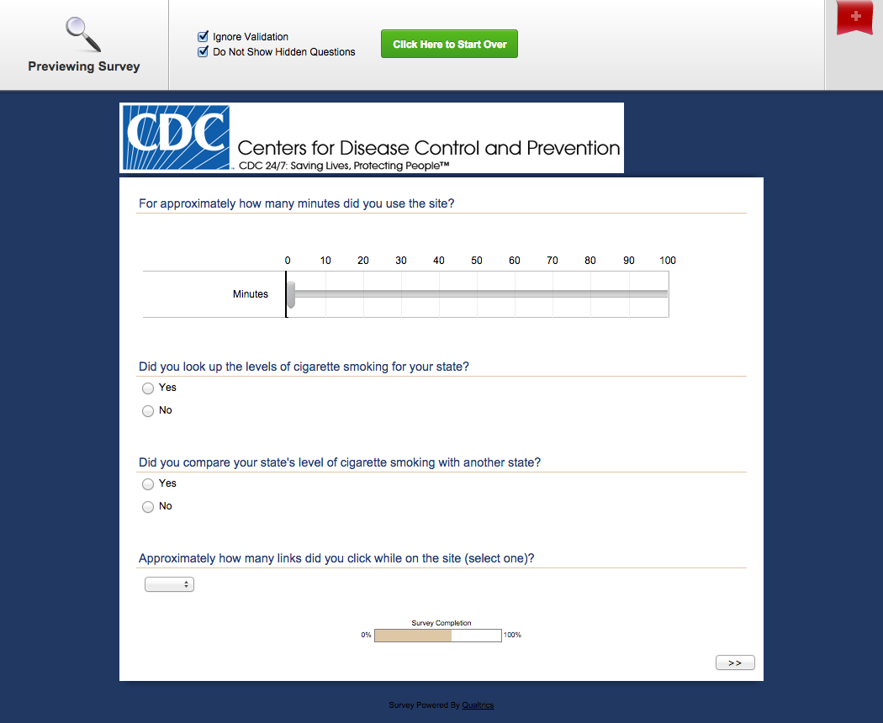
ONLY PARTICIPANTS IN GROUPS 3 AND 4 ANSWER THESE QUESTIONS
