Survey Monkey Screen Images
  - Survey Questions for Attorney Forms

Purpose
This document is prepared to support the survey approval process. Below are screen images of the Attorney Forms survey as it appears on SurveyMonkey.com. To preview the survey, use the link below. https://www.surveymonkey.com/create/survey/preview?r=true&sm=oeCaqLcZaq6hkSFymgePqZL9MACkW8KuYF_2B6bPSPPTzNoyY5XrA4JBX2YNS7OzzZ

Images
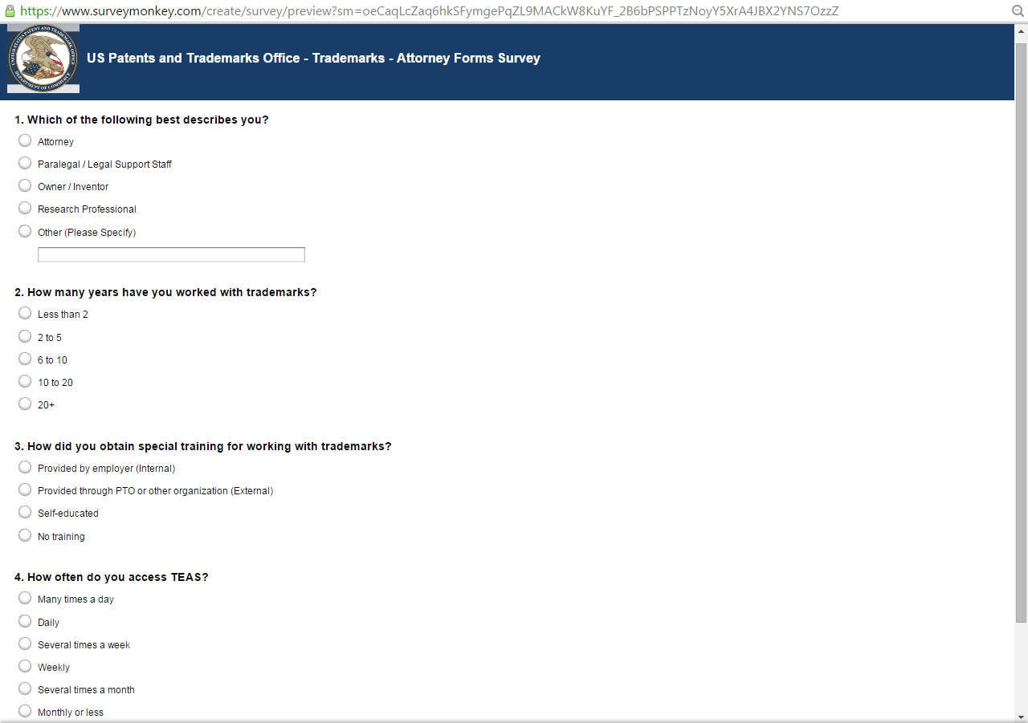
Figure 1 - Questions 1 through 4
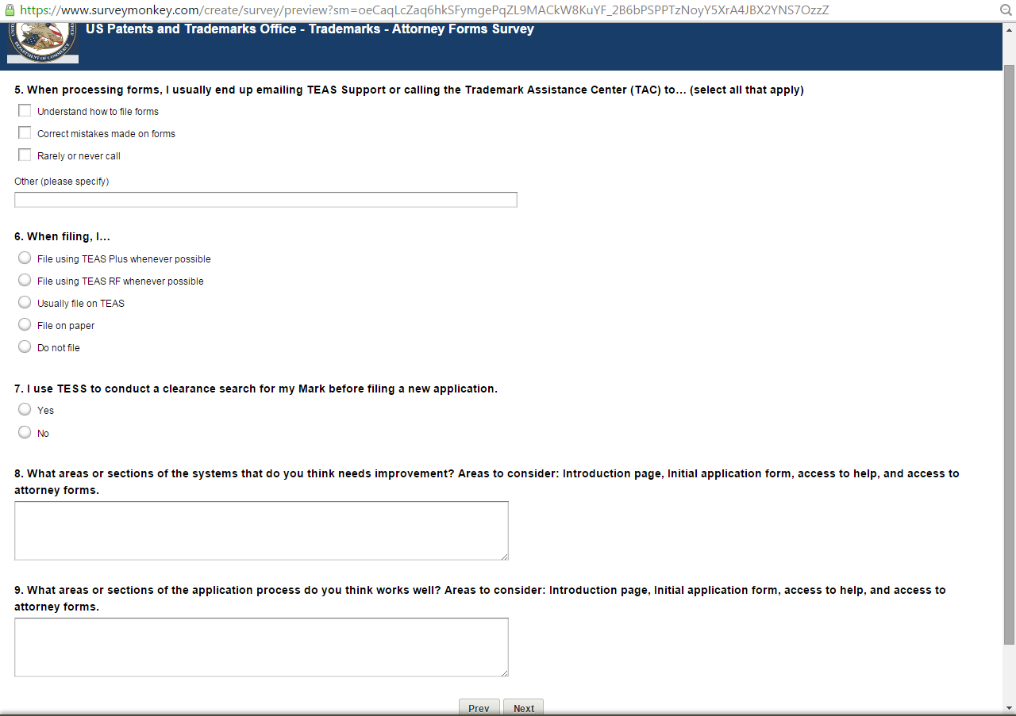
Figure 2 - Questions 5 through 9
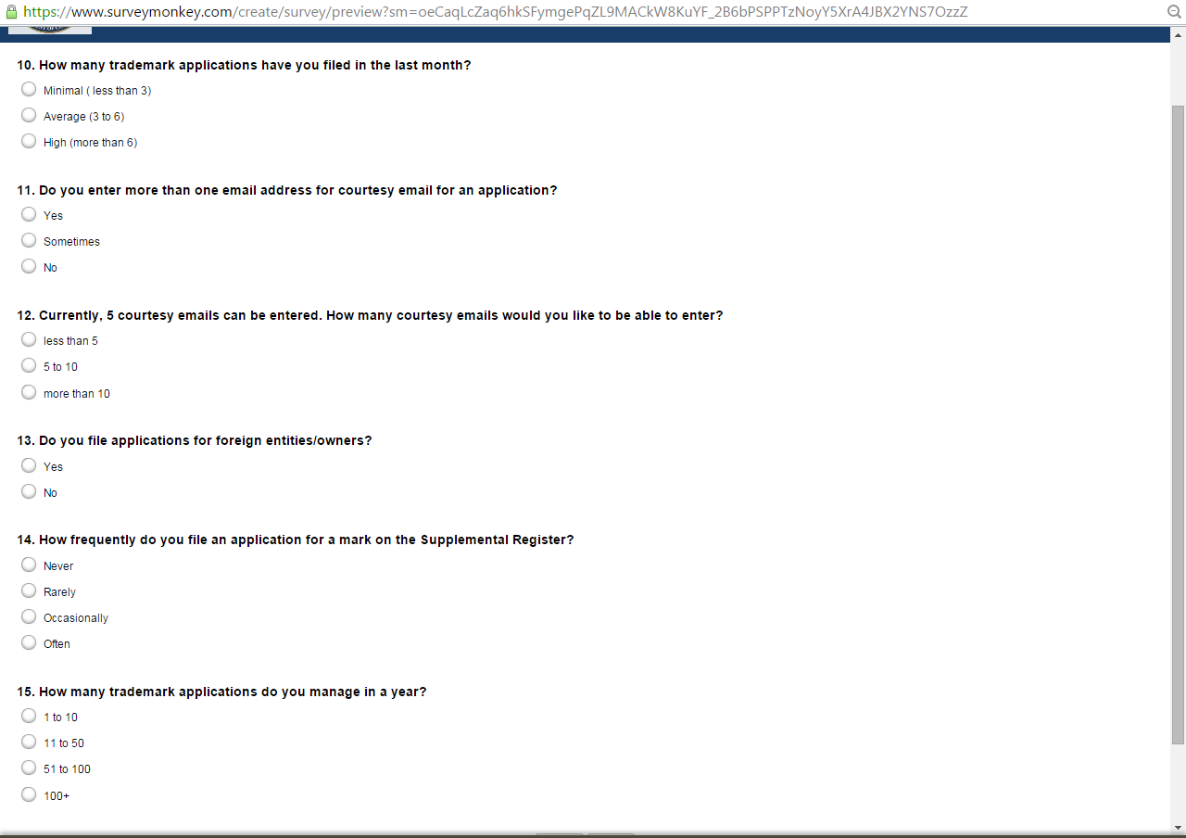
Figure 3 - Questions 10 through 15
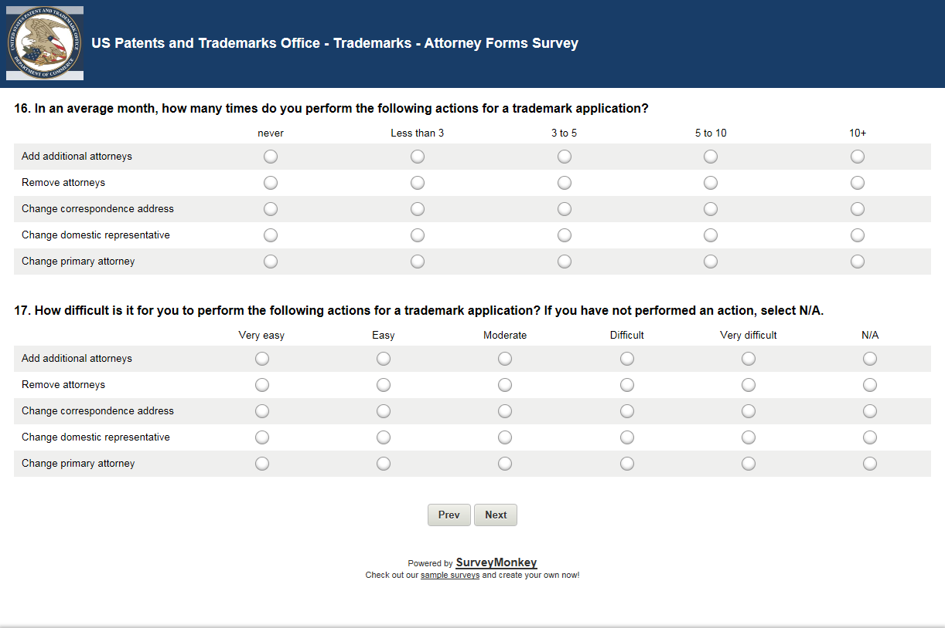
Figure 4 - Questions 16 and 17
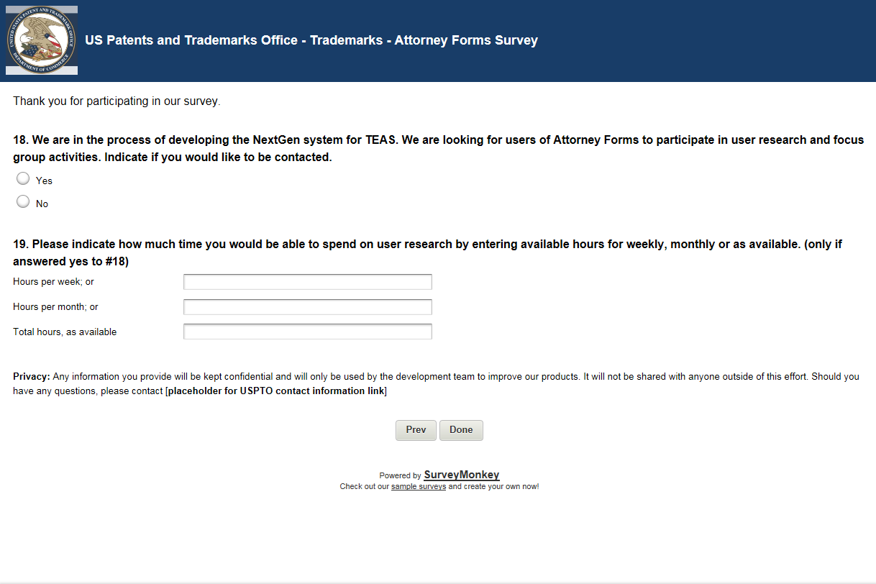
Figure 5 - Questions 18 and 19 (End of Survey)

