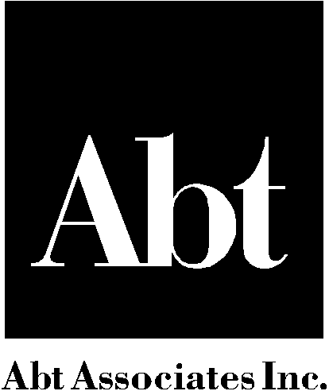

Appendix D: Abt Associates Inc.
Confidentiality/Non-Disclosure Agreement

As a condition of my employment with Abt Associates Inc., I agree to maintain the confidentiality of all information given to me during the course of my employment with Abt Associates Inc that is disclosed as confidential or proprietary in nature. I agree that I will not disclose any such information, during or after my employment with Abt Associates Inc., except to authorized representatives of Abt Associates Inc.

I also agree I will not, during or after my employment with Abt Associates Inc., disclose to anyone other than authorized representatives of Abt Associates Inc., any memoranda, manuals, questionnaires, work plans, or other materials or information furnished to me in the course of my employment at Abt Associates Inc. I agree to return any such materials in my possession to Abt Associates Inc. immediately upon the completion of my employment with Abt Associates Inc.

Nothing in this Agreement shall grant or confer on me any right to be employed by Abt Associates Inc. for any particular period of time.

I understand that any violation of this Agreement during the period of my employment with Abt Associates Inc. will be cause for immediate dismissal without notice.

Name: Date:

(Print Name)___________________

