OMB CONTROL NUMBER: 2132-0570
EXPIRATION DATE: mm/dd/yyyy

A federal agency may not conduct or sponsor, and a person is not required to respond to, nor shall a person be subject to a penalty for failure to comply with a collection of information subject to the requirements of the Paperwork Reduction Act unless that collection of information displays a current valid OMB Control Number. The OMB Control Number for this information collection is 2132-0570. Public reporting for this collection of information is estimated to be approximately 1 hour per response, including the time for reviewing instructions, gathering the data needed, and completing and reviewing the collection of information. All responses to this collection of information are mandatory (49 U.S.C. 13303 and 49 U.S.C. 13304). Send comments regarding this burden estimate or any other aspect of this collection of information, including suggestions for reducing this burden, to: Information Collection Clearance Officer, Federal Transit Administration, 1200 New Jersey Avenue, SE, Washington, D.C. 20590-0001.

DOT 
FTA

U.S. Department of Transportation
Federal Transit Administration

Application

Recipient 10: Recipient Name: Project 10: Budget Number:
Project Information:

Part 1: Recipient Information
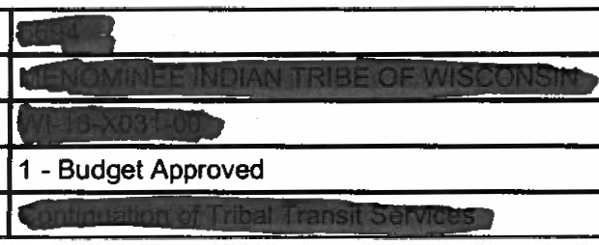

Project Number: Recipient 10: Recipient Name: Address: Telephone:
!Facsimile: _... _
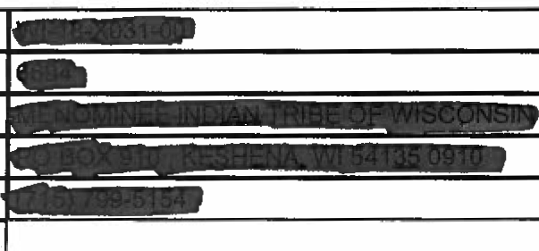

Union Information



Part 2:Project Information
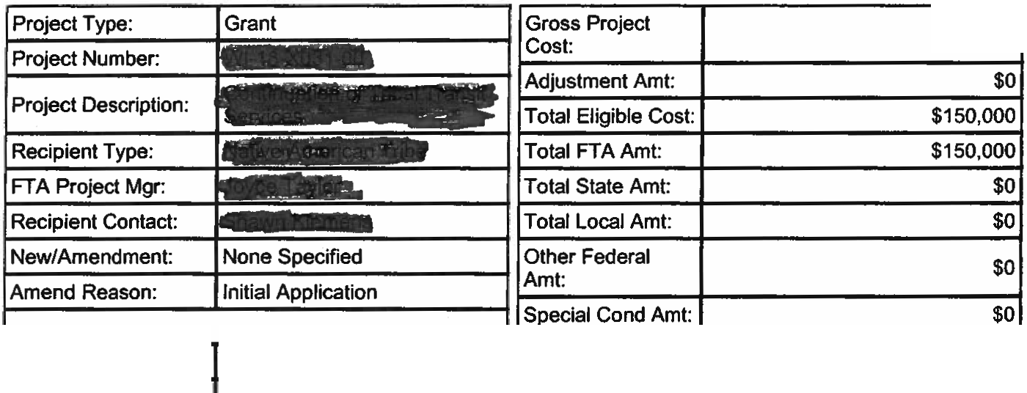

$150,000

Fed Dom Asst. #:
20509

Sec.of Statute: | 5311-1 | Special Condition: | None Specified
State Appl. 10: | None Specified | S.C. Tgt. Date: | None Specified
Start/End Date: | - | S.C. Eff.Date: | None Specified
Recvd. By State: | Aug. 15,2008 | Est. Oblig Date: | None Specified
EO 12372 Rev: | Not Applicable | Pre-Award  Authority?: | No
Review Date: | None Specified | Pre-Award  Authority?: | No
Review Date: | None Specified | Fed.Debt  Authority?: | No
Planning Grant?: | NO | Fed.Debt  Authority?: | No
Program Date (STIP/UPWP/FTA Prm Plan): | Jun.12,2008 | Fed.Debt  Authority?: | No
Program Date (STIP/UPWP/FTA Prm Plan): | Jun.12,2008 | Final Budget?: | No
Program Page: | None Specified
Application Type: | Electronic
Supp. Agreement?: | No
Debt. Delinq.Details:



State ID IDistrict Code IDistrict Official
None Specified

Project Details
FY 2007 Section 5311(c) fund utilized for continuation of transportation enhancements for th••••••111 inc1uded•are.. routes added to existing service and the addition of new routes to and from the


•1111 1
for medical, shopping/personal, education and employment.

Earmark$

Earmark Detail

Earmark ID Earmark Name



Total Amount Applied: 150,000

Date Sent for Release:

Orig. Balance

$150,000
Amount
Applied

$150,000

Date Released;

Security

No information found.

Part 3: Budget .

Project Budget
 | Quantity I FTA Amount l Tot..Elig._ Cost
SCOPE
300..00 OPERATING ASSISTANCE | of $15o,ooo.oo 1 $150,000.00
ACTIYI1Y
30.09.01 Operating Assistance | of $15o,ooo.oo 1 $150,000.00
Estimated Total Eligible Cost: I $150,000.00
Federal Share: I $150,000.00
Local Share:( $0.00

SOURCES OF FEDERAL FINANCIAL ASSISTANCE

UZAIO Total

$150,000.00

Total Previously Approved: $0.00

Total Amendment Amount: $150,000.00

Total from all Funding Sources: $150,000.00

Alternative Fuel Codes

Extended Budget Descriptions

300.00 OPERATING ASSISTANCE 0 $150,000.00 $150,000.00

::>ec:tton 5311(c) fund utilized for continuation of transportation enhancements forth
are additional routes added to existing service and the addition of new routes to and from
--" ...,.medical, shopping/personal, education and employment.

Changes since the Prior Budget


Unable to find change amount information.

Part 4. Milestones

30.09.01 Operating Assistance 0 $150,000 $150,000

 | Milestone Description | Est. Comp. Date
1. | Final Expenditure | Aug.31,2009

Part 5.Environmental Findings

300901 Operating Assistance 0 $150,000 $150,000

C16- Program Admin.& Operating Assistance
Program administration, technical assistance activities, and operating assistance to transit authorities to continue existing service or increase service to meet routine changes in demand.

Part 6:Fleet Status

Part 7. FTA Comments

FTA Internal


Comment Title: RA Concurrence

Comment By:

Date Created: Aug. 28, 2008

Date Updated: None Specified

Ref Section: Unknown

-
Comment Title: | Preliminary Review/Paralegal
Comment By:
Date Created: | Aug.13,2008
Date Updated: | None Specified
Ref Section: | Unknown
Comment: | Preliminary review complete. This concurrence relies on representations by TCR that all civil rights requirements have been met. Grantee may submit.

C-om-m-e-n-t T-it-le:-----FTA- L-egal Concurre-nc-e----------------------------------------


Comment By:
Date Created: Aug.25, 2008

Date Updated: Ref Section:
Comment:

None Specified

Unknown

Approval Stamp 8/25/2008

Comment Title: | Transportation Program Specialist
Comment By:
Date Created: | Aug. 19,2008
Date Updated: | None Specified
Ref Section: | Unknown
Comment: | Application Complete 8/19/2008

Comment Title: | Development
Comment By:
Date Created: | Aug.13, 2008
Date Updated: | None Specified
Ref Section: | Unknown
Comment: | Approval Stamp 8/13/2008

Comment Title: Comment By: Date Created:
Date Updated:
Certs & Assurances

Aug.13,2008

None Specified

Ref Section: Unknown

Comment: In TEAM in both the grant and on the Recipient Screen attachments
-

Comment Title: New Comment

Comment By:

Date Created: Aug.25, 2008


Date Updated: | None Specified
Ref Section: | Unknown
Comment: | Legal review complete.

Comment Title: | New Comment
Comment By:
Date Created: | Aug.14, 2008
Date Updated: | None Specified
Ref Section: | Unknown
Comment: | Grantee's civil rights programs are current.

Comment Title: | FTA Civil Rights Concurrence
Comment By:
Date Created: | Aug.20, 2008
Date Updated: | None Specified
Ref Section: | Unknown
Comment: | Approval Stamp 8/20/2008
-
Comment Title: | FTA Environment Concurrence
Comment By:
Date Created: | Aug.13,2008
Date Updated: | None Specified
Ref Section: | Unknown
Comment: | Approval Stamp 8/13/2008

Comment Title: Comment By: Date Created: Date Updated: Ref Section: Comment:
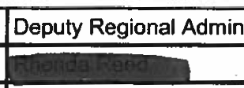

Aug.28, 2008

None Specified

Unknown

This grant is ready for award.
-- '
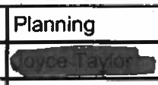

Comment Title: | New Comment
Comment By:
Date Created: | Aug.20, 2008
Date Updated: | None Specified
Ref Section: | Unknown
Comment: | The Office of Civil Rights concurs in the approval of this grant.

Comment Title: Comment By:

Date Created: | Aug.13, 2008
Date Updated: | None Specified
Ref Section: | Unknown
Comment: | Approval Stamp 8/13/2008

FTA Project Description


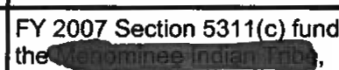



Comment Title: Comment By: Date Created: Date Updated:
. Ref Section:
New Comment

Aug. 13, 2008

None Specified

Unknown

Comment: utilized for continuation of transportation enhancements for included are deffsdffdfdsdfsfdf to existing service and
the new routes and from for medical,
shopping/personal, education and ...rn,nrn,_

Part 8:Results of Reviews The reviewer did not find any errors Part 9: Agreement

UNITED STATES OF AMERICA DEPARTMENT OF TRANSPORTATION FEDERAL TRANSIT ADMINISTRATION

Grant Agreement
October 1, 2007

On the date the authorized U.S. Department of Transportation, Federal Transit Administration (FTA) official's electronic signature is entered for this Grant Agreement, FTA has Awarded Federal assistance in support of the Project described below. Upon Execution of this Grant Agreement by the Grantee named below, the Grantee affirms this FTA Award, and enters into this Grant Agreement with FTA. The following documents are incorporated by reference and made part of this Grant Agreement:

(1) \"Federal Transit Administration Master Agreement,\ sfjkljsfj October 1, 2007, http://www.fta.dot.gov/documents dflkjds;eo;ifjef
(2) The Certifications and Assurances applicable to the Project that the Grantee has selected and provided to
FTA and
(3)Any Award notification containing special conditions or requirements, if issued.

FTA OR THE FEDERAL GOVERNMENT MAY WITHDRAW ITS OBLIGATION TO PROVIDE FEDERAL ASSISTANCE IF THE GRANTEE DOES NOT EXECUTE THIS GRANT AGREEMENT WITHIN 90 DAYS FOLLOWING THE DATE OF THIS FTA AWARD SET FORTH HEREIN.

FTA AWARD FTA hereby awards a Federal grant as follows:

Grantee;


Citation of Statute(s) Authorizing Project: 49 USC 5311 - Nonurbanized Area Programs

Estimated Total Eligible Cost (in U.S. Dollars): $150,000

Amount of this FTA Award (in U.S. Dollars);. $150,000

Percentages of Federal participation are based on amounts included in the Approved Project Budget, modified as set forth in the text following the Project Description.

U.S. Department of Labor Certification of Public Transportation Employee Protective Arrangements;

Original Project Certification Date: Project Description:
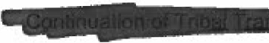

The Project Description includes information describing the Project within the Project Application submitted to FTA, and the Approved Project Budget, modified by any additional statements displayed in this Grant Agreement, and, to the extent FTA concurs, statements in other documents including Attachments entered into TEAM-Web.

Awarded By:

a
Regional Administrator
FEDERAL TRANSIT ADMINISTRATION
U.S. DEPARTMENT OF TRANSPORTATION
08/28/2008

EXECUTION OF GRANT AGREEMENT

The Grantee, by executing this Grant Agreement, affirms this FTA Award; adopts and ratifies all statements, representations, warranties, covenants, and materials it has submitted to FTA; consents to this FTA Award; and agrees to all terms and conditions set forth in this Grant Agreement.

By executing this Grant Agreement, I am simultaneously executing any Supplemental Agreement that may be required to effectuate this Grant Agreement.



EXHIBIT 16
AUTHORIZING RESOLUTION

The resolution must be executed by the governing body of the applicant. The resolution authorizes the applicant to file a Section 5309 Capital Program Application with the Georgia Department of Transportation and the Federal Transit Administration and it also identifies the person authorized to execute a grant on behalf of the applicant.

Resolution No.-------
Resolution authorizing the filing of an application with the Federal Transit Administration, an operating administration of the United States Department _ of Transportation; and the Georgia Department of Transportation for Federal transportation assistance authorized by 49 U.S.C. chapter 53, Title 23 United States Code, and other Federal statutes administered by the Federal Transit Administration.

WHEREAS, the Federal Transportation Administrator and the Georgia Department of Transportation are
authorized to award Federal financial assistance for transportation projects;

WHEREAS, the grant or cooperative agreement for Federal financial assistance will impose certain obligations upon the Applicant, and may require the Applicant to provide the local share of the project cost;

WHEREAS, the Applicant has or will provide all annual certifications and assurances to the Federal
Transit Administration and the Georgia Department of Transportation required for the project;

NOW, TIIEREFORE, BE IT RESOLVED BY (Governing Body of Applicant>

1. That (Title of Designated Official) is authorized to execute and file an application for Federal assistance on behalf of (Legal Name of Applicant) with the Federal Transit Administration and the Georgia Department of Transportation for Federal assistance authorized by 49 U.S.C. chapter 53, Title 23, United States Code, or other Federal statutes authorizing a project administered by the Federal Transit Administration. The Georgia Department of Transportation, the Designated Recipient as defined by 49 U.S.C. Section 5307(a) (2), will apply on behalf of the Applicant for Section 5309 Capital Program funds.

2. That <Title of Designated Official) is authorized to execute and file with its applications the annual certifications and assurances and other documents the Federal Transportation Administration and Georgia Department of Transportation require before awarding a Federal assistance grant or cooperative agreement.

3. That (Title of Designated Official) is authorized to execute grant and cooperative agreements with the Federal Transit Administration and the Georgia Department of Transportation on behalf of (Legal Name of Applicant>.

CERTIFICATION
The undersigned duly qualified Title of Designated Official). acting on behalf of the (Legal Name of Application).certifies that the foregoing is a true and correct copy of a resolution adopted at a legally convened meeting of the (Governing Body of Applicant) held on <Month, Day. Year).

If applicant has an official seal, impress here. Signature of Recording Officer

Title of Recording Office

Date

