Attachment 3.13
Anniston Community Health Survey: Follow up Study and Dioxin Analyses

Questionnaire Materials

Attachment 3.13a. Background Information 2

Attachment 3.13b. Main Questionnaire 7

Attachment 3.13c Interviewer’s Booklet 64

Attachment 3.13
Anniston Community Health Survey: Follow up Study and Dioxin Analyses
Background Information

ACHS-II questions are repeated verbatim from the original ACHS questionnaire (O), modified (M), or deleted (D) for the ACHS-II. New questions (N) are indicated along with their source, as follows:

SEC-TION | TOPIC | STATUS
1 | Residential History | N- OMB and DHHS-required primary language standard. See http://aspe.hhs.gov/datacncl/standards/ACA/4302/index.pdf. U.S Department Of Health and Human Services  Implementation Guidance on Data Collection Standards for Race, Ethnicity, Sex, Primary Language, and Disability Status (effective date Oct 2011).  N – place of birth  M – same as O but restricted to number of times moved since ACHS and location(s) (ACHS)  M – previously calculated and of poor quality; currently simply asks for self report of total number of years living in Anniston, AL (ACHS)
2 | Background | D – race and ethnicity (not subject to change)  O – sex, marital status, educational attainment (ACHS from BRFSS)
3 | General Health | D – SF-36 questions (licensed) (used in ACHS)  D – 53-item Brief Symptom Inventory (licensed)(used in ACHS)  D – RAND Medical Outcomes Study (MOS) SF-12 (licensed)(used in ACHS)  D – self-reported medication use questions will be replaced with Medications Form (Attachment 3.10)  M – general health status (ACHS from BRFSS )  N – six OMB and DHHS-required disability items to substitute for 101 items from the SF-36, BSI, and MOS SF-12. See http://aspe.hhs.gov/datacncl/standards/ACA/4302/index.pdf. U.S Department Of Health and Human Services  Implementation Guidance on Data Collection Standards for Race, Ethnicity, Sex, Primary Language, and Disability Status (effective date Oct 2011).

SEC-TION | TOPIC | STATUS
3 | Chronic Health Conditions | Participant Medical History:  O – Lifetime ever diabetes was repeated (BRFSS) same as O.  M - Diabetic symptoms assessed since the first survey (ACHS).  O - Lifetime ever hypertension was repeated (ACHS from BRFSS).  M – List of other health conditions similar to O, with reduced number of autoimmune diseases assessed and deletion of infectious diseases. These will be replaced with analytic tests for immune function (ACHS).  Family History of Chronic Health Conditions:  M – same as O but family relation modified to allow more than one member to be specified (ACHS).
4 | Physical Activity  (New Section) | N – Physical Activities List, new items developed to assess soil and dust exposures, heavy metals and PCB exposures in the home, outdoor water activities in Alabama (BRFSS).  N – Non-occupational Physical Activity Module will be used to assess adherence to American Diabetic Association guidelines (BRFSS).  M – Past year employment status is moved to this section as a precursor to assess occupational physical activity (modified from BRFSS)  N – Past 12 month hard physical work (1985-1990 NHIS Health Promotion and Disease Prevention Supplement)  N – Past 12-month weight loss or weight gain based on CDC definition of modest (5-10%) weight change or large weight change (>10%) (adapted from CDC guidelines at http://www.cdc.gov/healthyweight/losing_weight/index.html;  CDC References  ¹DHHS, AIM for a Healthy Weight, page 5. Available online:  http://www.nhlbi.nih.gov/health/public/heart/obesity/aim_hwt.pdf  ²Reference for 5%: Blackburn G. (1995). Effect of degree of weight loss on health benefits. Obesity Research 3: 211S-216S. 2  Reference for 10%: NIH, NHLBI Obesity Education Initiative. Clinical Guidelines on the Identification, Evaluation, and Treatment of Overweight and Obesity in Adults. Available online:  http://www.nhlbi.nih.gov/guidelines/obesity/ob_gdlns.pdf.

SEC-TION | TOPIC | STATUS
5 | Health Behaviors | D – Original exercise and physical activity questions were not structured to estimate adherence to American Diabetic Association physical activity guidelines. New questions moved to Section 4.  D – Original diet questions lacked detail to assess potential chemical exposure pathways. Moved to Section 6.  M – Different smoking and tobacco use items are used to allow calculation of pack-years and to include cigars, pipes, snuff, chewing tobacco (1999-2004 NHANES and 1999 NHIS).  N – Alcoholic beverage intake items based on NIH standard drink definition (http://rethinkingdrinking.niaaa.nih.gov/WhatCountsDrink/WhatsAstandardDrink.asp
6 | Diet  (New Section) | N – Past 12-month NCI Percentage Energy from Fat Screener (public domain at http://riskfactor.cancer.gov/diet/screeners/fat).  N – Fish and shellfish intake questions are used to assess relationships between dietary habits with chemical analytical measures (past week, past 12-month). Dietary fish modules are designed for consistency with Alabama Department of Public Health advisories on cooking and cleaning methods. Questions on fish species are developed with the input of the Alabama Department of Conservation and Natural Resources and the Alabama Department of Environmental Management.  N – Locally grown foods, wildlife, and game from the Coosa River Basin. If YES to these items, skip to Local Food Form for time period and food frequency. Questions on fish, game, and wildlife developed with input from Alabama Department of Public Health, Alabama Department of Conservation and Natural Resources, and the Alabama Department of Environmental Management.  The dietary and nutrition modules were very brief at baseline, asked only as ever-never items for major food categories potentially contaminated with PCBs. These were found to be strongly related in baseline statistical analyses to serum PCB levels. Therefore, this module will obtain more detail on dietary factors, timing, place and frequency of exposure.
7 | Health Care Access | O – Health insurance status and access to health care (ACHS from BRFSS)
8 | Women’s Health History | M – same format as O but restricted to since first survey (ACHS from Tri-State Health Study)

SEC-TION | TOPIC | STATUS
9 | Men’s Health History | M – same format as O, but restricted to since first survey; type of birth control questions deleted (ACHS from Tri-State Health Study)
10 | Children’s Health History | M – same format as O, but restricted to since first survey (ACHS)
11 | Work History | N – Past 12 months business or industry worked at. Past 12-months kind of work done (formatted from American Community Survey). N - Ever worked for Monsanto/Solutia and time periods and type of work there.  M – Same as O but since first survey, ever worked in industries producing chemicals of interest; added manganese and welding (ACHS).  M – Military history same as O but since first survey (ACHS)  M – Annual household income is modified due to poor item response in first survey. Collapsed 8 income categories to 4.
C | Children’s Health Form | M – same as O but restricted to any new children since the first survey.
F | Female Pregnancy Form | M – same as O but restricted to any new pregnancies since the first survey.
L | Local Food Form | N – Additional module, if YES to ever eaten local foods from Section 6. Purpose to assess time period these foods were eaten based on Anniston PCB production history.
M | Male Fathering Form | M – same as O but restricted to any new pregnancies since the first survey.

Published ACHS results noted that more detailed questions are needed on potential exposure pathways, lifestyles, and risk factors than previously assessed. This need is addressed in the increased number of items assessed on dietary patterns, tobacco and alcohol use, exercise, occupational histories related to PCB exposure, residential history, and potential exposure through consumption of locally contaminated foodstuffs.

The original questionnaire included items on history of pregnancy, birth outcomes, and reproductive symptoms. To complete the cohort follow-up, these items will only be asked for occurrences since the first Anniston study. No new health outcomes have been added to the revised questionnaire. The ACHS-II questionnaire will update the adult and child health histories for new self-reported diagnoses since the baseline health conditions were assessed.

Questionnaire Outline

Questionnaire Includes 11 Main Sections for:

- Residential History
- Background
- General Health and Chronic Health Conditions
- Physical Activity
- Health Behaviors
- Diet
- Health Care Access
- Women’s Health History
- Men’s Health History
- Children’s Health History
- Work History

Includes Supplemental Forms for:

- Children’s Health
F) Female Health
L) Local Food
M) Male Health
Attachment 3.13b
Anniston Community Health Survey: Follow up Study and Dioxin Analyses
Main Questionnaire

Form Approved
OMB No. 0923-XXXX
Exp. Date xx/xx/20xx

Flesch-Kincaid Grade Level 5.9
Public reporting burden of this collection of information is estimated to average 45 minutes per response, including the time for reviewing instructions, searching existing data sources, gathering and maintaining the data needed, and completing and reviewing the collection of information. An agency may not conduct or sponsor, and a person is not required to respond to a collection of information unless it displays a currently valid OMB control number. Send comments regarding this burden estimate or any other aspect of this collection of information, including suggestions for reducing this burden to CDC/ATSDR Information Collection Review Office, 1600 Clifton Road NE, MS D-74, Atlanta, Georgia 30333; ATTN: PRA (0923-XXXX).

ANNISTON COMMUNITY HEALTH SURVEY II
MAIN QUESTIONNAIRE

STUDY ID:_____ _____ _____ _____ _____
DATE OF INTERVIEW: mm/dd/yyyy
TIME INTERVIEW BEGAN: _____ _____ : _____ _____ |  | a.m. |  | p.m.

SECTION 1: RESIDENTIAL HISTORY

Thank you for taking part in this interview. Before we begin, I’d like to make sure that our questions will be easy for you to answer . . . .

1-1. | How well do you speak English? Would you say very well, well, not well, or not at all?  01 . . . VERY WELL  02 . . . WELL  03 . . . NOT WELL  04 . . . NOT AT ALL  88 . . . DK  99 . . . REF

The next few questions ask about the places where you have lived, especially since the first Anniston survey.

1-2. | Were you born in Anniston, Alabama?  01 . . . YES . . . . . . . SKIP TO 1-5  02 . . . NO  88 . . . DK  99 . . . REF

1-3. | What city and state or foreign country were you born in?  1-3a. CITY: ______________________________  1-3b. STATE OR FOREIGN COUNTRY: ___________________

1-4. | What year did you first move to Anniston, Alabama?

____ ____ ____ ____
YYYY
8888 . . . . . . . . DK
9999 . . . . . . . . REF

1-5. | Our records show that you took part in the first Anniston survey on [ACHS I - mm/dd/yyyy]. Since that time, how many times have you moved to a different Anniston house or a different city altogether?  ____ ____ NUMBER OF MOVES . . . . . . IF 00, SKIP TO 1-7  88 . . . . . . . . DK  99 . . . . . . . . REF
1-6. Please tell me the year you moved, and both the city and the state (or country) you moved to. If you moved to another Anniston address, tell me the name of the street you were living on.

Move No. | Year Moved Out | City and State or Foreign Country
1 | 1-6a1. PRESENT | 1-6a2.  CITY: Anniston  STATE OR FOREIGN COUNTRY: Alabama  (IF ANNISTON) STREET_________________________
2 | 1-6b1. YYYY  8888 DK  9999 REF | 1-6b2.  CITY_________________________________________  STATE OR FOREIGN COUNTRY__________________  (IF ANNISTON) STREET_________________________
3 | 1-6c1. YYYY  8888 DK  9999 REF | 1-6c2.  CITY_________________________________________  STATE OR FOREIGN COUNTRY__________________  (IF ANNISTON) STREET_________________________
4 | 1-6d1. YYYY  8888 DK  9999 REF | 1-6d2.  CITY_________________________________________  STATE OR FOREIGN COUNTRY__________________  (IF ANNISTON) STREET_________________________
5 | 1-6e1. YYYY  8888 DK  9999 REF | 1-6e2.  CITY_________________________________________  STATE OR FOREIGN COUNTRY__________________  (IF ANNISTON) STREET_________________________

1-7. | In your lifetime, what is the total number of years you lived in Anniston, Alabama?

____ ____ ____ TOTAL YEARS IN ANNISTON
000 . . . . . . . . LESS THAN ONE YEAR
888 . . . . . . . . DK
999 . . . . . . . . REF

SECTION 2: BACKGROUND

Next, I’d like to update some of your background information.

2-1. | What is your age?

____ ____ ____ AGE IN YEARS

888 . . . . . . . . . . . DK
999 . . . . . . . . . . . REF

2-2. | INDICATE SEX OF RESPONDENT. ASK ONLY IF NECESSARY.

01 . . . MALE
02 . . . FEMALE
88 . . . DK
99 . . . REF

2-3. | Are you married, divorced, widowed, separated, never married, or a member of an unmarried couple?

01 . . . MARRIED
02 . . . DIVORCED
03 . . . WIDOWED
04 . . . SEPARATED
05 . . . NEVER MARRIED
06 . . . MEMBER OF AN UNMARRIED COUPLE
88 . . . DK
99 . . . REF

2-4. | What is the highest grade or year of school you have completed?

01 . . . NEVER ATTENDED SCHOOL OR ONLY ATTENDED KINDERGARTEN
02 . . . GRADES 1 THROUGH 8 (ELEMENTARY)
03 . . . GRADES 9 THROUGH 11 (SOME HIGH SCHOOL)
04 . . . GRADE 12 OR GED (HIGH SCHOOL GRADUATE)
05 . . . COLLEGE 1 TO 3 YEARS (SOME COLL. OR TECHNICAL SCHOOL)
06 . . . COLLEGE 4 YEARS OR MORE (COLLEGE GRADUATE)
88 . . . DK
99 . . . REF

SECTION 3: GENERAL HEALTH
3-1. | Would you say that in general your health is excellent, very good, good, fair, or poor?

01 . . . EXCELLENT
02 . . . VERY GOOD
03 . . . GOOD
04 . . . FAIR
05 . . . POOR
88 . . . DK
99 . . . REF

3-2. | Are you deaf or do you have serious difficulty hearing?  01 . . . YES  02 . . . NO  88 . . . DK  99 . . . REF

3-3. | Are you blind or do you have serious difficulty seeing, even when wearing glasses?  01 . . . YES  02 . . . NO  88 . . . DK  99 . . . REF

3-4. | Because of a physical, mental, or emotional condition, do you have serious difficulty concentrating, remembering, or making decisions?  01 . . . YES  02 . . . NO  88 . . . DK  99 . . . REF

3-5. | Do you have serious difficulty walking or climbing stairs?  01 . . . YES  02 . . . NO  88 . . . DK  99 . . . REF

3-6. | Do you have difficulty dressing or bathing?  01 . . . YES  02 . . . NO  88 . . . DK  99 . . . REF

3-7. | Because of a physical, mental, or emotional condition, do you have difficulty doing errands alone such as visiting a doctor’s office or shopping?  01 . . . YES  02 . . . NO  88 . . . DK  99 . . . REF

This part of the interview will be about health conditions that you might have.

3-8. | Have you ever been told by a doctor, nurse, or other health care professional that you have diabetes?  (IF YES AND IF FEMALE) Was this only when you were pregnant?  (READ ONLY IF NECESSARY) By “other health professional” we mean a nurse practitioner, a physician‘s assistant, or some other licensed health professional.
 |  | 01 . . . YES . . . . . . . . . . . . . . . . . . . . . .  02 . . . YES, BUT FEMALE ONLY TOLD DURING PREGNANCY . . .  03 . . . NO  04 . . . NO, PRE-DIABETES OR BORDERLINE DIABETIC  88 . . . DK  99 . . . REF | How old were you when you were told? | 3-8a.  ____ ____ ____ years  888 . . . DK  999 . . . REF
 |  |  | Was that Type 1 or Type 2 diabetes? | 3-8b.  01 . . . Type 1  02 . . . Type 2  88 . . . DK  99 . . . REF

IF 3-8 = 02, 88, 99 --- SKIP TO 3-9

3-8c. | About how many times in the past 12 months have you seen a doctor, nurse, or other health professional for your diabetes?

____ ____ NUMBER OF TIMES
88 . . . . . . DK
99 . . . . . . REF

For the next set of questions, I’m going to ask about your diabetes care since the last survey.

3-8d. | Have you been told that you have eye disease or retinopathy?

01 . . . YES
02 . . . NO
88 . . . DK
99 . . . REF

3-8e. | (REPEAT IF NECESSARY . . . Since the last survey, . . . .) Have you been told that you have neuropathy or burning, tingling, or pain in the soles of your feet?

01 . . . YES
02 . . . NO
88 . . . DK
99 . . . REF

3-8f. | (REPEAT IF NECESSARY . . . Since the last survey, . . . .) Have you had any sores or irritations on your feet that took more than four weeks to heal?

01 . . . YES
02 . . . NO
88 . . . DK
99 . . . REF

3-8g. | Finally, (REPEAT IF NECESSARY . . . since the last survey, . . . .) have you had an amputation due to diabetes?

01 . . . YES
02 . . . NO
88 . . . DK
99 . . . REF

3-9. | Have you ever been told by a doctor, nurse, or other health care professional that you have high blood pressure?  (IF YES AND IF FEMALE) Was this only when you were pregnant?  (READ ONLY IF NECESSARY) By “other health professional” we mean a nurse practitioner, a physician‘s assistant, or some other licensed health professional.

 | 01 . . . YES . . . . . . . . . . . . . . . . . . . . . .  02 . . . YES, BUT FEMALE ONLY TOLD DURING PREGNANCY.  03 . . . NO  88 . . . DK  99 . . . REF  IF 3-9 = 02, 88, 99 --- SKIP TO 3-10 TRANSITION | How old were you when you were told? | 3-9a.  ____ ____ ____  years  888 . . . DK  999 . . . REF

3-9b. | About how many times in the past 12 months have you seen a doctor, nurse, or other health professional for your high blood pressure?

____ ____ NUMBER OF TIMES
88 . . . . . . DK
99 . . . . . . REF

The next set of questions asks about new health conditions that you may have been told about since the first Anniston Community Health Survey. Here is a card that lists each health condition. [SHOW CARD A].

Our records show that you took part in [ACHS I yyyy]. Since that year, has a doctor told you that you had any of the following . . . . ? If yes, tell me the year when you were first told.
 |  |  | YES |  | NO |  | DK |  | REF | YEAR
 | 3-10 | Cancer? | 01 |  | 02 |  | 88 |  | 99 | 3-10b
 | 3-10a | (If yes) What kind? _______________________________________
 | 3-11 | Stroke? | 01 |  | 02 |  | 88 |  | 99 | 3-11b
 | 3-12 | Liver disease? | 01 |  | 02 |  | 88 |  | 99 | 3-12b
 | 3-13 | Kidney disease? Do not include kidney stones, bladder infection or incontinence.  (INTERVIEWER NOTE: Incontinence is not being able to control urine flow.) | 01 |  | 02 |  | 88 |  | 99 | 3-13b
 | 3-14 | Heart attack (myocardial infarction)? | 01 |  | 02 |  | 88 |  | 99 | 3-14b
 | 3-15 | Congestive heart failure? | 01 |  | 02 |  | 88 |  | 99 | 3-15b
 | 3-16 | Coronary heart disease (angina)? | 01 |  | 02 |  | 88 |  | 99 | 3-16b
 | 3-17 | High blood cholesterol? | 01 |  | 02 |  | 88 |  | 99 | 3-17b
 | 3-18 | Hearing problems? | 01 |  | 02 |  | 88 |  | 99 | 3-18b
 | 3-19 | Cataracts? | 01 |  | 02 |  | 88 |  | 99 | 3-19b
 | 3-20 | Glaucoma? | 01 |  | 02 |  | 88 |  | 99 | 3-20b
 | 3-21 | Parkinson’s Disease? | 01 |  | 02 |  | 88 |  | 99 | 3-21b
 | 3-22 | Epilepsy or seizures? | 01 |  | 02 |  | 88 |  | 99 | 3-22b
 | 3-23 | Asthma? | 01 |  | 02 |  | 88 |  | 99 | 3-23b
 | 3-24 | COPD (Chronic Obstructive Pulmonary Disease), emphysema, or chronic bronchitis? | 01 |  | 02 |  | 88 |  | 99 | 3-24b
 | 3-25 | Hyperthyroidism? (overactive) | 01 |  | 02 |  | 88 |  | 99 | 3-25b
 | 3-26 | Hypothyroidism? (underactive) | 01 |  | 02 |  | 88 |  | 99 | 3-26b
 | 3-27 | Rheumatoid arthritis or osteoarthritis? | 01 |  | 02 |  | 88 |  | 99 | 3-27b
 | 3-27a | (IF YES) What kind? __________________________________________
 | 3-28 | Finally, any other autoimmune disease? Here are some examples …. [SHOW CARD B] | 01 | 02 |  | 88 |  | 99 |  | 3-28b
 | 3-28a | (IF YES) What kind? __________________________________________

The next questions ask about some health conditions that your family might have. We are interested in blood relatives like your children, parents, brothers or sisters, grandparents, and aunts or uncles.

First, I will ask if anyone has that condition. If you say yes, I will ask which family member [SHOW CARD C]

3-29. | Has any family member had cancer?  01 . . . YES . . . . . . . . . . . . . . . . . . . . . .  02 . . . NO  88 . . . DK  99 . . . REF | Who was that? And what type of cancer?  3-29a. _______________;  3-29a1. _______________  3-29b. _______________;  3-29b1. _______________  3-29c. _______________;  3-29c1. _______________  3-29d. _______________;  3-29d1. _______________  3-29e. _______________;  3-29e1. _______________

3-30. | Has any family member had heart disease?  01 . . . YES . . . . . . . . . . . . . . . . . . . . . .  02 . . . NO  88 . . . DK  99 . . . REF | Who was that?  3-30a. _______________  3-30b. _______________  3-30c. _______________  3-30d. _______________  3-30e. _______________
3-31. | Has any family member had high blood pressure?  01 . . . YES . . . . . . . . . . . . . . . . . . . . . . .  02 . . . NO  88 . . . DK  99 . . . REF | Who was that?  3-31a. _______________  3-31b. _______________  3-31c. _______________  3-31d. _______________  3-31e. _______________
3-32. | Has any family member had asthma?  01 . . . YES . . . . . . . . . . . . . . . . . . . . . . .  02 . . . NO  88 . . . DK  99 . . . REF | Who was that?  3-32a. _______________  3-32b. _______________  3-32c. _______________  3-32d. _______________  3-32e. _______________
3-33. | Has any family member had thyroid problems?  01 . . . YES . . . . . . . . . . . . . . . . . . . . . . 02 . . . NO  88 . . . DK  99 . . . REF | Who was that?  3-33a. _______________  3-33b. _______________  3-33c. _______________  3-33d. _______________  3-33e. _______________
3-34. | Has any family member had diabetes?  01 . . . YES . . . . . . . . . . . . . . . . . . . . . .  02 . . . NO  88 . . . DK  99 . . . REF | Who was that? And was that Type 1 or Type 2 diabetes?  3-34a. _______________;  3-34a1. _______________  3-34b. _______________;  3-34b1. _______________  3-34c. _______________;  3-34c1. _______________  3-34d. _______________;  3-34d1. _______________  3-34e. _______________;  3-34e1. _______________

3-35. | Has any family member had rheumatoid arthritis or osteoarthritis?  01 . . . YES . . . . . . . . . . . . . . . . . . . . . . 02 . . . NO  88 . . . DK  99 . . . REF | Who was that?  3-35a. _______________  3-35b. _______________  3-35c. _______________  3-35d. _______________  3-35e. _______________

3-36. | Finally has any family member had autoimmune diseases? Here are some examples …. [SHOW CARD D]
 | 01 . . . YES . . . . . . . . . . . . . . . . . . . . . . 02 . . . NO  88 . . . DK  99 . . . REF | Who was that? And what type of autoimmune disease?  3-36a. _______________;  3-36a1. _______________  3-36b. _______________;  3-36b1. _______________  3-36c. _______________;  3-36c1. _______________  3-36d. _______________;  3-36d1. _______________  3-36e. _______________;  3-36e1. _______________
SECTION 4: PHYSICAL ACTIVITY

We are interested in the times you have spent outdoors for recreation or in home maintenance.

Have you ever done any of these types of outdoor activities or hobbies on a regular basis? [SHOW CARD E] For each of these that you tell me “yes,” I will ask if you have done them since you took part in the last Anniston survey.

 |  | YES | NO | DK | REF | (IF YES) HAVE YOU DONE THEM SINCE ACHS I?
4-1 | Field sports? | 01 | 02 | 88 | 99 | 4-1b
4-2 | Gardening? | 01 | 02 | 88 | 99 | 4-2b
4-3 | Hiking, jogging, running, or walking? | 01 | 02 | 88 | 99 | 4-3b
4-4 | Horseback riding? | 01 | 02 | 88 | 99 | 4-4b
4-5 | Hunting game? | 01 | 02 | 88 | 99 | 4-5b
4-4 | Yardwork? | 01 | 02 | 88 | 99 | 4-6b
4-7 | Any other type of dusty outdoor activity? | 01 | 02 | 88 | 99 | 4-7b
4-7a | (IF YES) What is that? __________________________________________

Have you ever done any of these types of home maintenance activities or hobbies on a regular basis? [SHOW CARD F]. For each of these that you tell me “yes,” I will ask if you have done them since you took part in the first Anniston survey.

 |  | YES | NO | DK | REF | (IF YES) HAVE YOU DONE THEM SINCE ACHS I?
4-8 | Making lead weights, sinkers, or shot? | 01 | 02 | 88 | 99 | 4-8b
4-9 | Lead soldering? | 01 | 02 | 88 | 99 | 4-9b
4-10 | Carpentry or home renovation? | 01 | 02 | 88 | 99 | 4-10b
4-11 | Painting or papering the house? | 01 | 02 | 88 | 99 | 4-11b
4-12 | Window or door caulking? | 01 | 02 | 88 | 99 | 4-12b

4-13. | (IF 4-10b, 4-11b, OR 4-12b = YES) Were these home activities done in a home  or building that was built before 1940, between 1940 and 1959, or between 1960 and 1977? If there is more than one place, tell me about the one that is the oldest. [SHOW CARD G]

01 . . . YES, BEFORE 1940
02 . . . YES, 1940-1959
03 . . . YES, 1960-1977
04 . . . NO, ONLY 1978 OR NEWER
88 . . . DK
99 . . . REF

Have you ever done any of these types of water activities or hobbies [SHOW CARD H] on a regular basis in any Alabama rivers or lakes? [SHOW MAP A]

 |  |  | YES | NO | DK | REF | (IF YES) HAVE YOU DONE THEM SINCE ACHS I?
4-14 | Boating? |  | 01 | 02 | 88 | 99 | 4-14b
4-15 | Fishing from river bank or boat? |  | 01 | 02 | 88 | 99 | 4-15b
4-16 | Scuba diving or snorkeling? |  | 01 | 02 | 88 | 99 | 4-16b
4-17 | Stream fishing? |  | 01 | 02 | 88 | 99 | 4-17b
4-18 | Swimming in a pool? |  | 01 | 02 | 88 | 99 | 4-18b
4-19 | Surfing, swimming, or waterskiing in ocean, lake, river? |  |  |  |  |  | 4-19b
4-20 | Any other type of water activity? |  | 01 | 02 | 88 | 99 | 4-20b
4-20a |  | (IF YES) What is that? __________________________________________

IF 4-14 TO 4-20 = 02, 88, 99 --- SKIP TO 4-22 TRANSITION

4-21. | Have ever you done any of these water activities in Logan Martin Lake, Choccolocco Creek, or Snow Creek? [SHOW MAP B]

01 . . . YES
02 . . . NO
88 . . . DK
99 . . . REF

The next few questions are about exercise, recreation, or physical activities other than your regular job duties, and only in the past month.

HOUSEWORK MAY BE INCLUDED AS A PHYSICAL ACTIVITY OR EXERCISE. CODE AS “70 = OTHER” THEN SPECIFY.

4-22. | During the past month, other than your regular job, did you participate in any physical activities or exercises such as running, calisthenics, golf, gardening, or walking for exercise? [IF NECESSARY, SHOW CARD I]

01 . . . YES
02 . . . NO. . . . . . . . . . . . . . . . SKIP TO 4-29
88 . . . DK. . . . . . . . . . . . . . . . SKIP TO 4-29
99 . . . REF. . . . . . . . . . . . . . . . SKIP TO 4-29

4-23. | What type of physical activity or exercise did you spend the most time doing during the past month? [IF NECESSARY, SHOW CARD I]
4-23a.
____ ____ SEE CODE LIST . . . . . . . .IF “70”, SPECIFY: _____________
88 . . . . . . DK
99 . . . . . . REF

4-24. | How many times per week or per month did you take part in this activity during the past month?

1 ____ ____ TIMES PER WEEK
2 ____ ____ TIMES PER MONTH
8 88 . . . . . . DK
9 99 . . . . . . REF

4-25. | And when you took part in this activity, for how many minutes or hours did you usually keep at it?

___ ___:___ ___ HOURS AND MINUTES
88:88 DK
99:99 REF

4-26. | What other type of physical activity gave you the next most exercise during the past month? [IF NECESSARY, SHOW CARD I]
4-26a.
____ ____ SEE CODING LIST . . . . . . . . . . . IF “70”, SPECIFY: ___________
77 . . . . . . NO OTHER ACTIVITY
88 . . . . . . DK
99 . . . . . . REF

4-27. | How many times per week or per month did you take part in this activity during the past month?

1 ____ ____ TIMES PER WEEK
2 ____ ____ TIMES PER MONTH
8 88 . . . . . . DK
9 99 . . . . . . REF

4-28. | And when you took part in this activity, for how many minutes or hours did you usually keep at it?

___ ___:___ ___ HOURS AND MINUTES
88:88 DK
99:99 REF

4-29. | During the past month, how many times per week or per month did you do physical activities or exercises to strengthen your muscles? Do not count aerobic activities like walking, running, or bicycling. Count activities using your own body weight like yoga, sit-ups or push-ups and those using weight machines, free weights, or elastic bands.
1 ____ ____ TIMES PER WEEK
2 ____ ____ TIMES PER MONTH
8 88 . . . . . . DK
9 99 . . . . . . REF

Some people have jobs that require physical activity, too. I’d like to know if you were working in the past year.

4-30. | Are you currently employed for wages, self-employed, working without pay in a family business or farm, out of work for less than 1 year, out of work for more than one year, a homemaker, a student and not working, retired, or unable to work? [SHOW CARD J]

01 . . . EMPLOYED FOR WAGES
02 . . . SELF-EMPLOYED
03 . . . WORKING WITHOUT PAY IN A FAMILY BUSINESS OR FARM
04 . . . OUT OF WORK FOR LESS THAN 1 YEAR
05 . . . OUT OF WORK FOR MORE THAN 1 YEAR
06 . . . HOMEMAKER
07 . . . STUDENT, NOT WORKING
08 . . . RETIRED
09 . . . UNABLE TO WORK
88 . . DK
99 . . . REF
IF 4-30 = 05-99 --- SKIP TO 4-33

4-31. | How much hard physical work is (or was) required on your job in the past 12 months? Would you say a great deal, a moderate amount, a little, or none?

01 . . . GREAT DEAL
02 . . . MODERATE AMOUNT
03 . . . A LITTLE
04 . . . NONE . . . . . . . . . . . . . . . . SKIP TO 4-32
88 . . . DK . . . . . . . . . . . . . . . . . . .SKIP TO 4-32
99 . . . REF. . . . . . . . . . . . . . . . . . SKIP TO 4-32

4-31. | About how many hours per day do (or did) you perform hard physical work on your job?

____ ____ HOURS
88 . . . . . . DK
99 . . . . . . REF

I’d like for you to think about your current weight, and what it was 12 months ago. I will show you a card to help you remember. [SHOW CARD K]

4-32. | Compared to 12 months ago, is your current weight about the same (less than 5 percent change), or have you lost weight or gained weight?

01 . . . ABOUT THE SAME WEIGHT . . . . . . . . . . . . . . . . . .SKIP TO SECTION 5
02 . . . LOST WEIGHT, 5 PERCENT OR MORE
03 . . . GAINED WEIGHT, 5 PERCENT OR MORE . . . . . . .SKIP TO 4-34
88 . . . DK . . . . . . . . . . . . . . . . . . . . . . . . . . . . . . . . . . . . . . .SKIP TO SECTION 5
99 . . . REF. . . . . . . . . . . . . . . . . . . . .. . . . . . . . . . . . . . . . . .SKIP TO SECTION 5

4-33. | A modest amount of weight loss is 5 to 10 percent of your baseline weight. Have you currently lost between 5 to 10 percent, or more than 10 percent of your body weight compared to 12 months ago?

01 . . . LOST BETWEEN 5 TO 10 PERCENT
02 . . . LOST MORE THAN 10 PERCENT
88 . . . DK
99 . . . REF

SKIP TO SECTION 5

4-34. | A modest amount of weight gain is 5 to 10 percent of your baseline weight. Have you currently gained between 5 to 10 percent, or more than 10 percent of your body weight compared to 12 months ago?

01 . . . GAINED BETWEEN 5 TO 10 PERCENT
02 . . . GAINED MORE THAN 10 PERCENT
88 . . . DK
99 . . . REF

SECTION 5: HEALTH BEHAVIORS

The next questions ask about cigarette smoking and other tobacco use.

5-1. | Have you smoked at least 100 cigarettes in your entire life?  (5 PACKS = 100 CIGARETTES)

01 . . . YES
02 . . . NO. . . . . . . . . . . . . .SKIP TO 5-8
88 . . . DK. . . . . . . . . . . . . . SKIP TO 5-8
99 . . . REF. . . . . . . . . . . . . SKIP TO 5-8

5-2. | How old were you when you first started to smoke fairly regularly?

____ ____ ____ AGE IN YEARS
777 . . . . . . . . . . . . NEVER SMOKED CIGARETTES REGULARLY
888 . . . . . . . . . . . . DK
999 . . . . . . . . . . . . REF

5-3. | Do you now smoke cigarettes every day, some days, or not at all?

01 . . . EVERY DAY . . . . . . . . . . . SKIP TO 5-5
02 . . . SOME DAYS . . . . . . . . . . .SKIP TO 5-6
03 . . . NOT AT ALL
88 . . . DK
99 . . . REF

5-4. How long has it been since you quit smoking cigarettes?

1 ____ ____ DAYS . . . . . . . . . . . SKIP TO 5-8
2 ____ ____ WEEKS . . . . . . . . . SKIP TO 5-8
3 ____ ____ MONTHS. . . . . . . . SKIP TO 5-8
4 ____ ____ YEARS. . . . . . . . . . SKIP TO 5-8
888 . . . . . . DK
999 . . . . . . REF

5-5. On average, how many cigarettes do you now smoke per day?
(1 PACK = 20 CIGARETTES)
(ENTER “01” IF LESS THAN ONE)
(IF 95 OR MORE PER DAY, ENTER 95)

____ ____ CIGARETTE(S) . . . SKIP TO 5-8
88 . . . . . . . . DK. . . . . . . . . . . . . . SKIP TO 5-8
99 . . . . . . . . REF. . . . . . . . . . . . .SKIP TO 5-8

5-6. On how many of the past 30 days did you smoke a cigarette?
(ENTER “00” FOR NONE)

____ ____ DAY(S)
88 . . . . . . . . DK
99 . . . . . . . . REF

5-7. On average, when you smoked during the past 30 days, about how many cigarettes did you smoke per day?
(1 PACK = 20 CIGARETTES)
(ENTER “01” IF LESS THAN ONE)
(IF 95 OR MORE PER DAY, ENTER 95)

____ ____ CIGARETTE(S)
88 . . . . . . . . DK
99 . . . . . . . . REF

5-8. | Have you smoked a pipe at least 20 times in your entire life?

01 . . . YES
02 . . . NO. . . . . . . . . . . . . .SKIP TO 5-13
88 . . . DK. . . . . . . . . . . . . . SKIP TO 5-13
99 . . . REF. . . . . . . . . . . . . SKIP TO 5-13

5-9. | How old were you when you first started to smoke a pipe fairly regularly?

____ ____ ____ AGE IN YEARS
666 . . . . . . . . . . . . NEVER SMOKED A PIPE REGULARLY
888 . . . . . . . . . . . . DK
999 . . . . . . . . . . . . REF

5-10. | Do you now smoke a pipe every day, some days, or not at all?

01 . . . EVERY DAY . . . . . . . . . . . SKIP TO 5-11
02 . . . SOME DAYS . . . . . . . . . . .SKIP TO 5-13
03 . . . NOT AT ALL. . . . . . . . . . . SKIP TO 5-13
88 . . . DK. . . . . . . . . . . . . . . . . . . SKIP TO 5-13
99 . . . REF. . . . . . . . . . . . . . . . . . SKIP TO 5-13

5-11. How many pipefuls of tobacco do you now smoke per day?
(ENTER “01” IF LESS THAN ONE)
(IF 95 OR MORE PER DAY, ENTER 95)

____ ____ PIPEFUL(S)
88 . . . . . . . . DK
99 . . . . . . . . REF

5-12. For about how many years have you smoked this amount?
(IF LESS THAN ONE YEAR ENTER “01”)

____ ____ YEAR(S)
88 . . . . . . . . DK
99 . . . . . . . . REF

5-13. | Have you smoked a cigar at least 20 times in your entire life?

01 . . . YES
02 . . . NO. . . . . . . . . . . . . .SKIP TO 5-18
88 . . . DK. . . . . . . . . . . . . . SKIP TO 5-18
99 . . . REF. . . . . . . . . . . . . SKIP TO 5-18

5-14. | How old were you when you first started to smoke a cigar fairly regularly?

____ ____ ____ AGE IN YEARS
666 . . . . . . . . . . . . NEVER SMOKED CIGARS REGULARLY
888 . . . . . . . . . . . . DK
999 . . . . . . . . . . . . REF

5-15. | Do you now smoke a cigar every day, some days, or not at all?

01 . . . EVERY DAY
02 . . . SOME DAYS . . . . . . . . . . .SKIP TO 5-18
03 . . . NOT AT ALL . . . . . . . . . . .SKIP TO 5-18
88 . . . DK . . . . . . . . . . . . . . . . . . .SKIP TO 5-18
99 . . . REF . . . . . . . . . . .. . . . . . . SKIP TO 5-18

5-16. How many cigars do you smoke per day?
(ENTER “01” IF LESS THAN ONE)
(IF 95 OR MORE PER DAY, ENTER 95)

____ ____ CIGAR(S)
88 . . . . . . . . DK
99 . . . . . . . . REF

5-17. For about how many years have you smoked this amount?
(IF LESS THAN ONE YEAR, ENTER “01”)

____ ____ YEAR(S)
88 . . . . . . . . DK
99 . . . . . . . . REF

5-18. | Have you used snuff, such as Skoal, Skoal Bandit, or Copenhagen, at least 20 times in your entire life?

01 . . . YES
02 . . . NO. . . . . . . . . . . . . . . . . . . SKIP TO 5-23
88 . . . DK. . . . . . . . . . . . . . . . . . . SKIP TO 5-23
99 . . . REF. . . . . . . . . . . . . . . . . . SKIP TO 5-23

5-19. | How old were you when you first started to use snuff fairly regularly?

____ ____ ____ AGE IN YEARS
666 . . . . . . . . . . . . NEVER USED SNUFF REGULARLY
888 . . . . . . . . . . . . DK
999 . . . . . . . . . . . . REF

5-20. | Do you now use snuff every day, some days, or not at all?

01 . . . EVERY DAY
02 . . . SOME DAYS . . . . . . . . . . .SKIP TO 5-23
03 . . . NOT AT ALL . . . . . . . . . . .SKIP TO 5-23
88 . . . DK . . . . . . . . . . . . . . . . . . .SKIP TO 5-23
99 . . . REF . . . . . . . . . . . . . . . . . .SKIP TO 5-23

5-21. How many “pinches”, “dips”, or “rubs” of snuff do you use per day?
(ENTER “01” IF LESS THAN 1)
(IF 95 OR MORE PER DAY, ENTER 95)

____ ____ PINCH(ES), DIP(S), OR RUB(S)
88 . . . . . . . . DK
99 . . . . . . . . REF

5-22. For about how many years have you used this amount?
(IF LESS THAN ONE YEAR, ENTER “01”)

____ ____ YEAR(S)
88 . . . . . . . . DK
99 . . . . . . . . REF

5-23. | Have you used chewing tobacco, such as Redman, Levi Garrett, or Beechnut, at least 20 times in your entire life?

01 . . . YES
02 . . . NO. . . . . . . . . . . . . .SKIP TO 5-28 TRANSITION
88 . . . DK. . . . . . . . . . . . . . SKIP TO 5-28 TRANSITION
99 . . . REF. . . . . . . . . . . . . SKIP TO 5-28 TRANSITION

5-24. | How old were you when you first started to use chewing tobacco fairly regularly?

____ ____ ____ AGE IN YEARS
666 . . . . . . . . . . . . NEVER USED CHEWING TOBACCO REGULARLY
888 . . . . . . . . . . . . DK
999 . . . . . . . . . . . . REF

5-25. | Do you now use chewing tobacco every day, some days, or not at all?

01 . . . EVERY DAY
02 . . . SOME DAYS
03 . . . NOT AT ALL
88 . . . DK
99 . . . REF

SKIP TO 5-28 TRANSITION

5-26. How many “plugs”, “wads”, or “chaws” of chewing tobacco do you use per day?
(ENTER “01” IF LESS THAN ONE)
(IF 95 OR MORE PER DAY, ENTER 95)

____ ____ PLUG(S), WAD(S), OR CHAW(S)
88 . . . . . . . . DK
99 . . . . . . . . REF

5-27. For about how many years have you used this amount?
(IF LESS THAN ONE YEAR, ENTER “01”)

____ ____ YEAR(S)
88 . . . . . . . . DK
99 . . . . . . . . REF

The next questions are about alcohol drinks. These include liquor (such as whiskey or gin), beer, wine, wine coolers, and any other type of alcoholic beverage. By a drink, I mean a 12-ounce beer, a 5-ounce glass of wine, or 1-1/2 (one-and-a-half) ounces of liquor. [SHOW CARD L or SHOW DRINK MODELS]

5-28. In your lifetime, have you had at least 12 drinks of beer, wine, or liquor?

01 . . . YES
02 . . . NO . . . . . . . . . . . . . SKIP TO SECTION 8
88 . . . DK . . . . . . . . . . . . . SKIP TO SECTION 8
99 . . . REF. . . . . . . . . . . . . SKIP TO SECTION 8

5-29. Think about a weekend as Friday, Saturday, and Sunday. For a typical week in the past 12 months, what was the usual number of drinks you had on a weekend? (TOTAL FOR ALL THREE WEEKEND DAYS)

____ ____ ____ NUMBER OF DRINKS
888 . . . . . . . . . . . . DK
999 . . . . . . . . . . . . REF

5-30. Think about the weekdays as Monday, Tuesday, Wednesday, and Thursday. For a typical week in the past 12 months, what was the usual number of drinks you had during the weekdays? (TOTAL FOR ALL FOUR WEEKDAYS)

____ ____ ____ NUMBER OF DRINKS
888 . . . . . . . . . . . . DK
999 . . . . . . . . . . . . REF

IF SUM OF [7-29 + 5-30 = 000] CONTINUE; ALL ELSE, SKIP TO SECTION 6

5-31. How many years has it been since you drank alcohol drinks?

____ ____ ____ NUMBER OF YEARS
888 . . . . . . . . . . . . DK
999 . . . . . . . . . . . . REF

SECTION 6: DIET

The next set of questions is about the foods you eat.

Think about your eating habits over the past 12 months. About how often did you eat or drink each of the following foods? Remember breakfast, lunch, dinner, snacks, and eating out. For each food, select one choice from this card. [SHOW CARD M]

 |  | NEVER | <1 PERMO | 1-3 PER MO | 1-2 PERWK | 3-4 PER WK | 5-6 PER WK | 1 PER DAY | ≥2 PERDAY | DK | REF
6-1. | Cold cereal | 01 | 02 | 03 | 04 | 05 | 06 | 07 | 08 | 88 | 99
6-2. | Skim milk, on cereal or to drink | 01 | 02 | 03 | 04 | 05 | 06 | 07 | 08 | 88 | 99
6-3. | Eggs, fried or scrambled in margarine, butter, or oil | 01 | 02 | 03 | 04 | 05 | 06 | 07 | 08 | 88 | 99
6-4. | Sausage or bacon, regular-fat | 01 | 02 | 03 | 04 | 05 | 06 | 07 | 08 | 88 | 99
6-5. | Margarine or butter on bread, rolls, pancakes | 01 | 02 | 03 | 04 | 05 | 06 | 07 | 08 | 88 | 99
6-6. | Orange juice or grapefruit juice | 01 | 02 | 03 | 04 | 05 | 06 | 07 | 08 | 88 | 99
6-7. | Fruit (not juices) | 01 | 02 | 03 | 04 | 05 | 06 | 07 | 08 | 88 | 99
6-8. | Beef or pork hot dogs, regular-fat | 01 | 02 | 03 | 04 | 05 | 06 | 07 | 08 | 88 | 99
6-9. | Cheese or cheese spread, regular-fat | 01 | 02 | 03 | 04 | 05 | 06 | 07 | 08 | 88 | 99
6-10. | French fries, home fries, or hash brown potatoes | 01 | 02 | 03 | 04 | 05 | 06 | 07 | 08 | 88 | 99
6-11. | Margarine or butter on vegetables, including potatoes | 01 | 02 | 03 | 04 | 05 | 06 | 07 | 08 | 88 | 99
6-12. | Mayonnaise, regular-fat | 01 | 02 | 03 | 04 | 05 | 06 | 07 | 08 | 88 | 99
6-13. | Salad dressings, regular-fat | 01 | 02 | 03 | 04 | 05 | 06 | 07 | 08 | 88 | 99
6-14. | Rice | 01 | 02 | 03 | 04 | 05 | 06 | 07 | 08 | 88 | 99
6-15. | Margarine, butter, or oil on rice or pasta | 01 | 02 | 03 | 04 | 05 | 06 | 07 | 08 | 88 | 99

6-16. Over the past 12 months, when you prepared foods with margarine or ate margarine, how often did you use a reduced-fat margarine? [SHOW CARD N]

01 . . . DIDN’T USE MARGARINE
02 . . . ALMOST NEVER
03 . . . ABOUT ¼ OF THE TIME
04 . . . ABOUT ½ OF THE TIME
05 . . . ABOUT ¾ OF THE TIME
06 . . . ALMOST ALWAYS OR ALWAYS
88 . . . DK
99 . . . REF

6-17. | Overall, when you think about the foods you ate over the past 12 months, would you say your diet was high, medium, or low in fat?

01 . . . HIGH
02 . . . MEDIUM
03 . . . LOW
88 . . . DK
99 . . . REF

The next questions are about some other foods. Let’s start with fish and shellfish.

6-18. | Have you eaten fish or shellfish in past week?  01 . . . YES . . . . . . . . . . . . . . .  02 . . . NO  88 . . . DK  99 . . . REF | When was the most recent time you ate fish or shellfish?  01 . . . TODAY  02 . . . 1 DAY AGO  03 . . . 2 DAYS AGO  04 . . . 3 DAYS AGO | 6-18a.  05 . . . 4-7 DAYS AGO  88 . . . DK  99 . . . REF
 |  | And what type of fish or shellfish was this? | 6-18b.
 |  | SPECIFY: ___________________________
8888 . . . DK
9999 . . . REF

In a typical week in the past 12 months, did you eat . . . . . . . .

 |  | YES | NO | DK | REF
6-19. | Fish? | 01 | 02 | 88 | 99
6-20. | How about shellfish? | 01 | 02 | 88 | 99

IF 6-19 & 6-20 = 02, 88, 99 --- SKIP TO 6-66 TRANSITION

6-21. Compared to these models of servings of cooked fish or shellfish, would you say that a typical meal of fish or shellfish that you ate was usually more, about the same, or less? [SHOW FISH SERVING MODELS]

01 . . . MORE
02 . . . ABOUT THE SAME
03 . . . LESS
88 . . . DK
99 . . . REF

In the past 12 months, tell me how the fish you ate was usually cleaned. Did someone ….. [SHOW CARD O]

 |  | YES | NO | DK | REF
6-22. | Remove the head? | 01 | 02 | 88 | 99
6-23. | Remove the skin? | 01 | 02 | 88 | 99
6-24. | Trim the fat along the back? | 01 | 02 | 88 | 99
6-25. | Trim the dark meat along length of filet? In the picture it is called the “lateral line.” | 01 | 02 | 88 | 99
6-26. | Trim the belly flaps? | 01 | 02 | 88 | 99
6-27. | Remove the guts? | 01 | 02 | 88 | 99

In the past 12 months, tell me the usual ways the fish you ate was cooked. Was it ….. [SHOW CARD P]

 |  | YES | NO | DK | REF
6-28. | Pan fried? | 01 | 02 | 88 | 99
6-29. | Deep fried? | 01 | 02 | 88 | 99
6-30. | Baked or broiled? | 01 | 02 | 88 | 99
6-31. | Boiled or poached? | 01 | 02 | 88 | 99
6-32. | A stew or chowder? | 01 | 02 | 88 | 99
6-33. | Smoked? | 01 | 02 | 88 | 99
6-34. | Grilled? | 01 | 02 | 88 | 99
6-35. | Dried? | 01 | 02 | 88 | 99
6-36. | Pickled? | 01 | 02 | 88 | 99
6-37. | Raw? | 01 | 02 | 88 | 99

In the past 12 months, tell me the parts of the fish you usually ate. Did you eat the …..
[SHOW CARD Q]

 |  | YES | NO | DK | REF
6-38. | Filet? | 01 | 02 | 88 | 99
6-39. | Cheeks? | 01 | 02 | 88 | 99
6-40. | Eggs? | 01 | 02 | 88 | 99
6-41. | Skin? | 01 | 02 | 88 | 99
6-42. | Liver? | 01 | 02 | 88 | 99

In the past 12 months, tell me all the places where your fish and shellfish came from. Was it …….? [SHOW CARD R]

 |  | YES | NO | DK | REF
6-43. | Bought at a store or market? | 01 | 02 | 88 | 99
6-44. | Bought at a restaurant? | 01 | 02 | 88 | 99
6-45. | Bought or caught at a farm? | 01 | 02 | 88 | 99
6-46. | Wild caught by you or someone else? | 01 | 02 | 88 | 99
6-46b. | (IF YES) Was it caught in Alabama? | 01 | 02 | 88 | 99

Ranking these places from “1-to-3” with “1” being the “most often” and “3” being “least often,” tell me where you got your fish and shellfish in the past 12 months. Tell me any place you “never” got your fish and shellfish from in the past 12 months. I’ll mark these places with a “4.” [SHOW CARD S]

How about …… |  | RANK
6-43c. | From a store or market?
6-44c. | From a restaurant?
6-45c. | From a fish farm?
6-46c. | Caught in the wild?

01 . . . MOST OFTEN
02 . . . NOT MOST OR LEAST OFTEN, SOMEWHERE IN BETWEEN
03 . . . LEAST OFTEN
04 . . . NEVER
88 . . . DK
99 . . . REF

The next question is only about fish and shellfish from a store, a market, a restaurant, or a farm. Not including wild caught fish and shellfish, did you eat these types of fish in the past 12 months? [SHOW CARD T]

 |  | YES | NO | DK | REF
6-47. | White fish (cod, pollock, whiting, haddock)? | 01 | 02 | 88 | 99
6-48. | Catfish? | 01 | 02 | 88 | 99
6-49. | Clams? | 01 | 02 | 88 | 99
6-50. | Crab? | 01 | 02 | 88 | 99
6-51. | Flounder and other flatfish? | 01 | 02 | 88 | 99
6-52. | King mackerel? | 01 | 02 | 88 | 99
6-53. | Oysters? | 01 | 02 | 88 | 99
6-54. | Salmon steaks or filets? | 01 | 02 | 88 | 99
6-55. | Salmon, canned? | 01 | 02 | 88 | 99
6-56. | Shark? | 01 | 02 | 88 | 99
6-57. | Shrimp? | 01 | 02 | 88 | 99
6-58. | Swordfish? | 01 | 02 | 88 | 99
6-59. | Tilefish? | 01 | 02 | 88 | 99
6-60. | Tuna steaks or filets? | 01 | 02 | 88 | 99
6-61. | Tuna, canned? | 01 | 02 | 88 | 99

The next set of questions is only about wild caught fish from Alabama waters.
IF 6-46b = 01 --- SKIP TO 6-63 TRANSITION

6-62. | Have you ever eaten wild caught fish from any Alabama waters?

01 . . . YES
02 . . . NO. . . . . . . . . . . . . .SKIP TO 6-82 TRANSITION
88 . . . DK. . . . . . . . . . . . . . SKIP TO 6-82 TRANSITION
99 . . . REF. . . . . . . . . . . . . SKIP TO 6-82 TRANSITION

Have you ever eaten wild caught fish from the dams, creeks, or lakes along the . . . . [Show Map C]

 |  | YES | NO | DK | REF
6-63. | Coosa River? | 01 | 02 | 88 | 99
6-64. | Alabama River? | 01 | 02 | 88 | 99
6-65. | Mobile River? | 01 | 02 | 88 | 99

Have you ever eaten wild caught fish from these sections of the Coosa River …….

 |  | YES | NO | DK | REF
6-66. | Weiss Lake? (above Weiss Dam)  [SHOW MAP D] | 01 | 02 | 88 | 99
6-67. | H. Neely Henry Lake?  (between Weiss Dam and H. Neely Henry Dam) [SHOW MAP E] | 01 | 02 | 88 | 99
6-68. | Logan Martin Lake above Interstate 20?  (between H. Neely Henry Dam and I-20)  [SHOW MAP F] | 01 | 02 | 88 | 99
6-69. | Logan Martin Lake below Interstate 20, Choccolocco Creek, or Snow Creek?  (between I-20 and Logan Martin Dam)  [SHOW MAP G] | 01 | 02 | 88 | 99
6-70. | Lay Lake?  (between Logan Martin Dam and Lay Dam) [SHOW MAP H] | 01 | 02 | 88 | 99

Have you ever eaten these types of wild caught fish from any Alabama creeks, lakes, or rivers? [Show CARDS U-1 AND U-2]

 |  | YES | NO | DK | REF
6-71. | Largemouth bass? | 01 | 02 | 88 | 99
6-72. | Other bass (spotted, striped, smallmouth, white)? | 01 | 02 | 88 | 99
6-73. | Carp? | 01 | 02 | 88 | 99
6-74. | Catfish (channel, blue, flathead)? | 01 | 02 | 88 | 99
6-75. | Crappie (black or white)? | 01 | 02 | 88 | 99
6-76. | Bluegill, other bream, or panfish? (Sunfish) | 01 | 02 | 88 | 99
6-77. | Perch (walleye, sauger, yellow perch)? | 01 | 02 | 88 | 99
6-78. | Buffalo (largemouth, smallmouth)? | 01 | 02 | 88 | 99
6-79. | Suckers (hog, redhorse)? | 01 | 02 | 88 | 99
6-80. | Freshwater drum? | 01 | 02 | 88 | 99
6-81. | Other fish? | 01 | 02 | 88 | 99
6-81a. | (If yes) What kind? _______________________

We are interested in local foods from the Anniston area and from farms or land in the Coosa River Basin. These are foods and food products that are locally grown, harvested, caught, trapped, or hunted.

Have you ever eaten local . . . . . .

 |  | YES | NO | DK | REF
6-82. | Chickens? | 01 | 02 | 88 | 99
6-83. | Eggs? | 01 | 02 | 88 | 99
6-84. | Dairy products like milk or cheese? | 01 | 02 | 88 | 99
6-85. | Beef or beef products? | 01 | 02 | 88 | 99
6-86. | Pork or pork products? | 01 | 02 | 88 | 99

Have you ever eaten wild game like . . . . . .[Show CARD V]

 |  | YES | NO | DK | REF
6-87. | Woodcock or dove? | 01 | 02 | 88 | 99
6-88. | Quail or wild turkey? | 01 | 02 | 88 | 99
6-89. | Duck or goose? | 01 | 02 | 88 | 99
6-90. | Deer or other large game? | 01 | 02 | 88 | 99
6-91. | Squirrel, rabbit, or other small game? | 01 | 02 | 88 | 99

Eating clay is common among many people in the South and throughout the world.

 |  | YES | NO | DK | REF
6-92. | Have you ever eaten local clay?  This is clay gathered from Anniston and the Coosa River Basin. | 01 | 02 | 88 | 99

IF 6-62, AND 6-82 THROUGH 6-92 = 02, 88, 99 --- SKIP TO SECTION 7

IF 6-62, OR ANY 6-82 THROUGH 6-92 = 1 --- SKIP TO LOCAL FOODS FORM L

SECTION 7: HEALTH CARE ACCESS

The next few questions are about health care access.

7-1. | Do you have any kind of health care coverage, including health insurance, prepaid plans such as HMOs, or government plans?  Some examples of government plans include Medicare for people 65 years and older, Medicaid, Medical Assistance, other types of government-assistance plans for people with low income or disabilities, TRICARE or other military health care, Veterans Administration, or Indian Health Service.

01 . . . YES
02 . . . NO
88 . . . DK
99 . . . REF

7-2. | Do you have one person you think of as your personal doctor or health care provider?  (IF NO) Is there more than one, or is there no person who you think of as your personal doctor or health care provider?

01 . . . YES, ONLY ONE
02 . . . YES, MORE THAN ONE
03 . . . NO
88 . . . DK
99 . . . REF

7-3. | Was there a time during the past 12 months when you needed to see a doctor, but could not because of the cost?

01 . . . YES
02 . . . NO
88 . . . DK
99 . . . REF

IF MALE, SKIP TO SECTION 9: MEN’S HEALTH HISTORY

SECTION 8: WOMEN’S HEALTH HISTORY

These next questions ask about women’s health and pregnancy history.

IF 2-1 > 52 YEARS --- SKIP TO 8-3

8-1. | Have you been pregnant at any time in the past 12 months?  (IF YES) Are you currently pregnant?

01 . . . YES, IN PAST 12 MONTHS
02 . . . YES, CURRENTLY
02 . . . NO
88 . . . DK
99 . . . REF

8-2. | Have you breastfed at any time in the past 12 months?  (IF YES) Are you currently breastfeeding?

01 . . . YES, IN PAST 12 MONTHS
02 . . . YES, CURRENTLY
02 . . . NO
88 . . . DK
99 . . . REF

8-3. | Are you still having your menstrual cycles? (If currently missing cycles due to pregnancy or breastfeeding, 8-3 = 01)

01 . . . YES . . . . . . . . . . . SKIP TO 8-5
02 . . . NO
88 . . . DK. . . . . . . . . . . SKIP TO 8-5
99 . . . REF. . . . . . . . . . . SKIP TO 8-5

8-4. | (Other than pregnancy or breastfeeding . . . .) What was the reason your menstrual periods stopped? Was it due to …….? |  | 8-4a.
8-4. | 01 . . . Menopause? . . . . . . . . . . . .. . . . .  02 . . . A hysterectomy (removal of womb)? . . . . . . . . . . . . . . . . . . . . .  03 . . . Medical treatment such as chemotherapy, radiation, or hormones?. . . . . . . . . . . . . . . . . . .  88 . . . DK  99 . . . REF | (If 8-4 = 01, 02, or 03) How old were you when you stopped menstruating?  ____ ____ ____  YEARS OF AGE  888 . . . . . . . . . . DK  999 . . . . . . . . . . REF | 8-4a.

8-5. | What is the total number of times you have been pregnant in your lifetime?
____ ____ NUMBER OF PREGNANCIES
88 . . . . . . . DK
99 . . . . . . . REF

IF 8-5 = 00, SKIP TO 8-8

8-6. | What is the total number of months that you breastfed all your children? If you breast fed more than one child, please add up the number of months for each of them into your lifetime.  ____ ____ TOTAL NUMBER OF MONTHS  88 . . . . . . . DK  99 . . . . . . . REF

Our records show that you took part in the first Anniston Community Health Survey in [ACHS I yyyy].

8-7. | How many times were you pregnant since then?  ____ ____ NUMBER OF PREGNANCIES . .  88 . . . . . . . DK  99 . . . . . . . REF | (If 1 or more times) Were you ever pregnant in the past 12 months?  01 . . . YES  02 . . . NO  88 . . . DK  99 . . . REF | 8-7a.
IF 8-7 > 00, GO TO FEMALE PREGNANCY FORM F

8-8. | Since the first Anniston survey, have you ever tried to become pregnant but did not even though you wanted to?

01 . . . YES
02 . . . NO . . . . . . . . . . . SKIP TO 8-11 INTRODUCTION
88 . . . DK . . . . . . . . . . . SKIP TO 8-11 INTRODUCTION
99 . . . REF . . . . . . . . . . . SKIP TO 8-11 INTRODUCTION

8-9. | Did you ever see a doctor about the difficulty in becoming pregnant?

01 . . . YES
02 . . . NO . . . . . . . . . . . SKIP TO 8-11 INTRODUCTION
88 . . . DK . . . . . . . . . . . SKIP TO 8-11 INTRODUCTION
99 . . . REF . . . . . . . . . . . SKIP TO 8-11 INTRODUCTION

8-10. | Which of the following reasons caused your difficulty in becoming pregnant? [SHOW CARD W]

01 . . . Not ovulating
02 . . . Blocked tubes
03 . . . Egg not fertilized
04 . . . Egg not implanting
05 . . . Endometriosis
06 . . . Man had fertility problems
or
07 . . . Doctor did not find a reason
88 . . . DK
99 . . . REF

The next questions ask about some medical conditions that affect females. Since the first Anniston survey, has a doctor ever told you that you had developed …. ?

 |  | YES | NO | DK | REF
8-11. | Endometriosis? | 01 | 02 | 88 | 99
8-12. | Polycystic Ovarian Syndrome? | 01 | 02 | 88 | 99
8-13. | Fibroids? | 01 | 02 | 88 | 99
8-14. | Pelvic Inflammatory Disease? | 01 | 02 | 88 | 99

SKIP TO SECTION 10: CHILDREN’S HEALTH HISTORY

SECTION 9: MEN’S HEALTH HISTORY

These next questions ask about men’s health history, especially changes since the first Anniston Community Health Survey. Our records show that you took part in the first survey in [ACHS I yyyy].

9-1. | How many times did you get a woman pregnant after that date?

____ ____ NUMBER OF PREGNANCIES
88 . . . . . . . DK
99 . . . . . . . REF
IF 11-1 = 0, SKIP TO 11-4

9-2. | Since that date, did you smoke cigarettes in the 12 months before fathering any pregnancies?

01 . . . YES
02 . . . NO
88 . . . DK
99 . . . REF

9-3. | Since that date, did you smoke during any pregnancies you fathered?

01 . . . YES
02 . . . NO
88 . . . DK
99 . . . REF

IF 9-1 > 0, GO TO MALE FATHERING FORM M

9-4. | Since the first Anniston survey, did you ever see a doctor about the difficulty in getting a woman pregnant?

01 . . . YES
02 . . . NO . . . . . . . . . . . . . . . SKIP TO SECTION 10 INTRODUCTION
88 . . . DK . . . . . . . . . . . . . . . SKIP TO SECTION 10 INTRODUCTION
99 . . . REF . . . . . . . . . . . . . . . SKIP TO SECTION 10 INTRODUCTION

9-5. | Which of the following reasons caused your difficulty in getting a woman pregnant? [SHOW CARD X]

01 . . . Woman had fertility problems
02 . . . Poor semen or sperm quality
or
03 . . . Doctor did not find a reason
88 . . . DK
99 . . . REF

SECTION 10: CHILDREN’S HEALTH HISTORY

The next series of questions asks about children’s health history. We want to ask about each of your children born alive or adopted since the first Anniston survey. Again, our records show that you took part in the first survey in [ACHS I yyyy], and had |__|__| children.

10-1. | Since that time, how many live-born children did you have?

____ ____ NUMBER OF LIVEBIRTHS
88 . . . . . . . DK
99 . . . . . . . REF

10-2. | Since the first Anniston survey, how many children did you adopt?

____ ____ NUMBER OF ADOPTEES
88 . . . . . . . DK
99 . . . . . . . REF

10-3. | Since the first Anniston survey, you have (SUM OF 10-1 + 10-2) new children.

____ ____ TOTAL NUMBER OF NEW CHILDREN
88 . . . . . . . DK
99 . . . . . . . REF

10-4. | How many children under the age of 19 years are currently living in your household? These may include children you already had during the first Anniston survey.  ____ ____ TOTAL NUMBER OF CHILDREN  88 . . . . . . . DK  99 . . . . . . . REF
IF TOTAL NUMBER OF CHILDREN IN HOUSEHOLD = 00
--- SKIP TO SECTION 11
ELSE GO TO CHILDREN’S HEALTH FORM C

SECTION 11: WORK HISTORY

IF 4-29 = 05-99 > SKIP TO 11-3

Previously you told me that you have worked at least part of the time in the past 12 months.

11-1. | What kind of business or industry was this? If you worked at more than one job in the past 12 months, please describe the one that you worked the most hours.  (EXAMPLE: HOSPITAL, NEWSPAPER PUBLISHING, MAIL ORDER HOUSE, AUTO ENGINE MANUFACTURING, BANK)

SPECIFY: _______________________
8888 DK
9999 REF

11-2. In the past 12 months, what kind of work did you do?
(EXAMPLE: REGISTERED NURSE, PERSONNEL MANAGER, SUPERVISOR OF ORDER DEPARTMENT, SECRETARY, ACCOUNTANT)

SPECIFY: _______________________
8888 DK
9999 REF

The next questions ask about the places you have worked.

11-3. | Have you ever worked for Monsanto or Solutia?  01 . . . YES  02 . . . NO . . . . . . . . . . . . . . . SKIP TO 11-6  88 . . . DK . . . . . . . . . . . . . . . SKIP TO 11-6  99 . . . REF . . . . . . . . . . . . . . . SKIP TO 11.6

11-4. |  | Tell me all the time periods you worked for either company.  [SHOW CARD Y]  We are interested in three periods: first, 1971 and before when Monsanto was still producing PCBs; second, between 1972 and 1996, when Monsanto stopped making PCBs; and third, from 1997 to now when Solutia became the owners.  Did you work at any time from . . . ?
 |  |  |  | YES | NO | DK | REF
 | 11-4a. |  | 1971 and before? | 01 | 02 | 88 | 99
 | 11-4b. |  | 1972 to 1996? | 01 | 02 | 88 | 99
 | 11-4c. |  | 1997 to now? | 01 | 02 | 88 | 99

11-5. | What type of work did you do at either Monsanto or Solutia?  [SHOW CARD Z] Did you ever work in , , ,

 |  |  | YES | NO | DK | REF
 | 11-5a. | Production of PCBs? | 01 | 02 | 88 | 99
 | 11-5b. | Production of non-PCB chemicals? | 01 | 02 | 88 | 99
 | 11-5c. | Maintenance? | 01 | 02 | 88 | 99
 | 11-5d. | Other technical? | 01 | 02 | 88 | 99
 | 11-5e. | Administrative? | 01 | 02 | 88 | 99
 | 11-5f. | For the company but not at the Anniston site? | 01 | 02 | 88 | 99

Since the first Anniston survey or [ACHS I yyyy], have you worked at a job where you might have been exposed to any of the following substances? [SHOW CARD AA]
 |  | YES | NO | DK | REF
11-6. | Fertilizers | 01 | 02 | 88 | 99
11-7. | Pesticides | 01 | 02 | 88 | 99
11-8. | Herbicides | 01 | 02 | 88 | 99
11-9. | Solvents | 01 | 02 | 88 | 99
11-10. | Electrical Transformers | 01 | 02 | 88 | 99
11-11. | Ionizing Radiation | 01 | 02 | 88 | 99
11-12. | PCBs | 01 | 02 | 88 | 99
11-13. | Heavy metals such as Lead, Boron, Manganese, Mercury, or Cadmium | 01 | 02 | 88 | 99
11-14. | Welding Fumes | 01 | 02 | 88 | 99

IF 11-6, 11-7, AND 11-8 = 02-99 --- SKIP TO 11-16 TRANSITION

11-15. | What type of work did you do when you may have been exposed to fertilizers, pesticides, or herbicides? If you worked in more than one job, tell me about each one.  11-15a. SPECIFY: _______________________  8888 DK  9999 REF  11-15b. SPECIFY: _______________________  8888 DK  9999 REF  11-15c. SPECIFY: _______________________  8888 DK  9999 REF

The next questions are about any military history since the first Anniston survey. Again, our records show that you took part in the first survey in [ACHS I yyyy].

11-16. | Since that time, have you entered the military?

01 . . . YES
02 . . . NO . . . . . . . . . . . . SKIP TO 11-22.
88 . . . DK . . . . . . . . . . . . SKIP TO 11-22.
99 . . . REF . . . . . . . . . . . SKIP TO 11-22.

11-17. | What branch of the service did you join?

01 . . . ARMY
02 . . . NAVY
03 . . . AIR FORCE
04 . . . MARINES
05 . . . COAST GUARD
07 . . . OTHER: 11-17a. SPECIFY _____________________________
88 . . . DK
99 . . . REF

11-18. | What was your start date of military service?

____ ____ / ____ ____ ____ ____ MONTH / YEAR
888888 . . . . . . . . . . . . . . . . . . . . . . DK
999999 . . . . . . . . . . . . . . . . . . . . . . REF

11-19. | What was your end date of military service?

____ ____ / ____ ____ ____ ____ MONTH / YEAR
777777 . . . . . . . . . . . . . . . . . . . . . . CURRENTLY IN SERVICE
888888 . . . . . . . . . . . . . . . . . . . . . . DK
999999 . . . . . . . . . . . . . . . . . . . . . . REF

11-20. | Were you deployed in the Middle East after the first Anniston survey?

01 . . . YES
02 . . . NO
88 . . . DK
99 . . . REF

11-21. | Were you deployed in the Afghanistan after the first Anniston survey?

01 . . . YES
02 . . . NO
88 . . . DK
99 . . . REF

11-22. | Is your annual household income from all sources ….. ? [SHOW CARD AB]

01 . . . LESS THAN $15,000
02 . . . $15,000 - $34,999
03 . . . $35,000 - $49,999
04 . . . $50,000 OR MORE
88 . . . DK
99 . . . REF

END. Thank you for participating in this study. Our research team greatly appreciates your time and cooperation in answering our questions. The information you provided is important. Thank you.

TIME INTERVIEW ENDED: _____ _____ : _____ _____ |  | a.m. |  | p.m.

DATE OF INTERVIEW: ____ ____ / ____ ____ / ____ ____

SECTION C: CHILDREN’S HEALTH FORM

USE PART 1 ONLY FOR NEW CHILDREN SINCE FIRST ANNISTON SURVEY
IF NO NEW CHILDREN, SKIP TO PART 3.

Part 1. The next questions ask about the health history of any new children you had since the first Anniston survey. You just told me that you had |__|__| new children since then. Starting with the youngest, please answer the following questions about each new child.

New Child No. | NC-1. Is this your child or an adopted child? | NC-2. What is the child’s date of birth? | NC-3. What sex is the child? | NC-4. What was the child’s birth weight? | NC-5. Was the child’s birth premature? | NC-6. How many years has the child lived in Anniston? | NC-7. Was the mother in Anniston during her pregnancy?
For New Child 1, …… | NC-1-1.  01 … MY CHILD  02 … ADOPTED  88 … DK  99 … REF | NC-2-1.  __/__/______  MM/DD/YYYY  88888888 … DK  99999999 … REF | NC-3-1.  01 … MALE  02 … FEMALE  88 … DK  99 … REF | NC-4-1.  __ __  LB OZ  8888 … DK  9999 … REF | NC-5-1.  01 …YES  02 … NO  88 … DK  99 … REF | NC-6-1.  __ __  Y Y  88…DK  99…REF | NC-7-1.  01 …YES  02 … NO  88 … DK  99 … REF
For New Child 2, …… | NC-1-2.  01 … MY CHILD  02 … ADOPTED  88 … DK  99 … REF | NC-2-2.  __/__/______  MM/DD/YYYY  88888888 … DK  99999999 … REF | NC-3-2.  01 … MALE  02 … FEMALE  88 … DK  99 … REF | NC-4-2.  __ __  LB OZ  8888 … DK  9999 … REF | NC-5-2.  01 …YES  02 … NO  88 … DK  99 … REF | NC-6-2.  __ __  Y Y  88…DK  99…REF | NC-7-2.  01 …YES  02 … NO  88 … DK  99 … REF
For New Child 3, …… | NC-1-3.  01 … MY CHILD  02 … ADOPTED  88 … DK  99 … REF | NC-2-3.  __/__/______  MM/DD/YYYY  88888888 … DK  99999999 … REF | NC-3-3.  01 … MALE  02 … FEMALE  88 … DK  99 … REF | NC-4-3.  __ __  LB OZ  8888 … DK  9999 … REF | NC-5-3.  01 …YES  02 … NO  88 … DK  99 … REF | NC-6-3.  __ __  Y Y  88…DK  99…REF | NC-7-3.  01 …YES  02 … NO  88 … DK  99 … REF
For New Child 4, …… | NC-1-4.  01 … MY CHILD  02 … ADOPTED  88 … DK  99 … REF | NC-2-4.  __/__/______  MM/DD/YYYY  88888888 … DK  99999999 … REF | NC-3-4.  01 … MALE  02 … FEMALE  88 … DK  99 … REF | NC-4-4.  __ __  LB OZ  8888 … DK  9999 … REF | NC-5-4.  01 …YES  02 … NO  88 … DK  99 … REF | NC-6-4.  __ __  Y Y  88…DK  99…REF | NC-7-4.  01 …YES  02 … NO  88 … DK  99 … REF
For New Child 5, …… | NC-1-5.  01 … MY CHILD  02 … ADOPTED  88 … DK  99 … REF | NC-2-5.  __/__/______  MM/DD/YYYY  88888888 … DK  99999999 … REF | NC-3-5.  01 … MALE  02 … FEMALE  88 … DK  99 … REF | NC-4-5.  __ __  LB OZ  8888 … DK  9999 … REF | NC-5-5.  01 …YES  02 … NO  88 … DK  99 … REF | NC-6-5.  __ __  Y Y  88…DK  99…REF | NC-7-5.  01 …YES  02 … NO  88 … DK  99 … REF
For New Child 6, …… | NC-1-6.  01 … MY CHILD  02 … ADOPTED  88 … DK  99 … REF | NC-2-6.  __/__/______  MM/DD/YYYY  88888888 … DK  99999999 … REF | NC-3-6.  01 … MALE  02 … FEMALE  88 … DK  99 … REF | NC-4-6.  __ __  LB OZ  8888 … DK  9999 … REF | NC-5-6.  01 …YES  02 … NO  88 … DK  99 … REF | NC-6-6.  __ __  Y Y  88…DK  99…REF | NC-7-6.  01 …YES  02 … NO  88 … DK  99 … REF

SECTION C Part 1: continued

New Child No. | NC-1. Is this your child or an adopted child? | NC-2. What is the child’s date of birth? | NC-3. What sex is the child? | NC-4. What was the child’s birth weight? | NC-5. Was the child’s birth premature? | NC-6. How many years has the child lived in Anniston? | NC-7. Was the mother in Anniston during her pregnancy?
For New Child 7, …… | NC-1-7.  01 … MY CHILD  02 … ADOPTED  88 … DK  99 … REF | NC-2-7.  __/__/______  MM/DD/YYYY  88888888 … DK  99999999 … REF | NC-3-7.  01 … MALE  02 … FEMALE  88 … DK  99 … REF | NC-4-7.  __ __  LB OZ  8888 … DK  9999 … REF | NC-5-7.  01 …YES  02 … NO  88 … DK  99 … REF | NC-6-7.  __ __  Y Y  88…DK  99…REF | NC-7-7.  01 …YES  02 … NO  88 … DK  99 … REF
For New Child 8, …… | NC-1-8.  01 … MY CHILD  02 … ADOPTED  88 … DK  99 … REF | NC-2-8.  __/__/______  MM/DD/YYYY  88888888 … DK  99999999 … REF | NC-3-8.  01 … MALE  02 … FEMALE  88 … DK  99 … REF | NC-4-8.  __ __  LB OZ  8888 … DK  9999 … REF | NC-5-8.  01 …YES  02 … NO  88 … DK  99 … REF | NC-6-8.  __ __  Y Y  88…DK  99…REF | NC-7-8.  01 …YES  02 … NO  88 … DK  99 … REF
For New Child 9, …… | NC-1-9.  01 … MY CHILD  02 … ADOPTED  88 … DK  99 … REF | NC-2-9.  __/__/______  MM/DD/YYYY  88888888 … DK  99999999 … REF | NC-3-9.  01 … MALE  02 … FEMALE  88 … DK  99 … REF | NC-4-9.  __ __  LB OZ  8888 … DK  9999 … REF | NC-5-9.  01 …YES  02 … NO  88 … DK  99 … REF | NC-6-9.  __ __  Y Y  88…DK  99…REF | NC-7-9.  01 …YES  02 … NO  88 … DK  99 … REF
For New Child 10, …… | NC-1-10.  01 … MY CHILD  02 … ADOPTED  88 … DK  99 … REF | NC-2-10.  __/__/______  MM/DD/YYYY  88888888 … DK  99999999 … REF | NC-3-10.  01 … MALE  02 … FEMALE  88 … DK  99 … REF | NC-4-10.  __ __  LB OZ  8888 … DK  9999 … REF | NC-5-10.  01 …YES  02 … NO  88 … DK  99 … REF | NC-6-10.  __ __  Y Y  88…DK  99…REF | NC-7-10.  01 …YES  02 … NO  88 … DK  99 … REF
For New Child 11 …… | NC-1-11.  01 … MY CHILD  02 … ADOPTED  88 … DK  99 … REF | NC-2-11.  __/__/______  MM/DD/YYYY  88888888 … DK  99999999 … REF | NC-3-11.  01 … MALE  02 … FEMALE  88 … DK  99 … REF | NC-4-11.  __ __  LB OZ  8888 … DK  9999 … REF | NC-5-11.  01 …YES  02 … NO  88 … DK  99 … REF | NC-6-11.  __ __  Y Y  88…DK  99…REF | NC-7-11.  01 …YES  02 … NO  88 … DK  99 … REF
For New Child 12, …… | NC-1-12.  01 … MY CHILD  02 … ADOPTED  88 … DK  99 … REF | NC-2-12.  __/__/______  MM/DD/YYYY  88888888 … DK  99999999 … REF | NC-3-12.  01 … MALE  02 … FEMALE  88 … DK  99 … REF | NC-4-12.  __ __  LB OZ  8888 … DK  9999 … REF | NC-5-12.  01 …YES  02 … NO  88 … DK  99 … REF | NC-6-12.  __ __  Y Y  88…DK  99…REF | NC-7-12.  01 …YES  02 … NO  88 … DK  99 … REF

SECTION C Part 2
USE PART 2 ONLY FOR NEW CHILDREN SINCE FIRST ANNISTON SURVEY

FOR EACH CONDITION OR ILLNESS THAT A CHILD HAS, ASK WHICH ONE OF THE CHILDREN HAS IT, AND HOW OLD HE OR SHE WAS WHEN FIRST TOLD.
USE THE SAME NUMBER ASSIGNED IN PART 1 WITH THE YOUNGEST CHILD AS “NC1”. CODE EACH NEW CHILD AS NC1, NC2, NC3, ETC.

PART 2.
In Part 2, we are still asking questions about any new children you had since the first Anniston survey. Has a doctor ever said any of your new children had the following health conditions or illnesses? [SHOW CARD C-1]

 |  |  |  | YES | NO |  | DK |  | REF |  | WHICH CHILD? | CHILD’S AGE?
 | C-13. | Cancer? |  | 01 |  | 02 |  | 88 |  | 99 | C-13b. | C-13c.
 | C-13a. | (If yes) What kind? _______________________________________
 | C-14. | Kidney disease? |  | 01 |  | 02 |  | 88 |  | 99 | C-14b. | C-14c.
 | C-15. | Heart problems? |  | 01 |  | 02 |  | 88 |  | 99 | C-15b. | C-15c.
 | C-16. | Hyperthyroidism? (overactive) |  | 01 |  | 02 |  | 88 |  | 99 | C-16b. | C-16c.
 | C-17. | Hypothyroidism? (underactive) |  | 01 |  | 02 |  | 88 |  | 99 | C-17b. | C-17c.
 | C-18. | Hearing problems? |  | 01 |  | 02 |  | 88 |  | 99 | C-18b. | C-18c.
 | C-19. | Learning disability? |  | 01 |  | 02 |  | 88 |  | 99 | C-19b. | C-19c.
 | C-20. | Attention deficit hyperactivity disorder? |  | 01 |  | 02 |  | 88 |  | 99 | C-20b. | C-20c.
 | C-21. | Asthma? |  | 01 |  | 02 |  | 88 |  | 99 | C-21b. | C-21c..
 | C-22. | Allergies? |  | 01 |  | 02 |  | 88 |  | 99 | C-22b. | C-22c.
 | C-23. | Epilepsy or seizures? |  | 01 |  | 02 |  | 88 |  | 99 | C-23b. | C-23c.
 | C-24. | Diabetes? |  | 01 |  | 02 |  | 88 |  | 99 | C-24b. | C-25c.
 | C-25. | Frequent ear infection? |  | 01 |  | 02 |  | 88 |  | 99 | C-25b. | C-25c.
 | C-26. | Mononucleosis or EBV? |  | 01 |  | 02 |  | 88 |  | 99 | C-26b. | C-26c.
 | C-27. | Juvenile arthritis? |  | 01 |  | 02 |  | 88 |  | 99 | C-27b. | C-27c.
C-28 |  |  | Finally, any other autoimmune disease? Here are some examples …. [SHOW CARD C-2] | 01 |  | 02 |  | 88 |  | 99 | C-28b. | C-28c.
C-28a. |  |  | (If yes) What kind? __________________________________________

SECTION C Part 3:
USE PART 3 ONLY FOR CHILDREN FORMERLY REPORTED IN FIRST ANNISTON SURVEY. FOR EACH CONDITION OR ILLNESS THAT A CHILD HAS, ASK WHICH ONE OF THE CHILDREN HAS IT, AND HOW OLD HE OR SHE WAS WHEN FIRST TOLD. IF NO NEW CHILDREN, BEGIN PART 3. NUMBER FORMER CHILDREN FROM YOUNGEST TO OLDEST. CODE EACH FORMER CHILD AS FC1, FC2, FC3, ETC.

PART 3.

In Part 3, we are now asking questions about the children you already had during the first Anniston survey. Has a doctor ever said any of these children had the following health conditions or illnesses? [SHOW CARD C-3]

 |  |  | YES |  | NO | DK |  | REF |  | WHICH CHILD? | CHILD’S AGE?
C-32. |  | Cancer? | 01 |  | 02 | 88 |  | 99 |  | C-32b | C-32c
C-32a. |  | (If yes) What kind? _______________________________________
C-33. |  | Kidney disease? | 01 |  | 02 | 88 |  | 99 |  | C-33b | C-33c
C-34. |  | Heart problems? | 01 |  | 02 | 88 |  | 99 |  | C-34b | C-34c
C-35. |  | Hyperthyroidism? (overactive) | 01 |  | 02 | 88 |  | 99 |  | C-35b | C-35c
C-36. |  | Hypothyroidism? (underactive) | 01 |  | 02 | 88 |  | 99 |  | C-36b | C-36c
C-37. |  | Hearing problems? | 01 |  | 02 | 88 |  | 99 |  | C-37b | C-37c
C-38. |  | Learning disability? | 01 |  | 02 | 88 |  | 99 |  | C-39b | C-39c
C-39. |  | Attention deficit hyperactivity disorder? | 01 |  | 02 | 88 |  | 99 |  | C-40b | C-40c
C-40. |  | Asthma? | 01 |  | 02 | 88 |  | 99 |  | C-41b | C-41c
C-41. |  | Allergies? | 01 |  | 02 | 88 |  | 99 |  | C-42b | C-42c
C-42. |  | Epilepsy or seizures? | 01 |  | 02 | 88 |  | 99 |  | C-43b | C-43c
C-43. |  | Diabetes? | 01 |  | 02 | 88 |  | 99 |  | C-44b | C-44c
C-43. |  | Frequent ear infection? | 01 |  | 02 | 88 |  | 99 |  | C-45b | C-45c
C-44. |  | Mononucleosis or EBV? | 01 |  | 02 | 88 |  | 99 |  | C-48b | C-48c
C-44. |  | Juvenile arthritis? | 01 |  | 02 | 88 |  | 99 |  | C-49b | C-49c
 | C-46. | Finally, any other autoimmune disease? Here are some examples …. [SHOW CARD C-4] |  | 01 | 02 |  | 88 |  | 99 | C-50b | C-50c
 | C-46a. | (If yes) What kind? __________________________________________
CONTINUE TO SECTION 11

SECTION F: FEMALE PREGNANCY FORM (for women with any pregnancies since the first Anniston survey)

The next questions ask about each of your pregnancies since the first Anniston survey. You just told me that you’ve had |__|__| pregnancies since then. Let’s go through each one.

Pregnancy No. | F-1. What year did you become pregnant? | F-2. How old were you? | F-3. What method of birth control were you using 12 months before you became pregnant? [SHOW CARD F-1] | F-4. Did you plan to become pregnant? | F-5. What was the outcome of the pregnancy?  [SHOW CARD F-2] | F-6. Did you smoke cigarettes while you were pregnant? | F-7. Did you drink alcohol while you were pregnant? | F-8. Did you breastfeed this child? | F-8a. (If yes) how many months did you breastfeed?
For Pregnancy 1, …… | F-1-1.  __ __ __ __  Y Y Y Y  8888…DK  9999…REF | F-2-1.  __ __  Y Y  88…DK  99…REF | F-3-1.  01 … NONE  02 … BC PILL/RING/  IMPLANT/PATCH  03 … CONDOM  04 … DIAPHRAGM  05 … IUD  06 … JELLY/FOAM  07 … NATURAL FAMILY PLANNING  88 … DK  99 … REF | F-4-1.  1 …YES  2 … NO  8 … DK  9 … REF | F-5-1.  01 … ABORTION  02 … ECTOPIC PREGNANCY  03 … MISCARRIAGE  04 … SINGLETON  05 … STILLBIRTH  06 … TWINS  07 … TRIPLETS OR MORE  88 … DK  99 … REF | F-6-1.  1 …YES  2 … NO  8 … DK  9 … REF | F-7-1.  1 …YES  2 … NO  8 … DK  9 … REF | F-8-1.  1 …YES  2 … NO  8 … DK  9 … REF | F-8a-1.  __ __  M M  88…DK  99…REF
For Pregnancy 2, …… | F-1-2.  __ __ __ __  Y Y Y Y  8888…DK  9999…REF | F-2-2.  __ __  YY  88…DK  99…REF | F-3-2.  01 … NONE  02 … BC PILL/RING/  IMPLANT/PATCH  03 … CONDOM  04 … DIAPHRAGM  05 … IUD  06 … JELLY/FOAM  07 … NATURAL FAMILY PLANNING  88 … DK  99 … REF | F-4-2.  1 …YES  2 … NO  8 … DK  9 … REF | F-5-2.  01 … ABORTION  02 … ECTOPIC PREGNANCY  03 … MISCARRIAGE  04 … SINGLETON  05 … STILLBIRTH  06 … TWINS  07 … TRIPLETS OR MORE  88 … DK  99 … REF | F-6-2.  1 …YES  2 … NO  8 … DK  9 … REF | F-7-2.  1 …YES  2 … NO  8 … DK  9 … REF | F-8-2.  1 …YES  2 … NO  8 … DK  9 … REF | F-8a-2.  __ __  M M  88…DK  99…REF
For Pregnancy 3, …… | F-1-3.  __ __ __ __  Y Y Y Y  8888…DK  9999…REF | F-2-3.  __ __  YY  88…DK  99…REF | F-3-3.  01 … NONE  02 … BC PILL/RING/  IMPLANT/PATCH  03 … CONDOM  04 … DIAPHRAGM  05 … IUD  06 … JELLY/FOAM  07 … NATURAL FAMILY PLANNING  88 … DK  99 … REF | F-4-3.  1 …YES  2 … NO  8 … DK  9 … REF | F-5-3.  01 … ABORTION  02 … ECTOPIC PREGNANCY  03 … MISCARRIAGE  04 … SINGLETON  05 … STILLBIRTH  06 … TWINS  07 … TRIPLETS OR MORE  88 … DK  99 … REF | F-6-3.  1 …YES  2 … NO  8 … DK  9 … REF | F-7-3.  1 …YES  2 … NO  8 … DK  9 … REF | F-8-3.  1 …YES  2 … NO  8 … DK  9 … REF | F-8a-3.  __ __  M M  88…DK  99…REF

SECTION F: continued

Pregnancy No. | F-1. What year did you become pregnant? | F-2. How old were you? | F-3. What method of birth control were you using 12 months before you became pregnant? [SHOW CARD F-1] | F-4. Did you plan to become pregnant? | F-5. What was the outcome of the pregnancy?  [SHOW CARD F-2] | F-6. Did you smoke cigarettes while you were pregnant? | F-7. Did you drink alcohol while you were pregnant? | F-8. Did you breastfeed this child? | F-8a. (If yes) how many months did you breastfeed?
For Pregnancy 4, …… | F-1-4.  __ __ __ __  Y Y Y Y  8888…DK  9999…REF | F-2-4.  __ __  YY  88…DK  99…REF | F-3-4.  01 … NONE  02 … BC PILL/RING/  IMPLANT/PATCH  03 … CONDOM  04 … DIAPHRAGM  05 … IUD  06 … JELLY/FOAM  07 … NATURAL FAMILY PLANNING  88 … DK  99 … REF | F-4-4.  01 …YES  02 … NO  88 … DK  99 … REF | F-5-4.  01 … ABORTION  02 … ECTOPIC PREGNANCY  03 … MISCARRIAGE  04 … SINGLETON  05 … STILLBIRTH  06 … TWINS  07 … TRIPLETS OR MORE  88 … DK  99 … REF | F-6-4.  01 …YES  02 … NO  88 … DK  99 … REF | F-7-4.  01 …YES  02 … NO  88 … DK  99 … REF | F-8-4.  01 …YES  02 … NO  88 … DK  99 … REF | F-8a-4.  __ __  M M  88…DK  99…REF
For Pregnancy 5, …… | F-1-5.  __ __ __ __  Y Y Y Y  8888…DK  9999…REF | F-2-5.  __ __  YY  88…DK  99…REF | F-3-5.  01 … NONE  02 … BC PILL/RING/  IMPLANT/PATCH  03 … CONDOM  04 … DIAPHRAGM  05 … IUD  06 … JELLY/FOAM  07 … NATURAL FAMILY PLANNING  88 … DK  99 … REF | F-4-5.  01 …YES  02 … NO  88 … DK  99 … REF | F-5-5.  01 … ABORTION  02 … ECTOPIC PREGNANCY  03 … MISCARRIAGE  04 … SINGLETON  05 … STILLBIRTH  06 … TWINS  07 … TRIPLETS OR MORE  88 … DK  99 … REF | F-6-5.  01 …YES  02 … NO  88 … DK  99 … REF | F-7-5.  01 …YES  02 … NO  88 … DK  99 … REF | F-8-5.  01 …YES  02 … NO  88 … DK  99 … REF | F-8a-5.  __ __  M M  88…DK  99…REF
For Pregnancy 6, …… | F-1-6.  __ __ __ __  Y Y Y Y  8888…DK  9999…REF | F-2-6.  __ __  YY  88…DK  99…REF | F-3-6.  01 … NONE  02 … BC PILL/RING/  IMPLANT/PATCH  03 … CONDOM  04 … DIAPHRAGM  05 … IUD  06 … JELLY/FOAM  07 … NATURAL FAMILY PLANNING  88 … DK  99 … REF | F-4-6.  01 …YES  02 … NO  88 … DK  99 … REF | F-5-6.  01 … ABORTION  02 … ECTOPIC PREGNANCY  03 … MISCARRIAGE  04 … SINGLETON  05 … STILLBIRTH  06 … TWINS  07 … TRIPLETS OR MORE  88 … DK  99 … REF | F-6-6.  01 …YES  02 … NO  88 … DK  99 … REF | F-7-6.  01 …YES  02 … NO  88 … DK  99 … REF | F-8-6.  01 …YES  02 … NO  88 … DK  99 … REF | F-8a-6.  __ __  M M  88…DK  99…REF

SECTION F: continued

Pregnancy No. | F-1. What year did you become pregnant? | F-2. How old were you? | F-3. What method of birth control were you using 12 months before you became pregnant? [SHOW CARD F-1] | F-4. Did you plan to become pregnant? | F-5. What was the outcome of the pregnancy?  [SHOW CARD F-2] | F-6. Did you smoke cigarettes while you were pregnant? | F-7. Did you drink alcohol while you were pregnant? | F-8. Did you breastfeed this child? | F-8a. (If yes) how many months did you breastfeed?
For Pregnancy 7, …… | F-1-7.  __ __ __ __  Y Y Y Y  8888…DK  9999…REF | F-2-7.  __ __  YY  88…DK  99…REF | F-3-7.  01 … NONE  02 … BC PILL/RING/  IMPLANT/PATCH  03 … CONDOM  04 … DIAPHRAGM  05 … IUD  06 … JELLY/FOAM  07 … NATURAL FAMILY PLANNING  88 … DK  99 … REF | F-4-7.  01 …YES  02 … NO  88 … DK  99 … REF | F-5-7.  01 … ABORTION  02 … ECTOPIC PREGNANCY  03 … MISCARRIAGE  04 … SINGLETON  05 … STILLBIRTH  06 … TWINS  07 … TRIPLETS OR MORE  88 … DK  99 … REF | F-6-7.  01 …YES  02 … NO  88 … DK  99 … REF | F-7-7.  01 …YES  02 … NO  88 … DK  99 … REF | F-8-7.  01 …YES  02 … NO  88 … DK  99 … REF | F-8a-7.  __ __  M M  88…DK  99…REF
For Pregnancy 8, …… | F-1-8.  __ __ __ __  Y Y Y Y  8888…DK  9999…REF | F-2-8.  __ __  YY  88…DK  99…REF | F-3-8.  01 … NONE  02 … BC PILL/RING/  IMPLANT/PATCH  03 … CONDOM  04 … DIAPHRAGM  05 … IUD  06 … JELLY/FOAM  07 … NATURAL FAMILY PLANNING  88 … DK  99 … REF | F-4-8.  01 …YES  02 … NO  88 … DK  99 … REF | F-5-8.  01 … ABORTION  02 … ECTOPIC PREGNANCY  03 … MISCARRIAGE  04 … SINGLETON  05 … STILLBIRTH  06 … TWINS  07 … TRIPLETS OR MORE  88 … DK  99 … REF | F-6-8.  01 …YES  02 … NO  88 … DK  99 … REF | F-7-8.  01 …YES  02 … NO  88 … DK  99 … REF | F-8-8.  01 …YES  02 … NO  88 … DK  99 … REF | F-8a-8.  __ __  M M  88…DK  99…REF
For Pregnancy 9, …… | F-1-9.  __ __ __ __  Y Y Y Y  8888…DK  9999…REF | F-2-9.  __ __  YY  88…DK  99…REF | F-3-9.  01 … NONE  02 … BC PILL/RING/  IMPLANT/PATCH  03 … CONDOM  04 … DIAPHRAGM  05 … IUD  06 … JELLY/FOAM  07 … NATURAL FAMILY PLANNING  88 … DK  99 … REF | F-4-9.  01 …YES  02 … NO  88 … DK  99 … REF | F-5-9.  01 … ABORTION  02 … ECTOPIC PREGNANCY  03 … MISCARRIAGE  04 … SINGLETON  05 … STILLBIRTH  06 … TWINS  07 … TRIPLETS OR MORE  88 … DK  99 … REF | F-6-9.  01 …YES  02 … NO  88 … DK  99 … REF | F-7-9.  01 …YES  02 … NO  88 … DK  99 … REF | F-8-9.  01 …YES  02 … NO  88 … DK  99 … REF | F-8a-9.  __ __  M M  88…DK  99…REF
CONTINUE TO 8-6

SECTION L: LOCAL FOOD FORM

I am going to ask you about local foods you may have eaten in four different times in the past. You may have eaten these local foods during some time periods but not others. Try to remember as best as you can.

- One time period is 1971 and before when PCBs were still produced here in Anniston.

- A second time period is from 1972 to 1993. This is the time when PCBs were no longer made but public awareness was low and cleanup of the environment did not start.

- A third time period is from 1994-2005. This is the time when problems with PCB contamination became public, ADPH issued fish advisories, and PCB litigation occurred.

- We are also interested in the time period between the first Anniston survey and today. Let’s say from 2006 to now.

For each of the time periods I just described, I would like to know how often you ate each local food. Tell me if you never ate it, ate it regularly, or ate it only part of the time. [SHOW CARD L-1]

SECTION L: LOCAL FOOD FORM

Local Food | L-1. Have you ever eaten [FOOD NAME] from 1971 and earlier? | L-2. From 1971 and earlier, how often did you eat [FOOD NAME]? | L-3. Have you ever eaten [FOOD NAME] from 1972 to 1993? | L-4. From 1972 to 1993, how often did you eat [FOOD NAME]? | L-5. Have you ever eaten [FOOD NAME] from 1994 to 2005? | L-6. From 1994 to 2005, how often did you eat [FOOD NAME]? | L-7. Have you ever eaten [FOOD NAME] from 2006 to now? | L.8. From 2006 to now, how often did you eat [FOOD NAME]?  .
If 6-63 = 02,88,99 > SKIP TO L.1.2  Fish from Coosa River Basin | L-1-1.  01 … YES  02 … NO  88 … DK  99 … REF | L-2-1.  01 … LESS THAN ONCE A YEAR  02 … A FEW TIMES PER YEAR  03 … MONTHLY  04 … WEEKLY  05 … DAILY  88 … DK  99 … REF | L-3-1.  01 … YES  02 … NO  88 … DK  99 … REF | L-4-1.  01 … LESS THAN ONCE A YEAR  02 … A FEW TIMES PER YEAR  03 … MONTHLY  04 … WEEKLY  05 … DAILY  88 … DK  99 … REF | L-5-1.  01 … YES  02 … NO  88 … DK  99 … REF | L-6-1.  01 … LESS THAN ONCE A YEAR  02 … A FEW TIMES PER YEAR  03 … MONTHLY  04 … WEEKLY  05 … DAILY  88 … DK  99 … REF | L-7-1.  01 … YES  02 … NO  88 … DK  99 … REF | L-8-1.  01 … LESS THAN ONCE A YEAR  02 … A FEW TIMES PER YEAR  03 … MONTHLY  04 … WEEKLY  05 … DAILY  88 … DK  99 … REF
If 6-82 = 02,88,99 > SKIP TO L.1.3  Local Chicken | L-1-2.  01 … YES  02 … NO  88 … DK  99 … REF | L-2-2.  01 … LESS THAN ONCE A YEAR  02 … A FEW TIMES PER YEAR  03 … MONTHLY  04 … WEEKLY  05 … DAILY  88 … DK  99 … REF | L-3-2.  01 … YES  02 … NO  88 … DK  99 … REF | L-4-2.  01 … LESS THAN ONCE A YEAR  02 … A FEW TIMES PER YEAR  03 … MONTHLY  04 … WEEKLY  05 … DAILY  88 … DK  99 … REF | L-5-2.  01 … YES  02 … NO  88 … DK  99 … REF | L-6-2.  01 … LESS THAN ONCE A YEAR  02 … A FEW TIMES PER YEAR  03 … MONTHLY  04 … WEEKLY  05 … DAILY  88 … DK  99 … REF | L-7-2.  01 … YES  02 … NO  88 … DK  99 … REF | L-8-2.  01 … LESS THAN ONCE A YEAR  02 … A FEW TIMES PER YEAR  03 … MONTHLY  04 … WEEKLY  05 … DAILY  88 … DK  99 … REF
If 6-83 = 02,88,99 > SKIP TO L.1.4  Local Eggs | L-1-3.  01 … YES  02 … NO  88 … DK  99 … REF | L-2-3.  01 … LESS THAN ONCE A YEAR  02 … A FEW TIMES PER YEAR  03 … MONTHLY  04 … WEEKLY  05 … DAILY  88 … DK  99 … REF | L-3-3.  01 … YES  02 … NO  88 … DK  99 … REF | L-4-3.  01 … LESS THAN ONCE A YEAR  02 … A FEW TIMES PER YEAR  03 … MONTHLY  04 … WEEKLY  05 … DAILY  88 … DK  99 … REF | L-5-3.  01 … YES  02 … NO  88 … DK  99 … REF | L-6-3.  01 … LESS THAN ONCE A YEAR  02 … A FEW TIMES PER YEAR  03 … MONTHLY  04 … WEEKLY  05 … DAILY  88 … DK  99 … REF | L-7-3.  01 … YES  02 … NO  88 … DK  99 … REF | L-8-3.  01 … LESS THAN ONCE A YEAR  02 … A FEW TIMES PER YEAR  03 … MONTHLY  04 … WEEKLY  05 … DAILY  88 … DK  99 … REF

SECTION L: continued

Local Food | L-1. Have you ever eaten [FOOD NAME] from 1971 and earlier? | L-2. From 1971 and earlier, how often did you eat [FOOD NAME]? | L-3. Have you ever eaten [FOOD NAME] from 1972 to 1993? | L-4. From 1972 to 1993, how often did you eat [FOOD NAME]? | L-5. Have you ever eaten [FOOD NAME] from 1994 to 2005? | L-6. From 1994 to 2005, how often did you eat [FOOD NAME]? | L-7. Have you ever eaten [FOOD NAME] from 2006 to now? | L.8. From 2006 to now, how often did you eat [FOOD NAME]?  .
If 6-84 = 02,88,99 > GO TO L.1.5  Local Dairy,Milk, Cheese | L-1-4.  01 … YES  02 … NO  88 … DK  99 … REF | L-2-4.  01 … LESS THAN ONCE A YEAR  02 … A FEW TIMES PER YEAR  03 … MONTHLY  04 … WEEKLY  05 … DAILY  88 … DK  99 … REF | L-3-4.  01 … YES  02 … NO  88 … DK  99 … REF | L-4-4.  01 … LESS THAN ONCE A YEAR  02 … A FEW TIMES PER YEAR  03 … MONTHLY  04 … WEEKLY  05 … DAILY  88 … DK  99 … REF | L-5-4.  01 … YES  02 … NO  88 … DK  99 … REF | L-6-4.  01 … LESS THAN ONCE A YEAR  02 … A FEW TIMES PER YEAR  03 … MONTHLY  04 … WEEKLY  05 … DAILY  88 … DK  99 … REF | L-7-4.  01 … YES  02 … NO  88 … DK  99 … REF | L-8-4.  01 … LESS THAN ONCE A YEAR  02 … A FEW TIMES PER YEAR  03 … MONTHLY  04 … WEEKLY  05 … DAILY  88 … DK  99 … REF
If 6-85 = 02,88,99 > GO TO L.1.6  Local Beef, Beef Products | L-1-5.  01 … YES  02 … NO  88 … DK  99 … REF | L-2-5.  01 … LESS THAN ONCE A YEAR  02 … A FEW TIMES PER YEAR  03 … MONTHLY  04 … WEEKLY  05 … DAILY  88 … DK  99 … REF | L-3-5.  01 … YES  02 … NO  88 … DK  99 … REF | L-4-5.  01 … LESS THAN ONCE A YEAR  02 … A FEW TIMES PER YEAR  03 … MONTHLY  04 … WEEKLY  05 … DAILY  88 … DK  99 … REF | L-5-5.  01 … YES  02 … NO  88 … DK  99 … REF | L-6-5.  01 … LESS THAN ONCE A YEAR  02 … A FEW TIMES PER YEAR  03 … MONTHLY  04 … WEEKLY  05 … DAILY  88 … DK  99 … REF | L-7-5.  01 … YES  02 … NO  88 … DK  99 … REF | L-8-5.  01 … LESS THAN ONCE A YEAR  02 … A FEW TIMES PER YEAR  03 … MONTHLY  04 … WEEKLY  05 … DAILY  88 … DK  99 … REF
If 6-86 = 02,88,99 > GO TO L.1.7  Local Pork, Pork Products | L-1-6.  01 … YES  02 … NO  88 … DK  99 … REF | L-2-6.  01 … LESS THAN ONCE A YEAR  02 … A FEW TIMES PER YEAR  03 … MONTHLY  04 … WEEKLY  05 … DAILY  88 … DK  99 … REF | L-3-6.  01 … YES  02 … NO  88 … DK  99 … REF | L-4-6.  01 … LESS THAN ONCE A YEAR  02 … A FEW TIMES PER YEAR  03 … MONTHLY  04 … WEEKLY  05 … DAILY  88 … DK  99 … REF | L-5-6.  01 … YES  02 … NO  88 … DK  99 … REF | L-6-6.  01 … LESS THAN ONCE A YEAR  02 … A FEW TIMES PER YEAR  03 … MONTHLY  04 … WEEKLY  05 … DAILY  88 … DK  99 … REF | L-7-6.  01 … YES  02 … NO  88 … DK  99 … REF | L-8-6.  01 … LESS THAN ONCE A YEAR  02 … A FEW TIMES PER YEAR  03 … MONTHLY  04 … WEEKLY  05 … DAILY  88 … DK  99 … REF

SECTION L: continued

Local Food | L-1. Have you ever eaten [FOOD NAME] from 1971 and earlier? | L-2. From 1971 and earlier, how often did you eat [FOOD NAME]? | L-3. Have you ever eaten [FOOD NAME] from 1972 to 1993? | L-4. From 1972 to 1993, how often did you eat [FOOD NAME]? | L-5. Have you ever eaten [FOOD NAME] from 1994 to 2005? | L-6. From 1994 to 2005, how often did you eat [FOOD NAME]? | L-7. Have you ever eaten [FOOD NAME] from 2006 to now? | L.8. From 2006 to now, how often did you eat [FOOD NAME]?  .
If 6-87 = 02,88,99 > GO TO L.1.8  Woodcock or Dove | L-1-7.  01 … YES  02 … NO  88 … DK  99 … REF | L-2-7.  01 … LESS THAN ONCE A YEAR  02 … A FEW TIMES PER YEAR  03 … MONTHLY  04 … WEEKLY  05 … DAILY  88 … DK  99 … REF | L-3-7.  01 … YES  02 … NO  88 … DK  99 … REF | L-4-7.  01 … LESS THAN ONCE A YEAR  02 … A FEW TIMES PER YEAR  03 … MONTHLY  04 … WEEKLY  05 … DAILY  88 … DK  99 … REF | L-5-7.  01 … YES  02 … NO  88 … DK  99 … REF | L-6-7.  01 … LESS THAN ONCE A YEAR  02 … A FEW TIMES PER YEAR  03 … MONTHLY  04 … WEEKLY  05 … DAILY  88 … DK  99 … REF | L-7-7.  01 … YES  02 … NO  88 … DK  99 … REF | L-8-7.  01 … LESS THAN ONCE A YEAR  02 … A FEW TIMES PER YEAR  03 … MONTHLY  04 … WEEKLY  05 … DAILY  88 … DK  99 … REF
If 6-88 = 02,88,99 > GO TO L.1.9  Quail or Wild Turkey | L-1-8.  01 … YES  02 … NO  88 … DK  99 … REF | L-2-8.  01 … LESS THAN ONCE A YEAR  02 … A FEW TIMES PER YEAR  03 … MONTHLY  04 … WEEKLY  05 … DAILY  88 … DK  99 … REF | L-3-8.  01 … YES  02 … NO  88 … DK  99 … REF | L-4-8.  01 … LESS THAN ONCE A YEAR  02 … A FEW TIMES PER YEAR  03 … MONTHLY  04 … WEEKLY  05 … DAILY  88 … DK  99 … REF | L-5-8.  01 … YES  02 … NO  88 … DK  99 … REF | L-6-8.  01 … LESS THAN ONCE A YEAR  02 … A FEW TIMES PER YEAR  03 … MONTHLY  04 … WEEKLY  05 … DAILY  88 … DK  99 … REF | L-7-8.  01 … YES  02 … NO  88 … DK  99 … REF | L-8-8.  01 … LESS THAN ONCE A YEAR  02 … A FEW TIMES PER YEAR  03 … MONTHLY  04 … WEEKLY  05 … DAILY  88 … DK  99 … REF
If 6-89 = 02,88,99 > GO TO L.1.10  Duck or Goose | L-1-9.  01 … YES  02 … NO  88 … DK  99 … REF | L-2-9.  01 … LESS THAN ONCE A YEAR  02 … A FEW TIMES PER YEAR  03 … MONTHLY  04 … WEEKLY  05 … DAILY  88 … DK  99 … REF | L-3-9.  01 … YES  02 … NO  88 … DK  99 … REF | L-4-9.  01 … LESS THAN ONCE A YEAR  02 … A FEW TIMES PER YEAR  03 … MONTHLY  04 … WEEKLY  05 … DAILY  88 … DK  99 … REF | L-5-9.  01 … YES  02 … NO  88 … DK  99 … REF | L-6-9.  01 … LESS THAN ONCE A YEAR  02 … A FEW TIMES PER YEAR  03 … MONTHLY  04 … WEEKLY  05 … DAILY  88 … DK  99 … REF | L-7-9.  01 … YES  02 … NO  88 … DK  99 … REF | L-8-9.  01 … LESS THAN ONCE A YEAR  02 … A FEW TIMES PER YEAR  03 … MONTHLY  04 … WEEKLY  05 … DAILY  88 … DK  99 … REF

SECTION L: continued

Local Food | L-1. Have you ever eaten [FOOD NAME] from 1971 and earlier? | L-2. From 1971 and earlier, how often did you eat [FOOD NAME]? | L-3. Have you ever eaten [FOOD NAME] from 1972 to 1993? | L-4. From 1972 to 1993, how often did you eat [FOOD NAME]? | L-5. Have you ever eaten [FOOD NAME] from 1994 to 2005? | L-6. From 1994 to 2005, how often did you eat [FOOD NAME]? | L-7. Have you ever eaten [FOOD NAME] from 2006 to now? | L.8. From 2006 to now, how often did you eat [FOOD NAME]?  .
If 6-90 = 02,88,99 > GO TO L.1.11  Deer or Other Large Game | L-1-10.  01 … YES  02 … NO  88 … DK  99 … REF | L-2-10.  01 … LESS THAN ONCE A YEAR  02 … A FEW TIMES PER YEAR  03 … MONTHLY  04 … WEEKLY  05 … DAILY  88 … DK  99 … REF | L-3-10.  01 … YES  02 … NO  88 … DK  99 … REF | L-4-10.  01 … LESS THAN ONCE A YEAR  02 … A FEW TIMES PER YEAR  03 … MONTHLY  04 … WEEKLY  05 … DAILY  88 … DK  99 … REF | L-5-10.  01 … YES  02 … NO  88 … DK  99 … REF | L-6-10.  01 … LESS THAN ONCE A YEAR  02 … A FEW TIMES PER YEAR  03 … MONTHLY  04 … WEEKLY  05 … DAILY  88 … DK  99 … REF | L-7-10.  01 … YES  02 … NO  88 … DK  99 … REF | L-8-10.  01 … LESS THAN ONCE A YEAR  02 … A FEW TIMES PER YEAR  03 … MONTHLY  04 … WEEKLY  05 … DAILY  88 … DK  99 … REF
If 6-91 = 02,88,99 > GO TO L.1.12  Squirrel, Rabbit, or Other Small Game | L-1-11.  01 … YES  02 … NO  88 … DK  99 … REF | L-2-11.  01 … LESS THAN ONCE A YEAR  02 … A FEW TIMES PER YEAR  03 … MONTHLY  04 … WEEKLY  05 … DAILY  88 … DK  99 … REF | L-3-11.  01 … YES  02 … NO  88 … DK  99 … REF | L-4-11.  01 … LESS THAN ONCE A YEAR  02 … A FEW TIMES PER YEAR  03 … MONTHLY  04 … WEEKLY  05 … DAILY  88 … DK  99 … REF | L-5-11.  01 … YES  02 … NO  88 … DK  99 … REF | L-6-11.  01 … LESS THAN ONCE A YEAR  02 … A FEW TIMES PER YEAR  03 … MONTHLY  04 … WEEKLY  05 … DAILY  88 … DK  99 … REF | L-7-11.  01 … YES  02 … NO  88 … DK  99 … REF | L-8-11.  01 … LESS THAN ONCE A YEAR  02 … A FEW TIMES PER YEAR  03 … MONTHLY  04 … WEEKLY  05 … DAILY  88 … DK  99 … REF
If 6-92 = 02,88,99 > GO TO SECTION 9  Clay | L-1-12.  01 … YES  02 … NO  88 … DK  99 … REF | L-2-12.  01 … LESS THAN ONCE A YEAR  02 … A FEW TIMES PER YEAR  03 … MONTHLY  04 … WEEKLY  05 … DAILY  88 … DK  99 … REF | L-3-12.  01 … YES  02 … NO  88 … DK  99 … REF | L-4-12.  01 … LESS THAN ONCE A YEAR  02 … A FEW TIMES PER YEAR  03 … MONTHLY  04 … WEEKLY  05 … DAILY  88 … DK  99 … REF | L-5-12.  01 … YES  02 … NO  88 … DK  99 … REF | L-6-12.  01 … LESS THAN ONCE A YEAR  02 … A FEW TIMES PER YEAR  03 … MONTHLY  04 … WEEKLY  05 … DAILY  88 … DK  99 … REF | L-7-12.  01 … YES  02 … NO  88 … DK  99 … REF | L-8-12.  01 … LESS THAN ONCE A YEAR  02 … A FEW TIMES PER YEAR  03 … MONTHLY  04 … WEEKLY  05 … DAILY  88 … DK  99 … REF
GO TO SECTION 7

CONTINUE TO SECTION 12

SECTION M: MALE FATHERING FORM
USE IF NUMBER OF PREGNANCIES SINCE FIRST ANNISTON SURVEY
IS GREATER THAN 0

The next questions ask about each of your pregnancies since the first Anniston survey. You just told me that you’ve fathered |__|__| (pregnancy/pregnancies) since then. Let’s go through each one.

Pregnancy No. | M-1. What year did you father a pregnancy? | M-2. How old were you? | M-3. What method of birth control were you using 12 months before your partner became pregnant? (Mark all that apply.) [SHOW CARD M-1] | M-4. Did you plan for your partner to become pregnant? | M-5. What was the outcome of the pregnancy?  [SHOW CARD M-2]
For Pregnancy 1, …… | M-1-1.  __ __ __ __  Y Y Y Y  8888…DK  9999…REF | M-2-1.  __ __  Y Y  88…DK  99…REF | M-3-1.  01 … NONE  02 … BC PILL/RING/  IMPLANT/PATCH  03 … CONDOM  04 … DIAPHRAGM  05 … IUD  06 … JELLY/FOAM  07 … NATURAL FAMILY PLANNING  88 … DK  99 … REF | M-4-1.  01 …YES  02 … NO  88 … DK  99 … REF | M-5-1.  01 … ABORTION  02 … ECTOPIC PREGNANCY  03 … MISCARRIAGE  04 … SINGLETON  05 … STILLBIRTH  06 … TWINS  07 … TRIPLETS OR MORE  88 … DK  99 … REF
For Pregnancy 2, …… | M-1-2.  __ __ __ __  Y Y Y Y  8888…DK  9999…REF | M-2-2.  __ __  Y Y  88…DK  99…REF | M-3-2.  01 … NONE  02 … BC PILL/RING/  IMPLANT/PATCH  03 … CONDOM  04 … DIAPHRAGM  05 … IUD  06 … JELLY/FOAM  07 … NATURAL FAMILY PLANNING  88 … DK  99 … REF | M-4-2.  01 …YES  02 … NO  88 … DK  99 … REF | M-5-2.  01 … ABORTION  02 … ECTOPIC PREGNANCY  03 … MISCARRIAGE  04 … SINGLETON  05 … STILLBIRTH  06 … TWINS  07 … TRIPLETS OR MORE  88 … DK  99 … REF
For Pregnancy 3, …… | M-1-3.  __ __ __ __  Y Y Y Y  8888…DK  9999…REF | M-2-3.  __ __  Y Y  88…DK  99…REF | M-3-3.  01 … NONE  02 … BC PILL/RING/  IMPLANT/PATCH  03 … CONDOM  04 … DIAPHRAGM  05 … IUD  06 … JELLY/FOAM  07 … NATURAL FAMILY PLANNING  88 … DK  99 … REF | M-4-3.  01 …YES  02 … NO  88 … DK  99 … REF | M-5-3.  01 … ABORTION  02 … ECTOPIC PREGNANCY  03 … MISCARRIAGE  04 … SINGLETON  05 … STILLBIRTH  06 … TWINS  07 … TRIPLETS OR MORE  88 … DK  99 … REF

SECTION M: continued

Pregnancy No. | M-1. What year did you father a pregnancy? | M-2. How old were you? | M-3. What method of birth control were you using 12 months before your partner became pregnant? (Mark all that apply.) [SHOW CARD M-1] | M-4. Did you plan for your partner to become pregnant? | M-5. What was the outcome of the pregnancy?  [SHOW CARD M-2]
For Pregnancy 4, …… | M-1-4.  __ __ __ __  Y Y Y Y  8888…DK  9999…REF | M-2-4.  __ __  Y Y  88…DK  99…REF | M-3-4.  01 … NONE  02 … BC PILL/RING/  IMPLANT/PATCH  03 … CONDOM  04 … DIAPHRAGM  05 … IUD  06 … JELLY/FOAM  07 … NATURAL FAMILY PLANNING  88 … DK  99 … REF | M-4-4.  01 …YES  02 … NO  88 … DK  99 … REF | M-5-4.  01 … ABORTION  02 … ECTOPIC PREGNANCY  03 … MISCARRIAGE  04 … SINGLETON  05 … STILLBIRTH  06 … TWINS  07 … TRIPLETS OR MORE  88 … DK  99 … REF
For Pregnancy 5, …… | M-1-5.  __ __ __ __  Y Y Y Y  8888…DK  9999…REF | M-2-5.  __ __  Y Y  88…DK  99…REF | M-3-5.  01 … NONE  02 … BC PILL/RING/  IMPLANT/PATCH  03 … CONDOM  04 … DIAPHRAGM  05 … IUD  06 … JELLY/FOAM  07 … NATURAL FAMILY PLANNING  88 … DK  99 … REF | M-4-5.  01 …YES  02 … NO  88 … DK  99 … REF | M-5-5.  01 … ABORTION  02 … ECTOPIC PREGNANCY  03 … MISCARRIAGE  04 … SINGLETON  05 … STILLBIRTH  06 … TWINS  07 … TRIPLETS OR MORE  88 … DK  99 … REF
For Pregnancy 6, …… | M-1-6.  __ __ __ __  Y Y Y Y  8888…DK  9999…REF | M-2-6.  __ __  Y Y  88…DK  99…REF | M-3-6.  01 … NONE  02 … BC PILL/RING/  IMPLANT/PATCH  03 … CONDOM  04 … DIAPHRAGM  05 … IUD  06 … JELLY/FOAM  07 … NATURAL FAMILY PLANNING  88 … DK  99 … REF | M-4-6.  01 …YES  02 … NO  88 … DK  99 … REF | M-5-6.  01 … ABORTION  02 … ECTOPIC PREGNANCY  03 … MISCARRIAGE  04 … SINGLETON  05 … STILLBIRTH  06 … TWINS  07 … TRIPLETS OR MORE  88 … DK  99 … REF

CONTINUE TO 9-4

Attachment 3.13c
Anniston Community Health Survey: Follow up Study and Dioxin Analyses
Interviewer’s Booklet (Supplement to Questionnaire)

Includes response cards as visual aids for:
- Questionnaire Sections 1-11
- Optional Forms C, F, L, M

Interviewer Instructions:

- Flip through the booklet in the order of the interview.
- Display the response choices for each item to aid participant recall.
- For each item, if participant has difficulty choosing from among response choices, ask probing questions to help increase recall.

SECTION 3. CHRONIC HEALTH CONDITIONS SINCE ACHS

CARD A. HEALTH CONDITIONS

Cancer
Stroke
Liver disease
Kidney disease (not kidney stones, bladder infection or incontinence)
Heart attack (myocardial infarction)
Congestive heart failure
Coronary heart disease (angina)
High blood cholesterol
Hearing problems
Cataracts
Glaucoma
Parkinson’s Disease
Epilepsy or seizures
Asthma
COPD, emphysema, or chronic bronchitis
Hyperthyroidism (overactive)
Hypothyroidism (underactive)
Rheumatoid arthritis or osteoarthritis
Other

SECTION 3. OTHER AUTOIMMUNE DISEASES

CARD B. OTHER AUTOIMMUNE DISEASES

Crohn’s Disease
Fibromyalgia
Multiple Sclerosis
Psoriasis
Scleroderma
Systemic Lupus Erythematosis or Lupus
Other

SECTION 3. BLOOD RELATIVES

CARD C. BLOOD RELATIVES

Child
Parent
Brother
Sister
Grandmother
Grandfather
Aunt
Uncle
Cousin

SECTION 3. OTHER AUTOIMMUNE DISEASES

CARD D. OTHER AUTOIMMUNE DISEASES

Crohn’s Disease
Fibromyalgia
Multiple Sclerosis
Psoriasis
Scleroderma
Systemic Lupus Erythematosis or Lupus
Other

SECTION 4. OUTDOOR ACTIVITIES

CARD E. OUTDOOR ACTIVITIES

Field sports (football, lacrosse, rugby, soccer, softball, baseball)
Gardening (spading, tilling, weeding, digging, filling)
Hiking, jogging, running, or walking
Horseback riding
Hunting game (deer, elk, quail)
Yardwork (mowing, raking, trimming)
Other

SECTION 4. HOME ACTIVITIES

CARD F. HOME ACTIVITIES

Making lead weights, sinkers, or shot
Lead soldering
Carpentry/home renovation
Window/door caulking
Painting, papering house

SECTION 4. YEAR HOME OR BUILDING BUILT

CARD G. YEAR HOME BUILT

Before 1940
1940-1959
1960-1977
1978 or newer

SECTION 4. WATER ACTIVITIES

CARD H. WATER ACTIVITIES

Boating (canoeing, rowing, kayaking, sailing for pleasure or competition)
Fishing from river bank or boat
Scuba diving/Snorkeling
Stream fishing (e.g. in waders)
Swimming (pool)
Surfing/Swimming/Waterskiing (lake, river)
Other

SECTION 4. WATER ACTIVITIES IN ANY ALABAMA LAKES AND RIVERS

MAP A – ALABAMA LAKES AND RIVERS
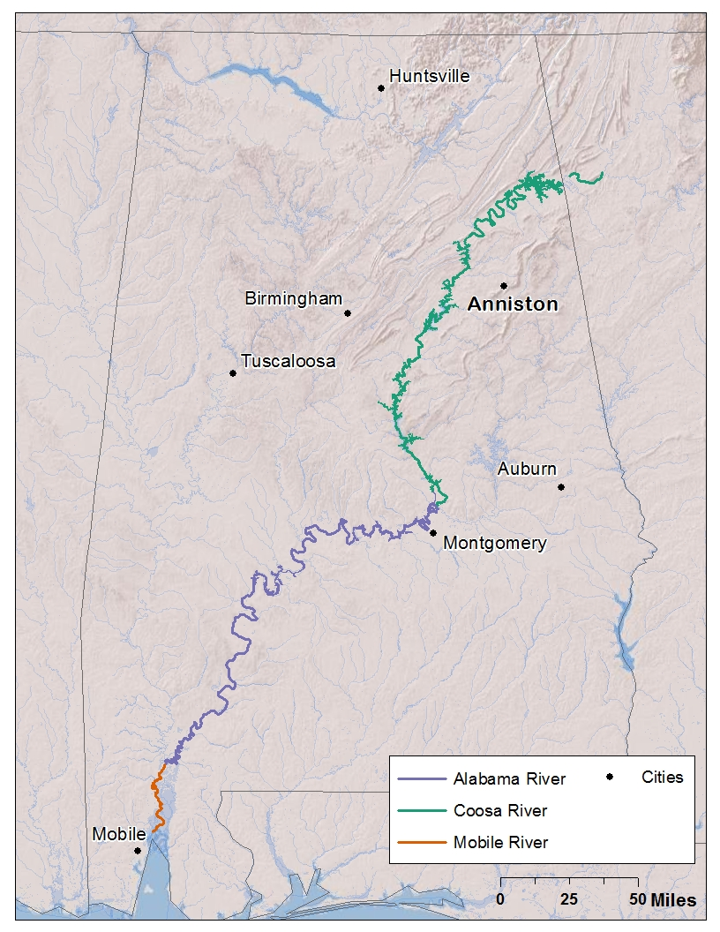

SECTION 4. LOGAN MARTIN LAKE, CHOCCOLOCCO CREEK, OR SNOW CREEK

MAP B – LOGAN MARTIN LAKE, CHOCCOLOCCO CREEK, OR SNOW CREEK

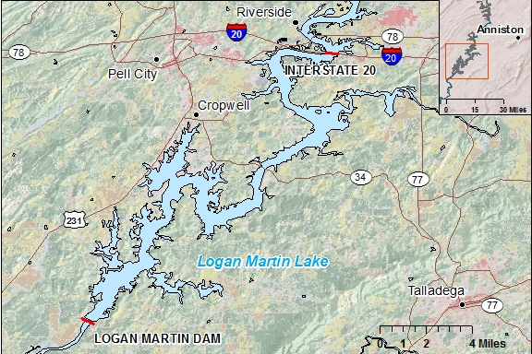

SECTION 4. PHYSICAL ACTIVITY OR EXERCISE

CARD I - PHYSICAL ACTIVITIES OR EXERCISE

0 1 Active Gaming Devices (Wii Fit, Dance Dance revolution)  0 2 Aerobics video or class  0 3 Backpacking  0 4 Badminton  0 5 Basketball  0 6 Bicycling machine exercise  0 7 Bicycling  0 8 Boating (Canoeing, rowing, kayaking, sailing for pleasure or camping)  0 9 Bowling  1 0 Boxing  1 1 Calisthenics  1 2 Canoeing/rowing in competition  1 3 Carpentry  1 4 Dancing-ballet, ballroom, Latin, hip hop, etc.  1 5 Elliptical/EFX machine exercise  1 6 Fishing from river bank or boat  1 7 Football (also see Touch Football)  1 8 Frisbee  1 9 Gardening (spading, weeding, digging, filling)  2 0 Golf (with motorized cart)  2 1 Golf (without motorized cart)  2 2 Handball  2 3 Hiking – cross-country  2 4 Hockey  2 5 Horseback riding  2 6 Hunting large game – deer, elk  2 7 Hunting small game – quail  2 8 Inline Skating  2 9 Jogging  3 0 Lacrosse  3 1 Mountain climbing  3 2 Mowing lawn  3 3 Paddleball  3 4 Painting/papering house | 3 5 Pilates  3 6 Racquetball  3 7 Raking lawn  3 8 Running  3 9 Rock climbing  4 0 Rope skipping  4 1 Rowing machine exercise  4 2 Rugby  4 3 Scuba diving  4 4 Skateboarding  4 5 Skating – ice or roller  4 6 Sledding, tobogganing  4 7 Snorkeling  4 8 Snow blowing  4 9 Snow shoveling by hand  5 0 Snow skiing  5 1 Snowshoeing  5 2 Soccer  5 3 Softball/Baseball  5 4 Squash  5 5 Stair climbing/Stair master  5 6 Stream fishing (e.g. in waders)  5 7 Surfing  5 8 Swimming  5 9 Swimming in laps  6 0 Table tennis  6 1 Tai Chi  6 2 Tennis  6 3 Touch football (also see Football)  6 4 Volleyball  6 5 Walking  6 6 Waterskiing  6 7 Weight lifting  6 8 Wrestling  6 9 Yoga  7 0 Other______

SECTION 4. WORK STATUS

CARD J. WORK STATUS

Employed for wages
Self-employed
Working without pay in a family business or farm
Out of work for less than 1 year
Out of work for more than 1 year
Homemaker
Student, not working
Retired
Unable to work

SECTION 4. WEIGHT CHANGE

CARD K. WEIGHT CHANGE IN PAST YEAR

GAIN NOW IS . . . |  | WEIGHT STAYED ABOUT THE SAME |  |  | LOSS NOW IS . . .
10% +  LARGE | 5-9.9%  MODEST | < 5% GAIN  BETWEEN | AND | < 5% LOSS  BETWEEN | 5-9.9%  MODEST | 10% +  LARGE
IF WEIGHT 1 YEAR AGO WAS . . . . |  |  | AND NOW IS | IF WEIGHT 1 YEAR AGO WAS . . . .
81 or less | 82-86 | 87 | 90 | 93 | 94-98 | 99 or more
86 or less | 87-90 | 91 | 95 | 99 | 100-103 | 104 or more
90 or less | 91-95 | 96 | 100 | 104 | 105-109 | 110 or more
94 or less | 95-100 | 101 | 105 | 109 | 110-115 | 116 or more
99 or less | 100-104 | 105 | 110 | 115 | 116-120 | 121 or more
104 or less | 105-109 | 110 | 115 | 120 | 121-125 | 126 or more
108 or less | 109-114 | 115 | 120 | 125 | 126-131 | 132 or more
112 or less | 113-119 | 120 | 125 | 130 | 131-138 | 138 or more
117 or less | 118-124 | 125 | 130 | 135 | 136-142 | 143 or more
122 or less | 123-128 | 129 | 135 | 141 | 142-147 | 148 or more
126 or less | 127-133 | 134 | 140 | 146 | 147-153 | 154 or more
130 or less | 131-138 | 139 | 145 | 151 | 152-159 | 160 or more
135 or less | 136-142 | 143 | 150 | 157 | 158-164 | 165 or more
140 or less | 141-147 | 148 | 155 | 162 | 163-169 | 170 or more
144 or less | 145-152 | 153 | 160 | 167 | 168-175 | 176 or more
148 or less | 149-157 | 158 | 165 | 172 | 173-181 | 182 or more
153 or less | 154-162 | 163 | 170 | 177 | 178-186 | 187 or more
158 or less | 159-166 | 167 | 175 | 183 | 184-191 | 192 or more
162 or less | 163-171 | 172 | 180 | 188 | 189-197 | 198 or more
166 or less | 167-176 | 177 | 185 | 193 | 194-203 | 204 or more
171 or less | 172-180 | 181 | 190 | 199 | 200-208 | 209 or more
176 or less | 177-185 | 186 | 195 | 204 | 205-213 | 214 or more
180 or less | 181-190 | 191 | 200 | 209 | 210-219 | 220 or more
184 or less | 185-195 | 196 | 205 | 214 | 215-225 | 226 or more
189 or less | 190-200 | 201 | 210 | 219 | 220-230 | 231 or more
194 or less | 195-204 | 205 | 215 | 225 | 226-235 | 236 or more
198 or less | 199-209 | 210 | 220 | 230 | 231-241 | 242 or more
202 or less | 203-214 | 215 | 225 | 235 | 236-247 | 248 or more
207 or less | 208-218 | 219 | 230 | 241 | 242-252 | 253 or more
212 or less | 213-223 | 224 | 235 | 246 | 247-257 | 258 or more
216 or less | 217-228 | 229 | 240 | 251 | 252-264 | 264 or more
220 or less | 221-233 | 234 | 245 | 256 | 257-269 | 270 or more
225 or less | 226-238 | 239 | 250 | 261 | 262-274 | 275 or more
230 or less | 230-242 | 243 | 255 | 267 | 268-279 | 280 or more
234 or less | 235-247 | 248 | 260 | 272 | 273-285 | 286 or more
238 or less | 239-252 | 253 | 265 | 277 | 278-291 | 292 or more
243 or less | 244-256 | 257 | 270 | 283 | 284-296 | 297 or more
248 or less | 249-261 | 262 | 275 | 288 | 289-301 | 302 or more
252 or less | 253-266 | 267 | 280 | 293 | 294-307 | 308 or more
256 or less | 257-271 | 272 | 285 | 298 | 299-313 | 314 or more
261 or less | 262-276 | 277 | 290 | 303 | 304-318 | 319 or more
266 or less | 267-280 | 281 | 295 | 309 | 310-323 | 324 or more
270 or less | 271-285 | 286 | 300 | 314 | 315-329 | 330 or more
274 or less | 275-290 | 291 | 305 | 319 | 320-335 | 336 or more
279 or less | 280-294 | 295 | 310 | 325 | 326-340 | 341 or more
284 or less | 285-299 | 300 | 315 | 330 | 331-345 | 346 or more
288 or less | 289-304 | 305 | 320 | 335 | 336-351 | 352 or more
- Identify current weight in blue column. Place ruler under the corresponding row of weights.
- Show row to participant. Ask for weight one year ago.
- Identify if weight loss, same weight, or weight gain from appropriate column heading.
- If loss or gain, identify if amount is large or moderate.

SECTION 5. ALCOHOL DRINKS

CARD L. ALCOHOL DRINKS

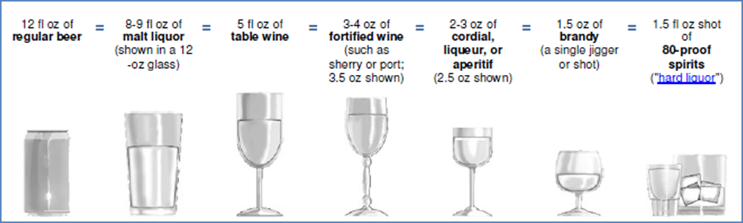
Source: http://rethinkingdrinking.niaaa.nih.gov/WhatCountsDrink/WhatsAstandardDrink.asp
Alternate: set up alcohol drink models as displayed above with appropriate measures of liquid to demonstrate drink servings.

SECTION 6. DIETARY SCREENER FOOD FREQUENCY

CARD M. HOW OFTEN EATEN

Never
Less than once per month
1 – 3 times per month
1 – 2 times per week
3 – 4 times per week
5 – 6 times per week

SECTION 6. MARGARINE USE

CARD N. MARGARINE USE

Didn’t use margarine
Almost never
About ¼ of the time
About ½ of the time
About ¾ of the time
Almost always or always

SECTION 6. FISH SERVING MODELS

DISPLAY FISH SERVING MODELS

Examples:
Shrimp (4 boiled)
Broiled perch (3-oz)
Pan-fried catfish (3-oz)
Canned tuna (¼ cup)
Poached salmon (3-oz)

Source: http://www.enasco.com/c/fcs/Nasco+Food+Replicas/Meat+%26+Protein/Seafood/

SECTION 6. FISH CLEANING METHODS

CARD O. FISH CLEANING METHODS

Source: http://www.adph.org/tox/assets/gethookedonhealth.pdf
SECTION 6. FISH COOKING METHODS

CARD P. FISH COOKING METHODS

Pan fried
Deep fried
Baked or broiled
Boiled or poached
Stew or chowder
Smoked
Grilled
Dried
Pickled
Raw

SECTION 6. PARTS OF FISH EATEN

CARD Q. FISH PARTS

Filet
Cheeks
Eggs
Skin
Liver

SECTION 6. PLACES FOR FISH

CARD R. PLACES FOR FISH

Bought at a store or market
Bought at a restaurant
Bought or caught at a farm
Wild caught

SECTION 6. RANK WHERE FISH CAME FROM

CARD S. RANK PLACES FOR FISH

Most often
Not most or least often, somewhere in between
Least often
Never

SECTION 6. TYPES OF FISH, BOUGHT OR FARMED

CARD T. TYPES OF FISH, BOUGHT OR FARMED

White fish (cod, pollock, whiting, haddock)
Catfish
Clams
Crab
Flounder and other flatfish
King mackerel
Oysters
Salmon steaks or filets
Salmon, canned
Shark
Shrimp
Swordfish
Tilefish
Tuna steaks or filets
Tuna, canned

SECTION 6. EAT FISH CAUGHT FROM ALABAMA WATERS

MAP C – COOSA, ALABAMA, MOBILE RIVER BASINS

SECTION 6. WEISS LAKE OF COOSA RIVER

MAP D – WEISS LAKE, ABOVE WEISS DAM

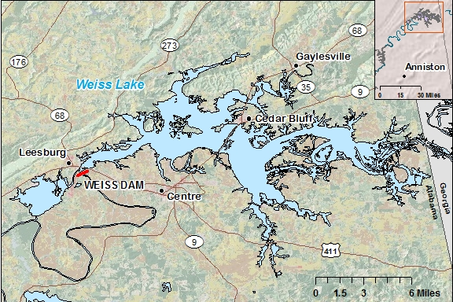

SECTION 6. H. NEELY HENRY LAKE OF COOSA RIVER

MAP E – H. NEELY HENRY LAKE, BETWEEN WEISS DAM AND H. NEELY HENRY DAM

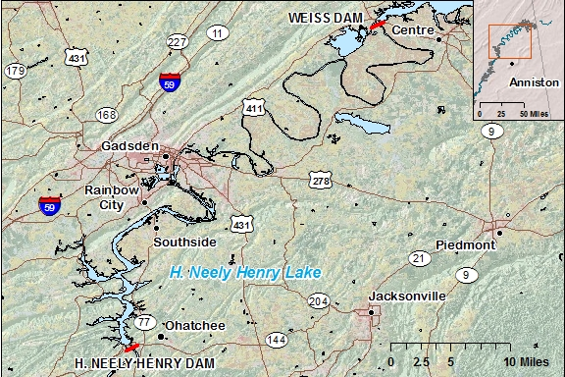

SECTION 6. LOGAN MARTIN LAKE OF COOSA RIVER

MAP F – LOGAN MARTIN LAKE, BETWEEN H. NEELY HENRY DAM AND INTERSTATE 20

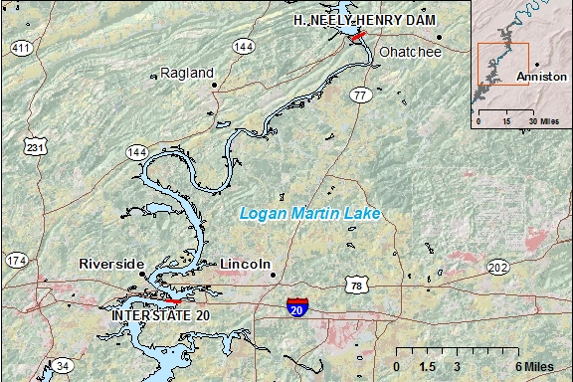

SECTION 6. LOGAN MARTIN LAKE BELOW INTERSTATE 20 OF COOSA RIVER

MAP G – LOGAN MARTIN LAKE, CHOCCOLOCCO CREEK, AND SNOW CREEK, BETWEEN INTERSTATE 20 AND LOGAN MARTIN DAM

SECTION 6. LAY LAKE OF COOSA RIVER

MAP H – LAY LAKE, BETWEEN LOGAN MARTIN DAM AND LAY DAM

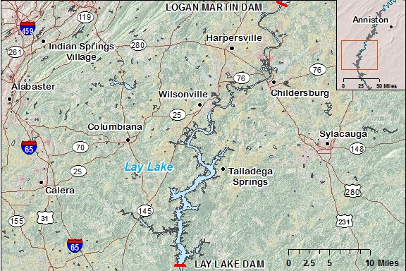

SECTION 6. WILD CAUGHT FISH

CARD U-1. ALABAMA FISH

LARGEMOUTH BASS  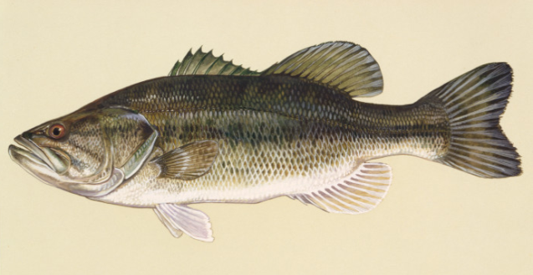 | STRIPED BASS  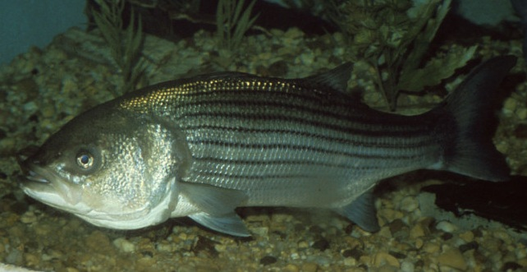
SMALLMOUTH BASS  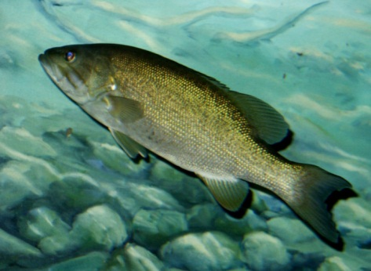 | CARP  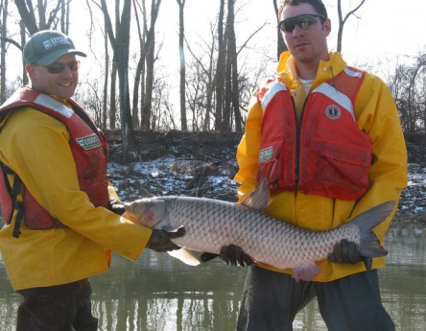
CHANNEL CATFISH  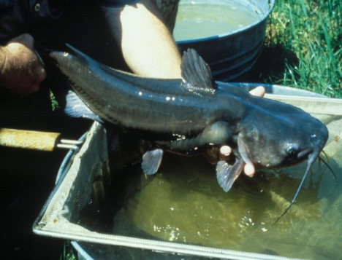 | FLATHEAD  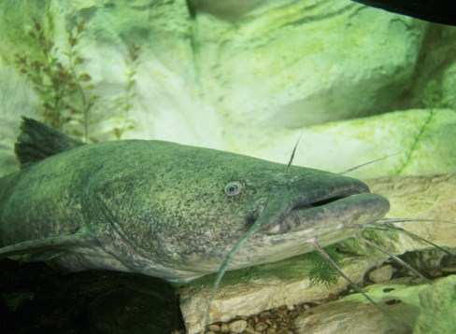
CRAPPIE (BLACK OR WHITE)  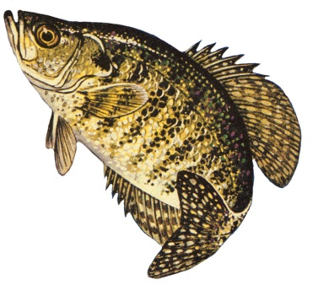 | BLUEGILL, BREAM, PANFISH  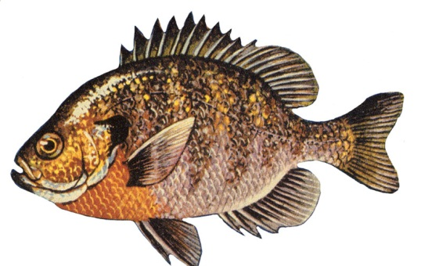
Image Source: U.S. Fish and Wildlife at http://digitalmedia.fws.gov/; NOAA, Great Lakes Environmental Research Laboratory at http://www.glerl.noaa.gov/pubs/photogallery/Fish/index.html

SECTION 6. WILD CAUGHT FISH

CARD U-2. ALABAMA FISH

WALLEYE (PERCH)  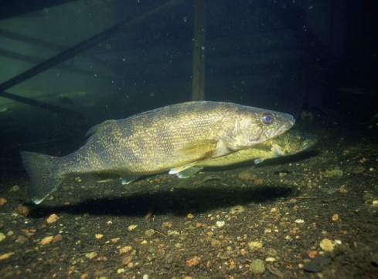 | YELLOW PERCH  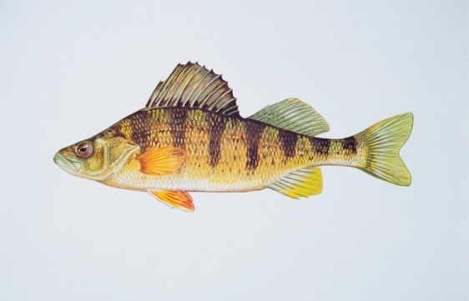
SAUGER (PERCH)  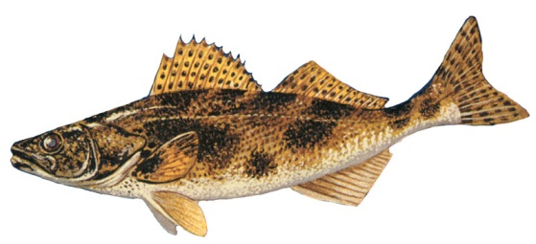 | SMALLMOUTH BUFFALO  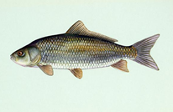
BIGMOUTH BUFFALO  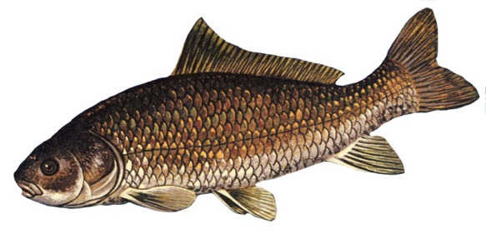 | REDHORSE (SUCKER)  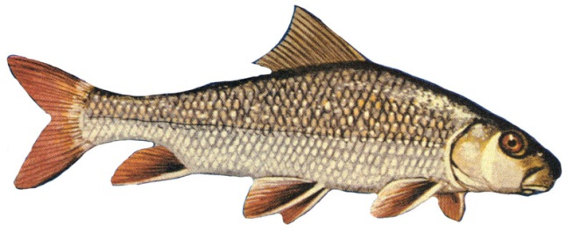
WHITE SUCKER  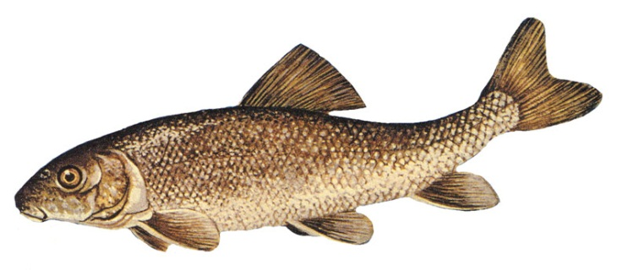 | FRESHWATER DRUM  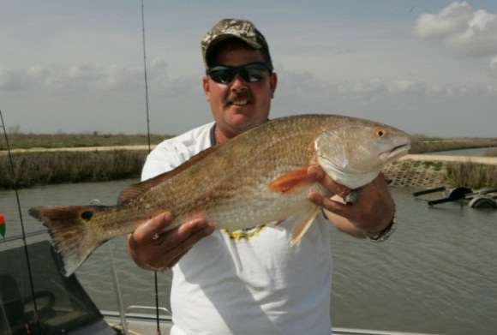
Image Source: U.S. Fish and Wildlife at http://digitalmedia.fws.gov/; NOAA, Great Lakes Environmental Research Laboratory at http://www.glerl.noaa.gov/pubs/photogallery/Fish/index.html

SECTION 6. WILD GAME

CARD V. WILD GAME

WOODCOCK  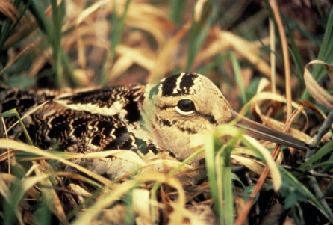 | DOVE  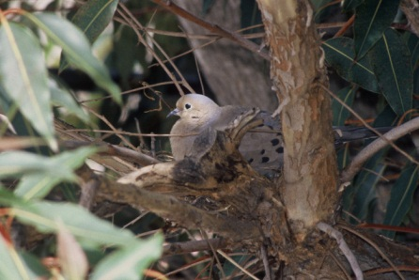
QUAIL  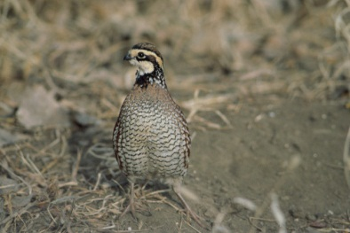 | WILD TURKEY  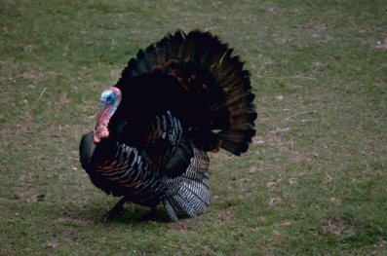
DUCK  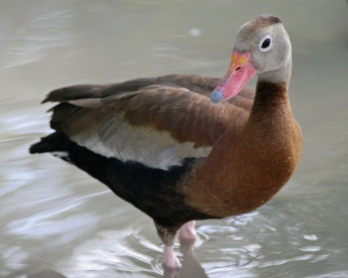 | GOOSE  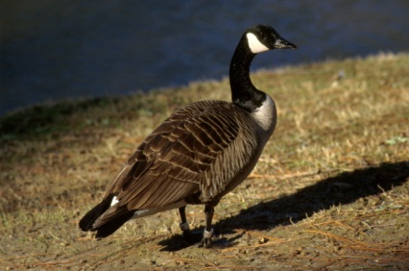
DEER  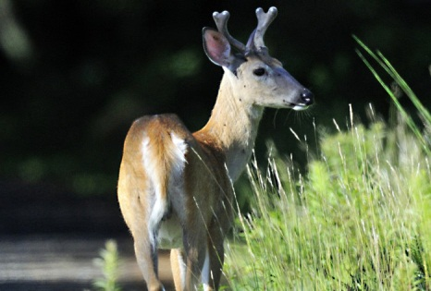 | WILD HOG  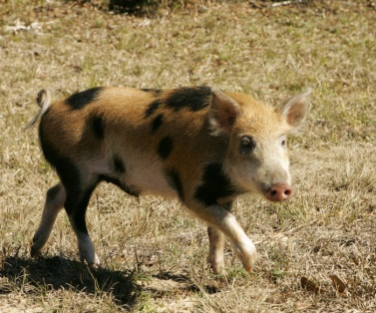
SQUIRREL  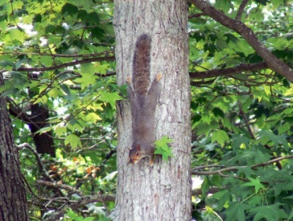 | RABBIT  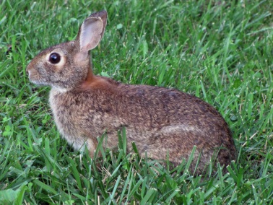
Image Source: U.S. Fish and Wildlife at http://digitalmedia.fws.gov/

SECTION 8. FEMALE PREGNANCY PROBLEMS

CARD W. FEMALE PREGNANCY PROBLEMS

Not ovulating
Blocked tubes
Problems with the egg not being fertilized
Problems with the fertilized egg implanting in the womb
Endometriosis
Man had fertility problems
Doctor did not find a reason

SECTION 9. MALE FERTILITY PROBLEMS

CARD X. MALE FERTILITY PROBLEMS

Woman had fertility problems
Problems with semen or sperm quality
Doctor did not find a reason

SECTION 11. TIME PERIOD WORKED AT MONSANTO OR SOLUTIA

CARD Y. TIME PERIOD WORKED

1971 and before
1972-1996
1997 to now

- 1971 and before - Monsanto produced PCBs

- 1972 and 1996 - Monsanto stopped making PCBs

- 1997 to now - Solutia became the facility owners.

SECTION 11. TYPE OF WORK AT MONSANTO OR SOLUTIA

CARD Z. TYPE OF WORK

Production of PCBs
Production of non-PCB chemicals
Maintenance
Other technical
Administrative
For the company but not at the Anniston site

SECTION 11. WORKPLACE CHEMICAL EXPOSURES

CARD AA. WORKPLACE EXPOSURES

Fertilizers
Pesticides
Herbicides
Solvents
Electrical transformers
Ionizing radiation
PCBs
Heavy metals
(lead, boron, manganese, mercury, or cadmium)
Welding fumes

SECTION 11. HOUSEHOLD INCOME

CARD AB. HOUSEHOLD INCOME

Less than $15,000
$15,000 - $34,999
$35,000 - $49,999
$50,000 or more

FORM C – CHILDREN’S HEALTH FORM PART 2 (NEW CHILDREN SINCE ACHS)

CARD C-1. HEALTH CONDITIONS

Cancer
Kidney disease
Heart problems
Hyperthyroidism (overactive)
Hypothyroidism (underactive)
Hearing problems
Learning disability
Attention deficit hyperactivity disorder
Asthma
Allergies
Epilepsy or seizures
Diabetes
Frequent ear infection
Mononucleosis or Epstein-Barr Virus
Juvenile arthritis
Other autoimmune disease

FORM C – CHILDREN’S HEALTH FORM PART 2 (NEW CHILDREN SINCE ACHS)

CARD C-2. OTHER AUTOIMMUNE DISEASE

Celiac Disease
Multiple Sclerosis
Psoriasis
Scleroderma
Systemic Lupus Erythematosis or Lupus
Other

FORM C – CHILDREN’S HEALTH FORM PART 3 (CHILDREN PREVIOUSLY REPORTED IN ACHS)

CARD C-3. HEALTH CONDITIONS

Cancer
Kidney disease
Heart problems
Hyperthyroidism (overactive)
Hypothyroidism (underactive)
Hearing problems
Learning disability
Attention deficit hyperactivity disorder
Asthma
Allergies
Epilepsy or seizures
Diabetes
Frequent ear infection
Mononucleosis or Epstein-Barr Virus
Juvenile arthritis
Other autoimmune disease

FORM C – CHILDREN’S HEALTH FORM PART 3 (CHILDREN PREVIOUSLY REPORTED IN ACHS)

CARD C-4. OTHER AUTOIMMUNE DISEASE

Celiac Disease
Multiple Sclerosis
Psoriasis
Scleroderma
Systemic Lupus Erythematosis or Lupus
Other

FORM F – FEMALE PREGNANCY FORM

CARD F-1. BIRTH CONTROL

None
Birth control pill, ring, implant, patch

Condom

Diaphragm

Intrauterine device (IUD)

Jelly or foam

Natural family planning

FORM F – FEMALE PREGNANCY FORM

CARD F-2. PREGNANCY OUTCOME

Abortion

Ectopic pregnancy

Miscarriage

Singleton

Stillbirth

Twins

Triplets or more

FORM L - LOCAL FOODS FORM

CARD L-1. EATING LOCAL FOODS

TIME PERIODS | HOW OFTEN
1971 and before  1972-1993  1994-2005  2006 to now | Less than once a year  A few times a year  Monthly  Weekly  Daily

- 1971 and before - PCBs were still produced here in Anniston.

- 1972 to 1993 - PCBs were no longer made, public awareness was low, and cleanup of the environment did not start.

- 1994-2005 - problems with PCB contamination became public, the health department issued fish advisories, and PCB litigation occurred.

- 2006 to now - the time period between the first Anniston survey and today.

FORM M – MALE FATHERING FORM

CARD M-1. BIRTH CONTROL

None
Birth control pill, ring, implant, patch
Condom
Diaphragm
Intrauterine device (IUD)
Jelly or foam
Natural family planning

FORM M – MALE FATHERING FORM

CARD M-2. PREGNANCY OUTCOME

Abortion
Ectopic pregnancy
Miscarriage
Singleton
Stillbirth
Twins
Triplets or more

