
Figure 1: Sender for all emails

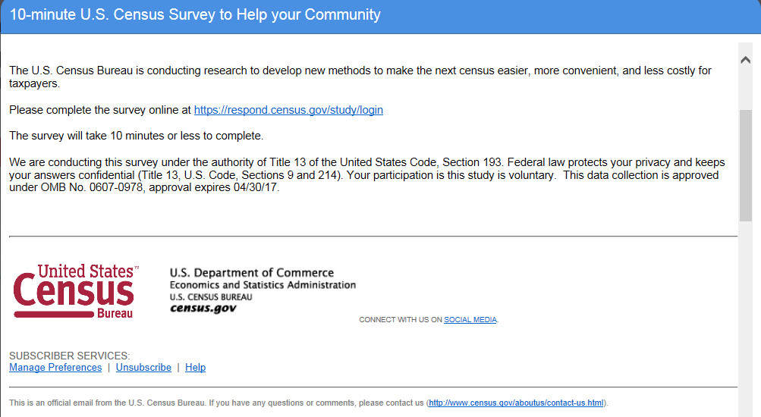
Figure 2: Panel 1: Text format/Short content

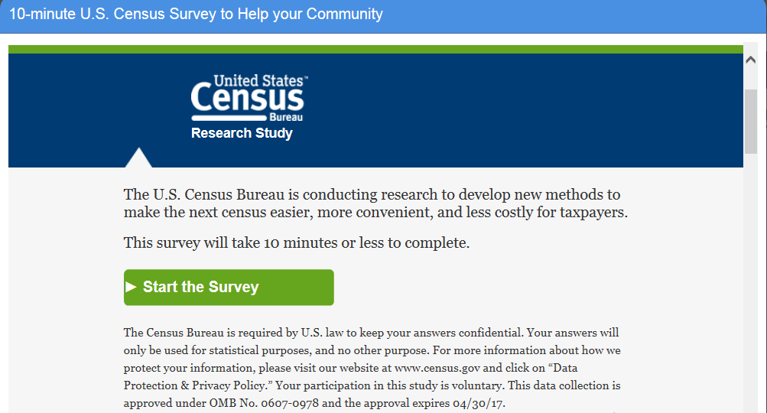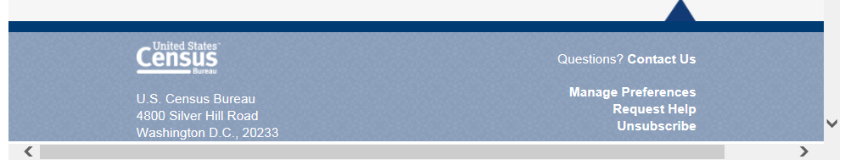
Figure 3: Panel 2: Graphical content/Short text
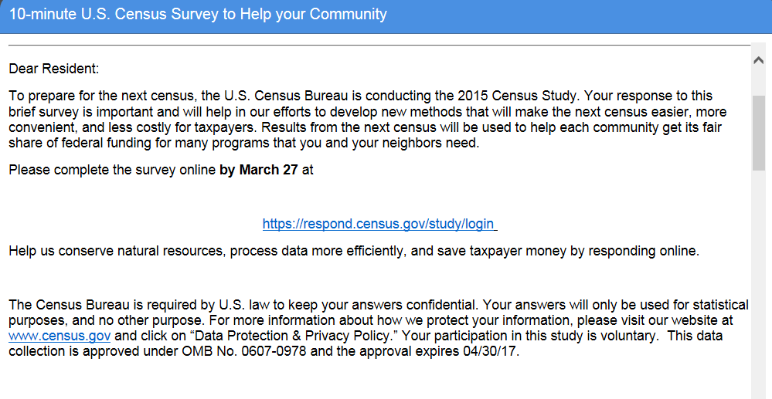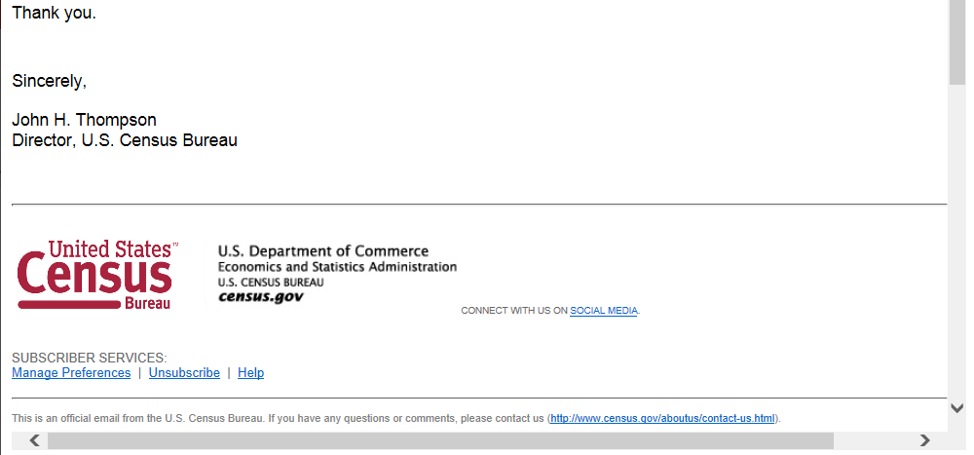
Figure 4: Panel 3: Text format/Long content (due date will change)

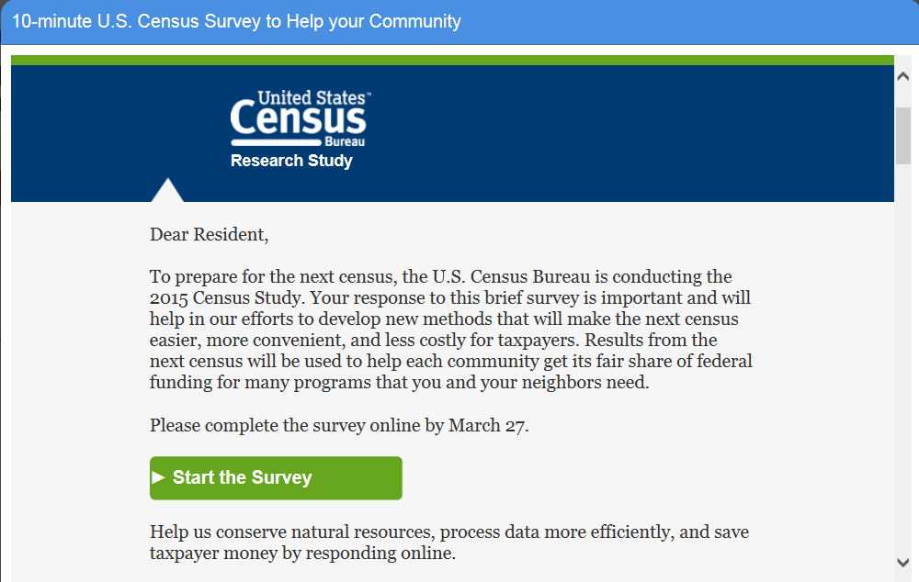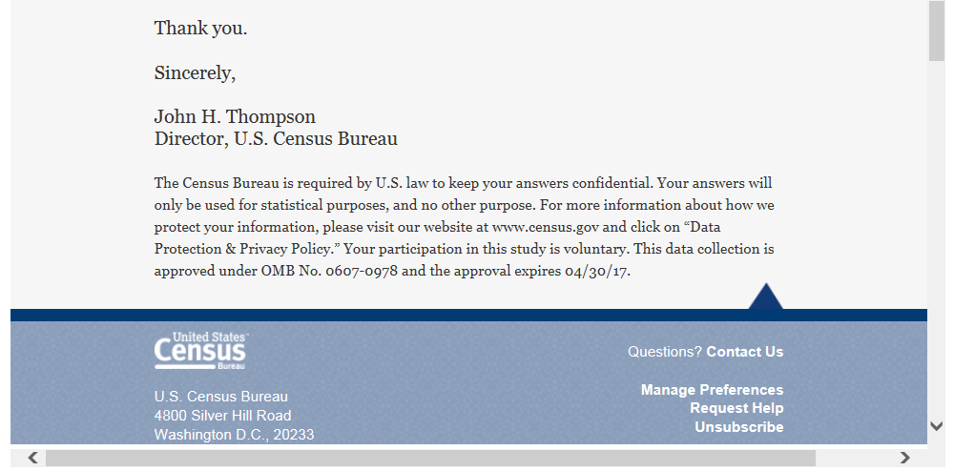
Figure 5: Panel 4 Graphical format/Long text (due date will change)

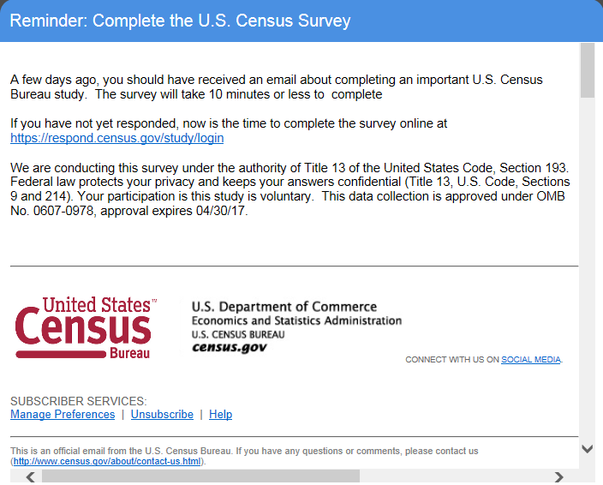
Figure 6: Panel 1: First reminder

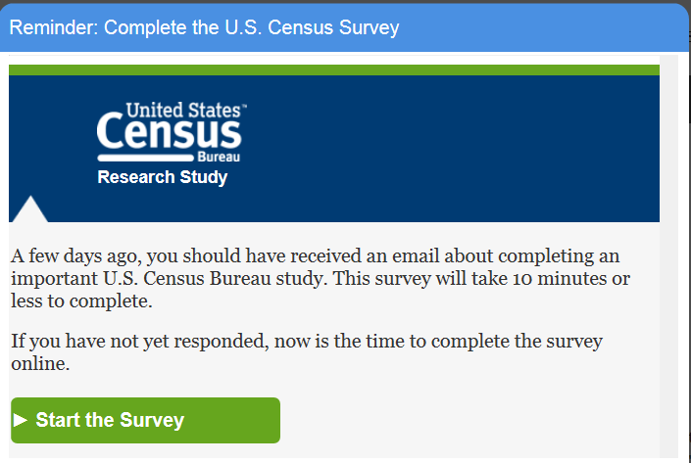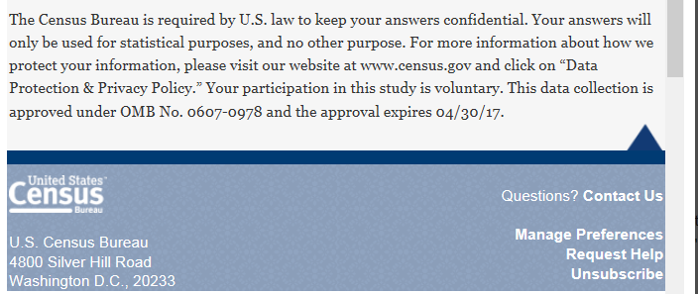
Figure 7: Panel 2 First reminder
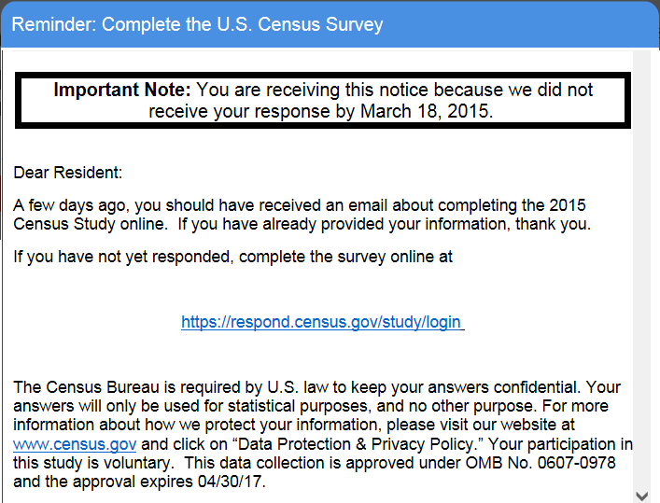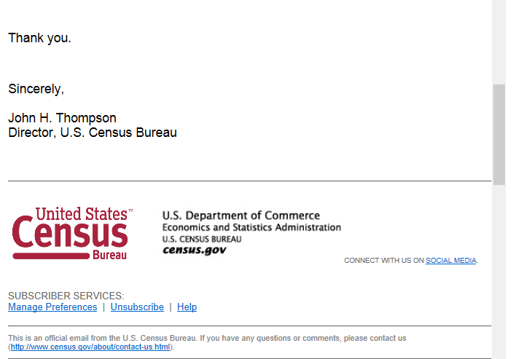
Figure 8: Panel 3: First reminder(due date will change)
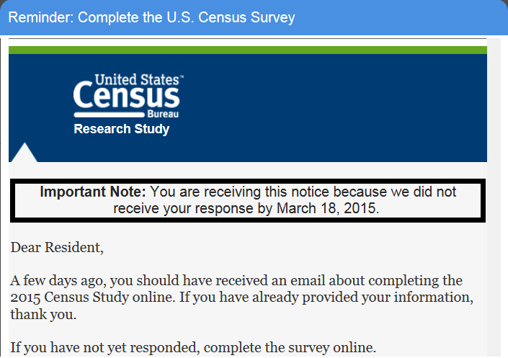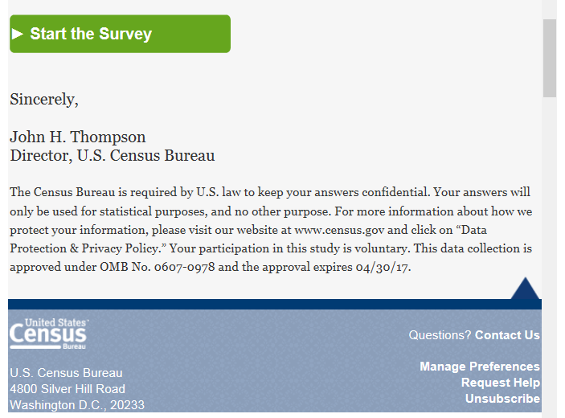
Figure 9: Panel 4 First reminder(due date will change)

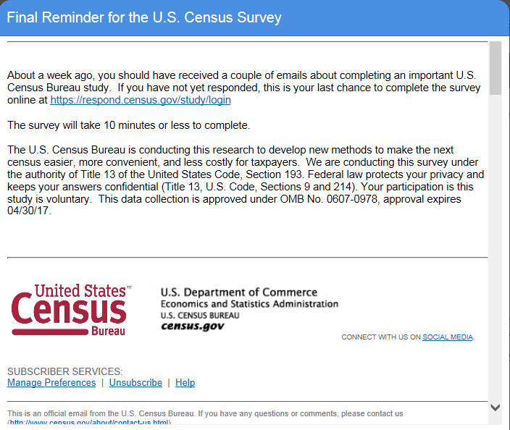
Figure 10: Panel 1 Final reminder

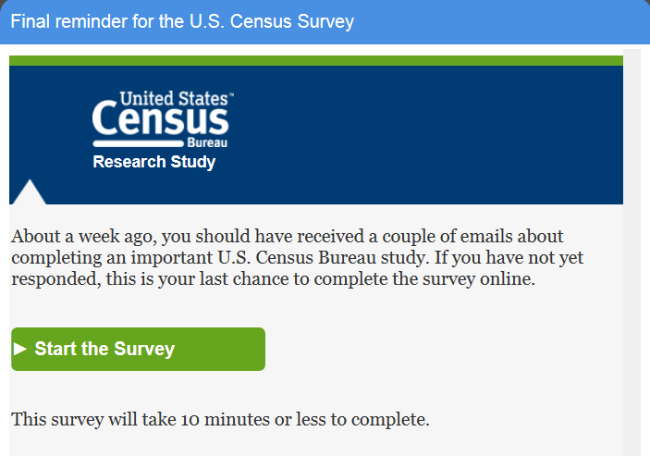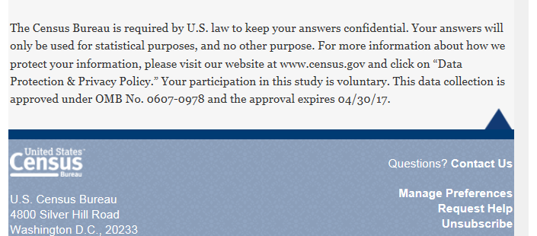
Figure 11: Panel 2 Final Reminder

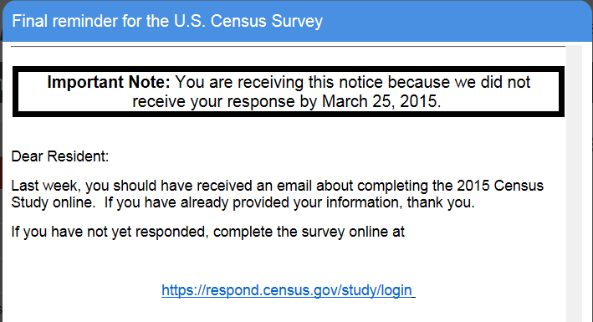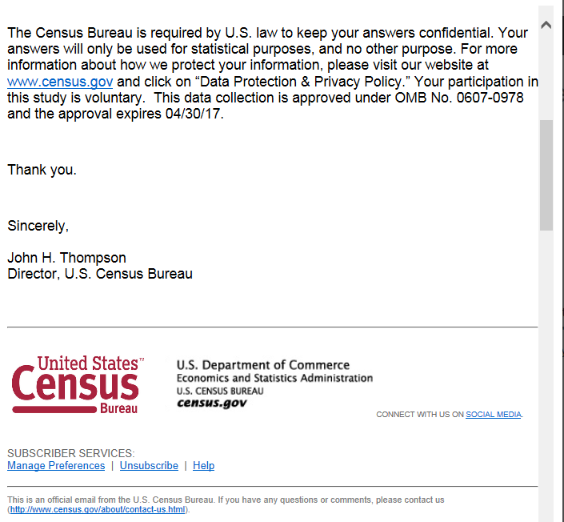
Figure 12: Panel 3 Final reminder(due date will change)

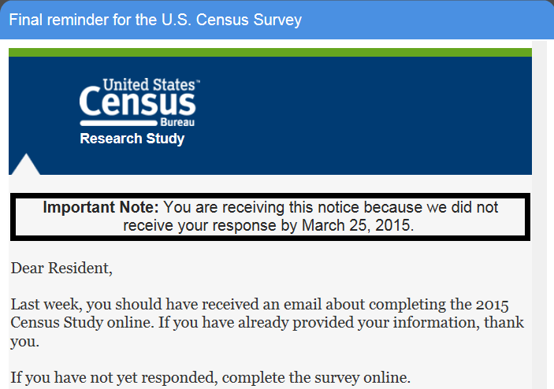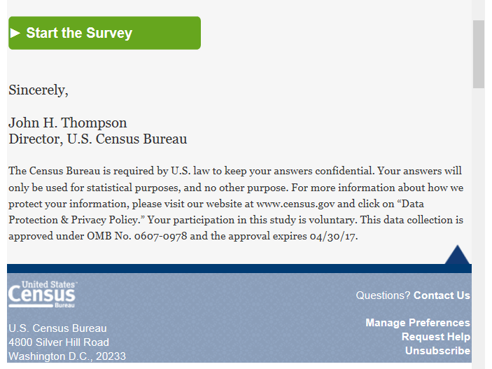
Figure 13: Panel 4 Final reminder(due date will change)
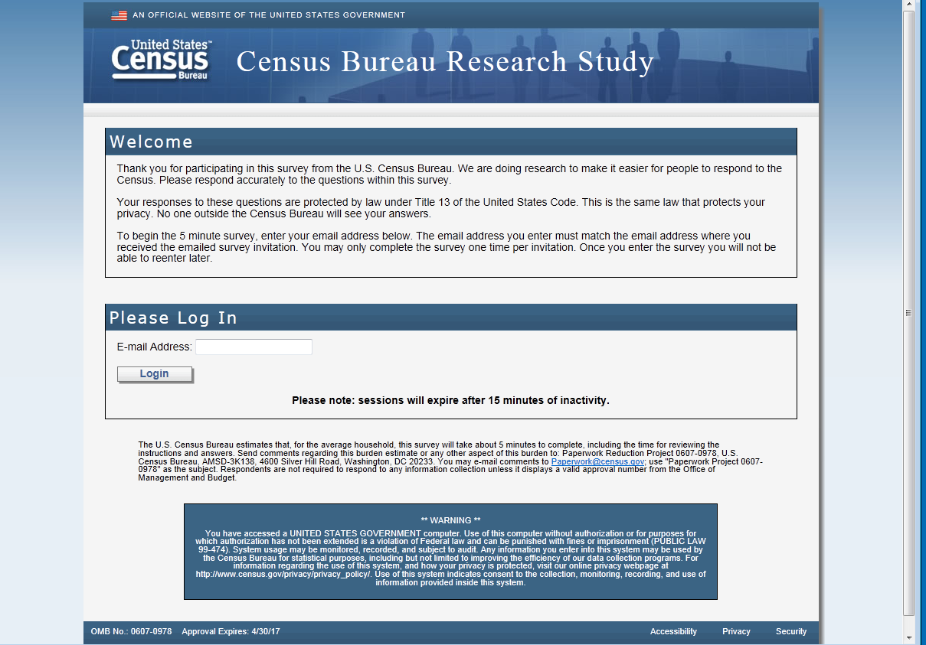
Figure 14: Login screen

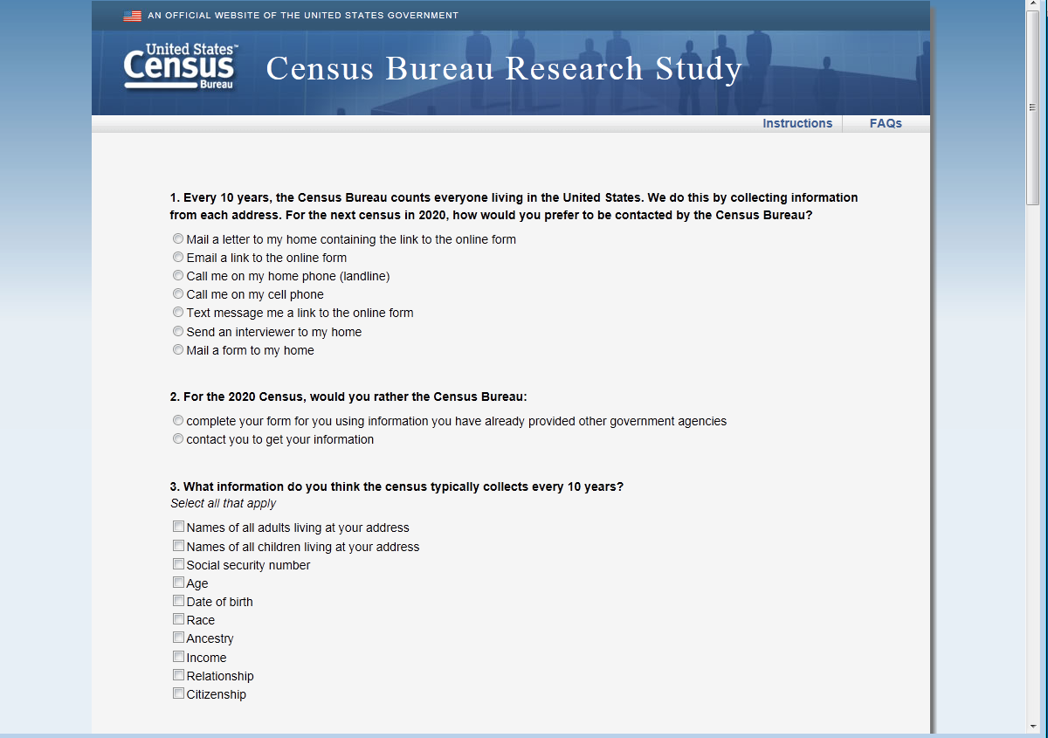
Figure 15: First set of questions, one long scroll design

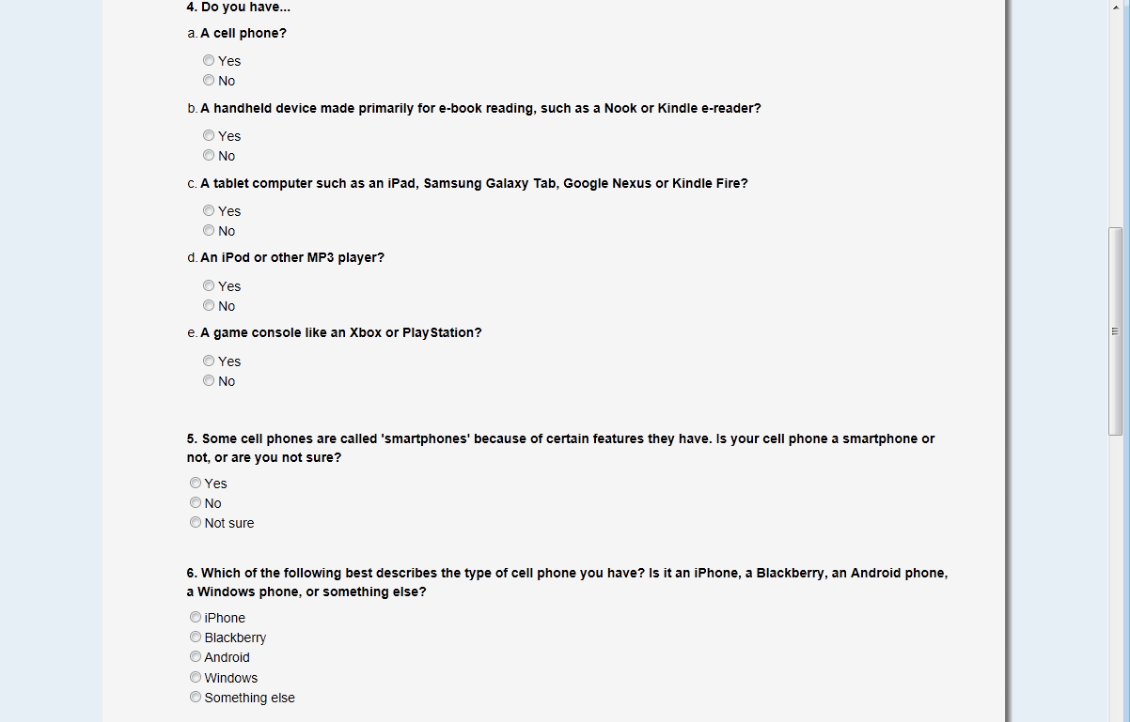
Figure 16: Continuation of first screen

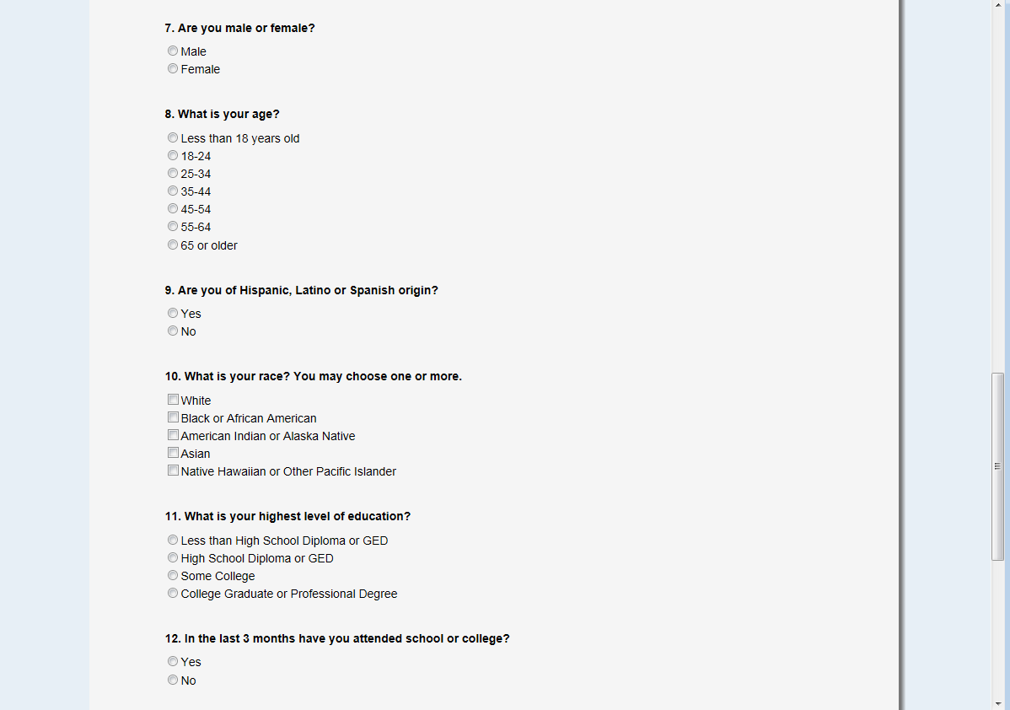
Figure 17: Continuation of first screen

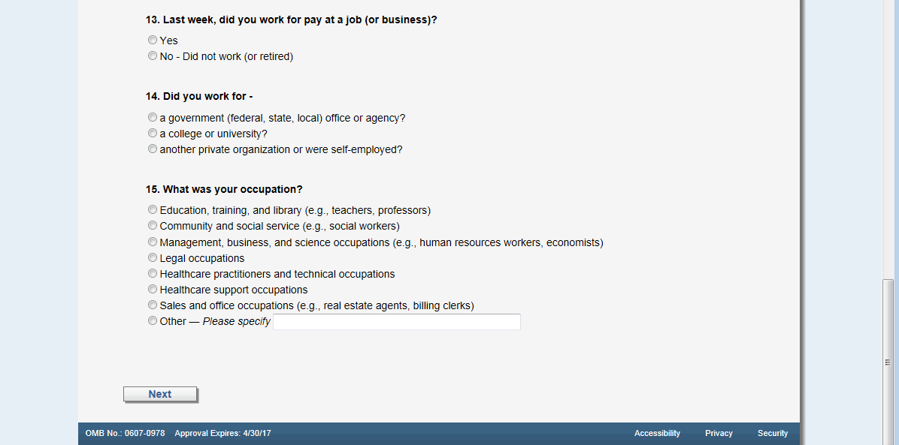
Figure 18: End of first screen

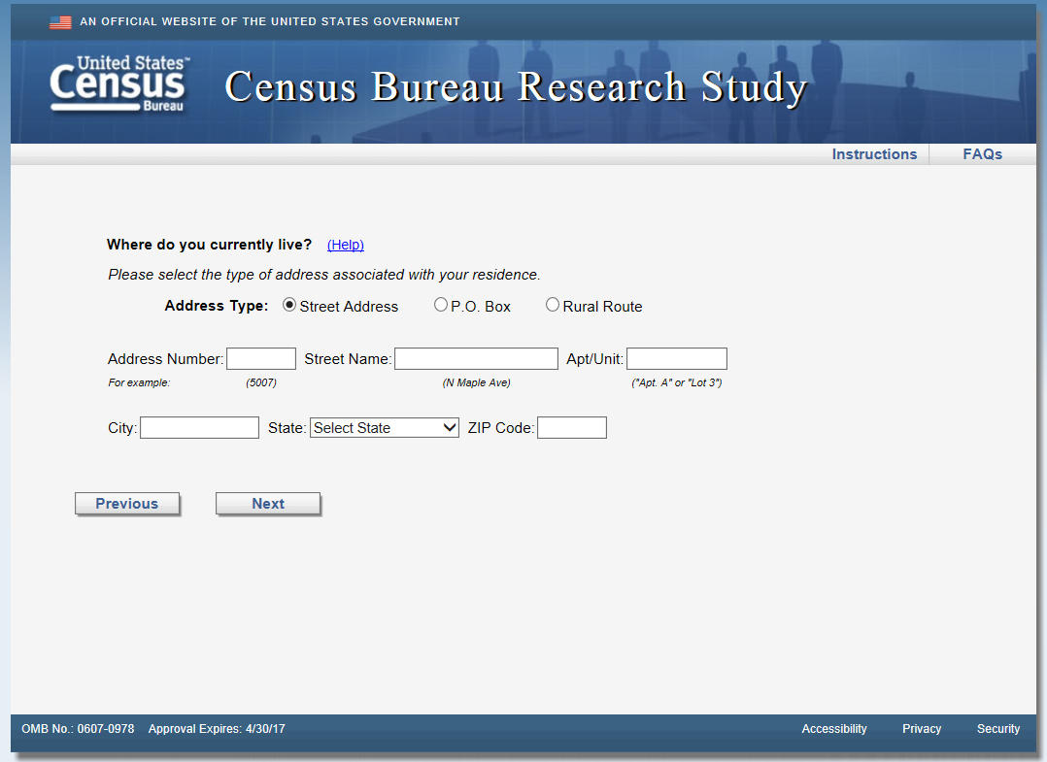
Figure 19: Default address screen

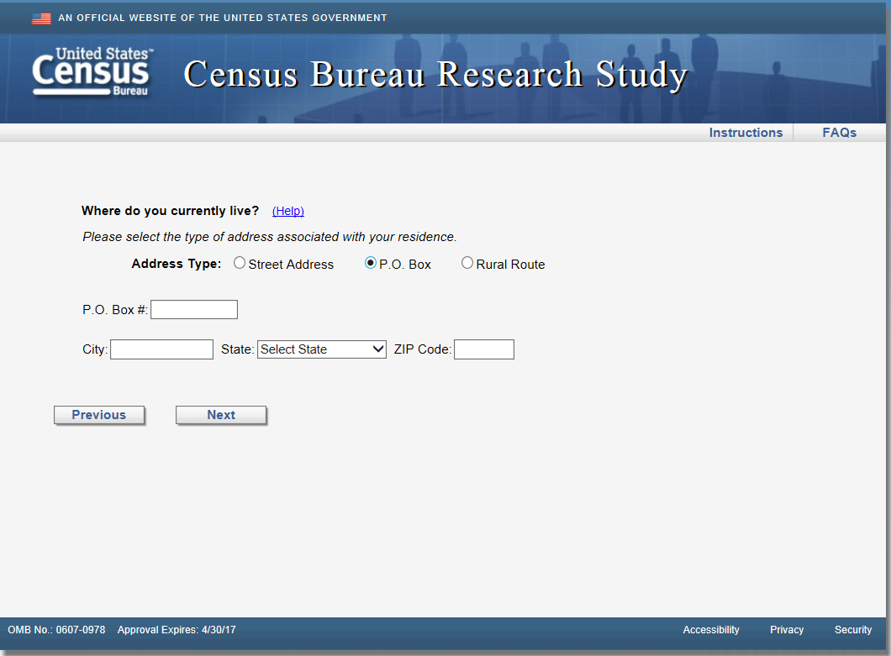
Figure 20: If respondent selects the P.O. Box radio button

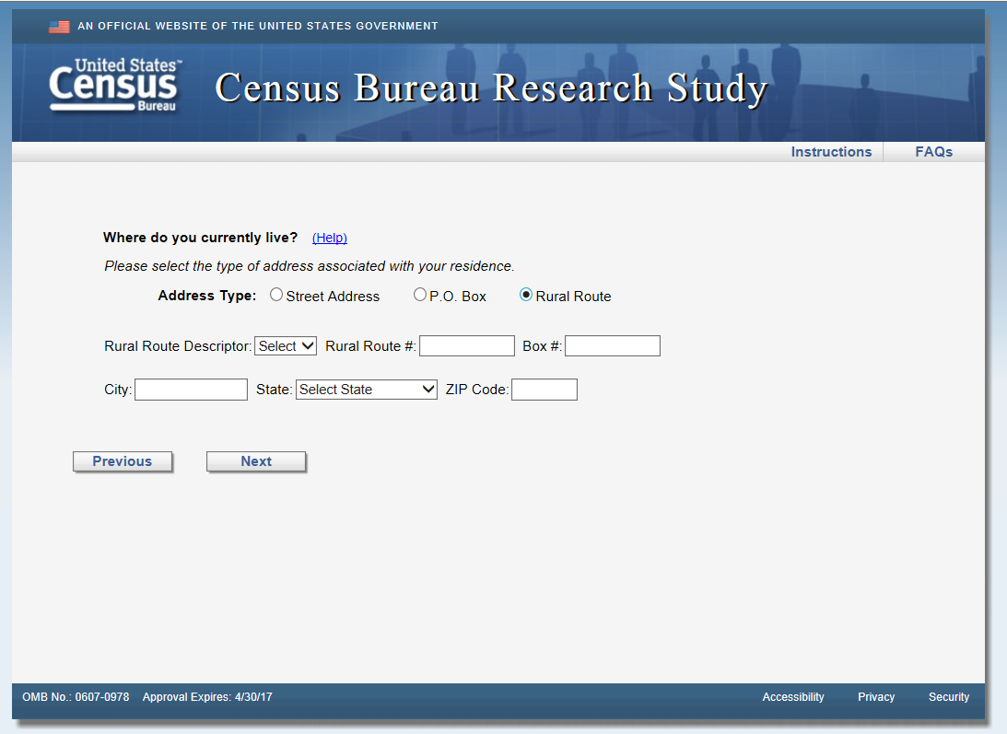
Figure 21: If respondent selects the Rural Route radio button

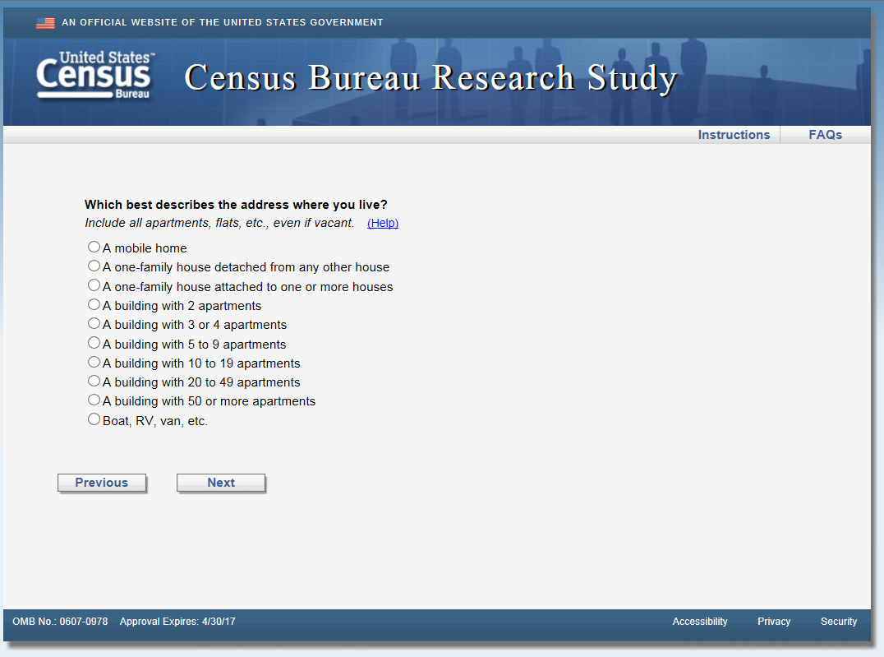
Figure 22: Type of unit screen, data are used for house/apartment/mobile home or unit fill in the question on the next screen
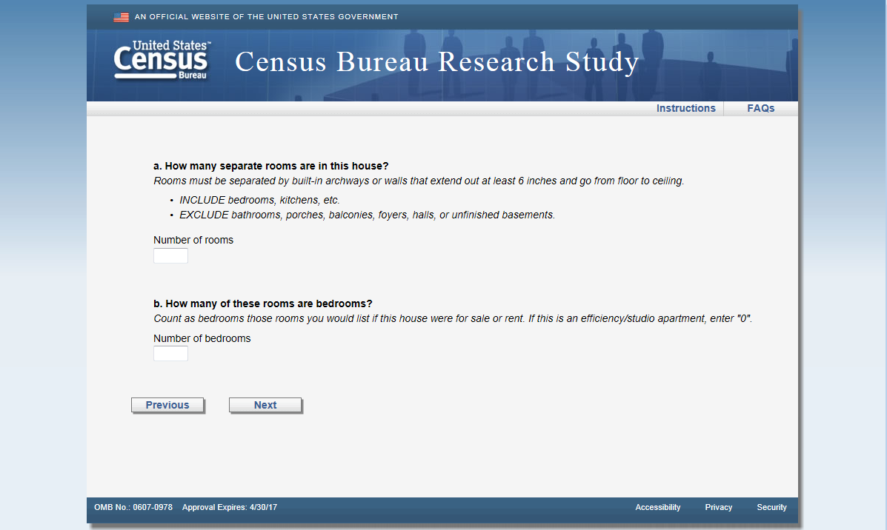
Figure 23: Number of rooms question: ACS design

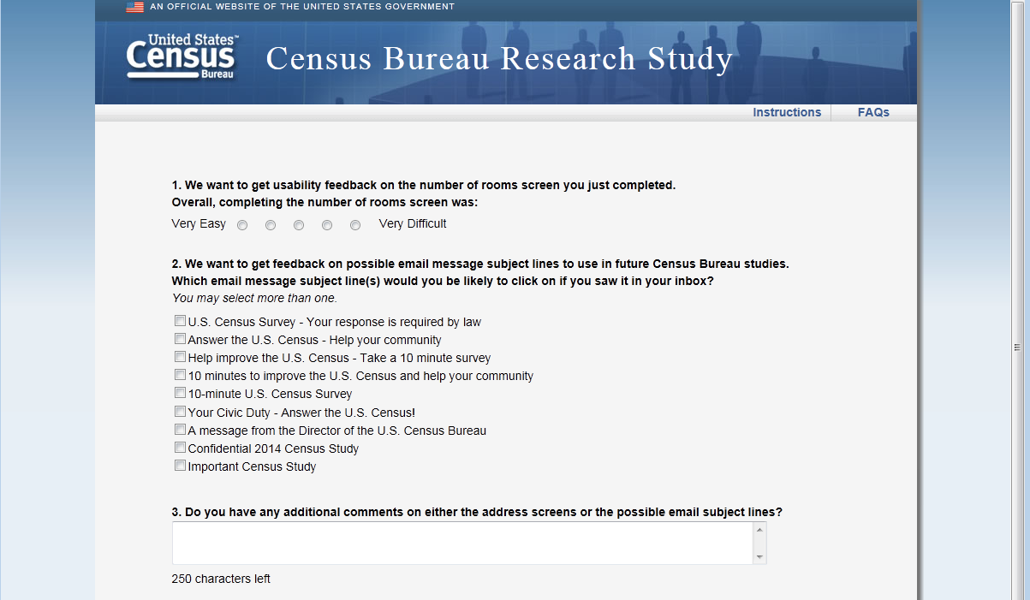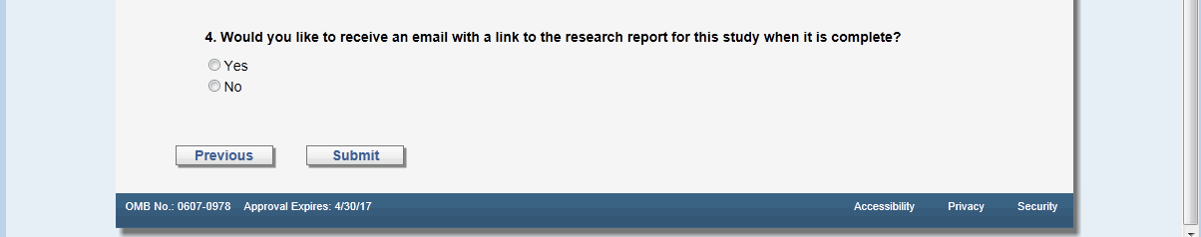
Figure 24: Usability page

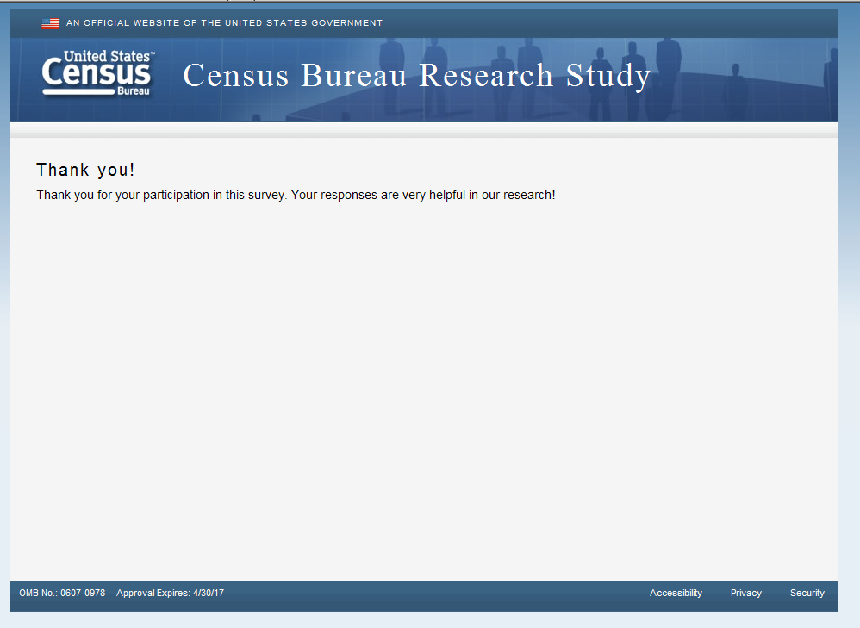
Figure 25: Thank you screen after submitting

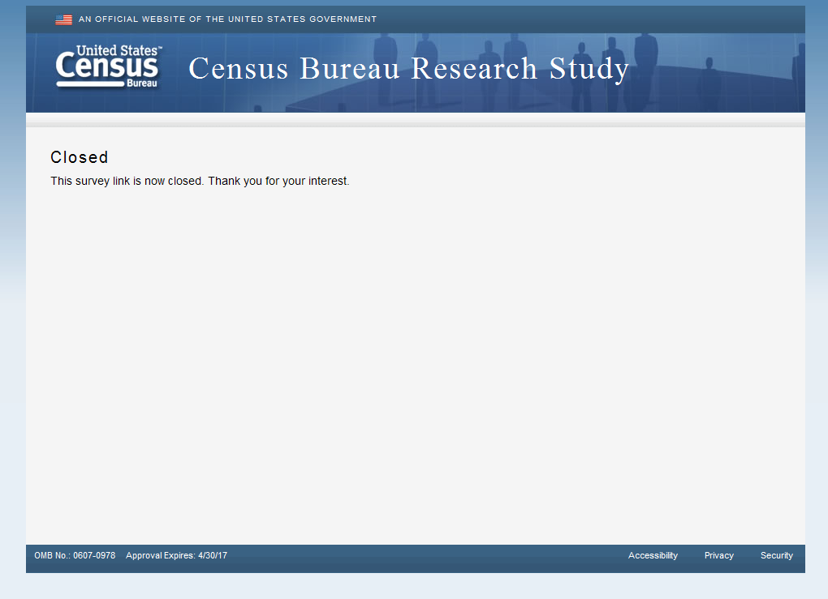
Figure 26: Screen when survey is closed out or when have previously entered survey

