Self Service
As of December 31, 2017, did this establishment offer a dedicated self-checkout lane for customers?

Yes
No
Question will be asked for 2017 NAICS: 444110, 445110, 445120, 446110, 452111, 452112, 452910, 452990

Pre-Ordering or Delivery Services
As of December 31, 2017, did this establishment offer pre-ordering or delivery services for customers?
Yes
No
Question will be asked for 2017 NAICS: 45110

Self Service

As of December 31, 2017, did this establishment use electronic devices for self-service table orders and/or payment (for example, through the use of a restaurant-provided electronic device at the table)?
Yes
No
Question will be asked for 2017 NAICS: 722410, 722511, 722513, 722514, and 722515

Retail Health Clinics
- Does this establishment operate or lease space for a retail clinic? {Y/N}

{The next questions to be asked only of establishments that have a clinic }

- What was the total revenue from patient-care services from this retail clinic? {round to nearest 000}

- Does this establishment offer any of the following patient care services?
Check all appropriate boxes
- Flu shots
- Immunizations other than flu shots, such as travel immunizations
- Other preventive health care services, including biometric screenings or lab tests
- Mild acute care, for example diagnosis and treatment of sore throats or minor skin conditions
- Chronic disease screening, monitoring, and/or management for conditions such as hypertension, diabetes, high cholesterol, or asthma
- Behavioral health screenings to help identify common mental health conditions
- Weight management programs
- Pharmacotherapy management program, which may include delivery of medications and consultation to hospital patients
- Information on health insurance options
- Other patient services - Describe {write-in box}

- Who operates the retail clinic?
Choose the best answer
-Operate own clinic
-Lease space to other business or health system that operates clinic
-Partner or jointly operate clinic with another business or health system

- Which of the following does the retail clinic use?
Check all that apply
- Electronic health records
- ePrescribing
- Telemedicine
- Mobile coaching applications
- Interactive patient-interview software

- What was the number of retail-clinic employees for the pay period including March 12, 2017?

- What was the number of employees by occupation for the following types of employees for the pay period including March 12, 2017? The total should equal the number reported in {6}.
- Nurse practitioner
- Physicians’ assistant
- Pharmacists
- Primary care physicians
- All other health practitioners
- All other employees
- TOTAL (Sum of lines 1-6 should equal {6})
Question will be asked for 2017 NAICS: 452111; 45211210; 45211220; 452210; 45291010; 45291020; 445110; 445120; 445210; 445220; 445230; 445291; 445310; 446110; 446120; 446191; 446199

Split between “Machinery and Equipment” and “Buildings and Other Structures”
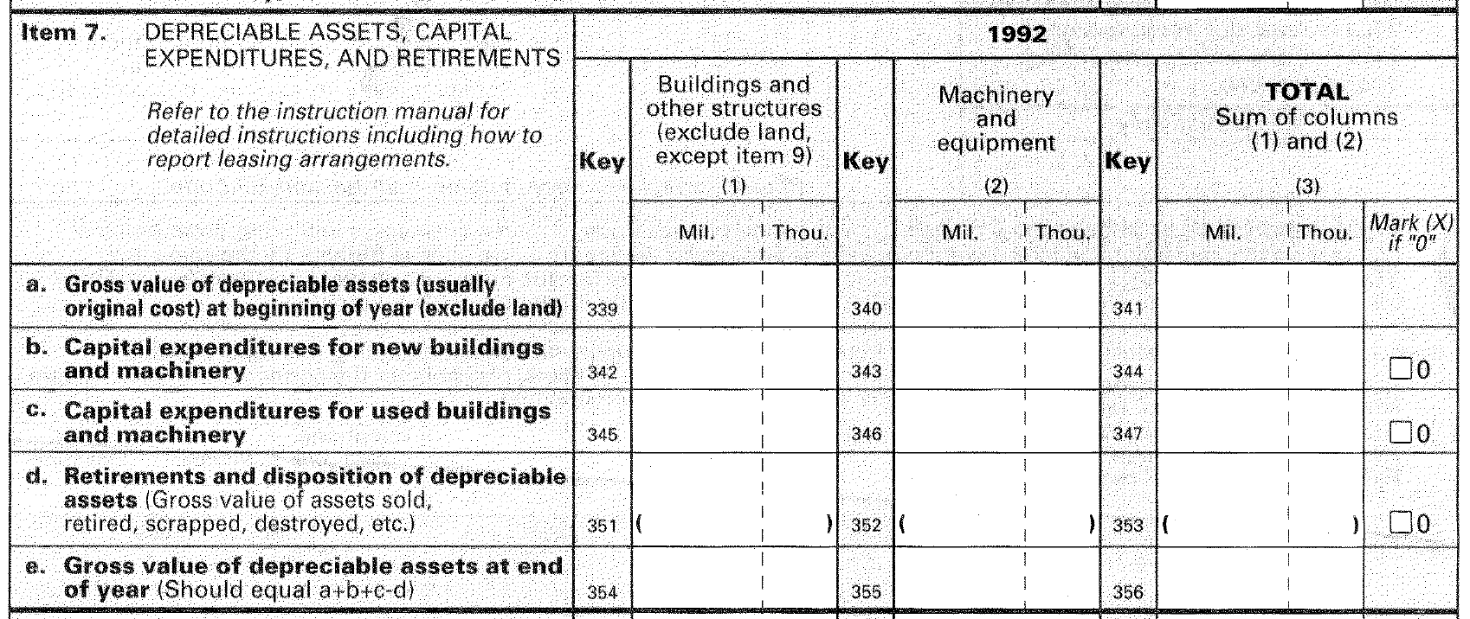
Question will be asked for NAICS: All manufacturing (31-33)

Water Use
As is standard, offer a Mark ‘X’ if None option for the two quantity questions.

1. What was this establishment’s water intake in 2017, that is, the quantity of new water introduced into the establishment for the first time, regardless of source or quality?
Include water used in the production process and auxiliary operations (such as cooling and condensing, boiler feed, sanitary and domestic use).

_ , _ _ _ , _ _ _ ,000,000 gallons

2. What was this establishment’s gross water use in 2017, that is, the quantity of water that would have been required if no water had been recirculated or reused?

For example, if total water intake was 500 million gallons and, of these 500 million gallons, 100 million gallons were used twice for cooling purposes and once for washing products or materials, the total water required would be 300 million gallons, plus the 400 million gallons not recirculated, for a total of 700 million gallons of gross water use (less consumption and evaporation loss).

_ , _ _ _ , _ _ _ ,000,000 gallons

3. What was this establishment’s main source of new water in 2017? (Mark only one.)
□ Public water system (publicly- or privately-owned utility, whose primary purpose is the supply of water to the general public and/or industrial users)
□ Self-supplied water system (e.g., through its own system of pumps, pipes, hoses, etc.)
□ Another source that is not primarily a water utility (i.e., a joint water supply system)
□ Other sources (may include rainwater and truck deliveries)

.

4. (If checked public water system) Which of the following was this establishment’s public water system? (Mark only one.)
□ Potable
□ Reclaimed wastewater

5. (If checked self-supplied water system) Which of the following was the source of this establishment’s self-supplied water system? (Mark only one.)
□ Rivers, streams, lakes, etc.
□ Wells, deep springs, etc.
□ Estuaries, bays, oceans, etc.
□ Mine water (e.g., underground mines, quarries, open pits, or other surface mining operations)
□ Water produced with oil
□ Other (Please specify: ____________________________ )

Question will be asked for NAICS: 333110, 325199, 325193, 322121, 324110, 325180, 322130, 211111, 3221110, 325312, 325110, 325312, 325110, 211112, 322122, 212234, 212321, 325311, 325130, 311611, 311411, 311421, 311615, 213111, 311314, 325211, 331313, 327310, 32520, 311221, 325998, 331511, 212392, 321113, 312120, 325194, 212210, 212312, 212322, 331315, 212112, 322299, 331210, 326199, 311224, 325320, 321912, 212111, 311511, 311422, 325220, 325212, 325411

Break out of Percentage of Receipts for Wired Telecommunications Carriers
Of this establishment’s total receipts ($x, fill from earlier question), what percent was from each of the following?  Broadband internet access from “bundled” services |  |  |  |  | %
Broadband internet access from “unbundled” or “stand alone” services |  |  |  |  | %
 |  |  |  | 100 | %
Of this establishment’s total receipts ($x, fill from earlier question), what percent was from each of the following?

Internet telephone services from “bundled” services |  |  |  |  | %
Internet telephone services from “unbundled” or “stand alone” services |  |  |  |  | %
 |  |  |  | 100 | %
Of this establishment’s total receipts ($x, fill from earlier question), what percent was from each of the following?

Multichannel programming distribution services from “bundled” services. |  |  |  |  | %
Multichannel programming distribution services from “unbundled” or “stand alone” services. |  |  |  |  | %
 |  |  |  | 100 | %
Question will be asked for NAICS: 51711010; 51711020; 51711030; 51721010; 51721020

Cloud Computing from the Distribution of Software on Physical Mediums
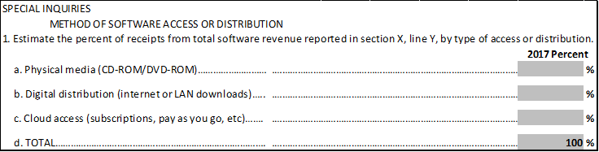
Of this establishment’s 2017 total software revenue ($x, fill from earlier question), what percent was from each of the following?
2017 Percent
- Physical media (e.g., CD-ROM, DVD-ROM, etc.) %
- Digital distribution (e.g., Internet, LAN downloads, etc.) %
- Cloud access (e.g. subscriptions, pay as you go, etc.) %
- TOTAL 100%

Question will be asked for NAICS: 511210

Property Type

Question | Which of the following best describes this establishment?  Limited-service facility - hotels and motels that provide lodging but very few additional services or amenities. These hotels and motels do not earn revenues from food and beverage services (such as operating a restaurant on-site or providing catering services). A hotel/motel which earns no food and beverage revenues but offers a free continental breakfast should still be considered a limited-service hotel.  Full-service facility - hotels and motels that offer food and beverage services, lounge facilities, and meeting spaces. These hotels and motels typically also offer bell service and room service.  Luxury facility - hotels that offer all the services of a full-service hotel as well as additional services, which may include 24-hour room service, upscale restaurants managed in-house, and concierge services.
Responses to Question | Limited-service facility  Full-service facility  Luxury facility

Question will be asked for NAICS: 721110, 721120, 721191, 721199

Multiple Investors/Joint Ventures
- Does this location have other multiple investors?
Yes – go to B
No – go to next question

- List all investors

Name of company Address Percentage of investment

Question will be asked for NAICS: 211111

