Attachment I: ACS Respondent Burden Testing Protocol, Group2, Version 2, Internet

Introduction
Hello, my name is ______________ and I work here at Westat. Thank you for taking the time to participate in this research study.

Westat is working to develop new questions for the American Community Survey, which is sponsored by the U.S. Census Bureau. Before surveys are conducted, it’s important to try out questions with the help of people such as yourself. The survey asks questions about you and your household.

It is important that the questions make sense, are easy to answer, and that everyone understands the questions the same way. If you agree to take part in this study, I will hand you the questions to answer as if you were filling them out on a Web survey. Afterwards, I will ask you some questions about the answers you gave. There are no right or wrong answers. Our purpose is not to compile information about you. Instead, your interview along with those of others will show us how to improve these questions for a later survey.

Informed Consent
Before we get started, there are a few things I should mention. This is a research project, and your participation is voluntary. If you prefer not to answer any questions just say so, and you can go on to the next one. It’s also okay if you change your mind after starting and would rather not participate.
All your answers, everything you say, will be kept confidential. We will not use your name in any reports. The interview will take about 40 minutes and you will receive $40. We will also need to audio record our conversation. This helps me so I can listen to what you are saying and won’t have to take a lot of detailed notes while you are talking; it will also help when we write up a summary of this interview. Only project staff will have access to the recording and other project materials, and those materials will be stored according to Title 13 requirements for protecting the identity of individual respondents. {Finally, some of the researchers developing the questions are here today observing our interview to learn if there are things that might need to be changed.}

HAND CONSENT FORMS TO RESPONDENT, This form contains all of the things I just told you about your rights in this interview. Please read it over and sign both copies if you are willing to take part in the study.

HAVE R SIGN TWO CONSENT FORMS, KEEP ONE AND GIVE ONE TO RESPONDENT.

TURN ON RECORDER. The date and time is ____________. Now that the recorder is running, let me ask again, is it okay with you if we record this interview?

Protocol
In a moment, I am going to ask you some questions about your household and then will hand you some questions to answer yourself. I’d like you to answer these questions as you would if you were filling them out in a Web survey. I am going to observe as you answer the questions and will hand you extra pages based on how you answer some of the questions. Also, you will notice that some questions ask about “this building,” which refers to your home, not the building we are sitting in today.
After you have finished answering the questions, we will talk about some of the answers you gave. Before we begin, do you have any questions about the process?

ADMINISTER HOUSEHOLD ROSTER. THEN STOP TO ASK P2 SELECTION QUESTION.

P2 Selection Question

IF FOLDER INDICATES A HH MBR WAS NATURALIZED:
When we recruited you, you indicated someone else in the HH came to live in the US at a different time than you. Thinking about the list of people in your household we just made, which person is that? (IF MORE THAN ONE, SELECT THE FIRST-ELIGIBLE PERSON LISTED ON THE ROSTER AND WRITE NAME BELOW)

IF FOLDER DOES NOT INDICATE A HH MBR WAS NATURALIZED:
Is there anyone (else) in this household age 15 or older who was not born a U.S. citizen?

YES - SELECT THE NEXT PERSON FROM THE ROSTER WHO WAS NOT BORN A US CITIZEN AND FOLLOW FLOWCHART BELOW
NO - GO TO COGNITIVE PROBES

FIRST NAME OF P2: _______________

NEXT, ADMINISTER PERSON 1 ITEMS BY HANDING INET_G1_Packet 1, THEN ASKING REMAINDER OF QUESTIONS ACCORDING TO P1 TABLE BELOW.

P1 Table of Instructions
P1 Question | Answer | Roster Q4a Year | Instruction
Q7 | Born in US |  | Go to P2 Selection Question on Page 5 of Protocol
Q7 | Born outside US |  | INET_G2_Packet 2
Q8 | US parents, US territory, or non-citizen | 1984 or earlier | INET_G2_V2_Packet 4a
Q8 | US parents, US territory, or non-citizen | 1985-1996 | INET_G2_V2_Packet 4b
Q8 | US parents, US territory, or non-citizen | 1997-2004 | INET_G2_V2_Packet 4c
Q8 | Citizen by naturalization | 1984 or earlier | INET_G2_V2_Packet 3a
Q8 | Citizen by naturalization | 1985-1996 | INET_G2_V2_Packet 3b
Q8 | Citizen by naturalization | 1997-2004 | INET_G2_V2_Packet 3c

IF YOU NEED TO ADMINISTER P2 QUESTIONS, HAND INET_G2_Packet 5 TO RESPONDENT, AND THEN FOLLOW THE P2 TABLE.

P2 Table of Instructions
P2 Question | Answer | Roster Q4a Year | Instruction
Q7 | Born in US |  | Go to Probes
Q7 | Born outside US |  | INET_G2_Packet 6
Q8 | US parents, US territory, or non-citizen | 1984 or earlier | INET_G2_V2_Packet 8a
Q8 | US parents, US territory, or non-citizen | 1985-1996 | INET_G2_V2_Packet 8b
Q8 | US parents, US territory, or non-citizen | 1997-2004 | INET_G2_V2_Packet 8c
Q8 | Citizen by naturalization | 1984 or earlier | INET_G2_V2_Packet 7a
Q8 | Citizen by naturalization | 1985-1996 | INET_G2_V2_Packet 7b
Q8 | Citizen by naturalization | 1997-2004 | INET_G2_V2_Packet 7c

COGNITIVE PROBES

IF P1 IS A NATURALIZED CITIZEN, CONTINUE. IF P1 WAS BORN ABROAD OF US CITIZEN PARENT, BORN IN A US TERRITORY, OR BORN ABROAD (NON-US CITIZEN), GO TO YEAR OF ENTRY PROBES ON PAGE 9 OF PROTOCOL. OTHERWISE, GO TO P2 PROBES ON PAGE 11 OF PROTOCOL.

Now I’m going to ask you to tell me more about your naturalization and entry to the United States.
NAturalization and Entry Personal Narrative
Research Questions:
Does respondents’ narrative history of their immigration and naturalization correspond with the answers they give for Questions 8 and 9?
Can respondents provide the exact year of naturalization for themselves?
Do respondents understand the concept of “naturalization”?
Can respondents provide the exact year of entry for themselves?
For those respondents who have moved into and out of the U.S. more than once, do they provide the most recent year of entry?

Setting aside the survey questions I asked you for a moment, I would like to understand the timeline of your first moving to the U.S. and becoming a naturalized citizen. Can you please walk me through that process in your own words?

IF NEEDED:
What was the main reason you came to the U.S. to live?
When did you first arrive in the U.S. to live?
After you first came to the U.S. to live, did you ever leave the U.S. to live somewhere else? (IF SO, When was the most recent time you came to live here?)
How long after you arrived in the U.S. did you start the naturalization process?
How long did the naturalization process take?
How long after you arrived in the U.S. did you become a naturalized citizen?
What was the actual date you were sworn in as a U.S. citizen?

Now let’s return to the survey questions about naturalization and arrival to the United States that you answered earlier.

Year of naturalization: Q8, INET_G2_V2_PACKEt 3A/B/C/D
Research Questions:
Which alternate version is easier for respondents to understand and answer and why?
Can respondents provide the exact year of naturalization for themselves?
Do respondents understand the concept of “naturalization”?

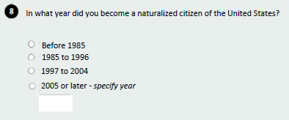

Let’s look at Question 8.

How easy or difficult was it for you to choose a category? What made it easy/difficult?
IF DIFFICULT: Did you think about choosing a different category than what you finally settled on for an answer? IF YES, Tell me about that.
This question asks about when you became a “naturalized citizen.” What does “naturalized” mean to you?
What did you think about groupings of the categories (before 1985, 1985 to 1996, 1997 to 2004, 2005 or later)? Would you have preferred some other grouping?
IF WROTE IN A YEAR: How easy or difficult was it for you to say the exact year you were naturalized? What made it easy/difficult?
IF PRIOR TO 2005: Would you have preferred to give your answer as an exact year, or in the ranges that were provided? Tell me more about your preference.
IF NATURALIZATION PROBES WEREN’T ADMINISTERED, READ INTRODUCTION STATEMENT BELOW. OTHERWISE, GO DIRECTLY TO PROBES:
Now let’s turn our focus to when you came to live in the United States.
Year of Entry: Q9, INET_g2_V2_packet 4a/b/c/d
Research Questions:
Which alternate version is easier for respondents to understand and answer and why?
Can respondents provide the exact year of entry for themselves?

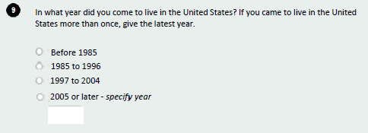

Now let’s look at Question 9.

How easy or difficult was it for you to choose a category? What made it easy/difficult?
IF DIFFICULT: Did you think about choosing a different category than what you finally settled on for an answer? IF YES, Tell me about that.

What did you think about the groupings of the categories (before 1985, 1985 to 1996, 1997 to 2004, 2005 or later)? Would you have preferred some other grouping?
IF WROTE IN A YEAR: How easy or difficult was it for you to say the specific year you came to live in the United States? What made it easy/difficult?

IF PRIOR TO 2005: Would you have preferred to give your answer as an exact year, or in the ranges that I provided? Tell me more about your preference.
What did you think about the year ranges on the categories? Would you have preferred some other grouping?
This question asks about when you “came to live” in the United States. What does the phrase “came to live” mean to you?
IF NEEDED: Did you notice when I said, “If you came to live in the United States more than once, give the latest year?”
In your own words, what did you think this instruction meant?
COMPARE ALTERNATE VERSION (Q9):
I’d like to present you with another way the question might be asked. (SHOW RESPONDENT Q9 IN INET_G2_V1_Packet 4a/4b/4c/4d)

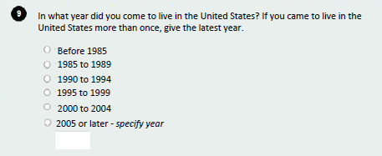

(SHOW BOTH VERSIONS TO RESPONDENT) Does one of these seem easier to answer than the other? What makes you say that?

[IF DETAILED QUESTIONS FOR PERSON 2 WERE ADMINISTERED, CONTINUE. OTHERWISE SKIP TO CLOSING] Now we will focus on the questions about [PERSON 2’s] naturalization and year of entry to the United States.

IF P1 DETAILED PROBES WERE NOT ADMINISTERED: First let’s talk about the questions about [PERSON 2]’s naturalization and entry to the United States.

Setting aside the survey questions I asked about [PERSON 2], I would like to understand the timeline of [PERSON 2]’s first moving to the U.S. and becoming a naturalized citizen. Can you please walk me through [PERSON 2]’s process in your own words?
IF NEEDED:
What was the main reason [PERSON 2] came to the U.S. to live?
When did [PERSON 2] first arrive in the U.S. to live?
After [PERSON 2] first came to the U.S. to live, did [PERSON 2] ever leave the U.S. to live somewhere else? (IF SO, When was the most recent time [PERSON 2] came to live here?)
How long after [PERSON 2] arrived in the U.S. did [PERSON 2] start the naturalization process?
How long did the naturalization process take?
How long after [PERSON 2] arrived in the U.S. did [PERSON 2] become a naturalized citizen?
What was the actual date [PERSON 2] was sworn in as a U.S. citizen?

Year of naturalization P2: Q8, INET_G2_V2_PAcket 7a/b/c/d
Research Questions:
Which alternate version is easier for respondents to understand and answer and why?
Can respondents provide the exact year of naturalization for the household member they’re reporting for?
Do respondents understand the concept of “naturalization”?

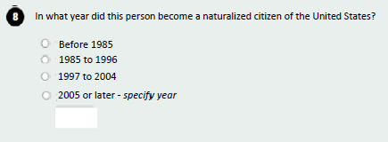

Now let’s look at Question 8 for [PERSON 2].

IF NOT ALREADY ASKED IN P1 PROBES: This question asks about when [PERSON 2] became a “naturalized citizen.” What does “naturalized” mean to you?
How easy or difficult was it for you to choose an answer for [PERSON 2]? What made it easy/difficult?
IF DIFFICULT: Did you think about choosing a different category than what you finally settled on for an answer? IF YES, Tell me about that.
How confident are you in your response?
IF WROTE IN YEAR: How easy or difficult was it for you to say the exact year [PERSON 2] was naturalized? What made it easy/difficult?

IF PRIOR TO 2005: Would you have preferred to give your answer as an exact year, or in the ranges that were provided? Tell me more about your preference.
Earlier, I presented you with another way the question might be asked. (SHOW RESPONDENT Q8 IN INET_G2_V1_Packet 4a/4b/4c/4d)

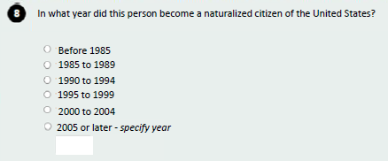
Thinking about the 2 different groupings of categories, does one of these seem easier to answer than the other for [PERSON 2]? What makes you say that?

Year of Entry P2: Q9, INET_g2_V2_packet 8a/b/c/d
Research Questions:
Which alternate version is easier for respondents to understand and answer and why?
Can respondents provide the exact year of entry for their household member?

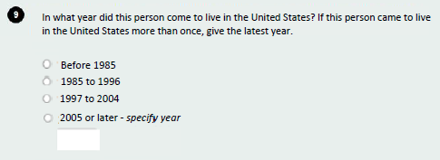

Now let’s look at Question 9 for [PERSON 2].

Did [PERSON 2] come to live in the U.S. more than once? IF YES: Were you thinking about the “last time” [PERSON 2] came to live in the U.S. or the first time?

How easy or difficult was it for you to answer for [PERSON 2]? What made it easy/difficult?
IF DIFFICULT: Did you think about choosing a different category than what you finally settled on for an answer? IF YES, Tell me about that.
What did you think about the year ranges on the categories? Would you have preferred some other grouping?
IF WROTE IN YEAR: How easy or difficult was it for you to say the specific year [PERSON 2] came to live in the United States? What made it easy/difficult?
IF PRIOR TO 2005: Would you have preferred to give [PERSON 2’s] answer as an exact year, or in the ranges that I provided? Tell me more about your preference.
How confident are you in your response?
IF NOT ALREADY ASKED IN P1 PROBES:
This question asks about when [PERSON 2] “came to live” in the United States. What does the phrase “came to live” mean to you?
IF NEEDED: When I said, “If <Name> came to live in the United States more than once,” in your own words, what did you think I was asking?

IF DID NOT ALREADY PRESENT ALTERNATE VERSION (Q9a):
I’d like to present you with another way the question might be asked. (SHOW RESPONDENT Q9 IN INET_G2_V1_Packet 8a/8b/8c/8d)
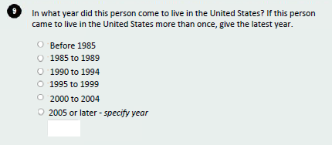

(SHOW BOTH VERSIONS TO RESPONDENT) Does one of these seem easier to answer than the other? What makes you say that?

Closing and Incentive
IF OBSERVERS ARE PRESENT, CHECK TO SEE IF THEY HAVE FURTHER QUESTIONS.

Those are all the questions I have for you. Is there anything we haven't discussed that you would like to mention?

DISCUSS ANY RESPONDENT COMMENTS.
Thank you for your time.

STOP TAPE RECORDER.
GIVE INCENTIVE AND HAVE RESPONDENT SIGN RECEIPT.

