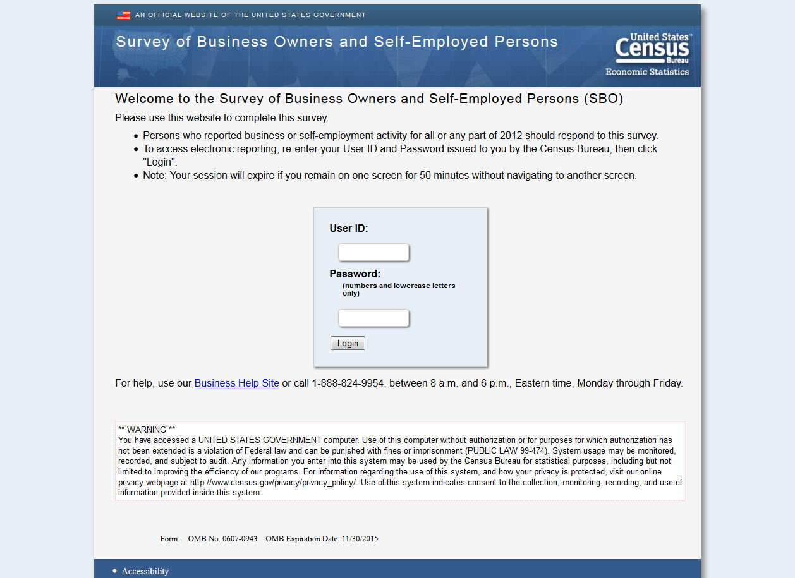

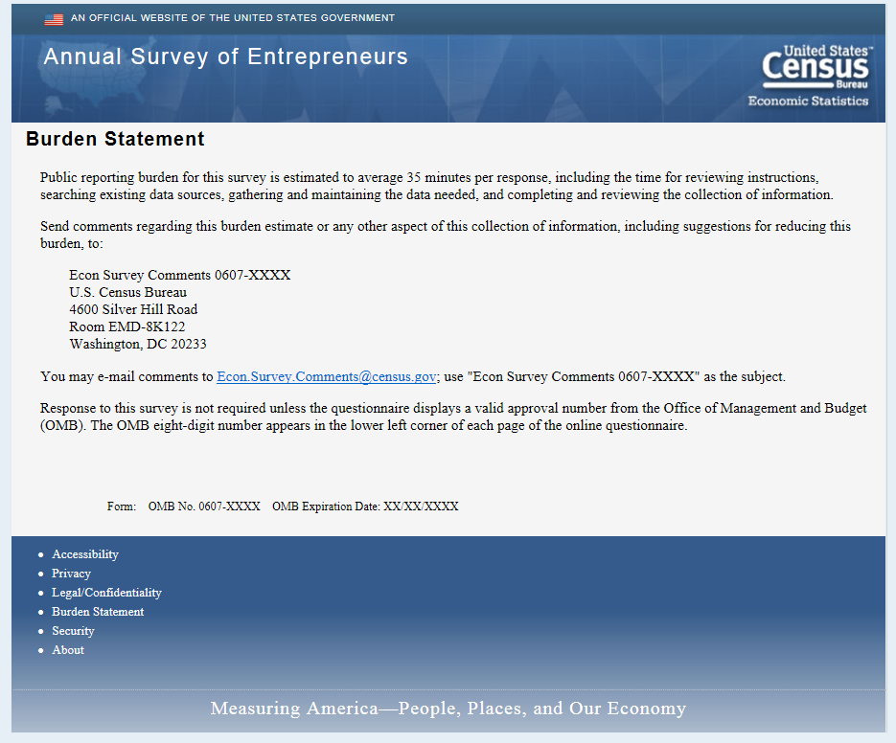

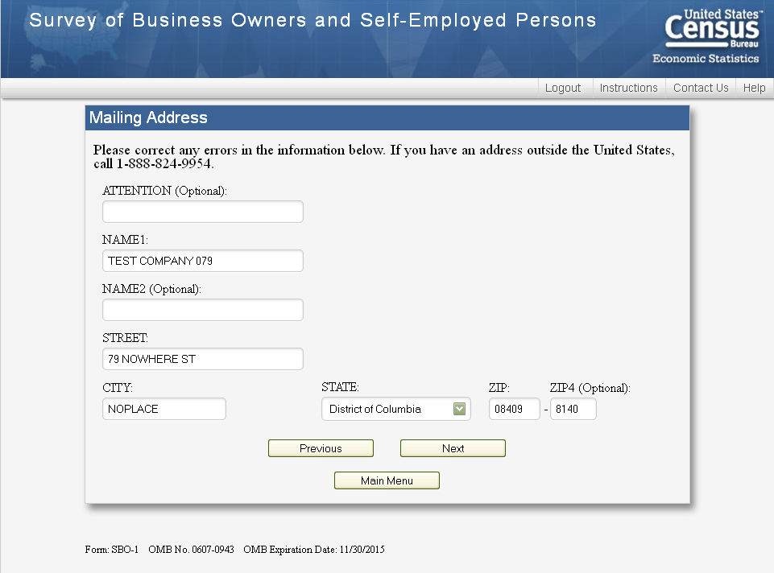
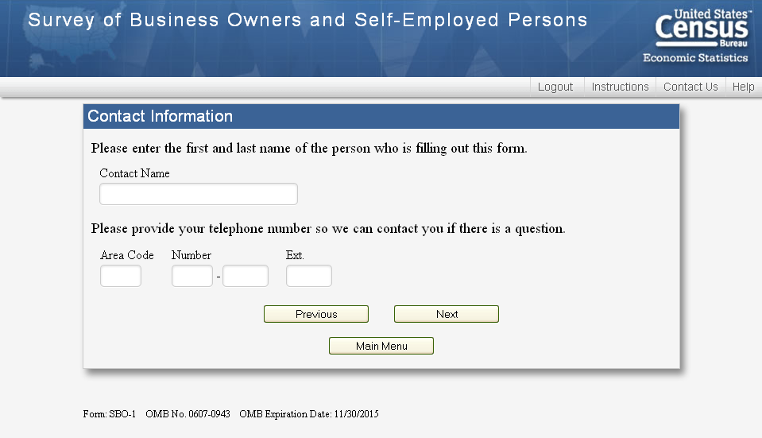

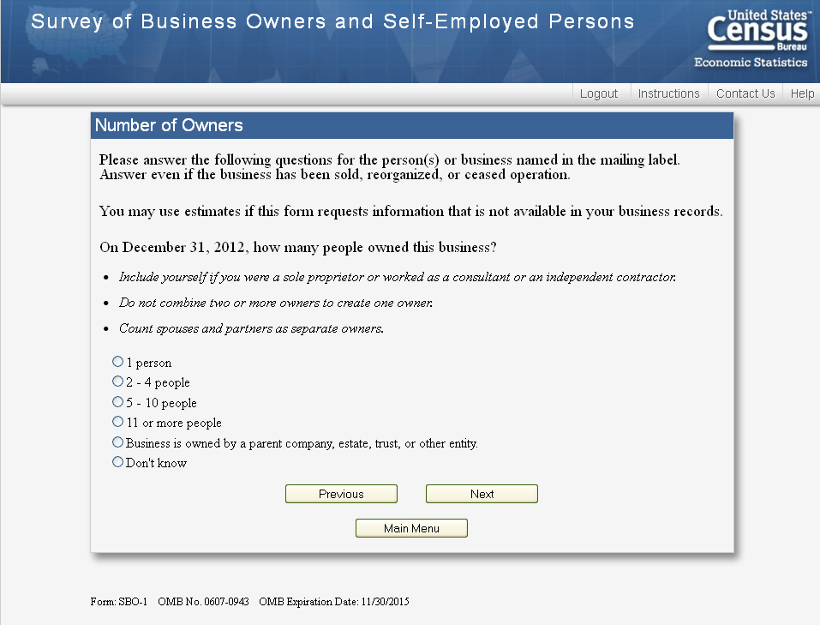
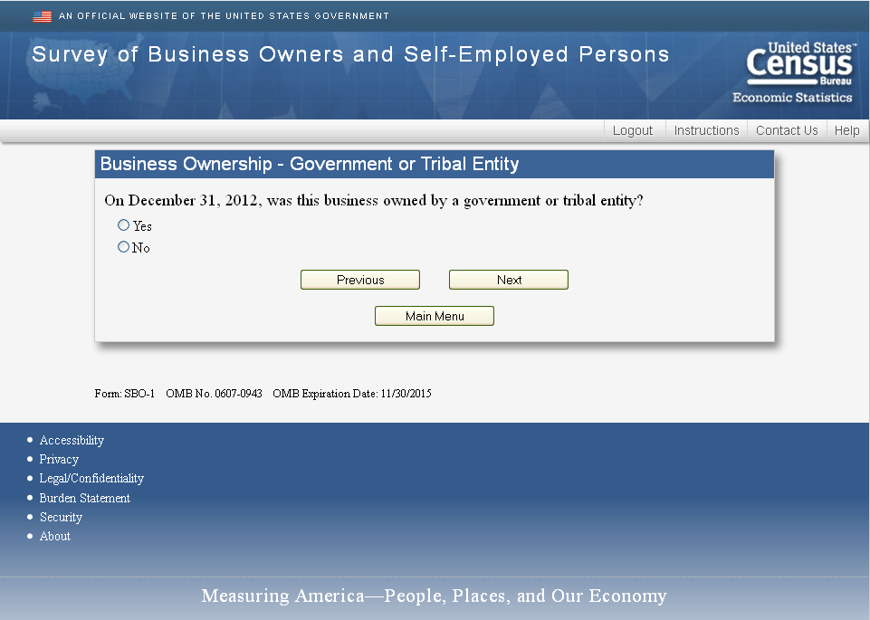
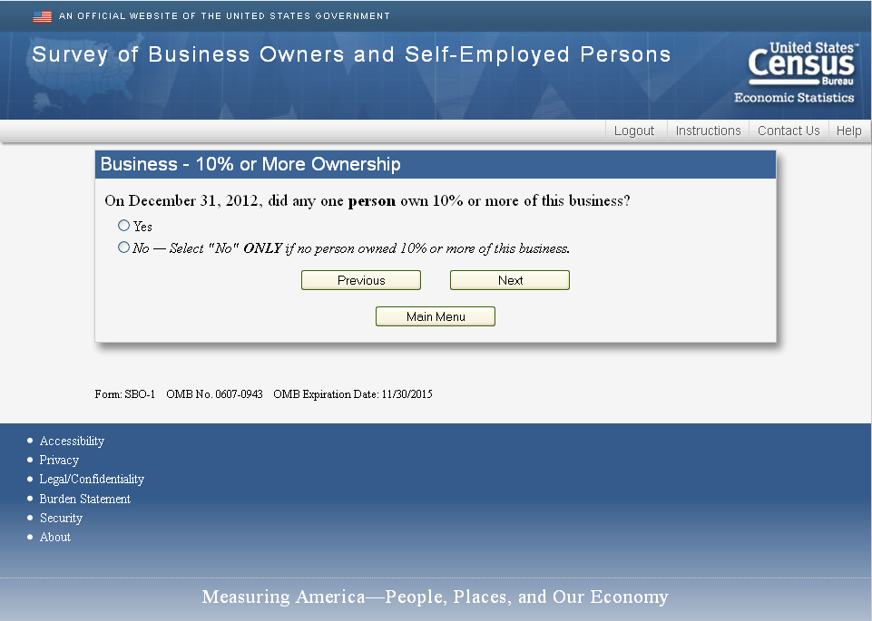

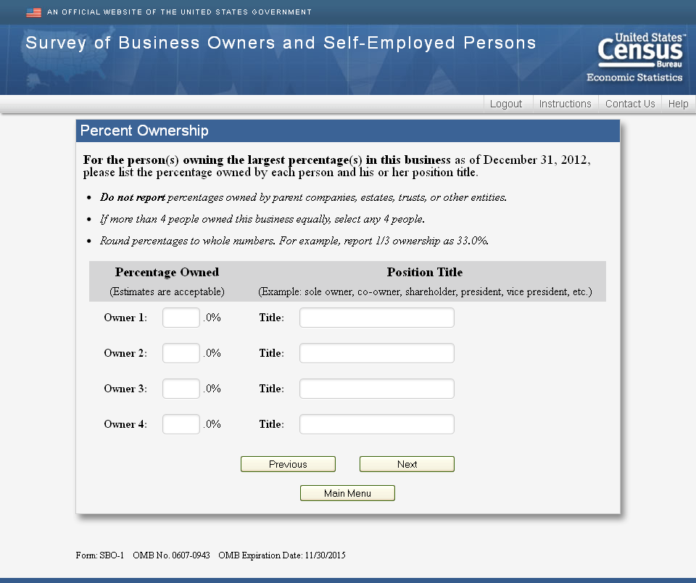

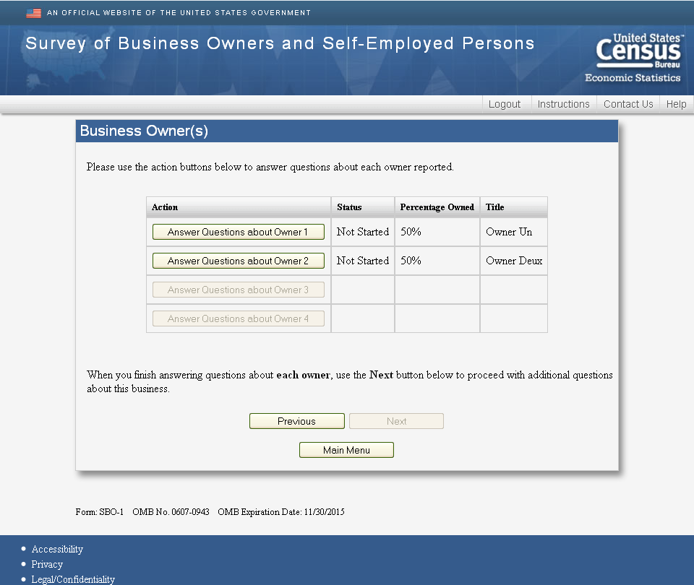

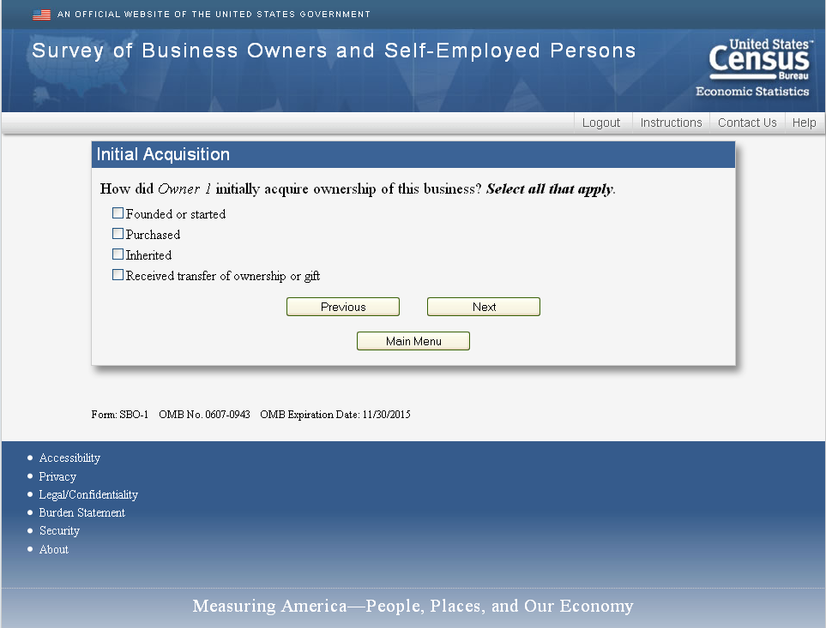

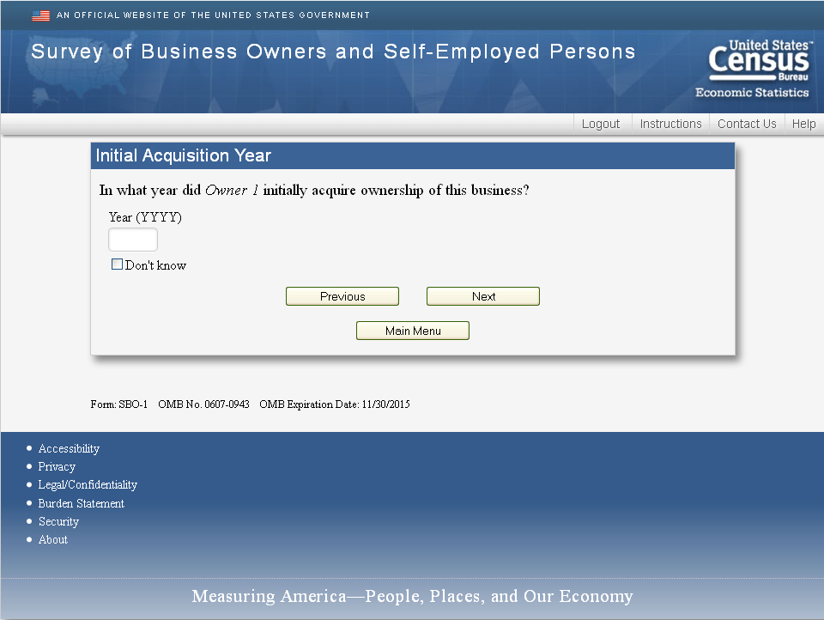

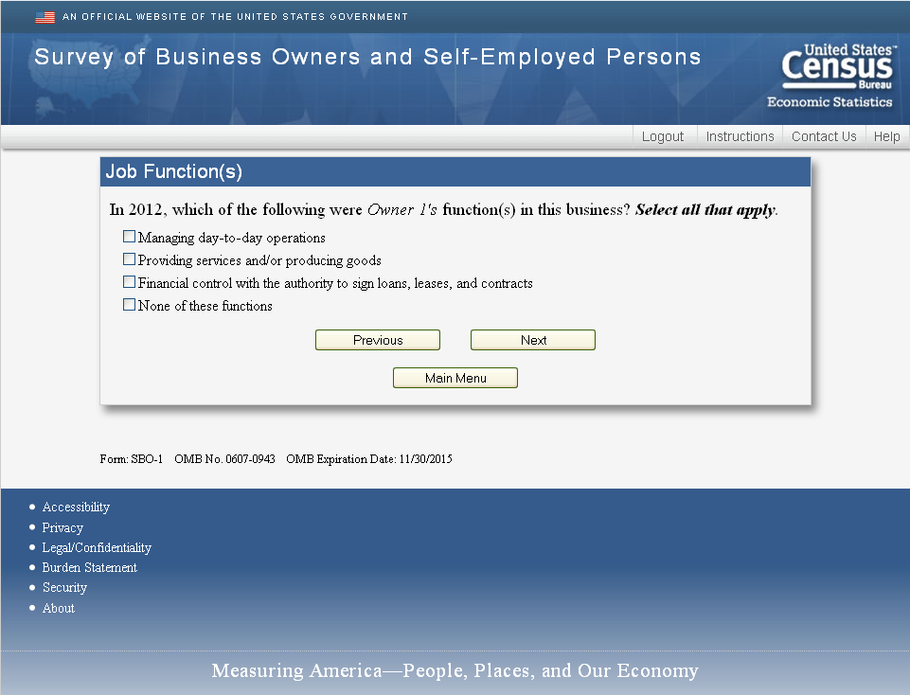

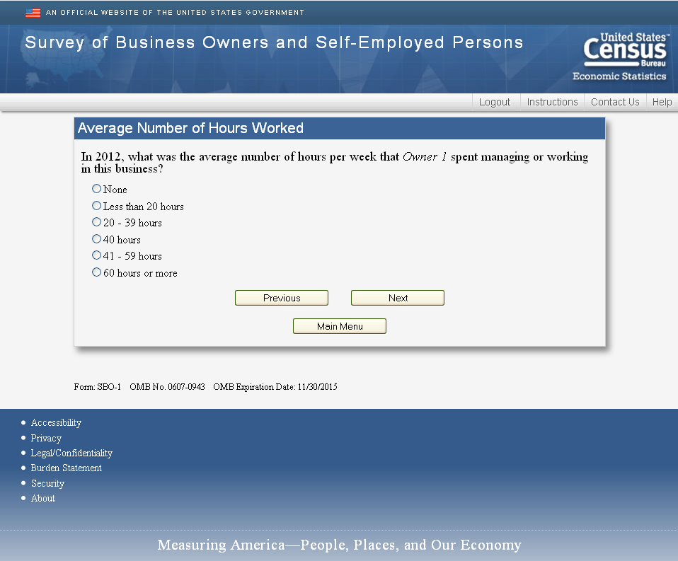

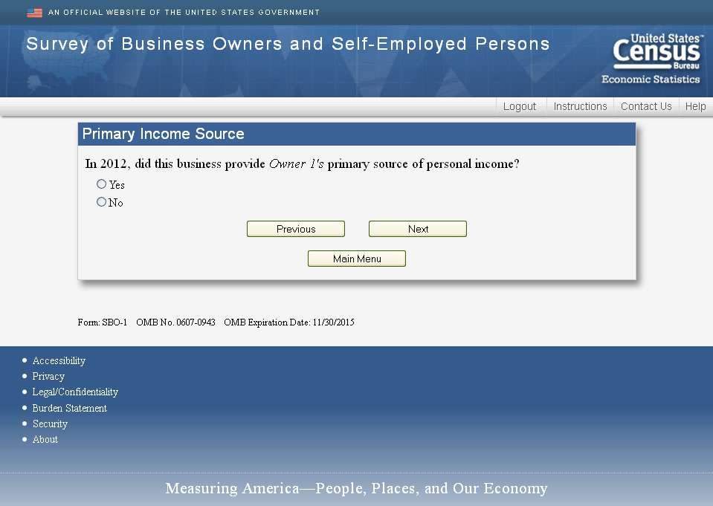

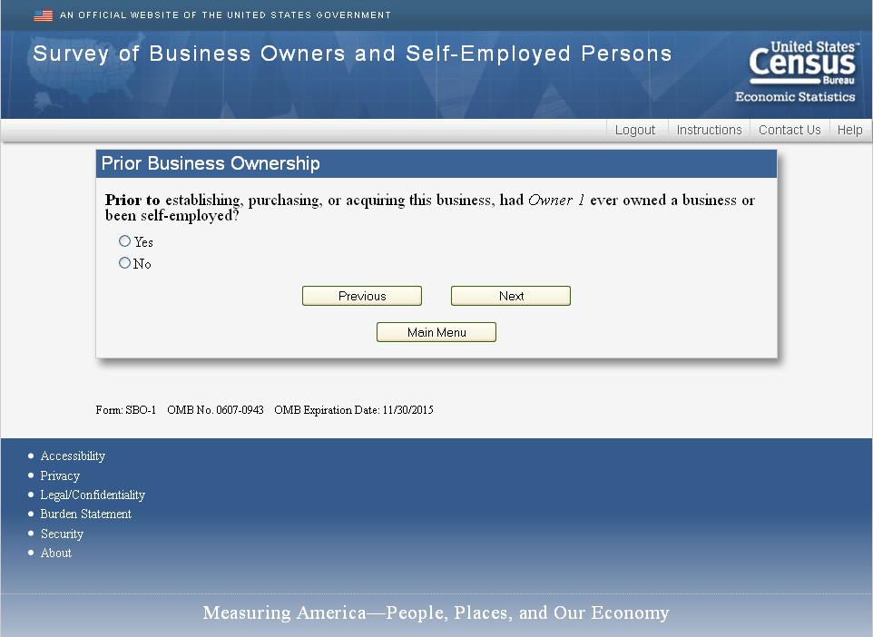

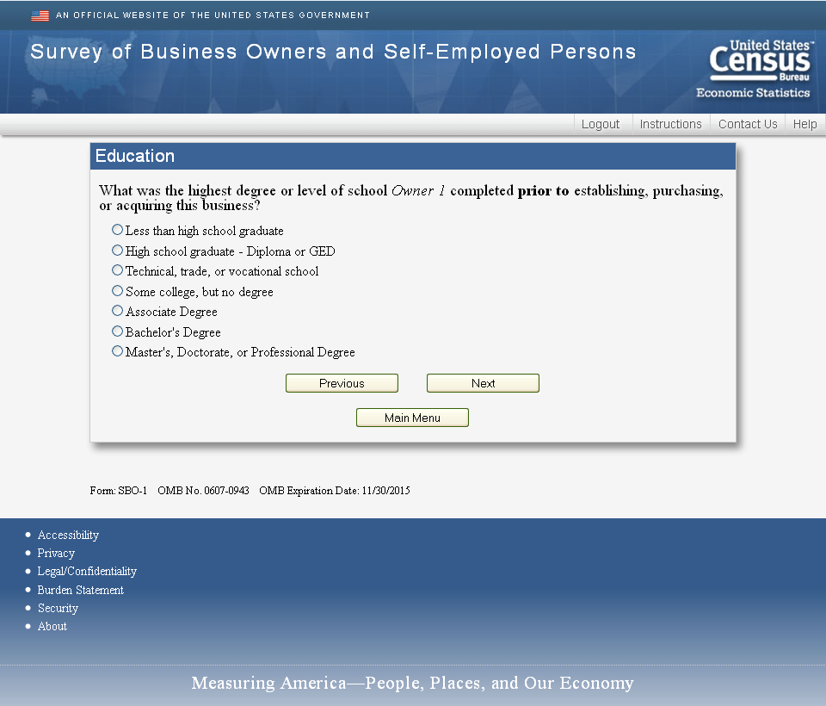

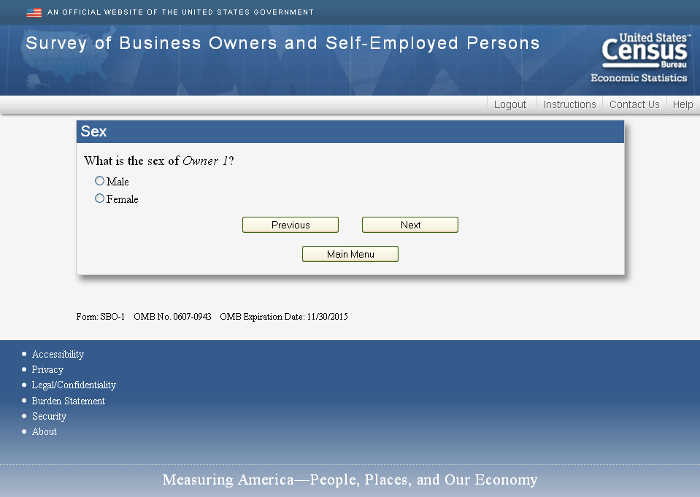

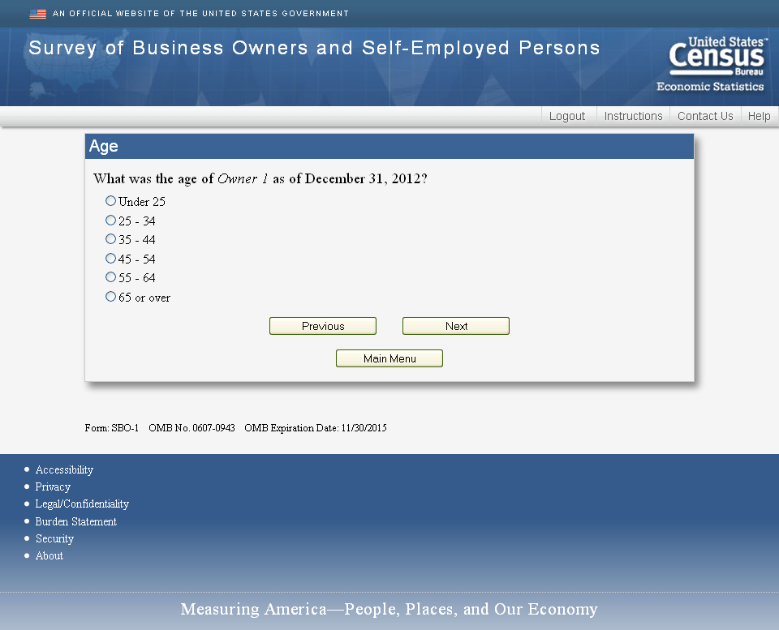

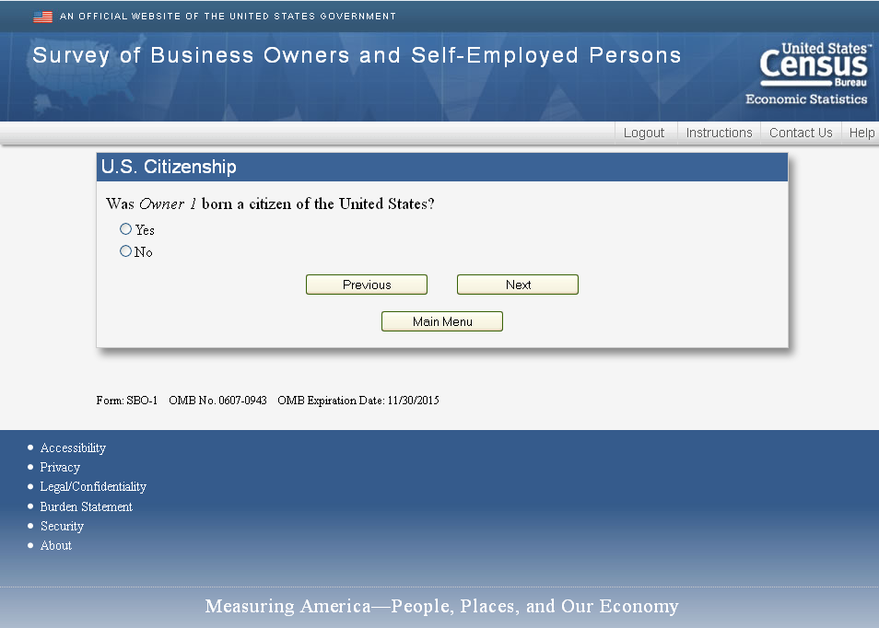
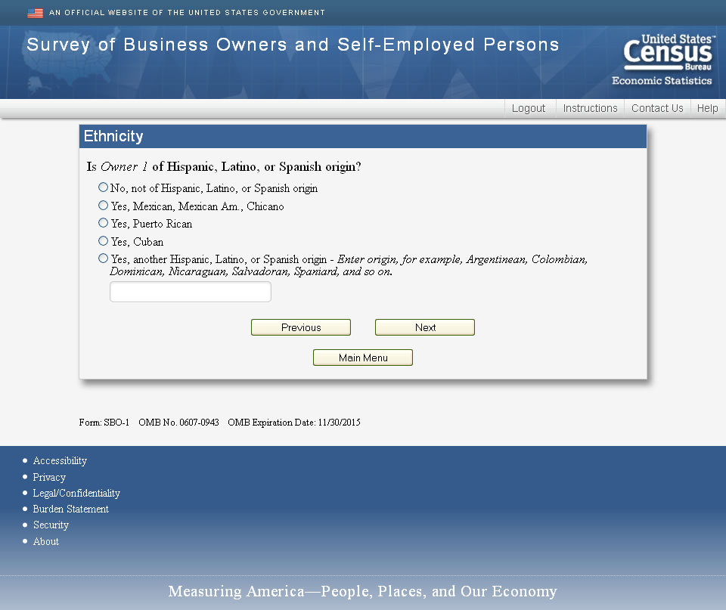

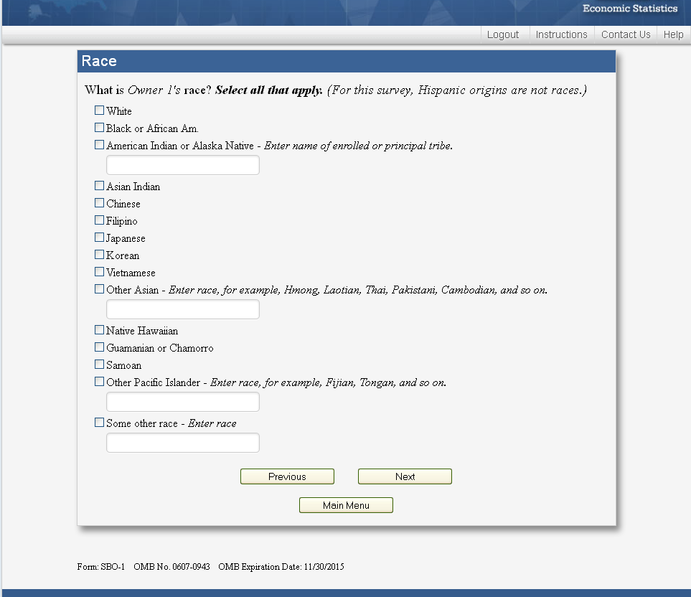
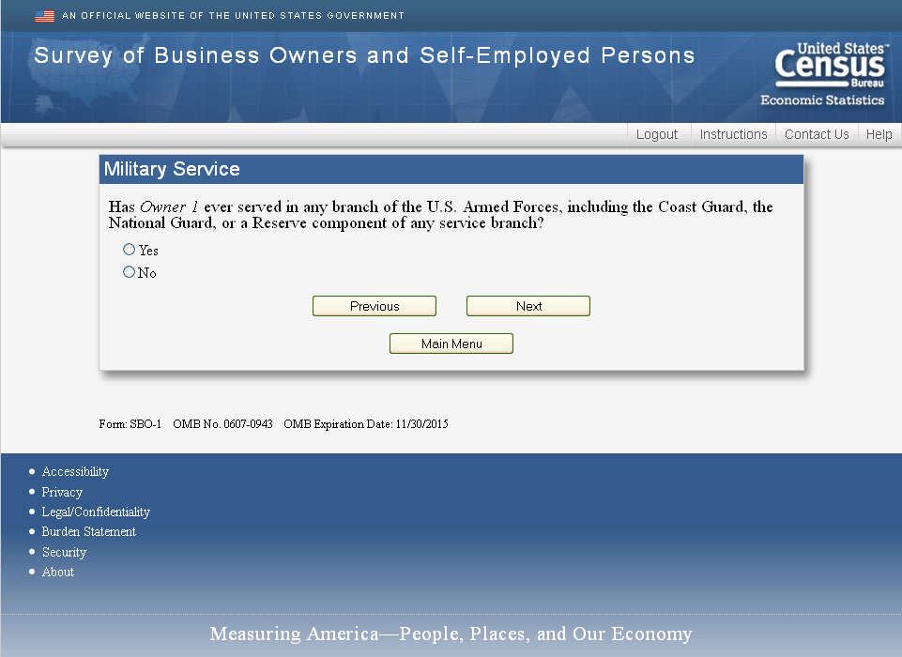

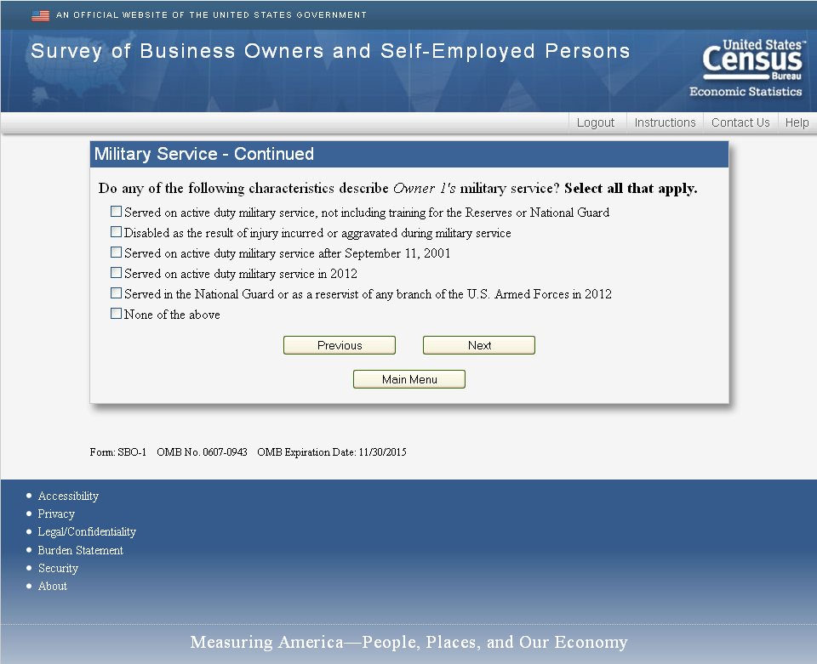

New Questions for 2014
How important to Owner1 are each of the following reasons for owning this business?” (Select one for each row)

 | Not  Important | Somewhat  Important | Very  Important
Wanted to be my own boss
Flexible hours
Balance work and family
Opportunity for greater income/Wanted to build wealth
Best avenue for my ideas/goods/services
Couldn't find a job/Unable to find employment
Working for someone else didn't appeal to me
Always wanted to start my own business
An entrepreneurial friend or family member was a role model
Other (Specify):

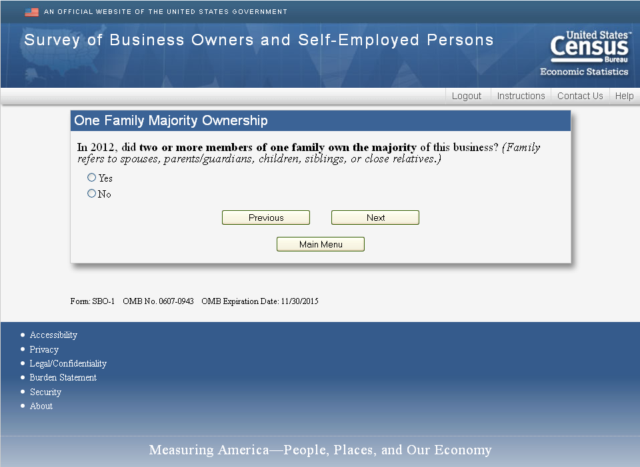

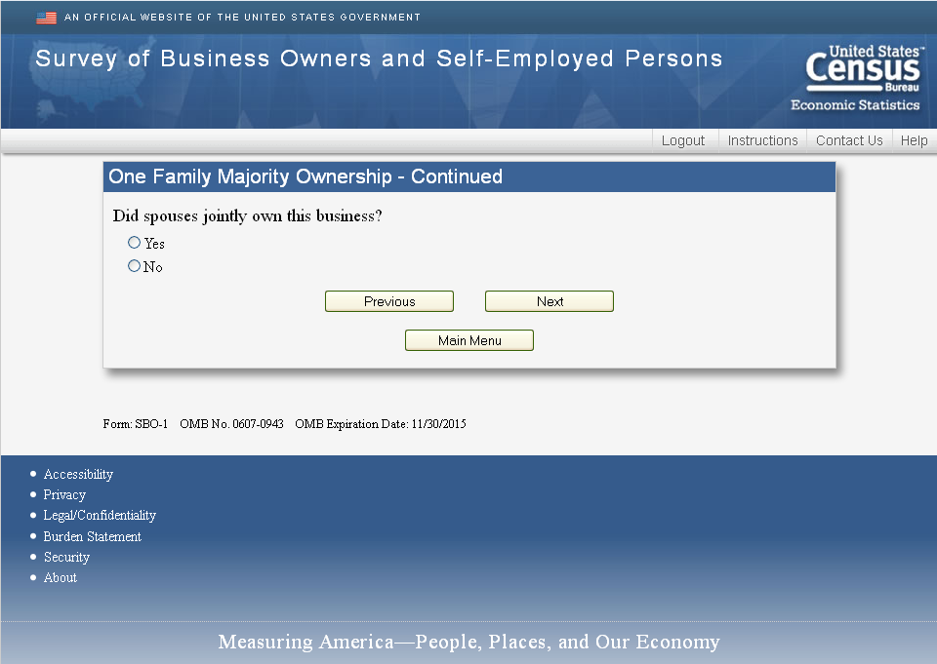

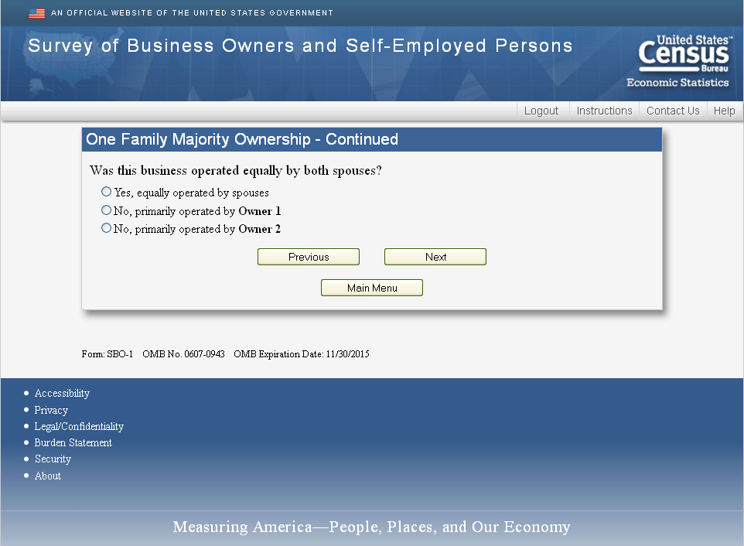

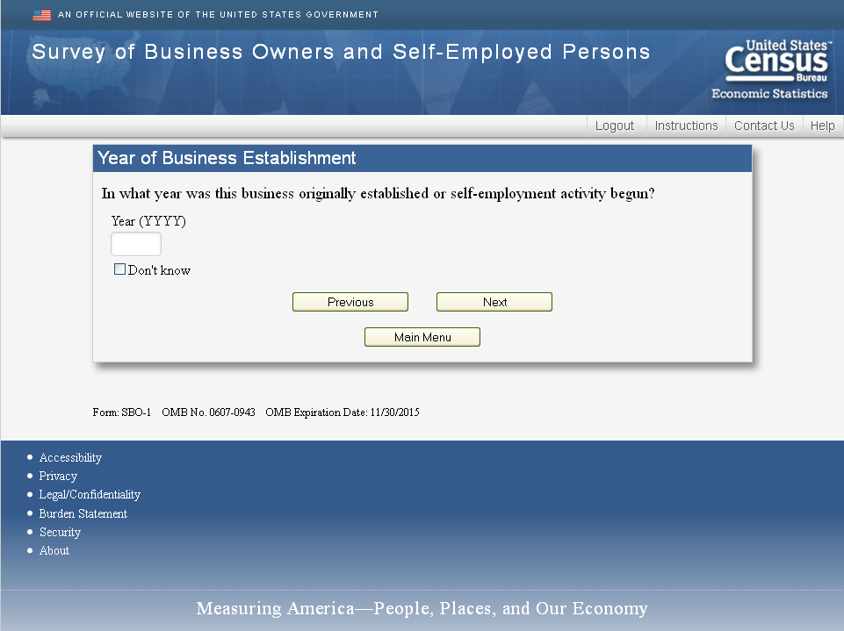
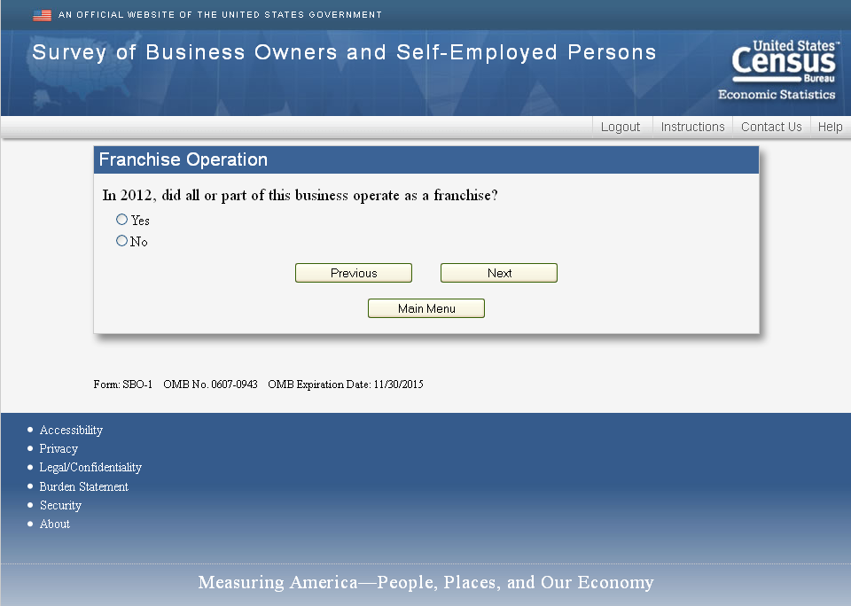

New Questions for 2014
Where would the owner(s) like this business to be in five years? (Select one)

- Larger in terms of sales or profits
- About the same amount of sales or profits
- Smaller in terms of sales or profits
- Other (Specify)

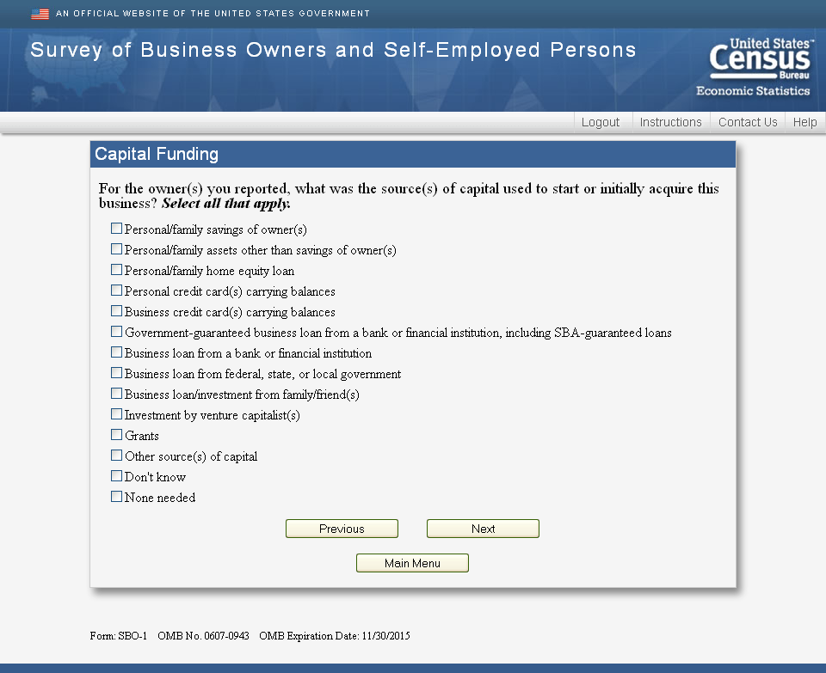

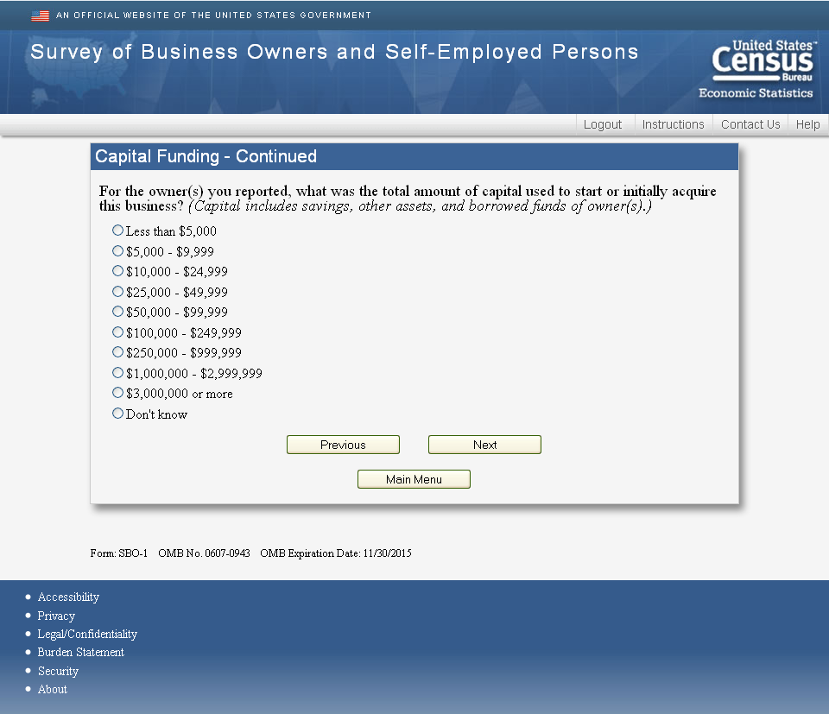

New Questions for 2014

For 2014, what was the total amount of money that the owner(s) personally put into the business? Your best estimate is fine. Please report in thousands.
Include:
  - Investments from personal savings
  - Personal retirement accounts
  - Home equity loans
  - Personally borrowed funds.

$_________,000

New Questions for 2014
For 2014, what was the total amount of money this business received from family, friends, and employees? Your best estimate is fine. Please report in thousands.

$_________,000

New Questions for 2014
For 2014, what was the total amount of money this business borrowed from a bank or other financial institution, including business loans, a business credit card carrying a balance, or a business line of credit? Include all draws on business line of credit, even if paid off during the year. Your best estimate is fine. Please report in thousands.

$_________,000

New Questions for 2014
For 2014, what was the total amount of money this business received from angel investors, venture capitalists, or other businesses in return for a share of ownership in this business? Your best estimate is fine. Please report in thousands. (An “angel investor” is an affluent individual who provides capital for a business start-up, usually in exchange for convertible debt or ownership equity.)

$_________,000

New Questions for 2014
For 2014, what was the total amount of money this business received from government grants (such as the Small Business Innovation Research (SBIR) and/or Small Business Technology Transfer (STTR) programs)? Your best estimate is fine. Please report in thousands.

$_________,000

New Questions for 2014
In 2014, did this business attempt to establish any new funding relationship (for example, loans, investments, or gifts) with any of the following sources? (Select one for each row)
 | No | Yes, received  total amount  of the funding requested | Yes, but did not receive the total amount  requested
Other owner(s) (if applicable)
Family, friends, or employees
Banks, credit unions, or other financial institutions
Home equity loans in name of business owners
Credit cards
Trade credit (for example, buy now, pay later)
Angel investors
Venture capitalists
Other investor businesses
Crowdfunding platform (for example, Prosper, Kickstarter, etc.)
Grants (for example., Federal government's Small Business Technology Transfer Program (STTR) or Small Business Innovation Research Program (SBIR)
Other (Specify)

New Questions for 2014
At any time during 2014, did this business need additional financing and the owner(s) chose not to apply?

  - Yes
  - No

New Questions for 2014
Why did this business choose not to apply for additional financing? (Select all that apply)
    - Did not think business would be approved by lender
    - Did not want to accrue debt
    - Decided the financing costs would be too high
    - Preferred to reinvest the business profits instead
    - Felt the loan search/application process would be too time consuming
    - Decided the additional financing was no longer needed
    - Decided to wait until funding conditions improved
    - Decided to wait until company hit milestones to be in stronger position to raise funds
    - Other (Specify)

New Questions for 2014
For 2014, did this business have profits, losses, or break even? (Select one)
- Profits
- Losses
- Break even

New Questions for 2014
For 2014, did each of the following negatively impact the profitability of this business? (Select one in reach row)
 | Yes | No
Access to financial capital
Cost of financial capital
Finding qualified labor
Taxes
Slow business or lost sales
Customers or clients not making payments or paying late
The unpredictability of business conditions
Changes or updates in technology
Other (Specify)

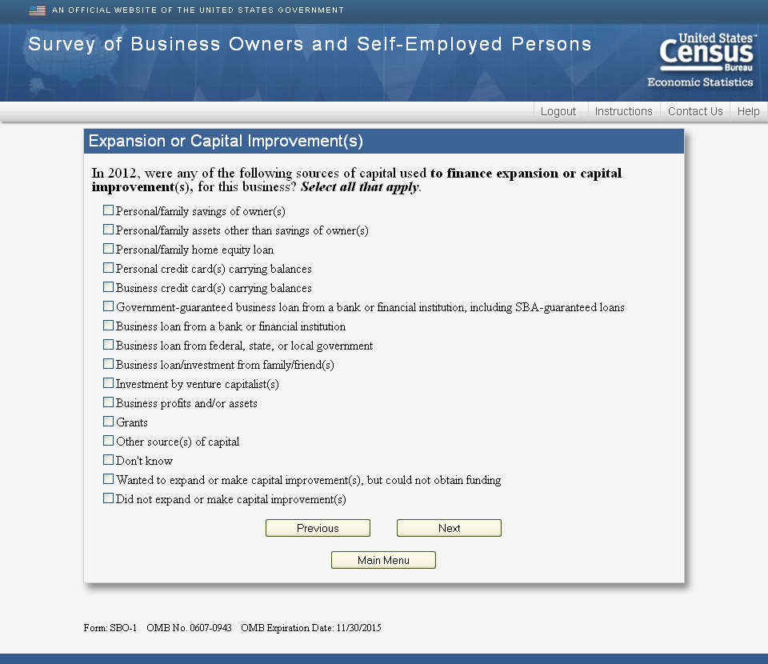

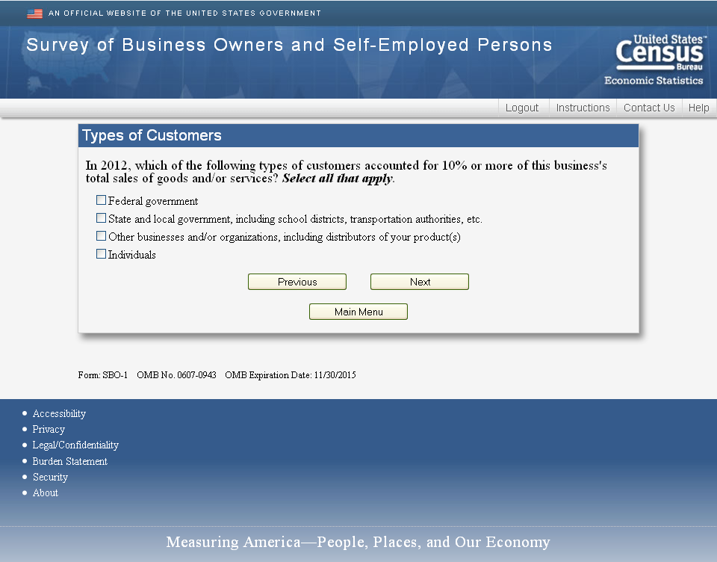

New Questions for 2014

During 2014, where were this business’s customers or clients located? Round to the nearest whole percent. Your best estimate is fine. If none, report “0.”
Same region as the business | _____%
Outside of the region but within the U.S. (Domestic) | _____%
Outside the United States (International) | _____%
Total | 100%

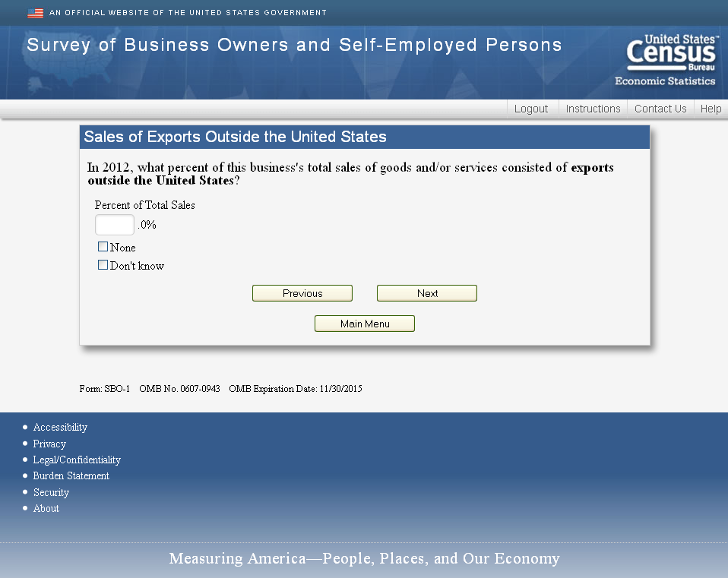
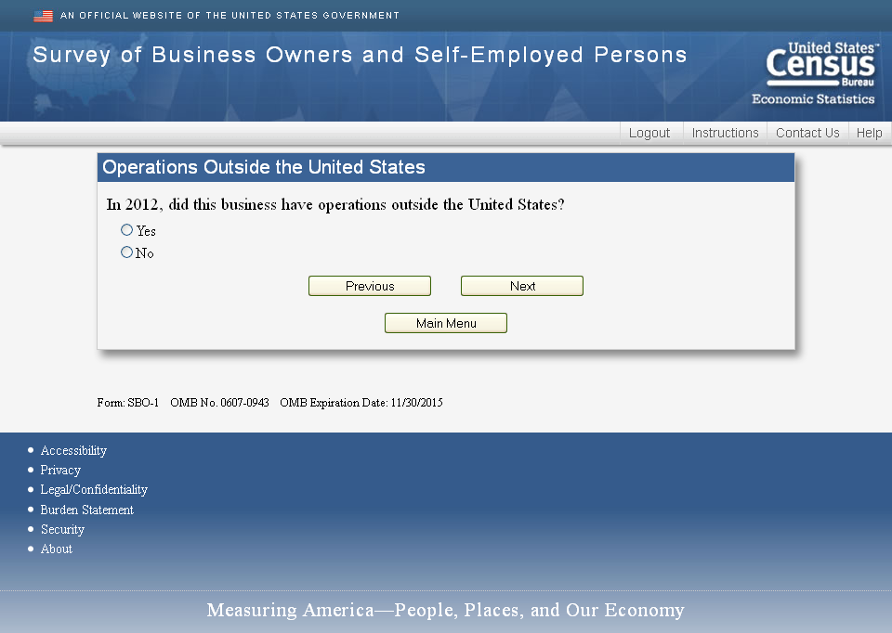

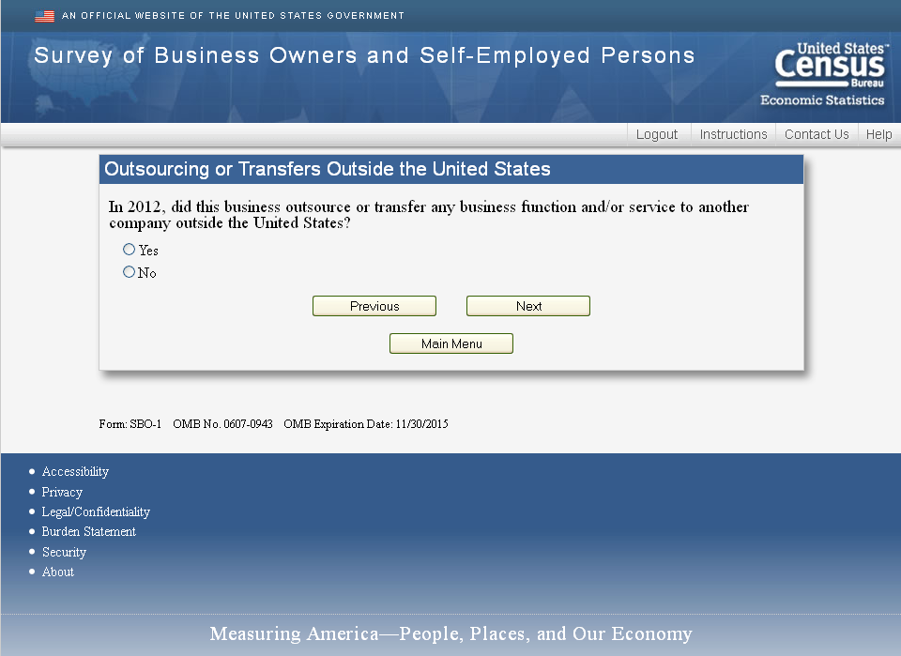
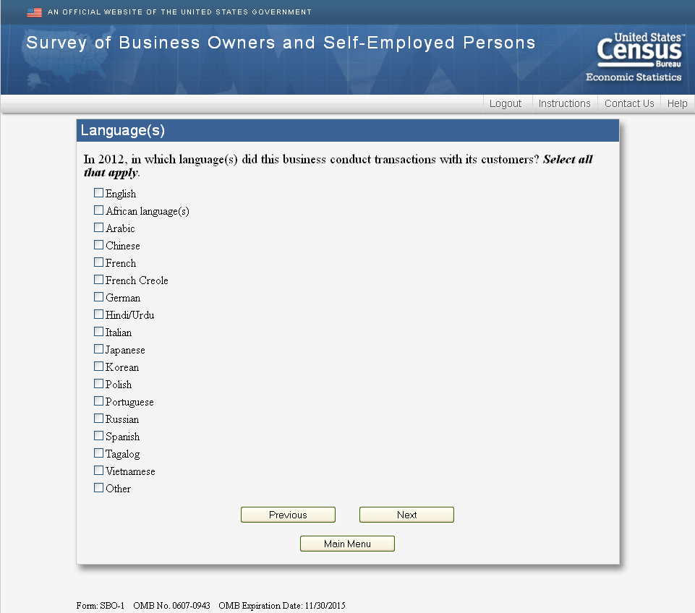

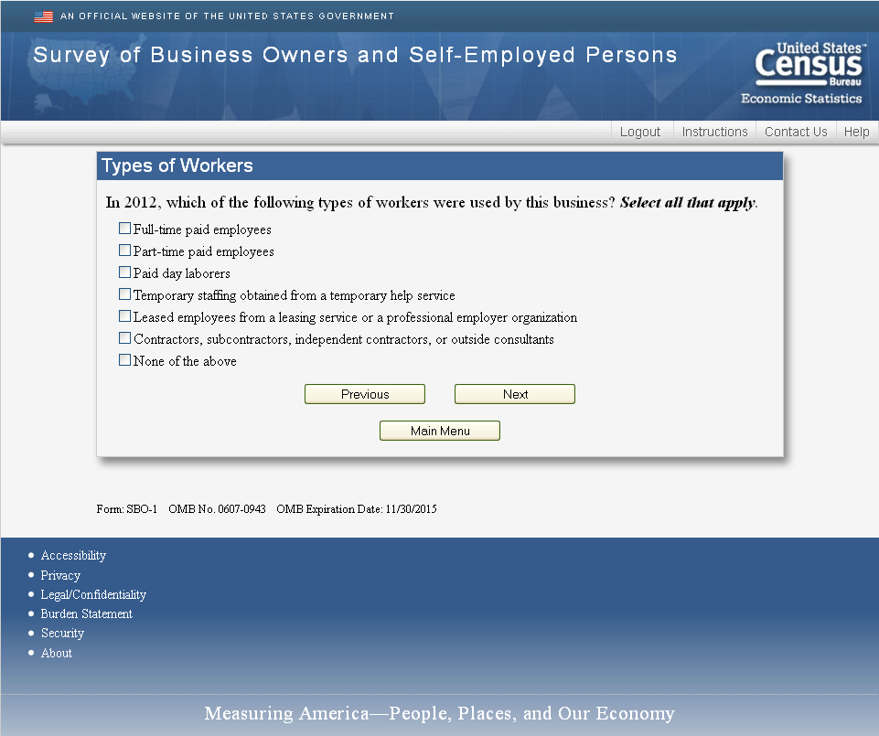

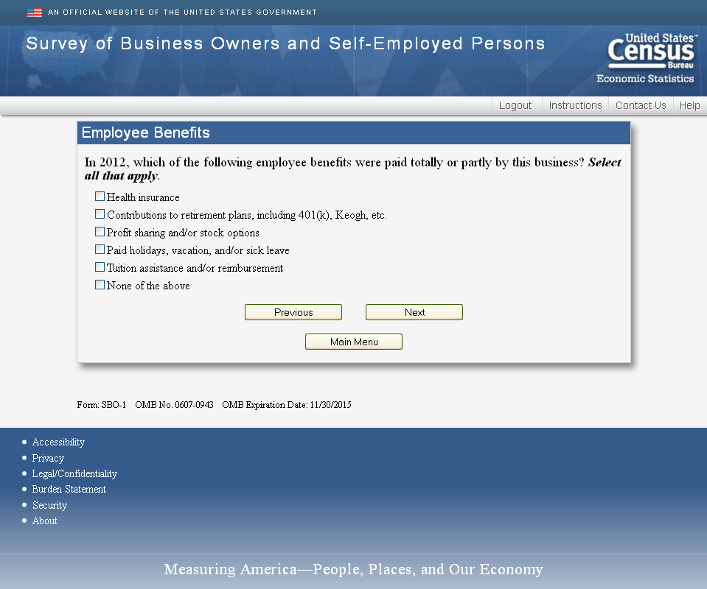

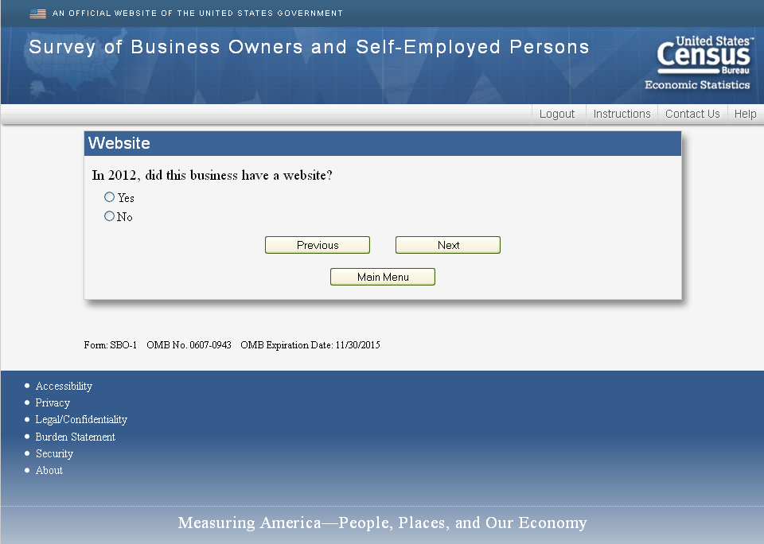

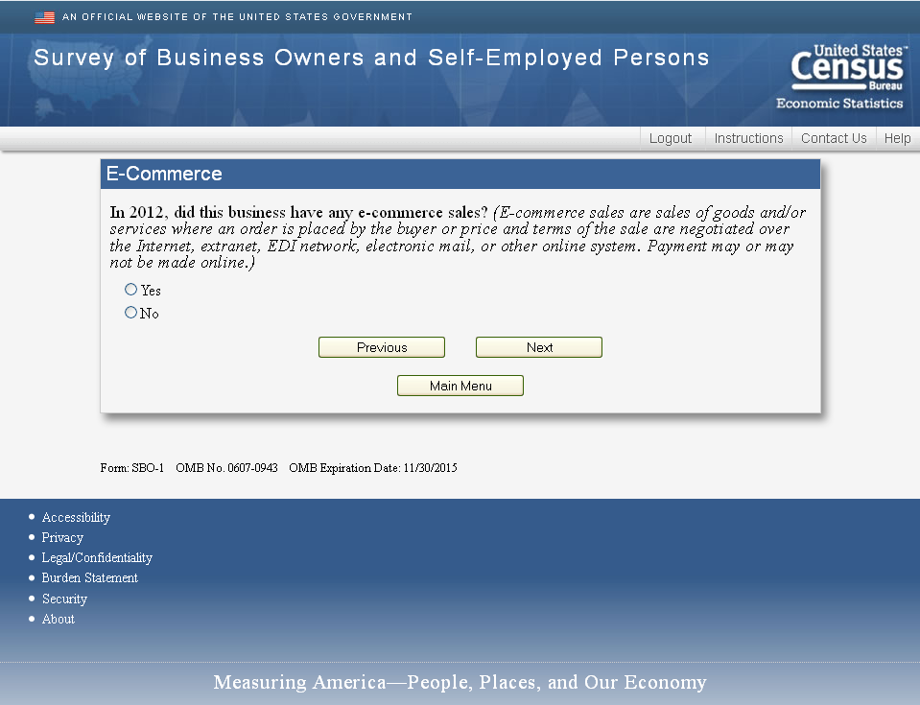
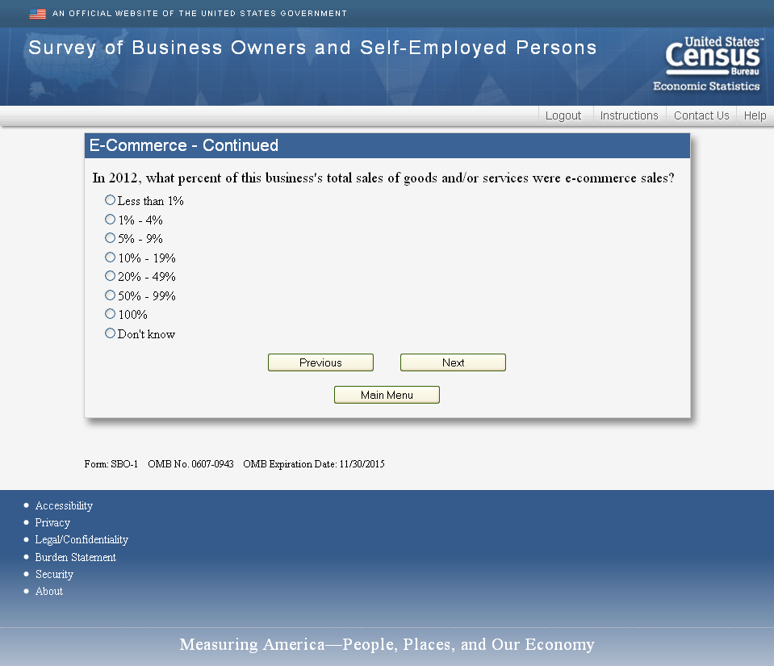

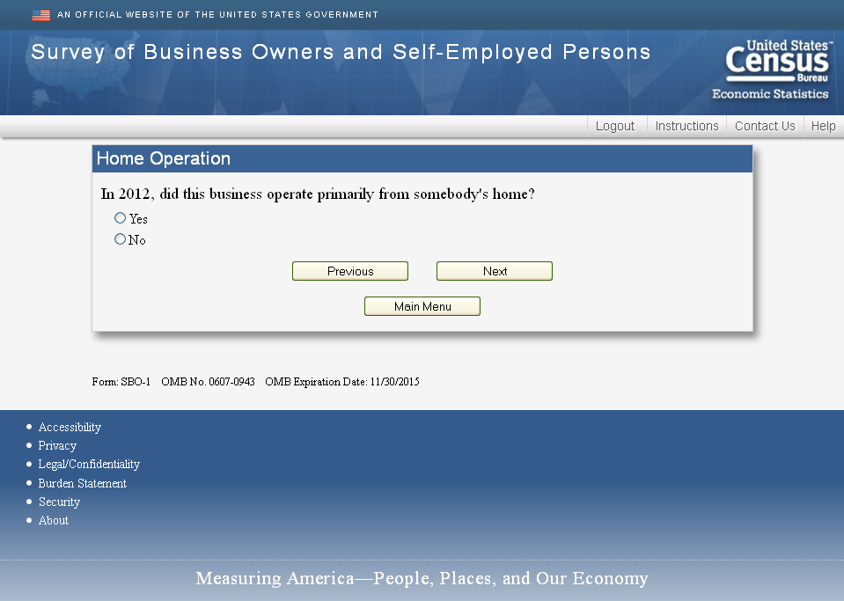
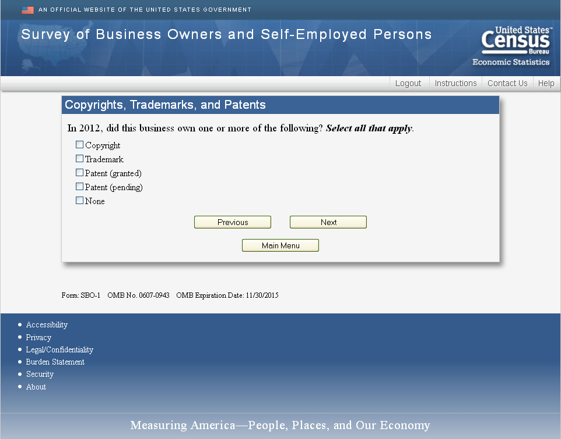
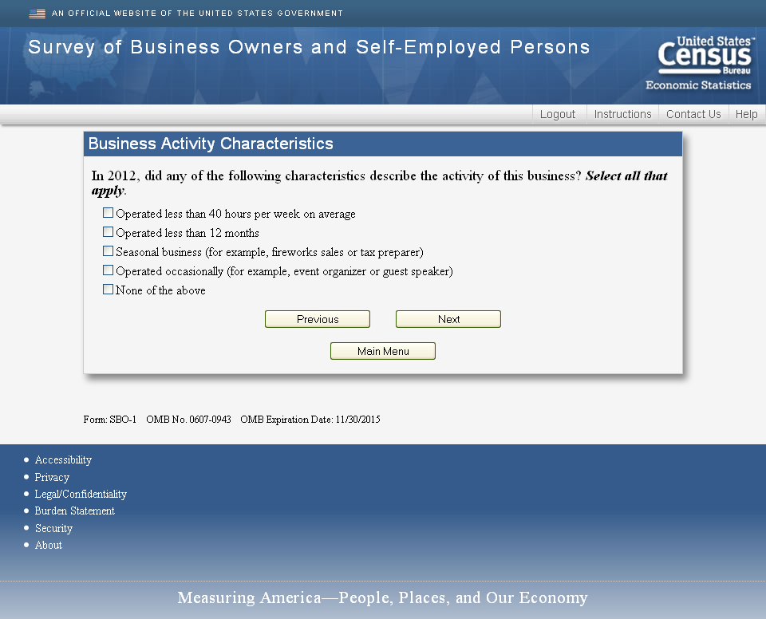
New Questions for 2014
“Product Innovation”
“During the last three years (2012, 2013, 2014), did this business do each of the following regarding the goods or services it offers? (Select one for each row)

Do not include adaptation or customization of a good or service for a specific customer’s needs.

 | Yes | No
Sold a new good or service that no other business has ever offered before
Sold a new good or service that this business has never offered before
Improved a good or service’s performance by making changes in materials, equipment, software or other components
Developed a new use for a good or service
Added a new feature to a good or service
Made it easier for customers to use a good or service

New Questions for 2014
“Process Improvement”
“During the last three years (2012, 2013, 2014), did this business do each of the following regarding the goods or services it offers? (Select one for each row)

 | Yes | No
Applied a new way of purchasing, accounting, computing, maintenance, inventory control, or other support activity
Reduced costs by changing the way a good or service was distributed
Upgraded a technique, equipment, or software to significantly improve a good or service
Made a significant improvement in a technique or process by increasing automation, decreasing energy consumption, or using better software
Decreased production costs by improving the materials, software, or other components
Changed a delivery method to be faster or more reliable

New Questions for 2014
“Research and Development Activity”
In 2014, did this business do any of the following research and development (R&D) activities? (Select one for each row)

(Include R&D activities that this business performed, others paid this business to do, or this business paid others to do.)

 | Yes | No
Conducted work that might lead to a patent
Developed and tested prototypes that were derived from scientific research or technical findings
Produced findings that could be published in academic journals or presented at scientific conferences
Applied scientific or technical knowledge in a way that has never been done before
Created new scientific research or technical solutions that can be generalized to other situations
Conducted work to discover previously unknown scientific facts, structures, or relationships
Conducted work to extend the understanding of scientific facts, relationships or principles in way that could be useful to others

New Questions for 2014
“Total R&D Cost”
“In 2014, what was this business’s total cost for R&D activities?
Include:
Labor paid for employees, temporary staff, contractors, independent contractors, and outside consultants
Materials, equipment, software, or other supplies purchased
Money spent for rent, utilities or other overhead

$______________,000

New Questions for 2014
“Purchased R&D Costs”
“In 2014, of the total ($XXXXXX) of R&D costs, what was the amount used to purchase R&D services from others?
Include labor paid for employees, temporary staff, contractors, independent contractors, and outside consultants
$_________,000“

New Questions for 2014
“Business R&D Costs”
“In 2014, what percent of the costs of R&D services performed by this business ($XXXX, Item XX – Item YY) consisted of the following purchases? Round to the nearest whole percent. Your best estimate is fine. If none, report “0.”
Employee payroll | ____%
Equipment purchases | ____%
Software and licensing purchases | ____%
Other R & D expenses | ____%
TOTAL | 100%

New Questions for 2014
“Funding Sources for R&D Activities”
In 2014, what percent of the costs of R&D services performed by this business ($XXXX, Item XX – Item YY) was paid by the following sources? Round to the nearest whole percent. Your best estimate is fine. If none, report “0.”

This business | ____%
Another U.S. business | ____%
U.S. college or university | ____%
U.S. nonprofit organization | ____%
U.S. federal government (Include R&D grants) | ____%
U.S. state or local government (Do not include public schools) | ____%
Other (Specify) | ____%

New Questions for 2014
“Number of R&D Employees”
For the pay period including March 12, 2014, how many of each type of the following workers worked on R&D activities?

 | Number of workers
Owner(s) | _____
Paid Employees | _____
Other Paid Workers - Include labor paid for temporary staff, contractors, independent contractors, and outside consultants. | _____
Unpaid Workers/Interns | _____

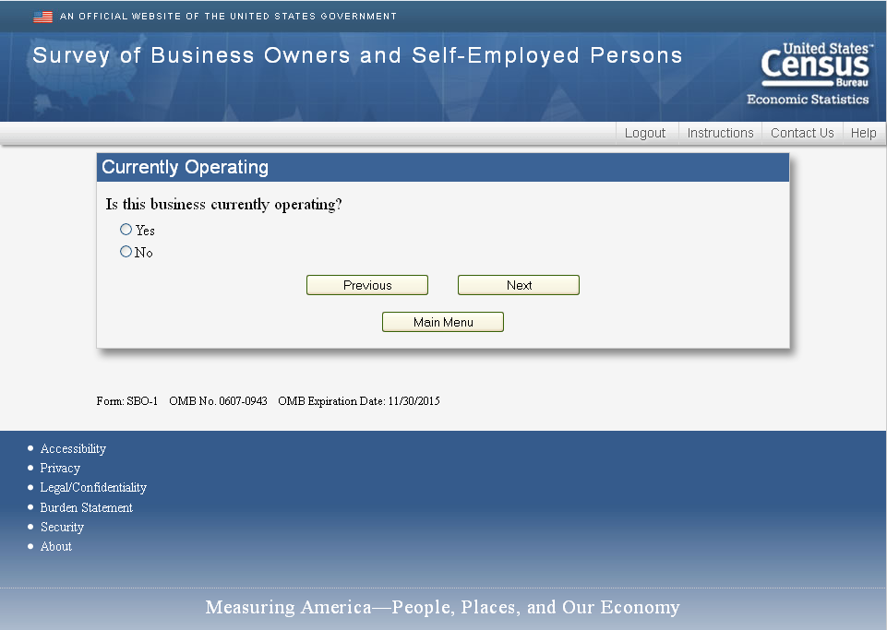

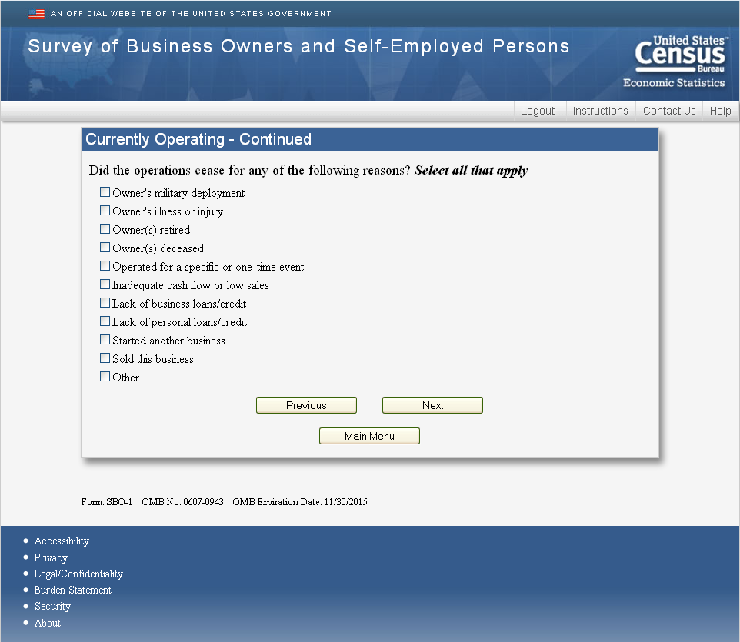

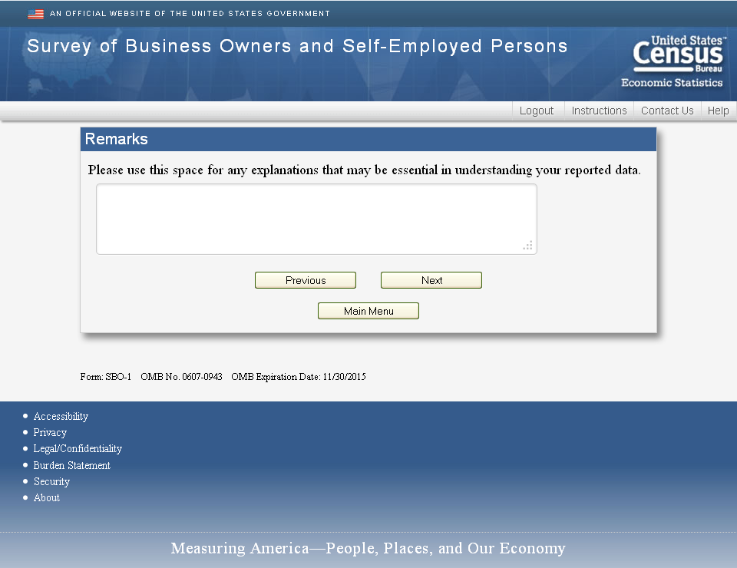

Review Screens
