American FactFinder with new Census Bureau look and feel – Main Page ‘A’
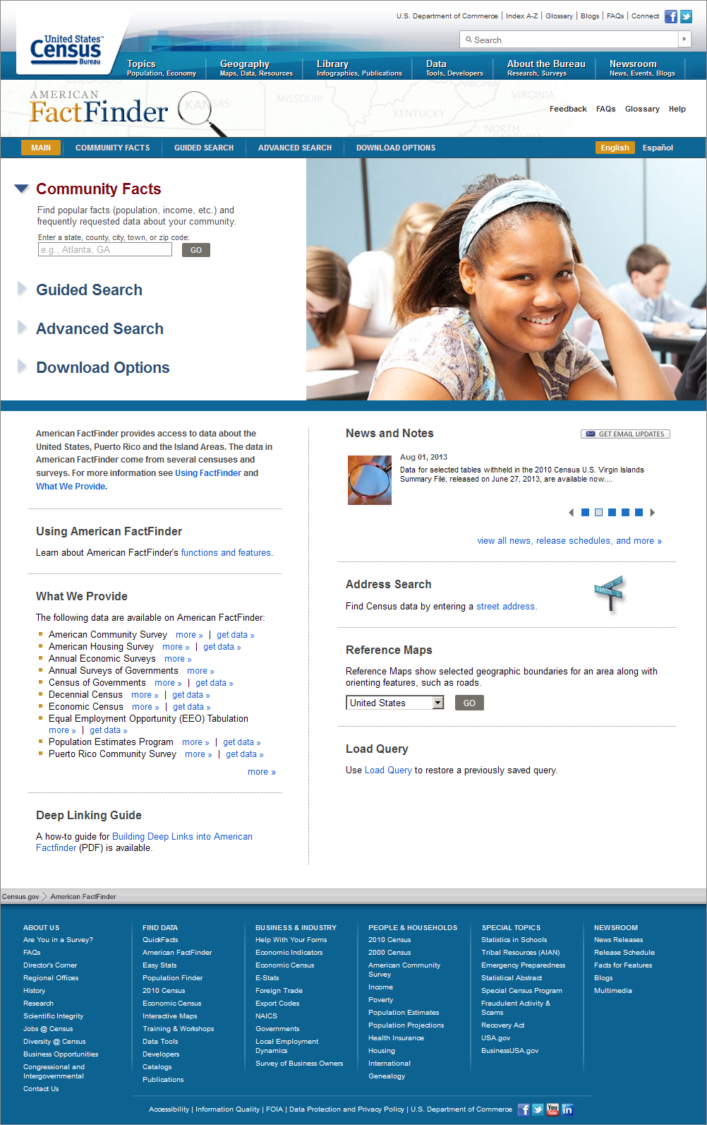

American FactFinder with new Census Bureau look and feel – Advanced Search Page ‘A’
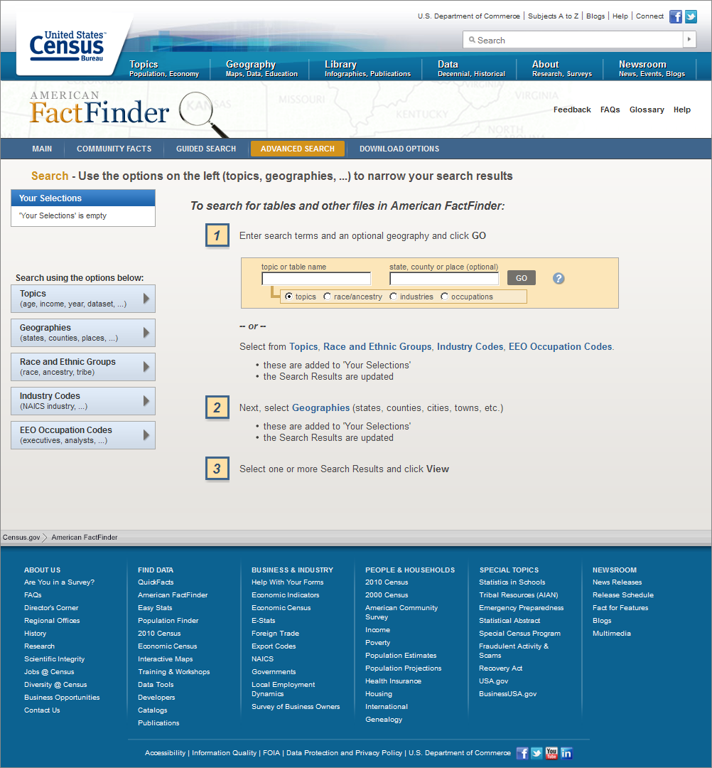

American FactFinder with new Census Bureau look and feel – Main Page ‘B’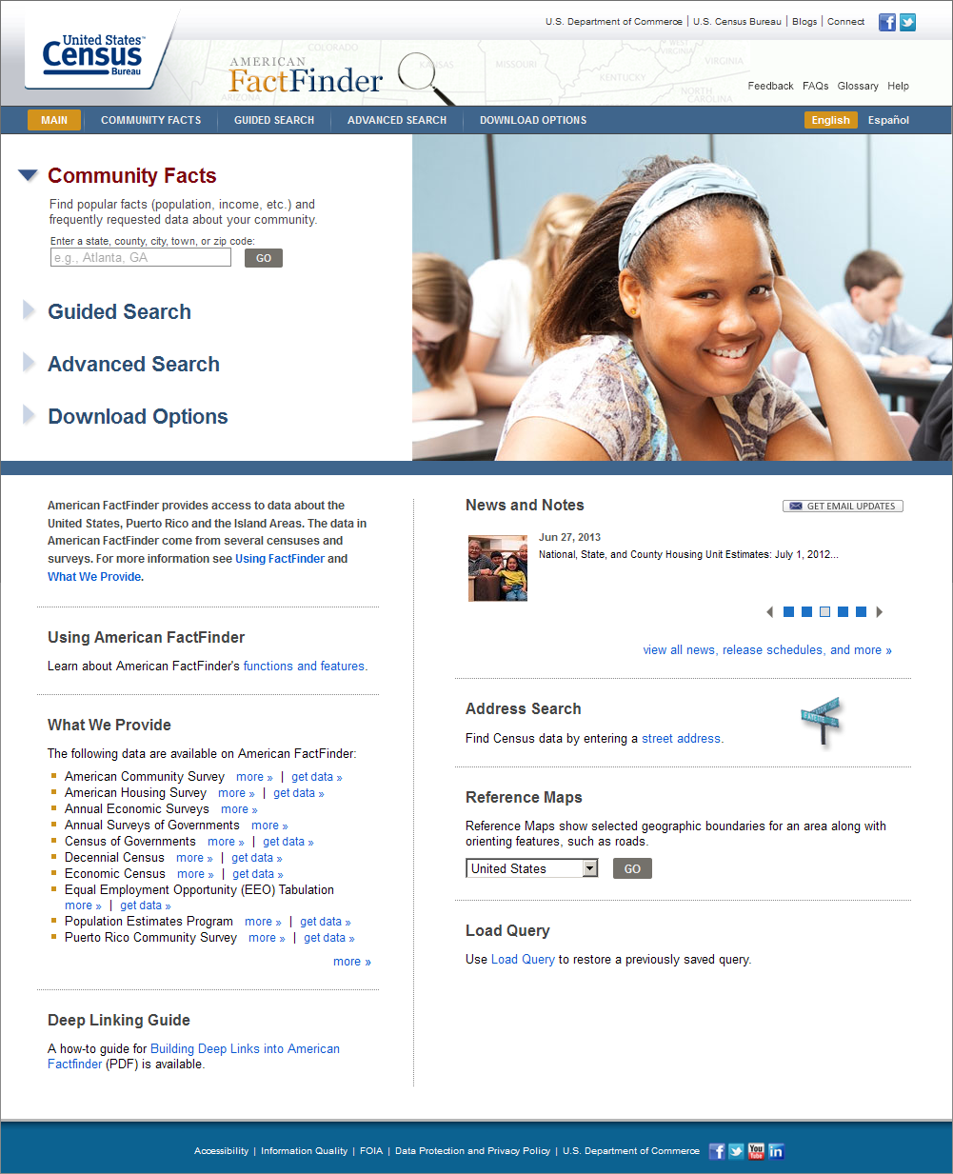
American FactFinder with new Census Bureau look and feel – Advanced Search Page ‘B’
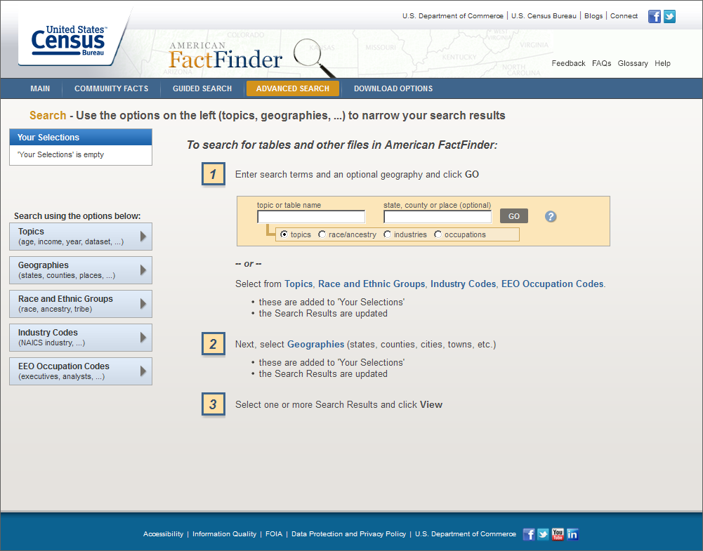

Race and Ethnic Group Selection – Basic Groups Tab
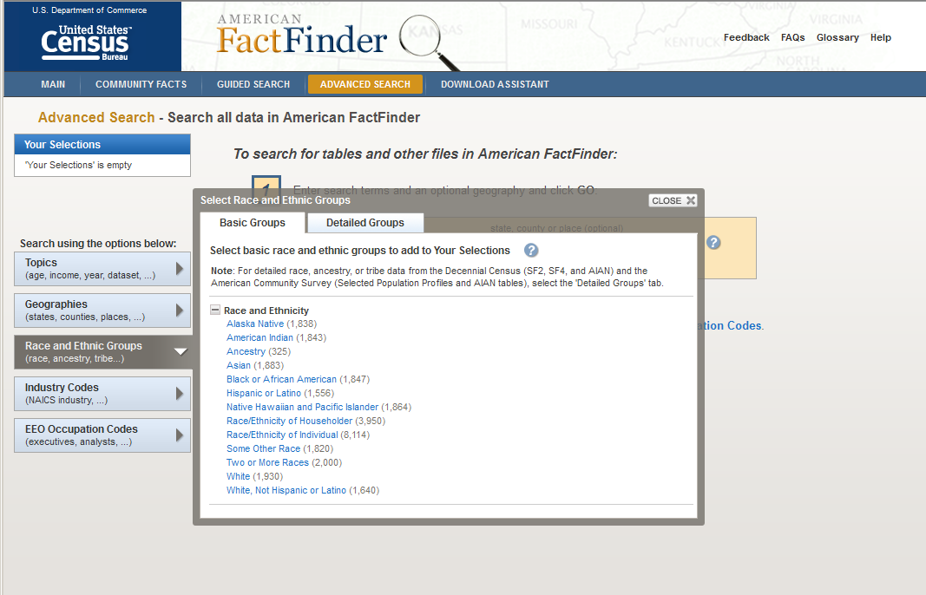

Race and Ethnic Group Selection – Detailed Groups Tab
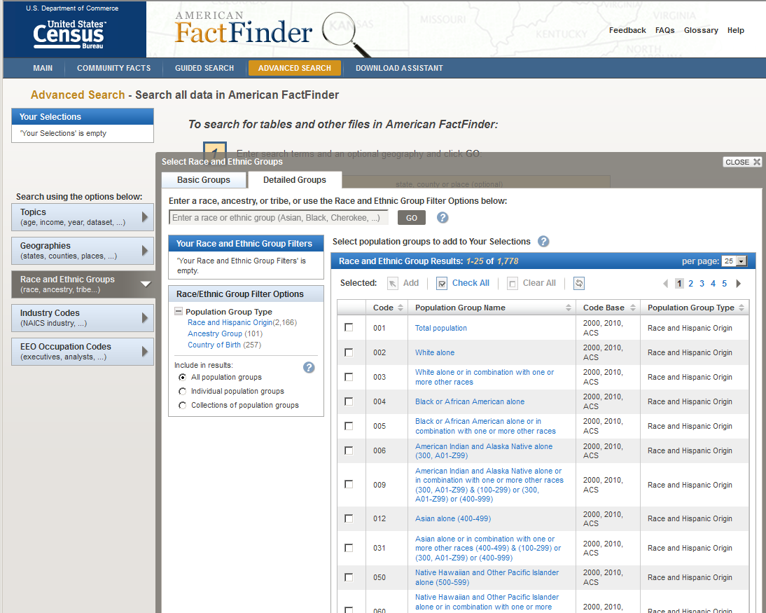

Guided Search – Step 2 showing the Race and Ethnic Group note on the Topics overlay
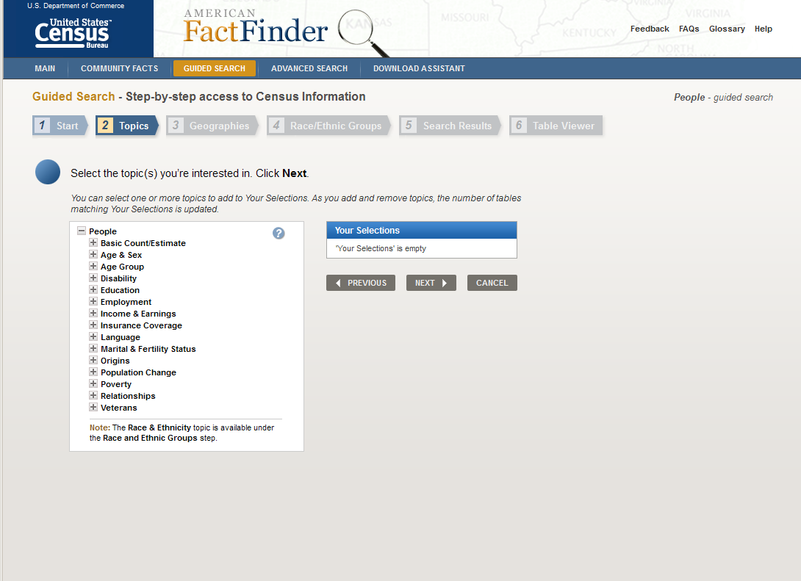

Guided Search – Step 4 – Race and Ethnic Group selection question
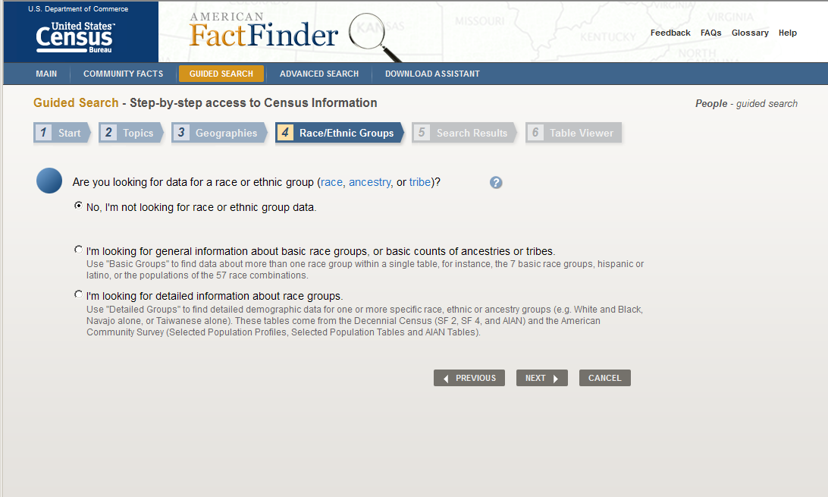

Guided Search – Step 4 – Race and Ethnic Group selection – Basic group selection
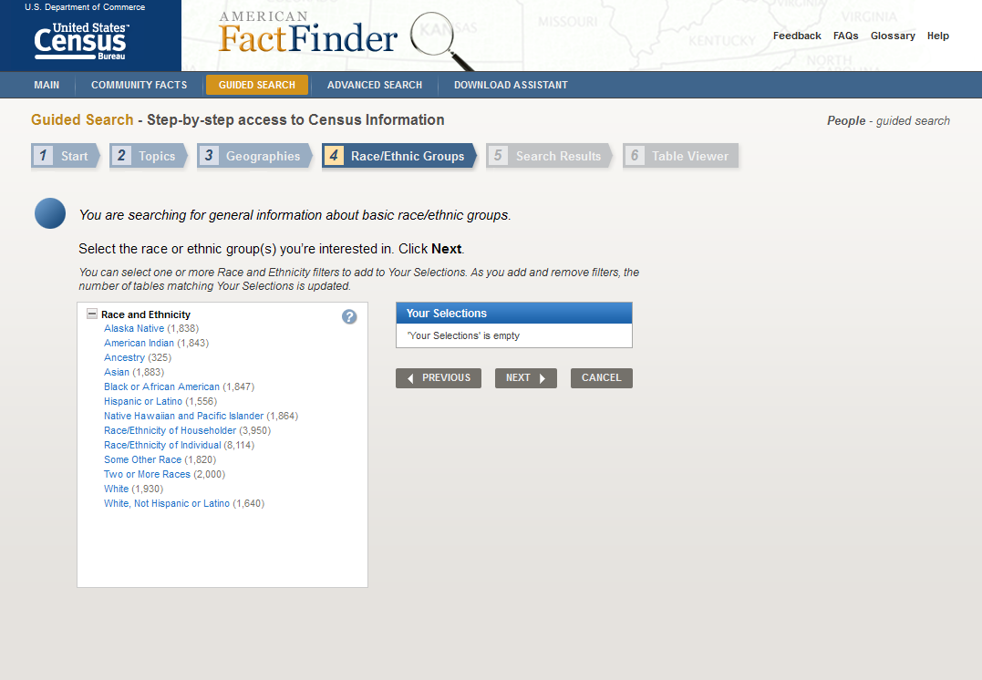

Guided Search – Step 4 – Race and Ethnic Group selection – Detailed group selection
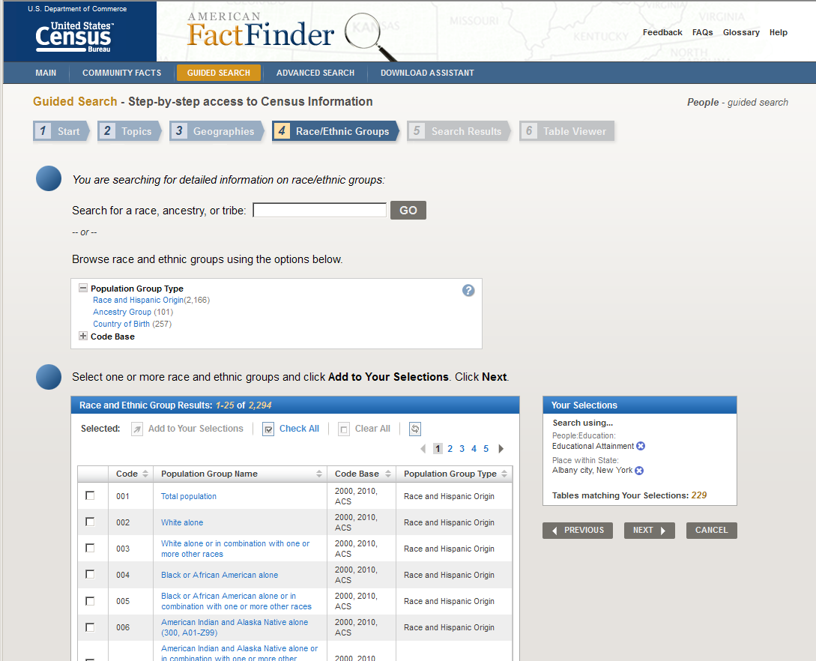

Advanced Search screen with search results and year selector dropdown
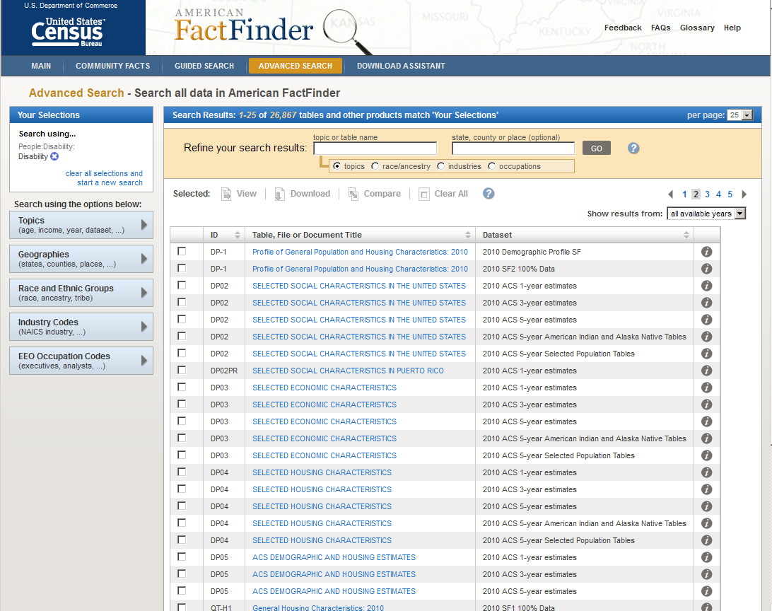

Download Assistant – Step 1
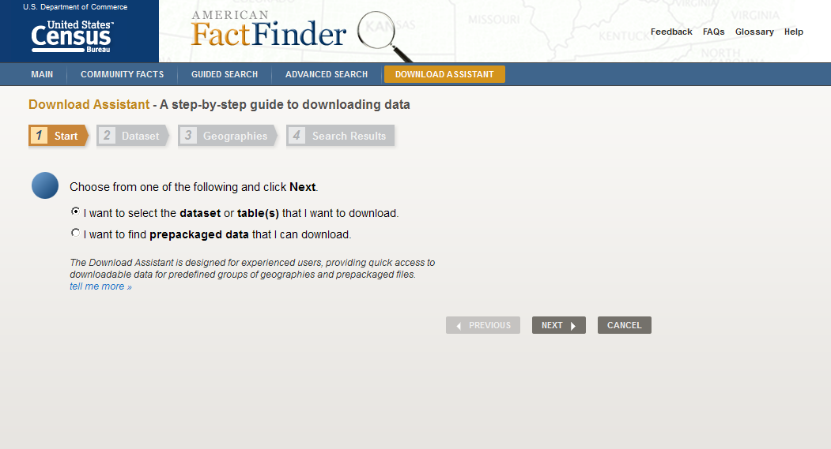

Download Assistant – Step 2
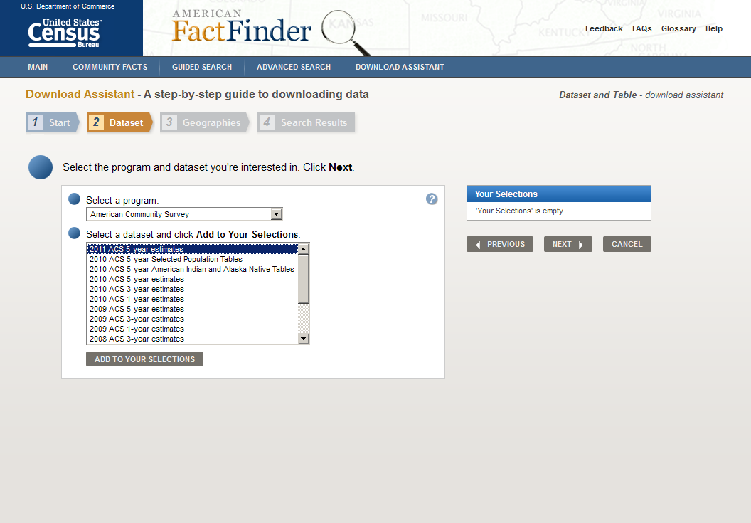

Download Assistant – Step 3
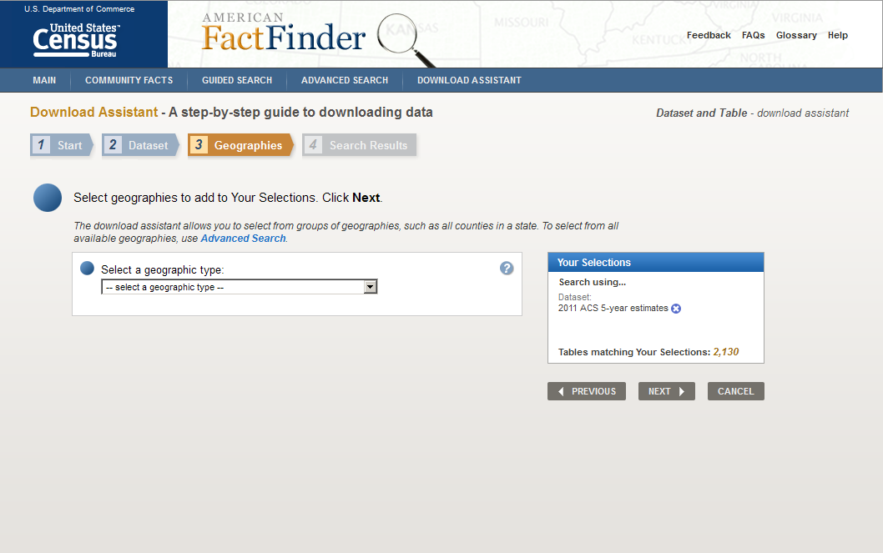

Download Assistant – Step 4
